Experiment No. 1
PART A

(PART A : TO BE REFFERED BY STUDENTS)

EXPERIMENT NO. 1

A.1 AIM: - Handwritten Digit Recognition System using Machine Learning in Python

A.2 Prerequisite
Different programming language (Python or Java), Understanding of Machine Learning Algorithms, Machine Learning Algorithms

A.3 Outcome

After successful completion of this experiment students will be able to understand working of Convolutional Neural Networks (CNN) and apply this algorithm wherever required

A.4 Theory

Convolutional Neural Networks (CNN) are complex feed forward neural networks. CNNs are used for image classification and recognition because of its high accuracy There are three types of layers in a convolutional neural network:

- Convolutional layer
- Pooling layer
- Fully connected layer .
Each of these layers has different parameters that can be optimized and performs a different task on the input data.

What is Pooling Layer?

Pooling layer is responsible for reducing the spatial size of the Convolved Feature. This is to decrease the computational power required to process the data through
dimensionality reduction. There are two types of Pooling i. Average Pooling. ii. Max Pooling Max Pooling returns the maximum value from the portion of the image covered by the Kernel. On the other hand, Average Pooling returns the average of all the values from the portion of the image covered by the Kernel. Max Pooling also performs as a Noise Suppressant. It discards the noisy activations altogether and also performs de-noising along with dimensionality reduction. On the other hand, Average Pooling simply performs dimensionality reduction as a noise suppressing mechanism. Hence, we can say that Max Pooling performs a lot better than Average Pooling.

What is Convolutional Layer?

Convolutional layers are the major building blocks used in convolutional neural networks. A convolution is the simple application of a filter to an input that results in an activation. Repeated application of the same filter to an input results in a map of activations called a feature map, indicating the locations and strength of a detected feature in an input, such as an image. A convolutional layer contains a set of filters whose parameters need to be learned. The height and weight of the filters are smal ler

than those of the input volume. Each filter is convolved with the input volume to compute an activation map made of neurons.

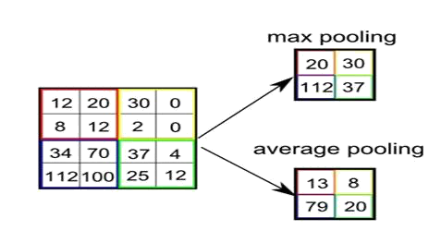

What is Fully Connected Layer?

A fully connected layer that takes the output of convolution/pooling and predicts the best lab the image.

We have three layers in the full connection step
- Input layer
- Fullyconnected layer
- Output layer Input Layer .
It takes the output of the previous layers, “flattens” them and turns them into a single vector that can be an input for the next stage.

Fully Connected Layer It takes the inputs from the feature analysis and applies weights to predict the correct label.
Output Layer It gives the final probabilities for each label.

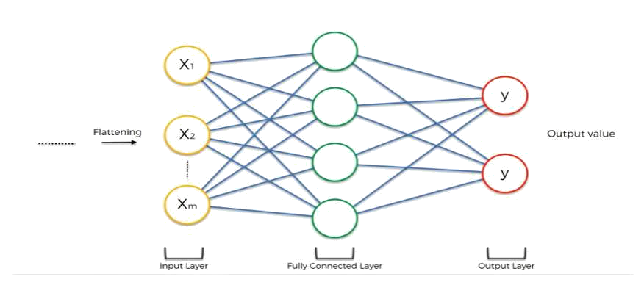

ReLU Layer

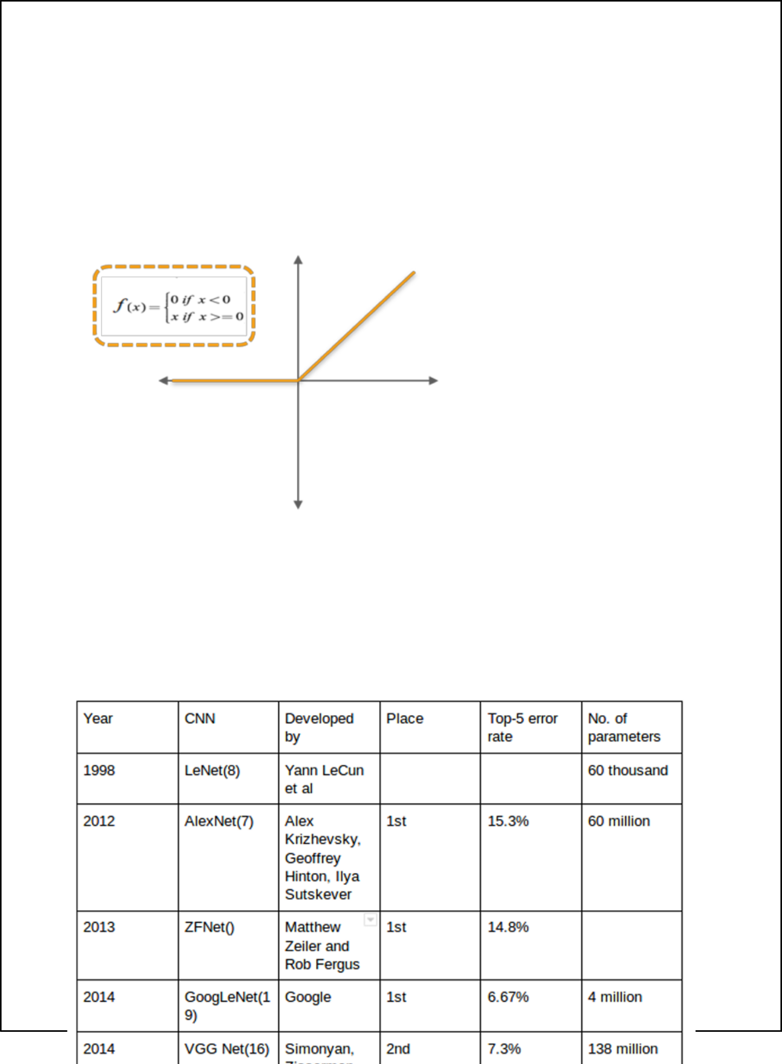
ReLU is an activation function. Rectified Linear Unit (ReLU) transform function only activates a node if the input is above a certain quantity, while the input is below zero, the output is zero, but when the input rises above a certain threshold, it has a linear relationship with the dependent var iable. The main aim is to remove all the negative values from the convolution. All the positive values remain the same but all the negative values get changed to zero

CNN Architectures : CNN architecture is formed by the s has its own number tack of distinct layers eg : conv layer pooling of layers and convolutional block. In the year 1994, and LENET5 convolutional neural networks [2] relu.. Each architecture is one of the very first with the passage of time different architectures are introduced with reduced error rate. Below is the comparison of different CNN architectures. Each architecture has its own no of layers and paramenters. [1]

Machine Learning with Tensor Flow

Machine learning is a comple is an open sou x discipline but with help of Tensor force machine learning frame work. It gives us Flow it is quite easy to do. Tensor Flow ease the process of acquiring data, training models, serving predictions, and refining futu re results.
Installation of Machine Learning Library
- Keras
- Tensorflow
You can install these packages from command prompt by using below commands
- Python Python m pip install keras
- pip install tensorflow
Hint: if Tensor Flow is not installed or give some error so first install virtual environment by this command python –m pip install –user virtualenv then install Tensor Flow. Lab

Task: You are given a basic CNN architecture implement this architecture in python with the help of tensor flow library. In this architecture you have 3 convolutional layers,2 pooling layers and 1 relu layer and at the end there is fully connected layer.

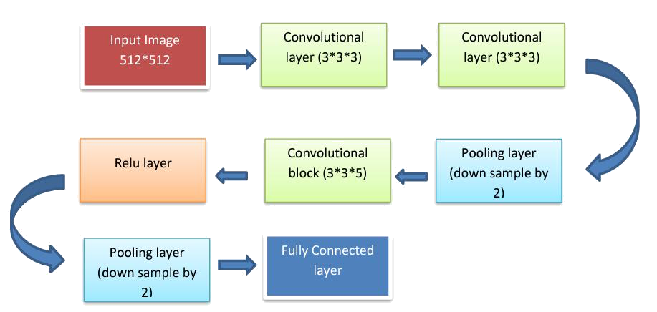

Dimensions: Suppose we have input image of size 512* 512 then after first convolution block in which we will apply 3 no of filters of size 3*3 and with padding .We get 512*512*3 dimensions again after second layer of convolutional block we will get same dimension 512 *512*3 then after third layer we will able to get less no of values because this layer will be able to down sample input values by 2 so we will have 256*256*3 dimensions ,again convolutional block in which we apply 5 filters of size 3*3 dimensions would be 256*256*5 then relu layer would have no effect on dimensions again pooling layer down samples the input values by 2 so dimensions would be 128*128*5 and when it comes to fully connected layer it flattens the 2D matrix into 1D finally we have 81,920*1 no of input values.

Some Useful Commands:

Several utilities/classes need to be imported first:
from keras.models import Sequential
from keras.layers import Dense, Conv2D, Flatten, MaxPooling2D An instance of Sequential class is then initiated (our model): my_model = Sequential()
Now, the layers can be added as we please:
my_model.add(Conv2D(64, kernel_size = 3, activation = “relu”, input_shape=(len,width,depth)))

my_model.add(Conv2D (32, kernel_size = 3, activation = “relu”))

my_model.add(MaxPooling2D(pool_size=(2,2))) my_model.add(Flatten())

my_model.add(Dense(3, activation = “softmax))
For compilation, training and making new predictions:
my_model.compile(loss = “categorical_crossentropy”, optimizer = optimizers.Adam(lr = 1e-4), metrics = [‘acc’])
my_model.fit(training_data, training_labels, epochs = 10, batch_size = 32)
my_predictions = my_model.predict(test_data)

A5. Task

Given the MNIST data set your goal is to correctly identify digits from a dataset of tens of thousands of handwritten images. Perform Handwriting detection using
- Computer vision fundamentals including simple neural networks.
- Classification methods such as SVM and K-nearest neighbors

Link: http://yann.lecun.com/exdb/mnist/

Or
Link: https://www.kaggle.com/competitions/digit-recognizer

Note: Assume necessary Details. Use Exploratory Data Analysis and show details.

You can use any technique for pre-processing if required.

PART B

(PART B : TO BE COMPLETED BY STUDENTS)

Name: Prachi Dave | Roll No.: C015
Class: B | Batch: EB1
Date of experiment: 22-12-2023 | Date of Submission: 22-12-2023
Grade:

Code written



Observations and Learning:

In this project on handwritten digit recognition, I explored several machine learning models, including DecisionTree, RandomForest, KNN, CNN, and SVM. Each algorithm provided unique insights into the dataset.

KNN: Utilizing neighboring data points for predictions, KNN demonstrated the importance of plotting the error rate against the number of neighbors (n_neighbors) to determine the optimal value.

SVM: Employing a decision boundary for prediction, SVM's hyperparameter tuning highlighted the significance of selecting appropriate kernels based on data relationships. Linear kernels for linear relations, polynomial kernels for polynomial relations, RBF kernels for circular datapoints, and Sigmoid kernels for sigmoid relations were considered.

DecisionTree, RandomForest: Both models exhibited 100% accuracy, indicating overfitting. This overfitting was attributed to the image-based nature of the data, where DecisionTree processed individual raw pixels rather than considering the entire image.

CNN: Initially prone to overfitting due to a large number of hidden layers, optimizing the model involved reducing complexity. Introducing dropout and max-pooling layers addressed overfitting issues.

PCA and Miscellaneous Techniques: Incorporating dimensionality reduction techniques like PCA significantly reduced the computational time required for model training and fitting to various datasets.

Conclusion:

 | Base |  | Optimised
 | Training | Testing | Training | Testing
KNN |  | 92.68 % |  | 90.97 %
SVM | 92.52 % | 93.66 % | 99.99 % | 91.99 %
Decision Tree | 100 % | 100 %
Random Forest | 100 % | 100 %
CNN | 90.89 % | 91.11 %

Considering the summarized accuracy, it appears that SVM might be the most promising option. However, it's essential to note that while implementing the SVM algorithm, PCA was employed to reduce data size for improved speed. This raises a consideration for production usage, as implementing SVM may entail a trade-off between speed and data integrity.

