SYLLABUS

Class – B.Com IV Sem. (All)
Subject: Principles of Management
Unit –I | Management- Meaning, Nature and Importance, Functions and Principles of Management, Management V/S Administration.  Development of Managerial Thought, Contribution by Taylor and Fayol Management by Exception and Management by objectives social responsibility of management.
Unit – II | Planning: Concept, Process and Techniques, Decision Making, Concept and Process.  Organisation – Concept, Nature, Principles and Significance.
Unit – III | Motivation: Concept – Theory, Monetary and Non Monetary Motivation.  Leadership – Concept and Leadership styles, Leadership Theories.  Direction and control – Process and Methods.
Unit – IV | Human Resource Management: Meaning, Objectives, Scope and Importance, Functions and Responsibilities of HR Manager. Principles of H.R.M.
Unit - V | Man Power Planning – Recruitment, Selection and Promotion.  Training and Development- Methods of Training Program, Job Evaluation concept and Techniques.
Unit-i
Introduction
Management is essential for all organizations big or small, profit or non-profit, services or manufacturing. Management is necessary so that individuals make their best contribution towards group objectives. If consists of a series of interrelated functions that are performed by all managers.

According to Harold Koontz, “Management is an art of getting things done through and with the people in formally organized groups. It is an art of creating an environment in which people can perform and individuals can co-operate towards attainment of group goals”. According to F.W. Taylor, “Management is an art of knowing what to do, when to do and see that it is done in the best and cheapest way”.

Definition:
- In the words of Henry Fayol: “Management is defined as, to manage is to forecast, to plan, to organize, to command, to coordinate and to control.”
- Koontz O’Donnell: Management is the task of manager to establish and maintain internal environment in which people working together in groups can perform effectively towards the attainment of group goals.
In short management may be defined as the agency that provides leadership, guidance, and control for the achievement of the objective set by administration.

Nature of Management
1) Management as Science- Science is a systematic body of knowledge pertaining to a specific field of study that contains general facts which explains a phenomenon. Since the principles of management are not as exact as the principles of science their application and use is not universal. They have to be modified according to on given situation.

2) Management as an Art-
Art implies application of knowledge & skill to trying about desired results. An art may be defined as personalized application of general theoretical principles for achieving best possible results. Art has the following characters –
- Practical Knowledge
- Personal Skill
- Creativity
- Perfection through practice
- Goal-Oriented

3) Management as a Profession-
A profession may be defined as an occupation that requires specialized knowledge and intensive academic preparations to which entry is regulated by a representative body. The practice of management is an art. However, managers can work better if their practice is based on the principles of management. These principles constitute the science of management. Management as an art and a science are therefore not mutually exclusive, but complement each other.

The essentials of a profession are:
- Specialized Knowledge
- Formal Education & Training
- Social Obligations
- Code of Conduct
- Representative Association

Features of Management-
Management is an activity concerned with guiding human and physical resources such that organizational goals can be achieved. Nature of management can be highlighted as: -
- Management is Goal-Oriented
- Management integrates Human, Physical and Financial Resources
- Management is Continuous.
- Management is all Pervasive
- Management is a Group Activity
- Management is the art of getting things done through and with people.
- Management is primarily direction.
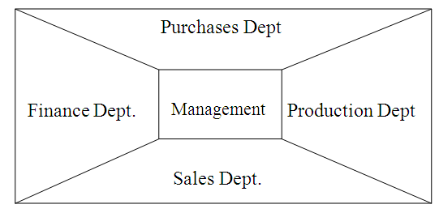

- Management is the development of people: It is the selection, the training the supervision and the development of people.
By American Corporation “We do not build automobiles, refrigerators, shoestring; we build men. The men build products.

The two important elements which make up the art of management are:

(a) Human Resources | (b) Physical Resources
(a) Personnel Admission | (a) Finance or Money
(b) Training | (b) Raw Materials
(c) Development of Human Environment | (c) Buildings
(d) Development of natural talent of the people. | (d) Machinery or Plant
(e) Development of Human personality. | (e) Other Equipments

Importance of Management
Management is a must for every enterprise. The existence of management ensures proper functioning and running of an enterprise. Management can plan the activities to achieve the objectives and utilize the available resources at minimum cost. Every business needs a direction. This direction is given by the management. The resources of production are converted into production. The resources will remain as resources in the absence of management. The conversion process is performed through the coordination of management. The significance or importance of management is briefly explained below:
- Management meets the challenge of change: In the modern business world, there are frequent changes. The changes place the business in a dangerous position. Only an efficient management can save the business from the dangers brought in by the challenges.
- Accomplishment of group goals: The achievement of objectives of a business depends upon three factors. The proper planning of available resources, adjusting possibility of business unit with existing business environment and the quality of decision taken and control made by the business unit are the factors responsible for achieving objectives.
- Effective utilization of business: There are eight M’s in the business. These are said to be man, money, materials, machines, methods, motivation, market and management. Management is the topmost of all other ‘Ms’. Management has control over other remaining ‘Ms’.
- Effective functioning of business: Ability, experience, mutual understanding, co-ordination, motivation and supervision are some of the factors responsible for the effective functioning of business. Management makes sure that the abilities of workers are properly used and co-operation is obtained with the help of mutual understanding. Besides, management can know the expectation of workers and the expectation is fulfilled through motivation techniques.
- Resource development: Efficient management is the life boat of any developed business. The resources of the business may be identified and developed by the management. The term ‘resources’ includes men, money, material and machines.
- Sound organization structure: Management lays down the foundation for sound organization structure. Sound organization structure clearly defines the authority and responsibility relationship-who is responsible to whom, who will command whom and who is responsible for what. Care is taken in appointing qualified persons to the right job by the management.
- Management directs the organization: The human mind directs and controls the functioning of human body. Similarly, the management directs and controls the functioning of an organization.
- Integrates various interests: Each person has his own interests these interests are different in nature. Management takes steps to integrate various interests to achieve the objectives of an organization.
- Stability: The fluctuations of business are stabilized by the management. The fluctuations of business are caused by the changing policy of the government, pressures on the part of competitors and changing preference of customers. The efficient management can run the business as per the policy framed y the government, face the competitors in the market and produce the articles as per the preference of customers.
- Innovation: New ideas are developed by the management and implements in the organization. Better performance is achieved through new ideas.
- Co-ordination and Team-spirit: All the activities of business are grouped department-wise. Management co-ordinates the activities of different departments and establishes team-spirit to achieve the objectives.
- Tackling problems: Good Management acts as a friend or a guide of workers while tackling problems. When workers get over confidence of solving the problems for effective performance of a job, they fail in tackling the problems efficiently.
- A tool for personality development: Management gives direction to workers for effective performance of a job. Besides, new methods or techniques are taught to workers. The training facilities are arranged by the management. In this way, management is a tool to develop the personality of workers to raise their efficiency and productivity ability.

FUNCTIONS of management
Management functions are the activities that a manager must perform as a result of the position held in the organization. The best way to analyse the management process is in terms of what a manager does. Generally the basic functions of management are: planning, organizing, staffing, directing and controlling. As managing is a dynamic and challenging activity, it includes three kinds of functions and tasks which are common to all managerial jobs. The list of management functions can be presented as follows:
I. Main Functions  - Planning  - Organizing  - Staffing  - Directing  - Co-ordination  - Motivation  - Controlling | II. Subsidiary functions  - Communication  - Decision making  - Innovation
Basic functions
1. planning
Planning is one of the most important functions because it sets the pattern for the other activities to follow. Planning function for the new era is more broadly described as delivering strategic value. It is a primary and crucial function which determines how to achieve an objective-deciding what is to be done and when to do it. It is looking ahead and preparing for the future.
Planning emphasizes the fact that if one knows where he is going, he is more likely to get there. Good managers endeavour to draft a plan which will make things happen in the desired way. This is also stressed by the saying “Good manager make things happen, things do not just happen to them.”

2. Organizing
Organizing is the process by which the structure and allocation of jobs are determined. To organize a business is to provide it with everything useful to its functioning. The whole process of forming groups and allocating jobs is organization.
Organizing as a process involves:
- Identification of activities.
- Classification of grouping of activities.
- Assignment of duties.
- Delegation of authority and creation of responsibility.
- Coordinating authority and responsibility relationships.

3. Staffing:- is concerned with ensuring that the right type of personnel is available to undertake and execute the varied activities required to attend the planned objectives of the organization. Staffing is the process of planning, recruiting, developing, compensating and maintaining human resources in an organization. In staffing, a manager recruits and selects suitable personnel for manning the jobs.
Staffing involves:
- Manpower Planning (estimating man power in terms of searching, choose the person and giving the right place).
- Recruitment, selection & placement.
- Training & development.
- Remuneration.
- Performance appraisal.
- Promotions & transfer.
4. directing:- is that part of the management process which activates the organization members to work efficiently and effectively for the attainment of organizational objectives. The fourth basic function of management is directing. This is also termed leading or actuating. While planning tells us what to do and organizing tells us how to do it, directing tells us why the employees should want to do it. Directing is concerned with guiding and leading people. It consists of supervising and motivating the subordinates towards the achievement of set goals.
  - Communication :- Exchanging ideas and information in order to create mutual understanding.
  - Command:- Issuing orders and instructions to subordinates.
  - Motivation: - Inspiring employees to work with zeal.
  - Leadership :- Influencing people
  - Supervision: - overseeing of subordinates at workplace with a view to guide and regulate their efforts.
  - Controlling:- is evaluating the performance and applying corrective measures so that the performance takes place according to plans.
5. Co-ordination: It may be defined as the synchronizing of effort from the stand point of time and the sequence of execution. Co-ordination leads to the completion of the production and other functions as per planned schedules.
6. Motivation ; It is psychological technique of executing the plans and policies through the effort of others. It is through motivation that the manager inspires the subordinates to do what he wants them to do.
7. controlling :- Breach defines control as “the process of checking actual performance against the agreed standards or plans with a view to ensuring adequate progress or satisfactory performance.” Controlling is evaluating the performance and applying corrective measures so that the performance takes place according to plans. It is reviewing the performance of the employees in the light of the targets and goals.
Controlling has following steps:
- Establishment of standard performance.
- Measurement of actual performance.
- Comparison of actual performance with the standards and finding out deviation if any.
- Corrective action.
Subsidiary functions
- Communication: In business management ideas, objectives, instructions, suggestions etc. have to be exchanged among the managerial staff for the purpose of planning, executing or operating the business policies.
- decision making: Decision making is the process by which a course of action is consciously chosen from available alternatives. Decision making is inherent in every managerial function.
- Innovation: Innovation means developing new ideas, new products, new quality or devising new methods of work. In other words, the real manger is always an innovator. Innovation is the specific function of entrepreneurial managers, the means by which they exploit change as an opportunity.
.Process of management
According to Stoner, Freeman and Gilbert, “a process is a systematic way of doing things.” In simple words, it is a step-by-step sequence. We refer to management as ‘process’ to emphasize that all managers engage in certain interrelated activities in order to achieve their desired goals. David Hampton says, “management is a common set of processes which, when competently carried out, contribute to organizational effectiveness and efficiency. The basic parts of this process are planning, organizing, leading, and controlling.”
Characteristics
The main characteristics of management process are as follows:

- Carried out by managers
- Consists of functions
- Parts
- Logical flow of activities
- Integrated process
- Performed at all levels
- Interactive process
- Social process
- Dynamic process
- Operational
- Goal-oriented
- Universal
- Influencing process
- Continuous process

Principles of Management
According to Koontz and O’Donnell ‘Principles are fundamental truths which are believed to be truths at a given time, expressing relationship between two or more its of variables.’ Management principles increase managerial efficiency, crystallize the nature of management, encourage research and help in attaining the social objectives.

Following are the important principles of Management
- Principle of Objective: Knootz & O’Donnell suggest that “The organisation as a whole and every part of it must contribute to the attainment of enterprise objectives.”
- Principles of Planning: Planning is an important element for good management. Policies, programmes etc must be prepared to execute them properly.
- Principles of Span of Control: Span of control means the number of subordinates under the direct supervision of a superior. The number of persons to be supervised depends upon the nature and type of work, ability of the supervisor etc.
- Principle of Balance: This principle states that different parts or units of an organisation should be in balance.
- Principle of Coordination: Human efforts and other resources should be coordinated in order to achieve organisation goals effectively.
- Principle of Exception: Superior should not interfere in the routine work of his subordinates so long as they do their work according to the plans & within the scope of their authority.
- Principle of Participation: Managers must encourage participation of their subordinates in taking decisions on matters directly offering them.

Management V/S Administration
Management and Administration – “Administration means overall determination of policies, setting of major objectives, the identification of general purposes and laying down of broad programmes and projects”. It refers to the activities of higher level. It lays down basic principles of the enterprise. According to Newman, “Administration means guidance, leadership & control of the efforts of the groups towards some common goals”.
Whereas, management involves conceiving, initiating and bringing together the various elements; coordinating, actuating, integrating the diverse organizational components while sustaining the viability of the organization towards some pre-determined goals. In other words, it is an art of getting things done through & with the people in formally organized groups.

The difference between Management and Administration can be summarized under 2 categories–
- Functions
- Usage/Applicability

On the Basis of Functions:-
Basis | Management | Administration
Meaning | Management is an art of getting things dones through others by directing their efforts towards achievement of pre-determined goals. | It is concerned with formulation of broad objectives, plans & policies.
Nature | Management is an executing function. | Administration is a decision-making & when it is to be done.
Process | Management decides who should as it & how should he not it. | Administration decides what is to be done & when it is to be done.
Function | Management is a doing function because managers get work done under their supervision. | Administration is a thinking function because plans & policies are determined under it.
Skills | Technical and Human skills | Conceptual and Human skills
Level | Middle & lower level function. | Top level function

On the Basis of Usage:-
Basis | Management | Administration
Applicability | It is applicable to business concerns i.e. profit-making organization. | It is applicable to non-business concerns i.e. clubs, schools, hospitals etc.
Influence | The management decisions are influenced by the values, opinions, beliefs & decisions of the managers. | The administration is influenced by public opinion, govt. policies, religious organizations, customs etc.
Status | Management constitutes the employees of the organization who are paid remuneration (in the form of salaries & wages. ) | Administration represents owners of the enterprise who earn return on their capital invested & profits in the form of dividend.

Practically, there is no difference between management & administration. Every manager is concerned with both – administrative management function and operative management function as Shown in the figure. However, the managers who are higher up in the hierarchy denote more time on administrative function & the lower level devote more time on directing and controlling worker’s performance.
Management V/S Administration

Administration

Management
Thinking Function
Doing function
Top management
Middle management

Lower management

There has been a sharp division of opinion, disagreement and terminological conflict about the use of the two terms management and administration. some experts assert that and some consider them as two separate functions. There are different views regarding management and administration which are as follows.
1. Administration is above managements: the American thinkers like allover Sheldon, William, Spiegel, Haimann view that administration is a higher level activity and involves thinking function while management is lower level activity and is doing/executing function.
2. Administration is part of management: British school of management considers management as wider term including administration and organisation. This view says that administration is a subordinate function to overall management function.
3. Management and administration are synonymous: authors like Henry Feyol, George Terry Treat Management and administrations as same concept. They believe that both the terms can be used interchangeably.

EVOLUTION OF MANAGEMENT THOUGHTS
Application of management knowledge is as old as human civilization but development of management thought and theory is relatively of recent origin. Management thoughts may be placed under three main categories which are discussed below:-

- Classical or Traditional Management Approach : Classical or Traditional Management Approach includes the following
(a) Scientific Management: - This theory was propounded by sir F.W. Taylor Sir Taylor has expressed the basic philosophy of scientific management in the following terms :-
- Science, not rule of thumb
- Harmony, not discord
- Cooperation, not individualism
- Maximum, not restricted output
- Development of each employee to his greatest efficiency and prosperity.
Sir Taylor based on his experience at the shop floor, developed guide lines to the practice of management which are as under –
- Scientific study and planning of work –
The work to be assigned to and performed by workers should be studied, analysed and planned as to determine a day’s fair work for each worker.
- Scientific selection, placement and training: - Employees selection should be made by using scientific methods, instead of relying on intuition and judgment of the foremen.
- Standardization: - Standard quality tools and equipments, raw material used and physical working conditions should be provided to the workers.
- Division of responsibility between management and workers: - Planning of work should be a responsibility of managers whereas role of workers should be confined to implementation of these plans.
- Functional Foremanship: - According to Sir Taylor, instead of having one foreman, there should be eight supervisors to guide and command the activities or workers.
- Mental Revolution: - In order to get desired results of scientific management, outlook, behaviour and attribute of the workers as well as management should be changed.
- Wage incentives :- The worker producing more should be given higher wages according to differential piece rate plan,

(b) Administrative theory of Management/Management process school:-
This theory was given by Sir Henri Fayol. He wrote a monograph titled as ‘General and Industrial Management’ published in 1916. It is in four parts which are discussed below:-

First part of monograph deals with classification of business activities as:-
- Technical activities (manufacturing and production)
- Commercial activities (buying, selling and exchange)
- Financial activities (raising and optimum use of capital)
- Accounting activities (recording, costing and statistics)
- Managerial activities (POSDCORB)
- Security activities (Protection of persons & property)
Second part of the monograph contained basic managerial functions viz:-
- Planning and forecasting.
- Organising
- Commanding
- Co-ordinating
- Controlling
Third part consists of Fayols 14 principles of management viz :-
- Division of work
- Authority and responsibility
- Discipline
- Unity of command
- Unity of direction
- Subordination of individual’s interest to interest of organisation
- Remuneration
- Centralisation
- Scalar chain
- Order
- Equity
- Stability of tenure of personnel
- Initiative
- Espirit-de-corps

The fourth part of monograph deals with managerial qualities which should be possessed by managers. These are:-
- Physical qualities (health, vigour, personality)
- Mental ability (ability to understand & learn, make decisions etc.)
- Moral education (loyalty, dignity, ethical values etc.)
- Special knowledge
- General education
- Experience (knowledge arising out of practice)
(c) Bureaucratic Organization:-
This model developed by sir Max Weber is based on the following characteristics:-
- Division of labour:-
It implies to divide and assign activities to various employees on the basis of their skills, abilities and aptitude.
- Hierarchy of authority: - All employees are attached to each other in the relationship of authority.
- Rigidity in compliance with proecedures and frame work of rules without any deviation.
- Impersonality :-
In a bureaucratic organization, there is no place of emotions, sentiments and personal attachment.
- Technical competence: - People ought to be hired and promoted on the basis of what they know about job.

- Behavioural or Neo-Classical Approach: - Neo-Classical approach included Human relation approached behavioural sciences approach.
- Human relation Approach :- It is based on the following factors –
- Human organization was considered as psycho-social system.
- Apart from economic needs, the employees have other social and psychological needs such as dignity, recognition, appreciation etc.
- Regarding human nature, highly optimistic assumptions were made about workers such as they want to work, assume responsibility provided they are given an opportunity.
- There should be no conflicts or clashes in organization and at all if it arises, it must be removed completely.
- As to secure maximum contribution the manager should get along with employees and workers.
- In order to inotivate individual employee his motivating desire should be ascertained in terms or his emotions beliefs, attitudes and habits.
- Sense of belongingness should be created among employees by giving them more importance and getting them involved in decision-making.

- Behavioural Science Approach: This approach also known as ‘Organizational Behaviour Approach’.
Advocates of behavioral Science strongly believe that organisation is socio-technical system which consists of individuals and their interpersonal and social relationship with each other on one hand and on the other various techniques methods and procedures used by them for performing several jobs assigned to them.
This approach highlights that individual goals and interests of employees can be integrated with organizational goals as to avoid conflict and clash between them.
According to this approach conflict and co-operation co-exist in organization.
Behavioural scientists recognize individual differences in terms of their personality. Goals, beliefs, values and perceptions.
Behavioural approach also assumes that people are the key to productivity.

Modern Approach to Management: Modern approach includes the following three approaches

- Quantitative Approach: - This approach also known as ‘management science approach’ has been developed during 1950. It is based on the approach of scientific management. It offers systematic and scientific analysis and solution to the problems faced by managers. The quantitative approach aims at achieving high degree of precision, perfection and objectivity by encouraging the use of mathematical and statistical tools for solving complex problems.
- System Approach: - System approach of management represents new thinking and latest developments related to organisation and management. It was developed after 1950 emphasizing interdependence and interrelationship among various activates or organization. The term system may be defined as a set of interrelated and interacting components assembled in in a particular sequence as to produce some results, these components may also be viewed as sub-systems of larger system. It is only through these sub-systems the larger system operates, thus larger system can be view as a whole entity or totality.
- Contingency Approach: - The theme behind contingency approach is that there is no single best way of managing applicable to all management situations. According to this approach, managers instead of applying principles & practices of management uniformly to every situation a they should study, analyze & diagnose the situation in terms of it’s variables & requirement s& then prepare a plan to deal with it effectively.

Development of management thought
The major historical stages or events in the development of management thought can be discussed under the following heads:
- Management in ancient civilizations.
- Management during the medieval period.
- Management during the period of Industrial Revolution.
- Period of systematized management. This period can be sub-divided into the following categories:
- Era of scientific management.
- Era of administrative management.
- Era of behavioural science.
- The modern era of new approaches to management.

Scientific Management
Systematic development of management thought started with the scientific management movement which is said to have its origin as early as 1830s.
The man who popularised the movement is Fredrick Winslow Taylor. He is known as the father of scientific management.

Philosophy and Principles of Taylor:
- Develop a science to replace rules of thumb: Taylor wanted to make management as a science. He, therefore, recommended that every activity of an organisation must rest on well organized, clearly defined principles, instead of depending on more or less hazy idea.
- Maximisation of output or production: Taylor believed maximum output instead of restricted output. It is because the prosperity for both employer and employees could be achieved only through maximising productivity.
- Equal division of responsibility: There should be equal division of responsibility between managers and workers. Managers must fulfill their responsibility of planning and organising effectively. On the other hand, workers must fulfill their responsibility by executing the work as per the directions of the ‘bosses’.
- Job specialisation: Taylor believed that each worker should be specialist in his job. At the same time, each worker must be supervised by different specialist supervisors.
- Scientific selection, training and development of workers: Taylor realized the importance of right person for the right job to attain highest efficiency. He therefore, stressed the need for proper selection and training of the workers.
- Standardisation: Taylor believed standardisation of methods, tools, time, materials etc. for each activity is very important. Therefore, standards should be fixed for each of them.
- Wage incentives: Taylor believed that wage incentives should be integral part of each job. Taylor suggested the differential wage rate for different job.
- Mental revolution: Taylor firmly believed that the principles of scientific management could succeed only when there is a complete mental revolution on the part of management and worker. In other words, both the parties should change their mental attitudes. For this, he suggested the following three things:
- They must create a sprit of mutual trust and confidence.
- Both must make efforts to increase production and productivity.
- Both must develop a scientific attitude towards the work and should not leave their arbitrary approach.
The mental revolution requires change in the attitude of both. Management must create congenial working conditions and develop best method and tools for optimum efficiency of the workers.

Contribution of Taylor
- Scientific task setting: Taylor suggested that the task of every worker for every day should be determined through scientific investigation. Taylor called it “a fair day’s work”. Every manager must know in advance the fair day’s work for each worker.
- Experimentation or work study: Work study means organised, systematic and objective analysis and assessment of the operational efficiency of all the elements connected with the work.
- Method study: It is a survey of production process. It aims to evolve the best method of doing a particular job by simplifying the production process, methods, tools etc.
- Motion study: Motion study relates to the study of movements of a worker or a machine in doing a job. It aims at eliminating unnecessary motions and to find out the best method of doing of doing a job efficiently.
- Time study:- Time study is the process of recording the exact time taken for doing a job with a view to find out a standard time for doing the job.
- Fatigue study: Fatigue study is the study of the reduction or diminution of human energy or capacity in doing in his job. Fatigue is caused by over-work without rest pause, poor working conditions, stress, strain etc. The fatigue study is undertaken to know the level and nature of fatigue and to find out the ways to eliminate or minimize the fatigue on the job.
- Planning: Taylor advocated that planning function should be separate from the doing function. Planning department should decided about the type, shape, and quality of the goods to be produced and the time schedule for delivery of the products.
- Scientific selection and training of workers: Taylor realsied the importance of the right person on the right job. Therefore, he advised for proper selection of the workers and their training.
- Specialisation: Taylor suggested that scientifically selected and trained workers should be allocated the tasks according to their specialisation.
- Standardisation: Taylor advocated for standardisation of materials, tools, equipments, methods etc. Standardised working environment should also be provided to the workers. Standardisation will increased efficiency and eliminate or minimise wastage of resource.
- Incentive wage plan: Taylor considered that incentive wage plan is an integral part of the scientific management. He, therefore suggested a differential wage payment plan. According to this plan, worker is to received a bonus in addition to his wages if the completed his job before the standard time fixed for the job.

Henri Fayol (1841-1925):
Henri Fayol was a French mining engineer and chief executive officer of a coal mine company. He propounded the administrative or functional theory of management.
- Administrative management thought era run almost parallel to the scientific management thought era. Henri Fayol is regarded as the herald of the administrative thought. Other contributors include Urwick, Mooney and Reiley, Davis etc.
- Elements of administration or management function: Fayol described five elements of administration or management functions. They are as follows:
- Planning, consisting of activities for making plans to achieve goal of the organisation. This function includes forecasting and decision-making.
- Organising, consisting of activities necessary for mobilising human and other resources of the organisation to implement the plans.

- Commanding, which consists a activities relating to directing, leading, motivating and communicating for getting things done.
- Coordinating, which is concerned with activities necessary for harmonising the efforts of all in order to achieve a common goal.
- Controlling, which is concerned with ensuring performance in accordance with plans.
- Principle of management: Fayol proposed fourteen principles of management.
- Flexible and adaptable principles: Fayol made it clear that the principle of management are flexible and adaptable to every need.
- Universal principles: He believed that principles of management are universally applicable. The principles are applicable in all organisations large or small, industrial, commercial, political, religious, or any other.
- Management education and training: Fayol realised the need for management education and training. He strongly pleased for introducing management education and training in schools and universities. He also suggested for conducting organizational ‘in-house’ training programmes.

General principles
Division of Work
To divide work among departments and employees according to requirement & owned activities & skills to get benefit of specialization & avoid time wastage. It says that every employee should be assigned only one of type of work else there will be waste of time and effort caused by changes from one work process to another.
Authority and Responsibility
Authority means right to give orders and power to exact obedience.
Responsibility is assignment of tasks and act to be completed in availability of resources accountability extent to which person can be made liable to answer for acts.Fayol said Authority and Responsibility are co existence in nature and must go hand in hard with proper parity in between.Authority without responsibility heads to irresponsible behaviour & responsibility without authority makes manager in effective.
Discipline
Implies compliance with organizational directions and rules, orders and instructions of superior & to co-operation with fellow workers. He considered discipline as the chief strength of organization and essential for smooth operation. Discipline generally depends essentially on ability of its leaders.
Fayol said best means of maintaining discipline are
- Goods superiors at all levels
- Clear & fair agreements between employees & employer
- Judicious application of penalties

Unity of command
According To this principle one subordinate should get orders and institutions regarding his work only from one superior.If a subordinate has more than one superior. It will undermine authority weaken discipline create divided loyalty and Lead to confusion, delays due to conflict in instructions & most important it would be difficult to pinpoint responsibility to him.

Unity of Direction
Means that the there should be complete identify between individual and organizational goals on one hand and between departmental goals on the other i.e. one head & one plan for a group of acts having the same objective. In other words the related acts should be put under one group, these should be one plan of action for them & they should be under the control of one particular manager.

Subordination of individual interest to General interest
This principle emphasises that the interest of one employee or group of employees should not prevail over that of the concern Fayol suggested these means to protect the general interest. They are
- Firmness and good ex on part of superiors
- Agreement as join as in possible
- Constant supervision

Remuneration of personnel
Fayol said that the remuneration & methods of payment should be fair and afford the maximum possible satisfaction to employees & employer.Time, job, piece rates, bonus, profit saving, welfare work, Non-financial incentives should be included in best scheme of payment.

Centralization
Centralization refers to decreasing role of subordination in decision making Fayol says Centralization is not a system of management goods or bad of itself. Centralization implies the Centralization of authority at the top management. Relationship between Centralization & decentralization of authority is a matter of proportion & optimum balance should be maintained according to needs of organization.

Scalar chain
Scalar chain refers to the chain of superiors ranging from the ultimate authority to lowest ranks. There should be clear line of authority ranging from top to bottom of organization the line of authority is the route followed via every link in the chain by all communication which start from as go the ultimate authority Fayol suggested the concept ‘gang plank’ which is used to prevent the scalar chain from bogging down action.
A
B
C
D
E
G
H
I
F
‘gang plank’

Order
To run well an organization should have a place of everything and everything should be in its place. These should be an orderly rationally thought out plan for arranging the things and material in their suitable places. There are two order material and social

Equity
The organizations runs best when there is a feeling of kindliness and justice among managers. Desire for equity & equality of treatment are the common aspirations of employees.

Stability of tenure of personnel
Efficiency is promoted when job security is assured to employees, time is required for an employee to get used to new work & succeed in doing it well. An employee cannot render worth while service if he is removed from the job before he is adjusted.

Initiative
Initiative refers to the freedom to thinks out a plan and use discretion in executing. It is a freedom to propose and to execute.

Esprit de corps -
This principle says that “in union there is strength” Harmony, teamwork and union among the employees is a great strength in a concern the morale of an organization people is an asset Fayol exhorts that the misguided motto ‘divide and rule and the abuse of written communication should be avoided by manager rather they should strive to maintain cooperation among employees.

Similarities of Taylor and Fayol:
- Both devoted to put science into management.
- Both devoted to the development of management thought.
- Both were concerned with the improvement of practice of management.
- Both men favoured the development of theory and principles to improve management practice.
- Both emphasised the need for cooperation between labour and management.
- Both realised the universality of management.
The Dissimilarities between the two are as follows:
- Taylor’s work is primarily concerned with the operative level at the shop level while Fayol’s work is concerned with management at top and middle levels.
- Taylor started from the bottom of the managerial hierarchy and had worker upwards whereas Fayol started from the top executive position and worked downwards.
- Taylor was concerned with increasing efficiency of labour whereas Fayol was concerned with with increasing efficiency of total organisation.
- Taylor aimed at increasing productivity by eliminating or reducing inefficiency and waste. On the other hand, Fayol aimed at organisational efficiency through application of management principles.
- Taylor described his philosophy as ‘Scientific management’ whereas Fayol called his views as ‘General theory of administration’.
- Taylor is known as the father of scientific management whereas Fayol is recognised as the father of modern management theory.
- Fayol recognised the need of education and training in schools and colleges whereas Taylor did not so realise.
- Fayol was a top executive, and therefore, was in a better position to look at the functions of a manager than Taylor.

Management by objectives (MBO)
Management by objective is a process whereby superior and subordinates jointly identify the law of objectives, set the results that should be achieved by the subordinates, assess the contribution of each individual, and integrate individuals with the organization so as to make best use of organizational resources. It is a way of managing which involves:
- Identification of organizational, divisional, departmental, group and individual objectives.
- Formulations of effective managerial strategies, policies and procedures
- Measurement of performance in terms of objectives
Definition of management by objectives
“MBO is a comprehensive managerial system that integrates many key managerial activities in a systematic manner, consciously directed towards the effective and efficient achievement of organizational objectives.” Koontz and O’ Donnell
“Management by objectives is regarded as a system for improving performance, both the individual managers and the enterprise as a whole by setting of objectives at the corporate departmental and individual managerial level.” Peter Druker

Characteristics of MBO
- A Philosophy of management
- Goal oriented approach
- Common objectives and individuals goal
- Participation and involvement
- An interactive approach
- A comprehensive approach
- A system approach
- Aims of optimum results
- Universal approach
- Increasing competence
Process of MBO

Starting of MBO Program
Establishment of Organizational goals & plans
Collaborative goal setting & planning
Communicating Organizational goals & plans
Periodic review
Evaluation

Meeting
Verifiable goals & clear plans
Resources

Steps involved in MBO
1. Diagnosis 4. Goal Setting 7. Joint agreement
2. Planning 5. Developing action plans 8. Interim Review
3. Defining the Employees job 6. Superior Review 9. Final Review
Advantages of MBO
- Encourages result oriented philosophy
- Clearer goals
- Effective planning
- Clarification of organizational roles
- Coordination
- Encourages commitment
- Self direction and control
- Motivation
- Facilitate control
- Improved performance appraisal
- Cordial relations between superior and subordinates
- Development of managerial skills.
- Facilities organizational change and development
- Improves communication
- Boosts employees morale
Limitations of MBO
- Lack of guidelines
- Difficulty of setting goals
- Emphasis on short term and quantitative goals
- Unethical means
- Inflexibility
- Time consuming
- Excessive paper work
- Uncertain environment
- Neglect of personal development goals
- Complex system.
Management by Execution (MBE)
Management by exception or the exception principle asserts that every subordinate should be authorized to manage or perform his routine jobs without any intervention from his superior manager. superior manager should be called to interfere only in exceptional circumstances. So long as the problem is within the scope of subordinates authority of the performance is within the limits of the standards manager need not interfere in their working similarly, the subordinates should refer the maters only of exception nature to his superior manager this practice of management is known as the MBE
Definition of MBE
Acc. To Lister Bitter
“Management by exception is an information and control technique that provides management with signals that tell when a condition or operation is within its prescribed standard and when it is not.”
Acc. To Thomas Divining
“Exception principle of management states that only significant deviations from policies and procedures should be brought to the attention of managers.”
Characteristics of Management by Exception
Following are the main characteristics of management by exception:
- Management by exception is a system under which only those matters and problems are brought to the notice of high level managers which are of great importance.
- Matters of routine nature or problems related to day to day working are resolved by subordinates on their own.
- In this system, there is stress on decentralization of authority.
- High management officials have competed trust on their subordinates and they delegate authority to them.
- This management technique lays stress on improving skills and working capabilities of the subordinates.
- High level managers concentrate their attention only on important matters in system f management by exceptions.
- In this system, effective communication is arranged and stress is laid on development of cordial relations.
Elements of MBE
Measurement
Projection
Selection
Observation
Comparison
Decision Making

Advantages
According to F.W. Taylor, “The principle provides leverage for the use of management time and enables the managers to accomplish far more than if they were to apply themselves indiscriminately to every problem that arose. The main advantages of MBE are as follows:
- It conserves the time effort and talent of subordinates as well as superiors.
- Subordinates may easily concentrate on their routine job without any interference.
- Superior can pay more attention on exceptional matters. They may concentrate on long-range strategic planning and control in key areas.
- It focuses the paper use of standards for doing the things and evaluating performance.
- It can limit or reduce the deviations in performance.
- It provides freedom to subordinates in their routine jobs.
- Subordinates have better opportunities of using their knowledge and expertise in performing their jobs.
- It helps in installing effective control system
- It helps in separating important information from unimportant information.
Disadvantages/Limitations:
In spite of benefits, MBE suffers from the following limitations:
- It requires establishment of clear and broad standards of performance. But it is very difficult to do so.
- It requires detailed reporting system, which is also not so easy.
- It is not easy for the subordinates to measure and evaluate the performance and find out deviations.
- Sometimes, it becomes very difficult to measure performance accurately. Therefore, the principle cannot be effectively applied.
- It requires delegation of authority which many managers do not want to do so.
- It requires too much paper work which renders it a costly and time consuming practice.
Distinction between MBO and MBE:
MBO and MBE may be distinguished as follows:
- MBO is technique of decentralization of authority and seeking participation in management of subordinates. On the other hand, MBE is a technique of managerial control.
- In MBO subordinates establish their own goals with the help of superior managers. On the other hand, in MBE superior managers control the exceptional problem in performance when they seek their help.
- In MBO, performance is jointly evaluated by the superior and the subordinate and former guides the latter to improve the performance. In MBE, superior uses his authority to correct the deviation or problem in performance.
- It is very difficult to remove deviation immediately in MBO whereas in MBE deviations may be corrected immediately.

-----------

Unit II
Planning

Planning is the process of defining organisational objective and selecting best possible future courses of action for achieving these objectives efficiently and effectively. Planning governs the survival, progress and prospering of any organisation in a competitive and ever changing environment. It requires anticipating future and decision making that is choosing from among alternative future courses of action. It provides the blueprints of actions to achieve goals.
Planning involves the selection of policies, procedures methods, rules and resources for achieving the objectives, thus, planning is a process which helps in getting answer of following questions:

- What is to be done
- Why it is to be done
- How it is to be done
- By whom to be done
- When to be done
- Where to be done
- What resources are required for doing it

Definition of planning
According to George R. Terry
“Planning is the selecting and relating of facts and making and using of assumptions regarding the future in the visualization and formulation of proposed activities believed necessary to achieve desired results.”
It is deciding what needs to be done, when and how it needs to be done, and who is to do it. It requires anticipating future and decision making, that is, choosing from among alternative future courses of action. It provides the blueprints of actions to achieve goals.

Characteristics or nature of planning :
- Primary task of management
- Intellectual process
- Future oriented
- Decision oriented
- Goal oriented
- Forecasting is the essence of planning
- Pervasive function
- Planning and action are twins of management
- Planning is wider than decision making
- Inter dependent activity
- Continuous and dynamic activity
- Planning is the basis of control
- Planning follows a systematic and reutilized procedure.
- It is participative in nature
- Planning always has a dimension of time.
- Planning also implies “managerial innovation” (Koontz and Weihrich)

Need /Importance and advantages of Planning
- Basis of success
- Keystone management function
- To manage by objectives
- To offset growing complexity of business
- Better utilization of resources
- To gain economy in operation
- Establishes coordinated effort
- Facilitates control
- Coping with change

- Improves competitive strength
- Creates forward looking attitude
- Promotes order
- Prevents hasty judgment and haphazard action
- Stay on track
- Managing crises
- Providing motivation
- Promotes growth and improvement
- Encourages creativity
- Facilitates decentralization
- It provides alternative courses of action
- Efficient methods and procedures of action can be developed.

TYPES OF PLANS
On the basis of Managerial Hierarchy
- Strategic Plans
- Administrative plans
- Operating Plans
On the basis of Frequency of Use
- Standing plans
- Single use plans
On the basis of Time Frame
- Short range plans
- Medium or Intermediate plans
- Long range plans
On the basis of Organizational Scope
- Business or divisional level plans
- Unit or functional level plans
On the basis of Specificity
- Specific plans
- Directional plans
SINGLE USE PLAN
STANDING PLANS
Mission
Strategies
Policies
Procedures
Rules & methods
Standards
Programmes
Budgets
Schedules
Projects

PLANS

PLANNING PROCESS

Assessing Environment Developing awareness
Establishing Goals
PLANNING PROCESS
Implementing the Plan
Numberizing Plan by Budgeting
Formulating Supportive Plans
Selecting the Best Alternative
Monitoring and Feedback
Comparing Alternatives
Premising Forecasting Formulating assumptions
Identifying Alternatives

Limitations of Planning
- Lack of reliable facts and information
- Inaccurate premises
- Rigid philosophy or lack of pragmatism
- Resistance to change
- Inflexibility of existing objectives and plans
- Lack of planning skills
- Failure to integrate with other functions
- Attitudes and conflicts among managers
- Conflict on the goals and priorities of planning.
- Conflict on the selection of the courses of action and resources.
- Conflicts on their roles in the implementation of plans.
- Conflict between line and staff managers due to their role in planning.
- Conflict on the issue of usefulness of the planning itself.
9. Psychological barriers.
i. Some managers feel that present is more important than the future. They regard present is more desirable and has certainity. Hence, they neglect the significance of planning.
ii. Some managers feel that certain things are bound to happen in future. Such things cannot be changed by planning.
- Some feel that planning is not successful always. Therefore, it is a waste of time, energy and money.
- Plans serve as standards for evaluating performance. Therefore, many managers fear that others will know their weaknesses at the time of performance evaluation.
- Expensive
- Inadequate resources
- Delay in actions
- Difficulties in implementation
- Rapid and random changes

Essentials of effective planning

- Well defined objectives
- Simple and easy to understand
- Comprehensive
- Flexible
- Balanced
- Economical
- Stable
- Continuity
- Unity
- Consistency
- Participation
- Practicable
- Written
- It should be logical and rational
- It must be time bound.

Principles of Planning
- Principle of contributions to objectives
- Principle of objective
- Principle of primacy of planning
- Principle of efficiency of plans: It means that the amount contribution of plans should exceed the costs involved in their formulation and implementation.
- Principle of planning premises: Planning premises means the assumptions regarding environment which are likely to affect the implementation of plans. This Principle emphasizes the need for consistent planning premises.
- Principle of strategy and policy framework
- Principle of limiting factor: A limiting factor is one which creates problems in the way of achieving predetermined objectives. This Principle states that Planner must recognize and solve the limiting factors in order to formulate Effective plans.
- Principle of commitment
- Principle of flexibility
- Principle of navigational change: This principle states that a manager must constantly monitor and review the conditions affecting the plans and redraw the plans if required by the changed conditions.
- Principle of pervasiveness
- Planning coordination
- Principle of timing
- Principle of participation/acceptance
- Principle of competitive strategies

TOOLS AND TECHIQUES OF PLANNING

Different tools and techniques are used in formulating and implementing plans. Some of the most important tools and techniques are as follows :

  - Forecasting
  - Budgeting
  - Break even analysis
  - Marginal analysis
  - Linear programming
  - Waiting line or Queuing theory
  - PERT/CPM
  - Theory of probability

DECISION MAKING

- Decision making is a process of selecting a course of action from among the available alternatives in order to achieve a desired goal in a given situation. This process involves the functions of searching and evaluating alternative courses of action in order to select a best possible course of action.
- Decision making is all pervasive.
- Decision making is a process but a decision is a particular stage of that process.

CHARACTERISTICS/NATURE OF DECISION MAKING

- Intellectual and logical process.
- Process in human mind
- Largely an intuitive process
- Purposeful
- Solves problem
- Commitment
- Environmental influence
- Pervasive activity
- Essence of management

IMPORTANCE/SIGNIFICANCE OF DECISION MAKING

- To perform management functions
- To ensure success of management process
- For evaluating managers
- For solving problems
- To limit risk
- For optimum utilization of resources
- To achieve objectives effectively
- To face challenges

CLASSIFICATIONS OF DECISIONS

- Organizational and personal decisions: Organization decisions are those that are taken by a manager in his official capacity.
- Personal decisions are those that are taken in a manager’s personal capacity.
- Routine decisions are those that relate with the day to day routine operations of the Organization. These are repetitive decisions.
- Non routine decisions are those that deal with the unusual problems or situations of the Organization.
- Strategic or policy decisions are those that related with the basic objectives and policy of the Organization whereas decisions are non routine decisions.
- Tactical or operational decisions are those that are made to implement the strategic decisions.
- Programmed decisions are those that deal with the routine or day to day recurring problems.
- Non programmed decisions are those that deal with noval, unusual or exceptional or non recurring problems.
9. Individual group decision: A decision taken by any individual manager is known as the individual decision.
10. Group or collective decisions are those that are taken by small or large group of persons.

Identification of problem
Diagnosing the problem
Establishing specific objectives
Feedback
Identifying limitations
Implementing the decision
Selecting appropriate alternative
Evaluating alternatives
DECISION MAKING PROCESS

The main principles of sound decision making:

- Principle of problem ascertainment
- Principle of reliable information
- Principle of alternatives
- Principle of limiting factor
- Principle of efficiency and effectiveness
- Principle of rationality
- Principle of participation
- Principle of flexibility
- Principle of timing
- Principle of integration of interests
- Principle of communication
- Principle of feedback
- Principle of economy.

The techniques of decision making:
- Experience or judgmental
- Intuition
- Habits
- Standing plans and procedures
- Organization structure
- Principles of management
- Economic and financial techniques
- Linear programming
- Game theory
- Waiting line or queuing theory
- Simulation
- Network techniques
- Heuristic technique
- Participative technique

ORGANIZATION

INTRODUCTION:-
"Organization may be considered as the vehicle, or the ways and means, to release and channel the intellectual and physical energies of men for the achievement of desired goals or results."
The word organization is generally used in two senses. First as a collective noun which means, an organization is a group of individuals who share authority and accountability relationships and secondly as a verb which mean process of organization. It refers the process of identifying and grouping of activities as signing duties, delegating authority, established relationships among the purpose of accomplishing specific objectives. The terms 'organization' refers to a mechanism which enables men to live together. In a static sense an organization is a structure manned by group of individuals who are working together towards a common goal. In a dynamic sense organization is a process of welding together a frame work of positions which can be used as a Management tool for the most effective pursuit of an enterprise.

Definition
Chester I. Barnard: ‘Organization system of co-operative activities of two or more persons’.
Oliver Sheldon: ‘Organization is the process of combining the work which individuals and groups have to performs with the faculties necessary for its execution that the duties so formed provide the best channels for efficient, systematic, positive and coordinated application of the available effort.’

Characteristics

- Group of persons
- Common objectives
- Deliberate creation
- Management, function
- Continuous process
- Division of work
- Cooperative relationships
- Hierarchy of authority
- Dependence or environment
- Dynamic and Flexible

Importance

- Ensures survival and success of enterprise.
- Facilitates performance of other Managerial functions
- Promotes speciation
- Clarifies authority relationships'
- Ensures flow of activities
- Facilitates communication
- Avoids overlapping and duplication Of work
- Facilitates coordination.
- Ensures sound human relations
- Ensures Optimum use of resources
- Stimulate Creativity
- Facilitates change
- Increase efficiency & effectiveness

Principles of Objectives

- Principles of objectives
- Principle of Division of work & specialization
- Principle of functional definition
- Principle of scalar chain
- Principle of span, of control
- Principle of Authority & Responsibility
- Principle of flexibility
- Principle of communication
- Principle of continuity
- Unity of direction
- Facilitation of leadership
- Principle of coordination
- Unity of command
- Principle of Balance
- Principle of human element

Significance

- Facilitates administration
- Facilitates growth and diversification
- Provides for optimum use of technological improvement
- Encourages human use of human beings
- Stimulates creativity

================================================================================

UNIT-III

MOTIVATION
Motivation is an art of stimulating someone or oneself to get designed course of action, to
push the right button to get desired action. Motivation is an act of inducement.

Motivation →Results → Satisfaction

M = is a drive to satisfy a want
S = is experienced when the outcome has been achieved.

The basic principle of motivation is based upon the following policy i.e., carrot or stick policy.
“Put a carrot in front of donkey to make it move or Jab him with a stick being.”

NATURE OF MOTIVATION

- It is a psychological concept
- It is total not piecemeal.
- Determined by human needs.
- May be financial or non financial.
- Constant process

NEED FOR MOTIVATION

* Maximum utilization of factors of production.
* Reduce labour turnover.
* Easy availability of right personnel.
* Increased the efficiency and output.
* Create sense of belonging.

KINDS OF MOTIVATION

1. Positive motivation
2. Negative motivation
3. Financial motivation
4. Non-financial motivation

MOTIVATIONAL TECHNIQUES

1. Monetary incentives
2. Job-based techniques
3. MBO Technique
4. Leadership Techniques
5. Sensitivity training technique

THEORIES OF MOTIVATION
Management experts have formulated different theories on motivation at different dimensions. They are :

1. Maslow’s theory of motivation.
2. Herzberg’s theory
3. Mc Gregor’s theory
4. Vrooms theory.

Need hierarchy theory: Abraham Maslow’s book on motivation and personality emphasizes multiplicity of human needs are arranged in an order.

* Physiological needs
* Safety needs
* Social needs
* Esteem needs
* Self actualization.

The first two sets of needs are called Lower order needs (1,2)
The other sets of needs are called Higher order needs (3,4)

According to him when one need is fulfilled, another need will emerge automatically. While going for achieving the particular need, people like to give priority to the pressing needs first and the rest in next.

Short – coming of Maslow’s theory are:
- Order cannot be regarded as rigid.
- No indication regarding satisfaction of needs.
- It may not have universal applicability.
- Motivation is piecemeal exercise by means of splitting of human needs.

HERZBERGS’ THEORY
According to Herzberg, factors that give real satisfaction to an individual are motivators. He classified the factors in to two :

Factors that prevent dissatisfaction - Hygiene factors (Maintenance Factors).
Factors that give satisfaction - Motivators (feeling of achievement,
Significance of growth)

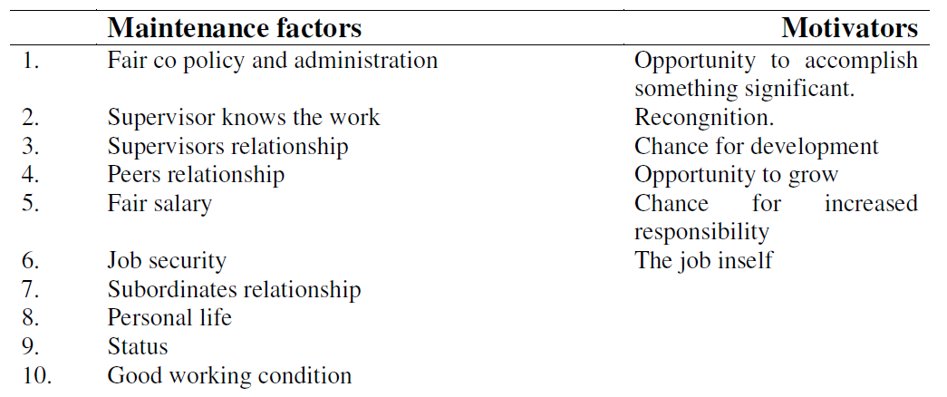

Needs priority, to a great extent, characterizes the types of behavior. It will be either directed towards achieving certain desirable positive goals, or conversely, towards avoiding other undesirable negative consequences. Thus, a question may arise as to what variables are perceived to be desirable goals to achieve and conversely undesirable conditions to avoid. In this connection a research study was conducted by Frederick Herzberg of Case-Western reserve University and associates. This study consisted of an intensive analysis of the experiences and feeling of 200 Engineers and accountants in 9 different companies in Pittsburg area, U.S.A. During the structured interview, they were agreed to desire a few previous job experience in which they felt exceptionally good or exceptionally bad about jobs. They were also agreed to rate the degree to which their feelings were influenced for better or worse by each experience which they described.

In concluding the information from the interview, Herzberg concluded that there were two categories of needs essentially independent of each other affecting behavior in different ways. His findings are that there are some job conditions which operate primarily to dissatisfy employees when the conditions are absent, their presence does not motivate them in a strong way. Another set of job conditions operates primarily to build strong motivation and high job satisfaction, but their absence clearly proves strongly dissatisfying. The first 80 job conditions has refused to as maintain or hygiene factors and second set job conditions as motivational factors.

HYGIENE FACTORS
According to Herzberg there are 10 maintenance or hygiene factors. They are company policy and Administration technical supervision, inter-personal relationship with supervisors with peers, with subordinates, salary, job security, personal life, working conditions and status. These are not intrinsic part of job but they are related to conditions under which a job is performed. They produce no growth in a worker’s output; they only prevent losses in workers performance due to work restrictions. These maintenance factors are necessary to maintain a reasonable level to satisfied employees; however any cut below this level will dissatisfy them. As such these are also called dissatisfiers since any increase to these factors will not affect employee’s level of satisfaction. Hence, these are in no way motivation them.

MOTIVATIONAL FACTORS
These factors are capable of having a positive effort on job satisfaction often resulting in an increasing one’s total output. Herzberg includes 6 factors that motivate employees. These are achievement, recognition, advancement work itself, possibility of growth and responsibility. Most of these factors are related with job contents. An increase in these factors will satisfy the employees; however, any decrease will not affect their level of satisfaction. Since, this increase in level of satisfaction in the employees can be used in motivating them for higher output. Herzberg maintains that potency to various factors is not entirely a function to factor themselves. It is also influenced by the personality characteristics to the individuals. From this point of view, individuals may be classified into two parts - Motivation seekers, maintenance seekers. The motivation seekers generally are individuals who are primarily motivated by the satisfier’s such as advancement, achievement and other factors associated with work itself. On the other-hand, the maintenance seekers tend to be more concerned with factors surrounding the job such as supervision; working conditions, pay etc. The shortcomings of Herzberg’s theory are:
1. Job satisfaction and dissatisfaction are two opposite points on a single continuum Individuals on the job are affected by any change either in the job environment or in the job content.
2. Herzberg model is method bound and a number of other methods used for similar study have shown different results not supporting his contentions other than the theory has limitation is general acceptability.
3. This theory does not attach much importance to pay, status, or inter-personal relationships which are of help generally as important contents of satisfaction.

Comparison of maslows and herzberg theory
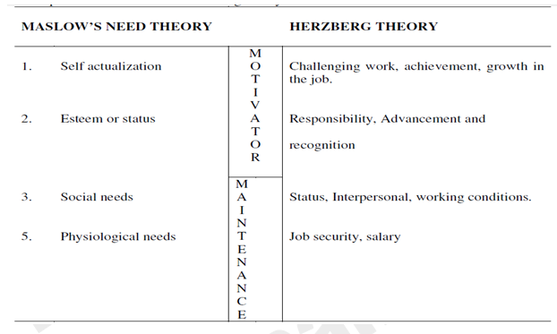

MC GREGOR’S THEORY
Prof. Douglas Mc. Gregor has introduced a fresh dimension in the discussion on theories relating to motivation. He has classified the prevalent theories into two groups viz.,
1. Traditional or X theory and
2. Modern or Y theory.

Traditional or X theory
It completely excludes workers from the process of managerial decision making the theory stress that would here only when forced to do so through ruthless exercise of managerial authority over them through constant rebuking scolding reprimanding. Decisions whether right or wrong have to be made by managers only, the only rule assigned to workers being to mainly incline the decision.

Assumptions of X theory

1. Lack of inclination to work.
2. Fear can alone force action.
3. Inbuilt dislike for responsibility
4. Living – off others.
5. Obsession with security.
6. Money alone can make the people to work.
7. Labour is only a factor of production.
8. Authority is synonymous with control.

Modern theory or Y theory
It is the exact opposite of X theory, it gives workers a pride of place in the process of management. It emphasises fuel and active cooperation, between workers and management to accomplish the enterprise objectives as per theory if workers are properly maturated, they would willingly accept responsibility and show the sense of creativity and imagination in their work performance. It can be said to be positive and optimistic outlook.

Assumptions of Y theory

1. Work is reward in itself
2. Inherent sense of responsibility
3. Recognition.
4. Sense of security.
5. Financial reward is not the only inspiration.
6. Decision – making ability is not the monopoly
7. Democratically inclined

GROUP DYNAMICS
Essentially dynamics is a branch of physics which means any matter in motion. It also means a moral force that produce activity or change. Group dynamics means the action of a group engaged in a common endeavor. The world dynamics comes from the Greek word meaning force. The phrase Group Dynamics thus means a study of cohesive and disruptive force operating within a group. The importance of group dynamic to a manager lies in the fact that many people tend to behave differently as individual and member of a group. The manager must thus study them both as individual and as group, as these are two interrelated elements of a motivational situation. The group dynamic will be structured around the three key element such as basic element of group behaviour, group cohesiveness and the group structure. The three basic elements which is generally of use in understanding the behavior of a group are activities, interactions and sentiments. Group cohesiveness refers to the degree to which its members are attracted to the group, are motivated to remain in the group, and mutually influence on another. Highly cohesive groups are more likely to confirm group pressures than are members of low-cohesive groups. Group structure if meant that the nature and characteristics of the interrelationships among the members of a group and the roles they play in it.

THE EXPECTANCY THEORY OF MOTIVATION – VICTOR H. VROOM
People will be motivated to do things to reach a goal if they believe in the worth of that goal and if they can see that what they do will help them in achieve it. Vroom makes the point that motivate is a product of the anticipated worth that an individual places on a goal and the chances the or she sees of achieving that goal. He states that:

FORCE = VALENCE * EXPECTANCY
Force = Strength of the person’s motivation.
Valence = Strength of an individual preference for an outcome.
Expectancy = Probability that a particular action will lead to a desired outcome.

Basic concepts of the theory are:
1. First and second level outcomes.
2. Instrumentality
3. Expectancy
4. Motivation.

Motivation is the multiplicative function of the valence for each first level outcome (V) and the believed expectancy (E) that a given effort will be followed by a particular first level outcome.

Merits of Vrooms Theory are:
1. It recognizes the importance of various individual needs and motivations.
2. It fits the concept of harmony of objectives
3. It is completely consistent with the system of management by objectives.

Demerits of Vrooms Theory are:
1. Perception of value vary among individuals at different times and in various places.
2. Difficulty to apply the practice.

THE PORTER AND LAWLER MODEL
Lyman W Porter and Edward Lawler III derived a substantially more complete model of motivation.

The strength of motivation and energy exected = value of reward + amount of energy required + probability of receiving reward.

Motivation is an extremely significant subject for managers get work done through others. Important characteristics of motivation are individual differ in their motivation, individuals are unaware of motivation sometimes, motivation may change and vary, motivation is a complex one. Maslow, Herzberg, Mc Gregore, V Room and Porter and Lawler are some the important writers on motivation.

LEADERSHIP
Leadership is an abstract quality in a human being to induce his followers to do whatever he is directed to do with the zeal and confidence.

Leadership is generally defined simply as the art of influencing people so that they will strive willingly
towards the achievement of group goals - KOONTZ & O’ DONNEL

IMPORTANCE OF LEADERSHIP
1. Driving force group efforts.
2. Aid to authority
3. Better utilization of man power.
4. Basis for co-operation.

INGREDIENTS OF LEADERSHIP
- Ability to use power effectively and in a responsible manner.
- Ability to comprehend the temperaments of human beings.
- Ability to inspire.
- Ability to act in a manner that will develop a climate conducive to and arousing motivations.

LEADERSHIP QUALITIES
I. Physical qualities
1. Sound health to fulfill his obligation.
2. Vitality and endurance to face al hardships.

II. Psychological qualities.

1. Personal magnetism
2. Enthusiasm.
3. Co-operation.
4. Exerting
5. Resourcefulness.
6. Ability to inspire and integrate.
7. Tact and skillful handling.

III. Intellectual traits

1. High degree of intelligence.
2. Sound judgment.
3. Capacity to deal with every situation.
4. Scientific approach.
5. Open mind.
6. Best teacher.

IV. Qualities of character

1. Integrity
2. Self discipline
3. Good natured
4. Willingness to work hard.
5. Willingness to accept and share responsibilities.

APPROACHES TO STUDY OF LEADERSHIP:
A. Personal Trait Approach
This approach says that all of us are possessing certain abilities and share responsibilities. Such qualities are considered as god given and hence leaders are born.
B. Situational / Contingency approach : (Fielder’s model) :
This is viewing that leadership qualities are determined by the situation in which he/she operates. It is not individuals characteristics.
C. Group approach :
A leader is one who comes attuned to he feelings and actins of people whom he is supposed to lead. Thus, the leader is one who comes closest to living up to the norms and standards of his group.
D. Path goal theory:
It suggests that the main functions of the leader is to clarify and set goals with subordinates the them find the best path for achieving the goals and remove obstacles.

Leader behavior may be grouped into four:
1. Supportive leadership.
2. Participative leadership.
3. Instrumental leadership.
4. Achievement oriented leadership.

TYPES OF LEADERSHIP
From the point of view of authority, leadership can be autocratic and democratic or free rein.

AUTOCRATIC LEADERSHIP
The leader alone determines policies and makes plans. He demands strict obedience and relies on power.
Merits:
1. It can increases the efficiency, save time and get good result.
2. It works well employees who have a low tolerance for ambiguity feel insecure with freedom.
3. Chain of command, and division of work are clear and full understood by all.
Demerits :
1. One – way communication may create costly errors.
2. Individual decision making may be dangerous in the changing environment.
3. Resentment in form of massive resistance, low morale and low productivity.

DEMOCRATIC LEADERSHIP
The entire group is involved in and accepts responsibility for goal setting and achievement. Subordinates have considerable freedom of action.
Merits:
1. The leader has the built-in personal motivation working for him.
2. The leader consistently receives the benefit of the best information, ideas, suggestions and talents of his people. This style permits and encourages people to develop grow and rise in the organization.
Demerits :
1. Time consuming.
2. Leaders may avoid responsibility.
Free rein leadership:
Leader exercises absolutely no control. He provides only information, materials and facilities to hi men to enable them to accomplish group objectives. This type does not hold good when the leader does not know well the competence and integrity of his people and their ability to handle this kind of freedom
Spectrum of Leadership Styles:
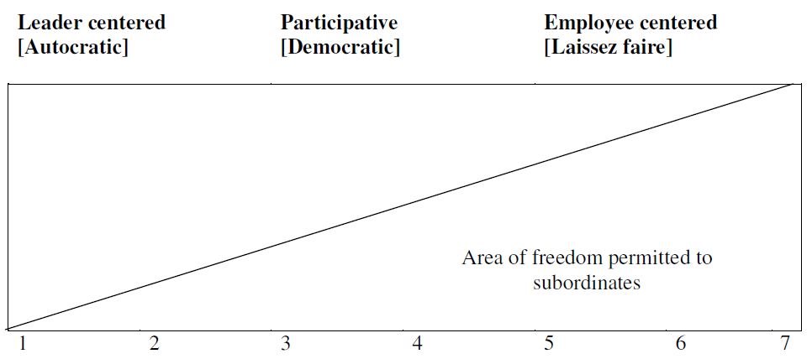
This spectrum depicts that a leader can adopt number of ways to relate himself with a group. The left side of the spectrum emphasizes that his style is leader centered. Such leaders are more care about production than for the welfare of his subordinates.
The right side of the spectrum denotes that the leadership style employee centered. They care about more for the welfare of their subordinates than for production.
The centre of the spectrum finds a more equitable balance between the authority exercised by the leader and the amount of participation the grotto exercise.
The different scales in the spectrum describe the following:
Point 1: Leader makes decision and announces it.
Point 2: Making the subordinate to accept the decision.
Point 3: Leader presents his idea and initiate discussion.
Point 4: Presents tentative decision subject to change.
Point 5: Present the problem, gets opinion and makes decision.
Point 6: Leader allows the group to make decision within limits.
Point 7: Leader allows the group to make decision within limits defined the situation.
MANAGERIAL GRID
It is a form of continuum which emphasize that leadership style consist of factors of both the task-oriented and people relations oriented behavior in variying degrees. It explains that whatever may be the type of leadership styles it ultimately relates with tasks to e performed and people with whom it is to be performed. Some styles emphasize on concern for production which means that the attitudes of superiors towards a variety of things, such as, quality of policy decisions, procedures and processes, creativeness of research, quality of staff service, work efficiency and volume of output. On the other hand there are certain leadership styles which emphasize on concern for people which means that degree of personal commitment towards goal achievement, maintaining the self-esteem of workers, responsibility based on trust, and satisfying inter-personal relations, Based on these two factors leadership styles can be identified n to 5 types as given in the diagram.
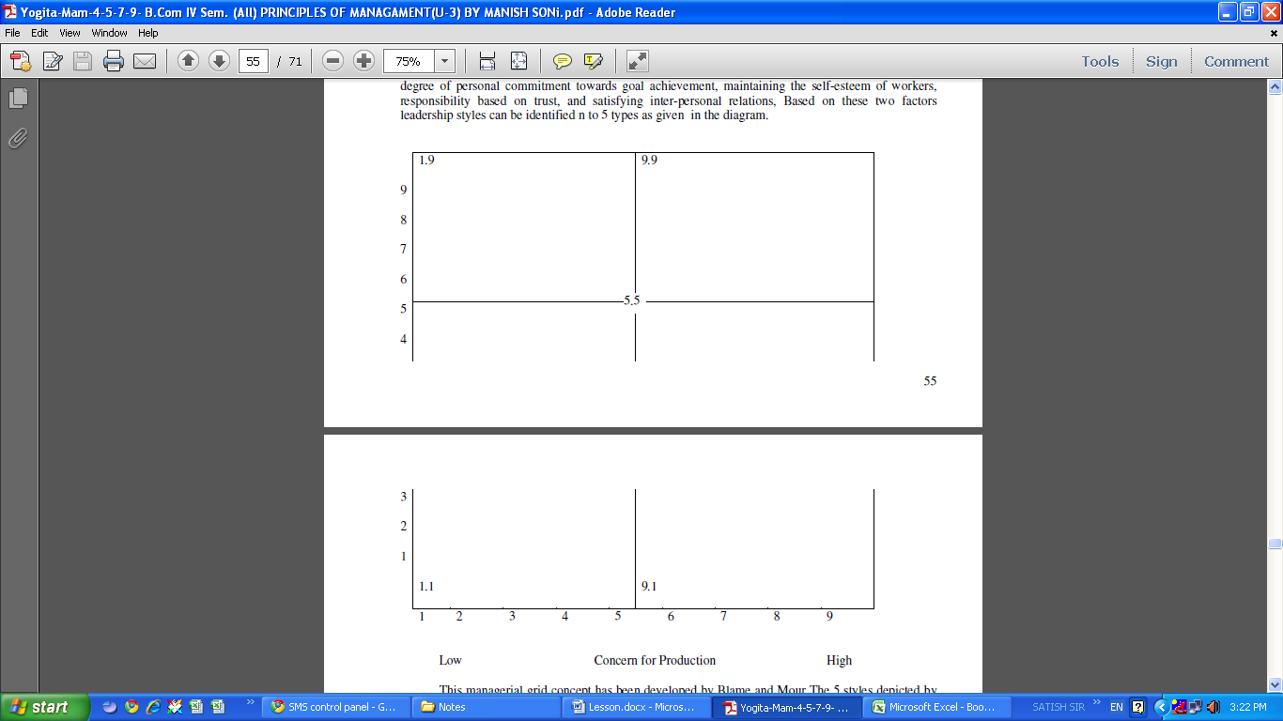

This managerial grid concept has been developed by Blame and Mour The 5 styles depicted by the diagram are :
Impoverished style where exertion of minimum effort is require get work done and sustain organization morale.

1.9 Country club style where thoughtful attention to needs of people leads to friendly and comfortable organization atmosphere and work tempo.

Task oriented style which says that efficiency results from arranging work in such a way that human elements have little effect.

Team model style which highlights that work accomplished is from committed people with interdependence through a common stake in organization purpose and with trust and respect.

Middle Road style rightly pointed out that adequate performance through balance of work requirements and maintaining satisfactory morale.

Among the five different styles, the most desirable leader behaviour is 9.9. So efforts have to be taken by developing suitable training programs that attempts to change managers towards 9.9 leadership style. Managerial gird helps the managers to identify and classify managerial styles and it helps to understand why he gets the reaction that he does from his subordinates. However, the mid point of the grid i.e. 5.5 is highly emphasized in the pure form of working conditions.

To summarize, leadership may be defined as the ability to influence and direct the task-related activities of the members of group. A leader is a goal-setter, planner, executive, expert, group representative, administrator of rewards and punishments and a symbol of the group. There are three approaches to the study of leader ship such as. The trans approach, Behavioral approach and Contingency approach. In that Behavioral approach has emphasized different leadership styles.

DIRECTION
Direction is instructing the subordinates to follow a certain process to attain a give objectives. It is getting the work done through instructions and orders. It is the function of diversion in the management process to get the work from the subordinates by means of guiding, motivation, communication, supervising, leading and if need be commanding. It is sum of total of managerial efforts that is applied for guiding and inspiring the working teams to make better accomplishments in the organization. It is the heart and soul of management.

PROCESS OF DIRECTION
1. Defining the objectives.
2. Organizing the efforts.
3. Measuring the work.
4. Developing the people.

Ever manager in the organization gives direction to his subordinates as superior and receives direction s subordinate from his superior.

Direction may be defined as the function of management which is related with instructing, guiding and inspiring human factor in the organization to achieve organization objective. The direction is not merely issuing orders and instructions by a superior to his subordinates, but is includes the process of guiding and inspiring them. The analysis of definition reveals that direction function consist of three elements.
- Motivation
- Leadership
- Communication

Direction has the following characteristics
- Direction is an important managerial function. Through direction management can initiates actions in the organization.
- Direction function is performed at every level of management.
- Direction is a continuous process and it continuous through out the life of the organization.
- Direction initiates at the top level in the organization follows and bottom through there
hierarchy. It emphasizes that a subordinates is to be directed by his own superior only.

IMPORTANCE OF DIRECTION
The importance of direction function in the organization can be presented as follows.
- Direction initiates action.
- Direction integrates employees efforts.
- Direction attempts to get maximum out of individuals.
- Direction facilitates charges in the organization.
- Direction provides stability and balance in the organization.

PRINCIPLES OF DIRECTION
Direction is one of the most complex function of the management as it ideals with people whose nature
itself is quite complex and unpredictable.
1. Principles of relating to the purpose of directing
a. Principles of maximum individual contribution.
b. Principle of harmony of objectives.
c. Principle of efficiency of direction.
2. Principle relating to direction process:
a. Principle of unity of command.
b. Principle of appropriateness of direction technique.
c. Principle of managerial communication.
d. Principle of comprehension.
e. Principle of use of informal organization.
f. Principle of leadership.
g. Principle of follow through.
Thus one of the basics functions of management is direction. Direction means the use of leadership and
motivation to guide the performance of subordinates towards the achievement of the organization’s
goals. Important requirements for effective direction are : Harmony of objectives, Unity of command,
direct supervision, efficient communication and follow-up.

CONTROLLING
Control is any process that guide activity towards some predetermined goals. Thus control can be applied is n any field such as price control, distribution control pollution control etc. Thus control process tries to find out deviations between planned performance and actual performance and to suggest corrective action wherever these are needed. For example terry has defined control as follows :

“controlling is determining what is being accomplish, that is evaluating the performance and, if necessary, applying corrected measures so that the performance takes place according to plan.

Control is checking event performance against pre-determined standards contained in the plans, with a view to ensuring adequate progress and satisfactory performance.

Controlling consists in verifying whether everything occurs inconformity with the plan adopted, the instructions issued and principles established. Its object is to point but weakness and errors in order to rectify them and prevent recurrence.
1. Control is forward looking
2. Control is both executive process and from the point of view of the organization of the system, a result
3. Control is a continuous process.
4. A control system is a coordinated – integrated system.

IMPORTANCE OF CONTROL
Thus control is an integrated action of an organization or manager. It offers help in the following directions.
1. Adjustment in operations
A control system acts as an adjustment in organizational operations. Every organization has certain objectives to achieve which become the basis for control.
2. Policy verification
Various policies in the organization generate the need for control. For organizational functioning, managers set certain policies and other planning elements which later become the basis and reason for control.
3. Managerial responsibility
In every organization, managerial responsibility is created through assignment of activities to various individuals. This process starts at the top level and goes to the lower levels.
4. Psychological pressure
Control process puts a psychological pressure on the individuals for the better performance. The performance of the individuals is evaluated in the light of targets set for them.
5. Coordination in action
Control system area designed n such a way that they focus not only on the operating responsibility of a manager but also on his ultimate responsibility. This forces a manager to co-ordinate the activities of his subordinate in such a way that each of them contributes positively towards the objectives of the superior.
6. Organizational efficiency and effectiveness
Proper control ensures organizational efficient and effectiveness various factors of control, namely, making managers responsible, motivating them for higher performance, and achieving coordination in their performance, control, ensures that their organization works efficiently.

STEPS IN CONTROLLING
The various steps in control process which are necessary for its relationship to planning. This steps may broadly be classified into four parts.
1. Establishment of control standards
2. Measurement of performance
3. Comparison between performance and standards and the communication and
4. Correction of deviations from standards

(1) Establishment of control standards
Every function in the organizations begins with plans which are goals, objectives or targets to be achieved. In the light of these standards are established which are criteria against which actual results are measured.

(2) Measurement of performance
The second major step in control process is the measurement of performance. The step involves measuring the performance in respect of a work in terms of control standards.

(3) Comparing Actual and Standard Performance
The third major step in control process is the comparison of actual and standard performance. It involves two steps
- finding out the extent of deviations and
- identifying the causes of such deviations.

(4) Correction of deviations
This is the last step in the control process which requires that actins should be taken to maintain the desired degree of control in the system or operation.

ESSENTIALS OF EFFECTIVE CONTROL SYSTEM
Control is necessary in every organization to ensure that everything is going properly. Every manager, therefore, should have an effective and adequate control system to assist him in making sure that events conform to plans. In this tailoring of control system, there are certain requirements which should be kept in mind.
1. Reflecting Organizational Needs : All control systems and techniques should reflect the jobs they are to perform.
2. Forward Looking : Control should be forward looking. Though many of the controls are instance, they must focus attention as to how future actions can be conformed with plans.
3. Promptness in Reporting Deviations: The success of a thermostat lies in the fact that it points the deviation promptly and takes corrective actions immediately.
4. Pointing out Exceptions at Critical points: Control should point exception at critical points and suggest whether action is to be taken for deviations or not.
5. Objectives: The control should be objective, definite and determinable in a clear and positive way.
6. Flexible: Control system should be flexible so that it remains workable in the case of changed plans, unforeseen
circumstances or failures.
7. Economical
Control should be economical and must be worth its costs. Economy is relative since the benefits vary with the importance of the activity, the size of the operation the expense that might be incurred in the absence of control and the contribution the control system can make.
8. Simple: Control system must be simple and understandable so that all managers can use it effectively.
9. Motivating: Control system should motivate both controller and controlled
10. Reflecting Organizational Pattern:

The control should reflect organizational pattern by focusing attention on positions in organization structure through which deviations are corrected.

Feedback loop of management control

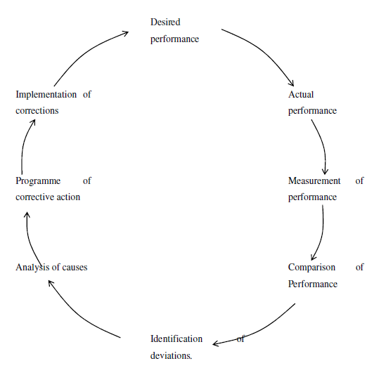

TECHNIQUES OF CONTROL
To control the activities in the organization, managers can use variety f tools and techniques. They are broadly grouped under two heads.
1. Traditional techniques.
2. Modern techniques.

Traditional techniques are those which have long been used by the managers. Some of the important techniques under this heads are budgetary control, financial statement and ratio analysis, auditing, break-even analysis and report writing etc.

“Budgetary control is a process of comparing the actual results with the corresponding budgeting data in order to approve accomplishments or to remedy differences by either adjusting the budget estimates or correcting the cause of the difference.”
- GEORGE R TERRY

The different budgets such as production budget, sales budget, overhead budget, labour budget etc. clearly indicate the limits for expenses and also the results to be achieved in a given period. It ensures effective co-ordination of the work of the entire organization. It promotes co-operation and team spirit among the employees

Standard Costing is one of the techniques of cost control and it is being increasingly used by modern business concerns for the purpose of cost reduction and cost control. It involves a comparison of actual with the standards and the discrepancy is called variance.

Break-even analysis is useful in planning and control because it emphasize the marginal cost and benefit concept. It helps to make profit estimation at the different levels of activity, ascertaining turnover for desire profit and estimating the impact of the variations of fixed and variable costs. It magnifies a set of relationships of fixed costs, variable cost, price, level of output and sales mix to the profitability of the organization.

Financial statement analysis such as Found Flow analysis, Cash Flow analysis and Ratio analysis help to know the financial performance and financial position of the business unit. The liquidity, profitability and solvency position of the business unit can be ascertained and efforts can be taken to maintain these factors in an optimum proportion,

Auditing is the process of investigating financial and other operation of a business establishment. It may be carried out by internal and external members. It helps to scrutinizes the applicability and relevance of policy, procedure and method which have a tendency to become obsolete. This it helps in choosing a suitable working procedures and methods.

Adoption of reporting system helps to analyse a particular problem and to take necessary corrective action over it. Reports may be prepared regarding taxation, legislation and its effect on profit, make or buy decisions, replacement f capital equipment, social pricing analysis etc.

A manager can also exercise effective control over his subordinates by observing them while they are engaging in work. Personal observation helps the managers not only in knowing the workers attitude towards work but also n correcting their work and method, if necessary.

MODERN TECHNIQUES
These are of recent origin, which provide information not readily available with traditional methods. These techniques help to give sharper focus and promise increasingly to improve the quality of control. Program Evaluation Review Technique (PERT) and Critical Path Method (CPM) are two major techniques coming under this head.

PERT has been, developed by an U.S. Office in 1958 in connection with the Polaris Weapon System and is credited with reduction the completion time of the program by two years. CPM has been jointly developed by DUPoint and Remington Rand USA in order to facilitate the control of large, complex industrial projects. These techniques are used to minimize total time, minimize to cost, minimize idle resources etc. It is helpful in solving problems of scheduling the activities of on-time projects. These tools re widely being used in construction industry, planning and launching a new projects, scheduling ship construction etc. It ensures improved management of resources by facilitating better decision making. It aims to have future oriented control mechanism for the organization.

Management Information System provides needed information to each manager at the right time, in right form which aids his understanding and stimulate his action. MIS is a refined form of traditional information collection and supply to the organization points.

Management Audit is an evaluation of management as a whole. It examine the total managerial process of planning, staffing, directing and controlling. To evaluate the management achievement, the organization plans, policies, procedures, organization structure, system of control personnel relation should be measure with its end results.
1. Budgetary control - Financial performance
2. Cost control - Cost performance
3. Production control - PERT CPM
Production, performance, quality
4. Inventory control - Stores function performance
5. Profit & Loss
Control ROL control - Overall organizational objective performance.
6. External audit control - Statutory performance
7. Management self audit –

DIRECT CONTROL VERSUS PREVENTIVE CONTROL
DIRECT CONTROL:
1. Cause of negative Deviations from standards. Uncertain, Lac of knowledge, experience or judgment
2. Questionable assumptions underlying direct control
Assumption that that performance can be measured
Assumption that personal responsibility exists
Assumption that time expenditure if warranted
Assumption that mistake can be discovered in time
Assumption that the person responsible will take.
Corrective steps.

PREVENTIVE CONTROL
Assumption :
Qualified managers make a minimum of errors.
Management fundamental can e used to measure performance
Application of management fundamentals can be evaluated.

Advantages:
1. Greater accuracy
2. Encourage self control
3. Lighten the managerial burden
4. Impressive

Thus control is a very important process through which managers ensure that actual activities confirm to planned activities. It is mainly used to measure progress, to uncover deviations and to indicate corrective action.

MANAGEMENT BY OBJECTIVES
It is a process whereby the superior and subordinate managers of an enterprise jointly identify its common goals, define each individual’s major areas of responsibility in terms of the results expected of him and use these measures as guides for operating the unit and assessing the contribution of each of its members.
- GEORGE S. ODIORNE

MBO is comprehensive managerial system that integrates many key managerial activities in a systematic manner and that is consciously directed toward the effective and efficient achievement of organizational and objective.

MBO PROCESS
Step – 1: Set down informally the goals of the enterprise.
Step – 2: Objective the goal so set out and define measures of performance.
Step – 3: The goals and sub-goals at all management levels must them be set out.
Step – 4 : Adjustment in the organization structure.
Step – 5: The goals to be set at all levels must be joint and agreed ones.
Step – 6: Continuous feedback from appraisal of internal Goals and the enterprise goal as it is set.
Step – 7: Appraisal of results proceed continuously against the goals at all levels.
Step – 8: Review of sub-results throws light on organization results.

BENEFITS OF MBO
1. Improvement of managing
2. Clarification of organization.
3. Encouragement of personal commitment
4. Development of effective controls.

WEAKNESS OF MBO
1. Failure to teach the philosophy of MBO
2. Failure to give guidelines to goal setters.
3. Difficulty of setting goals
4. Emphasis on short-term goals
5. Danger of inflexibility
6. Other dangers.

MANAGEMENT BY EXCEPTION (M.B.E.)
It is a system of identification and communication that signals the manager when his attention is needed: conversely, it remains silent when his attention is not required. The primary purpose of such a system is to simplify the management process itself. It permits the manager to find the problems that need his action and to avoid dealing with these the are better handled by his subordinates.

ELEMENTS OF MBE
The MBE system’s structure is constituted by the following elements
1. Measurement - by assigning values to performance
2. Projection - towards business objective & expectations.
3. Selection - follow progress towards its objectives
4. Observation - to know current state of performance.
5. Comparison - actual with expected and identify the exceptions.
6. Decision making - Prescribes the action that must be fallen in order
(i) Bring performance back into control
(ii) Adjust expectations to reflect changing conditions
(iii) Exploit opportunity

It is also deeply rooted in the principles of the decision of labour, delegation or responsibility and authority and span of control.

Merits
The practice of MBE in management yields benefit in the following way :
1. It save personal time
2. Concentrative executive effort
3. Reduces distortions
4. Facilitates broader management coverage
5. Lessens frequency of decision making.
6. Makes fuller use of knowledge of trends history and available business data.
7. Fully utilizes highly paid people on high-return work.
8. Identify crises and critical problems.
9. Provides qualitative and quantitative yardsticks for judging situations and people.
10. Enables inexperienced managers to handle new assignments with a minimum of related experience and training.
11. Alerts management to opportunity as well as difficulties.
12. Encourages more comprehensive knowledge of all phases of business operations.
13. Stimulates communication between different segments of an organization.

Demerits:
Peter Druker’s critically viewed MBE as follows :
1. It breeds organization man thinking
2. It is often dependent upon unbelievable data.
3. It rewires a comprehensive observing and reporting system.
4. It tends to proliferate paper work
5. It often assumes an un relational stability in business affairs.
6. It gives false sense of security to management.
7. Standard of comparison tend to become obsolete.
8. Some critical business factors are difficult to measure
9. It can’t be a substitute for thinking.

PRINCIPLES OF MBE
The make the MBE system effective the following principles may be followed.
1. Practice of Self-control
2. Discard pre-conceived notions.
3. Be guided by policy
4. Learn to live with accountants.
5. Delegate for result.
6. Sharpen your observational power
7. Use MBE to describe subordinates in different phases.
8. Invite enough participation
9. Expect some people to call you lazy
10. Differentiate between “Big” and “Little” jobs
11. Don’t be an “Over-the-Shoulder” supervisor
12. Avoid the “organization – man” attitude
13. Expect to work harder but to enjoy it more.
UNIT IV
HUMAN RESOURCE MANAGEMENT

A Textbook Definition Bratton and Gold define HRM as:

“… a strategic approach to managing employment relations which emphasises that leveraging people’s capabilities is critical to achieving sustained competitive advantage, this being achieved through a distinctive set of integrated employment policies, programmes and practices”.
Human Resource Management may be defined as the art of procuring, developing nad maintaining competent workforce to achieve organizational goals efficiently.
According to Invancevich and Glueck, “HRM is concerned with the most effective use of people to achieve organizational and individual goals”.
According to Byars and Rue, “HRM encompasses those activities that are designed to provide for and coordinate the human resources of an organization”.
According to Flippo, HRM is the planning, organising, directing and controlling of the procurement, development, compensation, integration, maintenance and separation of human resources to the objectives are accomplished”

Nature of HRM
Broader function : Human Resource Management is a comprehensive function because it is about managing people in the organization. It covers all types of people in the organization from workers till the top level management.
People oriented : Human resource is the core of all the processes of human resource management. So HRM is the process which brings people and organizations together so that their goals can be achieved.
Action oriented : Human resource management believes in taking actions in order to achieve individual and organizational goals rather than just keeping records and procedures.
Development oriented: Development of employees is an essential function of human resource management in order to get maximum satisfaction from their work so that they give their best to the organization.
Integrating Mechanism : HRM tries to build and maintain cordial relations between people working at various levels in the organization.
Continuous function : As human resource is a living factor among all factors of production therefore it requires continuous improvement and innovations in order to get excellence. So it requires a constant alertness and awareness of human relations and there importance in every day to day operations.
Future oriented : HRM is very important activity which helps organization to achieve its objectives in future by providing well motivated and competent employees.

FEATURES OF HRM
1. Management Discipline : It is not a discipline in itself, but a part of the Management discipline. As it is a discipline of Management studies, it describes the management concepts , principles and techniques and apply these in the management human resources.
2. As a Process : HRM is a process of four functions :-
Acquisition of human resources : This function includes Human Resource Planning, Recruitment, Selection, Placement and Induction of staff.
Development of human resources : This function includes Training and Development and Career development. The knowledge, skills, attitudes and social behavious of the staff are developed.
Motivation of human resources : This function includes giving recognition and rewards to the staff. It also includes Performance Appraisal and handling the problems of staff.
Maintenance of human resources : This function includes providing the best working conditions for employees. It also looks after the health and safety of the staff.
3. Continuous Process : HRM is not a one-time process. It is a continuous process. It has to continuously change and adjust according to the changes in the environment, changes in the expectations of the staff, etc. HRM has to give continuous training and development to the staff due to changes in technology.
4. Concerned with people : HRM is concerned with all types of personnel in the organization. It deals with top level to the supervisory and operatives. HRM is not only concerned with people in the organization but also with the people having potential to be bought in the organization.
5. Achievement of Objectives : Achievement of goals of an organization can be obtained by providing proper tools and techniques of HRM.
6. Universal function
HRM can be applied in business as well as other organizations organisations such as schools, colleges, hospital, religious organisations, etc.
Integrated use of Subsystems
HRM involves the integrated use of sub-systems such as Training and Development, Career Development, Orgnisational Development, Performance Appraisal, Potential Appraisal, etc. All these subsystems increase the efficiency of the staff and bring success to the organisation.

Developes Team Spirit
HRM tries to develop the team spirit of the full organisation. Team spirit helps the staff to work together for achieving the objectives of the organisation. Now-a-days more importance is given to team work and not to individuals.
Develops Staff Potentialities
HRM develops the potentialities of the staff by giving them training and development. This will make the staff more efficient, and it will give them more job satisfaction.
Long Term Benefits
HRM brings many long term benefits to the individuals (staff), the organization and the society. It gives many financial and non-financial benefits to the staff. It improves the image and profits of the organization. It also provides a regular supply of good quality goods and services at reasonable prices to the society.

Scope of the HRM
The scope of HRM is very immense. HRM plays a vital role of a worker from the time he enters into any organization till he leaves. HRM activities include –
1. Procurement : It the placement of right kind of personal to the right post. It includes, determination of manpower requirements. Job analysis, Nature and scope of requirement, employee selection and placement of employment.
2. Training and Development : Training and Development is a must in any organization. It prepares the worker to the actual situations in the orgnisation.
3. Job Analysis and Job Description : Job analysis and job description involves the studies of job requirements of the enterprise and assignment of well defined functions to jobs so that qualified employees may be hired. It also forms the basis of wage determination.
4.Remuneration : Providing proper remuneration to the employees for the job done through job analysis and job description. It includes determining wage rates, incentives, wage payment, rewards and benefits and performance appraisal.
5. Welfare and Industrial Relations : It includes health and safety program, sanitary facilities, recreational facilities etc.
FUNCTIONS OF HRM
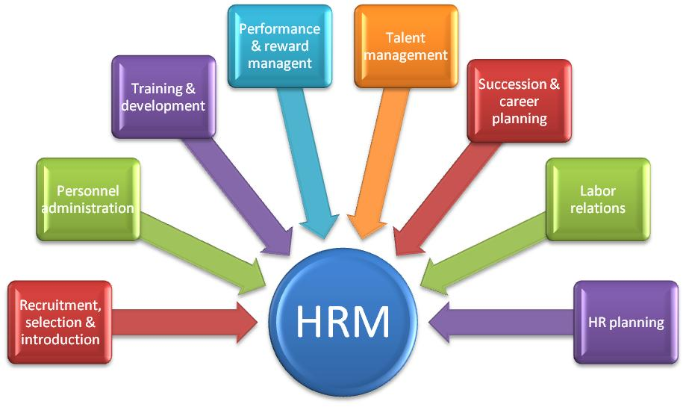

Responsibilities of hr manager
As HR Managers, the deliverables are quite diverse. The key HR Manager responsibility areas to make HR role effective is constantly evolving based on the life stage of the business and organization. There are mandatory activities to be taken care of in Human Resource Department that forms an integral part of HR Function in any organization and then there are dynamic and variety of expectations that the organization has and the business has from Human Resource Department and the team that works as HR partners.

The functions and Responsibilities are a mixture of behavior analysis, policy formulations and maintenance of good interpersonal relations. These include:
- Conducting job analyses (determining the nature of each employee’s job) Planning labor needs and recruiting job candidates
- Selecting job candidates
- Orienting and training new employees
- Managing Wages and Salaries (how to compensate employees) Providing incentives and benefits
- Appraising performance and Communicating (interviewing, counselling, disciplining)
- Training and developing
- Building employee commitment
- Equal opportunity and affirmative action
- Employee health and safety
- Grievances and labor relations
The Functions of HRM can be broadly classified into two categories
- Managerial Functions
- Operative Functions

Managerial Functions : HR Manager performs the functions of planning, organizing, directing and controlling.
Planning : Planning like all planning is forward looking or future oriented. It involves planning of Human resources, requirements, recruitment, selection, training etc. It involves the forecasting of manpower need, changing values, attitudes and behavior of employees and their impact on organization.
Organising : It is a process of achieving a goal by organizing people and other resources. It established a relationship among the employees to attain a companies goal.
Directing : It is a very important function in the management of any enterprise. It helps the managers in ensuring quality performance of jobs by the employees and achievement of organisational goals. It involves supervision, communication and providing leadership to the subordinates and motivating them to contribute to their best of capability. In this lesson we shall learn about this function in detail.
Coordinating : Management seeks to achieve co-ordination through its basic functions of planning, organizing, staffing, directing and controlling. That is why, co-ordination is not a separate function of management because achieving of harmony between individuals efforts towards achievement of group goals is a key to success of management. Co-ordination is the essence of management and is implicit and inherent in all functions of management.
Controlling : Controlling consists of verifying whether everything occurs in confirmities with the plans adopted, instructions issued and principles established. Controlling ensures that there is effective and efficient utilization of organizational resources so as to achieve the planned goals. Controlling measures the deviation of actual performance from the standard performance, discovers the causes of such deviations and helps in taking corrective actions.

Operative Functions :
The operative functions of personnel management are related to specific activities of personnel management viz, employment, development, compensation and relations. All these functions are interacted by managerial functions. Further these functions are to be performed in conjunction with management functions.

1. Employment - Employment is concerned with securing and employing the people possessing required kind and level of human resources necessary to achieve the organizational objectives. It covers the functions such as job analysis, human resources planning, recruitment, selection, placement, induction and internal mobility.

2. Job Analysis: It is the process of study and collection of information relating to the operations and responsibilities of a specific job. It includes:
1. Collection of data, information, facts and ideas relating to various aspects of jobs including men, machines and materials.
2. Preparation of job description, job specification, job requirements and employee specification which help in identifying the nature, levels and quantum of human resources.
3. Providing the guides, plans and basis for job design and for all operative functions of HRM.

3. Human Resources Planning:
It is a process for determination and assuring that the organization will have an adequate number of qualified persons, available at proper times, performing jobs which would meet the needs of the organization and which would provide satisfaction for the individuals involved. It involves
- Estimation of present and future requirement and supply of human resources basing on objectives and long range plans of the organization.
- Calculation of net human resources requirement based on present inventory of human resources.
- Taking steps to mould, change, and develop the strength of existing employees in the organization so as to meet the future human resources requirements.
- Preparation of action programs to get the rest of human resources from outside the organization and to develop the human resources of existing employees.

4. Recruitment:
It is the process of searching for prospective employees and stimulating them to apply for jobs in an organization. It deals with:
(a) Identification of existing sources of applicants and developing them.
(b) Creation / Identification of new sources of applicants.
(c) Stimulating the candidates to apply for jobs in the organization.
(d) Striking a balance between internal and external sources.

5. Selection:
It is the process of ascertaining the qualifications, experience, skill, knowledge etc., of an applicant with a view to appraising his / her suitability to a job appraising.

This function includes:
(a) Framing and developing application blanks.
(b) Creating and developing valid and reliable testing techniques.
(c) Formulating interviewing techniques.
(d) Checking of references.
(e) Setting up medical examination policy and procedure.
(f) Line managerial decision.
(g) Sending letters of appointment and rejection.
(h) Employing the selected candidates who report for duty.

Placement: It is the process of assigning the selected candidate with the most suitable job in terms of job requirements. It is matching of employees specifications with job requirements. This function includes:
(a) Counseling the functional managers regarding placement.
(b) Conducting follow-up study, appraising employee performance in order to determine employees adjustment with the job.
(c) Correcting misplacements, if any.

Induction and Orientation: Induction and orientation are the techniques by which a new employee is rehabilitated in the changed surroundings and introduced to the practices, policies, purposes and people etc., of the organization.
(a) Acquaint the employee with the company philosophy, objectives, policies, career planning and development, opportunities, product, market share, social and community standing, company history, culture etc.
(b) Introduce the employee to the people with whom he has to work such as peers, supervisors and subordinates.
(c) Mould the employee attitude by orienting him to the new working and social environment.

2. Human Resource Development :
Human resource development refers to the process whereby the employees are continuously helped in a planed way to
- Acquire or sharpen capabilities required to perform various tasks associated with their present /future expected roles.
- Develop their general capabilities as individuals so that they are able to discover and exploit their own inner potential for their own and/or organizational development purpose.
- Develop an organizational work culture where superior subordinate relationships, team work and collaboration among different units are strong and contribute to the professional well – being , motivation and pride.
This Function includes :
Performance Appraisal : It is the systematic evaluation of individuals with respect to their performance on the job and their potential for development . It Includes :
- Developing policies, procedures and techniques
- Helping the functional managers
- Reviewing of reports and consolidation of reports
- Evaluating the effectiveness of various programs

Training : It is the process of imparting the employees the technical and operating skills and knowledge . It includes
- Identification of training needs of the individuals and the company
- Developing suitable training programs
- Helping and advising line management in the conduct of training programs
- Imparting of requisite job skills and knowledge to employees.
- Evaluating the effectiveness of training programs.

Management Development : It is the process of designing and conducting suitable executive developments programs so as to develop the managerial and human relation skill of employees. It Includes :
- Identification of the areas in which management development is needed.
- Conducting development programs
- Motivating the executives
- Designing special development program for promotions
- Using the service of specialists, and /or utilizing of the institutional executive development programs.
- Evaluating the effectiveness of executives of executive development programs.

Career Planning and Development : It is the planning of one’s career and implementation of career plans by means of education, training job search and acquisition of work experience. It includes internal and external mobility.
a) Internal Mobility: It includes vertical and horizontal movement of an employee within an organization. It consists of transfer, promotion and demotion.
Transfer: It is the process of placing employees in the same level jobs where they can be utilized more effectively in consistence with their potentialities and needs of the employees and the organization. It also deals with:
- Developing transfer policies and*procedures.
- Guiding employees and line management on transfer. ,
- Evaluating the execution of transfer policies and procedures.
Promotion: It deals with upward reassignment given to an employee in the organization to occupy higher position which commands better status and/or pay keeping in view the human resources of the employees and the job requirements.
- This function covers the formulating of equitable, fair and consistent promotion policies and procedures.
- Advising line management and employees on matters relating to promotion.
- Evaluating the execution of promotion policies and procedures.
Demotion: It deals with downward reassignment to an employee in the organization.
- Develop equitable, fair and consistent demotion policies and procedure.
- Advising line managers on matters relating to demotions.
- Oversee the implementations of demotion policies and procedures.
b) External Mobility: External mobility is of two types, viz., accessions and separations.
Accessions: Accessions are additions of new candidates to the existing employees. Accessions include employment of new candidates, re-employment of former employees, employees called back to work after lay-off, etc.
Separations: Separations mean termination of employment. They are also called employee turnover. They include:
- Voluntary Quit: Voluntary quit or resignations by employees when they arc dissatisfied with the present job and/or organization, or when they get better employment in other organizations.
- Lay-off or Lack of Work: Organizations terminate the services of employees when the jobs are eliminated or reduced due to adoption to technology or adverse business conditions or lack of power, materials, breakdown of machinery, etc.
- Disciplinary Lay-off or Discharge: Organizations terminate the services of employees if they are dissatisfied with the performance or conduct of employees.
- Retirement, and
- Deaths: Stages in External Mobility: There are four stages in external mobility, viz.: Exploration, Establishment including mutual recruitment, acceptance to the recruitment conditions, entry, having first job assignment settlement, transfer, promotion and granting of tenure. Maintenance stage, and Decline stage.

Organization Development: It is a planned process designed to improve organization effectiveness and health through modifications in individual and group behavior, culture and systems of the organization using knowledge and technology of applied behavioral science.

3) Compensation: It is process of providing adequate, equitable and fair remuneration to the employees. It includes job evaluation, wage and salary administration, incentives, bonus, fringe benefits, social security measures, etc.

Job Evaluation: It is the process of determining relative worth of jobs;
a) Select suitable job evaluation techniques.
b) Classify jobs into various categories.
c) Determining relative value of jobs in various categories.

Wage and Salary Administration: This is the process of developing and operating a suitable wage salary program. It covers:
a) Conducting wage and salary survey.
b) Determining wage and salary .rates based on various factors.
c) Administering wage and salary programs.
d) Evaluating its effectiveness.

Incentives: It is the process of formulating, administering and reviewing the schemes of fir incentives in addition to regular payment of wages and salary. It includes:
a) Formulating incentive payment schemes.
b) Helping functional managers on the operation.
c) Review them periodically to evaluate effectiveness.

Bonus: It includes payment of statutory bonus according to the Payment of Bonus Act, 1956 and its latest amendments.

Fringe Benefits: These are the various benefits at the fringe of the wage Management provides these benefits to motivate the employees and to meet their life’s contingencies. These benefits include:
- Disablement benefit.
- Housing facilities
- Educational facilities to employees and children.
- Canteen facilities.
- Recreational facilities.
- Conveyance facilities.
- Credit facilities.
- Legal clinic.
- Medical, maternity and welfare facilities.
- Company stores.

Social Security Measures: Managements provide social security to their employees in addition to the fringe benefits. These measures include:
- Workmen’s compensation to those workers (or there dependents) who involve in accidents.
- Maternity benefits to women employees.
- Sickness benefits and medical benefits.
- Disablement benefits/allowance.
- Dependent benefits.
- Retirement benefits like provident fund, pension, gratuity etc.

Human Relations: It is the process of interaction among human being. Human relations is an area of management in integrating people into work situation in a way that motivates them to work together productively, co-operatively and with economic, psychological and social satisfaction. It includes:
- Understanding and applying the models of perception, personality, learning, intra and inter personal relations, intra and inter group relations,
- Motivating the employees,
- Boosting employee morale,
- Developing the communication skills,
- Developing the leadership skills.
- Redressing employee grievances properly and in time by means of a well formulated grievance procedure.
- Handing disciplinary case by means of an established disciplinary procedure,
- Counseling the employees in solving their personal, family and work problems and releasing-their stress, strain and tensions
- Improving quality of work life of employees through participation and other means.

Unit V

MANPOWER / HR PLANNING
Manpower planning means planning means deciding the number and type of the human resources required for each job, unit and the total company for a particular future date in order to carry out organizational activities. Manpower planning may be viewed as foreseeing the human resources requirement of an organization and the future supply of human resources and (i) making necessary adjustments between these two and organizational plans and (ii) foreseeing the possibility of developing the supply of manpower resources in order to match it with the requirements by introducing necessary changes in the functions of human resources management.

The process of manpower planning in an organization.

- Analysing the corporate and unit level strategies.
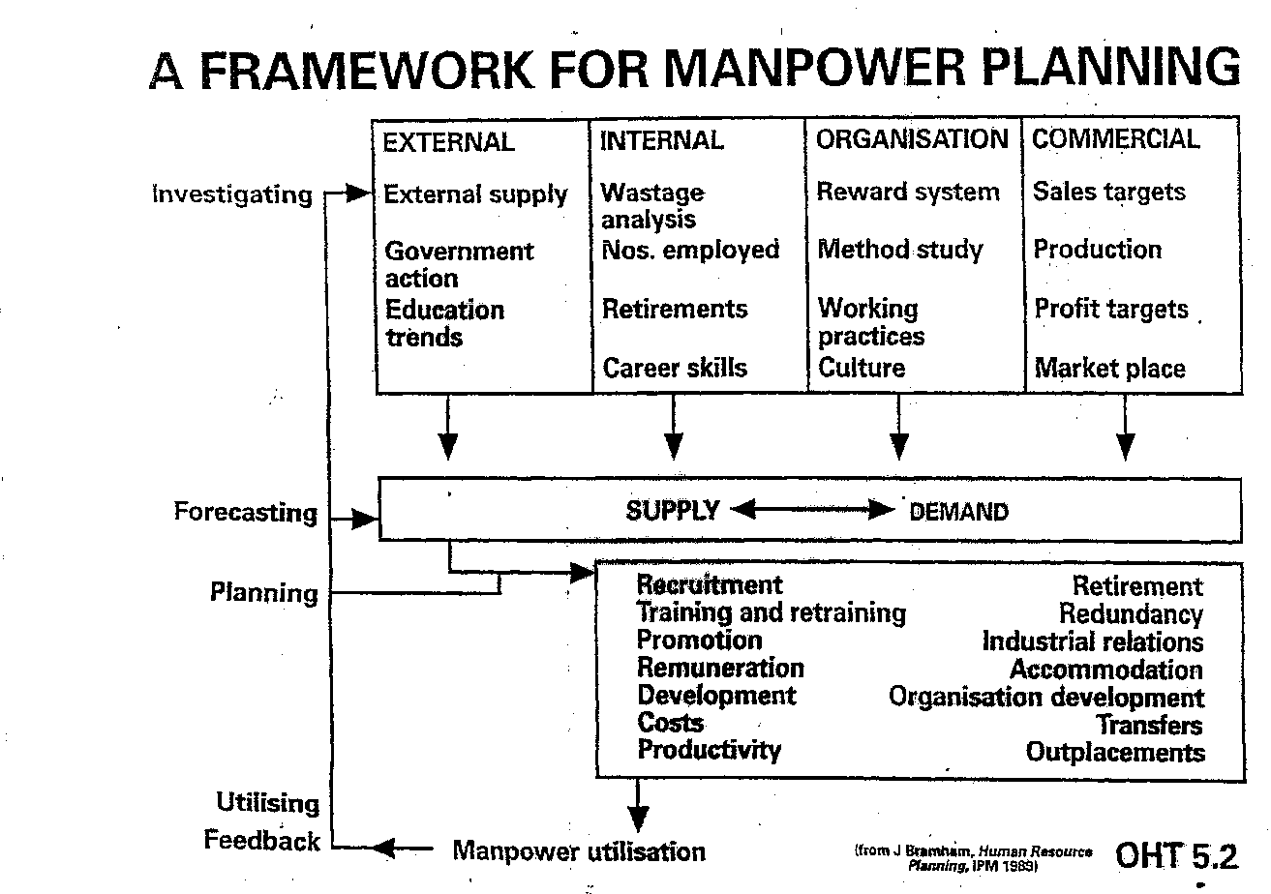
- Demand Forecasting: Forecasting the overall human resources requirements in accordance with the organisational plans.
- Supply Forecasting: Obtaining the data and information about the present inventory of manpower and forecast the future changes in the human resources inventory.
- Estimating the net manpower requirement.
- In case of future surplus than plan for redeployment.
- In case of future deficit, forecast the future supply of manpower from all sources with reference to plans of other companies.
- Plan for recruitment, development and internal mobility if future supply is more than or equal to net manpower requirements.
- Plan to modify and adjust the organizational plan if future supply will be inadequate with reference to future net requirements.
- Degree of uncertainty and length of planning period.

importance of manpower planning in an organization
- To recruit and retain the manpower of required quality and quantity.
- To foresee the employee turnover and make the arrangements for minimizing turnover and filling up of consequent vacancies.
- To meet the needs of the programmes of expansion, diversification etc.
- To foresee the impact of technology on work, existing employees and future human resource requirements.
- To improve the standards, skill, knowledge, ability, discipline etc.
- To assess the surplus or shortage of manpower and take measures accordingly.
- To maintain congenial industrial relations by maintaining optimum level and structure of human resources.
- To minimize the imbalances caused sue to non-availability of human resources of the right kind, right number in right time and right place.
- To make the best use of its human resources and
- To estimate the cost of human resources.

RECRUITMENT
Recruitment is a process to discover the sources of manpower to meet the requirement of the staffing schedule and to employ effective measures for attracting that manpower in adequate numbers to facilitate effective selection of efficient personnel.
Definitions: In the words of K. ASWATHAPPA.It is the process of finding and attracting capable applicants of employment. The process begins when new recruits are sought and ends when their applications are submitted. The result is pool of applicant from which new employees are selected.

significance:
The general purpose of recruitment is to provide a pool of potentially qualified job candidates. Specifically, the purpose is to:
1) Determine the present and future requirements of the organization in conjunction with its personal planning and job-analysis activities.
2) Increase the pool of job candidates at minimum cost.
3) Help to increase the success rate of the selection process by reducing the number of visibly under qualified or over qualified job applicants.
4)Help to reduce the probability that job applicants, once recruited and selected, will leave the organization only after a short period of time.
5) Meet the organization’s legal and social obligations regarding the composition of its workforce.
6) Begin identifying and preparing potential job applicants who will be appropriate candidates.
7) Increase organizational and individual effectiveness in the short term and long term.
8) Evaluate the effectiveness of various recruiting techniques and sources for all types of job applicants

Objectives of recruitment:
- To attract people with multi dimensional skills and experiences that suits the present and future organizational strategies.
- To induct the outsiders with a new perspective to lead the company
- To infuse fresh blood at all levels of the organization.
- To develop an organizational culture that attracts competent people to the company.
- To devise methodologies for assessing psychological traits.
- To seek out non-conventional grounds of talent.
- To design entry pay that competes on quality but not on quantum.

recruitment policy:
The recruitment policy of any organization is derived from the personnel policy of the same organization. It includes:
- Government policies
- Personnel policies of other competing organizations
- Organization’s personnel policies
- Recruitment sources
- Recruitment needs
- Recruitment cost
- Selection criteria and preference etc

sources of recruitment:The sources of recruitment are broadly divided into internal and external sources.
Internal Sources:
- Present permanent employees
- Present temporary or casual employees
- Retrenched or retired employees
- Dependents of deceased, disabled, present and retired employees.
External Sources
a) Campus recruitmen
b) Private employee agencies
c) Public employee exchanges
d) Professional Organizations
e) Data banks
f) Casual applicants
g) Similar organizations
h) Trade unions

Reasons for external sources:
- Candidates can be selected without any pre-conceived notion or reservations.
- HR mix can be balanced with different background, experience and skill etc.
- Latest knowledge skill, innovative or creative talent can also be flowed in to the organization.
- Long run benefit to the organization in the sense that qualitative human resources can be brought.
Recruitment Techniques:
These are the techniques by which the management contractsprospective employees or provides necessary information or exchanges ideas or stimulates them to apply for jobs. Management uses different types of techniques to stimulate internal and external candidates. Techniques useful to stimulate internal candidates are:
- Promotions
- Transfers
- Techniques useful to stimulate external candidates:
- Present employees
Advertising: Techniques of advertising aim at:
a) Attracting attention of the prospective candidates
b) Creating and maintaining interest
c) Stimulating action by the candidates

Modern sources and techniques of recruitment:
A number of modern recruitment sources and techniques are being used by the corporate sector in addition to traditional sources and techniques. These techniques include.
a) Walk-in:
The busy organizations and the rapid changing companies do not find time to perform various functions of recruitment. Therefore, they advise the potential candidates to attend for an interview directly and without a prior application on a specified date, time and at a specified place.
b) Consult-in:
The busy and dynamic companies encourage the potential job seekers to approach them personally and consult them regarding the jobs; the companies select the suitable candidates from among such candidates through the selection process.
c) Head Hunting (search consultants):
In this the professional organizations search for the most suitable candidates and advise the company regarding the filling up of the positions.
d) Body Shopping:
The prospective employees contact these organizations to recruit the candidates. These professional and training institutions are called body shoppers and these activities are known as body shopping.
e) Business Alliances:
Business alliances like acquisition, mergers and takeovers help in getting human resources. In addition, the companies do also have alliances in sharing their human resources on ad-hoc basis.
f) Tele-recruitment:
Organizations advertise the job vacancies through the World Wide Web (internet). The job seekers send their applications through e-mail or internet

SELECTION
Selection is the process by which a firm uses specific instruments to choose from a pool of applicants a person or persons most likely to succeed in the job(s), given management goals and legal requirements.
The selection methods
- Sifting applications: Application forms, CV-s and covering letters
- Biodata analysis: objective, weighted scoring of biographical data (e.g. sex, age, family background, work experience, leisure interest…)
- Work sample tests
- Written tests: ability, intelligence (or cognitive ability), personality, aptitude
- Interviews:
  - individual interviews, interview panels, selection boards
  - Structured or general interview
- Assessment centres
- References
- The final stage: offer a job contract

Selection Process

Flow chart of Selection Process

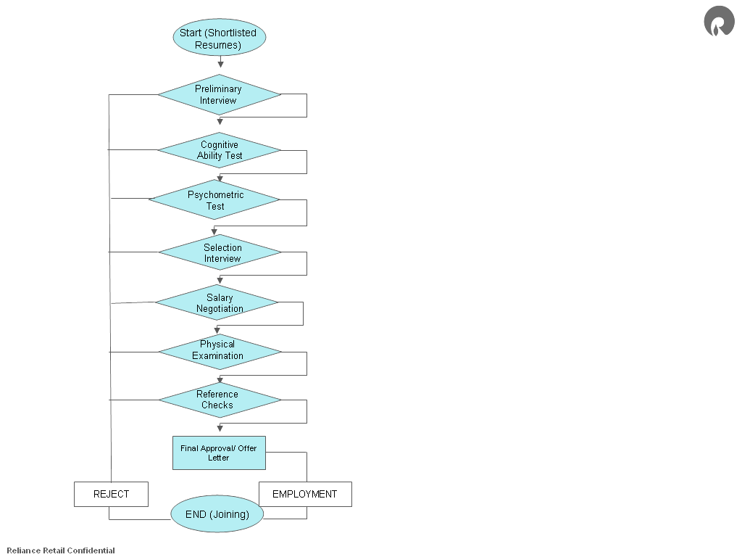

Training and Development

Training is an educational process. People can learn new information, re-learn and reinforce existing knowledge and skills, and most importantly have time to think and consider what new options can help them improve their effectiveness at work. Effective trainings convey relevant and useful information that inform participants and develop skills and behaviors that can be transferred back to the workplace.
The goal of training is to create an impact that lasts beyond the end time of the training itself. The focus is on creating specific action steps and commitments that focus people’s attention on incorporating their new skills and ideas back at work.
Training can be offered as skill development for individuals and groups. In general, trainings involve presentation and learning of content as a means for enhancing skill development and improving workplace behaviors.

Organizational Development is a process that “strives to build the capacity to achieve and sustain a new desired state that benefits the organization or community and the world around them.” (from the Organizational Development Network website) OD work implies creating and sustaining change.
An OD perspective examines the current environment, the present state, and helps people on a team, in a department and as part of an institution identify effective strategies for improving performance. In some situations, there may not be anything “wrong” at the present time; the group or manager may simply be seeking ways to continue to develop and enhance existing relationships and performance. In other situations, there may be an identifiable issue or problem that needs to be addressed; the OD process aims to find ideas and solutions that can effectively return the group to a state of high performance.
These two processes, Training and Organizational Development, are often closely connected. Training can be used as a proactive means for developing skills and expertise to prevent problems from arising and can also be an effective tool in addressing any skills or performance gaps among staff. Organizational Development can be used to create solutions to workplace issues, before they become a concern or after they become identifiable problem.

JOB EVALUATION
A job evaluation is the process whereby the relative worth of positions within the organization is established. The job description is the basis for a job evaluation. The result consists of assigning jobs to salary grades. The job evaluation methodology used to establish relative worth is a market pricing and slotting approach that focuses on the following components:

External Value: HRS reviews and analyzes published competitive salary survey information, which has been gathered and prepared by internationally recognized consulting firms. The analysis takes into consideration strength of job match, company size, industry, geography, and ownership.

Internal Value: HRS reviews and analyzes the job documentation to determine the position scope, complexity, and potential impact to the University as well as specific factors such as skill, effort, responsibility and working conditions required to successfully perform the job.
When establishing the worth of a position, issues of internal equity are considered. Internal equity is defined as fairness in the relationship of a job’s salary range when compared with the salary ranges of similar jobs within the organization. The salary range for a job is considered internally equitable if the salary is commensurate with responsibility level of the position. The salary range represents fair wage rates for the job compared to similar positions at the University.

Directors/Managers should not use an incumbent's base salary as a guide to slot a new position into a grade. HRS must determine the grade assignment through the evaluation process.

PROCEDURE
A job is eligible for re-evaluation when its primary duties have either increased or decreased in scope, complexity, and the position changes substantially or by more than 40%. In order to initiate the job reclassification process, the Director/Manager must complete a Reclassification/Audit Request Form and obtain the appropriate signatures (contact HR for this form). Position descriptions should be prepared by the Director/Manager to whom the position reports, or by the incumbent at the Director/Manager’s request. The Human Resource Services Department provides assistance and support for this process. New position descriptions may be drafted by the job incumbent using the appropriate Job Analysis Questionnaire (contact HR for this questionnaire). The Director/Manager of each Department is responsible for the accuracy of the document and the proper approvals.

The Human Resource Services Department will assign the appropriate job title and salary grade and forward the written determination to the Director/Manager who initiated the request. The manager should discuss the determination with the affected employee(s).

