**RECENT TRENDS IN BANKING (FINANCIAL TECHNOLOGY INDUSTRY)**

**Time for clarity on Fintech regulations**

There has been an exponential rise in the number of FinTechs in the country during the last six months. [India now ranks 17th in the world](http://fintechranking.com/2016/03/28/cashless-society-and-fintech-hubs/) in terms of number of FinTech companies present in the country. With the declaration of the [Startup Action Plan](http://startupindia.gov.in/actionplan.php), there has been a sudden boom in the number of FinTechs. The [FinTech segment also attracts a huge number of investors](http://xeler8.com/img/Indian-Startups-in-Q2-2016_Xeler8.pdf) and funding deals. The Indian FinTech segment mainly comprises of –

1. E-wallets / mobile wallets

2. Smart tax solutions

3. [P2P lending](http://www.india-financing.com/images/Articles/Peer_to_Peer_Lending_Business_Models.pdf)

4. Payment gateways,

5. [Prepaid payment instruments issuers](http://www.india-financing.com/images/Articles/issuance_of_instruments_to_pre_pay_for_transactions.pdf)

However, for the FinTech-based startups, the regulatory aspect still remains unclear.

As most of the activities mentioned above involve handling of large financial data of the general public, the general presumption is that a separate registration would be required. However, these activities either do not come under the scanner of the Reserve Bank of India (RBI) or do not need any registration requirement.

Most fintechs are a fusion of a payment solution and technology (Pay-tech) to avail goods and services. Innovative payment solutions are a result of advance in technology and lower communication cost. This has enabled us to experience cashless transactions. This fundamental barrier of risky cash transactions can be overcome with the exchange of information in place of hard cash between the parties to the transaction.

To overcome this barrier, [the Payment and Settlement Systems (PSS) Act, 2007](https://rbidocs.rbi.org.in/rdocs/Publications/PDFs/86706.pdf) was enacted to govern and regulate the activities which involved payment and settlement of transaction as a substitute to paying or settling a transaction by cash or by other means of physical movement of payment instruments to settle a transaction.

**Plastic Money**

The RBI in exercise of the powers given to it by the PSS Act, issued the [Payment and Settlement Systems Regulations, 2008](https://rbidocs.rbi.org.in/rdocs/Publications/PDFs/REGULATI050115.pdf). These regulations were made applicable to all the entities desirous of setting up the payment system. The words *“applicable to all the entities desirous of setting up a payment system in the nation”* is read differently by different entities, which is the main cause of confusion for FinTechs engaged in activities related with facilitation of payments and settlements. At first, it seems that the Payment and Settlement Systems Regulations, 2008, is applicable to all entities engaged in activities of payments and settlements. This view however, changes when we go a bit deeper into the *modus operandi* of the activities of the FinTechs engaged in payments and settlements.

FinTechs whose activities are directly related to payment, clearing and settlements of transactions are – M-wallets, E-wallets, Payment Gateways and Pre-paid Payment Instrument Issuers. The entities engaged in the above mentioned activities directly form part of the payment and settlement system and hence, are regulated by the RBI except the payment gateways. This is because the activities of the payment gateways are not seen as payment and settlement of transactions. To understand the point as to why the payment gateways are not seen as payment system providers by the RBI, we need to first understand three important points –

1. **Who is a payment system provider?**

The PSS Act defines a system provider as – *‘system provider’ means a person who operates an emonetiza payment system.*

**2. What is a payment system?**

The PSS Act defined a payment system as – *“payment system” means a system that enables payment to be effected between a payer and a beneficiary, involving clearing, payment or settlement service or all of them, but does not include a stock exchange;*

**3. *Modus operandi* of payment gateways.**

1. The buyer/ cardholder fills out a payment information form to pay for a purchase at a merchant’s website checkout.

b. The gateway collects the payment information and forwards it (securely encrypted) to the processing bank (gateway’s nodal account maintaining bank) for authorization.

c. The processing bank sends the request, through Visa, Master Card or RuPay’s payment networks, to the card issuer or directly to the buyer’s bank (in case of net-banking transaction).

d. The card issuer or bank approves or declines the transaction and sends its response, through Visa, MasterCard or RuPay, to the processing bank.

e. The processing bank forwards the response, through the gateway, to the merchant who completes the transaction accordingly.

f. In the case of an approved transaction, the merchant deposits the receipt with its processing bank, requesting payment.

g. The processing bank then credits the merchant’s account and submits the transaction to Visa, MasterCard, RuPay or buyer’s bank for a settlement.

h. Visa, MasterCard, RuPay or buyer’s bank then pays the processing bank, while simultaneously debiting the card/ account holder’s account.

The entire process is completed in less than five seconds, by way of high-speed transfers of encrypted data from one point to the other and back.

From a reading of the above points, we can understand that, to be identified as a payment system provider the entity must be in the activity of –

1. Effecting payments between payer and beneficiary; and/ or

ii. Effecting clearing and settlement service.

Clearly, the gateways merely act as information exchanges, facilitating payments and settlements and not providing the services to effect payment, clearing and settlements. The activities of payment, clearing and settlements are carried out by the processing banks. Hence the gateways are not emonetiza as payment system providers by the RBI.

However, the gateway does handle sensitive information of public, which includes credit or debit card numbers, ATM PIN, internet banking passwords, CVV numbers of the cards and other information. This information can be misused. While the PSS Act has paved the way to move on to a cashless economy, where payments and settlements will be by way of information exchange between emonetizat data centres, we need comprehensive regulation to keep a check on the activities of these emerging business activities.

**Can Fintech companies challenge banks?**

Financial technology (Fintech), an industry that recently emerged in the Indian economy, is now set to change the way lending and borrowing, as we know it, is done. Banks, which have been the primary institutions for lending funds for over a century, are now up for competition from some 21st century entrepreneurs.

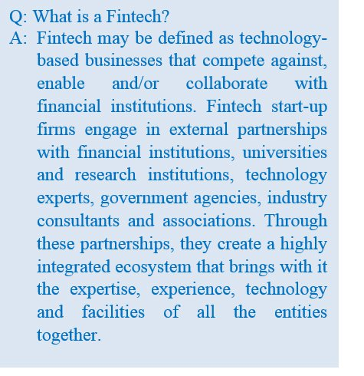Banks enjoyed the advantage of wide reach, which allowed them to route money over distant locations. However, with the emergence of new and improved technology it is now possible for other players to enter into the business of money- lending and compete with the banks.

Technology has made the world a smaller place as never before and people are now for the first time looking to alternative ways to meet their need for funds. As per estimates, over 45% of the fintechs active in India are into payment services.

India launched its Startup India plan during this time last year, with a view to transforming the country into a fertile ground for new and innovative businesses and, in turn, boost the national economy. Since the launch of the plan, most of the businesses which came up are e-commerce and fintechs. Both the businesses have technology as their core.

**Fintech in India**

The fintech industry in India can be divided into 12 broad categories:

1. Alternative Funding

2. Banking Tech

3. Crowdfunding

4. Consumer Finance

5. Cryptocurrency

6. Enterprise Finance

7. Foreign Exchange

8. Insurance Tech

9. Investment Tech

10. Mobile Wallets

11. Payments

12. Software for Institutional Investor

These categories have been rising steadily since 2015 and are expected to keep rising till 2020. The list below shows the number of fintechs founded since 2015 across different categories, [according to an article in Live Mint](http://www.livemint.com/Industry/LByMUFBJDIKzfG5SW9cRZI/The-state-of-fintech-in-India.html).

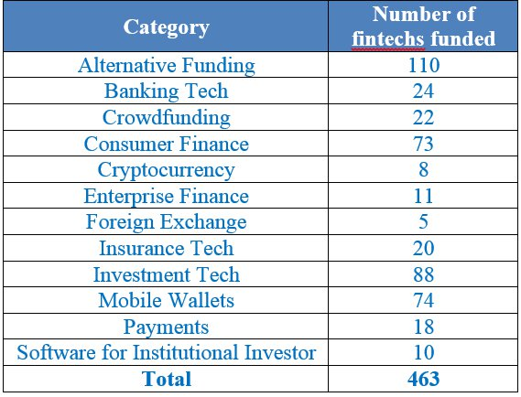

According to statista.com, the Indian fintech market has seen a transaction value of about $35.46 billion and the number is rising at an annual rate of 21%. With this rate of growth, the segment is expected to hit about $92 billion in transaction value by 2021. Apart from this, the fintech software segment is expected to reach $2 billion in value.

**Effects of emonetization**

The Indian fintech segment witnessed a major boost due to the recent emonetization. The e-payments and e-wallets segments have witnessed a boost of almost 500% in term of traffic (<https://yostartups.com/the-state-of-fintech-in-india/>). Government data shows that a whopping 1.7 million transactions were routed through payment wallets within one month of announcement of emonetization, till 7th December. Estimates suggest that among the fintechs active, almost 46% are into payment services.

**Legal scenario for Fintechs**

Most of the categories of the fintechs’ functions are not regulated. Categories like peer-to-peer (P2P) lending and payments systems are some sectors that need to be regulated as they deal with public money. P2P lending does not fall under the regulatory framework of Reserve Bank of India (RBI). Hence, these alternative lending institutions have an edge over banks and financial institutions and charge higher rates of interest than banks.

However, the alternative lending platform falls under the Usurious Loans Act, 1918. This Act gives courts in India the power to intervene in cases where interest rates are excessively high, thereby keeping a check on unfair rates of interest. Apart from this, around 22 states have separate Acts on money-lending, which need to be complied with. Also, the platform needs to acquire a licence from the state under the Act to carry out the business of lending.

Entities in the second category of fintechs, whose activities are regulated, are those engaged in the business of e-wallets and payment services. These entities are required to be registered with the RBI under the Payment and Settlement Systems Act. The RBI here has stringent rules and regulation. This ensures security of information and public money, which are routed through the servers of these fintechs. Apart from this, all other categories of fintech are non-regulated, which poses both a threat and an opportunity for the business enterprise. India needs to clarify its regulatory scene for fintechs.

**Fintech scenario around the world**

One of the most important ingredients for a business to be successful is the environment within which it operates. Like all other major economies around the world, India too is slowly making its business environment suitable for fintech startups. Below is a graphical representation of the business environments of various countries.

1. **The Unites States of America**

The US is the hub for entrepreneurs as well as hi-tech talent. It has attracted the highest fintech investment and built the largest network of start-up firms.

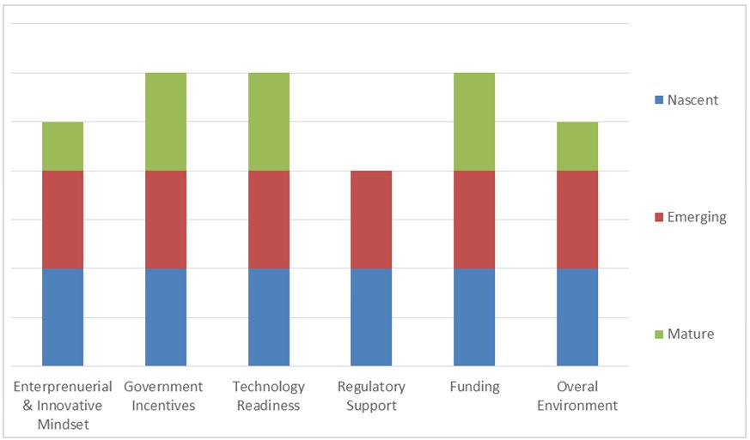

**2. The United Kingdom**

The UK has established itself as one of the most attractive locations for fintech, with high digital connectivity, an indigenous financial services workforce and a solid funding landscape.

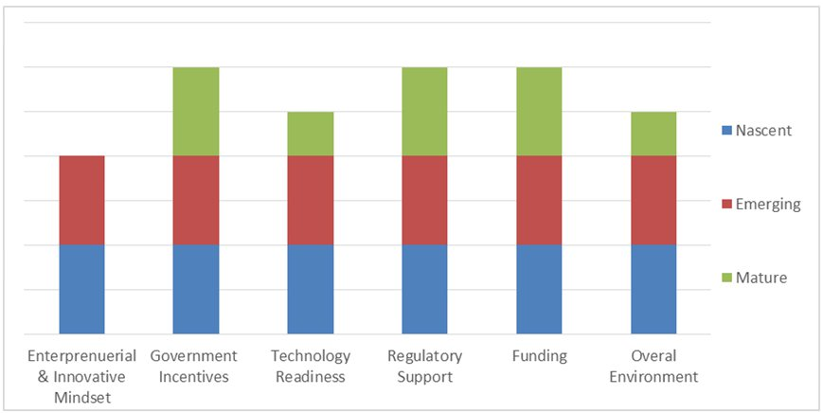

**3. Hong Kong**

Hong Kong is shaping up as a strong fintech hub in Asia, backed by robust investment support from the government and venture capitalists to nurture entrepreneurship.

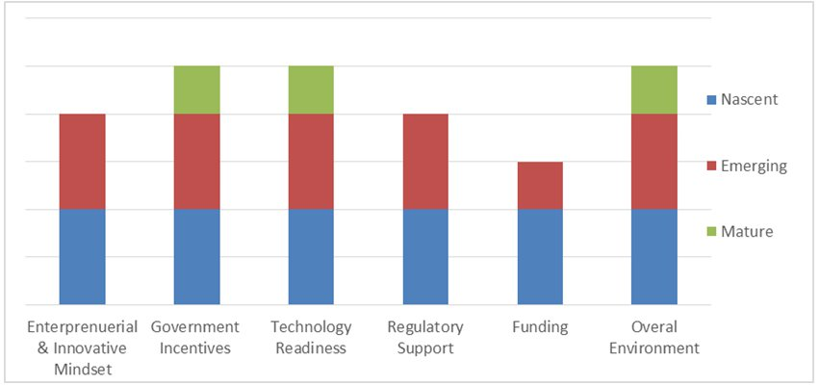

**4. India**

India is gaining ground in the fintech ecosystem with a fair supply of proficient and inexpensive talent, the potential to capture a large portion of the unbanked population and a steady inflow of funds.

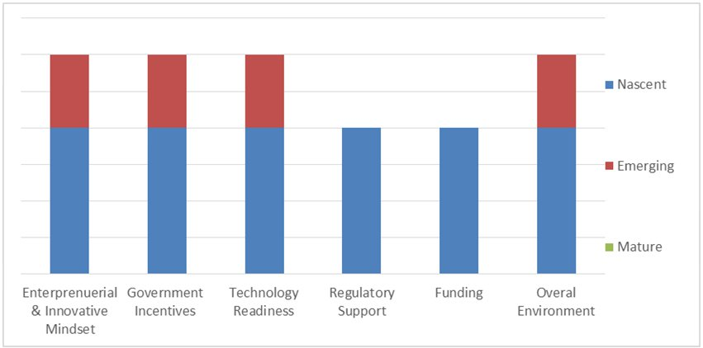

From the above charts we can see that the business environment is lagging behind in India. India needs to invest in its business environment so as to emerge as a startup haven, which it claims to achieve by 2020.

India, being the fastest growing economy of the world and home to the largest population under the age of 24 years, has got tremendous potential and opportunity to turn itself into a 21st century super economy. However, this would not be possible unless there is all round development of the business environment of the country.

**RISING NON PERFORMING ASSETS**

Recognising and writing off bad assets may not resolve the banking problem as the new financial order requires banks to lend to the default-prone, aggravating the woes

While recognising that risks to India’s banking sector are rising due to deterioration in asset quality and low profitability, the government and RBI spokespersons periodically declare that there is no cause for alarm. But there is much evidence (for example in the RBI’s Financial Stability Report of June 2016) that the problem is serious and the health of banks may deteriorate further, as changes in the nature of bank exposure have significantly increased systemic risk.

The indicator most often cited as reflecting the health of the banking system is the ratio of non-performing assets (NPAs) to total advances. The restructuring and recapitalisation process associated with the post-1991 ‘reforms’ had resulted in a sharp decline in the ratio of gross NPAs to gross advances from 15.7 per cent at the end of 1996-97 to 2.3 per cent at the end of 2008-09, the year of the global financial crisis.

However, since then there has been a reversal in trend, with the ratio rising to 3.4 per cent in 2012-13, 4.6 per cent in 2014-15 and 7.6 per cent in 2015-16 (Chart 1). The Financial Stability Report of the RBI provides a number of explanations for this trend.

One is the possibility that “boom period credit disbursal was associated with less stringent credit appraisal.” The other is accelerated credit growth, resulting from competitive credit disbursal encouraged by the sharp decline in the statutory liquidity ratio (SLR) from 30.5 per cent of total assets at end March 2005 to 22.6 per cent at end March 2008 and “the push for infrastructure projects, many of which later got into a logjam.”

**The missing fear**

But these do not explain the sharp spike in the NPA ratio in 2015-16. Two other developments during the last decade are important. The first was the creation of a corporate debt restructuring mechanism, which enabled the revival of large loans that were under threat of default. The mechanism involved measures such as extending the maturity of the loan, reducing the interest rate charged, converting a part of the loan into equity, providing additional financing, or some combination of these.

This was clearly intended to mitigate the risk of lending large sums, especially to capital-intensive projects with long gestation lags, as in infrastructure. If banks had to make provisions for likely losses on such loans at the first sign of them turning non-performing, the impact this would have on their finances would dissuade them from undertaking such lending. Restructuring was a way of allaying the fears of bankers, who had in the past avoided lending to capital-intensive projects for fear of being overexposed in long-maturing, illiquid loan assets.

With the decline of development banks post-liberalisation, public commercial banks were required to take on this new role, in which they did indeed finance capital intensive projects with greater liquidity risks.

**Change in status**

Secondly, in keeping with this policy inclination, in January 2009, to counter the adverse impact of the global financial crisis on the Indian economy, the RBI issued guidelines that allowed such restructured assets to be treated as standard assets. It hardly bears stating that restructuring is no guarantee that the asset concerned will ‘perform’ in future. Economic conditions that affected the repayment of the loan could deteriorate further, the project could prove to be structurally unviable for a host of reasons, or the borrower could just be a “wilful defaulter”.

So keeping these assets out of the NPA basket made the NPA ratio an inadequate indicator of bank stress. If banks resorted more often to the restructuring option, the volume of stressed assets in the system would rise much faster than the NPA numbers suggested.

This is exactly what happened in India after 2008. Banks used the opportunity offered by these two policy initiatives to paper over the problems created by their new role as financiers of large projects. As a result, restructured assets as a percentage of gross advances rose from 3.5 per cent at the end of March 2011 to 6.5 per cent at the end of March 2015. This 3 percentage points rise was higher than the 2.2 percentage points rise in the gross NPA ratio.

Realising that postponing bad debt recognition in this manner could result in the accumulation of stressed assets in bank balance sheets sufficient to create a systemic problem, the Reserve Bank in 2015 instituted an asset quality review to reclassify assets and reverse the practice of treating all restructured assets as standard assets. As a result, many “restructured standard assets” were reclassified as non-performing.

Simultaneously, the RBI seems to have put on hold the corporate debt restructuring process, with approvals of such restructuring initiatives falling to zero in 2015-16, as compared with 54 cases involving debt totalling ₹72,560 crore in 2014-15 (Chart 2).

In the event, most restructured assets were reclassified as non-performing. The spike in the NPA ratio in from end March 2015 to end March 2016 is largely explained by the decline in the ratio of restructured assets to gross advances from 6.5 per cent to 3.9 per cent over that period.

Overall stressed assets (including both NPAs and restructured assets) had increased from 5.9 per cent of gross advances at end March 2011to 11.1 per cent at end March 2015; but rose only marginally to 11.5 per cent by end March 2016. This is one reason the RBI is satisfied with the current position. In its view, once stressed assets are formally recognised as non-performing, the requisite provisions are set aside at the expense of short term profitability, and the banks are recapitalised, credit growth will see a revival, but within a more monitored framework.

**The real problem**

This, however, sidesteps the problem of managing the role handed over to commercial banks, of providing the long-term financing earlier undertaken by development banks. They are even required to make up for the shortfall in public capital formation within a low-tax and restricted fiscal deficit regime.

This has at least two implications. First, two sectors that account for high shares in total industrial credit advance, infrastructure (32.8 per cent) and basic metals and products (essentially iron and steel) (13.6 per cent), show very high ratios of stressed advances to gross advances (Chart 3). These are among the new areas into which neoliberal reform has taken the banks.

Second, as of March 2016, large borrowers (with liabilities of ₹5 crore and above) accounted for 58 per cent of scheduled commercial bank advances and 86.4 per cent of gross NPAs.

Thus, NPAs were concentrated with these large borrowers. The top 100 borrowers accounted 16 per cent of total advances and 22.3 per cent of gross NPAs.

Indeed, the gross NPA ratio of the top 100 borrowers rose from just 3.4 per cent in September 2015 to 22.3 per cent in March 2016, with the reclassification of restructured assets.

Thus, the fragility of the banking system is due to the large borrowers who have benefited from the restructuring route to concealing NPAs. If this proves to be unviable, growth itself is under threat. This provides the government with new grounds to adopt even more pro-business policies than it has in the past.

**NPA menace won’t reduce unless top management accountability is fixed**

The rising non-performing assets (NPAs) in public sector undertaking (PSU) banks cannot be controlled unless there are changes in the regulation for fixing accountability of top management, says a bank employees' union.

"The chairman and managing directors (CMDs), executive directors (EDs) and chief executives (CEOs) of PSU banks are President Appointees. Hence, no action can be taken against them or hold them accountable for their wrong doings. This provision enables them to take decisions in sanctioning of loans. If the loans are defaulted these CMDs or EDs or CEOs are not held accountable for the NPAs. Unless and until mandatory provisions are made in rules for fixing accountability of them, NPA problem will never end," says Subhash Sawant, General Secretary of Indian National Bank Employees' Federation (INBEF), the banking wing of INTUC (Indian National Trade Union Congress).

He alleged that such provisions are deliberately not being made by the Ministry of Finance as it will affect the loan sanction where politicians are interested. Sawant has been actively raising his voice against the rising NPAs in public sector banks (PSBs) and its inept handling by the bank officials for many years. His relentless battle in the past exposed the dubious dealings of Central Bank of India’s former chief Homai Daruwala.

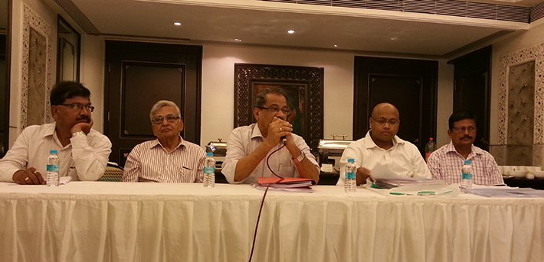

On 4 November 2010, Sanjeev Kumar Jindal, the then Director for Vigilance in the Finance Ministry wrote to the Secretary of Public Sector Enterprises Board (PSEB), which stated, "Provisions regarding taking disciplinary action in respect of heads of Public Sector Enterprises are governed by Nationalised Banks (Management & Miscellaneous Provisions) Scheme 1970/80. These provisions do not have any provision for initiation of disciplinary proceedings against CMDs and EDs, who are Presidential appointees, except removal from the service of the bank after following due procedure. In case an officer is found guilty of any misconduct and in the meantime he retires from the Board, Department has no option but to issue a 'displeasure' which may not serve any purpose."

This provision allowed Central Bank of India’s the then CMD Daruwala, who was accused of violating several guidelines, walk free with just a ‘letter of displeasure’. The case with the Central Bank of India CMD is not a one-off; there have been several other instances where bank heads have committed white-collar crimes, only to be let off without as much as a rap on the knuckles.

Commenting on the existing legal provisions, Sawant had said, "The present system allows corrupt high-level bank officials to go scot-free. There is absolutely nothing that can bring them to book. Up to the level of general manager, the particular bank's service regulations come into force, where provisions for disciplinary action are available. However, positions of CMD and executive director do not fall under these rules, as they are appointed by the president of India. Even if investigations are carried out, these officials escape during court proceedings, due to lacunae in the regulations. It is my firm opinion that these people be brought under the purview of some law."

Earlier on 10 December 2014, the INBEF had filed a public interest litigation (PIL) in Bombay High Court about rising NPAs in public sector banks. On 22 March 2016, the HC directed the central government, finance ministry, RBI and Central Vigilance Commission (CVC) to treat the PIL as a representation made by CBEU and take necessary decision as per the law. The HC also directed them to convey the decision to the bank employee union within three months. These three months would end on 22 June 2016 and we hope that the authorities will take right decision, says Sawant.

In March 2016, INBEF held a dharna at Jantar Mantar in New Delhi for several long pending demands as well as for introducing an agriculture loan restructuring policy for farmers. Prashant Bhushan, senior counsel at the Supreme Court, while congratulating INBEF for taking up the issue of the recovery of NPAs of banks, criticised functioning of the government, particularly, in the banking sector.

India's NPA problem has a flip side to it: the issue of rising corporate debts.

The IMF, in its latest Global Financial Stability Report, warned that rising corporate debts were a risk to growth in emerging markets and pointed out that India's debt is one of the highest among these economies. In fact, in 2016-17, trading in corporate debt securities at BSE and NSE shot up by 44 percent. There is a deep underlying problem within the system that is causing this issue of rising debt, which is so commonplace in corporate practices that it is often overlooked: The goal of "maximising shareholder value".

In a recent speech at the University of Virginia, Infosys co-founder N.R. Narayana Murthy said that "good governance is all about maximising shareholder value". The statement was not always passed around as truism till a few decades ago. The phenomenon first arose in the developed world and India merely imported these corporate practices.

In the immediate post-War era, the role of shareholders was restricted and the managers of large corporations enjoyed relative autonomy. The financial sector was strictly regulated and limits were imposed on the movement of capital. Corporations tended to retain the profit they earned and the people they employed -- and they reinvested this profit in accumulating physical and human capital.

In the 1960s and 1970s, this strategy of "retain and reinvest" hit a roadblock due to a massive growth of corporations. Through mergers and acquisitions, corporations grew too big with too many divisions in different kinds of businesses. Following this, there occurred two institutional changes that aligned the management's interests with that of the shareholders: Development of new financial instruments like junk bonds and tender offers that allowed hostile takeovers and changes in compensation of managers who were offered performance-related pay schemes and stock options.

The 1970s also witnessed the financial and banking deregulation of the American economy, which would help hostile takeovers in the next decade by allowing the risky trade in junk bonds -- a corporate or government bond that the bond-rating agencies consider being below "investment grade".

Managers responded to the "shareholder revolution" by a marked shift in their strategy. William Lazonick and Mary O'Sullivan famously wrote in 2000: "In the name of creating 'shareholder value', the period following the hostile takeover movement witnessed a marked shift in the strategic orientation of top corporate managers in the allocation of corporate resources and returns away from 'retain and reinvest' and towards 'downsize and distribute'."

Under the new regime, top managers downsize the corporations they control, with a particular emphasis on cutting the size of the labour forces they employ, in an attempt to increase the return on equity. It has been empirically shown that "reduction in force" announcements have a positive effect on share prices. Rational pursuit of these managers led them to do whatever they could to keep the stock prices up and the shareholders happy. There was a rise in dividends paid out to shareholders and repeated stock buy-backs to reduce the supply of shares in the market and artificially prop up their prices.

The shift towards shareholder value orientation of firms has resulted in a short-term strategy of boosting share prices rather than a focus on long-term growth of the firm with real investment for non-financial firms. Indian firms also began pursuing this self-destructive strategy, which ties to the corporate debt problem that they are currently facing and eventually to the country's ever-widening NPA crisis.

During the boom years of 2004-08, India's corporate profit as a percentage of GDP rose from 4.5 percent to 7.1 percent, as per RBI data. Post-crisis, profits immediately started falling, eventually reaching 4.5 percent in 2014. However, between 2004 and 2014, corporate debt-to-equity ratio consistently rose from 0.68 to 1.1. In value terms, corporate debt rose by 8.1 times while net profit had merely climbed 3.2 times.

It is quite clear that the debt was not being taken for productive purposes. On the contrary, despite troubling times, Indian corporates were generously handing out dividends. Between 2011 and 2016, the country's top listed companies had tripled their dividend payments while their profits rose by merely 50 per cent. They were quite honourably sticking to Narayana Murthy's idea of good governance.

This is not to argue that shareholders are not an important constituent of a firm, but the obsession with such a metric creates the wrong incentives for managers. They are forced to focus on boosting quarterly results rather than enhancing long-term growth; and satisfying shareholder needs rather than those of its customers and employees. Today, Indian firms are burdened with unmanageable corporate debt due to such misaligned goals. Firefighting the NPA issue will not help the economy in the long-run if inherent corporate practices maintain *status quo*.

**NEW KINDS OF BANKS**

The Reserve Bank of India is set to further expand the country’s banking landscape with licences to new types of banks like wholesale banks or custodian banks. This is in addition to the two types of differentiated bank licences granted in 2015, namely, payments banks and small finance banks.

“In addition to recently licensed differentiated banks such as payments banks and small finance banks, the Reserve Bank will explore the possibilities of licensing other differentiated banks such as custodian banks and banks concentrating on wholesale and long-term financing,” the central bank said on Tuesday while announcing its first bi-monthly policy review. RBI will put out a discussion paper on the issue by September 2016.

Wholesale banks are lenders that cater to large corporates which require long-term finance, particularly those engaged in infrastructure development. Typically, these banks raise long-term funds which are exempted from maintaining regulatory requirements like cash reserve ratio and statutory liquidity ratio.

Custodian banks, on the other hand, are specialised financial institutions mainly responsible for safeguarding a firm’s or individual’s financial assets, and are typically not engaged in conventional retail lending.

“The move will help the Indian financial sector get some niche and specialised players of global and Indian origin and create a focus on specific areas, which will help both institutions to become more competitive and innovative,” Shinjini Kumar, CEO designate, Paytm told [The Hindu](http://www.thehindu.com/news/cities/mumbai/business/rbi-to-allow-more-niche-banks/article8440003.ece). Paytm has received a licence to start a payments bank. RBI has granted licences to 11 entities to start payments banks and 10 entities for opening small finance banks. RBI governor Raghuram Rajan also said at the post-policy interaction with the media that the banking regulator will issue norms for on-tap for universal banks. Till date, the RBI has been offering banking licences for a limited period of time.

In 2014, RBI allowed banking licences to two entities, infrastructure financier IDFC and micro lender Bandhan Financial. The Indian corporate sector has been demanding on-tap process for a long time.

Since April 2014, the Reserve Bank of India (RBI) has granted 23 banking licences to new players - two were given universal banking licences (April 2, 2014), 11 were issued payments banks licences (August 19, 2015) and 10 were given licences for small finance banks (September 16, 2015). The niche banks - small finance and payments banks -have been set up to further the regulator's objective of deepening financial inclusion. Going ahead, RBI is planning to come up with "on tap" licences which means there will not be any cut-off date for applying for the licences.  
  
**HEADQUARTERS OF THE NEW BANKS**

**UNIVERSAL BANKS**

* Mumbai - IDFC
* Kolkata - Bandhan

**PAYMENTS BANKS**  
  
**Mumbai**

* Aditya Birla Nuvo
* Fino PayTech
* National Securities Depository
* Reliance Industries
* Dilip Shantilal Shanghvi
* Tech Mahindra
* Vodafone M-pesa

**New Delhi**

* Airtel M Commerce
* Department of Posts
* Vijay Shekhar Sharma

**Chennai**

* Cholamandalam Distribution

**SMALL FINANCE BANKS**  
  
**Mumbai**

* Au Financiers
* Suryoday Micro Finance

**Jalandhar**

* Capital Local Area Bank

**Ahmedabad**

* Disha Microfin

**Chennai**

* Equitas Holdings

**Thrissur**

* ESAF Microfinance and Investments

**Bengaluru**

* Ujjivan Financial Services
* Janalakshmi Financial Services

**Varanasi**

* Utkarsh Micro Finance

**Guwahati**

* RGVN (North East) Microfinance

**REGULATORY REQUIREMENTS**  
  
**UNIVERSAL BANKS**  
  
**Eligibility**  
  
Companies in the private and public sectors and non-banking financial companies (NBFCs) will be eligible to set up a bank through a wholly-owned non-operative financial holding company (NOFHC). These applicants need to meet the criteria set by RBI. The players will also need to have a sound and successful track record of 10 years  
  
**Capital requirement**  
  
The initial minimum paid-up voting equity capital for a bank needs to be at least Rs 500 crore. The bank will need to be listed within three years of starting business  
  
**Scope of activity**  
  
The bank can accept deposits and carry out lending activities without limitations in the area of operations. Also, the banks will have to work towards achieving financial inclusion and 40 per cent of their lending should be towards the priority sector  
  
**Promoter's contribution**  
  
The NOFHC and the bank will not have any exposure to the promoter group. The bank will not invest in equity / debt capital instruments of any financial entities held by the NOFHC  
  
**Foreign shareholding**  
  
The aggregate non-resident shareholding in the new bank will not exceed 49 per cent for the first five years, after which it will be according to the existing policy - 49 per cent under the automatic route and 74 per cent under the approval route  
  
**Other conditions**  
  
The bank's board should have a majority of independent directors. It needs to open at least 25 per cent of its branches in unbanked rural centres (population of up to 9,999, according to the latest census). Also, banks promoted by groups having 40 per cent or more assets/income from non-financial business will require RBI's prior approval for raising paid-up voting equity capital beyond Rs 1000 crore or for every block of Rs 500 crore  
  
**PAYMENTS BANKS**  
  
**Eligibility**  
  
Prepaid payment Instrument issuers, individuals/professionals, NBFCs, corporate business correspondents, mobile telephone companies, super-market chains, real sector cooperatives that are owned and controlled by residents, and public sector entities are eligible to apply for payments bank licences. The promoter should be able to meet the 'fit and proper' criteria with a sound track record of of five years  
  
**Capital requirements**  
  
The minimum paid-up equity capital for payments banks shall be Rs 100 crore  
  
**Scope of activity**  
  
Can accept deposits of up to Rs 1 lakh a customer and issue debit cards. It can also carry out payments and remittance services and is allowed to distribute insurance and mutual fund products. Payments banks can also serve as a business correspondent of another bank  
  
**Promoter's contribution**  
  
The promoter's minimum initial contribution to the paid-up equity capital should be at least 40 per cent for the first five years from the start of its business  
  
**Foreign shareholding**  
  
The foreign shareholding in payments banks would be according to the foreign direct investment (FDI) policy for private sector banks - 49 per cent under the automatic route and 74 per cent under the approval route  
  
**Other conditions**  
  
The operations of the bank should be fully networked and technology-driven from the beginning and it should also have a high powered customer grievances cell to handle complaints  
  
**SMALL FINANCE BANKS**  
  
**Eligibility**  
  
Resident individuals/professionals with 10 years of experience in banking and finance, companies and societies owned and controlled by residents, existing NBFCs, microfinance institutions, and local area banks can apply for small finance bank licences. All entities should be owned and controlled by Indian residents and should be able to meet the 'fit and proper' criteria stated by RBI  
  
**Capital requirements**  
  
The minimum paid-up equity capital required is Rs 100 crore  
  
**Scope of activity**  
  
They will primarily undertake basic banking activities of accepting deposits and lending to unserved and underserved sections, including small business units, small and marginal farmers, micro and small industries and unorganised sector entities. There will not be any restriction in the area of operations of small finance banks.  
  
**Promoter's contribution**  
  
The promoter's minimum initial contribution to the paid-up equity capital of small finance bank should be at least be 40 per cent and needs to be gradually brought down to 26 per cent within 12 years from the start of operations.  
  
**Foreign shareholding**  
  
Foreign shareholding in small finance banks would be according to the FDI policy for private sector banks- 49 per cent under the automatic route and 74 per cent under the approval route.  
  
**Other conditions**  
  
The small finance bank will be subject to all prudential norms and regulations of RBI, as applicable to existing commercial banks, including requirement of maintenance of cash reserve ratio and statutory liquidity ratio. Apart from this, they will be required to extend 75 per cent of adjusted net bank credit to the priority sector. Also, at least 50 per cent of its loan portfolio should comprise loans and advances of up to Rs 25 lakh

PAYMENT BANKS

Definition of 'Payments Banks'

**Definition:**A payments bank is like any other bank, but operating on a smaller scale without involving any credit risk. In simple words, it can carry out most banking operations but can't advance loans or issue credit cards. It can accept demand deposits (up to Rs 1 lakh), offer remittance services, mobile payments/transfers/purchases and other banking services like ATM/debit cards, net banking and third party fund transfers.   
  
**Description:**In September 2013, the Reserve Bank of India constituted a committee headed by Dr Nachiket Mor to study 'Comprehensive financial services for small businesses and low income households'. The objective of the committee was to propose measures for achieving financial inclusion and increased access to financial services.   
  
The committee submitted its report to RBI in January 2014. One of the key suggestions of the committee was to introduce specialised banks or 'payments bank' to cater to the lower income groups and small businesses so that by January 1, 2016 each Indian resident can have a global bank account.   
  
Why payments banks? The main objective of payments bank is to widen the spread of payment and financial services to small business, low-income households, migrant labour workforce in secured technology-driven environment.   
  
With payments banks, RBI seeks to increase the penetration level of financial services to the remote areas of the country.   
  
Existing prepaid payment instruments (PPI model) like Airtel Money does not give pay any interest on deposits.

After 11 applicants received in-principle approvals from the Reserve Bank of India (RBI) in August 2015 to open payments banks, three backed out citing business concerns.

Of the remaining eight, two entities have started operations while other two have talked about where they stand with respect to the preparation to open a payments bank. With less than two weeks left to receive final approval from the regulator, three in-principle approval holders—Reliance Industries, Aditya Birla Nuvo and Vodafone m Pesa—have not announced any defined plans.

If they fail to open a payments bank within the 18 month-period as stipulated by the RBI, they will have to surrender their in-principle approvals.

**Airtel Payments Bank**

It became the first payment bank to start operations in November by launching pilot programme in Rajasthan. The bank is offering 7.25% interest on savings account and is charging 0.65% on withdrawal amount above Rs4,000. The bank plans to invest Rs3,000 crore and intends to convert at least 100 million out of its 270 million Airtel customers with the bank. MasterCard will provide payment processing solutions to the bank.

**India Post Payments Bank**

It became the second entity to start operations in January by launching pilot in Raipur and Ranchi. The bank is offering 4.5-5.5% on savings account. It is providing door step banking services by charging a nominal fee of Rs15-35 per visit for amount below Rs10,000. The government has so far allocated Rs500 crore. The bank plans to open 650 branches by September 2017.

**Paytm** **Payments Bank**

Vijay Shekhar Sharma has received final licence from RBI in January to set up his payments bank. Paytm Payments Bank is likely to launch with a pilot in parts of Uttar Pradesh and has received investments of Rs 220 crore from Sharma and One97 Communications. The bank has set itself a target of 200 million accounts, across current and savings accounts, and mobile wallets, within 12 months of the launch.

**Fino Pay Tech Ltd**

The company is waiting to receive final nod from RBI. Fino Pay Tech plans to launch payment bank in Maharashtra, Madhya Pradesh, Uttar Pradesh and Bihar with 400 branches in the initial phase. It has indicated that the payments bank will keep the interest rate on its savings bank deposits within the current market range of 4-5%.

**National Securities Depository Ltd**

The depository intends to start operations in two months and is finalizing on a team which will handle payment bank operations.

**Aditya Birla Nuvo Ltd**

No defined plans regarding operations released in the public domain.

**Vodafone m-Pesa Ltd**

It received equity infusion worth Rs 47,700 crore from its parent company. No defined plans regarding operations in the public domain.

**Reliance Industries Ltd**

It signed an agreement with State Bank of India (SBI). No defined plans regarding operations are released in public domain.

BANDHAN BANKS

<http://www.bandhanbank.com/about-bandhan-bank.aspx>