**MARKETING MANAGEMENT**

**Unit I**

* **Marketing Management**
* **Marketing**
* **Scope of Marketing**
* **Traditional and Modern Selling**
* **Marketing Mix**
* **Marketing Process**
* **Marketing Environment**
* **Service Marketing**

**Definition of Marketing**

According to **American Marketing Association**, *"****Marketing****is an organisational function and a set of processes for creating, communicating and delivering value to customers and for managing customer relationships in ways that benefit the organisation and its stakeholders."*

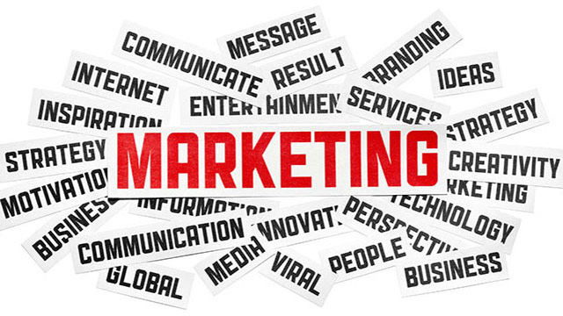

**Definition of Management**

According to **Harold Koontz**, *"****Management****is the art of getting things done through and with people in formally organised groups."*

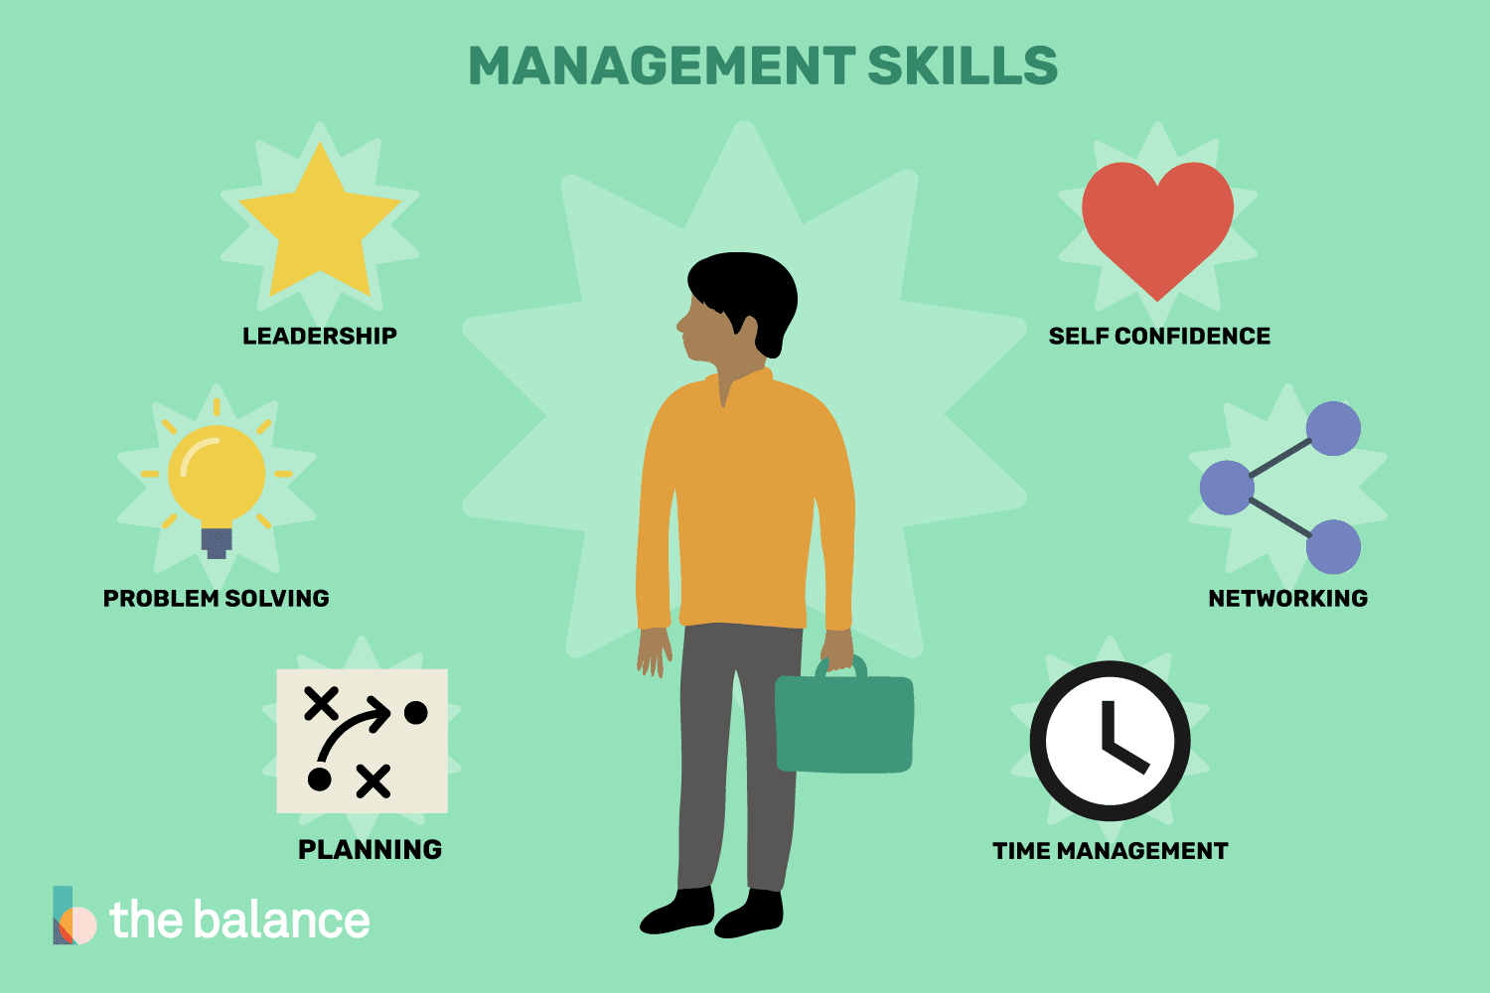

Management consists of the interlocking functions of creating corporate policy and organising, planning, controlling, directing an organisation's resources in order to achieve the objectives of the policy.

**Definition of Marketing Management**

According to **Philip Kotler**, *"****Marketing Management****is the analysis, planning, implementation and control of programmes designed to bring about desired exchanges with target audiences for the purpose of personal and of mutual gain. It relies heavily on the adoption and coordination of product, price, promotion and place for achieving responses."*.

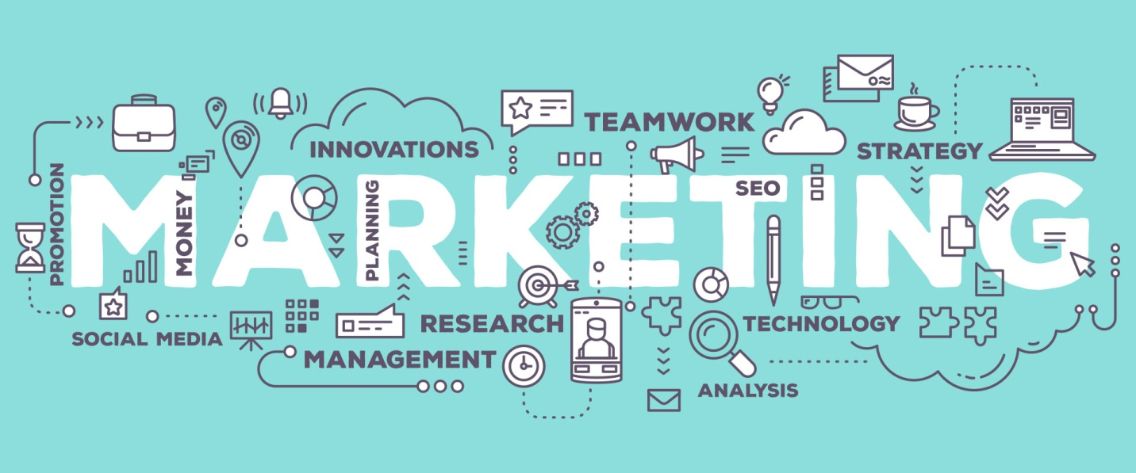

Marketing management is a business process, to manage marketing activities in profit seeking and non-profit organisations at different levels of management. Marketing management decisions are based on strong knowledge of marketing functions and clear understanding and application of supervisory and managerial techniques.

**Nature of Marketing Management**

**It Combines the Fields of Marketing and Management**

As the name implies, marketing management combines the fields of marketing and management. Marketing consists of discovering consumer needs and wants, creating the goods and services that meet those needs and wants; and pricing, promoting, and delivering those goods and services. Doing so requires attention to six major areas - markets, products, prices, places, promotion, and people.

Management is getting things done through other people. Managers engage in five key activities - planning, organising, staffing, directing, and controlling. Marketing management implies the integration of these concepts.

**Marketing Management is a Business Process**

Marketing management is a business process, to manage marketing activities in profit seeking and non-profit organisations at different levels of management, i.e. supervisory, middle-management, and executive levels. Marketing management decisions are based on strong knowledge of marketing functions and clear understanding and application of supervisory and managerial techniques. Marketing managers and product managers are there to execute the processes of marketing management. We, as customers, see the results of such process in the form of products, prices, advertisements, promotions, etc.

**Marketing Management is Both Science and Art**

“Marketing management is art and science of choosing target markets and getting, keeping and growing customers through creating, delivering and communicating superior customer value.” (Kotler, 2006). Marketing management is a science because it follows general principles that guides the marketing managers in decision making. The Art of Marketing management consists in tackling every situation in an creative and effective manner. Marketing Management is thus a science as well as an art.

**Marketing**

**Introduction**

In today's world of marketing, everywhere you go you are being marketed to in one form or another. Marketing is with you each second of your walking life. From morning to night you are exposed to thousands of marketing messages every day. Marketing is something that affects you even though you may not necessarily be conscious of it.

After reading this you'll understand - what exactly the marketing is, different definitions of marketing, and what the different approaches of marketing are.

**Definition and Meaning of Marketing**  
According to **American Marketing Association (1948)** - *"Marketing is the performance of business activities directed toward, and incident to, the flow of goods and services from producer to consumer or user."*  
  
**AMA (1960)** - *"Marketing is the performance of business activities that direct the flow of goods and services from producer to consumer or user."*

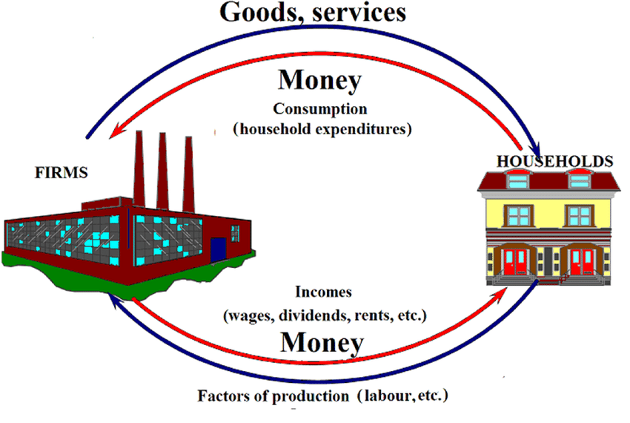  
  
The above definitions are based on the **economic approach** **of marketing**. Marketing embraces all the business activities involved in getting goods and services, from the hands of producers into the hands of final consumers. The business steps through which goods progress on their way to the final consumers is the concern of marketing.  
  
**Consumer's Approach of Marketing**  
According to **Star et al. (1977)** - *"Marketing is that process through which a business enterprise, institution, or organisation*

1. *selects target customers or constituents,*
2. *assesses the needs or wants of such target customers, and*
3. *Manages its resources to satisfy those customer needs or wants."*

The above definition is based on the consumer's approach of marketing. According to this approach marketing consists of four general activities:-

1. Identifying and selecting the type of  customer, understanding their needs and desires;
2. Designing product or services that suits the customers' desires;
3. Persuading customers to buy at the firm's offerings; and
4. Storing, moving, and displaying goods after they leave the production site.

**Societal Approach of Marketing**  
According to **Mazur (1947)** - *"Marketing is the delivery of a standard of living to society."*  
  
This definition is based on the societal approach of marketing. According to Cunningham and Cunningham (1981) societal marketing performs three essential functions:-

1. Knowing and understanding the consumer's changing needs and wants;
2. Efficiently and effectively managing the supply and demand of products and services; and
3. Efficient provision of distribution and payment processing systems.

**Managerial or Systems Approach**

According to **Eldridge (1970)** - *"Marketing is the combination of activities designed to produce profit through ascertaining, creating, stimulating, and satisfying the needs and/or wants of a selected segment of the market."*

The above definition is based on the managerial or systems approach of marketing. According to this approach the emphasis is on how the individual organisation processes marketing and develops the strategic dimensions of marketing activities.

**A Broader Approach of Marketing**

According to **Kotler (2000)** - *"A societal process by which individuals and groups obtain what they need and want through creating, offering, and freely exchanging products and services of value with others."*

According to **AMA (2004)** - *"Marketing is an organisational function and set of processes for creating, communicating and delivering value to customers and for managing relationships in a way that benefits both the organisation and the stakeholder."*

According to **Eldridge (1970)** - *"Marketing is the combination of activities designed to produce profit through ascertaining, creating, stimulating, and satisfying the needs and/or wants of a selected segment of the market."*

According to **Kotler (2000)** - *"A societal process by which individuals and groups obtain what they need and want through creating, offering, and freely exchanging products and services of value with others."*

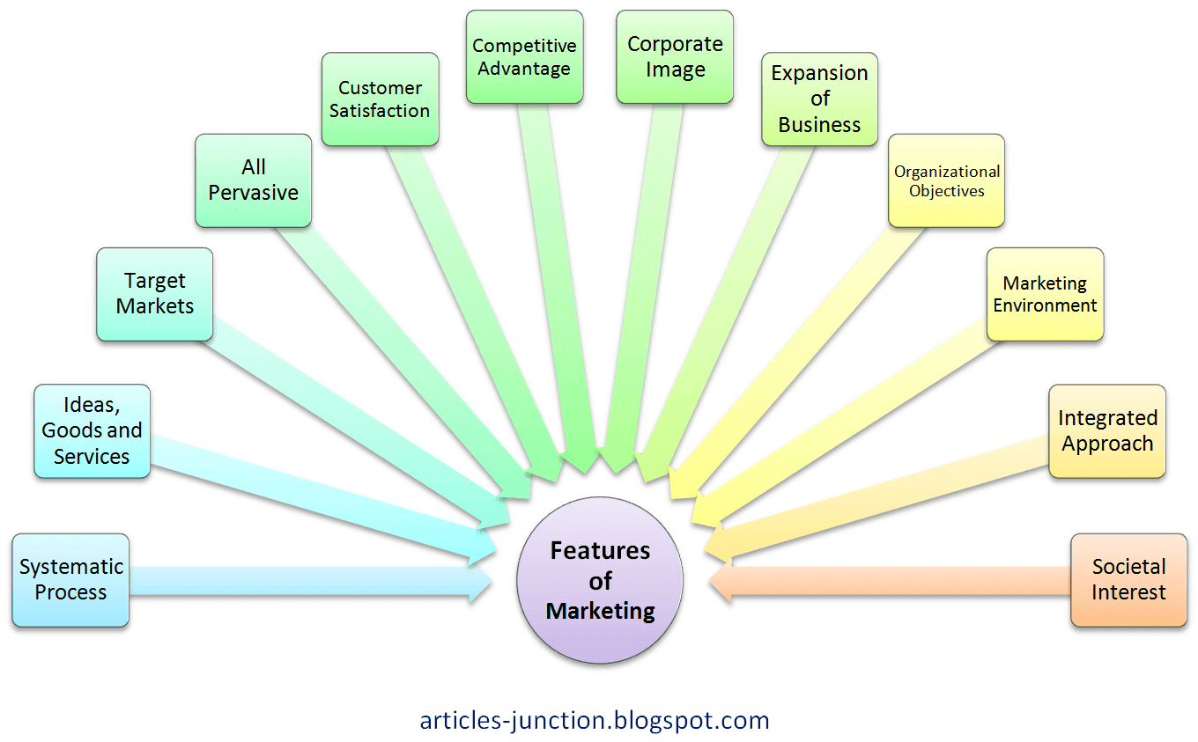

**Nature of Marketing**

**1. Marketing is an Economic Function**

Marketing embraces all the business activities involved in getting goods and services, from the hands of producers into the hands of final consumers. The business steps through which the goods progress on their way to the final consumers is the concern of marketing.

**2. Marketing is a Legal Process by which Ownership Transfers**

In the process of marketing the ownership of the goods transfer’s from seller to the purchaser or from producer to the end user.

**3. Marketing is a System of Interacting Business Activities**

Marketing is that process through which a business enterprise, institution, or organisation interacts with the customers and stakeholders with the objective to earn profit, satisfy customers, and manage relationship. It is the performance of business activities that direct the flow of goods and services from producer to consumer or user.

**4. Marketing is a Managerial function**

According to managerial or systems approach - *"Marketing is the combination of activities designed to produce profit through ascertaining, creating, stimulating, and satisfying the needs and/or wants of a selected segment of the market."*

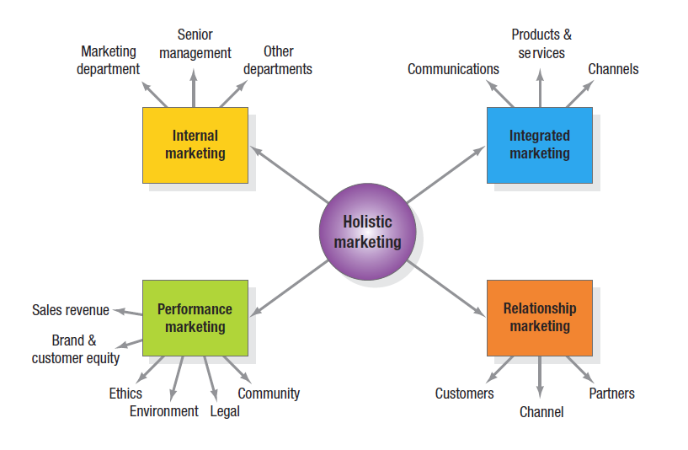

According to this approach the emphasis is on how the individual organisation processes marketing and develops the strategic dimensions of marketing activities.

**5. Marketing is a social process**

Marketing is the delivery of a standard of living to society. According to **Cunningham and Cunningham (1981)** societal marketing performs three essential functions:-

* Knowing and understanding the consumer's changing needs and wants;
* Efficiently and effectively managing the supply and demand of products and services; and
* Efficient provision of distribution and payment processing systems.

**6. Marketing is a philosophy based on consumer orientation and satisfaction  
  
7. Marketing had dual objectives - profit making and consumer satisfaction**

**Scope of Marketing**

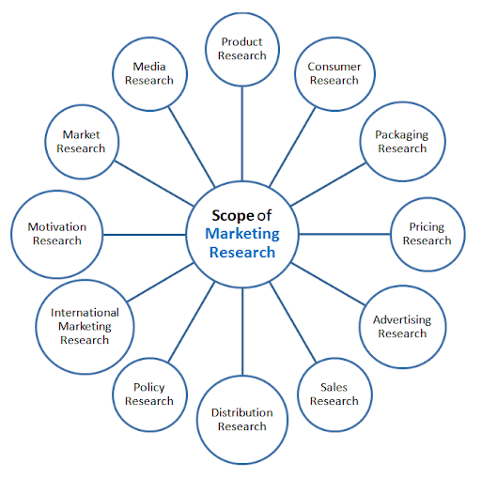

**1. Study of Consumer Wants and Needs**

Goods are produced to satisfy consumer wants. Therefore study is done to identify consumer needs and wants. These needs and wants motivates consumer to purchase.

**2. Study of Consumer behaviour**

Marketers perform study of consumer behaviour. Analysis of buyer behaviour helps marketer in market segmentation and targeting.

**3. Production planning and development**

Product planning and development starts with the generation of product idea and ends with the product development and commercialisation. Product planning includes everything from branding and packaging to product line expansion and contraction.

**4. Pricing Policies**

Marketer has to determine pricing policies for their products. Pricing policies differs form product to product. It depends on the level of competition, product life cycle, marketing goals and objectives, etc.

**5. Distribution**

Study of distribution channel is important in marketing. For maximum sales and profit goods are required to be distributed to the maximum consumers at minimum cost.

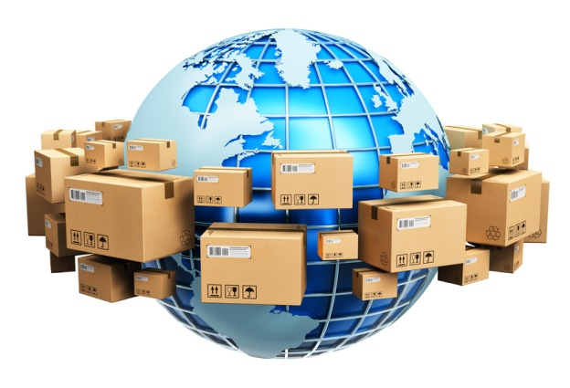

**6. Promotion**

Promotion includes personal selling, sales promotion, and advertising. Right promotion mix is crucial in accomplishment of marketing goals.

**7. Consumer Satisfaction**

The product or service offered must satisfy consumer. Consumer satisfaction is the major objective of marketing.

**8. Marketing Control**

Marketing audit is done to control the marketing activities.

**Traditional Vs Modern Selling t**

|  |  |
| --- | --- |
| Traditional selling | Modern selling |
| **Typical 1960s-80s selling, and still found today.** | **Essential to sustain successful business today.** |
| standard product | customised, flexible, tailored product and service |
| sales function performed by a ‘sales-person’ | sales function performed by a ‘strategic business manager’ |
| seller has product knowledge | seller has strategic knowledge of customer’s market-place and knows all implications and opportunities resulting from product/service supply relating to customer’s market-place |
| delivery service and supporting information and training are typical added value aspects of supply | strategic interpretation of the customer organisation’s market opportunities, and assistance with project evaluation and decision-making are added value aspects of supply |
| good lead-time is a competitive advantage | just-in-time (JIT) is taken for granted, as are mutual planning and scheduling; competitive advantages are: capability to anticipate unpredictable requirements, and assistance with strategic planning and market development |
| value is represented and judged according to selling price | value is assessed according to the cost to the customer, plus non-financial implications with respect to CSR (corporate social responsibility), environment, ethics, and corporate culture |
| the benefits and competitive strengths of the products or service are almost entirely tangible, and intangibles are rarely considered or emphasised | the benefits and competitive strengths of the product or service now include many significant intangibles, and the onus is on the selling organization to quantify their value |
| benefits of supply extend to products and services only | benefits of supply extend way beyond products and services, to relationship, continuity, and any assistance that the selling organization can provide to the customer to enable an improvement for their staff, customers, reputation and performance in all respects |
| selling price is cost plus profit margin, and customers have no access to cost and margin information | selling price is market driven (essentially supply and demand), although certain customers may insist on access to cost and margin information |
| seller knows the business customers’ needs | seller knows the needs of the business customers’ customers and partners and suppliers |
| sales person sells (customers only deal with sales people, pre-sale) | whole organization sells (customers expect to be able to deal with anybody in supplier organization, pre-sale) |
| sales people only sell externally, ie, to customers | sales people need to be able to sell internally to their own organization, in order to ensure customer needs are met |
| strategic emphasis is on new business growth (ie, acquiring new customers) | strategic emphasis is on customer retention and increasing business to those customers (although new business is still sought) |
| buying and selling is a function, with people distinctly responsible for each discipline within selling and customer organizations | buying and selling is a process, in which many people with differing jobs are involved in both selling and customer organizations |
| hierarchical multi-level management structures exist in selling and customer organizations | management structures are flat, with few management layers |
| authority of sales person is minimal, flexibility to negotiate is minimal, approvals must be sought via management channels and levels for exceptions | authority of sales person is high (subject to experience), negotiation flexibility exists, and exceptions are dealt with quickly and directly by involving the relevant people irrespective of grade |
| selling and buying organization are divided strictly according to function and department, inter-departmental communications must go up and down the management structures | selling organization is structured in a matrix allowing for functional efficiency and also for inter-functional collaboration required for effective customer service, all supply chain processes, and communications |
| supplier and customer organization functions tend to talk to their ‘opposite numbers’ in the other organization | open communications to, from and across all functions between supplier and customer organization |
| the customer specifies and identifies product and service requirements | the selling organization must be capable of specifying and identifying product and service requirements on behalf of the customer |
| the customer’s buyer function researches and justifies the customer organization’s needs | the selling organization must be capable of researching and justifying customer organization’s needs, on behalf of the customer |
| the customer’s buyer probably does not appreciate his/her organization’s wider strategic implications and opportunities in relation to the seller’s product or service, and there will be no discussion with the seller about this issues | the seller will help the buyer to understand the wider strategic implications and opportunities in relation to the seller’s product or service |
| the buyer will tell the seller what the buying or supplier-selection process is | the seller will help the buyer to understand and align the many and various criteria within their own (customer) organization, so that the customer organization can assess the strategic implications of the supplier’s products or services, and make an appropriatedecision whether to buy or not |

**Marketing Process**

**Meaning of Marketing Process**

The Marketing Process of a company typically involves identifying the viable and potential marketing opportunities in the environment, developing strategies to effective utilise the opportunities, evolving suitable marketing strategies, and supervising the implementation of these marketing efforts.

Marketing process involves ways that value can be created for the customers to satisfy their needs. Marketing process is a continual series of actions and reactions between the customers and the organisations which are making attempt to create value for and satisfy needs of customers. In marketing process the situation is analysed to identify opportunities, the strategy is formulated for a value proposition, tactical decisions are taken, plan is implemented, and results are monitored.

**Steps in Marketing Process**

Following are the steps involved in the Marketing Process :-

* Situation Analysis
* Marketing Strategy
* Marketing Mix Decision
* Implementation and Control

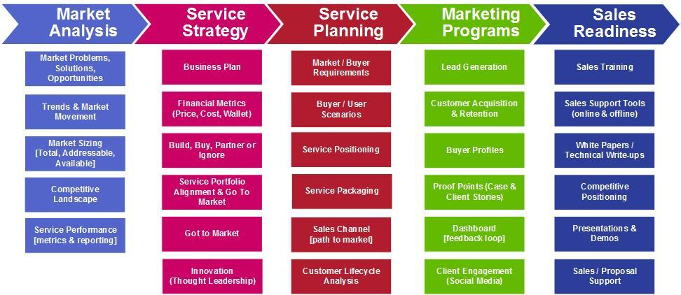

**1. Situation Analysis**

Analysis of situation in which the organisation finds itself serves as the basis for identifying opportunities to satisfy unfulfilled customer needs. Situational and environmental analysis is done to identify the marketing opportunities, to understand firms own capabilities, and to understand the environment in which the firm is operating.

**2. Marketing Strategy**

After identifying the marketing opportunities a strategic plan is developed to pursue the identified opportunities.

**3. Marketing Mix Decisions**

At this step detailed tactical decisions are made for the controllable parameters of the marketing mix. It includes - product development decisions, product pricing decisions, product distribution decisions, and product promotional decisions.

**4. Implementation and Control**

Finally, the marketing plan is implemented and the results of marketing efforts are monitored to adjust the marketing mix according to the market changes.

**Introduction**

In today's world of marketing, everywhere you go you are being marketed to in one form or another. Marketing is with you each second of your walking life. From morning to night you are exposed to thousands of marketing messages everyday. Marketing is something that affects you even though you may not necessarily be conscious of it.

**Marketing Environment**

The term Marketing Environment refers to the forces and factors that affects the organization ability to build and maintain good relationship with its customers. Marketing environment surrounds the organization and it impacts upon the organization. Marketers have to interact with internal and external people at micro and macro level and builds internal and external relationships. The key elements of marketing environment are as follows :-

1. Internal Environment,
2. Micro Environment, and
3. Macro Environment.

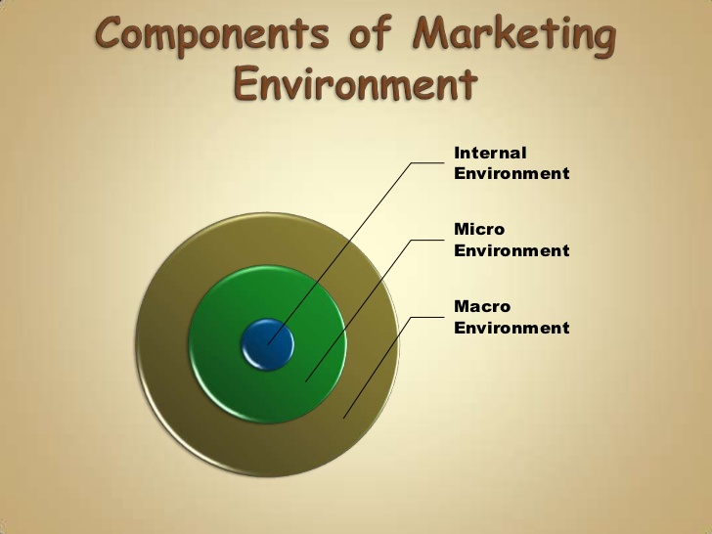

**Internal Environment**

Internal factors like men, machine, money, material, etc., on which marketing decision depends consists internal marketing environment. The internal environment refers to the forces that are within the organization and affects its ability to serve its customers. It includes marketing managers, sales representatives, marketing budget, marketing plans, procedures, inventory, logistics, and anything within organization which affects marketing decisions and its relationship with its customers.

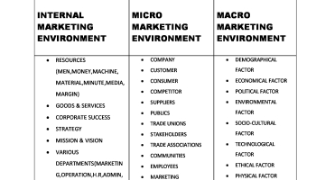

**Micro Environment**

Individuals and organizations that are close to the marketing organization and directly impacts its ability to serve its customers, makes Marketing Micro Environment. The micro environment refers to the forces that are close to the marketing organization and directly impact the customer experience. It includes the organization itself, its suppliers, marketing intermediaries, customers, markets or segments, competitors, and publics. Happenings in micro environment is relatively controllable for the marketing organization.

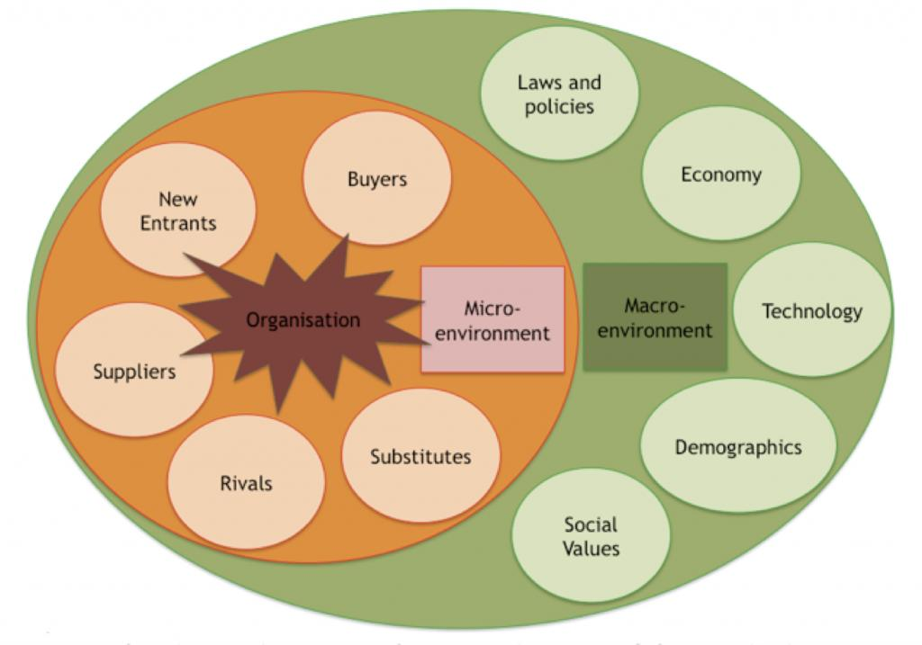

**Macro Environment**

Macro environment refers to all forces that are part of  the larger society and affects the  micro environment. It includes demography, economy, politics, culture, technology, and natural forces. Macro environment is less controllable.

Service Marketing

* **Definition,**
* **Features**
* **Problem Faced in Marketing Services**

## Types of marketing organizations.

**Meaning of Organization**

An organization is a group of people that is structured and managed to achieve a common goal. Every organization has a defined structure that determines relationship between its members, and assigns their roles, responsibilities, and authority.

**Meaning of Marketing Organization**

Marketing organization is a group of marketing persons brought together to make decisions on marketing areas like product, price, place, and promotion. Marketing organization is the foundation of effective sales planning for systematic execution of plans and policies. Marketing organization provides a system of relationships among various marketing functions to be performed by proper coordination among marketing persons.

**Definition of Marketing Organization**  
*"Marketing organization can be defined as a formal or informal group of individuals working together to reach quantitative and*qualitative *marketing objectives by making decisions on product, price, place, and promotion."*  
  
**Types of Marketing Organizations**  
Marketers must have knowledge of what type of marketing organization they have in place; and what type of marketing organization the company actually needs. Following are the different types of marketing organization that commonly exists today :-

* Functional Type of  Marketing Organization;
* Product Oriented  Marketing Organization;
* Market/Territory Oriented  Marketing Organization;
* Customer Oriented  Marketing Organization;

In**functional type of marketing organization** the different marketing activities are grouped on the basis of functions to be performed like - product planning, market research, advertising, sales, or promotion. Each main function is further divided to sub-functions to be performed to achieve marketing objectives. Each sub function is managed by separate manager under the control of marketing manager.

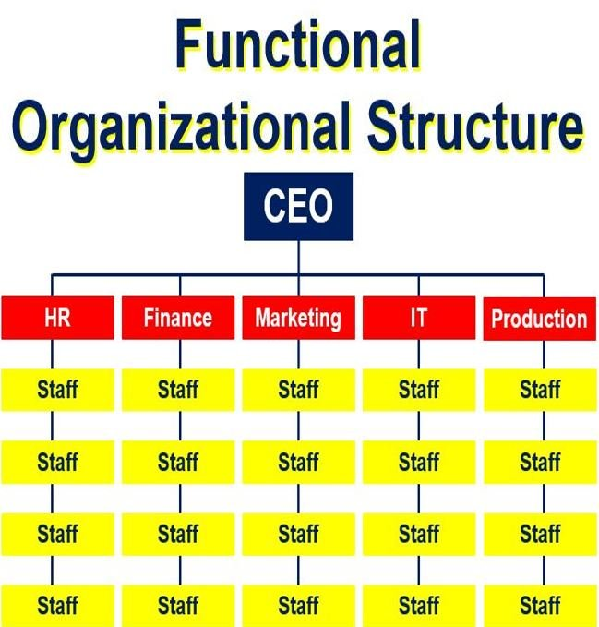

**Product oriented marketing organization** is common where organization is producing or marketing wide variety of products. For each product or group of products a separate product manager is assigned and made responsible for marketing decisions for that particular product or group of products.

E.g.

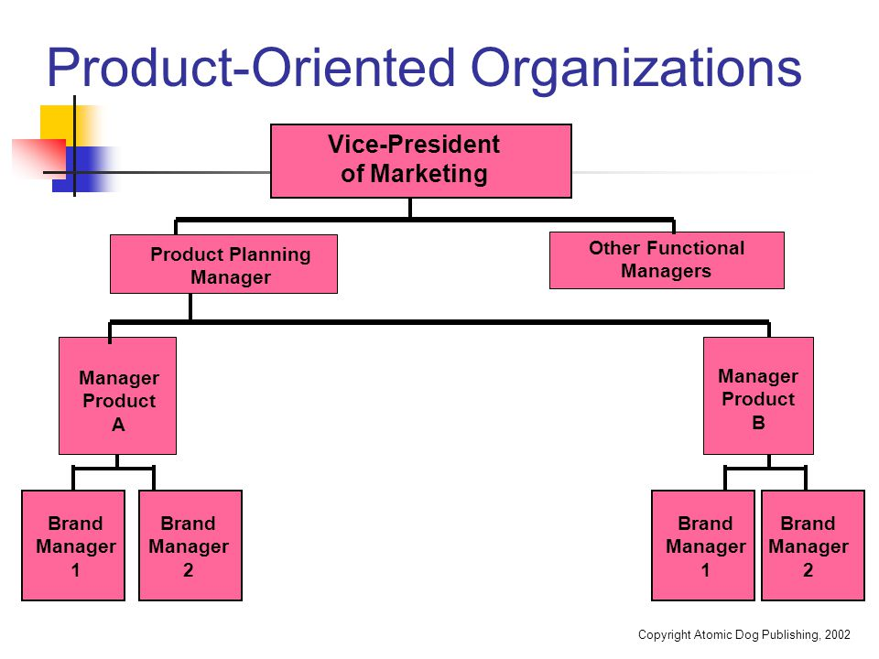

**Market oriented marketing organization** is common in big organizations serving large number of customers spreading over large territories. Depot manager, district manager, area manager, zonal manager, divisional manager, etc., are assigned to manage each territory.

E.g.

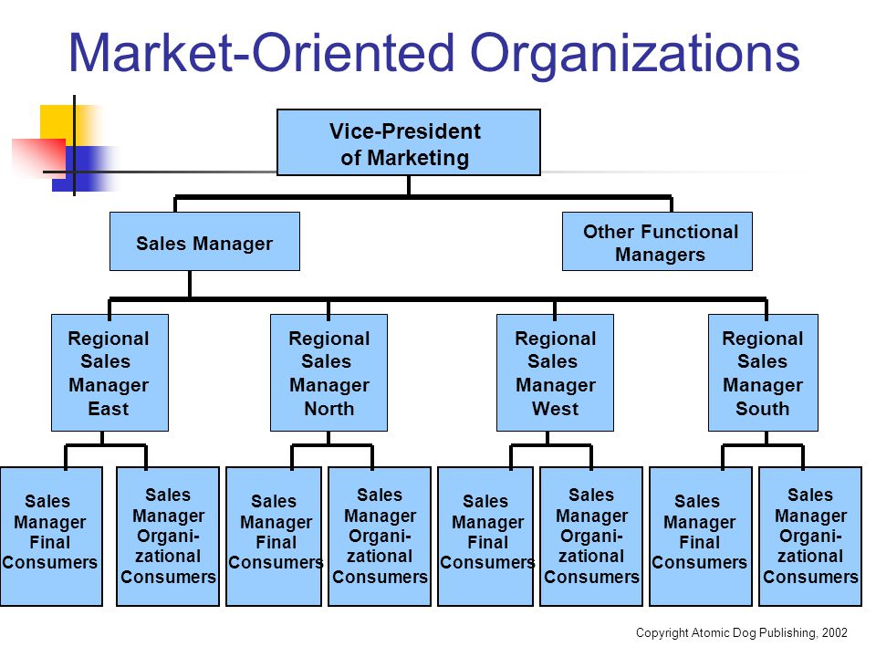

**Customer oriented marketing organization** is common in organizations engaged in providing specialized services to different class of customer.

E.g.

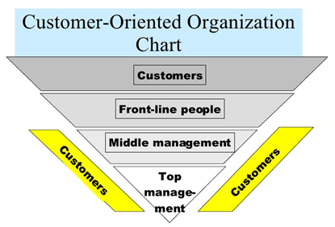

**Introduction**

Well said by Heraclitus - "The only thing that is constant is change." We are experiencing change in our daily life and at marketplace too. Customer needs, wants, expectations are changing more rapidly; customers are increasingly demanding better quality and reliability in products and services; new products and services are coming to market more quickly, competition is getting intense and global rather than just domestic; technology is changing rapidly; and e-commerce and Internet is having a great impact on marketing practises.

In such a rapidly changing marketing environment it is really difficult for business organizations to make quick and sound decisions, and facing various marketing challenges. So, today we are here to let you know what marketing challenges the business organizations are facing, and how to overcome these challenges.  
  
**Marketing Challenges The Business Organizations Facing Today**

* Rapidly changing customer needs, wants, and expectations;
* Increasing domestic and global competition;
* Heterogeneous and fragmented market
* Increasing popularity of Internet;
* Rapid technological changes;
* Challenge of selecting among too many options; and
* Challenge of generating leads.

**Rapidly Changing Customer Needs Wants, and Expectations**  
Today, the needs, wants, and expectations of customer are changing rapidly. It is a great challenge not only for small marketers but for big players too. It requires extensive study of market trends and consumer behaviour while developing new product or updating existing product.  
  
**Increasing Global and Domestic Competition**  
Competition today is global rather than just domestic. Marketers have to compete not only with domestic players but with global players too. The intense and global competition is a great challenge for marketers to deal with.

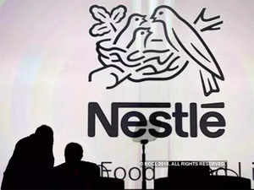  
  
**Increasing Popularity of Internet**  
with the increase in the popularity of Internet a new spectrum of marketing channel is emerged. The worldwide increase in number of Internet users brought a shift from traditional print-based media to new online platforms. It presents a new set of marketing challenges - challenge of deciding how much to allocate to digital v/s print-based media; challenge of using social media marketing largely because of regulatory issues and concerns over its measurability; and challenge of doing more with less money as the rise of Internet made communication cheaper and efficient .



**Challenge of Selecting among Too Many Options**  
The greatest challenge the marketers facing today is simply too many options. Too many potential customer segments. Too many products or services option.

Too many communication tools. It is really difficult and challenging for marketers to choose among too many options. The marketers today doesn't suffer from lack of opportunities or options. The picture is totally opposite today. Now they suffer from too many opportunities or options.

**When the buyer has too many options for shoes :**

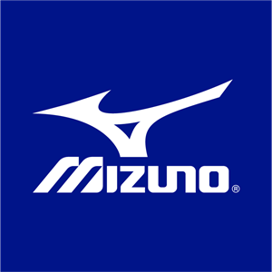

**Ways to Overcome These Challenges**  
For the success of any business overall performance is required to be taken care of. Not only financial performance but also marketing performance. Marketing performance includes - sales volume, market share, and, customer satisfaction. Various marketing challenges make it difficult for marketing managers to achieve the targeted marketing performance. But, there are ways to overcome such challenges. We are here to share the best possible ways to overcome marketing challenges the business organizations facing today.  
  
**Create a Learning Organization**  
Business organizations must include *learning as a key to improvement* in their organizational values. Proper training must be given to marketing employees and it should be considered as an investment rather than as a cost. Marketing managers are required to continually question their own views of the market place. Learning is not an one time activity it’s a continuous process, ability to learn can be a key competitive advantage for any business.

**Market Research**  
Marketing organizations must invest in market research and they are required to make extensive use of it. Organizations are required to be good at using information about markets, customers, and competitors. Market research must be focused on understanding customer needs, wants, and expectations.

**Revaluate the Old Mix - Four Ps to Four Cs**

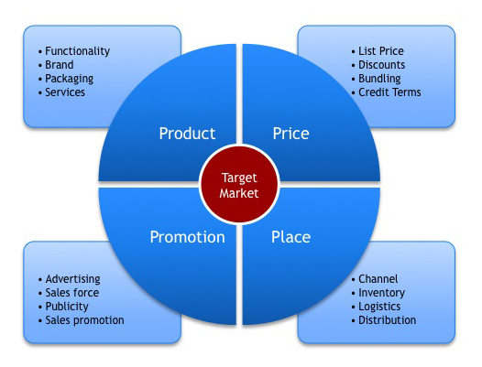

With the increasing globalization, competition, and popularity of Internet the old marketing mix is facing many new challenges; and to tackle these challenges marketing management must revaluate the old marketing mix to to new mix by converting four Ps to four Cs.

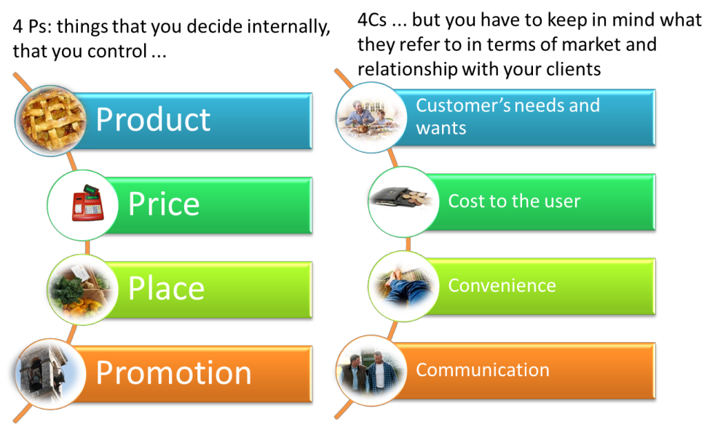

## Alliance Marketing



**Introduction**

Everyone knows one plus one is equals to two, but sometimes it is equals to eleven,  synergy between the forces makes it possible. Synergy is the interaction of two or more forces so that their combined effect is greater than the sum of their individual effects.  
  
In business two or more organizations comes together to produce some kind of synergistic effect or result. Similar happens in alliance marketing where two or more organizations jointlyundertakes marketing activities.

**Meaning of Alliance Marketing**

Alliance Marketing is marketing activity undertaken by two or more organizations, jointly to promote product, service, or concept with the purpose to provide benefit to all the stakeholders.  
  
Alliance marketing involves pooling resources like - expertise, brand reputation, distribution infrastructure, or money,  to produce an effect/result which would be more difficult and costly to achieve independently.

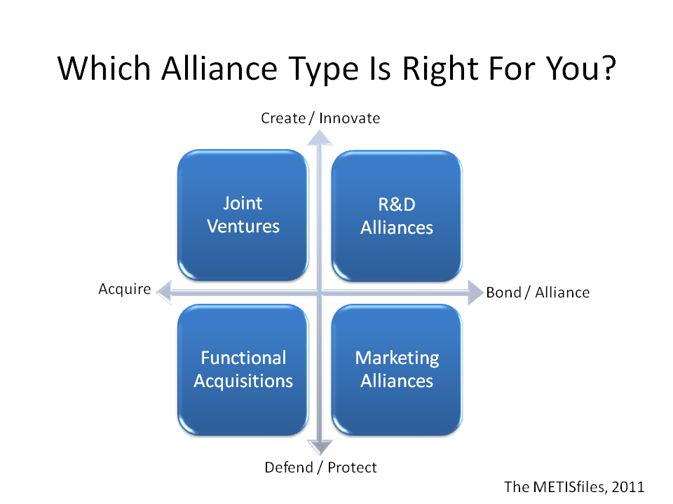

**Importance of Alliance Marketing**

* **To gain access to non-competitive businesses' customers** - Businesses not competing with each other can promote one another, they can refer customers back and forth to increase their sales.
* **To pool knowledge, expertise, and resources** - Pooling expertise, resources, and efforts reduce inefficiencies and expenses.
* **To turn competitors into partners**
* **To expand into new markets** - Independent expansion requires heavy investment, resources, and development of new distribution channels. Alliance marketing makes it easy, a firm in one country can offer a product through another firm already established in another country, thus expand into new market immediately.

For an alliance to work all the involved parties must work closely together to create business. The alliance/relationship must be communicated well to all the stakeholders. The greater the stakeholders' understanding of the value of the alliance, the more they can contribute to its success.

## Marketing mix and its elements.

|  |  |
| --- | --- |
| **The Marketing Mix** | |
| [Marketing Notes - The Marketing Mix](http://3.bp.blogspot.com/-3MqXrEOHxis/UTgzFtIicGI/AAAAAAAAAP0/xmU2DgOG7H0/s1600/Marketing_Mix.jpg) | **Summary**   * [Introduction to Marketing Mix](http://www.enotesmba.com/2013/03/marketing-notes-marketing-mix.html#introduction_to_marketing_mix) * [Definition of Marketing Mix](http://www.enotesmba.com/2013/03/marketing-notes-marketing-mix.html#definition_of_marketing_mix) * [Meaning of Marketing Mix](http://www.enotesmba.com/2013/03/marketing-notes-marketing-mix.html#meaning_of_marketing_mix) * [4P's - Producer-oriented Model](http://www.enotesmba.com/2013/03/marketing-notes-marketing-mix.html#producer_oriented_model) * [4C's - Consumer-oriented Model](http://www.enotesmba.com/2013/03/marketing-notes-marketing-mix.html#consumer_oriented_model) |

**Introduction to Marketing Mix**

**Marketing** is the process of identifying, anticipating, and satisfying customers' requirements with the purpose to make profits. In this process marketing managers and marketing representatives have to take various marketing decisions to make the operations profitable. They have to decide what combination of marketing policies and procedures be adopted to bring about desired behaviour of trade and consumers at minimum cost. They have to decide how can advertising, personal selling, pricing, packaging, channels, warehousing, and the other elements of marketing be manipulated and mixed to make marketing operations profitable. More specifically, they have to decide a marketing mix - a decision making method in relation with the product, price, promotion, and distribution.

The term Marketing Mix was introduced by **Neil H. Borden** in his article - "**The Concept of Marketing Mix**". He learned about it in a research bulletin on the management of marketing costs, written by his associate, **Prof. James Culliton**. in 1948. In this study of manufacturers' marketing costs he described the business executive as a "decider," an "artist" - a "**mixer of ingredients**," who sometimes follows a recipe prepared by others, sometimes prepares his own recipe as he goes along, sometimes adapts a recipe to the ingredients immediately available, and sometimes experiments with or invents ingredients no one else has tried.

**Definition of Marketing Mix**

According to**Philip Kotler** - *"****Marketing Mix****is the combination of four elements, called the 4P's (product, Price, Promotion, and Place), that every company has the option of adding, subtracting, or modifying in order to create a desired marketing strategy"*

According to **Principles of Marketing, 14e, Kotler and Armstrong, 2012** - *"****The Marketing Mix****is the set of tactical marketing tools - Product, Price, Promotion, and Place - that the firm blends to produce the response it wants in the target market."*

**Meaning of Marketing Mix**

The Marketing Mix is a marketing tool used by marketing professionals. It is often crucial when determining product or brand's offering, and it is also called as 4P's (Product, Price, Promotion, and Place) of marketing.  However, in case of services of different nature the 4 P's have been expanded to 7P's or 8P's.  
  
In recent times, giving more importance to customer a new concept have been introduced, i.e. **Concept of 4C's**. The Concept of 4C's is more customer-driven replacement of 4P's. According to Lauterborn's the 4C's are - Consumer, Cost, Communication, and Convenience. According to Shimizu's the 4C's are  -Commodity, Cost, Communication, and Channel.

**4P's - Producer-oriented Model of Marketing Mix**

* **Product** - Products are offerings that a marketer offers to the target audience to satisfy their needs and wants. Product can be tangible good or intangible service. Tangible products are goods like - cellphone, television, or motor car, whereas intangible products are services like - financial service in a bank, health treatment by a doctor, legal advice of a lawyer.
* **Price** - Price is the amount that is charged by marketer of his offerings or the amount that is paid by consumer for the use or consumption of the product. Price is crucial in determining the organization's profit and survival. Adjustments in price affects the demand and sales of the product. Marketers are required to be aware of the customer perceived value of the product to set the right price.
* **Promotion** - Promotion represents the different methods of communication that are used by marketer to inform target audience about the product. promotion includes - advertising, personal selling, public relation, and sales promotion.
* **Place** - Place or distribution refers to making the product available for customersat convenient and accessible places.

In case of services, the producer-oriented model of marketing mix is consists of 7P's. Including the above 4P's there are additional 3P's - **Physical Evidence**,**People**, and**Process**. Physical evidence refers to elements like uniform of employees, signboards, and etc. People refers to the employeesof the organization comes in contact with the customers in the process of marketing. Process refers to the systems and processes followed within organization.

**4C's - Consumer-oriented model of marketing Mix**

* **Consumer** - In this model the Product is replaced by Consumer. Marketers focuses more on consumer satisfaction. The product is designed and produced keeping in consideration the requirements of consumer.
* **Cost** - Price is replaced by Cost. Here the cost refers to the total cost of owning a product. It includes cost to use the product, cost to change the product, and cost of not choosing the competitor's product.
* **Communication** - Promotion is replaced by Communication. Communication includes advertising, public relation, personal selling, and any method that can be used for proper,timely, and accurate communication between marketer and consumer.
* **Convenience** - Place is replaced by Convenience. it focuses on ease of buying, convenience in reaching to the store/product, and convenience in getting product information.

# Green Marketing

**Introduction to Green Marketing**

The negative impact of human activities over environment is a matter of concern today. Governments all over the world making efforts to minimize human impact on environment. Today our society is more concerned with the natural environment. Understanding the society's new concerns businesses have begun to modify their behaviour and have integrated environmental issues into organizational activities. Academic disciplines have integrated green issues in their literature. This is true with marketing subject too, and the terms like "Green Marketing" and "Environmental Marketing are included in syllabus. Governments all over the world have become so concerned about green marketing that they have attempted to regulate them.

**Definition and Meaning of Green Marketing**

Definition according to **American Marketing Association** - *"****Green marketing****is the marketing of products that are presumed to be environmentally safe."*

According to **Polonsky 1994 b, 2** - *"****Green****or****Environmental Marketing****consists of all activities designed to generate and facilitate any exchanges intended to satisfy human needs or wants, such that the satisfaction of these needs and wants occurs, with minimal detrimental impact on the natural environment.*

Green Marketing incorporates broad range of activities including product modification, changes to the production process, packaging changes, and modifying advertising. Green marketing focuses on satisfaction of customer needs and wants with no or minimum harm to the natural environment.

**Why Green Marketing is Important?**

It is well known that increasing production and business activities are polluting the natural environment. Damages to people, crops, and wildlife are reported in different parts of the world. As resources are limited and human wants are unlimited, it is necessary for marketers to use resources efficiently, so that organizational objectives are achieved without waste of resources. So green marketing is inevitable. There is growing interest among people around the world regarding protection of natural environment. People are getting more concerned for environment and changing their behaviour for the protection of environment. As a result of this, the term "Green Marketing" has emerged. Hence, marketers are feeling their responsibility towards environment and giving importance to green marketing.  
  
Not only marketers but consumers are also concerned about the environment, and consumers are also changing their behaviour pattern. Now, individual as well as industrial consumers are becoming more concerned about environment-friendly products.

# Social Marketing Concept

**Definition of Social Marketing**

According to **Philip Kotler** - **Social Marketing** is *"the design, implementation, and control of programs seeking to increase the acceptability of  a social idea or practise in a target group"*

According to **W. Smith, Academy for Educational Development** - *"****Social Marketing****is a process for influencing human behaviour on a large scale, using marketing principles for the purpose of societalbenefit rather than commercial profit."*

Social marketing is based on tools and techniques of commercial marketing, it uses principles of commercial marketing for the purpose of societal benefit. In social marketing, advertising campaigns are designed, implemented, and controlled by using the principles of commercial marketing. The key features of social marketing are taken directly from commercial marketing, but the purpose of social marketing differs form the purpose of commercial marketing. The purpose of commercial marketing is to increase sales and revenue, but it is not so in the case of social marketing.

The purpose of social marketing is societal benefit rather than commercial profit. Its purpose is to bring about positive health and social change. Its ultimate outcome is behavioural change rather than increased sales.

Social advertising campaigns are advertising tools that attempt to influence attitude and behaviour related to social cause. For example, social advertising campaigns have been used to influence behaviour related to energy conservation, pollution, tobacco prevention, family planning, breast cancer screening, and etc.

Extending the Traditional Boundaries of Marketing Until fairly recently, marketing focused primarily on exchanges of goods between individuals (business-to-consumer (B2C) marketing) and businesses (business-tobusiness (B2B) marketing). Industrial marketing deals with the organizational purchases of goods to support production of other goods or daily operations or for resale. Table 1.1.2 highlights the differences between consumer marketing and industrial marketing. Table 1.1.2

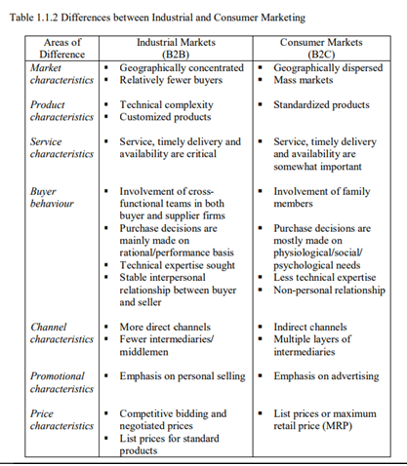

**Marketing Concepts**

Introduction

Having defined marketing in the previous lesson as a social and managerial process by which individuals and groups obtain what they need and want through creating and exchanging products and value with others, this lesson examines the important concepts that are included and implied in this definition.

These concepts are indicated in Figure 1.2.1 and it is important to note that they are linked, with each one building on the one before it.

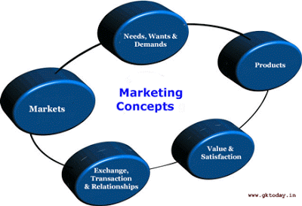

**Needs, Wants and Demands**

The most basic concept underlying marketing is that of human needs. A need is a state of felt deprivation. It is a part of the human makeup. Humans have many needs, viz., physical needs, social needs, spiritual needs and so on. Wants are the form taken by needs as they are shaped by the one’s culture and personality. Wants are thus shaped by both the internal and external factors. Wants are described in terms of objects that will satisfy needs. For example, thirst is a need. To quench this thirst, a person may consider a number of options – drink water or a soft drink or a fruit juice. These objects (which represent the different choices for a person to fulfill his/her need) comprise the potential want-list. As people are exposed to more objects that arouse their interest and desire, marketers try to provide more choices, that is, more want-satisfying products. People have almost unlimited wants but limited resources. Therefore, they want to choose products that provide the most satisfaction for their money. When backed by buying power (ability), a want becomes a demand.

**Products**

A product is anything that can be offered to a market to satisfy a need or want. People satisfy their needs and wants with products. Though the word suggests a physical object, the concept of product is not limited to physical objects. Marketers often use the expressions goods and services to distinguish between physical products and intangible ones. These goods and services can represent cars, groceries, computers, places, persons and even ideas. Customers decide which entertainers to watch on television, which places to visit for a holiday, which ideas to adopt for their problems and so on.

Thus the term ‘product’ covers physical goods, services and a variety of other vehicles that can satisfy customers’ needs and wants. If at times the term ‘product’ does not seem to be appropriate, other terms such as market offering, satisfier are used.

**Value and Satisfaction**

When the customers have so many choices to choose from to satisfy a particular need, how do they choose from among these many products? They make their buying choices based on their perceptions of a product’s value. The guiding concept is customer value. A customer will estimate the capacity of each product to satisfy his need. He/She might rank the products from the most need-satisfying to the least need-satisfying. Of course, the ideal product is the one which gives all the benefits at zero cost, but no such product exists. Still, the customer will value each existing product according to how close it comes to his/her ideal product and end up choosing the product that gives the most benefit for the rupee – the greatest value.

**Exchange, Transactions and Relationships**

Marketing occurs when people decide to satisfy needs and wants through exchange. Exchange is the act of obtaining a desired object from someone by offering something in return. Thought it is only one of the many ways people can obtain a desired object, it allows a society to produce much more than it would with any alternative system. For an exchange to take place, several conditions must be satisfied. Of course, at least two parties must participate, and each must have something of value to the other. Each party also must want to deal with the other party and each must be free to accept or reject the other’s offer. Finally, each party must be able to communicate and deliver. These conditions simply make exchange possible. Whether the exchange actually takes place depends on the parties’ coming to an agreement. If they agree, we must conclude that the act of exchange has left both of them better off or at least not worse off. After all, each was free to reject or accept the offer. In this sense, exchange creates value just as production creates value. It gives customers more consumption possibilities.

A transaction is marketing’s unit of measurement. It consists of a trade of values between two parties. A monetary transaction involves trading goods and services in return for money whereas a barter transaction involves trading goods and services for other goods and services. Transaction marketing is part of the larger idea of relationship marketing. Marketing is shifting from trying to maximize the profit on each individual transaction to maximizing mutually beneficial relationships with consumers and other parties. This is based on the assumption that if good relationships are built, profitable transactions will simply follow.

**Markets**

The concept of transactions leads to the concept of a market. A market is the set of actual and potential buyers of a product. It may exist in a physical environment as a marketplace or in a virtual environment (on the internet platform) as a marketspace.

To understand the nature of a market, imagine a primitive economy consisting of only four people – a farmer, a fisherman, a potter and a hunter. Figure 1.2.2 shows the different ways in which these traders could meet their needs. In the first case, self-sufficiency, they gather the needed goods for themselves. In the second case, decentralized exchange, each person sees the other three as potential buyers who make up a market. In the third case, centralized exchange, a new person called a merchant appears and locates in a central area called a marketplace. Each trader brings goods to the merchant and trades for other needed goods.

Merchants and central marketplaces greatly reduce the total number of transactions needs to accomplish a given volume of exchange. As economies grow, exchange becomes even more centralized, as seen in the growth of huge companies. Large supermarkets now serve millions of people who formerly shopped in smaller outlets.

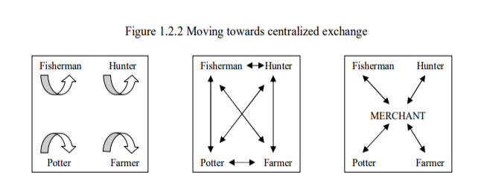

# Macro and Micro Environment of Marketing

Some authors are contended with the meaning of the word environment as something external to the marketing organisation. The earlier pages have made those ‘external’ forces. On the other hand, according to some group of authors including william j. Stanton, michael j. Etzel and bruce j. Walker, the environment has a broad meaning and according, they talk of external and internal environment.

According to them macro environment stands for external environment and micro environment stands for internal environment. To avoid confusion, these can be taken up afresh in brief. In effect it is subdivision of external environment into macro and micro.

### Macro Environment:

Any organisation is industrial and trading operates within an external environment that it generally cannot control. Macro environmental forces have considerable influence on any organizations marketing system. These are Demography, Economic conditions, Competitions; Social and Cultural forces; Political and Legal forces and Technology. They are macro- environmental forces because change in any of them can change in one or more of the others.

Therefore, they are closely interrelated. One thing is certain that all these forces have one thing in common that they are dynamic forces which are subject to change and at an increasing rate per sec. This is clearly demonstrated by Figure 2.

These six forces are largely uncontrollable by management. However these are not totally uncontrollable. A company may be able to influence its external environment to some extent. For instance, an international marketing company can improve its competitive position by a joint venture with a foreign firm that markets a complementary product.

NOVARTIS is a fine example where two well known pharmaceutical companies namely Ciba and Sandoz came together by merger.

Another example is that of Brooke Bond and Lipton came together as Lipton Brooke Bond renowned companies in tea and coffee beverages. A company may influence its political and legal environment by lobbying or by contributing to a legislator’s campaign fund for fighting elections.

In India, giant companies like HLL, GLINDIA, BIRLA Group, Tata Group, Reliance, Garware decide the politics and legal frame as a return. In case of technological front, new product research and development can strengthen a firm’s competitive position. This is going on in a big way in automobile industry and electronics.

**These six points in brief:**

#### 1. Demographic Forces:

Demography is the study of human population and its distribution. Demography deals with people and people constitute market for company’s products. These demographic features relate to growth of population Birth and Death rates, Sex ratio, Age group, rate of literacy, ethnic group, and density of population, rural and urban and so on.

Thus, the total population consists more of old people and babies, there is more demand for medicines and walking sticks. Younger generation component speaks of demand for personality improvement products. Quality of life is greatly influenced by rate of literacy and so on.

#### 2. Economic Forces:

Mere presence of people does not constitute market. We want people with money to spend and their willingness to spend. Hence, economic component features a force having significant impact as marketing activities.

A marketing programme of a company is influenced by such factors which are both current and anticipated. These are stage of business cycle, inflation, rates of interest. A business cycle has a typical four stages namely prosperity, recession, depression and recovery.

However, only two are mostly serious prosperity or boom and depression or doom. Prosperity is a period where organizations tend to extend and expand their marketing programs as they add new products and enter new markets.

It is a period of rising demand, free money supply, and optimistic mood of people to enjoy the goods and services as they have more disposable per capital income. On the other hand, depression is a period of stockpiles, restricted money supply, lack of demand, unemployment.

That is why marketing programs are cut-down to the rock bottom as there is modernized. In between these two, recession and recovery periods do have implications.

During recession, there is a temporary fall in demand as we are facing today where people expect further fall in prices. Take the examples of real estate. While goods where price wars are going on. This affects the prospects of company badly but temporarily.

In period recover, demand picks up, once again firms marketing’ programs get restalisation. Thus much depends on each phase. Inflation is another component of economic forces. Inflation is a rise in the prices of goods and services. That is the value of a dollar or a rupee has come down.

The purchasing power of a rupee or real value gets reduced. For same quantity and quality of goods, people are forced to pay higher prices. Inflation of wild dose is good for everyone but wild rise is bad for the society particularly middle and poor class.

That consumer spend less and less on luxuries, comforts and concentrate as basic necessities of living. This inflation poses a real problem in managing marketing programme in that as to how to price the products and how to control the costs.

The people spend not only less as purchasing power is reduced but also prefer to spend today than later as there is danger for further price rise. It is a precautionary stand as value of a rupee falls day by day.

Coming to INTEREST RATES is still another economic component having influence on marketing programme of a firm. It is but natural that when interest rates go high they do not go in for long-term needs such as housing, automobiles as they find it difficult to fulfil their short-term needs. That is why, the only anecdote to cut the prices of products substantially and zero rate of interest programmes in case of durable goods to increase or sustain business.

#### 3. Competition:

Obviously the competitive environment is a major component affecting the marketing efforts. A wise and skilful marketing executive constantly monitors all aspects of competitor’s marketing activities namely, their products, pricing, distribution system, promotion programmes and so on.

As firms are going global, there is threat of external competition in addition to internal competition. Today, Indian market is filled with all foreign products in important areas like electronics, electrical, textiles, agro-based products and the like. The types of competition can be brand competition, substitute product competition, limited customer competition.

#### 4. Social and Cultural Forces:

The marketing managers of today do not have sound sleep because social and cultural values and value systems are constantly changing affecting the present marketing programme. This component is made up of social and cultural forces.

Social forces stand for social values of life and living. The society of today can be divided into materialistic and spiritual values. The domestic or materialistic values say life is short-beg, borrow or steal but enjoy the life.

While other group says think of simple living and high thinking because more and more needs and wants are the root causes of our miseries of life.

On the other hand, cultural values are also changing as to clothing, shelter and day to day living. Take one aspect that fashions and style movement’s change and the business house are to give those. If girls and boys want jeans, other ever better products will not do.

Again we people as the member of society are interested in environmental friendly products like soap-less soap, smokeless cigarette, diet beer, high tech food, fast food and so on.

Today, women liberation movement has made home ministry all the powerful though finance minister is financing all the needs, because marketing manager of family is a housewife.

Again parents alone do not decide but children too. It has resulted in fast changing lifestyle of women and earning capacity bringing into play health and fitness, impulse buying and conveniences.

#### 5. Political and Legal Forces:

Each and every firm’s control is influenced more and more by political and legal forces in the country.

The political and legal forces prevailing in country can be grouped into at least five captions namely:

1. Monetary and Fiscal policies:

Marketing systems are affected by the level of government spending, the money supply and its tax policies.

2. Social legislation and Regulation:

Legislation affecting the environment anti-pollution laws, protection of public life and the like.

3. Governmental relationship with the industries:

This relates the treatment given by government in case of industries and industrial units in terms of subsidies and penalties. This also speaks of the encouragement and discouragement through incentives and fines controlling and decontrolling.

4. Legislation related specifically to marketing:

There are many Acts and Laws specifically applied in the area of marketing—that affect the working of these units. To illustrate MRTP Act, 1919, Consumer Protection Act of 1986, Indian Sale of Goods Act of 1930, Essential Commodities Act and so on.

Here the marketing executives need not be lawyers but should be aware of the Acts and provisions affecting their area. These Acts may be central, state and local.

5. Source of information and buyer of the product:

This area is one where governments at all levels publish information to help the executives as government is the bulk buyer in case of some common duties and services.

#### 6. Technology:

Technology has an immense impact on our daily life and life-styles, our consumption patterns and economic well-being. Just imagine the technological developments over the years of any commodity say watch, sport, radio, television, telephone, anit-bodies and think what would be the shape of the things to come after say 10 or 20 years.

Perhaps the most important breakthrough is miniaturization of electronic products. Today, a hand held computer smaller than laptop size allows sales people to place orders directly from customer’s location.

Technological breakthrough can affect markets and marketing activities at least in three ways:

(1) Can start entirely new industries as computers, lasers, robots have done.

(2) Can radically alter or totally destroy existing industries and

(3) Can stimulate markets and industries not related to the technology.

For instance, already existing home equipment and appliances can generate free time to households to engage in new activities. It should be noted that technology is a mixed blessing in other ways too.

On one hand it helps us to improve our lives, at the same time, creates environmental and social problems. Thus automobiles have come to stay, creating problems of traffic jams, air pollution.

### External Micro Environment:

The external micro environment is made up of three basic forces that are external but are part of company’s marketing system. These are the firm’s market, suppliers and its marketing intermediaries.

While they are generally controllable, these external forces can be influenced more than the macro forces so far discussed. For instance, a marketing organisation can exert pressure on its suppliers or middlemen. Through advertising, a firm has some influence on its market. Let us take up these three points for better understanding.

[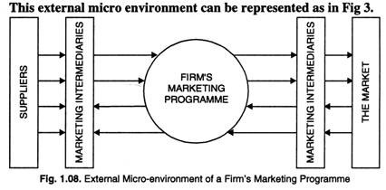](http://cdn.yourarticlelibrary.com/wp-content/uploads/2015/04/clip_image0026.jpg)

#### 1. The Market:

As noted earlier, market really is what marketing is all about how to reach it and serve it profitably and in a socially responsible manner. It goes without saying that market becomes the focus of all the marketing decisions in an organisation.

In this context, a market is a place where buyers and sellers meet, goods and services are offered for sale and transfer of title of the goods takes place.

In other words, market is demand made by a certain group of potential buyers for a good or service. For example, there is a farm market for plastic products.

In this context market is taken as people or organisation with wants to satisfy, money to spend and the willingness to spend. That is market demand for a given good or service taken into account three points people organisation with wants purchasing power their buying behaviour.

#### 2. Suppliers:

The marketing firm cannot sell unless it makes the products or buys it first. Suppliers are crucial to the firm’s success because they supply those products which consumers want from the marketing house. They are crucial because they supply those products what consumers want from the marketing house.

They are crucial because they take the responsibility of understanding consumer’s needs as viewed by selling or marketing firm. Marketing firm cannot sever the relations with suppliers as it cannot do so in case of its customers.

#### 3. Marketing Intermediaries:

Marketing intermediaries are the independent individuals or organisations that directly help in the free flow of goods and services between marketing organisations and its markets. These are basically of two types, namely ‘merchant’ and ‘agent’.

Merchant middlemen can be wholesalers and retailers. While agent middlemen can take five to six forms. These intermediaries render so important services that they cannot be removed and hence, become part and parcel of the system.

[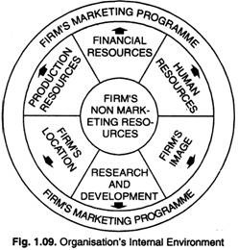](http://cdn.yourarticlelibrary.com/wp-content/uploads/2015/04/clip_image004.jpg)

### Marketing Organisations Internal Environment:

A firm’s marketing system is also shaped by internal forces that are controllable by management. These internal influences include a firms PRODUCTION FINANCIAL and PERSONNEL activities.

If Godrej company is thinking of adding a new brand of toilet soap which already has more than half a dozen brands, it must determine whether existing production facilitates a new brand, and its expertise can be used more fruitfully.

In case new brand needs a new plant and machinery, it gives rise to its financial culpabilities. The other marketing forces are company’s location, its research and development (R & D) strength, and the overall image or stand of the company in the minds of public. This organisation’s internal environment can be represented as under.

Another point which must not be forgotten is that of co-ordination of marketing and non-marketing activities. Sometimes, it is difficult task because of conflicts in goals and executive personalities.

Products people might think of long production runs of standard items while marketing executives may think of wider product line. However, financial executives have tighter credits and expense limits than warranted by other people.

The marketing manager is expected to achieve the present goals of profit maximization to the firm on one hand and enhancement of satisfaction to the class of consumers. These functional goals can be achieved through a kind of internal arrangement or a mechanism or organisation.

It is the manner in which the firm’s marketing activities are organised that decides the degree of success in above-two directions.

Therefore, this chapter plans to cover wide range of organisational aspects such as meaning, need for, the organising process, factors influencing the size of an organisation, criteria for sound organisation and its design, alternative organisational structures and the organisational problems encountered in day-to-day management. The chapter ends with chapter summary and chapter based questions.

**Marketing Segmentation and Consumer behavior**

UNIT- II

**Outline:** Introduction market strategy and consumer behavior; Market Analysis Consumer decision process

**Defining Consumer Behavior:**

Consumer behavior may be defined as the decision process and physical activity individuals engage in when evaluating, acquiring, using, or disposing of goods and services. Several aspects of this statement need emphasis and elaboration so that their meaning can be more fully appreciated.

**Customer and Consumer:**The term customer is typically used to refer to someone who regularly purchases form a particular store or company. Thus a person who shops at Agora or who uses BP petrol is viewed as a customer of these firms. The term consumer more generally refers to any one engaging in any of the activities used in our definition of consumer behavior. Therefore, a customer is defined in terms of a specific firm while a consumer in not.

**The Ultimate Consumer:**Those individuals who purchase for the purpose of individual or household consumption. Some have argued that studying ultimate consumers also reveals much about industrial and intermediate buyers and others involved in purchasing for business firms and institutions. While not denying this, we must recognized that much industrial purchasing behavior is unique because it often involves different buying motives and the influence of a large variety of people. For the sake of simplicity we will focus only on ultimate consume behavior and will not become involved in drawing comparisons with industrial purchasing situations.

**The Individual Buyer**:The most commonly thought of consumer situation is that of an individual making purchase with little or no influence form others. However, in some cases a number of people can be jointly involved in a purchase decision (new car, vacation). People can take different roles in what we have defined as consumer behavior. These roles may be initiator: the individual who determines that some need or want is not being met and authorizes a purchase to rectify the situation; influencer: a person who by some intentional or unintentional word or action influences the purchase decision, the actual purchase, and/or the use of the product or service; buyer: the individual who actually makes the purchase transaction; user: the person most directly involved in the consumption or use of the purchase. Therefore, focusing on the buyer, while allowing for the influence of others on the purchase decision, still gives considerable flexibility while concentrating on one consumer role.

**Need for Study of Consumer Behavior:**

Understanding the reasons for studying a discipline enables one to better appreciate its contributions, therefore, this section presents a justification for the time and effort that the reader will expand in learning about consumers.

(i) Significance in Daily Lives:In a general sense, the most important reason for studying consumer behavior is the significant role it plays in our lives. Much of our time is spent directly in the marketplace, shopping or engaging in other activities. A large amount of additional time is spent thinking about products and services, talking to friends about them, and seeing or hearing advertisements about them. In addition, the goods we purchase and the manner in which we use significantly influence how we live our daily lives. These general concerns alone are enough to justify our study.

(ii) Application to Decision Making:Consumers are often studied because certain decisions are significantly affected by their behavior or expected actions. For this reason, consumer behavior is said to be an applied discipline. Such applications can exist at two different levels of analysis. The micro perspective seeks application of this knowledge to problems faced by the individual firm or organization. The social perspective applies knowledge of consumers to aggregate-level problems faced by large groups or by society as a whole. Understanding consumer behavior form a macro perspective can provide insight into aggregate economic and social trends and can perhaps even predict such trends. In addition, this understanding may suggest ways to increase the efficiency of the market system and improve the well being of people in society.

**Applying Consumer Behavior Knowledge:**

The following sections have been made form a variety of practical applications in the field of consumer behavior. Some involves a societal perspective while others illustrate a micro viewpoint. Together they underscore the importance of understanding consumers for solving a variety of contemporary problems.

(i) Consumer behavior and marketing management:Marketing management is the process of planning and executing the conception, pricing, promotion, and distribution of goods, services, and ideas to create exchanges with target groups that satisfy customer and organizational objectives. A sound understanding of consumer behavior is essential to the long-run success of any marketing program. We need to know consumers’ wants and needs

company objectives and make an integrated strategy to achieve a firm’s objectives though consumer satisfaction.

(a) Market opportunity analysis: this activity involves examining trends and conditions in the marketplace to identify consumers’ need and wants that are not being fully satisfied.

(b) Target market selection: The process of reviewing market opportunities often results in identifying distinct groupings of consumers who have unique wants and needs, and

(c) Marketing mix determination: this stage involves developing and implementing a strategy for an effective combination of want-satisfying features to consumers within target markets (product, price, promotion and place).

(ii) Consumer behavior and nonprofit and social marketing:Can crime prevention, charitable contributions or the concept of family planning be sold to people in much the same way that some business firms sell soap? Very often, nonprofit and social marketing companies appeal to the public for support in addition to attempting to satisfy some wants or need in society. A clear understanding of consume decision process can assist their effort.

(iii) Consumer behavior and governmental decision-making:In recent years the relevance of consumer-behavior principles to governmental decision-making has become quite evident. Two major areas of activity have been affected

(a) government policies that provide services to the public or result in decisions that influence consumer behavior and

(b) the design of legislation to protect consumer or to assist them evaluating products and services.

(iv) Consumer behavior and de-marketing:The term de-marketing refers to such efforts to encourage consumers to reduce their consumption of particular products or services (e. g anti smoking campaign). Various government policies have supported the effort by private enterprise to stimulate the public to greater levels of consumption because of their favorable effect on economic development. However, it has become increasingly clear that we are entering an era of scarcity in terms of some natural resources such as oil, natural gas, and even water. These scarcities have led to promotions stressing conservation rather than consumption.

(v) Consumer behavior and consumer education:Consumers also stand to benefit from orderly investigations of their own behavior. This can occur on an individual basis or as part of more formal educational program. What is learned about consumer behavior can also directly benefit consumers in a more formal sense. The knowledge can serve as data for the development of educational programs designed to improve consumers’ decision-making regarding products and services. Such courses are increasingly popular in higher education, which is based on a clear understanding of the important variables influencing consumers.

Marketing strategyis defined byDavid Aakeras a process that can allow an organization to concentrate its resources on the optimal opportunities with the goals of increasing sales and achieving a sustainablecompetitive advantage.Marketing strategy includes all basic and long-term activities in the field of marketing that deal with the analysis of the strategic initial situation of a company and the formulation, evaluation and selection of marketoriented strategies and therefore contribute to the goals of the company and its marketing objectives.

Marketing strategies serve as the fundamental underpinning ofmarketing plansdesigned to fill market needs and reachmarketingobjectives.Plans and objectives are generally tested for measurable results. Commonly, marketing strategies are developed as multi-year plans, with a tactical plan detailing specific actions to be accomplished in the current year. Time horizons covered by themarketing planvary by company, by industry, and by nation, however, time horizons are becoming shorter as the speed of change in the environment increases.Marketing strategies are dynamic and interactive. They are partially planned and partially unplanned. Seestrategy dynamics. Marketing strategy needs to take a long term view, and tools such ascustomer lifetime valuemodels can be very powerful in helping to simulate the effects of strategy on acquisition, revenue per customer andchurn rate.

Marketing strategy involves careful and precise scanning of the internal and external environments.Internal environmental factors include themarketing mixandmarketing mix modeling, plus performance analysis and strategic constraints.External environmental factors include customer analysis,competitor analysis,target marketanalysis, as well as evaluation of any elements of the technological, economic, cultural or political/legal environment likely to impact success. A key component of marketing strategy is often to keep marketing in line with a company's overarchingmission statement.

Once a thorough environmental scan is complete, astrategic plancan be constructed to identify business alternatives, establish challenging goals, determine the optimal marketing mix to attain these goals, and detail implementation. A final step in developing a marketing strategy is to create a plan to monitor progress and a set of contingencies if problems arise in the implementation of the plan.

Marketing Mix Modelingis often used to help determine the optimal marketing budget and how to allocate across the marketing mix to achieve these strategic goals. Moreover, such models can help allocate spend across a portfolio of brands and manage brands to create value.

### 

**The Consumer Buying Decision Process**

The purchase is only the visible part of a more complex decision process created by the consumer for each buying decision he makes. But what happens before and after this purchase? What are the factors influencing the choice of product purchased by the consumer?

Today, let’s focus on theConsumer Buying Decision Process and the stages that lead a shopper to purchase a new product.

Engel,BlackwellandKollathave developed in 1968 a model of consumer buying decision process in five steps: Problem/need recognition, information search, evaluation of alternatives to meet this need, purchase decision and post-purchase behavior.

**I. Need recognition / Problem recognition :**

The need recognition is the first and most important step in the buying process. If there is no need, there is no purchase. This recognition happens when there is a lag between the consumer’s actual situation and the ideal and desired one.

However, not all the needs end up as a buying behavior. It requires that the lag between the two situations is quite important. But the “way” (product price, ease of acquisition, etc.) to obtain this ideal situation has to be perceived as “acceptable” by the consumer based on the level of importance he attributes to the need.

For example, you have a pool and you would like someone to take care of regularly cleaning it instead of you (ideal situation) because it annoys you to do it yourself (actual situation). But you don’t judge the “way” to reach this ideal situation (pay $250 / month for a specialized company) as “acceptable” because its price to obtain it seems too high. Especially compared to the relatively low level of importance you attach to it. So you won’t have a purchase behavior in this situation.

On the other hand, theability to be able to go to your work by car in 20 minutes every morning (ideal situation) rather than lose three hours in transit because you do not have a car and you live in the countryside (actual situation) is something that means a lot to you. So you will have a buying behavior to purchase a car. Even if the price is important.

In addition to a need resulting from a new element, the gap between the actual situation and the ideal situation may be due to three cases. The current situation has not changed, but the ideal situation has (a neighbor told you about the possibility –that you did not know –to clean the pool by a specialized company). Or, the ideal situation is still the same but it’s

the actual situation has changed (you’re tired of cleaning your pool by yourself). Or finally, the two situations have changed.

The recognition of a need by a consumer can be caused in different ways. Different classifications are used:

∑ Internal stimuli(physiological need felt by the individual as hunger or thirst) which opposes theexternal stimulisuch as exposure to an advertisement, the sight of a pretty dress in a shop window or the mouth-watering smell of a french “pain au chocolat” when passing by a bakery.

∑ Classification by type of needs: o Functional need: the need is related to a feature or specific functions of the product or happens to be the answer to a functional problem. Like a computer with a more powerful video card to be able to play the latest video games or a washing machine that responds to the need to have clean clothes while avoiding having to do it by hand or go tothe laundromat. o Social need: the need comes from a desire for integration and belongingness in the social environment or for social recognition. Like buying a new fashionable bag to look good at school or choose a luxury car to “show” that you are successful in life. o Need for change: the needhas its origin in a desire from the consumer to change. This may result in the purchase of a new coat or new furniture to change thedecoration of your apartment.

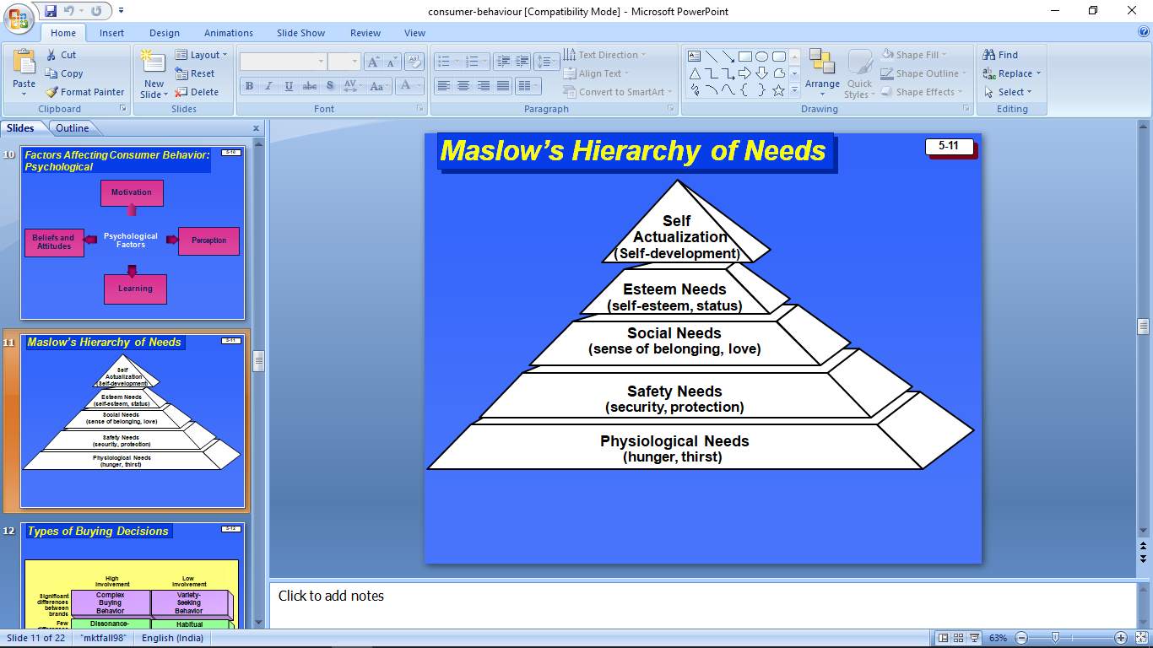

∑ TheMaslow’s hierarchy of needs: Developed by the eponymous psychologist, this is one the best known and widely used classifications and representations for hierarchy of needs. It specifies that an individual is “guided” by certain needs that he wants to achieve before seeking to focus on the following ones: o 1. Physiological needs o 2. Safety needs o 3. Need of love and belonging o 4. Need of esteem (for oneself and from the others) o 5. Need of self-actualization

**II. Information search**

Once the need is identified, it’s time for the consumer to seek information about possible solutions to the problem. He willsearch more or less information depending on the complexity of the choices to be made but also his level of involvement. (Buying pasta requires little information and involves fewer consumers than buying a car.)

Then the consumer will seek to make his opinion to guide his choice and his decision making with:

Internal information: this information is already present in the consumer’s memory. It comes from previous experiences he had with a product or brand and the opinion he may have of the brand.

Internal information is sufficient for the purchasing of everyday products that the consumer knows – including Fast-Moving Consumer Goods (FMCG) or Consumer Packaged Goods (CPG). But when it comes to a major purchase with a level of uncertainty or stronger involvement and the consumer does not have enough information, he must turns to another source:

∑ External information: This is information on a product or brand received from and obtained by friends or family, by reviews from other consumers or from the press. Not to mention, of course, official business sources such as an advertising or a seller’s speech.

During his decision-making process and his Consumer Buying Decision Process, the consumer will pay more attention to his internal information and the information from friends, family or other consumers. It will be judged more “objective” than these from an advertising, aseller’s speech or a commercial brochure of the product.

**III. Alternative evaluation**

Once the information collected, the consumer will be able to evaluate the different alternatives that offer to him, evaluate the most suitable to his needs and choose the one he think it’s best for him.

In order to do so, he will evaluate their attributes on two aspects. The objectivecharacteristics (such as the features and functionality of the product) but also subjective (perception andperceived valueof the brand by the consumer or its reputation).

Each consumer does not attribute the same importance to each attribute for his decision and his Consumer Buying Decision Process. And it varies from one shopper to another. Mr. Smith may prefer a product for the reputation of the brand X rather than a little more powerful but less known product. While Mrs. Johnson has a very bad perception of that same brand.

The consumer will then use the information previously collected and his perception or image of a brand to establish a set of evaluation criteria, desirable or wanted features,

classify the different products available and evaluate which alternative has the most chance to satisfy him.

The process will then lead to what is called “evoked set”. “The evoked set” (aka “consideration set”) is the set of brands or products with a probability of being purchased by the consumer (because he has a good image of it or the information collected is positive).

On the other hand, “inept set” is the set of brands or products that have no chance of being purchased by the shopper (because he has a negative perception or has had a negative buying experience with the product in the past). While “inert set” is the set of brands or products for which the consumer has no specificopinion.

The higher the level of involvement of the consumer and the importance of the purchase are stronger, the higher the number of solutions the consumer will consider will be important. On the opposite, the number of considered solutions will bemuchsmaller for an everyday product or a regular purchase.

**IV. Purchase decision**

Now that the consumer has evaluated the different solutions and products available for respond to his need, he will be able to choose the product or brand that seems most appropriate to his needs. Then proceed to the actual purchase itself.

His decision will depend on the information and the selection made in the previous step based on the perceived value, product’s features and capabilities that are important to him.

But hisConsumer Buying Decision Process and his decision process may also depend or be affected by such things as the quality of his shopping experience or of the store (or online shopping website), the availability of a promotion, a return policy or goodterms and conditions for the sale.

For example, a consumer committed to the idea of buying a stereo of a well-known brand could change his decision if he has an unpleasant experience with sellers in the store. While a promotion in a supermarket for a yogurt brand couldtip the scale for this brand in the consumer’s mind who was hesitating between three brands of his “evoked set”.

**V. Post-purchase behavior**

Once the product is purchased and used, the consumer will evaluate the adequacy with his original needs (those who caused the buying behavior). And whether he has made the right choice in buying this product or not. He will feel either a sense of satisfaction for the

product (and the choice). Or, on the contrary, a disappointment if the product has fallen far short of expectations.

An opinion that will influence his future decisions and buying behavior. If the product has brought satisfaction to the consumer, he will thenminimize stages of information search and alternative evaluation for his next purchases in order to buy the same brand. Which will produce customer loyalty.

On the other hand, if the experience with the product was average or disappointing, the consumer is going to repeat the 5 stages of theConsumer Buying Decision Process during his next purchasebut by excluding the brand from his “evoked set”.

The post-purchase evaluation may have important consequences for a brand. A satisfied customer is very likely to become a loyal and regular customer. Especially for everyday purchases with low level of involvement –such as Fast-Moving Consumer Goods (FMCG) or Consumer Packaged Goods (CPG). A loyalty which is a major source of revenue for the brand when you combine all purchases made by customer throughout his entire life (called “lifetime customer value”). The “Holy Grail” that all brands in the industry are trying to achieve.

Positive or negative, consumers will also be able to share their opinion on the brand. Whether in their family or by word-of-mouth. Or on a much broader scale now with social networks or on consumer product review websites. A tendency not to be overlooked because now with the Internet, an unhappy customer can have a strong power to harm for a brand.

That’s why that’s important for companies tohave awareness of that matter. In additionto optimizing the customer experience, a guarantee (for example, for a washing machine), an efficient customer service and a specific call center are some of the assets that can be developed to improve post-purchase behavior if there is any trouble with the product.

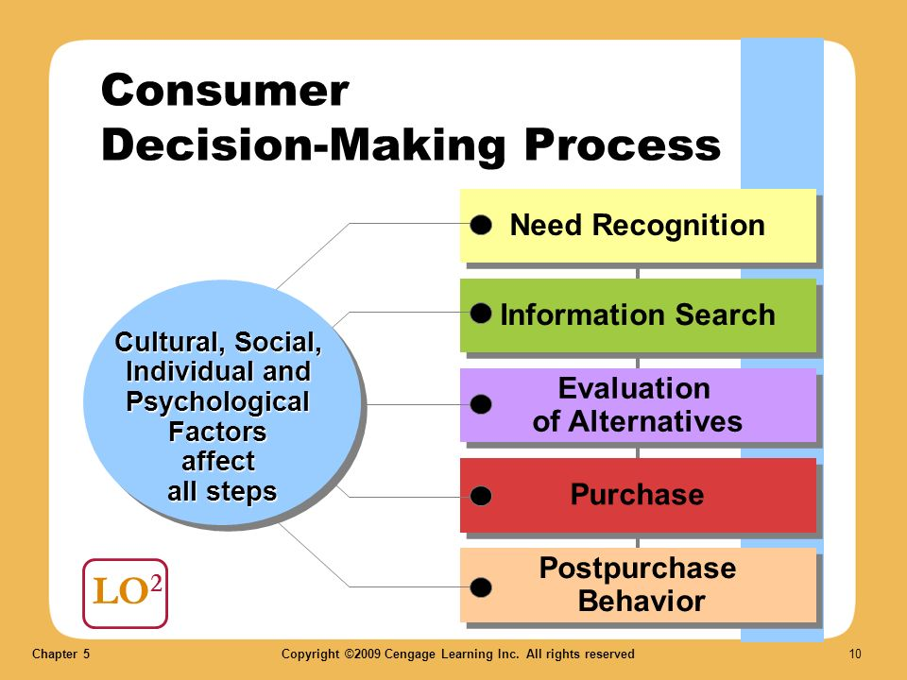

**An example of Consumer Buying Decision Process**

Nothing like a real example to better understand the five stages of the Consumer Buying Decision Process. Maybe this situation sounds familiar to you.

**Stage 1** – Need recognition:It’s Sunday night. You’re hungry (internal physiological stimuli) and there is nothing in the fridge. You will order food (statement of need).

**Stage 2** – Information search: You already have ordered to the Indian restaurant in your street last month (internal information). A friend recommended a pizzeria in your

neighborhood (external information from environment). And this morning you’ve found a flyer for a sushi restaurant in your mailbox (external information from advertising).

**Stage 3** – Alternative evaluation:You have a bad opinion of the Indian restaurant since you’ve been sick the last time (inept set). The pizzeria is both recommended by your friend and also happens to be a well-known brand (positive perception – evoked set). As for the sushi restaurant, it got good reviews on TripAdvisor(positive perception –evoked set).

**Stage 4** – Purchase decision: After evaluating the possibilities, you’ve decided to choose the well-known pizza delivery chain. In addition, a new episode of your favorite TV show is broadcasted tonight on TV.

**Stage 5** – Post-purchase behavior:The pizza was good (positive review). But you know there was too many calories and you regret a little bit (mixed feelings about yourself). The next time you will choose the sushi restaurant. There is less fat in sushi than pizza (next purchase behavior)!

Understand the Consumer Buying Decision Process in order to adapt your marketing strategy

By improving their knowledge of the Consumer Buying Decision Process, brands can improve their marketing strategy to effectively respond and be present with their customers at each stage of their buying behavior. And thus raise and create a need, strengthen their relationship with their customers and grow their sales.

It always starts with a recognition of a need!

The start of the buying behavior of the consumer is the need recognition. If there is no need, there is no purchase! That’s why generate or reinforce a need in consumers’ mind to trigger the buying behavior has a fundamental importance for brands.

Steve Jobs had become a master in the area with Apple thanks to remarquable marketing campaigns by successfully creating a need for millions of consumers for products they had never thought before. But have finally become an important part of their daily lives.

In a different field, TV infomercials are remarkable examples of how to create an unexpected need in a consumer’s mind for a new product. You probably never felt any difficulty to cook a salad, but while watching the introduction of thisgreat infomercial for this new kitchen tool, you finally realize the difficulty of the task and the importance of this new product as a solution to this problem.

Brands must focus on the activation or recall of a need – whether physiological, functional, social or change-related – for the consumer through their advertising campaigns. An even stronger challenge for new products, those with new features or those on new segments that consumers ignore the need or interest.

Brand awareness for everyday purchases is crucial

For everyday purchases with low level of involvement, consumers will consider only a limited number of brands when making their choice. Those that come in head first or they know at least by name. This is called “Top-of-mind awareness (TOPA)”.

For brands of the Fast-Moving Consumer Goods (FMCG) or Consumer Packaged Goods (CPG) industry, branding and brand awareness can therefore be a real factor of influence of the consumer buying decision process. Especially for products with a low level of differentiation.

Provide concrete information for the alternative evaluation

During the “alternative evaluation” stage of the Consumer Buying Decision Process, consumers are looking for solid, reliable and tangible information that will allow them to make their choice. Especially for purchasing and products with high level of involvement.

The brand’s interest is to provide concrete information and proof of the product features, its added value compared to its competitors and how it will respond to their need in order to provide consumers with the information they need and positive influence in their decision making process.

Improve the shopping experience and customer relationships

As we saw in previous section, the stage of post-purchase behavior can have important consequences for a brand. Positively or negatively.

To avoid reputation damage and to develop a lasting relationship with its customers, the brand’s interest is to multiply actions for optimizing the shopping experience in-store as well as the product experience. But also provide great customer service in case of dissatisfaction or issue with the product.

### MARKET SEGMENTATION

“The purpose of market segmentation is to determine difference among buyers which may be consequential in choosing among them or marketing to them.”

**Philip Kotler**

The modern marketing is customer – oriented. All marketing activities revolved around the customer. In order to achieve the marketing objectives, it is very necessary to have a clear picture of the customer’s characteristics, which are not a like.

Two consumers of the same commodity are never in conformity with each other as far as their nature, habits, taste or interests, income, age, mode of purchasing or other attitudes are concerned.

Such markets can be segmented. On the basis of characteristics of customers such as age, income sex religion etc. or on the basis of geographical area such as urban or rural markets, national, international or local markets etc or on the basic of psychographic or personality factors or on the basic of consumers behavior.

### Importance of market segmentation

The market segmentation affords the following advantages to the seller or producer: -

1. Adjustment of product and marketing appeals – Market segmentation presents an opportunity to understand the nature of the market. The seller can adjust his thrust to attract the maximum number of customers by various publicity media and appeals. More resources may be allocated to market segments where sales opportunities are better.
2. Better position to sport marketing opportunities – The producer can make a fair estimate of the volume of his sale and the possibilities of furthering his sales. In the regions where response of the customers is poor. The strategy of approach can be readjusted according to push the sales on the basis marketing research.
3. Allocation of marketing budget – It is on the basis of market segmentation that marketing budget is adjusted for a particular region or locality. In the place where the sales opportunities are limited, it is no use allocation a huge budget there.
4. Making the competition effectively – It helps the produce to face the competition of his rivals effectively. The produces can adopt different policies, programmes and strategies for different markets taking into account the rivals strategy policies and programmes.
5. Effective marketing programme: - It also helps the producer to adopt an effective marketing programme and serve the consumer better at comparatively low cost. Different marketing programmes can be attached for different segments.
6. Evaluation of marketing Activities: - Thus market segmentation helps the manufacturer to find out and compare the market potentialities of the product. It helps to adjust production and using his resources in the most profitable manner. As soon as the product becomes obsolete, the product line could be diversified or discontinued.
7. Increase in sales volume: - By segmenting, the market, the producer can increase his sales volume. As we know, each segment has different demand pattern and the producer satisfies the demand of each segment, by improving his product. Customer is also benefited by the market segmentation as the producer produces and supplies the goods, which serve their interest and satisfy their needs and wants.

### CRITERIA FOR MARKET SEGMENTATION

There may be several criteria or bases for market segmentation. The bases may differ from product to product because the sensitivity of customers differs.

Bases for consumer product Bases for Industrial produce.

1. Income of the consumer kinds of business.
2. Age of the consumer usual purchasing procedure.
3. Degree of urbanization of the size of user consumer.
4. Geographical market Geographical markets segmentation.
5. Sex of the consumer.
6. Educational attainment of the consumer.
7. Religion of the consumer.

MARKET AGGREGATION

Buyer’s behaviour is never the same and the market could be segmented on the basis of buyer’s characteristics. The producer must understand the behaviour of his customers and adopt different strategies according to the needs and characteristics of his customers. So that physical and human resources of the enterprise may be fully exploited and marketing objectives may be fully met. There are three types of marketing strategies.

1. **Market Aggregation or undifferentiated marketing strategy:** - Market aggregation is just the opposite of segmentation. Aggregation implies the policy of limping together into one mass of all the markets for the product. Under this concept management having only one product considers the entire buyers as one group.

When the economics of organizations do not permit the division of market into segments they conceive the total market concept. In the case of fully standardized product and where substitutes are not available differentiation need not to be undertaken.

Advantages – a firm adopting this strategy (i) can produce and sell its product on large scale and can get large-scale economics (ii) the firm can make use of standardization specialization and division of labor, (iii) the firm can utilize its resources to the maximum.

Disadvantages – The drawbacks of this strategy are

1. This is a product – oriented (and not a customer – oriented) strategy
2. The effectiveness of the strategy is doubtful in consumer-oriented market.
3. This strategy is successful only in short – run.
4. **Market segmentation or differentiated marketing strategy:** - Under this strategy, the firm groups the buyers on the basis of their common needs and desires. It differentiates one group from the other on the basis of their needs, region, characteristics, personality or behaviour. In other words, the classification of markets based on consumers characteristics is called market segmentation market segmentation is the process of taking the total heterogeneous markets or segments each of which tends to be homogeneous in all significants.

Advantages of Differentiated marketing strategy –

The differentiated marketing strategy offers the following advantages: -

(i) It is a consumer oriented market stress is laid on the needs of different types o customer, (ii) If attracts a large number of customer from all corners.

(iii) It increases sales and profits of the enterprise.

Disadvantages of Differented marketing strategy - It draw backs are:

* 1. Different types of products are to be produced for different segments of the market to satisfy the needs of the customers.
  2. It requires intensive marketing research.
  3. Different marketing programmes and strategies are require for different segments of the market.
  4. It increases the overall cost of the product because it increases the cost of research, product planning and development, physical distribution, advertising and sales promotion substantially.

1. **Concentrated marketing strategy:** - Both the concepts of undifferentiated marketing and differentiated marketing imply the approach of total market. Another option is to have concentrated efforts in a few markets capable of opportunities.

Advantages of concentrating marketing strategy: - It offers the following advantages –

* 1. It concentrates its efforts in certain markets to gain good position,
  2. It provides best possible satisfaction of customers of selected segments.
  3. It makes full exploitation of resources.
  4. It reduced cost of production and administration substantially.

Disadvantages: - The disadvantages of this strategy are: -

(i) It is risky because if a wrong segment is selected, the very existence of the firm is endangered.

(ii) It increases the possibilities of competition.

**Elements of Market segmentation:** -

The basic elements that influences in deciding the principle of segmentation are: -

1. Company Resources: - Market segmentation involves heavy expenditure in implementing it. It is not a mere blueprint in paper. Unless the company has got enough resources market segmentation cannot be undertaken at all.
2. Products characteristics – Most products are hetrogene in character but some other products show homogeneity. In the case of former type, market differentiated strategy is adopted but in the latter case the necessity of segmentation is disputed. Salt, kerosene etc come under this group of articles and in their case undifferentiated marketing is to select.
3. Position of the products in the product life cycle - The various stages of a product cycle viz. introduction, growth, maturity, saturation and decline have to be taken into consideration. In the first and last stages markets segmentation is meaningless and therefore undifferentiated marketing strategy should be selected. Differentiated strategy would be in the interest of the company at the stages of maturity and saturation.
4. Homogeneous Nature of market – When the market is of a homogeneous nature there is not much use of segmentation. Proper segmentation of market is required only when the customer preferences very from group to group.
5. Competitive marketing strategies – Sometimes it becomes quite necessary to fall in line with the competitor’s activity of market segmentation. Similar arrangements by competitors have to be made to meet the competition effectively.
6. Government policy: - Government policy also affects the decision of adopting marketing strategy. When government interferes, it is better to adopt the strategy, which suits government orders. In case, government does not interfere, differentiated or undifferentiated strategy may be selected.

**Components of a marketing information system**

A marketing information system (MIS) is intended to bring together disparate items of data into a coherent body of information. An MIS is, as will shortly be seen, more than raw data or information suitable for the purposes of decision making. An MIS also provides methods for interpreting the information the MIS provides. Moreover, as Kotler's1 definition says, an MIS is more than a system of data collection or a set of information technologies:

"A marketing information system is a continuing and interacting structure of people, equipment and procedures to gather, sort, analyse, evaluate, and distribute pertinent, timely and accurate information for use by marketing decision makers to improve their marketing planning, implementation, and control".

Figure 9.1 illustrates the major components of an MIS, the environmental factors monitored by the system and the types of marketing decision which the MIS seeks to underpin.

**Figure 9.1 The marketing information systems and its subsystems**

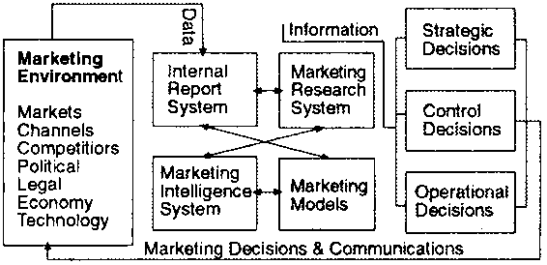

The explanation of this model of an MIS begins with a description of each of its four main constituent parts: the internal reporting systems, marketing research system, marketing intelligence system and marketing models. It is suggested that whilst the MIS varies in its degree of sophistication - with many in the industrialised countries being computerised and few in the developing countries being so - a fully fledged MIS should have these components, the methods (and technologies) of collection, storing, retrieving and processing data notwithstanding.

**Internal reporting systems:**All enterprises which have been in operation for any period of time nave a wealth of information. However, this information often remains under-utilised because it is compartmentalised, either in the form of an individual entrepreneur or in the functional departments of larger businesses. That is, information is usually categorised according to its nature so that there are, for example, financial, production, manpower, marketing, stockholding and logistical data. Often the entrepreneur, or various personnel working in the functional departments holding these pieces of data, do not see how it could help decision makers in other functional areas. Similarly, decision makers can fail to appreciate how information from other functional areas might help them and therefore do not request it.

The internal records that are of immediate value to marketing decisions are: orders received, stockholdings and sales invoices. These are but a few of the internal records that can be used by marketing managers, but even this small set of records is capable of generating a great deal of information. Below, is a list of some of the information that can be derived from sales invoices.

· Product type, size and pack type by territory  
· Product type, size and pack type by type of account  
· Product type, size and pack type by industry  
· Product type, size and pack type by customer  
· Average value and/or volume of sale by territory  
· Average value and/or volume of sale by type of account  
· Average value and/or volume of sale by industry  
· Average value and/or volume of sale by sales person

By comparing orders received with invoices an enterprise can establish the extent to which it is providing an acceptable level of customer service. In the same way, comparing stockholding records with orders received helps an enterprise ascertain whether its stocks are in line with current demand patterns.

**Marketing research systems:** The general topic of marketing research has been the prime ' subject of the textbook and only a little more needs to be added here. Marketing research is a proactive search for information. That is, the enterprise which commissions these studies does so to solve a perceived marketing problem. In many cases, data is collected in a purposeful way to address a well-defined problem (or a problem which can be defined and solved within the course of the study). The other form of marketing research centres not around a specific marketing problem but is an attempt to continuously monitor the marketing environment. These monitoring or tracking exercises are continuous marketing research studies, often involving panels of farmers, consumers or distributors from which the same data is collected at regular intervals. Whilst the *ad hoc* study and continuous marketing research differs in the orientation, yet they are both proactive.

**Marketing intelligence systems:** Whereas marketing research is focused, market intelligence is not. A marketing intelligence system is a set of procedures and data sources used by marketing managers to sift information from the environment that they can use in their decision making. This scanning of the economic and business environment can be undertaken in a variety of ways, including2

|  |  |
| --- | --- |
| Unfocused scanning | The manager, by virtue of what he/she reads, hears and watches exposes him/herself to information that may prove useful. Whilst the behaviour is unfocused and the manager has no specific purpose in mind, it is not unintentional |
|  |  |
| Semi-focused scanning | Again, the manager is not in search of particular pieces of information that he/she is actively searching but does narrow the range of media that is scanned. For instance, the manager may focus more on economic and business publications, broadcasts etc. and pay less attention to political, scientific or technological media. |
|  |  |
| Informal search | This describes the situation where a fairly limited and unstructured attempt is made to obtain information for a specific purpose. For example, the marketing manager of a firm considering entering the business of importing frozen fish from a neighbouring country may make informal inquiries as to prices and demand levels of frozen and fresh fish. There would be little structure to this search with the manager making inquiries with traders he/she happens to encounter as well as with other *ad hoc*contacts in ministries, international aid agencies, with trade associations, importers/exporters etc. |
|  |  |
| Formal search | This is a purposeful search after information in some systematic way. The information will be required to address a specific issue. Whilst this sort of activity may seem to share the characteristics of marketing research it is carried out by the manager him/herself rather than a professional researcher. Moreover, the scope of the search is likely to be narrow in scope and far less intensive than marketing research |

Marketing intelligence is the province of entrepreneurs and senior managers within an agribusiness. It involves them in scanning newspaper trade magazines, business journals and reports, economic forecasts and other media. In addition it involves management in talking to producers, suppliers and customers, as well as to competitors. Nonetheless, it is a largely informal process of observing and conversing.

Some enterprises will approach marketing intelligence gathering in a more deliberate fashion and will train its sales force, after-sales personnel and district/area managers to take cognisance of competitors' actions, customer complaints and requests and distributor problems. Enterprises with vision will also encourage intermediaries, such as collectors, retailers, traders and other middlemen to be proactive in conveying market intelligence back to them.

**Marketing models:**Within the MIS there has to be the means of interpreting information in order to give direction to decision. These models may be computerised or may not. Typical tools are:

· Time series sales modes  
· Brand switching models  
· Linear programming  
· Elasticity models (price, incomes, demand, supply, etc.)  
· Regression and correlation models  
· Analysis of Variance (ANOVA) models  
· Sensitivity analysis  
· Discounted cash flow  
· Spreadsheet 'what if models

These and similar mathematical, statistical, econometric and financial models are the analytical subsystem of the MIS. A relatively modest investment in a desktop computer is enough to allow an enterprise to automate the analysis of its data. Some of the models used are stochastic, i.e. those containing a probabilistic element whereas others are deterministic models where chance plays no part. Brand switching models are stochastic since these express brand choices in probabilities whereas linear programming is deterministic in that the relationships between variables are expressed in exact mathematical terms.

**Chapter Summary**

Marketing information systems are intended to support management decision making. Management has five distinct functions and each requires support from an MIS. These are: planning, organising, coordinating, decisions and controlling.

Information systems have to be designed to meet the way in which managers tend to work. Research suggests that a manager continually addresses a large variety of tasks and is able to spend relatively brief periods on each of these. Given the nature of the work, managers tend to rely upon information that is timely and verbal (because this can be assimilated quickly), even if this is likely to be less accurate then more formal and complex information systems.

Managers play at least three separate roles: interpersonal, informational and decisional. MIS, in electronic form or otherwise, can support these roles in varying degrees. MIS has less to contribute in the case of a manager's informational role than for the other two.

Three levels of decision making can be distinguished from one another: strategic, control (or tactical) and operational. Again, MIS has to support each level. Strategic decisions are characteristically one-off situations. Strategic decisions have implications for changing the structure of an organisation and therefore the MIS must provide information which is precise and accurate. Control decisions deal with broad policy issues and operational decisions concern the management of the organisation's marketing mix.

A marketing information system has four components: the internal reporting system, the marketing research systems, the marketing intelligence system and marketing models. Internal reports include orders received, inventory records and sales invoices. Marketing research takes the form of purposeful studies either *ad hoc* or continuous. By contrast, marketing intelligence is less specific in its purposes, is chiefly carried out in an informal manner and by managers themselves rather than by professional marketing researchers.

**UNIT-3**

**NEW PRODUCT PLANNING AND DEVELOPMENT**

**Learning Objectives**

After reading the lesson, you should be able to understand –

Define the new product and understand the need for new product development.

The steps in the new product development process;

The product modification and elimination process;

The concept and various stages of Product Life Cycle (PLC).

The products and services are the most visible assets of the organizations and the new products are, hence considered to be the corner stone of the long term survival and prosperity of many organizations. The rapid technological changes, shifting patterns of world market opportunities and the intense competition compel the business firms to continuously develop new products and services for their survival. But failure too in new product development is not uncommon. Apparently, new product development is an unstable activity, inherent in most organizations. But when market conditions pressurize there is no other go except to take the risk of introducing new products.

**NEW PRODUCTS DEFINITION**

Defining a new product is not a simple task. In an absolute sense, it is something new which has not existed before. When considered in a relative sense, it is something new which has not been experience before and perceived as new. In defining new products, the relative view is considered more useful because whether or not something is absolutely new, the interested persons who have not yet experienced it may represent opportunities or problems for consideration.

Thus, a new product is a multi-dimensional concept that has need satisfying capabilities for the stockholders interested in it and which has not been experienced by a significant number of them; but capable of offering a strategic competitive advantage. It means a major opportunity for an organization to create value. Although there is numerous perspective from which one could define a new product, the following definitions are worth to be noted.

Musselman and Jackson states that a product is said to be a New Product when it serves an entirely new function or makes a major improvement in a present function.

According to Stanton, new products are those which are really innovative and truly unique replacements for existing products that are significantly different from the existing goods and includes initiative products that are new to a company but not new to the market. If the buyers perceive that a given item is significantly different from competitive goods being replaced with some new features, like appearance or performance, then it is a new product.

For Kotler, new product mean original products, improved products, modified products and new brands which are develope

d by the firm through its own research and development ef

forts and includes those products which the consumers see as new.

A new product is thus perceived differently by different people. It is a need satisfying concept with benefit for buyers bundle of need satisfying features; for marketers, a way to add value; for intermediaries, an opportunity to design; for R&D and to assemble and process for production department.

New product development is one for the most important components of product policy and product management. It is not enough if the existing product lines and products are appraised properly, positioned effectively and brand decisions taken wisely. What is required, besides all these things, is that the organisation has to consider new product develop9ejmnt for the organization’s growth, ‘Innovate or die’, thus goes and old saying. This is especially true in marketing. Unless the organisatoins innovate and introduce new products, it cannot survive in the competitive market. In many cases the entire business strategies defining an organization’s future are built upon the portfolio of new products. New products are, therefore, the basis for following strategic reasons:

**NEED FOR NEW PRODUCT DEVELOPMENT**

The following are the strategic reasons for launching new products:

New products meet the changes in consumer demands.

New products are the source of competitive advantage.

They provide ling-term financial return on investment.

They utilize the existing production and operation resources to an optimum level.

They capitalize on research and development.

They provide opportunities for reinforcing or changing strategic direction.

They leverage marketing/brand equity.

They enhance corporate image

They affect human resources.

They meet environmental threats.

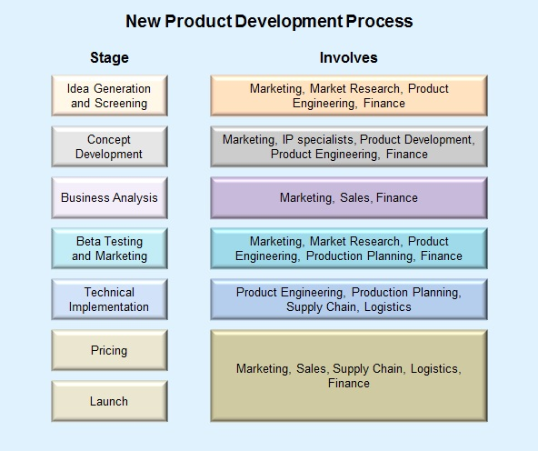

**Figure: New Product Development Process**

**STEPS IN THE NEW PRODUCT DEVELOPMENT PROCESS**

1. Generation of New Product Ideas

1. Screening of Ideas
2. Concept Development and Testing
3. Marketing Strategy Development
4. Business Analysis
5. Development of the Product
6. Market Testing
7. Commercialization

**1. GENERATION OF NEW PRODUCT IDEAS**

The new product development process starts with the search for ideas. An idea \is the highest form of abstraction of a new product. It is usually represented as a descriptive statement, written or verbalized. Generally, more the number of ideas, the better.

The objective of this stage is to obtain

(a) ideas for new products,

(b)new attribute for the existing products, and

(c)new uses of the existing products.

**Sources of New Product Ideas**

Major sources of new product ideas include sources, customer competitors, distributors and suppliers, and others.

**Internal Sources:**

One study found that more than 55 percent of all new-product ideas come from within the company. The company can find new ideas through formal research and development. It can get ideas from its scientists, engineers and manufacturing people. The company’s sales people are anther good source because they are in daily contact with customers.

**Customers:**

Almost 28 percent of all new-product ideas come from watching and listening to customers. The company can duct surveys or focus groups to learn about consumer needs and wants. The company can analyses customer problems. Companies can learn a great deal from observing and listening to customers. Finally, consumers often create new products on their own; and companies can benefits by finding these products and putting them on to the market.

**Competitors:**

Abort 30 percent of new-product ideas come from analyzing competitor’s products. The company can watch competitors’ advertisements and other and other communications to get clues about their new products. Companies buy competing new products, take them apart to see how they work, analyze their sales, and decide whether the company should bring out a new product of its own.

**Distributors, Suppliers and Others:**

Reseller are close to the market and can pass along information about consumer problems and new-product possibilities. Suppliers can tell the company about new concepts, techniques and materials that can be used to develop new products. Other idea sources include trade magazines, shows and seminars; government agencies; new-product consultants;

advertising agencies; marketing research firms; university and commercial labouratories.

**Idea Generating Techniques**

***SWOT Analysis***: It is the analysis of the strength, weakness,opportunities and threats. Through SWOT analysis a company can make a conscious, deliberate, and systematic effort to identify opportunities that can be profitability exploited. Regular SWOT analysis facilitators the generations of ideas.

***Clear Articulating of Objectives***: Top management should define theproducts and markets to emphasize and by stating the operational objectives clearly, it can channelize the efforts of employees and induce them to think more imaginatively. There should be clear articulation and prioritization of objectives to facilitate this.

***Forced Relationships***: By this technique several objects are listed andconsidered in relation to each other. For example, a sofa and a bed, two separate products are combined

into one, by removing the arms of a sofa and making the back collapsible, to form a sofa-cum-bed, fulfilling a felt need of using furniture in a limited space.

***Morphological Analysis***; The morphological analysis willsystematically explore the structural dimensions of a problem its basic parameters and all the known alternative means

of fulfilling them.

***Need/Problem Analysis***: This technique differ from the precedingones in that they require consumer input to generate ideas. Here, the consumers are approached to find out their needs, problems and ideas with reference to a particular product or project category.

***Brainstorming***: Brainstorming is an activity designed to providemaximum opportunity for the emergence of new and creative ides, approaches and solutions to particular problems.

***Synetics***: It is an operational theory for the conscious use ofpreconscious psychological mechanisms present in man’s creative activity and is particularly useful in the idea generation stage for new product development.

***Lateral Thinking***: According to De Bono, lateral thinking is a way ofusing he mind, a deliberate process, a general attitude which may make use of certain techniques on occasion. The most basic principle of lateral thinking is that nay particular way of looking at things in only one form among many other possible ways. Lateral thinking is considered with exploring other ways by restructuring and re-arranging the information that is available.

***Check Lists***: Literally, it is a list of factors or actins which should beconsidered or implemented in performing a predefined task such as launching a new product.

**2. SCREENING IDEAS**

The purpose of idea generation is to create a large number of ideas. The purpose of screening is to reduce that number. The first idea-reducing stage is ideas screening. The purpose of screening is to spot good ideas and drop poor ones as soon as possible.

In this stage managers use their knowledge and experience to weed out the poor ideas and will eliminate those ideas which are inconsistent with the firm’s product policies and objectives, existing skills and resources and so on. In he same way, ideas which are incompatible with the firm’s existing markets and customers are likely to be screened out.

To reduce the number of such ideas to an attractive, practicable level, some kind of preliminary screening is required. Towards this, the following aspects have to be looked into:

Compatibility with the promoter

Consistency with governmental priorities

Availability of inputs

Adequacy of markets

Reasonableness of cost

Acceptability of risk level

**Compatibility with the Promoter**

The idea being reviewed must be consonant with the interest, personality and resources of the firm. It should conform to the objectives and goals of the firm and should be accessible. Besides, it should offer the prospect of rapid growth and high return on invested capital.

**Consistency with Governmental Priorities**

The operationalizations of the idea must be feasible within the government policies and regulatory framework. It should be ascertained that the idea does not contravene the environment

al efforts or the government and that the idea can be pursued by obtaining necessary license and that the foreign exchange requirements, if any, can be met with.

**Availability of inputs**

The firm must be reasonably assured of the availability of resources and inputs required. The organisation must assess whether the capital requirements are within manageable limits and that the technical know-how required for the pursuance of the idea is obtainable. The organization should also assess the availability of raw materials domestically or if it is to be imported, will there be any problems. Availability of required power supply also has to be ascertained.

**Adequacy of the market**

The organization must decide whether the present market size offers the prospect of adequate sale volume. There must be a potential for growth and a reasonable return on investment.

**Reasonableness of Cost**

The cost structure of the proposal product must enable to realize an acceptable profit with a competitive price. In this regard, the organisation should examine the costs of material inputs, labour costs, factory overheads, general administration expenses, selling and distribution costs, service costs and economics of scale.

**Acceptability of Risk Level**

The desirability of an ideas is critically dependent on the risk characterizing it. While assessing the risk, the organization should consider the vulnerability to business cycles, technological changes, competition from substitutes, competition from imports and Governmental control over price and distribution.

1. **CONCEPT DEVELOPMENT AND TESTING**

**Concept Development**

An attribute idea must be develop d into a product concept. A product concept is distinguished form a product idea and product image. While a product idea is a possible product that the company might offer to the market, its elaborated version expressed in meaningful customer terms is a product concept. Product image is the particular picture of an actual or potential product perceived by the consumers.

At this stage, it is important to define the boundaries of the concept rather than the details. The target market, customers, their applications, major technical requirement etc. have to be defined and issues like these are addressed in a concept level business plan. The new product concept,

more specific in description than an idea, should include the customer, the major consumer benefits and features defining the new product.

The manger’s task is to develop the new product into alternative product concepts, find out how attractive each concept is to customers, and choose the best one. The new product concept can be verbal or written description. It may be in the form of a picture, diagram, model, or appear in another suitable presentation format which depicts the idea. Ideas and concepts are often combined and are considered to be part of one creative process.

**Concept Testing:**

Concept testing calls for testing new-product concepts with groups of target consumers. The concept maybe presented to consuer symbolically or physically. For some concept tests, a word or picture description might be sufficient. However, a more concrete and physical presentation of the concept will increase the reliability of the concept.

**Objectives of Concept Testing**

The major objectives of concept testing are:

1. To get the reaction of consumer’s views of the new product idea.
2. To give direction regarding the development of the project.

1. To choose the most promising concepts for development and
2. To ascertain whether the product in question has adequate potential for its commercialization.

Today, marketers are finding innovative ways to make product concepts more real to concept-test subjects. Customer feed back can be critical in providing insights into how potential customers will use and evaluate the new product.

1. **Marketing strategy development**

After developing and testing the new product concept, a new product manager should proceed to develop a marketing strategy plan for introducing the product into the market.

The marketing strategy statement consists of three parts:

The first part describes the size, structure and behave our of the target market, the planned product positioning and the sales, market share and profit goals sought in the first three years.

The second part outlines the product’s planned price, distribution strategy and marketing budget for the first year.

The third part describes the planned long-run sales and profit goals and marketing-mix strategy over time.

**5. BUSINESS ANALYSIS**

Business analysis is a stage where a new product idea is subjected to more sophisticated and detailed analysis. It involves a review of the sales, costs and profit projections for a new product to find out whether they satisfy the co0mpany’s objectives. If they do, the product can move to the product-development stage.

In a majority of new product development processes, three major interrelated questions emerge. They are regarding.

1. The estimate size and growth rate of the market segment, that is, the market opportunity for the new product concept.
2. The estimate sales and market share for the new product concept in the selected market or market segment.
3. The values of the new product program in terms of its expected financial performance.

Apparently these imply three types of new product forecasting, viz., market opportunity forecasting, sales forecasting and financial forecasting. These forecasting processes address different sets of problems and their forecasts must be integrated to provide a complete picture of the commercial viability of the new product.

Market opportunity forecasting assesses market size and growth for a new product in a potential market under various assumptions. Specific marketing research and modeling techniques are employer to measure sales response to alternative product concepts, prototypes and products and also price, distribution, promotion etc. it ensures that key product design decisions are made interactively with the market. For Sales forecasting the company should look at the sales history of similar products and should survey market opinion. It should estimate minimum and maximum sales to assess the range of risk. After preparing the sales forecast, management can estimate the expected product cost and profits, including marketing, R&D, manufacturing accounting, and finance costs.

Financial forecasting addresses the important question about the value of the new product and its launch program. It reconciles market potential, market penetration, sales costs and investment forecasts to support decision making. Estimates of profitability, cash flow, and other proforma financial measures over a planning period can be established.

The new product forecasting address major decision problems and in effect, provide a framework for a control system to track new product lunch and make necessary revisions and modifications to achieve desired results.

**6. PRODUCT DEVELOPMENT**

Product development is done after forecasted sales and budgeted costs promise a satisfactory

return on investment and after the company is satisfied that it can gain access to the target market. At this juncture, the objective is to establish if it is physically possible to product an object with the desired performance characteristics within the cost constraints indicated by the forecast demand schedule. Usually this phase is the longest in the whole process, and it is vitally important that, throughout development, the innovator should continue critically

to observe events and changes in the proposed target markets. In addition to updating the product concept to reflect changes in the market. In addition to updating the product concept to reflect changes in the market, the development phase should also provide for testing the product under real usage condition to ensure that it will deliver the promise satisfactions. The more complex the product and the more radical the behavioral change required of the end user, the more important this stage becomes. In the case of many capital material and consumer durable innovation, the development stage frequently continues well into the market launch stage on the ground that deficiencies and defects in the final product will only become apparent once it is exposed to a broad spectrum of usage situation.

**Prototype**

The R&D department will develop one or more physical versions of the product concept to find out a prototype that will be seen by the consumers as embodying the key attributes described in the product concept statement. A prototype is a working model or preliminary version of the final product, achieved through an implementation of the product concept. For many products the prototype is the first full-scale likeness of the product; for other, it is a scaled-down model. For some products a prototype is not possible without atleast a small-scale product launch. In such cases, prototyping and product development proceed simultaneously in market.



Scientist, engineers, designers, marketers and other responsible for product design and creativity will be heavily involved in prototype development. Some prototype may be relatively easy to develop, especially for organization already in business, for example, a new soap. For other it may be more difficult.

It is not sufficient to design the required functions characteristics alone. But the new product developed team should also know how to communicate the psychological aspects through physical cues on the basis of an understanding as to how consumer react to different colours, sizes, weights, and other physical cues.

**7. MARKET TESTING**

After developing a prototype, they must be put through vigorous functional and consumer tests. The functional tests are conducted in order to make sure that the product performs safely and effectively and they are conducted under laboratory and field conditions. Consumer testing is done in a variety of ways. They may be done by bringing consumers into laboratory or they may be given samples to use in their homes. In-home product placement tests are common in products like new home appliances, Consumer preference testing draws on variety of techniques, like simple ranking, paired comparisons, and rating scales, each with its own advantages and disadvantages.

Market testing methods differ in testing different types of goods. While testing consumer products, four variables are sought to be estimated. They are, trial, first repeat, adoption and purchase frequency. In testing the trade, a company seeks to learn how many and what types of retailers will handle the product, under what terms, and with what shelf position commitments.

Although test marketing can take a variety of forms, the three popular types used in practice in consumer goods markets are simulated, controlled and conventional test marketing. Kotler classifies them according to the cost testing, from the least to the most costly, are (1) Sales-wave research, (2) Simulated test marketing, (3) Controlled test marketing, and (4) conventional test marketing.

**Sales Wave Research**

In this method the consumers are initially offered to try the product at no cost and subsequently they are reoffered the product, or a competitor’s product, at slightly reduced prices. These reoffering, referred to as sales waves, may be restored to for as many as three to five times in order to find out how many customer selected the product again and their reported level

of satisfaction. This method may also include exposing customers to one or more advertising

concept in rough form to ascertain its effects on repeat purchase. The sales wave research can be implemented quickly.

**Simulated Test Marketing (STM)**

It is a research method that facilitates the measurement of market response to a new product and its marketing program among potential buyers in a pseudo market environment. It can be implemented in a laboratory setting, in the homes or places of business of potential buyers or in other places that will simulate the buying process as closely as possible.

The value of STMs is relatively low cost, quick execution, and secrecy from competitors. In many cases they are used to decide whether or not it is feasible to conduct a test market, and in other cases they are used to bypass test markets altogether and more directly to launch.

**Controlled Test Marketing**

One of the growing sources of data for new product test marketing is the controlled or electronic test markets that provide single-source data. Typically these are commercial services that are conducted in selected cities for test marketing. Selected retail outlets in these cities are equipped with electronic checkout scanners to record sales. A recruited panel of customers agrees to shop in these stores, and the individual order and a special identification care are scanned every time, a panel member makes a purchase. Each card code is associated with a profile of customer kept in a data base (containing demo-graphics, psychographics, and preferences and so on). The impact of local advertising and promotions during the test are also evaluated. Bringing these data sources together on a weekly or even daily basis can provide a powerful and highly controlled testing environment.

**Conventional Test Marketing**

It provides an opportunity to understand market response to the new product and its proposed marketing program in a more realistic market environment that in simulated and controlled test marketing. It is especially useful for measuring response to the product from a broader set of stakeholders, including competitors, the trade, media, regulator and others. It is also very helpful for discovering organizational and other market problems in implementing the new product program. The real benefits to conventional test marketing are the learning and subsequent adjustments that help ensure a successful launch, especially for new product situations with high stakes and high environment and market uncertainty. However, these benefits must often be traded off against cost and demands to speed market entry.

Industrial or business good can be tested in a number of ways, including trade shows, in-use situations, and sales presentations. The first method consists of displaying and demonstrating the product to obtain measures of interest and possible buying intentions. In-use test place the product with sample of potential buyers who agree to try it and to provide an evaluation of its performance. Sales demonstrations simply present the product to a sample of prospective customer sin an effort to learn how many would purchase it.

**8. COMMERCIALIZATION**

Commercialization can be considered as a final phase in the new product development when the product is launched into the market place, thus initiating its life cycle. Supplies can be made available to the distribution channel, intensive selling must take place to ensure widespread availability at the point of sale or to canvass order from prospective buyers. Maintenance and servicing facilities will be necessary and a large promotional investment will be needed to create awareness of the new product’s existence.

While commercializing a product, market entry decisions can be critical Market entry tends to be a highly situation specific decision. The dynamics of the environment, the market, the organization, and its new product developments process must be assessed by the

decision maker. Through rules are lacking, the following guidelines will help to make

a sound decision.

1. Recognize the situational aspects of market entry;
2. Clarify the strategic importance of the market entry decision; and
3. Formulate the market entry decision problem.

The launch marketing program at market entry represents the point of execution

of a business strategy. The company launching a new product must first decide on introduction

*timing.* Next, the company must decide *where* to launch the new product – in a single location,

a region , the national market, or the international market. Few companies have the confidence, capital, and capacity to launch new products into full national or international distribution. They will develop a panned *market rollout* over time. In particular, small companies may enter attractive cities or regions one at a time. Larger companies, however, may quickly introduce new models into several regions or into the full national market.

**PRODUCT MODIFICATION DECISION**

A product modification is may deliberate alteration in the physical attributes of a product or its packaging.

**Need for Product Modification**

A number of factors may prompt the manufacturer to modify his product.

To make advantage of a new technological development.

To modify the product out of competitive necessity.

To regenerate a product suffering from declining sales.

The attributes of the product such as taste, colour, size, material, functional features, styling and engineering, etc. or combination of these attributes could be

considered for modification.

Three important and contrasting product modification strategies are:

Quality improvement

Feature improvement

Styling improvement

A strategy of quality improvement aims at increasing the functional performance of the product – its durability, reliability, speed, taste etc. A manufacturer can often overtake competition by launching the new and improved automobiles, television set etc.

A strategy of feature improvement aims at adding new features such as size, weight, material, accessories that expand the products versatility, safety or convenience. The advantages of feature improvement are:

New features build a company image of progressiveness and leadership;

New features can be adapted quickly, dropped quickly and often made optional at little expense;

New features can win the loyalty of certain market segments;

New features can bring

the company free publicity;

New features can generate sales-force and distributor’s enthusiasm.

A strategy of style improvement aims a increasing the aesthetic appeal of the product. The periodic introduction of new car models amounts to style competition

rather than quality or features competition. In the case of house-hold products, companies introduce colour and texture variations and often restyle the package. The advantage of a style strategy is that it might confer a unique market identity. Yet style competitiosn has some problems. First it is difficult to predict whether people – which people – will like a new style. Second, style changes

usually, an discounting the old style, and the company risks losing some customers who liked the old style.



The three stages of product modification were contrasted as if they were mutually exclusive. In practice, a firm generally pursues some mixture of all three strategies. Just to maintain its competitive position, the firm must incorporate the latest development in quality, styling and functional features.

**PRODUCT ELIMINATION DECISIONS**

Product eliminations is an act of discontinuing or dropping the existing product. Many sick or marginal products never die; they are allowed to continue in the company’s product until they ‘fade away’. As a result, these marginal products lessen the firm’s profitability and reduce its ability to take advantage of new opportunities.

**Reasons for Product Elimination**

The weak product tends to consume a disproportionate amount of management’s time

If often requires frequent price and inventory adjustmentsIf generally involves short production runs in spite of expensive set up times.

It requires both advertising and sales-force attention that might better be diverted to making the ‘healthy’ products more profitable.

Its very unfitness can cause customer misgivings and cast a shadow on the company’s image.

In view of the costs of carrying weak products, why does management shy away from product-pruning programs due to logical as well as sentimental reasons. Sometimes, it is expected that product sales will pick up in the course of time when economic or market factors become more propitious. Sometime, the fault is thought to lie in the marketing programme which the company plans to revitalize. It may be felt that the solution lies in reviewing dealer enthusiasm, increasing the advertising budget, changing the advertising theme or modifying some other marketing factor. Management may feel that the solution lies in product modification through quality, styling or features.

The foregoing are all logical arguments for retaining weak products in the mix. But there are also situation such as management sentiment or just corporate inertia or presence of vested interests in retaining weak products.

The majority companies have not established orderly procedures for pruning their products. Such action is usually undertaken either on a piece-meal basis or on a crisis basis, such as decline in total sales, piling inventories or rising costs. But neither piecemeal running nor crisis pruning is really a satisfactory practice.

A somewhat more systematic approach is for the manufacturer to review periodically all products whose profitability is less than the corporate average for each such product, the manager is requested to recommended action for improving earning or elimination of the product.

A company that wishes ot maintain a strong product mix must commit itself to the idea of periodic product review, preferably by a product review committee. The product review process begins with collecting and analyzing the data for each product showing industry sales, company sales, unit cost, prices and other information over the last several years, which may reveal the most dubious products.

The dubious products are then rated basing on the criteria such as:

What is the future market potential for this product?

How much could be gained by product modification?

How much could be gained by marketing strategy modification?

How much executive time, could be released by abandoning the product?

How good are the firm’s alternative opportunities?

How much is the product contributing beyond the direct costs.

How much is the product contributing to the sale of the other products.

The Committee then decides which products to drop and then decides strategies for phasing our each of them.

For each product to be eliminated, management must determine its obligations to the various parties affected by the decisions. Management may want to provide a stock of replacement parts and service to stretch over the expected life of most recently sold units.

Some of the products can be dropped quite easily with little repercussion while other product eliminations will require an elaborate phasing-out plan. Some of the factors that will influence phasing-our tactics and timing are:

How much finished and semi-finished stock remains in our inventory; how much finished goods are in distributor’s inventories?

What kinds of guarantees and compensations should be offered to distributors and consumers.

How soon could the executive and employees be shifted to other useful assignments?

How much salvage value would company get for its machinery and unfinished stock?

**Product Failure**

The new product development can be very risky. One study found that the new product failure rate was 40 percent for consumer products, 20 percent for industrial products and 18 percent for services. The failure rate for consumer new products is specially disturbing.

**Reasons for New Products Failure**

1. A senior executive might push a favourit idea through in spite of negative markting research findings.
2. The idea may be good, but the market size is over estimated.
3. The actual product is not designed.
4. The product may be incorrectly positioned in the market.
5. The product may not be advertises effectively.
6. The product may be over priced.
7. The cost of product development may be higher than expected.
8. The competitions may be severe than expected.
9. The product might fail due to governmental regulation.
10. The product might fail due to inadequate marketing research
11. The product may fail due to delays in decision-making or poor timing.
12. Lack of managers attention to complaints
13. It may fail due to poor after-sales-service.

Thus, the main reasons for the failure of new products are:

Poor marketing research;Technical problems in the new products design or in its production; Poor timing in product introduction or ineffective launching, and Other poor management practices.

**Types of Product Failure**

1. An absolute product failure: it losses money and its sales do not cover variable costs.
2. A partial product failure: it loses money but its sale cover all the variable costs and some of the fixed costs.
3. A relative product failure: it yields a profit that is less than the company’s normal rate of return.

**PRODUCT LIFE CYCLE**

Like human beings, every product has a life span. When a new product is launched din the market, its life starts and the product passes thorough various distinct stages and after the expiration of its life span dies – dies in terms of its capacity to generate sales and profit. This is called Product Life Cycle (PLC).

The Product Life Cycle is an attempt to recognize ‘distinct stages’ in the ‘sales history’ of the product. In each stage, there are distinct opportunities and problems with respect to marketing strategy and profit potential. Hence, products require different marketing, financing, manufacturing, purchasing and personnel strategies in the different stages of their life cycle. The PLC concept provides a useful framework for developing effective marketing strategies in different stages of the Product Life Cycle.

There are four stages in the Product Life Cycle – *introduction,* *growth, maturity and decline.*

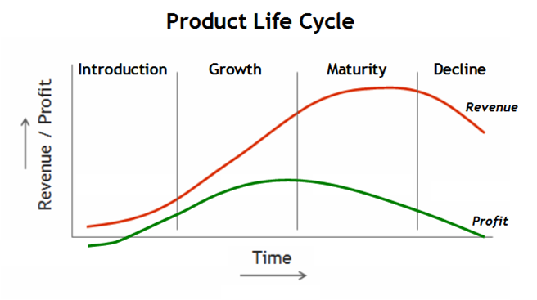

*Figure*

**Introduction Stage**

The introduction stage starts when the new product is first launched. In this stage only a few consumers will buy the product. Further, it takes time to fill the dealer pipeline and to make available the product in several markets. Hence, sales will be low a profit will be negative or low. The distribution and promotion expenses will be very high. There are only a few competitors. Regarding pricing, the management can pursue either skimming strategy i.e. fixing a high price or penetration strategy i.e. fixing a low price.

The company might adopt one of several marketing strategies for introducing a new product. It can set a high or low level for each marketing variable, such as price, promotion, distributions and product quality. Considering only price and promotion, for example, management might launch the new product with a high price and lose promotion spending. The high price helps recover as much gross profit per unit as possible which the low promotions spending keeps marketing spending down. Such a strategy makes sense when the market is limited in size, when most consumers in the market know about the product and are

willing to pay a high price, and when there is littlie immediate potential competition.

On the other hand, a company might introduce its new product with a low price and heavy promotion spending. This strategy promises to bring the fastest market penetration and the largest market share. It makes sense when the market is large, potential buyers are price sensitive and unaware of the product, there is strong potential competition and the company’s unit manufacturing costs fall with the scale of production and accumulated manufacturing experience.

**Growth Stage**

If the new product satisfies the market, it will enter a growth stage. This stage is market by quick increase in sales and profits. The early adopters will continue to buy, and later buyers will start following their lead, especially if they hear favourable word of mouth. New competitors enter the market, attracted by the opportunities for high profit. The market will expand. Prices remain the same. Companies maintain their promotional expenditure at the same level or slightly higher level to meet competition and continue educating the market.

During this stage, the company uses the following marketing strategies:

The company improves product quality and adds new-product features and models.

It enters new market segments.

It enters new distribution channel.

It changes the price at the right time to attract more buyers.

In the growth stage, the firm faces a trade-off between high market share and high current profit. By spending a lot of money on product improvement, promotion and distribution, the company can capture a dominant position. In doing so, it gives up maximum current profit, which it hopes to make up in the next stage.

**Maturity Stage**

This stage normally lasts longer than the previous stages and it poses strong challenges to marketing management. At this stage, sales will slow down. This stage can be divided into three phases. – growth maturity, stable maturity and decaying maturity.

In the growth maturity phase, the sales start to decline because of distribution saturation. In the stable maturity phase, sales become static because of market saturation. In the decaying maturity phase, the absolute level of sales now starts to decline and customers starts moving toward other products and substitutes. Competitions become acute.

Although many product in the mature stage appear to remain unchanged for long periods, most successful ones are actually evolving to meet changing consumer needs. Product managers should do more than simply ride along with or defend their mature products – a good offense is the best defense. They should consider modifying the market, product and marketing mix.

***Marketing Modification:*** The company should seek to expand themarket and enters into new markets. It looks for new users and find ways to increase usage among present customers.

***Product Modificaiton:*** the company should modify the product’scharacteristics such as quality improvement, features improvement, style improvement to attract new users and/or usage from current users.

***Marketing-mix Modification***: The company should also try tostimulate sales through modifying one or more marketing-mix elements such as price cut, step-up sales promotion, change advertisement copy, extending credit etc.

1. major problem with marketing-mix modification is that they highly imitable by competitors. The firm may not gain as much as expected and in fact all firms my experience profit erosion as they complete each other.

**Decline Stage**

In this stage, sales decline and eventually dip due to number of reasons including technological advances, consumer changes in tastes and acute competitions. As sales and profit decline some firms withdraw from the market. Those remaining may reduce the number of product offerings.

They may drop smaller market segments and marginal trade channels. They may reduce the promotion budget and prices further.

Hence, companies need to pay more attention to their aging products. The firm has to identify those products in the decline stage by regular’s reviewing sales, market shares, costs and profit trends. Then, management must decide whether to maintain, harvest, or drop each of these declaiming products.

**Marketing Strategies during the Decline Stage**

Identify the weak products by appointing a product-review committee with representatives from marketing, manufacturing and finance.The firms may adopt the following strategies.

1. Management may decide to *maintain* its brand without change in the hope that competitors will leave the industry.
2. Management may *harvest* by selling whatever is possible in the market.
3. Management may decide to *drop* the product from the line.

When a company decides to drop a product, the firm can sell or transfer the product to someone else or drop it completely. It must decide to drop the product quickly or slowly. It must decide on how much parts in inventory and service required to maintain service to past consumers.

**USES OF *PLC* CONCEPT**

PLC concept’s usefulness varies in different decision-making situations. As a planning tool, the PLC concept characteristics the main marketing challenges in each stage and suggests major alternat

ive marketing strategies the firm might pursue. As a control tool, it allows the company to compare product performance against similar products in the past.

**CRITICISM OF *PLC* CONCEPT**

1. PLC stages do not have predictable duration. It may very from product to product.
2. The marketer cannot tell at what stage the product is in as there is no definite line of demarcation between one stage to another stage.
3. Not all products pass through all the stages. It is possible that the product may travel to the first and second stage and die out.
4. A product may not be in an identical stage in all the market segments; it may be in the second stage in one segment, whereas in the third stage in another segment at a particular point of time.

Not all products pass through all the stages of its life cycle. Some products are introduced and

die quickly; others stay in the nature stage for a long, ling time. Some enter the decline stage and re then cycled back into the growth stage through strong promotion or repositioning.

**Review questions:**

1. Discuss the various steps involved in new product development process.
2. What are causes and methods of product modification and product elimination?
3. What are the reasons for new product failure?
4. What is Product Life Cycle concept? What are the stages of PLC concept? Explain their marketing implications?

**********

**UNIT-4**

**MARKETING MANAGEMENT - PRICING DECISION**

Pricing is a process to determine what manufactures receive in exchange of the product. Pricing depends on various factors like manufacturing cost, raw material cost, profit margin etc.

## Objectives of Pricing

The main objectives of pricing can be learnt from the following points −

* Maximization of profit in short run
* Optimization of profit in the long run
* Maximum return on investment
* Decreasing sales turnover
* Fulfill sales target value
* Obtain target market share
* Penetration in market
* Introduction in new markets
* Obtain profit in whole product line irrespective of individual product profit targets
* Tackle competition
* Recover investments faster
* Stable product price
* Affordable pricing to target larger consumer group
* Pricing product or services that simulate economic development

Pricing objective is to price the product such that maximum profit can be extracted from it.

## Factors Influencing Pricing

Pricing of a product is influenced by various factors as price involves many variables. Factors can be categorized into two, depending on the variables influencing the price.

## Internal Factors

The following are the factors that influence the increase and decrease in the price of a product internally −

* Marketing objectives of company
* Consumer’s expectation from company by past pricing
* Product features
* Position of product in product cycle
* Rate of product using pattern of demand
* Production and advertisement cost
* Uniqueness of the product
* Production line composition of the company
* Price elasticity as per sales of product

Internal factors that influence pricing depend on the cost of manufacturing of the product, which includes fixed cost like labour charges, rent price, etc., and variable costs like overhead, electric charges, etc.

### External Factors

The following are the external factors that have an impact on the increase and decrease in the price of a product −

* Open or closed market
* Consumer behavior for given product
* Major customer negotiation
* Variation in the price of supplies
* Market opponent product pricing
* Consideration of social condition
* Price restricted as per any governing authority

External factors that influence price depend on elements like competition in market, consumer flexibility to purchase, government rules and regulation, etc.

## Pricing Methods

Let us now discuss the various pricing methods −

### Cost plus Pricing

Cost plus pricing can be defined as the cost of production per unit of product plus profit margin decided by the management.

**Step 1** − (Calculation of average variable cost)

**Step 2** − (Calculation of average fixed cost), i.e.,

AFC=TotalFixedCostUnitsOfOutputProductsAFC=TotalFixedCostUnitsOfOutputProducts

or,

AFC=TotalFixedCostExpectedUnitSalesAFC=TotalFixedCostExpectedUnitSales

**Step 3** − (Determination of the desired profit margin)

Selling Price = Unit total cost + Desired unit profit

i.e., Selling Price = AVC + AFC + Mark up

i.e.,**SellingPrice**=**UnitTotalCost**−(**DesiredProfitMarginSellingPrice=UnitTotalCost−(DesiredProfitMargin)**

These are the steps one needs to follow to calculate cost plus pricing.

### Break Even Analysis

It is a point when the investment and revenue of an enterprise is equal; after this point an enterprise gains profit.

### Prices Based on Marginal analysis

In this method, additional cost of that activity is compared to additional profit and the price is calculated according to margin cost. Thus, the cost and price is evaluated and as per the result, the price is decided so as to maximize the profit.

## Pricing Strategies

Let us now understand the various pricing strategies −

### Skimming Pricing

In this method, a new product is introduced in the market with high price, concentrating on upper segment of the market who are not price sensitive, and the result is skimmed.

### Penetration Pricing

In penetration pricing, a product is introduced in the market with a low initial price. The price is kept low to increase target consumer. Using this strategy, more consumers can be penetrated or reached.

### Discounts and Allowances

Discounts are provided in order to increase the demand of product in the market. The main points to be considered to offer discounts are as follows −

* Discount in quantity
* Discount in trade
* Discount in cash
* Other discounts like seasonal, promotional, etc.

### Geographic Pricing Strategies

Geographic pricing strategy is used to price product as per its geographical location. As the distance increases from the point of production, the cost of the product increases.

The main points to be considered under this are as follows −

* Point of production pricing strategy
* Uniform delivery pricing strategy
* Zone delivery pricing strategy
* Freight absorption pricing strategy

### Special Pricing Strategies

Special pricing strategy is mostly used for the promotion of the product. In this strategy, pricing is changed for a short interval of time. These strategies can be lined up as follows −

* One price strategy
* Flexible price strategy
* Flat rate pricing strategy
* Single price strategy
* Odd pricing
* Leader pricing
* High low pricing
* Resale price maintenance
* Everyday low pricing
* Price lining

# Marketing Management - Promotion Decisions

Promotion decision is used to find the appropriate and effective method to promote a particular product to increase the sales.

## Integrated Marketing Communication

Integrated marketing communication (IMC) is a continuous effort to plan, execute and evaluate techniques for selling or advertising a product by using traditional and non traditional methods of promotion.

The following are the major features of promotion decisions −

* Awareness of target consumer and their preference of media
* Knowledge of consumers’ beliefs that can be related to the product to get the expected response
* Setting different promotional tools, each tool for specific target but all linked to acquire a common target
* Coordinating of advertising, sales, promotion and public relation as proportional strategy
* Continuous broadcasting of information about the product

Promotion decisions are made on the basis of characteristics. Such decisions help in target marketing of the product; these decreases the advertising expenses.

## Marketing Communication Process

Marketing communication process comprises the following eight stages −

* **Stage I** − Source
* **Stage II** − Encoding
* **Stage III** − Transmission
* **Stage IV** − Decoding
* **Stage V** − Receipt
* **Stage VI** − Response
* **Stage VII** − Feedback

The source is the information which is introduced for the promotion while the feedback is provided by the consumer, which is evaluated and changes are made for promotion.

**Pricing methods or pricing strategies in marketing**

There are different pricing methods or strategies which are used by the marketer to attract the customer.

**1.) Cost based pricing:**this type of pricing strategies uses break even concept which means the point where the total cost = total revenue. Profit will be zero at breakeven point. At level where the total revenue > total cost there is profit and where total revenue < total cost there is loss.

**2.) Demand based pricing:** it is of two types;

**a) Skimming pricing:** it means skim the market initially with high price and high profit, later settle down for the lower price. It means skim the cream initially from the market.

**b) Penetration pricing:** it seeks to achieve high sale with low price. It is generally used when there are non luxury goods.

**3.) Competition oriented pricing:**in a competitive market the companies generally opt for this pricing strategy. It has three types.

**a) Premium pricing**: it means price above the competitor’s price.

**b) Discount pricing**: it means price below the competitor’s price.

**c) Parity pricing**: it means price equals to the competitor’s price.

**4.) Value pricing**: this method is used when the objective is not to recover the cost of the product but to judge the value of the product in the eyes of the customer. Like homeshop 18.

**5.) Product line pricing:**in this case the company need not fix the price for each product rather they fix the price for the entire product line which results in optimal sales through optimal profit.

**6.) Sealed bid or tender pricing:** this is suitable for those companies where institutional customers call the tenders from the companies. The best and lowest price tender is accepted.

**7.) Affordable or social welfare pricing:** the pricing is done in such a way that all the segments of the market afford to buy and consume the product as per their need. Like government subsidy help each segment of the consumer to buy the product at an affordable pricing.

**8.) Differentiated pricing:** in this case different price is charged by the company from the different segment. Like charging low price from the whole sellers and high price from the retailers.

**9.) Psychological pricing:** many sellers use this technique of selling the product. Like 99 store.

**10.) Target pricing:**here the price is fixed at full cost + mark up.

**11.) Loss leader:**sometime firm sell multiple products, charge relatively low price on some popular product with the hope that customer who will buy this product will also buy the other product of the firm.

**12.) Cyclical pricing:** in depression firm reduce the price of the product while in boom increases the price.

**13.) Suggested pricing:**in this case the manufacturer or whole seller suggests the retailer to charge this price from the customers.

All the above discussed are the general pricing strategies used by the marketer.

# Pricing

In the narrowest sense, price is the amount of money charged for a product or service. More broadly, price is the sum of all the values that consumers exchange for the benefits of having or using the product or service.

**PRICE** – The amt of money charged for a product or service, or the sum of the values that consumers exchange for the benefits of having or using the product or service.

“One can define price as that which people have to forego in order to acquire a product or service.” What does a buyer think? To a buyer, price is the value placed on what is exchanged. Something of value – usually purchasing power – is exchanged for satisfaction or utility. Purchasing power depends on a buyer’s income, credit, and wealth.

Buyers’ concern about price is related to their expectations about the satisfaction or utility associated with a product. Buyers must decide whether the utility gained in an exchange is worth the purchasing power sacrificed. Different terms can be used to describe price for different forms of exchange, (rent, premium, toll, retainer, fee, interest, etc.).

Historically, price has been the major factor affecting buyer choice. This is still true in poorer nations, among poorer groups and with commodity products. However, non-price factors have become more important in buyer-choice behavior in recent decades.

Price is also one of the most flexible elements of the marketing mix. Do you agree? Unlike product features and channel commitments, price can be changed very quickly. At the same time, [pricing](https://www.marketing91.com/pricing-strategies/) and price competition is the number-one problem facing many marketers.

**SETTING THE PRICE** – Let us now attempt to understand the process of how firms set prices. When does a firm set prices? A firm must set a price for the first time when it develops a new product, when it introduces its regular product into a new distribution channel or geographical area, and when it enter bids on new contract work. Is setting prices easy? It involves making a number of guesses about the future. You would want to know how, an organization should proceed as follows:

1. Identify the target market segment for the product or service, and decide what share of it is desired and how quickly.
2. Establish the price range that would be acceptable to occupants of this segment. If this looks unpromising, it is still possible that consumers might be educated to accept higher price levels, though this may take time.
3. Examine the prices (and costs if possible) of potential or actual competitors.
4. Examine the range of possible prices within different combinations of the marketing mix (e.g. different levels of product quality or distribution methods).
5. Determine whether the product can be sold profitably at each price based upon anticipated sales levels (i.e. by calculating break-even point) and if so, whether these profits will meet strategic objectives for profitability.
6. If only a modest profit is expected it may be below the threshold figure demanded by an organization for all its activities. In these circumstances, it may be necessary to modify product specifications downwards until costs are reduced sufficiently to produce the desired profit.

An organization goes through the following steps in setting its pricing policy

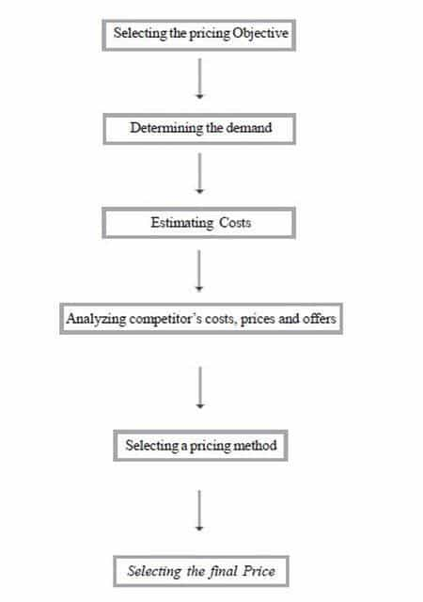

Now let us discuss the process in detail

**1) Selecting the pricing Objective** – You would agree that the foremost step is identifying pricing objectives. The company first decides where it wants to position its marketing offering. The clearer a firm’s objectives, the easier it is to set price. What are pricing objectives? A company can pursue any of five major objectives through pricing: survival, maximum current profit, maximum market share, maximum market skimming, or product-quality leadership.

Companies pursue survival, as their major objective if they are plagued with overcapacity intense competition, or changing consumer wants. As long as prices cover variable costs and some fixed costs, the company stays in business. Survival is a short-run objective: in the long run, the firm must learn how to add value or face extinction.

What happens when companies wants to maximize profit? Many companies try to set a price that will maximize current profits. They estimate the demand and costs associated with alternative prices and choose the price that produces maximum current profit, cash flow or rate of return on investment. This strategy assumes that the firm has knowledge of its demand and cost functions; in reality these are difficult to estimate.

Some companies want to maximize their market share. They believe that a higher sales volume will lead to lower unit costs and higher long-run profit. They set the lowest price, assuming the market is price sensitive. The following conditions favour setting a low price. The market is highly price sensitive, and a low price stimulates market growth. Production and distribution costs fall with accumulated production experience; A low price discourages actual and potential competition Companies unveiling a new technology favour setting high prices to “skim” the market. [Sony](https://www.marketing91.com/marketing-mix-sony/) is a frequent practitioner of market skimming pricing.

Whatever the specific objective, businesses that use price as a strategic tool will profit more than those who simply let costs or the market determine their pricing

**2) Determining the demand** – Following the identification of objectives, the firm needs to determine demand. Each price will lead to a different level of demand and therefore have a different impact on a company’s marketing objectives. In the normal case, demand and price are inversely related: the higher the price, the lower the demand .In the case of prestige goods, the demand curve sometimes slopes upward. E.g. Perfume Company raised its price and sold more perfume rather  
than less! Some consumers take the higher price to signify a better product. However if the price is too high, the level of demand may fall.

Do you agree that generally speaking customers are most price-sensitive to products that cost a lot or are bought frequently? They are less price-sensitive to low cost items or items they buy infrequently. They are also less price-sensitive when price is only a small part of the total cost of obtaining, operating and servicing the product over its lifetime. A seller can charge a higher price than competitors and still get the business if the company can convince the customer that it offers the lowest total cost of ownership (TCO).

The process of estimating demand therefore leads to  
i. Estimating Price sensitivity of market  
ii. Estimating and analyzing demand curve  
iii. Determining price elasticity of demand.

**3. Estimating Costs** – Demand sets a ceiling on the price the company can charge for its product. Can you discuss this statement in detail? Costs set the floor. The company wants to charge a price that covers its cost of producing, distribution and selling the product, including a fair return for its effort and risk.

Do you know different costs of organization? How are these costs related with pricing? A company’s cost take two forms, fixed and variable. Fixed costs (also known as overhead) are costs that do not vary with production or sales revenue. A company must pay bills each month for rent heat, interest, salaries and so on. , Regardless of output. Variable costs vary directly with the level of production. These costs tend to be constant per unit produced. They are called variable because their total varies with the number of units produced. Total costs consists have the sum of the fixed and variable costs for any given level of production. Average cost is the cost per unit at the level of production; it is equal to total costs divided by production.

To price intelligently, management needs to know how its costs vary with different levels of production.

Do you want to know what the Japanese do?

The Japanese Method – TARGET COSTING – Costs change as a result of a concentrated effort by designers, engineers and purchasing agents to reduce them. The Japanese use a method called target costing. They use market research to establish a new product’s desired functions. Then they determine the price at which the product will sell, given its appeal and competitor’s prices. They deduct the desired profit margin from this price, and this leaves the target cost they must achieve.

**4. Analyzing competitor’s costs, prices and offers** – You would agree that analyzing competitor’s costs, prices and offers is also important factor in setting prices. Within the range of possible prices determined by market demand and company costs, the firm must take the competitor’s costs, prices and possible price reactions into account.

While demand sets a ceiling and costs set a floor to pricing, competitors’ prices provide an in between point you must consider in setting prices. Learn the price and quality of each competitor’s product or service by sending out comparison shoppers to price and compare. Acquire competitors’ price lists and buy competitors’ products and analyze them. Also ask customers how they perceive the price and quality of each competitor’s product or service. If your product or service is similar to a major competitor’s product or service, then you will have to price close to the competitor or lose sales. If your product or service is inferior, you will not be able to charge as much as the competitor. Be aware that competitors might even change their prices in response to your price.

**5. Selecting a pricing method** – Do you know any pricing methods? As consumers have you been able to distinguish between pricing strategies? Let us have a look at various pricing methods.

WHAT ARE VARIOUS PRICING METHODS?

There are three pricing methods that can be employed by a firm:  
1. Cost Oriented Pricing  
2. Competitor Oriented Pricing  
3. Marketing Oriented Pricing

Cost Oriented Pricing

Companies often use cost oriented pricing methods when setting prices. Two methods are normally used

*Full cost pricing* – Can you attempt to explain this? What does a firm do here? Here the firm determines the direct and fixed costs for each unit of product. The first problem with Full-cost pricing is that it leads to an increase in price as sales fall. The process is illogical also because to arrive at a cost per unit the firm must anticipate how many products they are going to sell. There is an almost impossible prediction. This method focuses upon the internal costs of the firm as opposed to the prospective customers’ willingness to pay.

*Direct (or marginal) Cost Pricing* – Do you have some idea about this? This involves the calculation of only those costs, which are likely to increase as output increases. Indirect or fixed costs (plant, machinery etc) will remain unaffected whether one unit or one thousand units are produced. Like full cost pricing, this method will include a profit margin in the final price. Direct cost approach is useful when pricing services for example. Consider aircraft seats; if they are unused on a flight then the revenue is lost. These remaining seats may be offered at a discount so that some contribution is made to the flight expenses. The risk here is that other customers who paid the full price may find out about the discounted offer and complain. Direct costs then, indicate the lowest price at which it is sensible to take business if the alternative is to let machinery, aircraft seats or hotel rooms lie idle.

Competition-based approach

*Going-Rate Pricing –* In going-rate pricing, the firm bases its price largely on competitors’ prices, with less attention paid to its own costs or to demand. The firm might charge the same, more, or less than its major competitors. Where the products offered by firms in a certain industry are very similar the public often finds difficulty in perceiving which firm meets their needs best. In cases like this (for example in financial services and delivery services) the firm may attempt to differentiate on delivery or service quality in an attempt to justify a higher selling price.

*Competitive Bidding* – Many contracts are won or lost on the basis of competitive bidding. The most usual process is the drawing up of detailed specifications for a product and putting the contract out for tender. Potential suppliers quote a price, which is confidential to themselves and the buyer. In sealed-bid pricing (i.e. only known to client and not to the other parties tendering for the service), firms bid for jobs, with the firms basing the price on what it thinks other firms will be bidding rather than on its own costs or demand. All other things being equal the buyer will select the supplier that offers the lowest price.

Marketing Oriented Pricing

The price of a product should be set in line with the marketing strategy. The danger is that if price is viewed in isolation (as would be the case with full cost pricing) with no [reference](https://www.marketing91.com/reference-groups-in-consumer-buying/) to other marketing decisions such as positioning, strategic objectives, and promotion, distribution and product benefits. The way around this problem is to recognize that the pricing decision is dependent on other earlier decisions in the marketing planning process. For new products, price will depend upon positioning, strategy, and for existing products price will be affected by strategic objectives.

**6. Selecting the final Price –** Pricing methods narrow the range from which the company must select its final price. In selecting that price, the company must consider additional factors, including psychological pricing, gain and risk pricing, the influence of other marketing -mix elements on price, company -pricing policies, and the impact of price on other parties.

## INITIATING AND RESPONDING TO PRICE CHANGES

After the development of structure and strategies of prices, the firm usually, face situations in which they must have to initiate price changes or respond to price changes by competitors.

#### Initiating Price Changes

In some cases, the company might find it desirable to initiate either a price cut or a price increase. In both cases, it must have to anticipate possible buyer and competitor reactions.

**Initiating Price Cuts**

Several situations might lead a company to consider cutting its price. One of such kind of circumstance is excess capacity. Another is falling of demand in the face of strong price competition or a weakened economy. In such cases, the company might aggressively cut prices for boosting the sales and market share. But as various industries like the airline, fast-food, automobile, and other industries have learned in recent years, cutting prices in an industry loaded with excess capacity might lead to price wars as competitors tend to hold onto market share. A firm might also cut prices in a drive to dominate the market via lower costs. Either the firm starts with lower costs than its competitors, or it cuts the prices in the hope of gaining market share which will further cut costs through larger volume. Lenovo uses an aggressive low-cost, low-price strategy in order to increase its share of the PC market in developing countries.

**Initiating Price Increases**

A successful price increase could greatly improve profits. For example, if the firm’s profit margin is 3 percent of the sales,  1 percent price increase will definitely boost profits by 33 percent if the sales volume is unaffected. The main factor in price increases costs inflation. Rising costs will squeeze profit margins and lead firm to pass cost increases along to consumers. Another factor leading to price increases is over demand: When a company could not supply all that its customers need, it may raise its prices, ration products to consumers, or both. Consider today’s worldwide oil and gas industry.

When raising prices, the firm must avoid being perceived as a price gouger. For example, when gasoline prices rise rapidly, angry consumers usually accuse the major oil firms of enriching themselves at the expense of consumers.

Customers have long memories, and they will definitely turn away from companies or even whole industries that they perceive as charging excessive or high prices. In the extreme, claims of price gouging might even bring about increased government regulation.

There are some of the techniques for avoiding these problems. One is about maintaining a sense of fairness surrounding any price increase. Price increases must be supported by firm communications telling customers why prices are being increased. Wherever possible, the firm should consider ways to meet higher costs or demand without increasing prices.

**Buyer Reactions to Price Changes**

Consumers do not always interpret change in price in a straight forward way. A price increase, that would normally lower sales, might have some positive meanings for buyers. For example, what would the customer think if Rolex raised the price of its latest watch model? On the one hand, they might think that the watch is now even more exclusive or better made. On the other hand, they might think that Rolex is simply being greedy by charging what the traffic will bear.

Similarly, customers might view a price cut in various ways. For example, what would a customer think if Rolex were to suddenly cut its prices? They might think that they are getting a better deal on an exclusive product. More likely, however, they would think that quality had been reduced, and the brand’s luxury image may be tarnished. A brand’s price and image are usually closely linked. A price change, especially a drop in price, could adversely affect how customers view the brand.

**Competitor Reactions to Price Changes**

An organization considering a price change must worry about the reactions of its competitors as well as those of its consumers. Competitors are most likely to react if the number of firms involved is small, if the product is uniform, and if the buyers are well informed about products and prices.

How could the organization anticipate the likely reactions of its competitors? The problem is quite complex because, like the customer, the competitor can interpret a company price cut in several ways. It might think the firm is trying to grab a larger market share or that it is doing poorly and trying to boost its sales. It might also think that the firm wants the whole industry to cut prices in order to increase total demand.

The firm must be able to guess each competitor’s likely reaction. If all competitors behave alike, this will amount to analyzing only a typical competitor. But if the competitors do not behave alike—perhaps because of differences in size, market shares, or policies—then separate analyses are required. However, if some competitors will match the price change, there is better reason to expect that the rest will also match it.

**Responding to Price Changes**

It is necessary to understand how a firm should respond to a price change by a competitor. The company needs to consider many issues: Why did the competitor has changed the price? Is the price change is permanent or temporary? What will happen to the firm’s market share and profits if it does not respond? Do other competitors go to respond? Besides these issues, the firm must also consider its own situation and strategy and possible buyer reactions to price changes.

Suppose the firm learns that a competitor has cut its price and decides that this cut-off price is likely to harm its sales and profits. It may simply decide to hold its current price and profit margin. The firm might believe that it won’t lose too much market share, or it would lose too much profit if it reduced its own price. It might decide that it must wait and respond when it has more information on the effects of the competitor changes of price. However, waiting for too long to act may let the competitor get stronger and more confident as its sales increase.

If the firm decides that effective action can and should be taken, it may make several responses. First, it could decrease its price to match the competitor’s price. It might decide that the market is price sensitive and that it would lose too much market share to the lower-priced competitor. The cutting of the price will reduce the firm’s profits in the short run. Some firms may also decrease their product quality, services, and marketing communications in order to retain profit margins, but this will ultimately hurt long-run market share. The firm should try to maintain its quality as it cuts prices.

Alternatively, the firm may maintain its price but raise the perceived value of its offer. It can improve its communications, stressing the relative value of its product over that of the lower price competitor. The company might find it cheaper to maintain price and spend money for improving its perceived value than to cut price and operate at a lower margin. Or, the firm may improve quality and increase the price, moving its brand into a higher price value position. The greater quality generates greater customer value, which justifies the higher price. In turn, the higher price preserves the firm’s higher margins.

### INITIATING PRICE CHANGES –INITIATE PRICE CUTS AND INCREASES SUCCESSFULLY

In many cases, companies must initiate either a price cut or a price increase. But initiating price changes should be done right to lead to success. Just initiating price changes without considering possible buyer and competitor reactions can be a regretful mistake.

### Initiating price cuts – Initiating price changes

**Initiating price cuts** may appear easier than imitating price changes. In fact, customer response to price cuts is normally better than to price increases. On the other hand, price cuts reduce the profit margin for the company. But what situations may lead a firm to consider cutting its prices?

One such circumstance is excess capacity, which requires initiating price changes. Another situation is falling demand in the face of strong price competition or a weakening economy. In such cases, several options exist for the firm to choose from: it may aggressively cut prices to boost sales and market share. But cutting prices is not always the best option: This way of initiating price changes can easily lead to price wars as competitors try to hold on to market share.

The company may also cut prices in a drive to dominate the market through lower costs. Either the company starts with lower costs than its competitors, or it cuts prices in the hope of gaining market share that will further cut costs through larger volume. An example for this strategy of imitating price changes is the company Lenovo: it uses an aggressive low-cost, low-price strategy to increase its market share of the PC market in developing countries.

### Initiating price increases – Initiating price changes

**Initiating price increases** can be a greater challenge than initiating price cuts, since it often leads to displeased customers. However, a successful price increase can greatly improve profits. For instance, if the company’s profit margin is 3% of sales, a 1% price increase will boost profits by 33% if the sales volume is unaffected. A major factor in price increases is cost inflation.

Rising costs squeeze profit margins and lead companies to pass cost increases on to customers. Another factor leading to price increases is over demand: when a company cannot supply all that its customers need, it may raise its prices, ration products to customers, or both. An example for this tactic of initiating price changes is the worldwide oil and gas industry.

When raising prices, the firm must avoid being perceived as a price gouger. For instance, in the face of constantly rising petrol prices, angry customers often accuse the major oil companies of enriching themselves at the expense of consumers. And in fact, customers have long memories, meaning that they will eventually turn away from companies or even whole industries perceived as charging excessive prices. In the extreme, claims of price gouging may even lead to increased government regulation.

In order to avoid these problems in initiating price changes, some techniques can be applied. One is to simply maintain a sense of fairness surrounding any price increase. Price increases should be supported by company communications telling customers why prices are being raised. If there is no tangible reason for them, customers will not feel willing to pay more. Also, wherever possible, the company should consider ways to meet higher costs or demand without raising prices. For instance, more cost-effective ways to produce or distribute the products could be the key to avoiding price increases. The company could shrink the product or substitute less-expensive ingredients instead of raising the price. Or it can unbundle its market offering, by removing features, packaging or services, and separately pricing elements that were formerly part of the offer.

Of course, **buyer reactions to price changes**can be of quite diverse nature. They often depend on the way of initiating price changes. Customer reactions to price changes are not always straightforward: A price increase, which would normally lower sales, may have some positive meaning for buyers. For instance, what would you think if Rolex raised the price of a watch? It might be even more exclusive or better made. Similarly, a price cut in the case of Rolex would rather indicate reduced quality and a tarnished brand luxury image than that you get a better deal on an exclusive product.

Most important to know is that a brand’s price and image are often very closely linked, which is why initiating price changes must be done carefully. Especially a drop in price can adversely affect how consumers view the brand.

## Promotion Decisions

Special pricing strategy is mostly used for the promotion of the product. In this strategy, pricing is changed for a short interval of time.

Promotion decision can be executed by implementing the following steps −

* **Step 1** − Setting of the objectives
* **Step 2** − Determining promotion budget
* **Step 3** − Target Market
* **Step 4** − The appeal
* **Step 5** − Promotion Mix

## Promotion Mix

Promotion mix is a combination of various marketing techniques, oriented to acquire a common target. It provides a structure for budget allocation for different elements of the promotional mix.

Some elements of promotional mix are as follows −

* Advertising
* Sales promotion
* Public relations and publicity
* Personal selling
* Direct marketing
* Type of product market
* Overall marketing strategy
* Buyer readiness stage
* Product life cycle stage

## Direct Marketing

Direct marketing is a form of marketing in which a single customer is approached for advertisement of the product.

It attempts to acquire and retain customers by contacting them without the use of an intermediary. The objective of direct marketing is to garner a direct response, which may take one of the following forms −

* A purchase over the telephone or by post
* A request for a catalogue or sales literature
* An agreement to visit a location / event (e.g., an exhibition)
* Participation is some form of action (e.g., joining a political party)
* A request for a demonstration of a product
* A request for a sales person’s visit

## Forms of Direct Marketing

The following are the different forms of direct marketing −

* Catalogue marketing
* Direct mail marketing
* Telemarketing
* Teleshopping /home shopping
* Database marketing
* Kiosk marketing

In these methods, the product is advertised directly to the potential customers by approaching them.

# Marketing Management - Distribution Channels

A distribution channel is the route through which goods or services move from the company to the customer or the transfer of payment happens from the customer to the company.

Distribution channels can mean selling of products directly or selling through wholesalers, retailers etc. The same applies for payment transfer from customers to company; it can move through a path or can be sent directly to the company.

## Functions of Distribution Channels

Distribution channels basically function to deliver goods from the manufacturer to the customer.

The following are the functions of distribution channels −

* Facilitate selling by being physically close to customers
* Gather information about potential and current customer competitions, other factors and forces of the environment
* Provide distributional efficiency by bridging the gap between the manufacturer and the user efficiently and economically
* Assemble products into assortments to meet buyers’ needs
* Match segments of supply with segments of demand
* Assist in sales promotion
* Assist in introducing new products
* Assist in implementing the price mechanism
* Assist in developing sales forecast
* Provide market intelligence and feedback
* Maintain records
* Take care of liaison requirements
* Standardize transaction

## Objectives of Distribution Channels

Objectives of a distribution channel are planned as per the target of the enterprise and executed respectively. The following are the various objectives behind the planning of distribution channels −

* To ensure availability of products at the point of sale
* To build channel member’s loyalty
* To stimulate channel members to put greater selling efforts
* To develop management efficiency in channel organization
* To identify the organization at the level
* To have an efficient and effective distribution system for making the products and services available readily, regularly, equitably and fresh.

## Major Channels of Distribution

Here is a list of some of the major channels of distribution −

* Manufacturer → Consumer
* Manufacturer → Retailer → Customer
* Manufacturer → Wholesaler → Customer
* Manufacturer → Wholesaler → Retailer → Customer
* Manufacturer → Agent → Retailer → Customer
* Manufacturer → Agent → Wholesaler → Customer
* Manufacturer → Agent → Wholesaler → Retailer → Customer

Profit distribution decreases as the channel length increases.

## Designing Distribution Channels

We have seen what a distribution channel is. Let us now see the designing process of a distribution channel.

The following steps are involved in the designing of a channel system −

* Formulating the channel objectives
* Identifying the functions to be performed by the channel
* Analyzing the product and linking the channel design to the product characteristics
* Evaluating the distribution environment, including legal aspects
* Evaluating competitor’s channel designs
* Evaluating company resources and matching the channel design to the resources
* Generating alternative designs, evaluating them and selecting the one that suits the firm best

## Classification of Wholesalers

A wholesaler purchases from the manufacturer and further distributes the product to customers or retailers. Wholesalers can be classified into the following categories as per area of functioning −

* Merchant wholesalers
* Agents and brokers
* Manufacturer’s sales branches and offices

# Marketing Management - Physical Distribution

The planning, implementation, and controlling of the physical flow of material or product from one point to another to meet the customer requirements in the market is known as physical distribution.

## Importance of Physical Distribution

The importance of physical distribution becomes significant when the manufacturers and market are geographically far from each other. The following points highlight the importance of physical distribution −

* Execute physical flow of product from the manufacture to the customers.
* Grant time and place for the product
* Build customer for the product
* Cost reduction
* Fulfil the demand of the product in the market so that business takes place

## Steps in Designing a Physical Distribution System

To design a physical distribution system for a product, following steps need to be followed −

* **Step 1** − Defining distribution objective and services required for product distribution
* **Step 2** − Articulating customer requirement
* **Step 3** − Comparing the strategy with market competitors
* **Step 4** − Managing the cost of distribution to decrease cost without compromising on the quality of service
* **Step 5** − Building physical distribution system that is flexible for implementation of changes, if required

Designing of a physical distribution system involves these steps. It is necessary to consider all steps involved for smooth distribution of goods and services.

## Components of a Physical Distribution System

Physical distribution can be controlled and monitored by its different components. Each component should be evaluated and managed in order to accomplish physical distribution without any problems.

The following are the different components of the physical distribution system −

* Planning of physical distribution system
* Storage planning in plant
* Logistics
* Warehousing on field
* Receiving
* Handling
* Sub distribution of product
* Management of inventory at various levels
* Execution of order
* Accounting transactions
* Communication at different levels

## Supply Chain Management (SCM)

Supply Chain Management (SCM) involves managing of goods and services. It includes different stages like storage of goods, logistics and supply of goods to the customer after manufacturing.

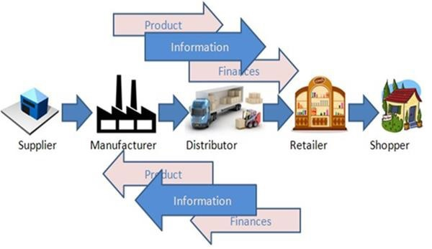

It can also be referred as the combination of materials management and product distribution of an enterprise.

### Advantages of SCM

Supply chain management increases the flexibility and efficiency for the logistics of a product. The following are the advantages of supply chain management −

* It increases the efficiency to deliver on time by approximately 20 %.
* It reduces inventory requirement by approximately 50 %.
* It increases the sales of product from 3 to 6 %.
* It provides integrated controlling for the function of logistics at the front and back end of business.

### Disadvantages of SCM

The following are the disadvantages of supply chain management −

* It considers material management important and customer requirement for logistics as superfluous for the supply cycle.
* Consequently, customer requirement for logistics is not executed with high importance.

Thus, supply chain management has both advantages and disadvantages and both have to be considered for implementation in an organization.

**UNIT -5**

**The Marketing Mix**

Promotion Strategies

**Introduction**

A successful product or service means nothing unless the benefit of such a service can be communicated clearly to the target market. An organisation's promotional mix strategy can consist of many things. The table below takes you through some of the methods.

**Promotional Mix Methods**

| **Types of Promotion** | **Explanation** |
| --- | --- |
| Advertising | Communication through mass media, the firm will usually pay for this type of communication. |
| Public Relations | Developing a positive relationship between the organisation and the media and the public. Good public relationships involves not only creating favourable publicity through the media but also involves minimising the impact of negative situations. |
| Sales Promotion | Promotions designed to create a short term increase in sales. Examples of sales promotion include money off coupons, discount codes and "flash sales". |
| Personal Selling | Sales interaction between the firm's representative and a consumer on a one to one basis. |
| Direct Mail (post and e-mail) | This involves sending marketing to a named individual or organisation. Firms often buy lists of names, e-mails and postal addresses for this purpose. This can be highly effective when the direct mail recipients are within the firm's target market. |
| Internet Marketing | Placing adverts on internet pages through programmes such as Google's AdWords. |
| Social Media | Firms place daily messages on social media such as Facebook and Twitter to keep customers interested in their organisation. They may even run promotions, flash sales and discounts just for their social media readers. |
| Sponsorship | An organisation or event is paid to use your branding and logos. Sponsorship is commonly used in sporting events; player's clothing and stadiums will be covered in the firm's branding and even the tournament may be named after the firm. Although effective sponsorship requires a large audience you may get smaller firms interested in local business sponsoring small events in their area e.g. school fairs. |

Message Strategy

Firms need to carefully consider the message that their promotion strategy will be conveying to their target audience. What message will promotion activity send to the target audience and how will it impact on the firm's reputation?

The promotion's message should reinforce product benefits and help the firm to develop a positioning strategy for their products. Apples message strategy reinforces the quality that they are trying to create about their brand. Mcdonalds message strategy is about the convenience of their products and the value they offer.

Media Strategy

Media strategy refers to how the organisation is going to deliver its message. What aspects of the promotional mix will the company use to deliver their message strategy. Where will they promote it? Clearly the company must take into account the readership and general behaviour of their target audience before they select their media strategy. What newspapers do their target market read? What TV programmes do they watch? Targeting through effective media campaigns could save the company valuable financial resources. Amazon is a good example of an organisation that uses a varied promotional mix, which includes, TV, online and print. Amazons media strategy reflects the diversity of their customers.

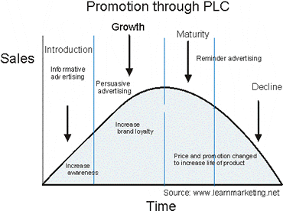

Promotion Through The Product Life Cycle

As products move through the four stages of the product life cycle different promotional strategies should be employed at these stages to ensure the healthy success and life of the product.

Promotion strategies that can be employed at each stage of the Product Life Cycle are as follows:

▪ Introduction

When a product is new the organisation's objective will be to inform the target audience of its entry. Television, radio, magazine, coupons etc may be used to push the product through the introduction stage of the life cycle. Push and Pull Strategies will be used at this crucial stage.

▪ Growth

As the product becomes accepted by the target market (at this stage of the life cycle) the organisation will employ strategy to increase brand awareness and customer loyalty.

▪ Maturity

At this stage of the life cycle the product will be experiencing increased competition and will need persuasive tactics to encourage consumers to choose their product over their rivals. Any differential advantage/benefit will be need to be clearly communicated to the target audience.

▪ Decline

As the product reaches the decline stage of its life cycle, all the organisation can do is use strategy to remind consumers about the product in a bid to slow the inevitable.

Promotion Through The Internet

The development of the world wide web has changed the business environment forever. Dot com fever has taken the industry and stock markets by storm. The e-commerce revolution promises to deliver a more efficient way of conducting business. Shoppers can now purchase from the comfort of their home 24 hours a day 7 days a week.

Owning a website is a now a crucial ingredient to the marketing mix strategy of an organisation. Consumers can obtain instant information on products or services to aid them in their crucial purchase decision. Sony Japan took pre-orders of their popular Play Station 2 console over the net, which topped 1 million after a few days, European football stars issue press releases through the internet and have websites registered under their names. Hit rates are phenomenal. Advertisers have now moved their money over to the internet as customers are now spending more time online than watching TV.

If you would like to learn more about the promotion mix and promotional strategy take a look at our promotional mix expanded article which includes above the line advertising, below the line advertising and through the line advertising.

**UNIT-6**

**Channels of Distribution, Logistics, and Wholesaling**

**Distribution Channel: Notes on Distribution Channel!**

Distribution refers to all the activities undertaken to transfer the product from the manufacturer to the consumer.

**[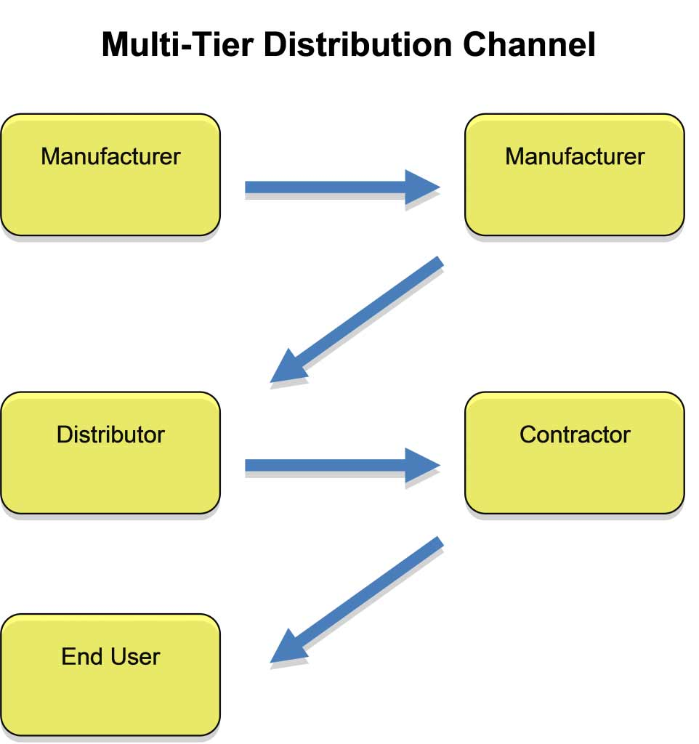](http://cdn.yourarticlelibrary.com/wp-content/uploads/2013/12/b29.jpg)**

The distribution channel is made up of various kinds of intermediaries such as retailers, distributors, wholesalers, and agents. These intermediaries fulfil a variety of functions. The structure of the distribution channel has to be decided first and foremost.

**Going Directly to the Consumer:**

As it is, there is a huge tendency on the part of entrepreneurs to bypass all and reach the customer directly. With the advent of the Net, this has become a very popular alternative. Using the Net is a natural choice if your product can be digitized and distributed, for example, music, books, and software; but that does not mean that this alternative is restricted to these categories.

Michael Dell used a business model dependent on reaching the customer directly and was able to grow Dell Computers into one of the leading PC manufacturers and he is now among the wealthiest people in the world.

Going direct to the customer is feasible in the case of many high-value items. Consumer durables, custom-made sports gear, and real estate are some big-ticket items routinely sold directly by the producers.

Another category that uses the direct route is services. Many service providers are not comfortable in outsourcing the distribution because, in many cases, the point of sale is also where the production takes place. For example, Cafe Coffee Day does not franchise its operations. All outlets are company owned and company operated. That is a very effective way of maintaining high-service standards.

Reaching the customer directly means that all the activities that were the respon­sibility of the distribution channel are now your direct responsibility. Appropriate investments have to be made to properly take care of those functions for a long time. Sometimes, new ventures can start off with a strategy involving going direct to the consumer and then as sales volume increase, bringing in intermediaries.

**Going Directly to the Retailer: Bypass Distributor:**

A traditional distribution system will have super-stockists, distributors, and retailers. Many entrepreneurs find it profitable to bypass the distributor and go directly to the retailer. This is a sustainable strategy, especially in the light of the current crop of retailers coming into the market.

Organized retail in India is about 3 per cent of the total retail sale, but it is over 50 per cent in Western countries such as the US. Now, many big names such as Reliance, Birla, Pantaloon, and Walmart- Airtel are competing for a share of the Indian retail market. In this scenario, the power and role of independent distributors is going to decrease.

Ordinarily, there is no major scope of a distributor till a certain volume is achieved. So, an effective strategy could be to go directly to the retailer and once there is a certain volume of sales, an independent distributor can be contacted to take over the distribution.

Naturally, it will be cheaper and easier to convince distributors to take on a product that is currently selling in the market than trying to convince them to sell a new untried product totally new to the consumer.

**Using Sales Agents:**

It is more appropriate to use agents when selling to businesses. Till volumes pick up, it will be costlier to rely on your own sales force. Even in the long term, many firms have found it profitable to have a company sales force that works in tandem with sales agents. Sales agents are valuable because of their specialized knowledge on certain sector or certain regions.

Also, in the case of B2B sales, losing one customer can make a huge difference to the total sales. It is wiser to split the contact with the customer between a company salesman and an outside agent. The firm is equally likely to lose the services of either and by having two contacts the risk of losing the customer is minimized.

The use of agents to sell high-value items in the consumer market is also very prevalent. It is common to see agents who are dealing in real estate, travel packages, and costly educational products.

**Participate in Established Channel Structure:**

Each region is likely to have many established distributors. These distributors have been dealing with retailers for a long time and have developed a working relationship with them. Some of these distributors will have specialized in certain product categories, but many others would be dealing with varied products. Many of them would have grown big and now would also be providing carry and forward services.

Making use of their services is a tempting alternative. It would immediately allow you to access a number of retail outlets and you would be associating with an experienced intermediary.

There can be a number of disadvantages in tapping existing established intermediaries. They would be willing to take on your product, but that would cause decrease in sales of their existing brands. For example, if you go to a distributor of P&G and ask him/her to stock your shampoo he/she will be immediately concerned that the sales of Pantene (a P&G product) will get affected.

An alternative could be to go to a distributor who does not stock a similar product. For example, you could go with your shampoo to a Britannia distributor. This is a better strategy, but the established distributor will always place very stringent conditions while dealing with a new inexperienced manufacturer. Usually, he/she may ask for higher margins, longer period of credit, free samples, and for reimbursement of some market-related expenses.

**Set Up Your Own Intermediaries:**

A very good alternative is to set up your own intermediaries. It can even be friends and relatives. There will be some people known to you who wish to get into the distribution business; they can be persuaded to start with your product.

Now, it should be kept in mind that if you have encouraged someone to start his/her business dependant on you, your responsibility towards that person is more. Practically speaking, if anything goes wrong, he/she is going to lay the blame on you.

Another way of doing this is if you have started by going directly to retailers, in time one of the retailers can be persuaded to take up the distribution function. This will work much better than bringing in an absolute novice.

**Deciding on the Distribution Channel:**

One of the main strategic decisions to be taken in relation to the distribution channel is deciding on the intensity of the distribution channels. At one end, there is the exclusive distribution option, while at the other end, there is the intensive option. Even though there are a lot of reasons to go for an exclusive channel strategy, most entrepreneurs do not consider that option seriously. Let us look at the distribution options available to the entrepreneur.

**Exclusive Distribution:**

Exclusive distribution gives the retailer an exclusive right to sell your product in a defined area for a period of time. There are several advantages of offering an exclusive distributorship. Some of them are given here:

i. It is usually easier to find a distributor by offering territorial exclusivity.

ii. An exclusive dealership implies greater control over the activities of the retailer.

iii. With exclusivity, it is easier to maintain higher margins for all.

iv. There is less competition at the point of sale.

v. The retailer will be willing to exert effort on ‘pushing’ your products to the consumers.

There are also some of the following disadvantages that have to be considered:

i. The product receives less coverage in the target markets.

ii. The image of the retailer has an impact on the customer’s image of the brand.

iii. By being your exclusive seller in a region, some bargaining power shifts in favour of the retailer.

iv. Some minimum guarantees have to be given to the retailer regarding local advertising spend and contributing towards the establishment cost by promis­ing minimum sales.

One hybrid method is to give territorial exclusivity to a retailer and the retailer continues to stock competitor’s products. This is not a very good idea as it leaves your product very vulnerable.

**Intensive Distribution:**

This is the opposite extreme of exclusivity. Anyone who wishes to stock your product is encouraged to do so. The objective is to reach the customer in as many ways as possible. This strategy is best suited for many fast-moving consumer goods (FMCG) and for many fads. If an FMCG is widely available, the likelihood of sales goes up. Since a fad is not going to sustain for long, it is wise to cover many retailers and make the product widely available for its short shelf life. The advantages of having an intensive distribution are as follows:

i. The product gets wider coverage in the target market.

ii. It is convenient for customers to find the product.

iii. Faster sales cycle is possible.

The disadvantages to be considered are as follows:

i. You have lesser control over the retail operations.

ii. Since there is less push for the retailer, a consumer pull has to be generated.

**Selective Distribution:**

Midway between exclusive and intensive distribution options is selective distribution. In selective distribution, no single retailer has exclusive rights over an area, but retailers are not appointed indiscriminately. A few retailers are chosen to stock the product in a given region.

Some of the positive attributes of exclusive distribution such as control over the retailer and an exclusive image, can be retained without sacrificing too much of market coverage. Many sellers of consumer durables, apparel, and other relatively high-value goods use this kind of distribution network.

**The Importance of Distribution:**

Most producers use intermediaries to bring their products to market. They try to develop a distribution channel (marketing channel) to do this. A distribution channel is a set of interdependent organizations that help make a product available for use or consumption by the consumer or business user. Channel intermediaries are firms or individuals such as wholesalers, agents, brokers, or retailers who help move a product from the producer to the consumer or business user.

A company’s channel decisions directly affect every other marketing decision. Place decisions, for example, affect pricing. Marketers that distribute products through mass merchandisers such as Wal-Mart will have different pricing objectives and strategies than will those that sell to specialty stores. Distribution decisions can sometimes give a product a distinct position in the market. The choice of retailers and other intermediaries is strongly tied to the product itself. Manufacturers select mass merchandisers to sell mid-price-range products while they distribute top-of-the-line products through high-end department and specialty stores. The firm’s sales force and communications decisions depend on how much persuasion, training, motivation, and support its channel partners need. Whether a company develops or acquires certain new products may depend on how well those products fit the capabilities of its channel members.

Some companies pay too little attention to their distribution channels. Others, such as FedEx, Dell Computer, and Charles Schwab have used imaginative distribution systems to gain a competitive advantage.

**Functions of Distribution Channels**

Distribution channels perform a number of functions that make possible the flow of goods from the producer to the customer. These functions must be handled by someone in the channel. Though the type of organization that performs the different functions can vary from channel to channel, the functions themselves cannot be eliminated. Channels provide time, place, and ownership utility. They make products available when, where, and in the sizes and quantities that customers want. Distribution channels provide a number of logistics or physical distribution functions that increase the efficiency of the flow of goods from producer to customer. Distribution channels create efficiencies by reducing the number of transactions necessary for goods to flow from many different manufacturers to large numbers of customers. This occurs in two ways. The first is called breaking bulk. Wholesalers and retailers purchase large quantities of goods from manufacturers but sell only one or a few at a time to many different customers. Second, channel intermediaries reduce the number of transactions by creating assortments—providing a variety of products in one location—so that customers can conveniently buy many different items from one seller at one time. Channels are efficient.

The transportation and storage of goods is another type of physical distribution function. Retailers and other channel members move the goods from the production site to other locations where they are held until they are wanted by customers. Channel intermediaries also perform a number of facilitating functions, functions that make the purchase process easier for customers and manufacturers. Intermediaries often provide customer services such as offering credit to buyers and accepting customer returns. Customer services are oftentimes more important in B2B markets in which customers purchase larger quantities of higher-priced products.

Some wholesalers and retailers assist the manufacturer by providing repair and maintenance service for products they handle. Channel members also perform a risk-taking function. If a retailer buys a product from a manufacturer and it doesn’t sell, it is “stuck” with the item and will lose money. Last, channel members perform a variety of communication and transaction functions. Wholesalers buy products to make them available for retailers and sell products to other channel members. Retailers handle transactions with final consumers. Channel members can provide two-way communication for manufacturers. They may supply the sales force, advertising, and other marketing communications necessary to inform consumers and persuade them to buy. And the channel members can be invaluable sources of information on consumer complaints, changing tastes, and new competitors in the market.

**The Internet in the Distribution Channel**

By using the Internet, even small firms with limited resources can enjoy some of the same competitive advantages as their largest competitors in making their products available to customers internationally at low cost. E-commerce can result in radical changes in distribution strategies. Today most goods are mass-produced, and in most cases end users do not obtain products directly from manufacturers. With the Internet, however, the need for intermediaries and much of what has been assumed about the need and benefits of channels will change. In the future, channel intermediaries that physically handle the product may become largely obsolete. Many traditional intermediaries are already being eliminated as companies question the value added by layers in the distribution channel. This removal of intermediaries is termed disintermediation, the elimination of some layers of the distribution channel in order to cut costs and improve the efficiency of the channel.

**Wholesaling:**

Wholesaling is all activities involved in selling products to those buying for resale or business use. Wholesaling intermediaries are firms that handle the flow of products from the manufacturer to the retailer or business user.

Wholesaling intermediaries add value by performing one or more of the following channel functions:

* Selling and Promoting
* Buying and Assortment Building
* Bulk-Breaking
* Warehousing
* Transportation
* Financing
* Risk Bearing
* Market Information – giving information to suppliers and customers about competitors, new products, and price developments
* Management Services and Advice – helping retailers train their sales clerks, improving store layouts and displays, and setting up accounting and inventory control systems.

**Independent Intermediaries**

Independent intermediaries do business with many different manufacturers and many different customers. Because they are not owned or controlled by any manufacturer, they make it possible for many manufacturers to serve customers throughout the world while keeping prices low.

**Merchant Wholesalers**

Merchant wholesalers are independent intermediaries that buy goods from manufacturers and sell to retailers and other B2B customers. Because merchant wholesalers take title to the goods, they assume certain risks and can suffer losses if products get damaged, become out-of-date or obsolete, are stolen, or just don’t sell. At the same time, because they own the products, they are free to develop their own marketing strategies including setting prices. Merchant wholesalers include full-service merchant wholesalers and limited-service wholesalers. Limited-service wholesalers are comprised of cash-and-carry wholesalers, truck jobbers, drop shippers, mail-order wholesalers, and rack jobbers.

**Merchandise Agents or Brokers**

Merchandise agents or brokers are a second major type of independent intermediary. Agents and brokers provide services in exchange for commissions. They may or may not take possession of the product, but they never take title; that is, they do not accept legal ownership of the product. Agents normally represent buyers or sellers on an ongoing basis, whereas brokers are employed by clients for a short period of time. Merchandise agents or brokers include manufacturers’ agents (manufacturers’ reps), selling agents, commission merchants, and merchandise brokers.

**Manufacturer-Owned Intermediaries**

Manufacturer-owned intermediaries are set up by manufacturers in order to have separate business units that perform all of the functions of independent intermediaries, while at the same time maintaining complete control over the channel. Manufacturer-owned intermediaries include sales branches, sales offices, and manufacturers’ showrooms. Sales branches carry inventory and provide sales and service to customers in a specific geographic area. Sales offices do not carry inventory but provide selling functions for the manufacturer in a specific geographic area. Because they allow members of the sales force to be located close to customers, they reduce selling costs and provide better customer service. Manufacturers’ showrooms permanently display products for customers to visit. They are often located in or near large merchandise marts, such as the furniture market in High Point, North Carolina.

**Types of Distribution Channels:**

The first step in selecting a marketing channel is determining which type of channel will best meet both the seller’s objectives and the distribution needs of customers.

**Channel Length**

Distribution channels can be described as being either short or long. A short channel involves few intermediaries. A long channel, on the other hand, involves many intermediaries working in succession to move goods from producers to consumers. In general, business products tend to move through shorter channels than consumer products due to geographical concentrations and comparatively few business purchases. Service firms market primarily through short channels because they sell intangible products and need to maintain personal relationships within their channels. Not-for-profit institutions also tend to work with short, simple, and direct channels. Please note Table 15.1 below that highlights the characteristics of short and long marketing channels.

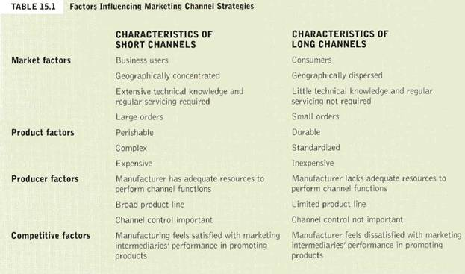

**Consumer Channels**

The simplest and shortest distribution channel is a direct channel. A direct channel carries goods directly from a producer to the business purchaser or consumer. One of the newest means of selling in a direct channel is the Internet. A direct channel may allow the producer to serve its customers better and at a lower price than is possible using a retailer. Sometimes a direct channel is the only way to sell the product because using channel intermediaries may increase the price above what consumers are willing to pay. Another reason to use a direct channel is control.

Many producers, however, choose to use indirect channels to reach consumers. Customers are familiar with certain retailers or other intermediaries and habitually turn to them when looking for what they need. Intermediaries also help producers fulfill the channel functions previously cited. By creating utility and transaction efficiencies, channel members make producers’ lives easier and enhance their ability to reach customers.

The producer-retailer-consumer channel is the shortest indirect channel. GE uses this channel when it sells small appliances through large retailers such as Wal-Mart or Sears. The producer-wholesaler-retailer-consumer channel is another common distribution channel in consumer marketing.

**Business-to-Business Channels**

B2B distribution channels facilitate the flow of goods from a producer to an organizational customer. Generally, B2B channels parallel consumer channels in that they may be direct or indirect. The simplest indirect channel in industrial markets occurs when the single intermediary—a merchant wholesaler referred to as an industrial distributor rather than a retailer—buys products from a manufacturer and sells them to business customers. Direct channels are more common to business-to-business markets because B2B marketing often means selling high-dollar, high-profit items to a market made up of only a few customers. In such markets, it pays for a company to develop its own sales force and sell directly to customers at a lower cost than if it used intermediaries.

**Channels for Services**

Because services are intangible, there is no need to worry about storage, transportation, and the other functions of physical distribution. In most cases, the service travels directly from the producer to the customer. Some services, however, do need an intermediary, often called an agent, who helps the parties complete the transaction. Examples include insurance agents, stockbrokers, and travel agents.

Note the alternative distribution channels for consumer goods, business goods, and services illustrated in Figure 15.2 below:

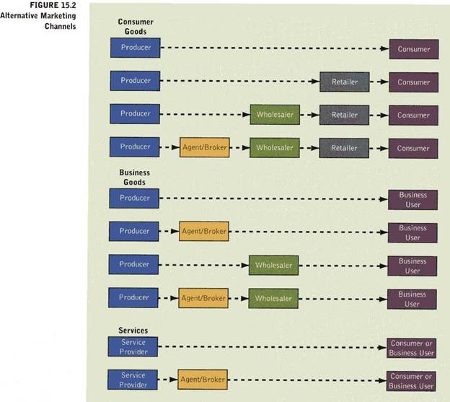

**Horizontal Marketing Systems**

A horizontal marketing system is a channel arrangement in which two or more companies at one level join together to follow a new marketing opportunity. By working together, companies can combine their financial, production, or marketing resources to accomplish more than any one company could alone. Companies can join forces with competitors or non competitors. McDonald’s places “express” versions of its restaurants in Wal-Mart stores. McDonald’s benefits from Wal-Mart’s considerable store traffic, while Wal-Mart keeps hungry shoppers from having to go elsewhere to eat.

**Multichannel Distribution Systems**

A multichannel distribution system is a distribution system in which a single firm sets up two or more marketing channels to reach one or more customer segments. This is also called a hybrid marketing channel. Multichannel distribution systems offer many advantages to companies facing large and complex markets. With each new channel, the company expands its sales and market coverage and gains opportunities to tailor its products to the specific needs of diverse customers. Multichannel distribution systems, however, are harder to control, and they generate conflict as more channels compete for customers and sales.

**Channel Strategy:**

Marketers face several strategic decisions in choosing channels and marketing intermediaries for their products. Selecting a specific channel is the most basic of these decisions. Marketers must also resolve questions about the level of distribution intensity, the desirability of vertical marketing systems, and the performance of current intermediaries.

**Marketing Channel Selection**

Marketing channel selection can be facilitated by analyzing market, product, producer, and competitive factors. A marketer could refer to Table 15.1 above for insights into whether the distribution channel should be short or long for the product in question. Then, he or she could refer to Figure 15.2 above and consider the alternative long or short channels for consumer goods, business goods, or services.

**Distribution Intensity**

Distribution intensity refers to the number of intermediaries through which a manufacturer distributes its goods. The decision about distribution intensity should ensure adequate market coverage for a product. In general, distribution intensity varies along a continuum with three general categories: intensive distribution, selective distribution, and exclusive distribution.

**Intensive Distribution**

An intensive distribution strategy seeks to distribute a product through all available channels in an area. Usually, an intensive distribution strategy suits items with wide appeal across broad groups of consumers, such as convenience goods.

**Selective Distribution**

Selective distribution is distribution of a product through only a limited number of channels. This arrangement helps to control price cutting. By limiting the number of retailers, marketers can reduce total marketing costs while establishing strong working relationships within the channel. Moreover, selected retailers often agree to comply with the company’s rules for advertising, pricing, and displaying its products. Where service is important, the manufacturer usually provides training and assistance to dealers it chooses. Cooperative advertising can also be utilized for mutual benefit. Selective distribution strategies are suitable for shopping products such as clothing, furniture, household appliances, computers, and electronic equipment for which consumers are willing to spend time visiting different retail outlets to compare product alternatives. Producers can choose only those wholesalers and retailers that have a good credit rating, provide good market coverage, serve customers well, and cooperate effectively. Wholesalers and retailers like selective distribution because it results in higher sales and profits than are possible with intensive distribution where sellers have to compete on price.

**Exclusive Distribution**

Exclusive distribution is distribution of a product through one wholesaler or retailer in a specific geographical area. The automobile industry provides a good example of exclusive distribution. Though marketers may sacrifice some market coverage with exclusive distribution, they often develop and maintain an image of quality and prestige for the product. In addition, exclusive distribution limits marketing costs since the firm deals with a smaller number of accounts. In exclusive distribution, producers and retailers cooperate closely in decisions concerning advertising and promotion, inventory carried by the retailers, and prices. Exclusive distribution is typically used with products that are high priced, that have considerable service requirements, and when there are a limited number of buyers in any single geographic area. Exclusive distribution allows wholesalers and retailers to recoup the costs associated with long selling processes for each customer and, in some cases, extensive after-sale service. Specialty goods are usually good candidates for this kind of distribution intensity.

**Channel Conflict**

The channel captain or leader, the dominant and controlling member of a distribution channel, must work to resolve conflicts between channel members. Conflicts can be horizontal and vertical.

**Horizontal & Vertical Conflict**

Horizontal conflict occurs among firms at the same level of the channel (i.e. between two retailers). Vertical conflict is conflict between different levels of the same channel (i.e. between a wholesaler and a retailer). Some conflict in the channel takes the form of healthy competition. Severe or prolonged conflict, however, can disrupt channel effectiveness and cause lasting harm to channel relationships.

**Vertical Marketing Systems**

A vertical marketing system (VMS) is a distribution channel structure in which producers, wholesalers, and retailers act as a unified system. One channel member owns the others, has contracts with them, or has so much power that they all cooperate. A conventional distribution channel consists of one or more independent producers, wholesalers, and retailers. A vertical marketing system, on the other hand, provides a way to resolve the channel conflict that can occur in a conventional distribution channel where channel members are separate businesses seeking to maximize their own profits—even at the expense sometimes of the system as a whole. The VMS can be dominated by the producer, wholesaler, or retailer. There are three major types of vertical marketing systems: corporate, contractual, and administered.

A corporate VMS is a vertical marketing system that combines successive stages of production and distribution under single ownership—channel leadership is established through common ownership. A little-known Italian eyewear maker, Luxottica, sells its many famous eyewear brands—including Giorgio, Armani, Yves Saint Laurent, and Ray-Ban—through the world’s largest optical chain, LensCrafters, which it also owns.

A contractual VMS is a vertical marketing system in which independent firms at different levels of production and distribution join together through contracts to obtain more economies or sales impact than they could achieve alone. Coordination and conflict management are attained through contractual agreements among channel members. The franchise organization is the most common type of contractual relationship. There are three types of franchises: manufacturer-sponsored retailer franchise system (Ford Motor Co.), manufacturer-sponsored wholesaler franchise system (Coca-Cola bottlers), and service-firm-sponsored retailer franchise system (McDonald’s). The fact that most consumers cannot tell the difference between contractual and corporate VMSs shows how successfully the contractual organizations compete with corporate chains.

An administered VMS is a vertical marketing system that coordinates successive stages of production and distribution, not through common ownership or contractual ties, but through the size and power of one of the parties. Manufacturers of a top brand can obtain strong trade cooperation and support from resellers (P&G). Large retailers such as Wal-Mart can exert strong influence on the manufacturers that supply the products they sell.

**Logistics:**

Logistics is the process of designing, managing, and improving the movement of products through the supply chain. The supply chain is all the firms that engage in activities necessary to turn raw materials into a product and put it in the hands of the consumer or business customer. The difference between a supply chain and a distribution channel is the number of members and their function. A supply chain consists of those firms that supply the raw materials, component parts, and supplies necessary for a firm to produce a product plus the firms that facilitate the movement of that product from the producer to the ultimate users of the product—the channel members.

**Physical Distribution**

Logistics has the objective of delivering exactly what the customer wants—at the right time, in the right place, and at the right price. In planning for the delivery of goods to customers, marketers have usually looked at a process termed physical distribution, which refers to the activities used to move finished goods from manufacturers to final customers. Physical distribution activities include order processing, warehousing, materials handling, transportation, and inventory control. This process impacts how marketers physically get products where they need to be, when they need to be there, and at the lowest possible cost.

In logistics, the focus is on the customer. When planning for the logistics function, firms consider the needs of the customer first. The customer’s goals become the logistics provider’s goals. With most logistics decisions, firms must compromise between low costs and high customer service.