Managerial Economics

Unit 1 :

* **Definition of Managerial economics**
* **Objectives of Managerial Economics**
* **Characteristics of Managerial Economics**
* **Scope of Managerial Economics**
* **Nature of Managerial Economics**
* **Decision Making and Planning**
* **Basic Tools of economics in Management**
* **Definition of Managerial economics**

***Managerial economics***, used synonymously with business economics. It is a branch of economics that deals with the application of microeconomic analysis to decision-making techniques of businesses and management units. It acts as the via media between economic theory and pragmatic economics. Managerial economics bridges the gap between "theory and practice". Managerial economics can be defines as:

* ***“The integration of economic theory with business practice for the purpose of facilitating decision-making and forward planning by management”.***

**Spencer and Siegelman**

* ***“Managerial economics is the application of economic theory and methodology to decision-making problems faced by both public and private institutions”.***

**McGutgan and Moyer**

* ***Managerial economics is a stream of management studies which emphasises solving*** [***business***](https://theinvestorsbook.com/business.html) ***problems and decision-making by applying the theories and principles of microeconomics and macroeconomics. It is a specialized stream dealing with the organisation’s internal issues by using various economic theories.***

Business and industrial enterprises aim at earning maximum proceeds. In order to achieve this objective, a managerial executive has to take recourse in decision making, which is the process of selecting a specified course of action from a number of alternatives. A sound decision requires fair knowledge of the aspects of economic theory and the tools of economic analysis, which are directly involved in the process of decision-making. Since managerial economics is concerned with such aspects and tools of analysis, it is pertinent to the decision making process.

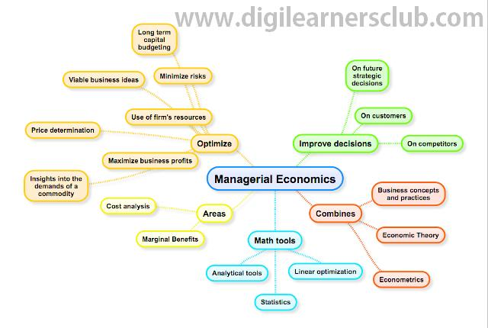

**Objectives of Managerial Economics**

## Implement Analytical Tools

An objective of managerial economics is to implement devices that will measure and analyze a broad scale of a company&rsquo;s financial goals. These devices can be as simple as manually recording production processes to making cost-effective suggestions to developing a top-scale database program that will help identify obstacles and potential growth areas.

## Analyze Business Goals

Managerial economics helps to assess business goals and stratagem on a continuous basis--weekly, monthly and quarterly, for example. Using managerial economics helps to scrutinize the hazards of business choices and evaluate marketing techniques and procedures.

* Make New Business or Product Decisions

The process of managerial economics also allows for deciding if an investment in a new business or product venture is financially sound. After assembling the necessary data, decision makers are able to develop a strategy and plan for production, quantity, pricing, marketing and handling. Understanding the risks and cost beforehand will allow the company a better opportunity to reach its objectives and make a profit.

* **Characteristics of Managerial Economics:**

(i) It studies the problems and principles of an individual business firm or an individual industry. It aids the management in forecasting and evaluating the trends of the market.

(ii) It is concerned with varied corrective measures that a management undertakes under various circumstances. It deals with goal determination, goal development and achievement of these goals. Future planning, policy making, decision making and optimal utilization of available resources, come under the banner of managerial economics.

(iii)  Managerial economics is pragmatic. In pure microeconomic theory, analysis is performed, based on certain exceptions, which are far from reality. However, in managerial economics, managerial issues are resolved daily and difficult issues of economic theory are kept at bay.

(iv) Managerial economics employs economic concepts and principles, which are known as the theory of Firm or 'Economics of the Firm'. Thus, its scope is narrower than that of pure economic theory.

(v) Managerial economics incorporates certain aspects of macroeconomic theory. These are essential to comprehending the circumstances and environments that envelop the working conditions of an individual firm or an industry. Knowledge of macroeconomic issues such as business cycles, taxation policies, industrial policy of the government, price and distribution policies, wage policies and antimonopoly policies and so on, is integral to the successful functioning of a business enterprise.

(vi) Managerial economics aims at supporting the management in taking corrective decisions and charting plans and policies for future.

(vii) Science is a system of rules and principles engendered for attaining given ends. Scientific methods have been credited as the optimal path to achieving one's goals. Managerial economics has been is also called a scientific art because it helps the management in the best and efficient utilization of scarce economic resources. It considers production costs, demand, price, profit, risk etc. It assists the management in singling out the most feasible alternative. Managerial economics facilitates good and result oriented decisions under conditions of uncertainty.

(viii) Managerial economics is a normative and applied discipline. It suggests the application of economic principles with regard to policy formulation, decision-making and future planning. It not only describes the goals of an organization but also prescribes the means of achieving these goals.

## Scope of Managerial Economics:

The scope of managerial economics includes following subjects:

(i) Theory of Demand

(ii) Theory of Production

(iii) Theory of Exchange or Price Theory

(iv) Theory of Profit

(v) Theory of Capital and Investment

**Types of Managerial Economics**

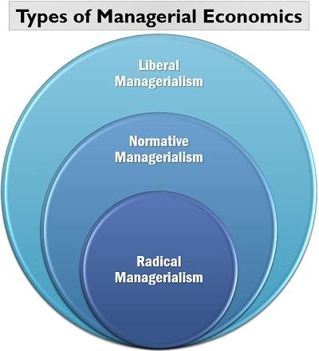

* **Liberal Managerialism**: A market is a democratic place where people are liberal to make their choices and decisions. The organisation and the managers have to function according to the customer’s demand and market trend; else it may lead to business failures.
* **Normative Managerialism**: The normative view of managerial economics states that managerial decisions are based on real-life experiences and practices. They have a practical approach to demand analysis, forecasting, cost management, product design and promotion, [recruitment](https://theinvestorsbook.com/recruitment.html), etc.
* **Radical Managerialism**: Managers must have a revolutionary attitude towards business problems, i.e. they must make decisions to change the present situation or condition. They focus more on the customer’s requirement and satisfaction rather than only profit maximization.

## Principles of Managerial Economics

## The great macroeconomist N. Gregory Mankiw has given ten principles to explain the significance of managerial economics in business operations.

## 

• Principles **of How People Make Decisions**: To understand how the decision making takes place in real life, let us go through the following principles:

* **People Face Tradeoffs**: To make decisions, people have to make choices where they have to select among various options available.
* [**Opportunity Cost**](https://theinvestorsbook.com/opportunity-cost.html): Every decision involves an opportunity cost which the cost of those options which we let go while selecting the most appropriate one.
* **Rational People Think at the Margin**: People usually think about the margin or the profit they will earn before investing their money or resources at a particular project or person.
* **People Respond to Incentives**: Decisions making majorly depends upon the incentives associated with a product, service or activity. Negative incentives discourage people whereas positive incentives motivate them.

**Principles of How People Interact**: Communication and market affect business operations. To justify the statement, let us see the following related principles:

* **Trade Can Make Everyone Better off**: This principle says that trade is a medium of exchange among people. Everyone gets a chance to offer those products or services which they are good at making. And purchase those products or services too which others are good at manufacturing.
* **Markets Are Usually A Good Way to Organize Economic Activity**: Markets mostly acts as a medium of interaction among the consumers and the producers. The consumers express their needs and requirement (demands) whereas the producers decide whether to produce goods or services required or not.
* **Governments Can Sometimes Improve Market Outcomes**: Government intervenes business operations at the time of unfavourable market conditions or for the welfare of society. One such example is when the government decides minimum wages for labour welfare.

• Principles **of How Economy Works As A Whole**: The following principle explains the role of the economy in the functioning of an organization:

* **A Country’s Standard of Living Depends on Its Ability to Produce Goods and Services**: For the growth of the economy of a country, it is essential that the organisations are efficient enough produce goods and services. It ultimately meets the consumer’s demand and improves GDP to raise the country’s standard of living.
* **Prices Rise When the Government Prints Too Much Money**: If there are surplus money available with people, their spending capacity increases, ultimately leading to a rise in demand. When the producers are unable to meet the consumer’s demand, inflation takes place.
* **Society Faces a Short-Run Tradeoff Between Inflation and Unemployment**: To reduce unemployment, the government brings in various economic policies into action. These policies aim at boosting the economy in the short run. Such practices lead to inflation.

### Scope of Managerial Economics

Managerial economics is widely applied in organizations to deal with different business issues. Both the micro and macroeconomics equally impact the business and its functioning.

Following points illustrate its scope:

## 

**Nature of Managerial Economics**

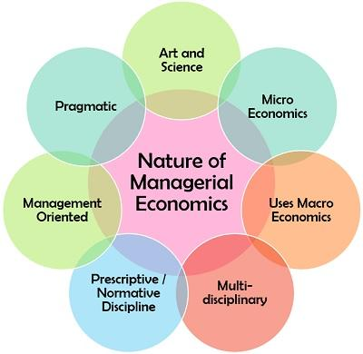

**UNIT 2**

* **Concept of Demand**
* **Elasticity of demand curve**
* **Individual Demand curve**
* **Market demand curve**
* **Increase-Decrease and Shift in Demand Curve**
* **Elasticity of Demand – Price income and Cross Demand Estimation**
* **Demand forecasting –concept of revenue**
* **Average Revenue ,Total Revenue and Marginal Revenue**

**What Is Demand?**

**Demand** in economics is defined as consumers' willingness and ability to consume a given good. An increase in price will decrease the quantity demanded of most goods. A decrease in price will increase the quantity demanded of most goods. The inverse relationship between price and quantity demanded of a good is known as the law of demand and is typically represented by a downward sloping line known as the demand curve.

**Concepts**

**1. Demand** It refers to various amounts of a commodity that a consumer is ready to buy at different possible prices of the commodity, during a period of time.

**2. QuantityDemanded** If refers to the specific quantity of a commodity which is demanded during a particular period of time.

**3. Market Demand** It is the sum of individual demand at different price level at a particular period of time by different people.

**4. Demand Schedule** The table related to price and quantity demanded is called the demand schedule.

**5. Individual Demand Schedule** It is a table showing various quantities of a commodity, which an individual buyer is ready to buy at different possible prices of the commodity at a given point of time.

**6. Market Demand Schedule** It is a table showing various quantities of a commodity, which all the buyers in the market are ready to buy at different possible prices of the commodity at a given point of time.

**7. Demand Curve** It is a graphic presentation of demand schedule.

**8. Market Demand Curve** It is a graphical presentation of market demand schedule, i.e. a horizontal summation of individual demand curves

**DEMAND CURVE**

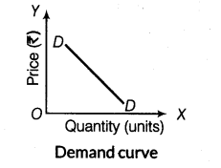

**9. Determinants/Factors Affecting Demand**

(i) Price of the commodity (Px)       (ii) Income of the consumers (y)

(iii)Price of related goods (Pr)       (iv) Taste and preferences of the consumers (T)

(v) Expectations (E)                       (vi) Distribution of Income (Dy)

(vii) Size of population (Ps)

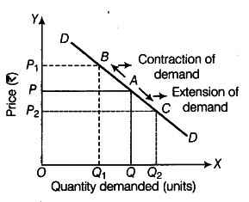

**Note** Factors (i) to (v) affect individual demand, hence considered under individual demand function, whereas factors- (i) to (vii) affects market demand, hence considered under market demand function.

**10. Demand Function** It shows the relationship between demand for a commodity and its various determinants. Written as :

Dx = f(Px, Y, Pr, T, E, Dy, Ps) [Where Dx = Demand for good x]

**11.Normal Goods** These are the goods for which the demand is directly related to consumer’s income i.e. with rise in income demand rises and vice-versa, e.g. full cream milk, pulses, grains, etc.

**12. Inferior Goods** These are the goods for which the demand is inversely related to consumer’s income, i.e. with rise in income demand falls and vice-versa, e.g. coarse cereals, tonned milk, etc.

**13. Substitute Goods** These are the goods which can be substituted for each other, such as tea and coffee or ball pen and ink pen. In case of such goods, increase in the price of one causes increase in the demand for other, (i.e. direct relation between price of one good and demand of other good).

**14. Complementary Goods**These are those goods which complete the demand for each other and are therefore, demanded together in a fixed proportion, e.g. pen and ink, bread and butter, etc. A fall in price of one causes increase in demand of the other and vice versa.

**15.Law of Demand** The law states that other things remaining constant, quantity demanded of a commodity increases with a fall in its own price and diminishes with a rise in its own price, i.e. there exist a inverse relationship between price and quantity demanded. Geometrically, it is represented by a downward sloping demand curve.

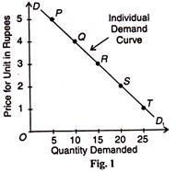

**Assumptions of the Law of Demand**

(i)Tastes and preferences of the consumer remain constant.

(ii)There is no change in the income of the consumers.

(iii) Prices of the related goods do not change.

(iv)No change in the total assets.

(v)No change in population.

(vi)No expectation of further changes in the price of a commodity.

**Exceptions to the Law of Demand**

i) Conspicuous consumption

ii) Giffen goods

iii) Ignorance of the buyers

iv) Conspicuous necessities

**Causes for Downward Sloping of Demand Curve**

i) Law of Diminishing Marginal Utility

ii) Income effect

iii) Substitution effect

iv) Size of consumer group,

v) Different uses

**Giffen Good** It is a special type of inferior good whose income effect is negative, but price effect is positive, i.e. demand increase with rise in price and vice versa.

**Income Effect** It refers to change in quantity demanded of a commodity when real income of the consumer changes owing to change in own price of the commodity

**Substitution Effect** It refers to change in quantity demanded of commodity X when relative price of the commodity (Px/Py) changes owing to change in Px or Py.

Where Px is Price of goods X and Py is price of good y.                       –

**Price Effect** It refers to change in quantity demanded of a commodity owing to change in its own price, other things remaining constant. It includes both income effect and substitution effect.

**Cross Price Effect** It refers to effect of a change in price of commodity X on demand for commodity Y, when X and Y are related goods, i.e. either substitutes or complementary.

## The Shift in Demand

## It occurs when demand for a commodity is related to factors other than own price of the commodity. When more is demanded at the same price, there is rightward shift in demand curve (called increase in demand), when less is demanded at the same price, there is leftward shift in demand curve (called decrease in demand).

* Price of complementary goods
* Price of substitute goods
* Income
* Tastes and preferences
* An expectation of change in the price in future
* Population

## When only Demand Changes

A change in demand can be recorded as either an increase or a decrease. Note that in this case there is a shift in the demand curve.

### Increase in Demand

When there is an increase in demand, with no change in supply, the demand curve tends to shift rightwards. As the demand increases, a condition of excess demand occurs at the old equilibrium price. This leads to an increase in competition among the buyers, which in turn pushes up the price.

Of course, as price increases, it serves as an incentive for suppliers to increase supply and also leads to a fall in demand. It is important to realize that these processes continue to operate until a new equilibrium is established. Effectively, there is an increase in both equilibrium price and quantity.

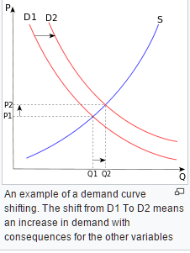

### Decrease in Demand

Under conditions of a decrease in demand, with no change in supply, the demand curve shifts towards left. When demand decreases, a condition of excess supply is built at the old equilibrium level. This leads to an increase in competition among the sellers to sell their produce, which obviously decreases the price.

Now as for price decreases, more consumers start demanding the good or service. Observably, this decrease in price leads to a fall in supply and a rise in demand. This counter mechanism continues until the conditions of excess supply is wiped out at the old equilibrium level and a new equilibrium is established. Effectively, there is a decrease in both equilibrium price and quantity.

**Extension and contraction of demand**

The demand for a commodity changes due to a change in price. It is called extension and contraction of demand. When there is decrease in price of commodity there is in increase in demand of that commodity. This is called extension of demand. When there is increase in price of a commodity there is decrease in the demand for that commodity. This called contraction of demand. Thus demand varies in opposite direction due to change in price.

**Extension of demand**

There is extension of demand for a commodity when there is decrease in the price of that commodity. When price is 15 dollars the demand is 50 kilograms. When price comes down to 10 dollars there is extension in demand fro m 50 to 60 kilograms.

|  |  |
| --- | --- |
| Price | Demand |
| $15 | 50 kg |
| 10 | 60 |

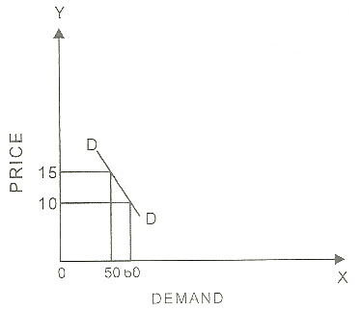

The diagram shows extension of demand. Quantity of demand is shown on OX axis. The price is shown on OY axis. DD is demand curve. When price comes down the quantity demanded extends and demand curve moves downward.

**Contraction of demand**

There is contraction of demand for a commodity when there is increase in the price of commodity. When price is 10 dollars per kilogram the demand is 40 kilograms. When price increases to 20 dollars there is contraction of demand from 40 to 30 kilograms.

|  |  |
| --- | --- |
| Price | Demand |
| $10 | 40 kg |
| 20 | 30 |

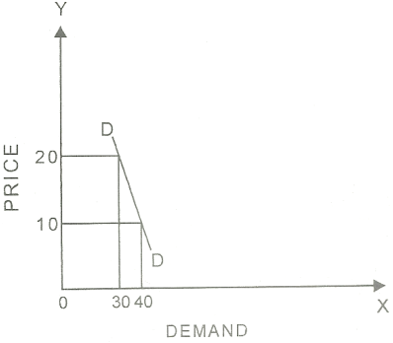

The diagram shows contraction of demand. Quality of demand is shown on OX axis. The price is shown on OY axis. DD is demand curve. When price increases the quantity demanded comes down and demand curve moves upward.

**Elasticity Of Demand:**

In economics, the demand elasticity (elasticity of demand) refers to how sensitive the demand for a good is to changes in other economic variables, such as prices and consumer income. Demand elasticity is calculated as the percent change in the quantity demanded divided by a percent change in another economic variable***. Higher demand elasticity for an economic variable means that consumers are more responsive to changes in this variable***

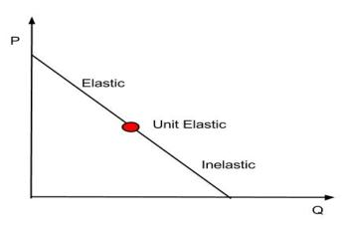

***Definition:*** *The* ***Elasticity of Demand*** *is a measure of change in the quantity demanded in response to the change in the price of the commodity. Simply, the effect of a change of price on the quantity demanded is called as the elasticity of demand.*

**Understanding Demand Elasticity**

Demand elasticity measures change in demand for a good when another economic factor changes. Demand elasticity helps firms model the potential change in demand due to changes in the price of a good, the effect of changes in prices of other goods, and many other important market factors. If the demand for a good is more elastic, in response to changes in other economic factors, companies must use caution when raising prices.

Demand elasticity is typically measured in absolute terms. If demand elasticity is greater than 1, it is elastic: Demand is sensitive to economic changes (e.g., price). Demand elasticity that is less than 1 is inelastic: Demand does not change relative to economic changes such as price. Demand is unit elastic when the absolute value of demand elasticity is equal to 1, which means that demand will move proportionately with economic changes.

Suppose that a company calculated that the demand for a soda product increases from 100 to 110 bottles because of the price decrease from $2 to $1.50 per bottle. The price elasticity is calculated as the percentage change in quantity demanded (110 - 100 / 100 = 10%) divided by a percentage change in price ($2 - $1.50 / $2). The price elasticity of demand for this example is thus 0.4. Since the result is less than 1, it is inelastic; the change in price has little effect on the quantity demanded.

***Marshall, a renowned economist, has suggested a mathematical method to measure the elasticity of demand:***

[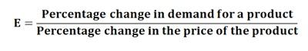](https://businessjargons.com/wp-content/uploads/2016/04/Elasticity-of-demand-1.jpg)

According to this formula, the elasticity of demand can be defined as a percentage change in demand as a result of the percentage change in price. Numerically, it can be written as:

[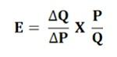](https://businessjargons.com/wp-content/uploads/2016/04/Elasticity-of-demand-2.jpg)

***Where***  
ΔQ = Q1 –Q0  
ΔP = P1 – P0Q1= New quantity  
Q2= Original quantity  
P1 = New price  
P0 = Original price

**Importance of Elasticity of Demand**

* The concept of demand elasticity helps in understanding the price determination by the monopolist. A monopoly is the market structure wherein there is only one seller whose main objective is to maximize the profits. The price he chooses for his product depends on the elasticity of demand. Such as, if the demand for a commodity is high he can choose the higher price as the consumers will buy the product even when the price rise. But however, if the demand is elastic, he will choose the lower prices.
* The determination of the price depends on demand for and supply of the commodity. But however, the demand is governed by the demand elasticity and the supply too is governed by the elasticity of supply. Therefore, the price of a commodity depends on both the demand and supply elasticity.
* The concept of demand elasticity also helps in understanding other types of prices, such as exchange rates, i.e. a rate at which currency unit of one country is exchanged for the currency unit of another country. Also, the terms of trade, i.e. the rate at which the exports are changed for imports can be easily understood through this concept.
* The concept of elasticity of demand also helps the government in its taxation policies. This helps the government to have a fair idea about the demand elasticity of goods which are being taxed.
* This concept also helps in the determination of wages, such as if the demand for labor is inelastic the union can demand higher wages and conversely if the labor demand is elastic the demand for higher wages could not be raised.

Thus, the concept of elasticity of demand is very important to understand the economic problems and policies. This is very well elucidated through the points explained above.

**Types of Elasticity of Demand**

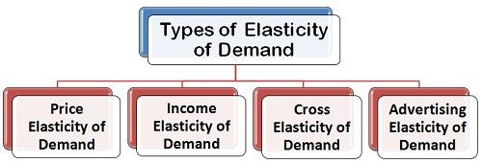

• Price **Elasticity of Demand:** The price elasticity of demand, commonly known as the elasticity of demand refers to the responsiveness and sensitiveness of demand for a product to the changes in its price. In other words, the price elasticity of demand is equal to

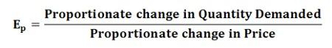

***Numerically,***

[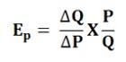](https://businessjargons.com/wp-content/uploads/2016/04/Price-elasticity-of-demand-2.jpg)

**ΔQ = Q1 –Q0,**

**ΔP = P1 – P0,**

***Where***

Q1= New quantity,

Q2= Original quantity,

P1 = New price,

P0 = Original

**Types of Price Elasticity of Demand**:

* Perfectly Elastic Demand
* Perfectly Inelastic Demand
* Relatively Elastic Demand
* Relatively Inelastic Demand
* Unitary Elastic Demand

• **Income Elasticity of Demand:** The income is the other factor that influences the demand for a product. Hence, the degree of responsiveness of a change in demand for a product due to the change in the income is known as income elasticity of demand. The formula to compute the income elasticity of demand is:

[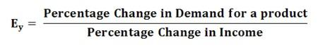](https://businessjargons.com/wp-content/uploads/2016/04/types-2.jpg)

For most of the goods, the income elasticity of demand is greater than one indicating that with the change in income the demand will also change and that too in the same direction, i.e. more income means more demand and vice-versa.

• **Cross Elasticity of Demand:** The cross elasticity of demand refers to the change in quantity demanded for one commodity as a result of the change in the price of another commodity. This type of elasticity usually arises in the case of the interrelated goods such as substitutes and complementary goods. The cross elasticity of demand for goods X and Y can be expressed as:

[types-3](https://businessjargons.com/wp-content/uploads/2016/04/types-3.jpg)

The two commodities are said to be complementary, if the price of one commodity falls, then the demand for other increases, on the contrary, if the price of one commodity rises the demand for another commodity decreases. For example, petrol and car are complementary goods.

While the two commodities are said to be substitutes for each other if the price of one commodity falls, the demand for another commodity also decreases, on the other hand, if the price of one commodity rises the demand for the other commodity also increases. For example, tea and coffee are substitute goods.

## Types of price Elasticity of Demand

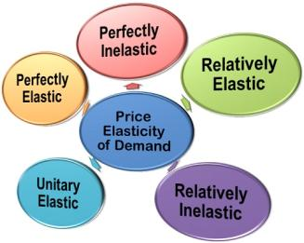

**Perfectly Elastic Demand (Ep = ∞):** The demand is said to be perfectly elastic when a slight change in the price of a commodity causes a major change in its quantity demanded. Such as, even a small rise in the price of a commodity can result into fall in demand even to zero. Whereas a little fall in the price can result in the increase in demand to infinity.  
In perfectly elastic demand the demand curve is a **straight horizontal line** which shows, the flatter the demand curve the higher is the elasticity of demand.

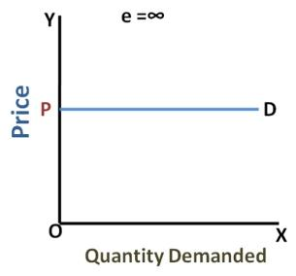

**Perfectly Inelastic Demand (Ep =0):** When there is no change in the demand for a product due to the change in the price, then the demand is said to be perfectly inelastic. Here, the demand curve is a **straight vertical line** which shows that the demand remains unchanged irrespective of change in the price., i.e. quantity OQ remains unchanged at different prices, P1, P2, and P3.

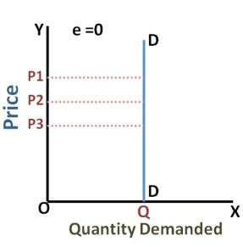

**Relatively Elastic Demand (1 to ∞):** The demand is relatively elastic when the proportionate change in the demand for a commodity is greater than the proportionate change in its price. Here, the demand curve is **gradually sloping** which shows that a proportionate change in quantity from OQ0 to OQ1 is greater than the proportionate change in the price from OP1 to Op2.

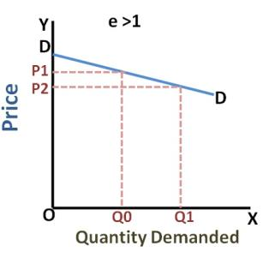

**Relatively Inelastic Demand (0-1):** When the proportionate change in the demand for a product is less than the proportionate change in the price, the demand is said to be relatively inelastic demand. It is also called as the elasticity less than unity, i.e. 1. Here the demand curve is **rapidly sloping**, which shows that the change in the quantity from OQ0 to OQ1 is relatively smaller than the change in the price from OP1 to Op2.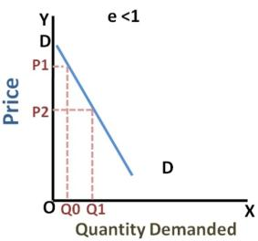

**Unitary Elastic Demand (Ep =1):** The demand is unitary elastic when the proportionate change in the price of a product results in the same change in the quantity demanded. Here the shape of the demand curve is a **rectangular hyperbola**, which shows that area under the curve is equal to one.

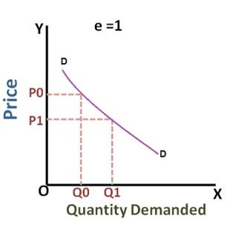

**DEMAND FORECASTING**

**Definition**

**Demand Forecasting:*refers to the process of predicting the future demand for the firm’s product. In other words, demand forecasting is comprised of a series of steps that involves the anticipation of demand for a product in future under both controllable and non-controllable factors.***

The business world is characterized by risk and uncertainty, and most of the business decisions are taken under this scenario. An organization come across several risks, both internal or external to the business operations such as technology, attrition, unrest, employee grievances, recession, inflation, modifications in the government laws, etc.

**Predicting the future demand for a product helps the organization in making decisions in one of the following areas:**

* Planning and scheduling the production and acquiring the inputs accordingly.
* Making the provisions for finances.
* Formulating a pricing strategy.
* Planning advertisement and implementing it.

Demand forecasting **holds significance in the businesses where large-scale production** is involved. Since the large-scale production requires a long gestation period, a good deal of forward planning should be done. Also, the potential future demand should be estimated to avoid the conditions of overproduction and underproduction. Most often, the firms face a question of what would be the future demand for their product as they have to acquire the input (labor and raw material) accordingly.

The objective of demand forecasting is attained only when the forecasting is done systematically and scientifically. Thus, the following **steps in demand forecasting** are followed to facilitate a systematic estimation of future demand for product:

1. Specifying the Objective
2. Determining the Time Perspective
3. Choice of method for Demand Forecasting
4. Collection of Data and Data Adjustment
5. Estimation and Interpretation of Results

Thus, demand forecasting is a systematic process that assumes greater significance in large-scale producing firms. Demand forecasting may not be a serious issue for the small scale firms which supply a small portion of total demand or produces the product that caters to the short demand or seasonal demand. Such firms can plan their production on the basis of the business skills and their past experiences.

**Demand Forecasting** is a systematic process of predicting the future demand for a firm’s product. Simply, estimating the potential demand for a product in the future is called as demand forecasting.

The demand forecasting finds its significance where the large-scale production is involved. Such firms may often face difficulties in obtaining a fairly accurate estimation of future demand. Thus, it is essential to forecast demand systematically and scientifically to arrive at desired objective. Therefore, the following steps are taken to facilitate a systematic demand forecasting:

1. **Specifying the Objective:** The objective for which the demand forecasting is to be done must be clearly specified. The objective may be defined in terms of; long-term or short-term demand, the whole or only the segment of a market for a firm’s product, overall demand for a product or only for a firm’s own product, firm’s overall market share in the industry, etc. The objective of the demand must be determined before the process of demand forecasting begins as it will give direction to the whole research.
2. **Determining the Time Perspective:** On the basis of the objective set, the demand forecast can either be for a short-period, say for the next 2-3 year or a long period. While forecasting demand for a short period (2-3 years), many determinants of demand can be assumed to remain constant or do not change significantly. While in the long run, the determinants of demand may change significantly. Thus, it is essential to define the time perspective, i.e., the time duration for which the demand is to be forecasted.
3. **Making a Choice of Method for Demand Forecasting:** Once the objective is set and the time perspective has been specified the method for performing the forecast is selected. There are several methods of demand forecasting falling under two categories; **survey methods** and **statistical methods**.

The Survey method includes consumer survey and opinion poll methods, and the statistical methods include trend projection, barometric and econometric methods. Each method varies from one another in terms of the purpose of forecasting, type of data required, availability of data and time frame within which the demand is to be forecasted. Thus, the forecaster must select the method that best suits his requirement.

1. **Collection of Data and Data Adjustment:** Once the method is decided upon, the next step is to collect the required data either primary or secondary or both. The primary data are the first-hand data which has never been collected before. While the secondary data are the data already available. Often, data required is not available and hence the data are to be adjusted, even manipulated, if necessary with a purpose to build a data consistent with the data required.
2. **Estimation and Interpretation of Results:** Once the required data are collected and the demand forecasting method is finalized, the final step is to estimate the demand for the predefined years of the period. Usually, the estimates appear in the form of equations, and the result is interpreted and presented in the easy and usable form.

Thus, the objective of demand forecasting can only be achieved only if these steps are followed systematically.

# Methods of Demand Forecasting

**Definition:Demand Forecasting** is a systematic and scientific estimation of future demand for a product. Simply, estimating the sales proceeds or demand for a product in the future is called as demand forecasting.

There are several methods of demand forecasting applied in terms of; the purpose of forecasting, data required, data availability and the time frame within which the demand is to be forecasted. Each method varies from one another and hence the forecaster must select that method which best suits the requirement.

**The methods of forecasting can be classified into two broad categories:**

[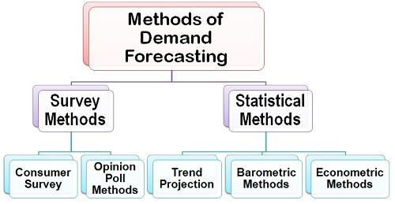](https://businessjargons.com/wp-content/uploads/2016/06/Methods-of-Demand-Forecasting.jpg)

1. **Survey Methods:** Under the survey method, the consumers are contacted directly and are asked about their intentions for a product and their future purchase plans. This method is often used when the forecasting of a demand is to be done for a short period of time. **The survey method includes**:

[**Consumer Survey Method**](https://businessjargons.com/consumer-survey-method.html)

[**Opinion Poll Methods**](https://businessjargons.com/opinion-poll-method.html)

1. **Statistical Methods:** The statistical methods are often used when the forecasting of demand is to be done for a longer period. The statistical methods utilize the time-series (historical) and cross-sectional data to estimate the long-term demand for a product. The statistical methods are used more often and are considered superior than the other techniques of demand forecasting due to the following reasons:

* There is a minimum element of subjectivity in the statistical methods.
* The estimation method is scientific and depends on the relationship between the dependent and independent variables.
* The estimates are more reliable
* Also, the cost involved in the estimation of demand is the minimum

**Concept of Revenue**

The term revenue refers to the income obtained by a firm through the sale of goods at different prices. In the words of Dooley, ‘the revenue of a firm is its sales, receipts or income’. The amount of money that a producer receives in exchange for the sale proceeds is known as revenue. For example, if a firm gets Rs. 16,000 from sale of 100 chairs, then the amount of Rs. 16,000 is known as revenue. Revenue refers to the amount received by a firm from the sale of a given quantity of a commodity in the market.

*Revenue is a very important concept in economic analysis. It is directly influenced by sales level, i.e., as sales increases, revenue also increases*.

### Concept of Revenue:

The concept of revenue consists of three important terms; Total Revenue, Average Revenue and Marginal Revenue.

**[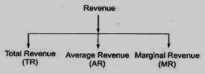](http://cdn.yourarticlelibrary.com/wp-content/uploads/2013/09/clip_image00250.jpg)**

#### Total Revenue (TR):

The income earned by a seller or producer after selling the output is called the total revenue. In fact, total revenue is the multiple of price and output. The behavior of total revenue depends on the market where the firm produces or sells.

***“Total revenue is the sum of all sales, receipts or income of a firm.”***

***~ Dooley***

***Total revenue may be defined as the “product of planned sales (output) and expected selling price.” Clower and Due***

***“Total revenue at any output is equal to price per unit multiplied by quantity sold.”***

***Stonier and Hague***

[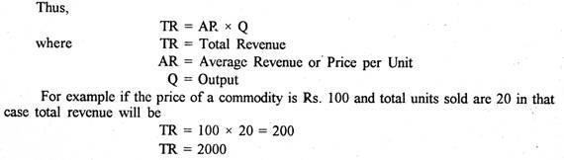](http://cdn.economicsdiscussion.net/wp-content/uploads/2015/05/clip_image0045.jpg)

#### Average Revenue:

Average revenue refers to the revenue obtained by the seller by selling the per unit commodity. It is obtained by dividing the total revenue by total output.

***“The average revenue curve shows that the price of the firm’s product is the same at each level of output.”***

***~Stonier and Hague***

[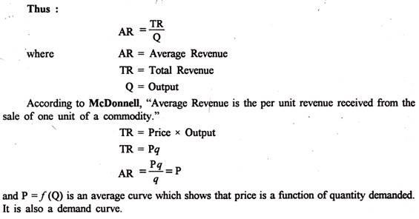](http://cdn.economicsdiscussion.net/wp-content/uploads/2015/05/clip_image0065.jpg)

#### Marginal Revenue:

Marginal revenue is the net revenue obtained by selling an additional unit of the commodity***. “Marginal revenue is the change in total revenue which results from the sale of one more or one less unit of output.”***

***~Ferguson.***

Thus, marginal revenue is the addition made to the total revenue by selling one more unit of the good. In algebraic terms, marginal revenue is the net addition to the total revenue by selling n units of a commodity instead of n – 1.

**Therefore,**

[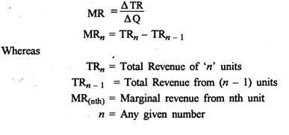](http://cdn.economicsdiscussion.net/wp-content/uploads/2015/05/clip_image0082.jpg)

***“The marginal revenue is the change in total revenue resulting from selling an additional unit of the commodity.”***

***~A. Koutsoyiannis***

***If*** total revenue from (n) units is 110 and from (n – 1) units is 100.

in that case

**MRnth = TRn – TRn _ 1 = 100 – 100**

**MRnth = 10**

**MR in mathematical terms is the ratio of change in total revenue to change in output**

**MR = ∆TR/∆q or dR/dq = MR**

**Table Representation:**

The relationship between TR, AR and MR can be expressed with the help of a table 1. [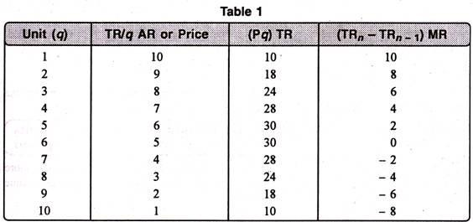](http://cdn.economicsdiscussion.net/wp-content/uploads/2015/05/clip_image0102.jpg)

From the table 1 we can draw the idea that as the price falls from Rs. 10 to Re. 1, the output sold increases from 1 to 10. Total revenue increases from 10 to 30, at 5 units. However, at 6th unit it becomes constant and ultimately starts falling at next unit i.e. 7th. In the same way, when AR falls, MR falls more and becomes zero at 6th unit and then negative. Therefore, it is clear that when AR falls, MR also falls more than that of AR: TR increases initially at a diminishing rate, it reaches maximum and then starts falling.

**The formula to calculate TR, AR and MR is as under:**

**TR = P x q**

**Or TR = MR1 + MR2 + MR3 + MR3 +….. MR„**

**TR**

**AR = TR/q MR = TRn – TRn _ x**

In fig. 1 three concepts of revenue have been explained. The units of output have been shown on horizontal axis while revenue on vertical axis. Here TR, AR, MR are total revenue, average revenue and marginal revenue curves respectively.

In figure 1 (A), a total revenue curve is sloping upward from the origin to point K. From point K to K’ total revenue is constant. But at point K’ total revenue is maximum and begins to fall. It means even by selling more units total revenue is falling. In such a situation, marginal revenue becomes negative.

Similarly, in the figure 1 (B) average revenue curves are sloping downward. It means average revenue falls as more and more units are sold.

In fig. 1 (B) MR is the marginal revenue curve which slopes downward. It signifies the fact that MR with the sale of every additional unit tends to diminish. Moreover, it is also clear from the fig. that when both AR and MR are falling, MR is less than AR. MR can be zero, positive or negative but AR is always positive.

[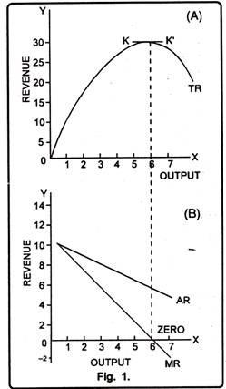](http://cdn.economicsdiscussion.net/wp-content/uploads/2015/05/clip_image0121.jpg)

**Unit III**

* **Production –fixed and variable inputs**
* **Production function**
* **TP,AP MP**
* **Law of variable proportions**
* **Linear homogenous production**
* **Production isoquants**
* **Optimal combination of resource to return**
* **Concept of cost**
* **Economies and diseconomies of scale**

#### Definition

Production in ordinary sense means creation of a commodity. We say the carpenter has produced the chair. But in Economics it is a wrong view. The carpenter has given shape to the wood which is a free gift of nature as a result of which it has become more useful to us than before. He has strictly speaking, created additional utility. So production in Economics means creation of new utility. Man takes the things given by nature and simply gives it a new form so that it becomes more useful to us than before.

**Man may create additional utility in at least three ways:**

(a) By changing the form of an object of nature, viz., iron ore into steel, wood into furniture. It is known as form utility.

(b) By changing the place, i.e., transferring a thing from the place of abundance to the place of scarcity. It is called place utility.

(c) Utility may be increased by transferring a thing from one time to another, i.e., when it is relatively abundant to a time when it is scarce. It is what is known as place utility.

Production requires co-operation of certain factors. These are known as agents of production. Broadly, there are five such agents, namely entreprenuer, land, labour, capital and organisation. Land includes both manual and intellec­tual labour. Capital is produced means of production.

#### Types of Production:

ADVERTISEMENTS:

**For general purposes, it is necessary to classify production into three main groups:**

**1. Primary production:**

Primary production is carried out by ‘extractive’ industries like agriculture, forestry, mining and oil extraction. These indus­tries are engaged in such activities as extracting the gifts of Nature from beneath the earth’s surface and from the oceans. Primary activities refer to such things as extraction of raw materials from the earth’s surface, e.g., coal mining or pisiculture (fishing). In advanced countries, the primary sector is providing less employment because machinery is replacing man power.

**2. Secondary production:**

This includes production in manufacturing industry, viz., turning out semi-finished and finished goods from raw materials and intermediate goods — conversion of flour into bread or iron ore into finished steel. These activities are generally described as manufac­turing and construction industries, such as the manufacture of cars, furnishing, clothing and chemicals, as also engineering and building. In short, secondary production is concerned with conversion of raw mate­rials into finished products, e.g., manufacturing motor cars, shirts, medicines, food, etc.

**3. Tertiary production:**

Industries in the tertiary sector produce all those services which enable the finished goods to be put in the hands of consum­ers. In fact, these services are supplied to the firms in all types of industries and directly to consumers. Examples cover distributive traders, banking, insurance, transport and communications. Government services, such as law, administration, education, health and defence, are also included.

**Serv­ices provided by the tertiary sector are essentially of two types:**

(a) Commer­cial services; and,

(b) Social services.

**(a) Commercial services:**

There are various examples of such services. For example, an estate agent selling a house, a car mechanic mends a vehicle. These types of services are increasing in volume and importance as people are becoming more and more service-oriented. Thus, luxury serv­ices, such as eating out at restaurants and playing golf, are becoming more popular.

**(b) Social services:**

These services are provided free or subsidised at a cheap rate, because the government thinks these are desirable. These are not provided in order to make a profit, but to meet an important need. Exam­ples are medical treatment, and services such as these have increased because the government wants more should be provided.

#### ****Agents of Production:****

Production in ordinary sense means creation of a commodity. We say the carpenter has produced the chair. But, in Economics it is a wrong view. The carpenter has given shape to the wood which is a free gift of nature as a result of which it has become more useful to us than before.

He has strictly speaking, created additional utility. So, production in Economics means creation of new utility. Man takes the things given by nature and simply gives it a new form so that it becomes more useful to us than before.

**Man may create additional utility in at least three ways:**

(a) By changing the form of an object of nature, viz., iron ore into steel, wood into furniture. It is known as form utility.

(b) By changing the place, i.e., transferring a thing from the place of abundance to the place of scarcity. It is called place utility.

(c) Utility may be increased by transferring a thing from one time to another, i.e., when it is relatively abundant to a time when it is scarce. It is what is known as place utility.

Production requires cooperation of certain factors. These are known as agents of production. Broadly, there are four such agents, namely, land, labour, capital and organisation. Land includes both manual and intellec­tual labour. Capital is produced means of production.

Organisation is a broad term. It is the factor that faces all the challenges and hazards of production. It pilots the ships of production unit through storm and strain. Factors of production may again be classified into two categories — fixed factors and variable factors. The former include those factors whose quantity cannot be changed in the short-run, such as capital goods.

The cost incurred for such factors is known as fixed cost or supple­mentary cost. There are some other factors the quantity of which must vary with the level of output, e.g., raw materials cost, casual labour costs, etc. In the long run all factors are likely to be variable, The former include those factors whose quality cannot be changed in the short-run such as capital goods. The cost incurred for such factors is known as fixed cost or supplementary cost. There are some other factors the quantity of which must vary with the level of output — e.g., raw materials cost, casual labour costs, etc. In the long-run all factors are likely to be variable

**Production Function**

In simple words, production function refers to the functional relationship between the quantity of a good produced (output) and factors of production (inputs).

“The production function is purely a technical relation which connects factor inputs and output.” Prof. Koutsoyiannis

Production function reflects how much output we can expect if we have so much of labour and so much of capital as well as of labour etc. In other words, we can say that production function is an indicator of the physical relationship between the inputs and output of a firm.

Mathematically, such a basic relationship between inputs and outputs may be expressed as:

**Q = f( L, C, N )**

Where

**Q = Quantity of output**

**L = Labour**

**C = Capital**

**N = Land.**

**Hence, the level of output (Q), depends on the quantities of different inputs (L, C, N) available to the firm. In the simplest case, where there are only two inputs, labour (L) and capital (C) and one output (Q), the production function becomes.**

**Q =f (L, C)**

***“The relationship between inputs and outputs is summarized in what is called the production function. This is a technological relation showing for a given state of technological knowledge how much can be produced with given amounts of inputs.”***

***~ Prof. Richard J. Lipsey***

### ****Total Product****

In simple terms, we can define Total Product as the total volume or amount of final output produced by a firm using given inputs in a given period of time.

### ****Marginal Product****

The additional output produced as a result of employing an additional unit of the variable factor input is called the Marginal Product. Thus, we can say that marginal product is the addition to Total Product when an extra factor input is used.

Marginal Product = Change in Output/ Change in Input

Thus, it can also be said that Total Product is the summation of Marginal products at different input levels.

Total Product = Ʃ Marginal Product

### ****Average Product****

It is defined as the output per unit of factor inputs or the average of the total product per unit of input and can be calculated by dividing the Total Product by the inputs (variable factors).

Average Product = Total Product/ Units of Variable Factor Input

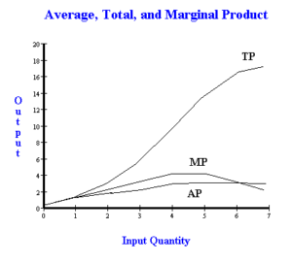

### Relationship between Marginal Product and Total Product

The **law of variable proportions** is used to explain the relationship between Total Product and Marginal Product. It states that when only one variable factor input is allowed to increase and all other inputs are kept constant, the following can be observed:

* When the Marginal Product (MP) increases, the Total Product is also increasing at an increasing rate. This gives the Total product curve a convex shape in the beginning as variable factor inputs increase. This continues to the point where the MP curve reaches its maximum.
* When the MP declines but remains positive, the Total Product is increasing but at a decreasing rate. Thisgiveends the Total product curve a concave shape after the **point of inflexion**. This continues until the Total product curve reaches its maximum.
* When the MP is declining and negative, the Total Product declines.
* When the MP becomes zero, Total Product reaches its maximum.

### Relationship between Average Product and Marginal Product

There exists an interesting relationship between Average Product and Marginal Product. We can summarize it as under:

* When Average Product is rising, Marginal Product lies above Average Product.
* When Average Product is declining, Marginal Product lies below Average Product.
* At the maximum of Average Product, Marginal and Average Product equal each other.

**Law of variable proportions**

The law of variable proportions states that as the quantity of one factor is increased, keeping the other factors fixed, the marginal product of that factor will eventually decline. This means that upto the use of a certain amount of variable factor, marginal product of the factor may increase and after a certain stage it starts diminishing. When the variable factor becomes relatively abundant, the marginal product may become negative.

**Assumptions:** The law of variable proportions holds good under the following conditions:

1. ***Constant State of Technology***: First, the state of technology is assumed to be given and unchanged. If there is improvement in the technology, then the marginal product may rise instead of diminishing.
2. ***Fixed Amount of Other Factors***: Secondly, there must be some inputs whose quantity is kept fixed. It is only in this way that we can alter the factor proportions and know its effects on output. The law does not apply if all factors are proportionately varied.
3. ***Possibility of Varying the Factor proportions***: Thirdly, the law is based upon the possibility of varying the proportions in which the various factors can be combined to produce a product. The law does not apply if the factors must be used in fixed proportions to yield a product.

**Illustration of the Law:** The law of variable proportion is illustrated in the following table and figure. Suppose there is a given amount of land in which more and more labour (variable factor) is used to produce wheat.

The law of variable proportions states that as the quantity of one factor is increased, keeping the other factors fixed, the marginal product of that factor will eventually decline. This means that upto the use of a certain amount of variable factor, marginal product of the factor may increase and after a certain stage it starts diminishing. When the variable factor becomes relatively abundant, the marginal product may become negative.

**Assumptions:** The law of variable proportions holds good under the following conditions:

1. ***Constant State of Technology***: First, the state of technology is assumed to be given and unchanged. If there is improvement in the technology, then the marginal product may rise instead of diminishing.
2. ***Fixed Amount of Other Factors***: Secondly, there must be some inputs whose quantity is kept fixed. It is only in this way that we can alter the factor proportions and know its effects on output. The law does not apply if all factors are proportionately varied.
3. ***Possibility of Varying the Factor proportions***: Thirdly, the law is based upon the possibility of varying the proportions in which the various factors can be combined to produce a product. The law does not apply if the factors must be used in fixed proportions to yield a product.

**Illustration of the Law:** The law of variable proportion is illustrated in the following table and figure. Suppose there is a given amount of land in which more and more labour (variable factor) is used to produce wheat.

|  |  |  |  |
| --- | --- | --- | --- |
| **Units of Labour** | **Total Product** | **Marginal Product** | **Average Product** |
| 1 | 2 | 2 | 2 |
| 2 | 6 | 4 | 3 |
| 3 | 12 | 6 | 4 |
| 4 | 16 | 4 | 4 |
| 5 | 18 | 2 | 3.6 |
| 6 | 18 | 0 | 3 |
| 7 | 14 | -4 | 2 |
| 8 | 8 | -6 | 1 |

t can be seen from the table that upto the use of 3 units of labour, total product increases at an increasing rate and beyond the third unit total product increases at a diminishing rate. This fact is shown by the marginal product which is the addition made to Total Product as a result of increasing the variable factor i.e. labour.

It can be seen from the table that the marginal product of labour initially rises and beyond the use of three units of labour, it starts diminishing. The use of six units of labour does not add anything to the total production of wheat. Hence, the marginal product of labour has fallen to zero. Beyond the use of six units of labour, total product diminishes and therefore marginal product of labour becomes negative. Regarding the average product of labour, it rises up to the use of third unit of labour and beyond that it is falling throughout.

**Three Stages of the Law of Variable Proportions:** These stages are illustrated in the following figure where labour is measured on the X-axis and output on the Y-axis.

***Stage 1. Stage of Increasing Returns***: In this stage, total product increases at an increasing rate up to a point. This is because the efficiency of the fixed factors increases as additional units of the variable factors are added to it. In the figure, from the origin to the point F, slope of the total product curve TP is increasing i.e. the curve TP is concave upwards upto the point F, which means that the marginal product MP of labour rises. The point F where the total product stops increasing at an increasing rate and starts increasing at a diminishing rate is called the point of inflection. Corresponding vertically to this point of inflection marginal product of labour is maximum, after which it diminishes. This stage is called the stage of increasing returns because the average product of the variable factor increases throughout this stage. This stage ends at the point where the average product curve reaches its highest point.

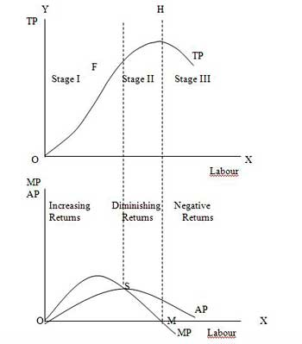

***Stage 2. Stage of Diminishing Returns:*** In this stage, total product continues to increase but at a diminishing rate until it reaches its maximum point H where the second stage ends. In this stage both the marginal product and average product of labour are diminishing but are positive. This is because the fixed factor becomes inadequate relative to the quantity of the variable factor. At the end of the second stage, i.e., at point M marginal product of labour is zero which corresponds to the maximum point H of the total product curve TP. This stage is important because the firm will seek to produce in this range.

***Stage 3. Stage of Negative Returns:*** In stage 3, total product declines and therefore the TP curve slopes downward. As a result, marginal product of labour is negative and the MP curve falls below the X-axis. In this stage the variable factor (labour) is too much relative to the fixed factor.

**Importance and Applicability of the Law ofVariable Proportion:**

The Law of Variable Proportion has universal applicability in any branch of production. It forms the basis of a number of doctrines in economics. The Malthusian theory of population stems from the fact that food supply does not increase faster than the growth in population because of the operation of the law of diminishing returns in agriculture.

Ricardo also based his theory of rent on this principle. According to him rent arises because the operation of the law of diminishing return forces the application of additional doses of labour and capital on a piece of land. Similarly the law of diminishing marginal utility and that of diminishing marginal physical productivity in the theory of distribution are also based on this theory.

The law is of fundamental importance for understanding the problems of underdeveloped countries. In such agricultural economies the pressure of population on land increases with the increase in population. This leads to declining or even zero or negative marginal productivity of workers. This explains the operation of the law of diminishing returns in LDCs in its intensive form. RagnarNurksehave suggested ways to make use of these disguisedly unemployed labour by withdrawing them and putting them in those occupations where the marginal productivity is positive.

**Linear Homogeneous Production Function**

**Definition:** The **Linear Homogeneous Production Function** implies that with the proportionate change in all the factors of production, the output also increases in the same proportion. Such as, if the input factors are doubled the output also gets doubled. This is also known as **constant returns to a scale.**

The production function is said to be homogeneous when the elasticity of substitution is equal to one. The linear homogeneous production function can be used in the empirical studies because it can be handled wisely. That is why it is widely used in linear programming and input-output analysis. This production function can be shown symbolically:

**nP = f(nK, nL)**

Where, n = number of times  
nP = number of times the output is increased  
nK= number of times the capital is increased  
nL = number of times the labor is increased

Thus, with the increase in labor and capital by “n” times the output also increases in the same proportion. The concept of linear homogeneous production function can be further comprehended through the illustration given below:

[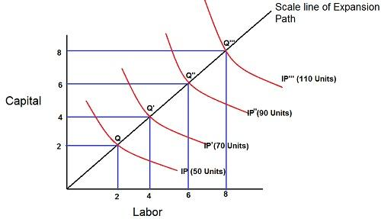](https://businessjargons.com/wp-content/uploads/2015/12/Linear-Homogeneous-production-function.jpg)In the case of a linear homogeneous production function, the expansion is always a straight line through the origin, as shown in the figure. This means that the proportions between the factors used will always be the same irrespective of the output levels, provided the factor prices remains constant.

The production function shows the relationship between the out­put of a good and the inputs (factors of production) required to make that good.

**It usually takes the following general form:**

Q = f (K, L, t, etc.)

Where Q is output, K is capital input, L is labour input, t is ‘technology or the art of production’ and the term ‘etc.’ indicates that other inputs may also be relevant (such as land, or raw materials). The production function shows how output changes are related to changes in inputs or factors of produc­tion. It is also an efficiency relation showing the maximum amount of output that can be obtained from a fixed amount of resources.

Production functions may take a variety of forms. Economists often work with homogeneous production functions. One example of such function is the famous Cobb-Douglas production function.

**Production Isoquants:**

The long-run production function involving the usage of two factors (say, capital and labour) is represented by isoquants or equal product curves (or production indifference curves).

**Definition:**

An isoquant is a curve or locus of points showing all possible combinations of inputs physically capable of producing a certain fixed level of output. An isoquant which lies above another shows a higher level of output.

Fig. 1 shows two typical isoquants — capital use is measured on the vertical axis and labour use on the horizontal. Isoquant Q1 shows the locus of combinations of capital and labour yielding 100 units of output. The producer can produce 100 units of out­put by using 10 units of capital and 75 of labour or 50 units of capital and 15 of labour, or by using any other combina­tion of inputs on Q1 = 100. Similarly, isoquant Q2 shows the various combi­nations of capital and labour that can produce 200 units of output.

[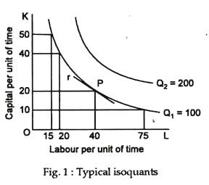](http://cdn.economicsdiscussion.net/wp-content/uploads/2016/12/clip_image0021.jpg)

We can draw any number of iso­quants in Fig. 1 because there are an infinite number of possible production levels between 100 and 200 units (as also below 100 units or above 200 units).

**Properties:**

Isoquants have four important properties.

**These are the following:**

1. Firstly, an isoquant which lies above and to the right of another shows a higher level of output. So, any point on a higher isoquant is always better than any point on a lower isoquant.

2. Secondly, isoquants cannot meet or intersect one another. If they did, then one combination of K and L would yield two different levels of output. The producer’s technology is inconsistent. We rule out such events.

3. Thirdly, as shown in Fig. 1, isoquants slope downward over the relevant range of production. This negative slope indicates that, if the producer decreases the amount of capital employed, more labour must be added in order to keep the rate of output constant. Or, if labour use is decreased, capital use must be increased to keep output constant. Thus, the two inputs can be substituted for one another to maintain a constant level of output.

**The marginal rate of technical substitution (MRTS):**

**The rate at which one input can be substituted for another along an isoquant is called the marginal rate of technical substitution (MRTS), defined as:**

MRTSL for K = – ∆K/∆L

where K is capital, L is labour and ∆ denotes any change. The minus sign is added in order to make MRTS a positive number, since ∆K/∆L, the slope of the isoquant, is negative.

For any movement along an isoquant, the MRTS equals the ratio of the marginal products of the two inputs.

**To prove this, suppose the use of L increases by 3 units and K by 5. If, in this stage, the MPL is 4 units of Q per unit of L and that of K is 2 units of Q per unit of K, the resulting change in output (Q) is:**

ADVERTISEMENTS:

∆Q = (4 x 3) + (2 x 5) = 22

This means that when L and K are allowed to vary slightly, the change in Q resulting from the change in the two inputs is the marginal product of L times the amount of change in L plus the marginal product of K times its change.

**As a general rule:**

∆Q = MPL. ∆L + MPK.∆K.

**Along an isoquant, Q is constant; therefore ∆Q equals zero. Setting ∆Q in the above equation equal to zero and solving for the slope of the isoquant, ∆K/∆L, we have:**

∆K/∆L = MPL/MPK = MRTSLfor K

Since along an isoquant K and L must vary inversely, ∆K/∆L is negative.

4. Fourthly, over the relevant stage, the MRTS diminishes. This means that isoquants are convex to the origin. This point is illustrated in Fig. 1. If capital is decreased by 10 units, from 50 to 40, labour must be increased by only 5 units, from 15 to 20, in order to keep the level of output at 100 units. If capital is decreased by 10 units, from 20 to 10, labour must be increased by 35 units, from 40 to 75, to keep output at 100 units.

**Optimal Combination of Resources:**

A rational producer has the goal of either maximising output given a fixed budget (say, Rs. 300 per day) or minimising cost given a required output to produce (say, 150 units). Each goal is a problem of constrained optimisation.

Our task here is to determine the specific combinations of inputs a firm should select when it is constrained. Here we will observe that a firm attains the highest possible level of output for any given level of cost or the lowest possible cost for producing any level of output when the MRTS for any two inputs equals the ratio of their prices.

**Input Prices and Isocost Lines:**

The total cost, C, of using any value of K and L is C = r k + w L, the sum of the cost of K units of capital at a price of r per unit and of L units of labour at price of w per unit.

Suppose, capital costs Rs. 30 per unit (r = Rs 30) and labour receives a wage of Rs. 15 per day (w = Rs. 15). If only capital is used we have: C = r K + 0 and the maximum amount of capital that can be purchased is K = C/r = Rs. 300/Rs. 30 = 10 units. Similarly, if only labour is hired, we have: C = 0 + w L and the maximum number of workers that can be hired (per day) is L = C/w = Rs. 300/Rs. 15 = 20. We can also think of various other combinations of capital and labour that can be purchased (hired) with the same budget.

The budget equation is illustrated in Fig. 2. The line AB is called the isocost line or the line of equal cost. It is indeed the producer’s budget line.

[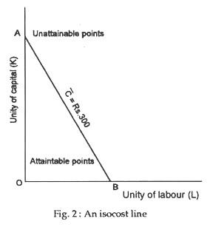](http://cdn.economicsdiscussion.net/wp-content/uploads/2016/12/clip_image0041-1.jpg)

**Definition and Scope:**

The isocost line is a locus of points showing alternative combinations of K and L that can be purchased with a fixed amount of money at prevailing market prices.

**Its slope is:**

[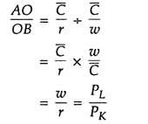](http://cdn.economicsdiscussion.net/wp-content/uploads/2016/12/clip_image005-4.jpg)

This is called the factor price ratio or the actual rate of factor substitution. Here, w is the price of labour (PL) and r is the price of capital (PK).

**Output Maximisation subject to Cost Constraint:**

A rational producer, whose ob­jective is output maximisation subject to cost constraint, will always try to reach the highest attainable isoquant permitted by the isocost line. This point is illustrated in Fig. 3. Here, the producer reaches Q2 with his isocost line AB and produces 150 units of output at a cost of Rs 300. So, cost per unit is Rs. 2. Can total cost be reduced further?

[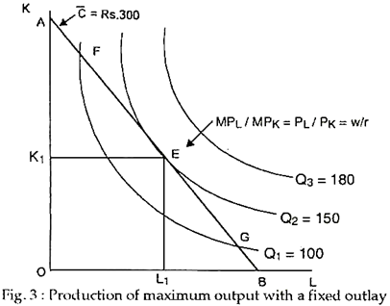](http://cdn.economicsdiscussion.net/wp-content/uploads/2016/12/image-21.png)

No. If, through mistake or miscalculation, the producer moves to point F or G along the same isoquant, his total cost (outlay) will remain the same, but his output will fall to 100 units. So, his cost per unit will rise to 150 units. Thus, only point E can be an op­timal point. And the com­bination of K and L corresponding to the point (viz., K1 and L1) is called the least-cost com­bination. So, a rational producer maximises out­put by choosing the least- cost combination of inputs, the prices of which are taken as given (i.e., de­termined by market forces).

**At point E the slope of the isoquant or MRTS is equal to the slope of the isocost line:**

**[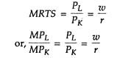](http://cdn.economicsdiscussion.net/wp-content/uploads/2016/12/clip_image008-1.jpg)**

**Production of a Fixed Output at the Lowest Cost:**

Suppose, now, that the objective of the producer is to produce exactly 150 units of output, neither more nor less. This goal can also be achieved by choosing the least cost combination of inputs or by fulfilling the above condition. In Fig. 4 the only isoquant indicating an output of 150 units just touches the isocost line A2B2 at point E.

[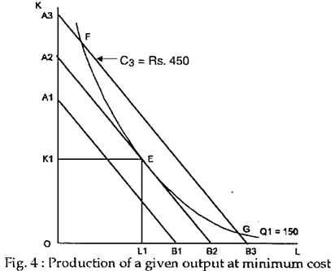](http://cdn.economicsdiscussion.net/wp-content/uploads/2016/12/image-22.png)

This meant that the minimum cost of producing a given output of 150 units is Rs. 2. If the producer moves to the right or left of point E along the same isoquant, cost will rise. Thus, E is the optimum point, indicating least cost combination of inputs. For ex­ample, at point on output is 30 units but total cost is Rs. 100 which means that cost per unit is Rs. 3.

**Conclusion:**

Thus, the two alternative strategies illus­trated here give the same results. In Order to maximise output subject to a given cost or to minimise cost subject to a given output, the producer must employ inputs in such amounts as to equate the marginal rate of technical substitution and the factor price ratio.

**Cost Concepts**

Cost analysis is all about the study of the behavior of cost with respect to various production criteria like the scale of operations, prices of the factors of production, size of output, etc. It is all about the financial aspects of production. In order to understand the cost function well, in this article, we will look at various cost concepts.

**Cost Concepts**

***Accounting and Economic Costs***

When a firm starts producing goods, it has to pay the price for the factors employed for the production. These factors include wages to workers employed, prices for the raw materials, fuel and power used, rent for the building he hires, and interest on the money borrowed for doing business, etc. Accounting Costs are these costs which are included in the cost of production. Hence, accounting costs take care of all payments and charges that the firm makes to suppliers of different productive factors.

Usually, a businessman invests some capital in his firm. If he would have invested the amount in some other firm, then he could have earned a certain interest/dividend. Further, he invests time for his business and also contributes his entrepreneurial and managerial ability to the business. If not involved in the business, he could have offered his services to other firms for an amount of money. Accounting costs DO NOT involve these costs. They form a part of the Economic Costs. Hence, Economic costs include:

* The normal return on the money that the businessman invests in his own business
* The salary not paid to the entrepreneur but could have been earned if the services would have been sold elsewhere.
* A reward for all factors owned by the businessman and used in his own business.

Therefore, the accounting costs involve cash payments that the firm makes. Economic costs, on the other hand, include the accounting costs and also take into account the amount of money the businessman could have earned with his resources if he would not have started the business.

Another name for accounting costs is Explicit Costs. Whereas, the alternate name for the costs of factors that the businessman owns is Implicit Costs. A businessman earns profits when his revenues exceed both explicit and implicit costs.



***Outlay and Opportunity Costs***

Outlay costs include the actual expenditure of funds on factors like material, rent, wages, etc. On the other hand, opportunity costs are the costs of missed opportunities. In other words, it compares the policy chosen and policy rejected.

Outlay cost concepts are actual expenditures and the books of accounts record them. Opportunity costs are about sacrificed opportunities and the books of accounts do not record them. These costs are very useful. For example, if a cloth mill spins its own yarn, the opportunity cost of yarn to the weaving department is the price at which the yarn sells. This is used for measuring the profitability of the weaving operations.

***Direct or Traceable Costs and Indirect or Non-Traceable Costs***

Direct costs – costs which are easily identifiable and traceable to a particular product, operation or plant. For example, manufacturing costs are direct costs since they can be related to either a product line or territory or customer class, etc. Ensure that you know the purpose of the cost calculation before determining if a cost is direct or indirect.

Indirect costs – costs which are not easily identifiable or traceable to specific goods, services, operations, etc. These costs bear some functional relationship to production and may vary with the output. For example, costs related to electric power and the common costs incurred for the general operation of the business benefitting all products.

***Fixed and Variable Costs***

[Fixed costs](https://www.toppr.com/guides/quantitative-aptitude/profit+and-loss/fixed-variable-and-semi-variable-cost/) or Constant costs are not a function of the output. That is, they do not vary with the output up to a certain extent. They require a fixed expenditure of funds regardless of the output. For example, rent, property taxes, interest on loans, etc. However, note that fixed costs can vary with the size of the plant and are usually a function of capacity. Therefore, we can conclude that fixed costs do not vary with the output volume within a capacity level.

Businesses cannot avoid fixed costs and are applicable as long as the business is operating. Alternate names for fixed costs are inescapable or uncontrollable costs. It is important to note here, that some fixed costs continue even after the suspension of business. For example, costs associated with storing of machines that the business cannot sell in the market, etc.

### Fixed Cost

A fixed cost is the other cost incurred by businesses and corporations. Unlike the variable cost, a company's fixed cost does not vary with the volume of production. It remains the same even if no goods or services are produced, and therefore, cannot be avoided.

Using the same example above, suppose company ABC has a fixed cost of $10,000 per month for the rent of the machine it uses to produce mugs. If the company does not produce any mugs for the month, it would still have to pay $10,000 for the cost of renting the machine. On the other hand, if it produces one million mugs, its fixed cost remains the same. The variable costs change from zero to $2 million in this example.

The more fixed costs a company has, the more revenue a company needs in order to break even, which means it needs to work harder to produce and sell its products. That's because these costs occur regularly and rarely change.

The most common examples of fixed costs include lease and rent payments, utilities, insurance, certain salaries, and interest payments.

While variable costs tend to remain flat, the impact of fixed costs on a company's bottom line can change based on the number of products it produces. So, when production increases, the fixed cost drops. The price of a greater amount of goods can be spread over the same amount of a fixed cost. A company can, therefore, achieve [economies of scale](https://www.investopedia.com/terms/e/economiesofscale.asp).

For example, ABC has a lease of $10,000 a month on its production facility and it produces 1,000 mugs per month. It can spread the fixed cost of the lease at $10 per mug. If it produces 10,000 mugs a month, the fixed cost of the lease goes down, to the tune of $1 per mug.

Variable costs are cost concepts which are a function of the output in the production period. Variable costs vary directly with the output. Some examples of variable costs are the cost of raw materials, wages, etc. Sometimes, they vary proportionally with the output too. However, these variations depend on the utilization of fixed facilities and resources during the production process.

### Variable Cost

A [variable cost](https://www.investopedia.com/terms/v/variablecost.asp) is a company's cost that is associated with the amount of goods or services it produces. A company's variable cost increases and decreases with its production volume. When production volume goes up, the variable costs will increase. On the other hand, if the volume goes down, so too will the variable costs.

Variable costs are generally different between industries. Therefore it's not useful to compare the variable costs between a car manufacturer and an appliance manufacturer because their product output isn't comparable. So it's better to compare the variable costs between two businesses that operate in the same industry, such as two car manufacturers.

Variable costs can be calculated by multiplying the quantity of output by the variable cost per unit of output. So, suppose company ABC produces ceramic mugs for a cost of $2 a mug. If the company produces 500 units, its variable cost will be $1,000. However, if the company does not produce any units, it will not have any variable cost for producing the mugs. Similarly, if the company produces 1000 units, the cost will rise to $2,000. This calculation is simple and obviously does not take into account any other costs such as labor or raw materials.

Examples of variable costs include labor costs, utility costs, commissions, and the cost of raw materials that are used in production.

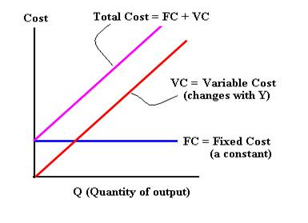

**Total Cost = TFC +TVC**

**Average Costs**

**Where**

**ATC =AVC +AFC**

**Now**

## What Does Average Variable Cost Mean?

**What is the definition of average variable cost?** As a rule of thumb, when the firm’s output is relatively small, the average cost decreases, whereas when the output starts increasing, the average cost increases too. Firms that seek to maximize their profits, use the average cost to determine the point that they should shut down production in the short term.

Therefore, if the price of a good is higher than the AVC of the good, it means that the firm is covering all the variable costs and a percentage of the fixed costs. In this case, firms continue production. On the contrary, if the price they receive for good is lower than the AVC, firms cease production to avoid additional variable costs.

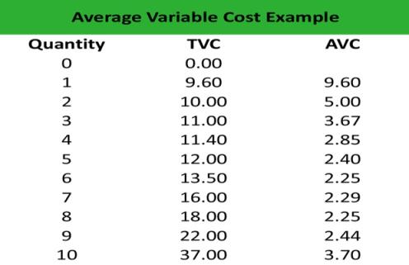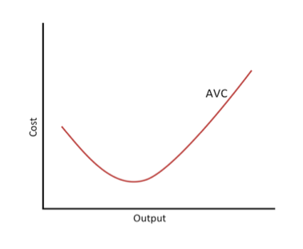

Let’s look at an example.

## Example

Adam works as an accountant in a manufacturing firm, which produces equipment for tractors. He is asked to calculate the average variable cost formula of production so that the management decides whether they should go on or cease production after a given level of output.

Adam constructs a spreadsheet and calculates the AVC as follows:



After displaying all numbers, Adam gains an insight into the AVC. First, he notices that the AVC is relatively high for the first three inputs, and then declines until increasing again when the quantity is 10 units. This is consistent with the U-shaped pattern of the variable cost line. Secondly, the average cost is always higher than zero. The only possibility for the AVC to turn negative is if the total variable cost turns negative, which, in practice, makes no sense.

Given the level of price for each given level of output, the management can decide to cease production or continue in the short term.

## Summary Definition

**Define Average Variable Costs:** AVC means the average of all costs on a per unit basis that change with production level

**Average fixed costs**

Average fixed costs are found by dividing total fixed costs by output. As fixed cost is divided by an increasing output, average fixed costs will continue to fall.

|  |  |  |
| --- | --- | --- |
| **OUTPUT** | **TOTAL FIXED COST (£000)** | **AVERAGE FIXED COST (£000)** |
| 1 | 100 | 100 |
| 2 | 100 | 50 |
| 3 | 100 | 33.3 |
| 4 | 100 | 25 |
| 5 | 100 | 20 |
| 6 | 100 | 16.6 |
| 7 | 100 | 14.3 |
| 8 | 100 | 12.5 |

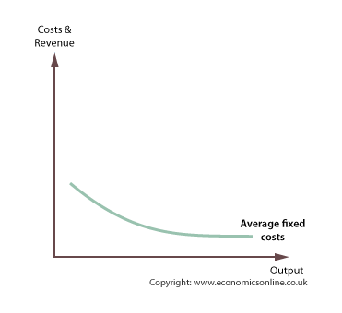

The *average fixed cost* (AFC) curve will slope down continuously, from left to right

**Average variable costs**

Average variable costs are found by dividing total fixed variable costs by output.

|  |  |  |
| --- | --- | --- |
| **OUTPUT** | **TOTAL VARIABLE COST (£000)** | **AVERAGE VARIABLE COST (£000)** |
| 1 | 50 | 50 |
| 2 | 80 | 40 |
| 3 | 100 | 33.3 |
| 4 | 110 | 27.5 |
| 5 | 150 | 30 |
| 6 | 220 | 36.7 |
| 7 | 350 | 50 |
| 8 | 640 | 80 |

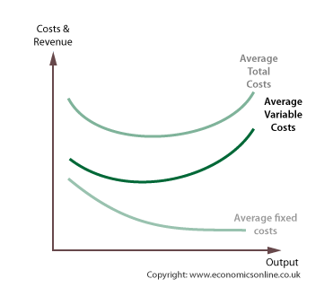

The *average variable cost* (AVC) curve will at first slope down from left to right, then reach a minimum point, and rise again.

AVC is ‘U’ shaped because of the principle of variable Proportions, which explains the three phases of the curve:

1. Increasing returns to the variable factors, which cause average costs to fall, followed by:
2. Constant returns, followed by:
3. Diminishing returns, which cause costs to rise.

**Average total cost**

Average total cost (ATC) is also called average cost or *unit cost*. Average total costs are a key cost in the theory of the firm because they indicate how efficiently scarce resources are being used. Average variable costs are found by dividing total fixed variable costs by output.

|  |  |  |  |
| --- | --- | --- | --- |
| **OUTPUT** | **AVERAGE FIXED COST (£000)** | **AVERAGE VARIABLE COST (£000)** | **AVERAGE TOTAL COSTS (£000)** |
| 1 | 100 | 50 | 150 |
| 2 | 50 | 40 | 90 |
| 3 | 33.3 | 33.3 | 67 |
| 4 | 25 | 27.5 | 52.5 |
| 5 | 20 | 30 | 50 |
| 6 | 16.6 | 36.7 | 53.3 |
| 7 | 14.3 | 50 | 64.3 |
| 8 | 12.5 | 80 | 92.5 |

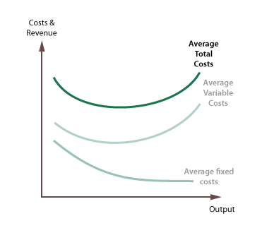

Average total cost (ATC) can be found by adding average fixed costs (AFC) and average variable costs (AVC). The ATC curve is also ‘U’ shaped because it takes its shape from the AVC curve, with the upturn reflecting the onset of diminishing returns to the variable factor.

**Areas for total costs**

Total Fixed costs and Total Variable costs are the respective areas under the Average Fixed and Average Variable cost curves.

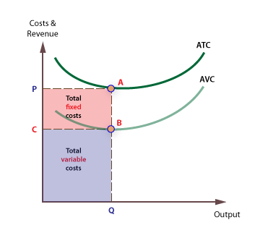

**Marginal costs**

Marginal cost is the cost of *producing one extra* unit of output.  It can be found by calculating the change in total cost when output is increased by one unit.

|  |  |  |
| --- | --- | --- |
| **OUTPUT** | **TOTAL COST** | **MARGINAL COST** |
| 1 | 150 |  |
| 2 | 180 | 30 |
| 3 | 200 | 20 |
| 4 | 210 | 10 |
| 5 | 250 | 40 |
| 6 | 320 | 70 |
| 7 | 450 | 130 |
| 8 | 740 | 290 |

It is important to note that marginal cost is derived solely from variable costs, and not fixed costs.

The marginal cost curve falls briefly at first, then rises. Marginal costs are derived from variable costs and are subject to the principle of [variable proportions](https://www.economicsonline.co.uk/Business_economics/Production.html).

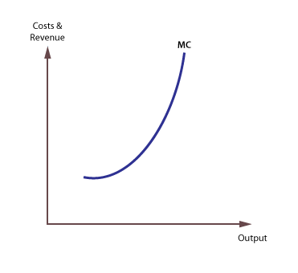

**The significance of marginal cost**

The marginal cost curve is significant in the theory of the firm for two reasons:

1. It is the *leading* cost curve, because changes in total and average costs are derived from changes in marginal cost.
2. The *lowest price* a firm is prepared to supply at is the price that just covers marginal cost.

**ATC and MC**

Average total cost and marginal cost are connected because they are derived from the same basic numerical cost data.  The general rules governing the relationship are:

1. Marginal cost will always cut average total cost from below.
2. When *marginal cost is below average total cost*, average total cost will be *falling*, and when *marginal cost is above average total cost,* average total cost will be *rising*.
3. A firm is most *productively efficient* at the lowest average total cost, which is also where *average total cost* (ATC) = *marginal cost* (MC).

**Total costs and marginal costs**

Marginal costs are derived exclusively from variable costs, and are unaffected by changes in fixed costs. The MC curve is the gradient of the TC curve, and the positive gradient of the total cost curve only exists because of a positive variable cost. This is shown below:

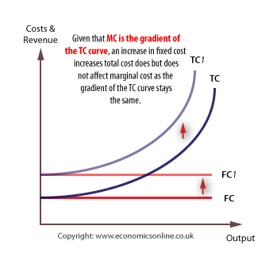

**Sunk costs**

*Sunk costs* are those that cannot be recovered if a firm goes out of business. Examples of sunk costs include spending on advertising and marketing, specialist machines that have no scrap value, and stocks which cannot be sold off.

Sunk costs are a considerable [barrier to entry](https://www.economicsonline.co.uk/Business_economics/Barriers_to_entry.html) and exit.

## Short Run Average Cost Curve:

In the short run, the shape of the average total cost curve (ATC) is U-shaped. The, ***short run*** [***average cost curve***](https://economicsconcepts.com/average_cost.htm) falls in the beginning, reaches a minimum and then begins to rise. The reasons for the average cost to fall in the beginning of production are that the fixed factors of a firm remain the same. The change only takes place in the variable factors such as raw material, labor, etc.

As the fixed cost gets distributed over the output as production is expanded, the average cost, therefore, begins to fall. When a firm fully utilizes its scale of operation (plant size), the average cost is then at its minimum. The firm is then operating to its optimum capacity. If a firm in the short-run increases its level of output with the same fixed plant; the economies of that scale of production change into diseconomies and the average cost then begins to rise sharply.

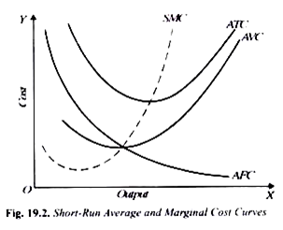

## Long Run Average Cost Curve:

In the long run, all costs of a firm are variable. The factors of production can be used in varying proportions to deal with an increased output. The firm having time-period long enough can build larger scale or type of plant to produce the anticipated output. The shape of the ***long run average cost curve*** is also U-shaped but is flatter that the short run curve as is illustrated in the following diagram:

### Diagram/Figure:

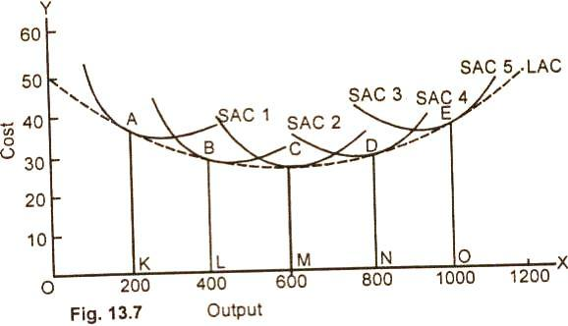

In the diagram 13.7 given above, there are five alternative scales of plant SAC1 SAC2, SAC3, SAC4 and, SAC5. In the long run, the firm will operate the scale of plant which is most profitable to it.

**For example,** if the anticipated rate of output is 200 units per unit of time, the firm will choose the smallest plant It will build the scale of plant given by SAC1 and operate it at point A. This is because of the fact that at the output of 200 units, the cost per unit is lowest with the plant size 1 which is the smallest of all the four plants. In case, the volume of sales expands to 400, units, the size of the plant will be increased and the desired output will be attained by the scale of plant represented by SAC2 at point B, If the anticipated output rate is 600 units, the firm will build the size of plant given by SAC3 and operate it at point C where the average cost is $26 and also the lowest The optimum output of the firm is obtained at point C on the medium size plant SAC3.

If the anticipated output rate is 1000 per unit of time the firm would build the scale of plant given by SAC5 and operate it at point E. If we draw a tangent to each of the short run cost curves, we get the long average cost (LAC) curve. The LAC is U-shaped but is flatter than tile short run cost curves. Mathematically expressed, the long-run average cost curve is the envelope of the SAC curves.

In this figure 13.7, the long-run average cost curve of the firm is lowest at point C. CM is the minimum cost at which optimum output OM can be, obtained.

## Relationship Between Log Run Average Cost and Marginal Cost:

The relationship between the long run average total cost and log run marginal cost can be understood better with the help of following **diagram:**

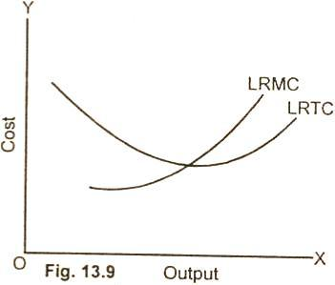

It is clear from the diagram (13.9), that the long run marginal cost curve and the long run average total cost curve show the same behavior as the short run marginal cost curve express with the short run average total cost curve. So long as the average cost curve is falling with the increase in output, the marginal cost curve lies below the average cost curve.

When average total cost curve begins to rise, marginal cost curve also rises, passes through the minimum point of the average cost and then rises. The only difference between the short run and long run marginal cost and average cost is that in the short run, the fall and rise of curves LRMC is sharp. Whereas In the long run, the cost curves falls and rises steadily.

**Relation of Average Variable Cost and Average Total Cost to Marginal Cost:**

Before we explain, ***the relationof average variable cost (AVC) and average total cost (ATC) to marginal cost (MC),***it seems necessary that the various types of costs and their relationship should be shown in the form of a table. This is illustrated in the table below:

**Schedule:**

|  |  |  |  |  |  |  |
| --- | --- | --- | --- | --- | --- | --- |
| **Units of Output** | **Total Fixed Cost (TFC)** | **Total Variable Cost (TVC)** | **Average Total Cost (ATC)** | **Average Fixed Cost (AFC)** | **Average Variable Cost (AVC)** | **Marginal Cost (MC)** |
| **($)** | **($)** | **($)** | **($)** | **($)** | **($)** |
| 1 | 30 | 15 | 45 | 30 | 15 | 15 |
| 2 | 30 | 16.9 | 23.4 | 15 | 8.4 | 1.9 |
| 3 | 30 | 18.4 | 16.1 | 10.1 | 6.1 | 1.5 |
| 4 | 30 | 19.4 | 12.3 | 7.5 | 4.8 | 1 |
| 5 | 30 | 20 | 10 | 6 | 4.0 | 0.6 |
| 6 | 30 | 22 | 8.7 | 5 | 3.7 | 2 |
| 7 | 30 | 25 | 7.8 | 4.3 | 3.6 | 3 |
| 8 | 30 | 30 | 7.5 | 3.7 | 3.7 | 5 |
| 9 | 30 | 36 | 7.3 | 3.3 | 4 | 6 |
| 10 | 30 | 43 | 7.3 | 3 | 4.3 | 7 |
| 11 | 30 | 60 | 8.2 | 2.7 | 5.5 | 17 |
| 12 | 30 | 90 | 10 | 2.5 | 7.5 | 30 |
| 13 | 30 | 125 | 11.9 | 2.3 | 9.6 | 35 |
| 14 | 30 | 165 | 13.9 | 2.1 | 11.8 | 40 |
| 15 | 30 | 210 | 16 | 2 | 14.8 | 45 |
| 16 | 30 | 270 | 18.7 | 1.9 | 16.7 | 60 |

From the table, the reader can understand the relation of various types of costs to each other. We take, first of all, the relation of average total cost to marginal cost. As production increases, the average total cost and the marginal cost both begin to decrease.

The average total cost goes on decreasing up to the 9th unit and then after 10, it begins to rise. The marginal cost goes on falling up to 5th unit and then it begins to increase. So long as the average total cost does not rise, the marginal cost remains below it. When average total cost begins to increase, toe marginal cost rises more than the average total cost.

**Summing Up:**

(1) When average cost is falling, the marginal cost is always lower than the average cost.

(2) When average cost is rising, marginal cost lies above AC and rises faster than AC.

(3) The marginal cost curve must cut the average cost curve at the minimum point of AC.

**Average Variable Cost and Marginal Cost:**

The relation of average variable cost and marginal cost is also very clear from the diagram given below. The AVC goes on falling up to the 7th unit, and then it steadily moves upwards. On the other hand the marginal cost falls up to the 5th unit and then rises more rapidly than average variable cost.

**Diagram/Figure:**

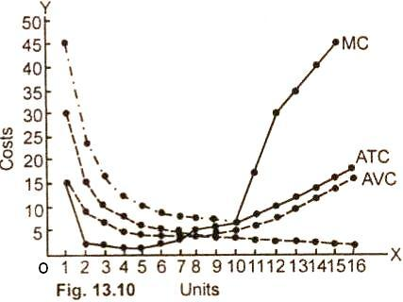

In the diagram (13.10) AFC, AVC, ATC and MC curves are shown. Here, units of production are measured along OX and cost along OY. ATC and AVC both fall in the beginning, reach a minimum point and then begin to rise. So is the case with the marginal cost curve. It first falls and then after rising, sharply crosses through the lowest point of average variable cost and average total cost and rises.

**Unit IV**

* **Price and output decision under different market structure**
* **Price and Output Decision under –**

**- Monopoly,**

**-Monopolistic**

**-Oligopoly**

* **Kinked Demand Curve –Price Leadership**
* **Pricing under collusion**

**Pricing and Market Structure**

Price determination is one of the most crucial aspects in economics. Business managers are expected to make perfect decisions based on their knowledge and judgment. Since every economic activity in the market is measured as per price, it is important to know the concepts and theories related to pricing. Pricing discusses the rationale and assumptions behind pricing decisions. It analyzes unique market needs and discusses how business managers reach upon final pricing decisions.

It explains the equilibrium of a firm and is the interaction of the demand faced by the firm and its supply curve. The equilibrium condition differs under perfect competition, monopoly, monopolistic competition, and oligopoly. Time element is of great relevance in the theory of pricing since one of the two determinants of price, namely supply depends on the time allowed to it for adjustment.

## Market Structure

A market is the area where buyers and sellers contact each other and exchange goods and services. Market structure is said to be the characteristics of the market. Market structures are basically the number of firms in the market that produce identical goods and services. Market structure influences the behavior of firms to a great extent. The market structure affects the supply of different commodities in the market.When the competition is high there is a high supply of commodity as different companies try to dominate the markets and it also creates barriers to entry for the companies that intend to join that market. A monopoly market has the biggest level of barriers to entry while the perfectly competitive market has zero percent level of barriers to entry. Firms are more efficient in a competitive market than in a monopoly structure.

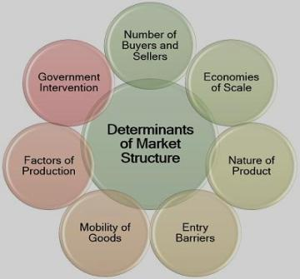

**Market Structure:**

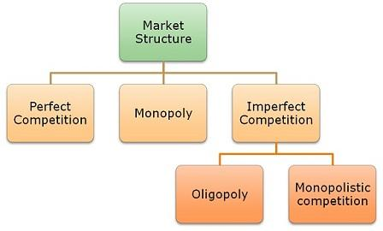

## Perfect Competition

Perfect competition is a situation prevailing in a market in which buyers and sellers are so numerous and well informed that all elements of monopoly are absent and the market price of a commodity is beyond the control of individual buyers and sellers

With many firms and a homogeneous product under perfect competition no individual firm is in a position to influence the price of the product that means price elasticity of demand for a single firm will be infinite.

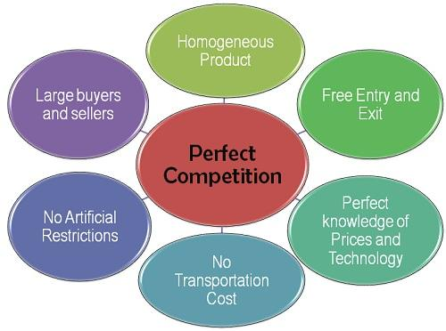

**Price and Output Determination under Perfect Competition**

Perfect competition refers to a market situation where there are a large number of buyers and sellers dealing in homogenous products.

Moreover, under perfect competition, there are no legal, social, or technological barriers on the entry or exit of organizations.

In perfect competition, sellers and buyers are fully aware about the current market price of a product. Therefore, none of them sell or buy at a higher rate. As a result, the same price prevails in the market under perfect competition.

Under perfect competition, the buyers and sellers cannot influence the market price by increasing or decreasing their purchases or output, respectively. The market price of products in perfect competition is determined by the industry. This implies that in perfect competition, the market price of products is determined by taking into account two market forces, namely market demand and market supply.

In the words of Marshall, “Both the elements of demand and supply are required for the determination of price of a commodity in the same manner as both the blades of scissors are required to cut a cloth.” As discussed in the previous chapters, market demand is defined as a sum of the quantity demanded by each individual organizations in the industry.

On the other hand, market supply refers to the sum of the quantity supplied by individual organizations in the industry. In perfect competition, the price of a product is determined at a point at which the demand and supply curve intersect each other. This point is known as equilibrium point as well as the price is known as equilibrium price. In addition, at this point, the quantity demanded and supplied is called equilibrium quantity. Let us discuss price determination under perfect competition in the next sections.

**Demand under Perfect Competition:**

Demand refers to the quantity of a product that consumers are willing to purchase at a particular price, while other factors remain constant. A consumer demands more quantity at lower price and less quantity at higher price. Therefore, the demand varies at different prices.

**Figure-1 represents the demand curve under perfect competition:**

**[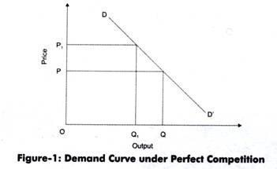](http://cdn.economicsdiscussion.net/wp-content/uploads/2015/01/clip_image00276.jpg)**

As shown in Figure-1, when price is OP, the quantity demanded is OQ. On the other hand, when price increases to OP1, the quantity demanded reduces to OQ1. Therefore, under perfect competition, the demand curve (DD’) slopes downward.

**Supply under Perfect Competition:**

Supply refers to quantity of a product that producers are willing to supply at a particular price. Generally, the supply of a product increases at high price and decreases at low price.

**Figure-2 shows the supply curve under perfect competition:**

[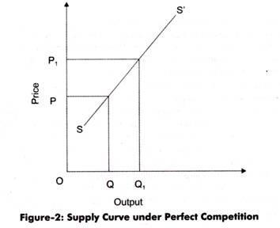](http://cdn.economicsdiscussion.net/wp-content/uploads/2015/01/clip_image00430.jpg)

In Figure-2, the quantity supplied is OQ at price OP. When price increases to OP1, the quantity supplied increases to OQ1. This is because the producers are able to earn large profits by supplying products at higher price. Therefore, under perfect competition, the supply curves (SS’) slopes upward.

**Equilibrium under Perfect Competition:**

As discussed earlier, in perfect competition, the price of a product is determined at a point at which the demand and supply curve intersect each other. This point is known as equilibrium point. At this point, the quantity demanded and supplied is called equilibrium quantity.

**Figure-3 shows the equilibrium under perfect competition:**

[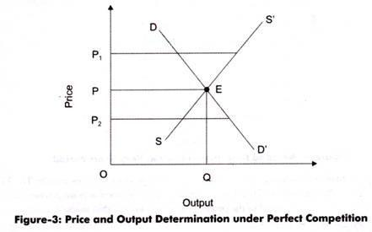](http://cdn.economicsdiscussion.net/wp-content/uploads/2015/01/clip_image00518.jpg)

In Figure-3, it can be seen that at price OP1, supply is more than the demand. Therefore, prices will fall down to OP. Similarly, at price OP2, demand is more than the supply. Similarly, in such a case, the prices will rise to OP. Thus, E is the equilibrium at which equilibrium price is OP and equilibrium quantity is OQ.

## Pricing Decisions

### Determinants of Price under Perfect Competition

Market price is determined by the equilibrium between demand and supply in a market period or very short run. The market period is a period in which the maximum that can be supplied is limited by the existing stock. The market period is so short that more cannot be produced in response to increased demand. The firms can sell only what they have already produced. This market period may be an hour, a day or a few days or even a few weeks depending upon the nature of the product.

### Market Price of a Perishable Commodity

In the case of perishable commodity like fish, the supply is limited by the available quantity on that day. It cannot be stored for the next market period and therefore the whole of it must be sold away on the same day whatever the price may be.

### Market Price of Non-Perishable and Reproducible Goods

In case of non-perishable but reproducible goods, some of the goods can be preserved or kept back from the market and carried over to the next market period. There will then be two critical price levels.The first, if price is very high the seller will be prepared to sell the whole stock. The second level is set by a low price at which the seller would not sell any amount in the present market period, but will hold back the whole stock for some better time. The price below which the seller will refuse to sell is called the Reserve Price.

## Monopolistic Competition

Monopolistic competition is a form of market structure in which a large number of independent firms are supplying products that are slightly differentiated from the point of view of buyers. Thus, the products of the competing firms are close but not perfect substitutes because buyers do not regard them as identical. This situation arises when the same commodity is being sold under different brand names, each brand being slightly different from the others.

**For example** − Lux, Liril, Dove, etc.

Each firm is therefore the sole producer of a particular brand or “product”. It is monopolist as far as a particular brand is concerned. However, since the various brands are close substitutes, a large number of “monopoly” producers of these brands are involved in a keen competition with one another. This type of market structure, where there is competition among a large number of “monopolists” is called monopolistic competition.

In addition to product differentiation, the other three basic characteristics of monopolistic competition are −

* There are large number of independent sellers and buyers in the market.
* The relative market shares of all sellers are insignificant and more or less equal. That is, seller-concentration in the market is almost non-existent.
* There are neither any legal nor any economic barriers against the entry of new firms into the market. New firms are free to enter the market and existing firms are free to leave the market.
* In other words, product differentiation is the only characteristic that distinguishes monopolistic competition from perfect competition.

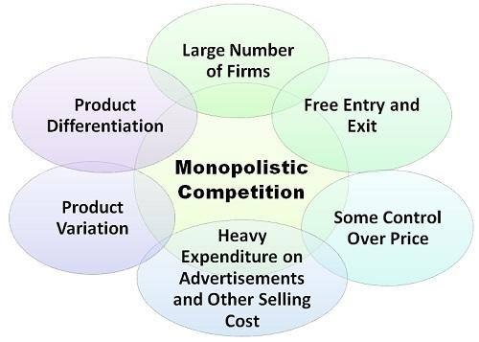

**Price-output determination under Monopolistic Competition: Equilibrium of a firm**

In monopolistic competition, since the product is differentiated between firms, each firm does not have a perfectly elastic demand for its products. In such a market, all firms determine the price of their own products. Therefore, it faces a downward sloping demand curve. Overall, we can say that the elasticity of demand increases as the differentiation between products decreases.

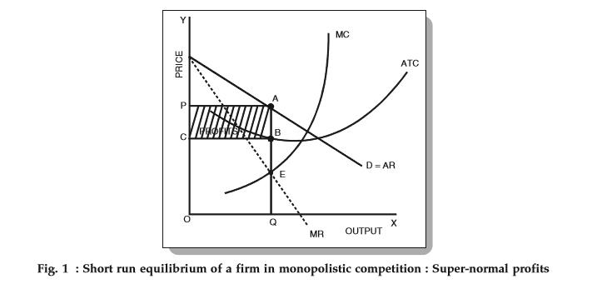

Fig. 1 above depicts a firm facing a downward sloping, but flat demand curve. It also has a U-shaped short-run cost curve.

**Conditions for the Equilibrium of an individual firm**

The conditions for price-output determination and equilibrium of an individual firm are as follows:

1. MC = MR
2. The MC curve cuts the MR curve from below.

In Fig. 1, we can see that the MC curve cuts the MR curve at point E. At this point,

* Equilibrium price = OP and
* Equilibrium output = OQ

Now, since the per unit cost is BQ, we have

* Per unit super-normal profit (price-cost) = AB or PC.
* Total super-normal profit = APCB

The following figure depicts a firm earning losses in the short-run.

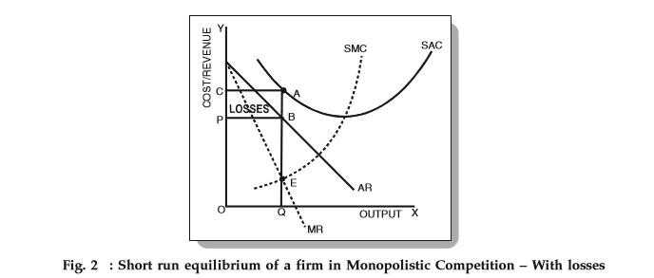

From Fig. 2, we can see that the per unit cost is higher than the price of the firm. Therefore,

* AQ > OP (or BQ)
* Loss per unit = AQ – BQ = AB
* Total losses = ACPB

**Long-run equilibrium**

If firms in a monopolistic competition earn super-normal profits in the short-run, then new firms will have an incentive to enter the industry. As these firms enter, the profits per firm decrease as the total demand gets shared between a larger number of firms. This continues until all firms earn only normal profits. Therefore, in the long-run, firms, in such a market, earn only normal profits.

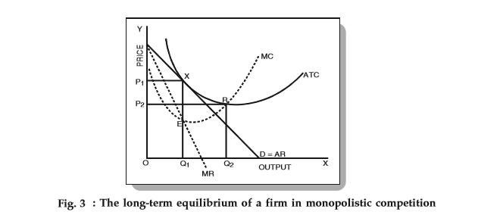

As we can see in Fig. 3 above, the average revenue (AR) curve touches the average cost (ATC) curve at point X. This corresponds to quantity Q1 and price P1. Now, at equilibrium (MC = MR), all super-normal profits are zero since the average revenue = average costs. Therefore, all firms earn zero super-normal profits or earn only normal profits.

It is important to note that in the long-run, a firm is in an equilibrium position having excess capacity. In simple words, it produces a lower quantity than its full capacity. From Fig. 3 above, we can see that the firm can increase its output from Q1 to Q2 and reduce average costs. However, it does not do so because it reduces the average revenue more than the average costs. Hence, we can conclude that in monopolistic competition, firms do not operate optimally. There always exists an excess capacity of production with each firm.

In case of losses in the short-run, the firms making a loss will exit from the market. This continues until the remaining firms make normal profits only.

## Monopoly

Monopoly is said to exist when one firm is the sole producer or seller of a product which has no close substitutes. According to this definition, there must be a single producer or seller of a product. If there are many producers producing a product, either perfect competition or monopolistic competition will prevail depending upon whether the product is homogeneous or differentiated.

On the other hand, when there are few producers, oligopoly is said to exist. A second condition which is essential for a firm to be called monopolist is that no close substitutes for the product of that firm should be available.

From above it follows that for the monopoly to exist, following things are essential −

* One and only one firm produces and sells a particular commodity or a service.
* There are no rivals or direct competitors of the firm.
* No other seller can enter the market for whatever reasons legal, technical, or economic.
* Monopolist is a price maker. He tries to take the best of whatever demand and cost conditions exist without the fear of new firms entering to compete away his profits.

The concept of market power applies to an individual enterprise or to a group of enterprises acting collectively. For the individual firm, it expresses the extent to which the firm has discretion over the price that it charges. The baseline of zero market power is set by the individual firm that produces and sells a homogeneous product alongside many other similar firms that all sell the same product.

Since all of the firms sell the identical product, the individual sellers are not distinctive. Buyers care solely about finding the seller with the lowest price.

In this context of “perfect competition”, all firms sell at an identical price that is equal to their marginal costs and no individual firm possess any market power. If any firm were to raise its price slightly above the market-determined price, it would lose all of its customers and if a firm were to reduce its price slightly below the market price, it would be swamped with customers who switch from the other firms.

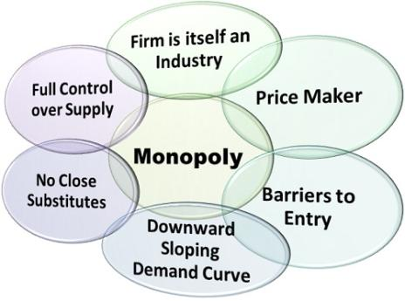

# Price and Output Determination under Monopoly

#### Demand and Revenue under Monopoly:

In monopoly, there is only one producer of a product, who influences the price of the product by making Change m supply. The producer under monopoly is called monopolist. If the monopolist wants to sell more, he/she can reduce the price of a product. On the other hand, if he/she is willing to sell less, he/she can increase the price.

As we know, there is no difference between organization and industry under monopoly. Accordingly, the demand curve of the organization constitutes the demand curve of the entire industry. The demand curve of the monopolist is Average Revenue (AR), which slopes downward.

**Figure-9 shows the AR curve of the monopolist:**

**[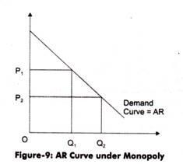](http://cdn.economicsdiscussion.net/wp-content/uploads/2015/01/clip_image00275.jpg)**

In Figure-9, it can be seen that more quantity (OQ2) can only be sold at lower price (OP2). Under monopoly, the slope of AR curve is downward, which implies that if the high prices are set by the monopolist, the demand will fall. In addition, in monopoly, AR curve and Marginal Revenue (MR) curve are different from each other. However, both of them slope downward.

**The negative AR and MR curve depicts the following facts:**

i. When MR is greater than AR, the AR rises

ii. When MR is equal to AR, then AR remains constant

iii. When MR is lesser than AR, then AR falls

Here, AR is the price of a product, As we know, AR falls under monopoly; thus, MR is less than AR.

**Figure-10 shows AR and MR curves under monopoly:**

**[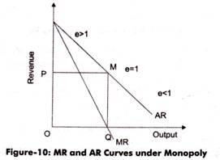](http://cdn.economicsdiscussion.net/wp-content/uploads/2015/01/clip_image00323.jpg)**

In figure-10, MR curve is shown below the AR curve because AR falls.

**Table-1 shows the numerical calculation of AR and MR under monopoly:**

**[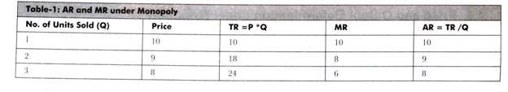](http://cdn.economicsdiscussion.net/wp-content/uploads/2015/01/clip_image00431.jpg)**

[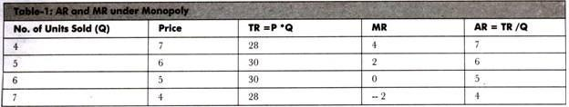](http://cdn.economicsdiscussion.net/wp-content/uploads/2015/01/clip_image00621.jpg)

As shown in Table-1, AR is equal to price. MR is less than AR and falls twice the rate than AR. For instance, when two units of

Output are sold, MR falls by Rs. 2, whereas AR falls by Re. 1.

#### Monopoly Equilibrium:

Single organization constitutes the whole industry in monopoly. Thus, there is no need for separate analysis of equilibrium of organization and industry in case of monopoly. The main aim of monopolist is to earn maximum profit as of a producer in perfect competition.

Unlike perfect competition, the equilibrium, under monopoly, is attained at the point where profit is maximum that is where MR=MC. Therefore, the monopolist will go on producing additional units of output as long as MR is greater than MC, to earn maximum profit.

**Let us learn monopoly equilibrium through Figure-11:**

[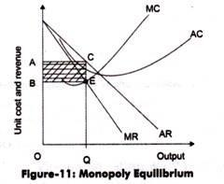](http://cdn.economicsdiscussion.net/wp-content/uploads/2015/01/clip_image00714.jpg)

In Figure-11, if output is increased beyond OQ, MR will be less than MC. Thus, if additional units are produced, the organization will incur loss. At equilibrium point, total profits earned are equal to shaded area ABEC. E is the equilibrium point at which MR=MC with quantity as OQ.

**It should be noted that under monopoly, price forms the following relation with the MC:**

Price = AR

MR= AR [(e-1)/e]

e = Price elasticity of demand

As in equilibrium MR=MC

MC = AR [(e-1)/e]

**Exhibit-2:**

**Determining Price and Output under Monopoly:**

Suppose demand function for monopoly is Q = 200-0.4Q

Price function is P= 1000-10Q

Cost function is TC= 100 + 40Q + Q2

Maximum profit is achieved where MR=MC

To find MR, TR is derived.

TR= (1000-10Q) Q = 1000Q-10Q2

MR = ∆TR/∆Q= 1000 – 20Q

MC = ∆TC/∆Q = 40 + 2Q

MR = MC

1000 – 20Q = 40 + 2Q

Q = 43.63 (44 approx.) = Profit Maximizing Output

Profit maximizing price = 1000 – 20*44 = 120

Total maximum profit= TR-TC= (1000Q – 10Q2) – (100+ 40Q+Q2)

At Q = 44

Total maximum profit = Rs. 20844

**Monopoly Equilibrium in Case of Zero Marginal Cost:**

In certain situations, it may happen that MC is zero, which implies that the cost of production is zero. For example, cost of production of spring water is zero. However, the monopolist will set its price to earn profit.

**Figure-12 shows the monopoly equilibrium when MC is zero:**

[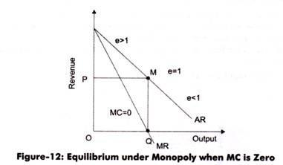](http://cdn.economicsdiscussion.net/wp-content/uploads/2015/01/clip_image0099.jpg)

In Figure-12, AR is the average revenue curve and MR is the marginal revenue curve. In such a case, the total cost is zero; therefore, AR and MR are also zero. As shown in Figure-12, equilibrium position is achieved at the point where MR equals zero that is at output OQ and price P.We can see that point M is the mid-point of AR curve, where elasticity of demand is unity. Therefore, when MC = 0, the equilibrium of the monopolist is established at the output (OQ) where elasticity of demand is unity.

**Short-Run and Long-Run View under Monopoly:**

Till now, we have discussed monopoly equilibrium without taking into consideration the short-run and long- run period. This is because there is not so much difference under short run and long run analysis in monopoly.

In the short run, the monopolist should make sure that the price should not go below Average Variable Cost (AVC). The equilibrium under monopoly in long-run is same as in short-run. However, in long-run, the monopolist can expand the size of its plants according to demand. The adjustment is done to make MR equal to the long run MC.

In the long-run, under perfect competition, the equilibrium position is attained by entry or exit of the organizations. In monopoly, the entry of new organizations is restricted.

The monopolist may hold some patents or copyright that limits the entry of other players in the market. When a monopolist incurs losses, he/she may exit the business. On the other hand, if profits are earned, then he/she may increase the plant size to gain more profit.

## Oligopoly

In an oligopolistic market there are small number of firms so that sellers are conscious of their interdependence. The competition is not perfect, yet the rivalry among firms is high. Given that there are large number of possible reactions of competitors, the behavior of firms may assume various forms. Thus there are various models of oligopolistic behavior, each based on different reactions patterns of rivals.

Oligopoly is a situation in which only a few firms are competing in the market for a particular commodity. The distinguishing characteristics of oligopoly are such that neither the theory of monopolistic competition nor the theory of monopoly can explain the behavior of an oligopolistic firm.

Two of the main characteristics of Oligopoly are briefly explained below −

* Under oligopoly the number of competing firms being small, each firm controls an important proportion of the total supply. Consequently, the effect of a change in the price or output of one firm upon the sales of its rival firms is noticeable and not insignificant. When any firm takes an action its rivals will in all probability react to it. The behavior of oligopolistic firms is interdependent and not independent or atomistic as is the case under perfect or monopolistic competition.
* Under oligopoly new entry is difficult. It is neither free nor barred. Hence the condition of entry becomes an important factor determining the price or output decisions of oligopolistic firms and preventing or limiting entry of an important objective.

**For Example** − Aircraft manufacturing, in some countries: wireless communication, media, and banking.

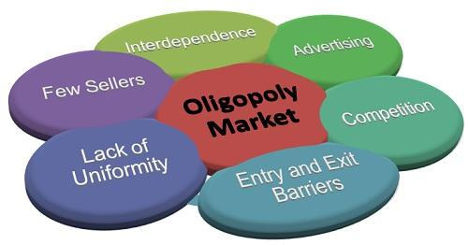

# Kinked Demand Curve

In an oligopolistic market, firms cannot have a fixed demand curve since it keeps changing as competitors change the prices/quantity of output. Since an oligopolist is not aware of the demand curve, economists have designed various price-output models based on the behavior pattern of other firms in the industry. In this article, we will look at the kinked demand curve hypothesis.

## Kinked Demand Curve

In many oligopolist markets, it has been observed that prices tend to remain inflexible for a very long time. Even in the face of declining costs, they tend to change infrequently. American economist Sweezy came up with the kinked demand curve hypothesis to explain the reason behind this price rigidity under [oligopoly](https://www.toppr.com/guides/business-economics/determination-of-prices/oligopoly/).

According to the kinked demand curve hypothesis, the demand curve facing an oligopolist has a kink at the level of the prevailing price. This kink exists because of two reasons:

1. The segment above the prevailing price level is highly elastic.
2. The segment below the prevailing price level is inelastic.

The following figure shows a kinked demand curve dD with a kink at point P.

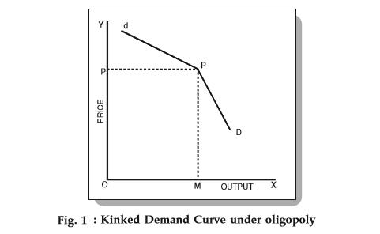

From the figure, we know that

1. The prevailing price level = P
2. The firm produces and sells output = OM
3. Also, the upper segment (dP) of the demand curve (dD) is elastic.
4. The lower segment (PD) of the demand curve (dD) is relatively inelastic.

This difference in elasticities is due to an assumption of the kinked demand curve hypothesis.

#### Assumption:

Each firm in an oligopoly believes the following two things:

1. If a firm lowers the price below the prevailing level, then the competitors will follow him.
2. If a firm increases the price above the prevailing level, then the competitors will not follow him.

There is logical reasoning behind this assumption. When an oligopolist lowers the price of his product, the competitors feel that if they don’t follow the price cut, then their customers will leave them and buy from the firm who is offering a lower price. Therefore, they lower their prices too in order to maintain their customers. Hence, the lower portion of the curve is inelastic. It implies that if an oligopolist lowers the price, he can obtain very little sales.

On the other hand, when a firm increases the price of its product, it experiences a substantial reduction in sales. The reason is simple – consumers will buy the same/similar product from its competitors. This increases the competitors’ sales and they will have no motivation to match the price rise. Therefore, the firm that raises the price suffers a loss and hence refrain from increasing the price.

This behavior of oligopolists can help us understand the elasticity of the upper portion of the demand curve (dP). The figure shows that if a firm raises the price of a product, then it experiences a large fall in sales. Hence, no firm in an oligopolistic market will try to increase the price and a kink is formed at the prevailing price. This is how the kinked demand curve hypothesis explains the rigid or sticky prices.

**UNIT V**

* **Pricing Policies and Practices**
* **Factors governing pricing objectives**
* **Role of Cost in pricing**
* **Pricing Methods** 
  + - * **Full Cost**
      * **Target Pricing**
      * **Going Rate Pricing**
      * **Follow up Pricing**
* **Pricing New Product – Price Skimming and Penetrating Pricing**
* **Phases of Business Cycle**
* **Effects of cyclical fluctuation on business firms**
* **Economic Forecasting and Methods of Forecasting**

# Pricing Policy: Meaning, Objectives and Factors

#### Meaning of Pricing Policy:

A pricing policy is a standing answer to recurring question. A systematic approach to pricing requires the decision that an individual pricing situation be generalised and codified into a policy cover­age of all the principal pricing problems. Policies can and should be tailored to various competitive situations. A policy approach which is becoming normal for sales activities is comparatively rare in pricing.

Most well managed manufacturing enterprises have a clear cut advertising policy, product customer policy and distribution-channel policy. But pricing decision remains a patchwork of ad hoc decisions. In many, otherwise well managed firms, price policy has been dealt with on a crisis basis. This kind of price management by catastrophe discourages the kind of systematic analysis needed for clear cut pricing policies.

#### Considerations Involved in Formulating the Pricing Policy:

**The following considerations involve in formulating the pricing policy:**

**(i) Competitive Situation:**

Pricing policy is to be set in the light of competitive situation in the market. We have to know whether the firm is facing perfect competition or imperfect competition. In perfect competition, the producers have no control over the price. Pricing policy has special signifi­cance only under imperfect competition.

**(ii) Goal of Profit and Sales:**

The businessmen use the pricing device for the purpose of maxim­ising profits. They should also stimulate profitable combination sales. In any case, the sales should bring more profit to the firm.

**(iii) Long Range Welfare of the Firm:**

Generally, businessmen are reluctant to charge a high price for the product because this might result in bringing more producers into the industry. In real life, firms want to prevent the entry of rivals. Pricing should take care of the long run welfare of the company.

**(iv) Flexibility:**

Pricing policies should be flexible enough to meet changes in economic conditions of various customer industries. If a firm is selling its product in a highly competitive market, it will have little scope for pricing discretion. Prices should also be flexible to take care of cyclical variations.

**(v) Government Policy:**

The government may prevent the firms in forming combinations to set a high price. Often the government prefers to control the prices of essential commodities with a view to prevent the exploitation of the consumers. The entry of the government into the pricing process tends to inject politics into price fixation.

**(vi) Overall Goals of Business:**

Pricing is not an end in itself but a means to an end. The fundamental guides to pricing, therefore, are the firms overall goals. The broadest of them is survival. On a more specific level, objectives relate to rate of growth, market share, maintenance of control and finally profit. The various objectives may not always be compatible. A pricing policy should never be established without consideration as to its impact on the other policies and practices.

**(vii) Price Sensitivity:**

The various factors which may generate insensitivity to price changes are variability in consumer behaviour, variation in the effectiveness of marketing effort, nature of the prod­uct, importance of service after sales, etc. Businessmen often tend to exaggerate the importance of price sensitivity and ignore many identifiable factors which tend to minimise it.

**(viii) Routinisation of Pricing:**

A firm may have to take many pricing decisions. If the data on demand and cost are highly conjectural, the firm has to rely on some mechanical formula. If a firm is selling its product in a highly competitive market, it will have little scope for price discretion. This will have the way for routinised pricing.

#### Objectives of Pricing Policy:

The pricing policy of the firm may vary from firm to firm depending on its objective. In practice, we find many prices for a product of a firm such as wholesale price, retail price, published price, quoted price, actual price and so on.

Special discounts, special offers, methods of payment, amounts bought and transportation charges, trade-in values, etc., are some sources of variations in the price of the product. For pricing decision, one has to define the price of the product very carefully.

Pricing decision of a firm in general will have considerable repercussions on its marketing strategies. This implies that when the firm makes a decision about the price, it has to consider its entire marketing efforts. Pricing decisions are usually considered a part of the general strategy for achieving a broadly defined goal.

**While setting the price, the firm may aim at the following objectives:**

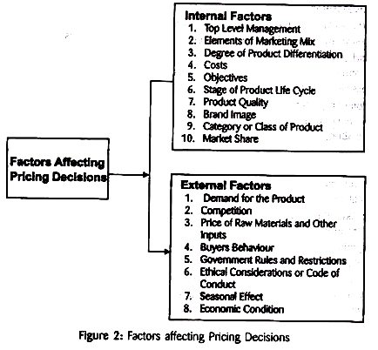

**(i) Price-Profit Satisfaction:**

The firms are interested in keeping their prices stable within certain period of time irrespective of changes in demand and costs, so that they may get the expected profit.

**(ii) Sales Maximisation and Growth:**

A firm has to set a price which assures maximum sales of the product. Firms set a price which would enhance the sale of the entire product line. It is only then, it can achieve growth.

**(iii) Making Money:**

Some firms want to use their special position in the industry by selling product at a premium and make quick profit as much as possible.

**(iv) Preventing Competition:**

Unrestricted competition and lack of planning can result in waste­ful duplication of resources. The price system in a competitive economy might not reflect society’s real needs. By adopting a suitable price policy the firm can restrict the entry of rivals.

**(v) Market Share:**

The firm wants to secure a large share in the market by following a suitable price policy. It wants to acquire a dominating leadership position in the market. Many managers believe that revenue maximisation will lead to long run profit maximisation and market share growth.

**(vi) Survival:**

In these days of severe competition and business uncertainties, the firm must set a price which would safeguard the welfare of the firm. A firm is always in its survival stage. For the sake of its continued existence, it must tolerate all kinds of obstacles and challenges from the rivals.

**(vii) Market Penetration:**

Some companies want to maximise unit sales. They believe that a higher sales volume will lead to lower unit costs and higher long run profit. They set the lowest price, assuming the market is price sensitive. This is called market penetration pricing.

**(viii) Marketing Skimming:**

Many companies favour setting high prices to ‘skim’ the market. Dupont is a prime practitioner of market skimming pricing. With each innovation, it estimates the highest price it can charge given the comparative benefits of its new product versus the available substitutes.

**(ix) Early Cash Recovery:**

Some firms set a price which will create a mad rush for the product and recover cash early. They may also set a low price as a caution against uncertainty of the future.

**(x) Satisfactory Rate of Return:**

Many companies try to set the price that will maximise current profits. To estimate the demand and costs associated with alternative prices, they choose the price that produces maximum current profit, cash flow or rate of return on investment.

#### Factors Involved in Pricing Policy:

**The pricing of the products involves consideration of the following factors:**

(i) Cost Data.

(ii) Demand Factor.

(iii) Consumer Psychology.

(iv) Competition.

(v) Profit.

(vi) Government Policy.

**(i) Cost Data in Pricing:**

Cost data occupy an important place in the price setting processes. There are different types of costs incurred in the production and marketing of the product. There are production costs, promotional expenses like advertising or personal selling as well as taxation, etc.

They may necessitate an upward fixing of price. For example, the prices of petrol and gas are rising due to rise in the cost of raw materials, such as crude transportation, refining, etc. If costs go up, price rise can be quite justified. However, their relevance to the pricing decision must neither be underestimated nor exaggerated. For setting prices apart from costs, a number of other factors have to be taken into consideration. They are demand and competition.

**Costs are of two types:**

Fixed costs and variable costs. In the short period, that is, the period in which a firm wants to establish itself, the firm may not cover the fixed costs but it must cover the variable cost. But in the long run, all costs must be covered. If the entire costs are not covered, the producer stops production.

Subsequently, the supply is reduced which, in turn, may lead to higher prices. If costs are not covered, the producer stops production. Subsequently, the supply is reduced which, in turn, may lead to higher prices. If costs were to determine prices why do so many companies report losses?

There are marked differences in costs as between one producer and another. Yet the fact remains that the prices are very close for a somewhat similar product. This is the very best evidence of the fact that costs are not the determining factors in pricing.

In fact, pricing is like a tripod. It has three legs. In addition to costs, there are two other legs of market demand and competition. It is no more possible to say that one or another of these factors determines price than it is to assert that one leg rather than either of the other two supports a tripod.

Price decisions cannot be based merely on cost accounting data which only contribute to history while prices have to work in the future. Again it is very difficult to measure costs accurately. Costs are affected by volume, and volume is affected by price.

The management has to assume some desired price-volume relationship for determining costs. That is why, costs play even a less important role in connection with new products than with the older ones. Until the market is decided and some idea is obtained about volume, it is not possible to determine costs.

Regarding the role of costs in pricing, Nickerson observes that the cost may be regarded only as an indicator of demand and price. He further says that the cost at any given time represents a resistance point to the lowering of price. Again, costs determine profit margins at various levels of output.

Cost calculation may also help in determining whether the product whose price is determined by its demand, is to be included in the product line or not. What costs determine is not the price, but whether the production can be profitably produced or not is very important.

**Relevant Costs:**

The question naturally arises: “What then are the relevant costs for pricing decision? Though in the long run, all costs have to be covered, for managerial decisions in the short run, direct costs are relevant. In a single product firm, the management would try to cover all the costs.”

In a multi-product firm, problems are more complex. For pricing decision, relevant costs are those costs that are directly traceable to an individual product. Ordinarily, the selling price must cover all direct costs that are attributable to a product. In addition, it must contribute to the common cost and to the realisation of profit. If the price, in the short run, is lower than the cost, the question arises, whether this price covers the variable cost. If it covers the variable cost, the low price can be accepted.

But in the long run, the firm cannot sell at a price lower than the cost. Product pricing decision should be lower than the cost. Product pricing decision should, therefore, be made with a view to maximise company’s profits in the long run.

**(ii) Demand Factor in Pricing:**

In pricing of a product, demand occupies a very important place. In fact, demand is more impor­tant for effective sales. The elasticity of demand is to be recognised in determining the price of the product. If the demand for the product is inelastic, the firm can fix a high price. On the other hand, if the demand is elastic, it has to fix a lower price.

In the very short term, the chief influence on price is normally demand. Manufacturers of durable goods always set a high price, even though sales are affected. If the price is too high, it may also affect the demand for the product. They wait for arrival of a rival product with competitive price. Therefore, demand for product is very sensitive to price changes.

**(iii) Consumer Psychology in Pricing:**

Demand for the product depends upon the psychology of the consumers. Sensitivity to price change will vary from consumer to consumer. In a particular situation, the behaviour of one individual may not be the same as that of the other. In fact, the pricing decision ought to rest on a more incisive rationale than simple elasticity. There are consumers who buy a product provided its quality is high.

Generally, product quality, product image, customer service and promotion activity influence many consumers more than the price. These factors are qualitative and ambiguous. From the point of view of consumers, prices are quantitative and unambiguous.

Price constitutes a barrier to demand when it is too low, just as much as where it is too high. Above a particular price, the product is regarded as too expensive and below another price, as constituting a risk of not giving adequate value. If the price is too low, consumers will tend to think that a product of inferior quality is being offered.

With an improvement in incomes, the average consumer becomes quality conscious. This may lead to an increase in the demand for durable goods. People of high incomes buy products even though their prices are high. In the affluent societies, price is the indicator of quality.

Advertisement and sales promotion also contribute very much in increasing the demand for advertised products. Because the consumer thinks that the advertised products are of good quality. The income of the consumer, the standard of living and the price factor influence the demand for various products in the society.

**(iv) Competition Factor in Pricing:**

Market situation plays an effective role in pricing. Pricing policy has some managerial discretion where there is a considerable degree of imperfection in competition. In perfect competition, the individual producers have no discretion in pricing. They have to accept the price fixed by demand and supply.

In monopoly, the producer fixes a high price for his product. In other market situations like oligopoly and monopolistic competition, the individual producers take the prices of the rival products in determining their price. If the primary determinant of price changes in the competitive condition is the market place, the pricing policy can least be categorised as competition based pricing.

**(v) Profit Factor in Pricing:**

In fixing the price for products, the producers consider mainly the profit aspect. Each producer has his aim of profit maximisation. If the objective is profit maximisation, the critical rule is to select the price at which MR = MC. Generally, the pricing policy is based on the goal of obtaining a reasonable profit. Most of the businessmen want to hold the price at constant level.

They do not desire frequent price fluctuation. The profit maximisation approach to price setting is logical because it forces decision makers to focus their attention on the changes in production, cost, revenue and profit associated with any contemplated change in price. The price rigidity is the practice of many producers. Rigidity does not mean inflexibility. It means that prices are stable over a given period.

**(vi) Government Policy in Pricing:**

In market economy, the government generally does not interfere in the economic decisions of the economy. It is only in planned economies, the government’s interference is very much. According to conventional economic theory, the buyers and sellers only determine the price. In reality, certain other parties are also involved in the pricing process. They are the competition and the government.

The government’s practical regulatory price techniques are ceiling on prices, minimum prices and dual pricing. In a mixed economy like India, the government resorts to price control. The business establish­ments have to adopt the government’s price policies to control relative prices to achieve certain targets, to prevent inflationary price rise and to prevent abnormal increase in prices.

**Pricing Methods**

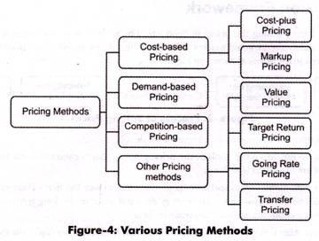

**The different pricing methods (Figure-4) are discussed below;**

#### Cost-based Pricing:

Cost-based pricing refers to a pricing method in which some percentage of desired profit margins is added to the cost of the product to obtain the final price. In other words, cost-based pricing can be defined as a pricing method in which a certain percentage of the total cost of production is added to the cost of the product to determine its selling price. Cost-based pricing can be of two types, namely, cost-plus pricing and markup pricing.

**These two types of cost-based pricing are as follows:**

**i. Cost-plus Pricing:**

Refers to the simplest method of determining the price of a product. In cost-plus pricing method, a fixed percentage, also called mark-up percentage, of the total cost (as a profit) is added to the total cost to set the price. For example, XYZ organization bears the total cost of Rs. 100 per unit for producing a product. It adds Rs. 50 per unit to the price of product as’ profit. In such a case, the final price of a product of the organization would be Rs. 150.

Cost-plus pricing is also known as average cost pricing. This is the most commonly used method in manufacturing organizations.

**In economics, the general formula given for setting price in case of cost-plus pricing is as follows:**

P = AVC + AVC (M)

ADVERTISEMENTS:

AVC= Average Variable Cost

M = Mark-up percentage

AVC (m) = Gross profit margin

Mark-up percentage (M) is fixed in which AFC and net profit margin (NPM) are covered.

AVC (m) = AFC+ NPM

ii. For determining average variable cost, the first step is to fix prices. This is done by estimating the volume of the output for a given period of time. The planned output or normal level of production is taken into account to estimate the output.

The second step is to calculate Total Variable Cost (TVC) of the output. TVC includes direct costs, such as cost incurred in labor, electricity, and transportation. Once TVC is calculated, AVC is obtained by dividing TVC by output, Q. [AVC= TVC/Q]. The price is then fixed by adding the mark-up of some percentage of AVC to the profit [P = AVC + AVC (m)].

**iii. The advantages of cost-plus pricing method are as follows:**

a. Requires minimum information

b. Involves simplicity of calculation

c. Insures sellers against the unexpected changes in costs

**The disadvantages of cost-plus pricing method are as follows:**

a. Ignores price strategies of competitors

b. Ignores the role of customers

**iv. Markup Pricing:**

Refers to a pricing method in which the fixed amount or the percentage of cost of the product is added to product’s price to get the selling price of the product. Markup pricing is more common in retailing in which a retailer sells the product to earn profit. For example, if a retailer has taken a product from the wholesaler for Rs. 100, then he/she might add up a markup of Rs. 20 to gain profit.

**It is mostly expressed by the following formulae:**

a. Markup as the percentage of cost= (Markup/Cost) *100

b. Markup as the percentage of selling price= (Markup/ Selling Price)*100

c. For example, the product is sold for Rs. 500 whose cost was Rs. 400. The mark up as a percentage to cost is equal to (100/400)*100 =25. The mark up as a percentage of the selling price equals (100/500)*100= 20.

#### Demand-based Pricing:

Demand-based pricing refers to a pricing method in which the price of a product is finalized according to its demand. If the demand of a product is more, an organization prefers to set high prices for products to gain profit; whereas, if the demand of a product is less, the low prices are charged to attract the customers.

The success of demand-based pricing depends on the ability of marketers to analyze the demand. This type of pricing can be seen in the hospitality and travel industries. For instance, airlines during the period of low demand charge less rates as compared to the period of high demand. Demand-based pricing helps the organization to earn more profit if the customers accept the product at the price more than its cost.

#### Competition-based Pricing:

Competition-based pricing refers to a method in which an organization considers the prices of competitors’ products to set the prices of its own products. The organization may charge higher, lower, or equal prices as compared to the prices of its competitors.

The aviation industry is the best example of competition-based pricing where airlines charge the same or fewer prices for same routes as charged by their competitors. In addition, the introductory prices charged by publishing organizations for textbooks are determined according to the competitors’ prices.

#### Other Pricing Methods:

**In addition to the pricing methods, there are other methods that are discussed as follows:**

**i. Value Pricing:**

Implies a method in which an organization tries to win loyal customers by charging low prices for their high- quality products. The organization aims to become a low cost producer without sacrificing the quality. It can deliver high- quality products at low prices by improving its research and development process. Value pricing is also called value-optimized pricing.

**ii. Target Return Pricing:**

Helps in achieving the required rate of return on investment done for a product. In other words, the price of a product is fixed on the basis of expected profit.

**iii. Going Rate Pricing:**

Implies a method in which an organization sets the price of a product according to the prevailing price trends in the market. Thus, the pricing strategy adopted by the organization can be same or similar to other organizations. However, in this type of pricing, the prices set by the market leaders are followed by all the organizations in the industry.

**iv. Transfer Pricing:**

Involves selling of goods and services within the departments of the organization. It is done to manage the profit and loss ratios of different departments within the organization. One department of an organization can sell its products to other departments at low prices. Sometimes, transfer pricing is used to show higher profits in the organization by showing fake sales of products within departments.

## Pricing a New Product

Most companies do not consider pricing strategies in a major way, on a day-today basis. The marketing of a new product poses a problem because new products have no past information.

Fixing the first price of the product is a major decision. The future of the company depends on the soundness of the initial pricing decision of the product. In large multidivisional companies, top management needs to establish specific criteria for acceptance of new product ideas.

The price fixed for the new product must have completed the advanced research and development, satisfy public criteria such as consumer safety and earn good profits. In pricing a new product, below mentioned two types of pricing can be selected −

### Skimming Price

Skimming price is known as short period device for pricing. Here, companies tend to charge higher price in initial stages. Initial high helps to “Skim the Cream” of the market as the demand for new product is likely to be less price elastic in the early stages.

**How does Price Skimming Work?**

 Customers known as early adopters will pay steeper prices for a cutting edge product if it’s marketed as a “must have”, whether the price accurately reflects the value or not. Eventually, prices are lowered to follow the product demand curve and attract more price-sensitive customers. Theoretically, as each customer segment is “skimmed” off the top a company can capture some of the consumer surplus by charging the maximum price each segment is willing to pay.

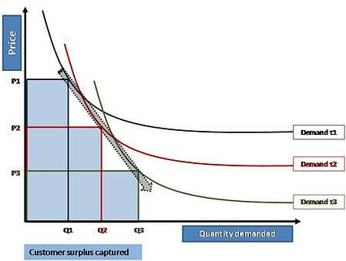

“Theoretically” is the key word here, because although price skimming can effectively segment the market, it’s almost impossible for the strategy to capture all of the consumer surplus. Price skimming is most effective when the product follows an inelastic demand curve, meaning the quantity demanded doesn’t rise or fall drastically in response to a change in prices (for more on this, see our post on [price elasticity](https://www.priceintelligently.com/blog/bid/154374/Price-Elasticity-101-The-Necessities-and-Your-Pricing-Strategy)). While necessities like gasoline and electricity are almost always inelastic, state-of-the-art products like the iPhone can potentially walk the same path. Let’s uncover the pros and cons of price skimming before exploring the market characteristics that make the strategy a viable tactic for your business.

## ****Pros of Price Skimming****

### *****1. Higher Return on Investment*****

Charging more during the launch of an innovative product, particularly in high tech industries, can help your company recoup research and development costs as well as promotional expenses. Companies like Apple benefit from high short term profits during a product’s introduction, and the initial higher prices are justified by the technological breakthroughs they achieve.

The bottom line is, if you invested all of your cash flow and resources into the development of a gadget or service no competitor can match, then you should be able to charge higher prices during the launch to recover the bulk of your investment and hopefully fund further developments.

### *****2. It Helps Create and Maintain Your Brand Image*****

Price skimming can also create the perception that a product is a high quality “must have” for those early adopters who can’t live without the latest tech products. Higher prices in the beginning of a product’s life cycle enable you to build a [prestigious brand image](https://www.priceintelligently.com/blog/bid/182414/How-to-Optimize-Your-Pricing-Strategy-with-Prestige-Pricing) that actually attracts status conscious consumers, and in addition, you’ll have the breathing room you need to lower prices as competitors enter the market. In some cases a lower starting price in the beginning can also increase customer price sensitivity, making it impossible to raise rates in the future without losing sales.

### *****3. It Segments the Market*****

As discussed before, price skimming is an effective way to segment your customer base, potentially allowing you to earn the greatest possible profits from different types of customers as you reduce the price. Starting with a higher price won’t deter your early adopters, and as you lower the price over time you’ll attract more price sensitive consumers. If you alter prices based on the product demand curve and the maximum price the customers are willing to pay, you can capture some of that consumer surplus and rake in more revenue.

### *****4. Early Adopters Help Test New Products*****

One benefit of early adopter customers is they act as guinea pigs for new products. Those status conscious consumers that purchase your innovative product first can provide valuable feedback and help you work out the kinks before the next update and foreseeably a wider user base. In addition to being valuable testers, early adopters who love your product can act as brand evangelists that create a perception of quality via word of mouth. This free promotion will persuade new customers to buy the product when the price drops.

## ****Cons of Price Skimming****

### *****1. It Only Works if Your Demand Curve is Inelastic*****

Price skimming might be a viable tactic for Apple, but that’s because the quantity demanded doesn’t rise and fall dramatically when the prices change. If the demand curve for your product is generally elastic, meaning price changes have a greater effect on product demand, then initial high prices could really hurt your sales. The goal of any company is to make a product as inelastic as possible, but not everyone is selling tech products or services that are ingenious enough to appear indispensable to consumers.

### *****2. It’s Not a Great Strategy in a Crowded Market*****

In any industry, assessing [customer valuations](https://www.priceintelligently.com/blog/bid/162160/Value-Based-Pricing-101-The-Necessities-and-Your-Pricing-Strategy) and analyzing the competition prior to setting your prices is crucial. If you already have a lot of competitors then chances are your demand curve is fairly elastic, and high prices during your product launch will send customers running in the other direction. Price skimming is not a viable strategy in an already busy market, so unless your product includes amazing new features no one can match, it might be a good idea to avoid skimming if fierce competition already exists.

### *****3. Skimming Attracts Competitors*****

Maybe your product is ground breaking enough that it will create a new market, but as shown by the introductions of the iPhone and the iPad, competitors like Samsung and Microsoft are lurking just around the corner. The success of high prices in the beginning of a new product’s life cycle will intrigue competitors to enter the market, and the inelasticity of a demand curve is almost always reduced over time due to the introduction of viable substitutes. Price skimming can also slow the rate of adoption by your potential customers, giving the competition more time to imitate and improve upon your product before you’ve capitalized on the demand for the innovation.

### *****4. It Can Infuriate Your Early Adopters*****

Remember those brand evangelists that bought your product first? They can just as easily trigger your worst PR nightmare. If prices drop too much or too soon after the initial product launch, your early adopters will feel like they got the short end of the stick. Apple experienced this type of backlash in 2007 when the company reduced the price of the iPhone by $200 dollars just two months after its introduction. The quick 33% price drop from $599 to $399 may have helped increase demand, but some of the phone’s early adopters were understandably upset.

To ensure the customers at the top of your demand curve don’t feel cheated, it’s important to use price skimming in a consistent manner and avoid hurried or blatantly obvious reductions in price. Price skimming can also be considered price discrimination, which is the strategy of selling the same product at different prices to different groups of consumers. In some cases this strategy is against the law, but the actual conditions that define illegal price discrimination are shady to say the least. For more on the ethical issues of price discrimination, check out our post on [pricing strategy ethics](https://www.priceintelligently.com/blog/bid/164830/5-Must-Know-Pricing-Strategy-Ethics-Issues).

### Penetration Price

Penetration price is also referred as stay out price policy since it prevents competition to a great extent. In penetration pricing lowest price for the new product is charged. This helps in prompt sales and keeping the competitors away from the market. It is a long term pricing strategy and should be adopted with great caution.

**Business Cycle**

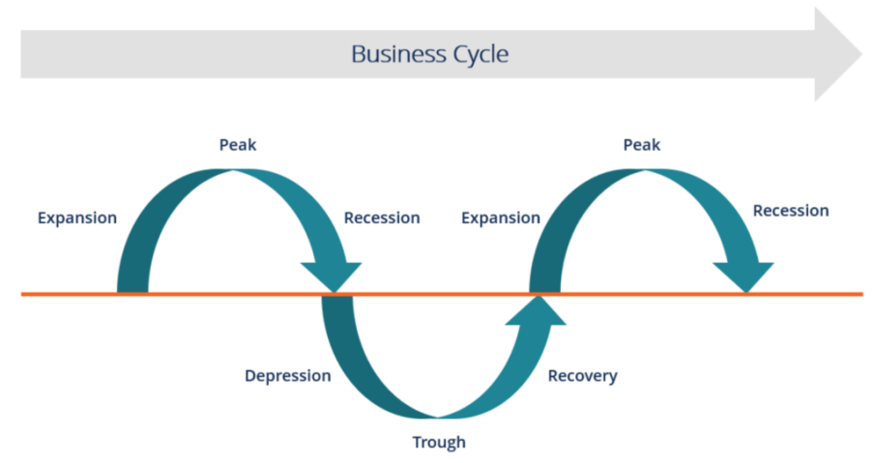

# 5 Phases of a Business Cycle (With Diagram)

Business cycles are characterized by boom in one period and collapse in the subsequent period in the economic activities of a country.

These fluctuations in the economic activities are termed as phases of business cycles.

The fluctuations are compared with ebb and flow. The upward and downward fluctuations in the cumulative economic magnitudes of a country show variations in different economic activities in terms of production, investment, employment, credits, prices, and wages. Such changes represent different phases of business cycles.

**The different phases of business cycles are shown in Figure-1:**

**[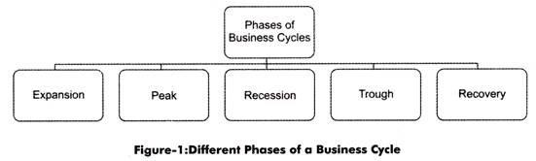](http://cdn.economicsdiscussion.net/wp-content/uploads/2015/01/clip_image00278.jpg)**

There are basically two important phases in a business cycle that are prosperity and depression. The other phases that are expansion, peak, trough and recovery are intermediary phases.

**Figure-2 shows the graphical representation of different phases of a business cycle:**

**[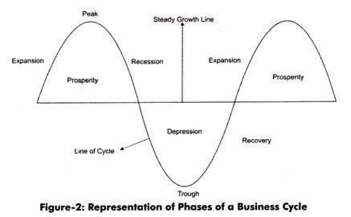](http://cdn.economicsdiscussion.net/wp-content/uploads/2015/01/clip_image00324.jpg)**

As shown in Figure-2, the steady growth line represents the growth of economy when there are no business cycles. On the other hand, the line of cycle shows the business cycles that move up and down the steady growth line. The different phases of a business cycle (as shown in Figure-2) are explained below.

**1. Expansion:**

The line of cycle that moves above the steady growth line represents the expansion phase of a business cycle. In the expansion phase, there is an increase in various economic factors, such as production, employment, output, wages, profits, demand and supply of products, and sales.

In addition, in the expansion phase, the prices of factor of production and output increases simultaneously. In this phase, debtors are generally in good financial condition to repay their debts; therefore, creditors lend money at higher interest rates. This leads to an increase in the flow of money.

In expansion phase, due to increase in investment opportunities, idle funds of organizations or individuals are utilized for various investment purposes. Therefore, in such a case, the cash inflow and outflow of businesses are equal. This expansion continues till the economic conditions are favorable.

**2. Peak:**

The growth in the expansion phase eventually slows down and reaches to its peak. This phase is known as peak phase. In other words, peak phase refers to the phase in which the increase in growth rate of business cycle achieves its maximum limit. In peak phase, the economic factors, such as production, profit, sales, and employment, are higher, but do not increase further. In peak phase, there is a gradual decrease in the demand of various products due to increase in the prices of input.

The increase in the prices of input leads to an increase in the prices of final products, while the income of individuals remains constant. This also leads consumers to restructure their monthly budget. As a result, the demand for products, such as jewellery, homes, automobiles, refrigerators and other durables, starts falling.

**3. Recession:**

As discussed earlier, in peak phase, there is a gradual decrease in the demand of various products due to increase in the prices of input. When the decline in the demand of products becomes rapid and steady, the recession phase takes place.

In recession phase, all the economic factors, such as production, prices, saving and investment, starts decreasing. Generally, producers are unaware of decrease in the demand of products and they continue to produce goods and services. In such a case, the supply of products exceeds the demand.

Over the time, producers realize the surplus of supply when the cost of manufacturing of a product is more than profit generated. This condition firstly experienced by few industries and slowly spread to all industries.

This situation is firstly considered as a small fluctuation in the market, but as the problem exists for a longer duration, producers start noticing it. Consequently, producers avoid any type of further investment in factor of production, such as labor, machinery, and furniture. This leads to the reduction in the prices of factor, which results in the decline of demand of inputs as well as output.

**4. Trough:**

During the trough phase, the economic activities of a country decline below the normal level. In this phase, the growth rate of an economy becomes negative. In addition, in trough phase, there is a rapid decline in national income and expenditure.

In this phase, it becomes difficult for debtors to pay off their debts. As a result, the rate of interest decreases; therefore, banks do not prefer to lend money. Consequently, banks face the situation of increase in their cash balances.

Apart from this, the level of economic output of a country becomes low and unemployment becomes high. In addition, in trough phase, investors do not invest in stock markets. In trough phase, many weak organizations leave industries or rather dissolve. At this point, an economy reaches to the lowest level of shrinking.

**5. Recovery:**

As discussed above, in trough phase, an economy reaches to the lowest level of shrinking. This lowest level is the limit to which an economy shrinks. Once the economy touches the lowest level, it happens to be the end of negativism and beginning of positivism.

This leads to reversal of the process of business cycle. As a result, individuals and organizations start developing a positive attitude toward the various economic factors, such as investment, employment, and production. This process of reversal starts from the labor market.

Consequently, organizations discontinue laying off individuals and start hiring but in limited number. At this stage, wages provided by organizations to individuals is less as compared to their skills and abilities. This marks the beginning of the recovery phase.ADVERTISEMENTS:

In recovery phase, consumers increase their rate of consumption, as they assume that there would be no further reduction in the prices of products. As a result, the demand for consumer products increases.

In addition in recovery phase, bankers start utilizing their accumulated cash balances by declining the lending rate and increasing investment in various securities and bonds. Similarly, adopting a positive approach other private investors also start investing in the stock market As a result, security prices increase and rate of interest decreases.

Price mechanism plays a very important role in the recovery phase of economy. As discussed earlier, during recession the rate at which the price of factor of production falls is greater than the rate of reduction in the prices of final products.

Therefore producers are always able to earn a certain amount of profit, which increases at trough stage. The increase in profit also continues in the recovery phase. Apart from this, in recovery phase, some of the depreciated capital goods are replaced by producers and some are maintained by them. As a result, investment and employment by organizations increases. As this process gains momentum an economy again enters into the phase of expansion. Thus, a business cycle gets completed.

### What is Economic Forecasting

Economic forecasting is the process of attempting to predict the future condition of the economy using a combination of important and widely followed indicators. Economic forecasting typically tries to come up with a future gross domestic product (GDP) growth rate, involving the building of statistical models with inputs of several key variables, or indicators. Some of the primary [economic indicators](https://www.investopedia.com/terms/e/economic_indicator.asp) include inflation, interest rates, industrial production, consumer confidence, worker productivity, retail sales and [unemployment rates](https://www.investopedia.com/terms/u/unemploymentrate.asp), to name several.

### BREAKING DOWN Economic Forecasting

Economic forecasts are geared toward predicting quarterly or annual GDP growth rates, the top level macro number upon which many businesses and governments base their decisions with respect to investments, hiring, spending, and other important policies that impact aggregate economic activity. While economic [forecasting](https://www.investopedia.com/terms/f/forecasting.asp) is not an exact science — in fact, it often misses the mark (economics has been labeled the "dismal science" for a reason) — managers of businesses need a quantified target to plan for future operating activities and government officials need a guide for fiscal and monetary policies.