**BUSINESS ENVIRONMENT**

**BCOMLLB- VI sem**

**What is Business?**

• It is a continuous production and distribution of goods and services with the aim of earning profits under uncertain market conditions.

• It is a form of regular activity conducted with an objective of earning profits for the benefit of those on whose behalf the activity is conducted.

**Nature of Business**

* An activity to earn profit by providing goods/services
* No limit of partners (can be 1 or 10,000)
* Main purpose should be earning i.e. economic activity

**Features/Characteristics of Business**

* Exchange of goods and services
* Deals in numerous transactions
* Profit is the main Objective
* Business skills for economic success
* Risks and Uncertainties
* Buyer and Seller
* Connected with production 8. Marketing and Distribution of goods
* Deals in goods and services Consumer goods Producer goods
* To Satisfy human wants
* Social obligations

**Business Environment**

Environment refers to all external forces, which have a bearing on the functioning of business. Environment factors “are largely if not totally, external and beyond the control of individual industrial enterprises and their managements.  
  
The business environment poses threats to a firm or offers immense opportunities for potential market exploitation. Environmental business solutions will give way to the environmental business opportunities.

# Classification of Business Environment: Internal and External

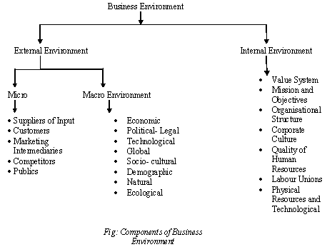

### Internal Environment:

The factors which can be controlled by company or Primary factors which directly affects the⎫ growth of organization….. man, material, money, machinery and management.

**Types of Internal Environment**

1. Value System

2. Mission & Objectives

3. Management Structure and Nature

4. Internal Power relationship

5. Human Resources

6. Company Image & Brand Equity …

### External Environment:

The external environment consists of legal, political, socio-cultural, demographic factors etc. These are uncontrollable factors and firms adapt to this environment. They adjust internal environment with the external environment to take advantage of the environmental opportunities and strive against environmental threats. Business decisions are affected by both internal and external environment.

[**[http://cdn3.businessmanagementideas.com/wp-content/uploads/2016/08/clip_image002_thumb-14.jpg](http://cdn3.businessmanagementideas.com/wp-content/uploads/2016/08/clip_image002-14.jpg)**](http://cdn3.businessmanagementideas.com/wp-content/uploads/2016/08/clip_image002-14.jpg)

The external environment consists of the micro environment and macro environment

#### 1. Micro Environment:

“The micro environment consists of factors in the company’s immediate environment”. These factors affect the performance of a company and its ability to serve the customers. Micro environment consists of customers, suppliers, competitors, public and market intermediaries.

**Firm’s micro environment is as follows:**

**(i) Customers:**

Customers constitute important segment of the micro environment. Business exists to serve its customers. Unless there are customers, business has no meaning. A company can have different types of customers like, households, producers, retailers, Government and foreign buyers.

**(ii) Suppliers:**

They supply inputs (money, raw material, fuel, power and other factors of production) and help in smooth conduct of the business. Firms should remain aware of the policies of suppliers as increase in prices of inputs will affect their sales and profits. Shortage of supplies also affects the production schedules. Firms should have more than one supplier so that change in policies of one supplier does not affect their production schedules.

**(iii) Competitors:**

Competitors form important part of the micro environment. Firms compete to capture big share of the market. They constantly watch competitors’ policies and adjust their policies to gain customer confidence.

**(iv) Public:**

“A public is any group that has an actual or potential interest in or impact on an organisation’s ability to achieve its interest”. Public can promote or demote company’s efforts to serve the market. The term ‘public’ consists of financial public (banks, financial institutions etc.), media public (newspapers, radio, television etc.), Government public, customer organisations, internal public (workers and managers), local public (neighbourhood or community residents) and general public (buyers at large). Companies observe the behaviour of these groups to make functional policies.

**(v) Market intermediaries:**

They are the links that help to promote, sell and distribute the products to final consumers. They are the physical distribution firms (transport firm), service agencies (media firms), financial intermediaries (banks, insurance companies) etc. that help in producing, marketing and insuring the goods against loss of theft, fire etc. Firms maintain good relations with them to carry their activities smoothly. All these factors are largely controllable by the firms but they operate in the larger macro environment beyond their control.

Micro Environment

• Suppliers

• Customers – Wholesalers – Retailers – Industries – Government and Other Institutions – Foreigners

• Market Intermediaries – Middleman – Marketing Agencies – Financial Intermediaries – Physical Intermediaries

• Competitors

• Public Macro Environment

• Economic Environment: It is very complex and dynamic in nature that keeps on changing with the change in policies or political situations.

It has three elements: –

* Economic Conditions of Public
* Economic Policies of the country
* Economic System
* Other Economic Factors Infrastructural Facilities, Banking, Insurance companies, money markets, capital markets etc.

**Macro Environment**

• Non-Economic Environment: Following are included in non-economic environment:

1. **Political Environment**: It affects different business units extensively. Components are

• Political Belief of Government

• Political Strength of the Country

• Relation with other countries

• Defense and Military Policies

• Centre State Relationship in the Country

• Thinking Opposition Parties towards Business Unit

**2. Socio-Cultural Environment**

– Influence exercised by social and cultural factors, not within the control of business, is known as Socio-Cultural Environment.

– These factors include: attitude of people to work, family system, caste system, religion, education, marriage etc.

**3. Technological Environment**

– A systematic application of scientific knowledge to practical task is known as technology.

– Everyday there has been vast changes in products, services, lifestyles and living conditions, these changes must be analyzed by every business unit and should adapt these changes.

**4. Natural Environment**

– It includes natural resources, weather, climatic conditions, port facilities, topographical factors such as soil, sea, rivers, rainfall etc

. – Every business unit must look for these factors before choosing the location for their business.

**5. Demographic Environment**

– It is a study of perspective of population i.e. its size, standard of living, growth rate, age-sex composition, family size, income level (upper level, middle level and lower level), education level etc.

– Every business unit must see these features of population and recognize their various needs and produce accordingly.

**6. International Environment**

– It is particularly important for industries directly depending on import or exports

. – The factors that affect the business are

• Globalization

• Liberalization

• Foreign business policies

• Cultural exchange

**Government interacts with the business in the following ways:**

**Some of the laws that exist in the country for smooth operation of business enterprises are as follows:**

* Economic Laws [Air (Prevention and Control of Pollution) Act, 1981;
* Consumer Protection Act, 1986;
* Essential Commodities Act, 1955;
* Foreign Exchange Management Act, 1999;
* Foreign Trade (Development & Regulation) Act, 1992;
* Industries (Development & Regulation) Act, 1951;
* Patents Act, 1970;
* Standards of Weights and Measures Act, 1976;
* Trade Marks Act, 1999],

**(ii) Socio-cultural environment:**

It represents the values, culture, beliefs, norms and ethics of the society in which business enterprises operate. People are important to organizations both as human resource and customers. Their buying habits, buying capacities, tastes, preferences and education affect business enterprises.

**The socio-cultural environment, thus, affects:**

**(a) Business objectives**:

**(b) Organizational processes:**

**(c) Goods and services to be produced:**

**(iii) Technical environment:**

Technology refers to application of scientific and organized knowledge to organizational tasks. It includes inventions and innovations regarding techniques of production.

**(iv) Demographic environment:**

It consists of population in its varied forms, such as gender, age, income, growth rate, language, religion, etc. Increasing population increases the demand for business products and also provides labour at low rate.

**(v) Natural environment:**

The natural environment consists of the renewable and non­renewable resources used in the production processes. The renewable resources are air, water and solar energy which can be replenished and non-renewable resources are oil, coal, wood etc. which cannot be replenished.

**(vi) International environment:**

It represents the global environment characterized by the “borderless world”. The Indian economy entered the global world in 1991 through its liberalization policies. There have been significant economic and political changes and increasing role for the private sector to play since then.

The global business environment is significantly influenced by the principles and agreements of World Trade Organization (WTO). WTO monitors and regulates the business transacted in the international environment.

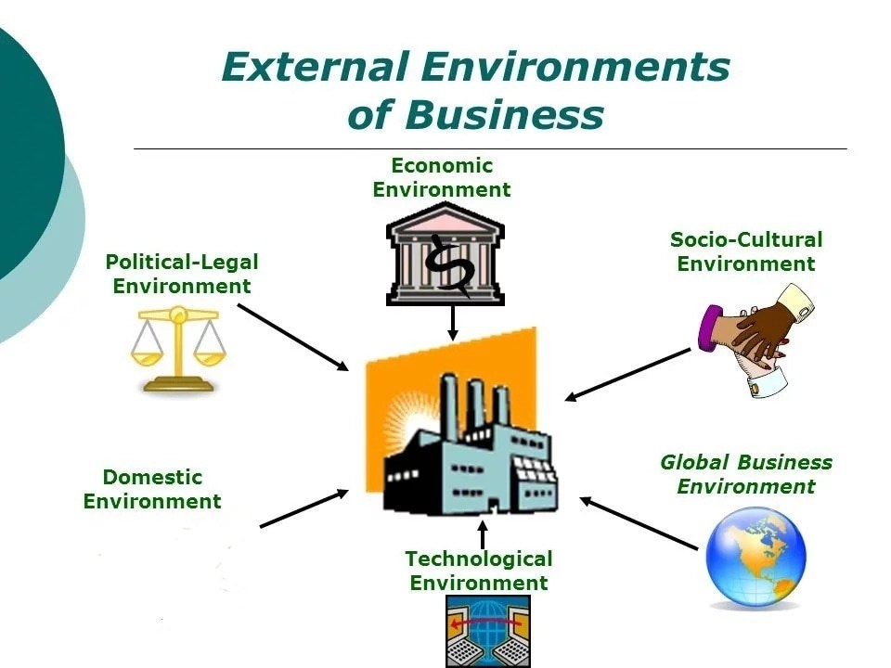

**Characteristics**

* Business environment is compound in nature.
* It is constantly changing process.
* It is different for different business units.
* It has both long term and short term impact.
* Unlimited influence of external environment factor
* . It is very uncertain.
* Inter-related components.
* It includes both internal and external environment.

**IMPORTANCE OF BUSINESS ENVIRONMENT**

There is a close and continuous interaction between the business and its environment. This interaction helps in strengthening the business firm and using its resources more effectively. As stated above, the business environment is multifaceted, complex, and dynamic in nature and has a far-reaching impact on the survival and growth of the business. To be more specific, proper understanding of the social, political, legal and economic environment helps the business in the following ways:

1. Determining Opportunities and Threats: The interaction between the business and its environment would identify opportunities for and threats to the business. It helps the business enterprises for meeting the challenges successfully.
2. Giving Direction for Growth: The interaction with the environment leads to opening up new frontiers of growth for the business firms. It enables the business to identify the areas for growth and expansion of their activities.
3. Continuous Learning: Environmental analysis makes the task of managers easier in dealing with business challenges. The managers are motivated to continuously update their knowledge, understanding and skills to meet the predicted changes in realm of business.
4. Image Building: Environmental understanding helps the business organizations in improving their image by showing their sensitivity to the environment within which they are working. For example, in view of the shortage of power, many companies have set up Captive Power Plants (CPP) in their factories to meet their own requirement of power.

UNIT-II

#### Concept of Social Responsibilities

Social responsibility implies formulation of business objectives, plans, policies and programmes etc. with emphasis on not only the economic concept of the profit-maximisation; but also with an orientation towards meeting social obligations.

**Definition**

“Social responsibilities refer to the businessman’s decisions and actions taken to reasons at least partially beyond the firm’s direct economic or technical interests.” —Keith Davis

“Social responsibilities refer to the obligation (of businessmen) to pursue those policies, to make those decisions, or to follow those lines of action which are desirable, in terms of objectives and values of society.” —Howard R. Bowen

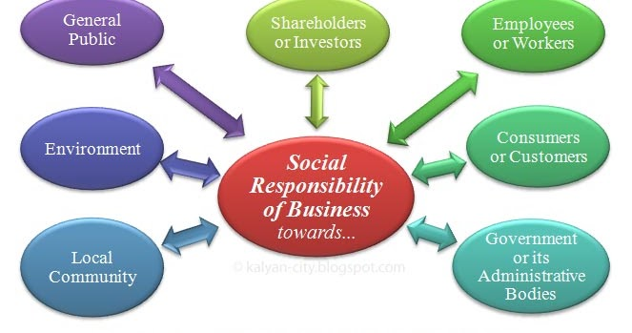

## CORE SUBJECTS AND KEY PRINCIPLES OF SOCIAL RESPONSIBILITY

[***ISO 26000: Guidance on social responsibility***](https://asq.org/quality-press/display-item?item=T866E) identifies [seven core social responsibility subjects](https://asq.org/quality-resources/iso-26000#cs):

1. [Organizational governance](https://asq.org/quality-resources/governance)
2. Human rights
3. Labor practices
4. The environment
5. Fair operating practices
6. Consumer issues
7. Community involvement and development

In addition to the core subjects, ISO 26000 also defines seven key principles of socially responsible behavior:

1. Accountability
2. Transparency
3. Ethical behavior
4. Respect for [stakeholder interests](https://asq.org/quality-resources/stakeholders)
5. Respect for the rule of law
6. Respect for international norms of behavior
7. Respect for human rights

#### Case for Social Responsibilities:

**(i) Creation of Society:**

A business enterprise is a creation of society. It gets all inputs-men, money, materials, technology, information etc. from society; and unloads its output onto society by marketing goods and services in society. Therefore, it must be loyal to society; and perform its social responsibilities.

**(ii) Theory of Trusteeship:**

Mahatma Gandhi evolved the theory of trusteeship, according to which businessmen are the trustees of the wealth of society; and should not use this wealth for their self-enrichment, at the cost of society. Hence, businessmen must perform social responsibilities to justify their role as trustees of the wealth of society.

**(iii) Long – Term Interest of Business:**

Fulfillment of social responsibilities is in the long-term best interest of business. Performance of social responsibilities will help in the survival and growth of business enterprises.

For example, if the business sector helps in spreading education in society; in the long-run, it will get more skilled and educated manpower for its functioning.

**(iv) ‘Joint-Venture’ Concept:**

A business enterprise is not an exclusive creation of owners, who provide funds for its functioning. Rather, it is run on a joint-venture concept i.e. employees, consumers, suppliers etc. all support the functioning of the enterprise, in their own ways.

**(v) Public Image:**

Performance of social responsibilities makes for the image of business in society. Such public image, is, yet another name for the goodwill of business. Creation of business goodwill pays huge rewards to business, in many ways.

**(vi) Government Intervention:**

Businessmen should perform social responsibilities voluntarily. In case otherwise, the government might intervene and force businessmen to perform social responsibilities through enactment and enforcement of suitable legislation vis-a-vis social responsibilities.

**(vii) Ample Financial Resources:**

There is no doubt that the ‘business-class’ is the richest class of society, endowed with huge financial resources. This class is the fittest agency to perform social responsibilities, by virtue of, its financial powers.

**(viii) Business Leadership Needed:**

Business leadership is very powerful and dynamic. Such leadership is needed to solve those social problems, which even the government cannot solve.

Hence, business should make a available to society the advantage of its talented leadership, through undertaking critical social responsibilities like controlling environmental pollution, promoting rural development, generation of employment opportunities in society etc.

**(ix) No Law for all Situations:**

Government cannot enact legislations covering all aspects and spheres of social responsibilities. The business should morally undertake to perform social responsibilities in those areas which are not regulated or guided by any of the governmental legislations e.g. eradication of poverty, holding the price-line, giving up cut-throat competition and so on.

**[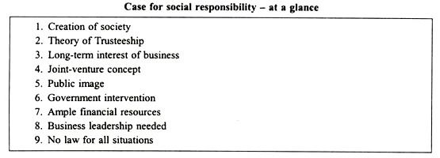](http://cdn.yourarticlelibrary.com/wp-content/uploads/2015/11/clip_image006_thumb72.jpg)**

#### Specific Social Responsibilities:

**Specific social responsibilities of business could be described under various categories as depicted in the following chart:**

**[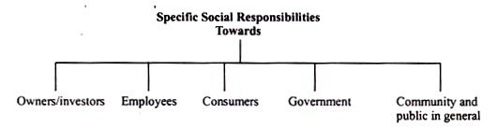](http://cdn.yourarticlelibrary.com/wp-content/uploads/2015/11/clip_image008_thumb9.jpg)**

**(1) Responsibilities towards Owners/Investors:**

**Some specific social responsibilities of business towards owners are:**

(i) Paying a reasonable rate of dividend as a reward for risking capital in business.

(ii) Ensuring safety of investment of funds provided by owners.

(iii) Giving owners a true and fair account of the functioning, profitability and financial position of the company.

(iv) Showing due regard towards the interest of minority of members.

(v) Ensuring growth of the company.

(vi) Not to indulge in undesirable speculation to the detriment of the interests of genuine investors.

(vii) Not to mislead prospective investors, by any means, whatsoever, to invest in the company.

**(2) Responsibilities towards employees**

**Some specific social responsibilities of business towards employees are:**

(i) Payment of adequate and timely wages

(ii) Providing congenial work environment

(iii) Providing adequate industrial safety devices

(iv) Granting job security.

(v) Providing opportunities for promotion and advancement.

(vi) Providing benefits like – subsidized housing, free medical care, leave with pay, entertainment and recreational facilities etc.

(vii) Ensuring reasonable workers participation in management.

(viii) Giving workers their due share in the excess profits of the business.

(ix) Giving humane treatment to workers.

(x) Taking care of the personal problems of workers, of a serious nature.

**(3) Responsibilities towards Consumers:**

**Some specific responsibilities of business towards consumers are:**

(i) Supplying goods of good quality, at fair prices.

(ii) Avoidance of indulging in unfair trade practices like:

1.  Supplying lesser weight

2. Defective packing of goods

3. Black-marketing, hoarding and profiteering.

4. Adulteration etc.

(iii) Taking due care of after-sales services.

(iv) Not to indulge in false, misleading and vulgar advertising.

(v) Immediate redress of consumer grievances.

(vi) Discouraging salesmen from resorting to pressurizing tactics to win customers.

**(4) Responsibilities towards the State or Government:**

**Some specific responsibilities of the business towards the State (i.e. the government) are:**

(i) Timely payment of legitimate taxes.

(ii) Co-operating with the government in the implementation of its economic and social policies.

(iii) Supplying the required information to government departments, from time to time.

(iv) Refraining from corrupting public servants.

(v) Not to indulge in winning political favours for selfish interests.

**(5) Responsibilities towards Community and Public in General:**

**Some specific responsibilities of business towards community and public in general are:**

(i) Ensuring best utilization of the scarce economic resources of society.

(ii) Generation of maximum employment opportunities.

(iii) Controlling environmental pollution.

(iv) Preventing urban congestion.

(v) Undertaking programmes for rural development.

(vi) Helping in spread of housing, medical, educational and recreational facilities in society.

(vii) Innovating and implementing schemes for the uplift of the downtrodden.

**BUSINESS ETHICS**

The term business Ethics refers to the system of moral principles and rules of conduct applied to business.

Business Ethics means that the business should be conducted according to certain self-recognized moral standards. Business being a social organ, shall be not conduct itself in a way detrimental to the interests of society and the business sector itself.

Peter Drucker ones stated that every individual and organ in society should abide by certain moral codes and there is no separate ethics of business.

In 1930s, Rotary International developed its Code of Ethics that is still used extensively. It uses 4questions that are called the four way ethical behavior for any ethical issue a business faces.

1. Is it the truth?
2. Is it fair to all concerned?
3. Will it build goodwill and better friendship?
4. Will it be beneficial to all concerned?

The most important professional ethics is expressed by the Hippocratic oath of the Greek physician: “***Premium non nocere”*** (not knowingly do harm).this dictum implies that a professional should carefully evaluate his decision and ensure that his actions will not produce negative effects. Thus, this code rules out all anti-social business practices.

**Important Ethical Principles**

* Do not deceive or cheat customers by selling sub-standard or defective

Products, by under-measurement or by any other means.

* Do not resort to hoarding, black-marketing or profiteering.
* Do not destroy or distort competition.
* Ensure sincerity and accuracy in advertising, labeling & packaging.
* Do not tarnish the image of competitors by unfair practices.
* Make accurate business records available to all authorized persons.
* Pay taxes and discharge other obligations promptly.
* Do not form cartel agreements, even informal, to control production, price etc , to the common detriment.
* Refrain from secret payoffs to customers, suppliers, administrators, politicians, etc.
* Ensure payment of fair wages to and fair treatment of employees.

**Role of Trade Association**

Trade associations which are voluntary organizations of businessmen formed to promote their common interests can promote business ethics in three important ways-

**Unit- III**

**INDIAN BUSINESS ENVIRONMENT**

Business environment refers to those aspects of the surroundings of business enterprise which have influence on the functioning of business. An organization can survive and grow only when it continuously and quickly adopts to changing environment.

Acc. to Wheeler, “Business Environment is the total of all things external to business firms and industries which affect their organization and operations.”

**Components of Business Environment:-**Business Environment has two components :-

a) Internal Environment b) External Environment

**Significance of Business Environment**

* Business and its external environment interact in the following ways. Exchange of information. Exchange of resources.. Exchange of influence and power.
* For incorporating dynamic behavior of environment
* Complete knowledge of internal environment
* To understand international events, pressures& impact
* Economic policies of the govt.
* Economic policies of the govt.
* To face business problems &challenges
* Vigilant regarding dangers
* Administrative system
* Optimum utilization of resources
* Market conditions
* Scientific & industrial advancement
* Development & success of business

**Economic trends**

India is the [world's fourth-largest economy](https://www.thebalance.com/world-s-largest-economy-3306044). It produced [$9.4 trillion in goods and services](https://www.cia.gov/library/publications/the-world-factbook/geos/in.html) in 2017. But it has a long way to go to beat the top three: [China](https://www.thebalance.com/china-economy-facts-effect-on-us-economy-3306345), with a production worth $23.1 trillion; the [European Union](https://www.thebalance.com/what-is-the-european-union-how-it-works-and-history-3306356), with $19.9 trillion; and the United States, with $17.4 trillion.

[India](https://www.cia.gov/library/publications/the-world-factbook/geos/in.html) has had rapid growth despite the [Great Recession](https://www.thebalance.com/the-great-recession-of-2008-explanation-with-dates-4056832). It grew 6.7 percent in 2017, 7.1 percent in 2016 and 8 percent in 2015. From 2008 through 2014, it grew between 5 percent and 11 percent. That phenomenal growth rate has reduced [poverty](https://www.thebalance.com/federal-poverty-threshold-3305793) by 10 percent in the last decade.

### What Type of Economy Is India?

India has a [mixed economy](https://www.thebalance.com/mixed-economy-definition-pros-cons-examples-3305594). Half of India's workers rely on agriculture, the signature of a [traditional economy](https://www.thebalance.com/traditional-economy-definition-examples-pros-cons-3305587). One-third of its workers are employed by the services industry, which contributes two-thirds of India's output. The productivity of this segment is made possible by India's shift toward a [market economy](https://www.thebalance.com/market-economy-characteristics-examples-pros-cons-3305586). Since the 1990s, India has deregulated several industries. It's privatized many state-owned enterprises, and opened doors to foreign direct investment.

### India's Strengths

India is an attractive country for [outsourcing](https://www.thebalance.com/how-outsourcing-jobs-affects-the-u-s-economy-3306279) and a cheap source of imports. Its economy has these five [comparative advantages](https://www.thebalance.com/comparative-advantage-3305915):

1. The [cost of living](https://www.thebalance.com/cost-of-living-define-calculate-compare-rank-3305737) is lower than in the United States. Its [gross domestic product per capita](https://www.thebalance.com/gdp-per-capita-formula-u-s-compared-to-highest-and-lowest-3305848) is $7,200, half that of China or Brazil. This is an advantage because Indian workers don't need as much income since everything costs less.
2. India has many well-educated technology workers.
3. English is one of India’s official languages. Many Indians speak it. This, combined with the high level of education, attracts U.S. technology and call centers to India. For example, an Indian call center employee only costs $12 per hour. That's almost half the American counterpart of $20 an hour. According to the Technology Manufacturing Corporation, more than 250,000 call center jobs, as a result, were outsourced to India and the Philippines between 2001 and 2003.

4.[India’s 1.3 billion people](https://www.economist.com/special-report/2015/05/23/modis-many-tasks" \t "_blank) come from a wide range of economic and cultural backgrounds. This [diversity can be a strength](https://www.thebalance.com/cultural-diversity-3306201) or a challenge. Socioeconomic status is largely determined by geography. India’s three main regions each have distinct class and education divisions. Annually, 11 million people leave the rural areas to live in the cities. Most of them are young and educated. They seek a higher quality of life.

5.The profitable Indian film industry is called "[Bollywood](http://www.ibtimes.com/bollywood-100-how-big-indias-mammoth-film-industry-1236299" \t "_blank)." It's a portmanteau of Bombay, now called Mumbai, and Hollywood. Bollywood makes twice the number of movies Hollywood makes. The most popular actor in the world is India's Shah Rukh Khan. In 2016, Bollywood contributed $4.5 billion to India's GDP. It generates less revenue than Hollywood’s $51 billion only because its ticket prices are much lower. On the plus side, Bollywood films cost less to make: $1.5 million on average versus $47.7 million in Hollywood.

These comparative advantages mean great opportunities for American business. [Foreign direct investment](https://www.thebalance.com/foreign-direct-investment-fdi-pros-cons-and-importance-3306283) in Indian companies has the potential to be very profitable. The Indian middle class is almost 250 million people. That's bigger than the U.S. middle class. It will continue to drive India's consumer spending and economic growth.

In addition to FDI, India has seen more than 100 [initial public offerings](https://www.thebalancesmb.com/ipo-initial-public-offering-definition-2948116)in the last 18 months. [Private equity](https://www.thebalance.com/private-equity-firms-funds-trends-3305957) funding grew in 2012 and 2013, a trend that is expected to continue. Energy, health care, industry, and materials have been the top four sectors. While inbound [mergers and acquisitions deals](https://www.thebalancesmb.com/why-do-companies-merge-mergers-and-acquisitions-explained-392847) have declined in the last year, outbound deals have increased substantially in the emerging markets in the Middle East, Asia, Africa and South America. These deals are driven by depressed valuations due to the recent recession.

In March 2016, Mr. Modi dedicated [$1.5 billion in funding and tax breaks to boost high-tech startups](https://www.gfmag.com/magazine/march-2016/india-bets-big-start-companies). The program will streamline patent applications and investments. That should double India's new startups to 11,500 in the next five years.

**TRADE & BALANCE OF PAYMENT**

* Trade between two or more nations is called foreign trade or international trade
* Foreign trade is also known as external trade.

**Importance**

**Development of economy.**

**Meeting of shortage.**

**IMPORTs**

**Import for better living standards.**

**Improving quality of production.**

**Growth of the economy-Production, employment, expansion, demand of other goods: utilization of resources.**

**Sources of Foreign Exchange.**

Foreign trade is an important component of any economy even if its contribution to GNP mat not be large. In a country like India which faces problem of balance of payments due to trade deficit and overall balance of payments deficit, all efforts are being made to promote exports are being made to promote exports, curtail imports and encourages larger inflow of foreign capital and loans, encourage exports, of invisibles and discourage outgo of foreign exchange in such a manner that balance of payments becomes favorable or at least receipt and payments are equal.

**Factor Affecting Trade-**

1. If world trade rises at high speed it is likely that exports of various countries will also rise. When the rate of growth of world trade is high it implies that demands of various commodities are rising and so the exporters have greater chances to increase exports.
2. The comparative prices of goods of competing countries in international markets.
3. There should be demand in world markets of goods produced by a country. There is a big change in demand of structure of goods and services in the world markets.
4. The goods and services should be competitive not only in price but also in quality and packing. In some goods Indian prices are competitive but as India is not competitive on other fronts exports are not rising adequately.
5. The country should have some specific advantages to attract foreign customers
6. The country should be able to export in volume needed in international markets.
7. International trade agreements, tariff rates, quota restrictions and non- tariff restrictions imposed by various countries also influence trade growth.

**COMPOSITION**

**EXPORT**

**IMPORT**

**IMPORTS**

* It refers to goods that we buy from other countries.
* At times of independence India was an agrarian economy.
* Partition of our country has brought food shortage because wheat growing regions vested with Pakistan.
* Hence India needs to import in large quantities, food, and cotton jute. Etc
* With development of economy over these days, there occurred changes in composition of imports.
* The development required setting up of industries modernization of agriculture etc.
* Capital goods like machinery chemicals fertilizers metals minerals petroleum products etc.

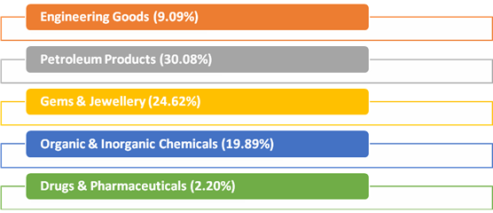

**EXPORTS**

* Exports mean that we are selling commodities to other countries.
* At the time of independence our exports comprise of agricultural products like tobacco, spices, raw materials of cotton and jute etc.
* Due to industrialization the proportion of raw materials in our export declined.

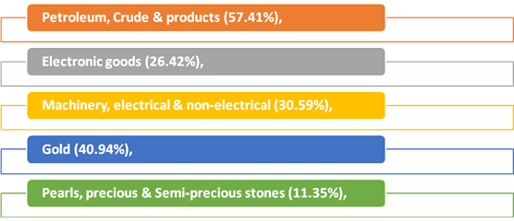

**CRUDE OIL AND NON-OIL IMPORTS:**

Oil imports during July 2018 were valued at US$ 12.35Billion(Rs. 84,828.57crore) which was 57.41 percent higher in Dollar terms and 67.76 percent higher in Rupee terms compared to US$ 7.84 Billion (Rs. 50,565.29crore) in July 2017.Oil imports during April-July2018-19 were valued at US$ 46.98 Billion (Rs. 3,17,097.71crore) which was 51.45 per cent higher in Dollar terms and 58.58 percent higher in Rupee terms compared to US$ 31.02 Billion (Rs. 1,99,961.19crore) in the corresponding period last year.

In this connection it is mentioned that the global Brent price ($/bbl) has increased by 53.16% in July 2018 vis-à-vis July 2017 as per data available from US Energy Information Administration(EIA).

Non-oil imports during July 2018 were estimated at US$ 31.44Billion(Rs.2,15,956.15crore) which was 20.23 per cent higher in Dollar terms and 28.13 percent higher in Rupee terms compared to US$ 26.15 Billion (Rs. 1,68,543.60crore) in July 2017.Non-oil imports during April-July2018-19 were valued at US$ 124.21 Billion(Rs.8,37,783.99crore) which was 7.79 per cent higher in Dollar terms and 12.79 percent higher in Rupee terms compared to US$ 115.23 Billion (Rs. 7,42,778.81crore in April-July, 2017-18.

Non-Oil and Non-Gold imports in July 2018 valued at US $ 28.47 billion has recorded a positive growth of 18.42 % as compared to Non-Oil and Non-Gold import in July 2017. Non-Oil and Non-Gold imports in April-July 2018 valued at US $ 112.80 billion has recorded a positive growth of 10.74 % as compared to Non-Oil and Non-Gold import in April-July 2017.

**TRADE IN SERVICES (for June, 2018, as per the RBI Press Release dated 14th August 2018)**

**EXPORTS (Receipts)**

Exports during June 2018 were valued at US$ 16.87Billion (Rs.1,14,380.52Crore) registering a positive growth of 4.32per cent in dollar terms as compared to negative growth of 7.91per cent during May2018(as per RBI’s Press Release for the respective months).

**IMPORTS (Payments)**

Imports during June2018 were valued at US$ 10.30Billion (Rs. 69,820.11Crore) registering a positive growth of 0.89per cent in dollar terms as compared to negative growth of 6.48per cent during May2018(as per RBI’s Press Release for the respective months).

**TRADE BALANCE**

**MERCHANDISE**: The trade deficit for July 2018 was estimated at US$ 18.02Billionas against the deficit of US$ 11.45Billion during July 2017.

**SERVICES**: As per RBI’s Press Release dated 14th August 2018, the trade balance in Services (i.e. net export of Services) for June, 2018 was estimated at US$ 6.57Billion.

**OVERALL TRADE BALANCE:** Taking merchandise and services together, overall trade deficit for April-July2018-19 is estimated at US$ 43.77Billion as compared to US$ 34.07 Billion during April-July2017-18. (Services data pertains to April-June 2018-19 as June 2018is the latest data available as per RBI’s Press Release dated 14th August 2018)

**DIRECTION OF INDIA’S FOREIGN TRADE**

* Direction means countries to which India exports its goods and countries from which it imports.
* Direction of trade also helps to understand the diplomatic relationship maintained by India with other countries of trade.
* West Europe (28.1 per cent), America (25.4 per cent), Africa⎫ (6.3 per cent) and East Europe (3.1 per cent)

**Group of countries to which India Exports**

Organization of Petroleum Exporting Countries (OPEC).

Eastern Europe.

Developing Nations.

Organization for Economic Cooperation & Development (OECD).

• China, Hong Kong, South Korea, Singapore and Malaysia.

• Romania, Russia and others.

• Kuwait, Iran, Iraq, Saudi Arabia and others.

* USA Canada, European (EU), Australia and Japan.

**QUICK ESTIMATES FOR SELECTED MAJOR COMMODITIES FOR JANUARY 2018**

**TRADE: EXPORT**

|  |  |  |  |  |
| --- | --- | --- | --- | --- |
| **Sl. No.** | **Commodities** | **(Values in Million USD)** | | **% change** |
| **JAN'17** | **JAN'18** | **JAN'18** |
| 1 | Tea | 62.70 | 70.55 | 12.52 |
| 2 | Coffee | 51.99 | 52.83 | 1.62 |
| 3 | Rice | 517.94 | 661.82 | 27.78 |
| 4 | Other cereals | 24.49 | 14.11 | -42.38 |
| 5 | Tobacco | 56.77 | 79.13 | 39.39 |
| 6 | Spices | 217.40 | 223.35 | 2.74 |
| 7 | Cashew | 64.65 | 66.61 | 3.03 |
| 8 | Oil Meals | 97.08 | 93.45 | -3.74 |
| 9 | Oil seeds | 154.75 | 84.41 | -45.45 |
| 10 | Fruits & Vegetables | 201.50 | 224.18 | 11.26 |
| 11 | Cereal preparations & miscellaneous processed items | 91.65 | 110.27 | 20.32 |
| 12 | Marine Products | 402.35 | 473.33 | 17.64 |
| 13 | Meat, dairy & poultry products | 273.70 | 296.39 | 8.29 |
| 14 | Iron Ore | 179.09 | 88.69 | -50.48 |
| 15 | Mica, Coal & Other Ores, Minerals including processed minerals | 274.25 | 326.24 | 18.96 |
| 16 | Leather & leather products | 415.81 | 439.28 | 5.64 |
| 17 | Ceramic products & glassware | 144.40 | 165.69 | 14.74 |
| 18 | Gems &Jewellery | 3002.17 | 3028.90 | 0.89 |
| 19 | Drugs & Pharmaceuticals | 1272.33 | 1381.81 | 8.60 |
| 20 | Organic & Inorganic Chemicals | 1206.94 | 1612.50 | 33.60 |
| 21 | Engineering Goods | 5498.98 | 6366.09 | 15.77 |
| 22 | Electronic Goods | 465.46 | 461.21 | -0.91 |
| 23 | Cotton Yarn/Fabs./made-ups, Handloom Products etc. | 933.41 | 843.72 | -9.61 |
| 24 | Man-made Yarn/Fabs./made-ups etc. | 406.02 | 402.95 | -0.76 |
| 25 | RMG of all Textiles | 1523.61 | 1395.93 | -8.38 |
| 26 | Jute Mfg. including Floor Covering | 27.33 | 28.36 | 3.77 |
| 27 | Carpet | 118.72 | 111.30 | -6.25 |
| 28 | Handicrafts excl. handmade carpet | 144.14 | 138.62 | -3.83 |
| 29 | Petroleum Products | 2746.79 | 3831.83 | 39.50 |
| 30 | Plastic & Linoleum | 465.95 | 607.01 | 30.27 |
|  | Sub-Total | 21042.37 | 23680.56 | 12.54 |
|  | **GRAND   TOTAL** | 22356.32 | 24383.97 | 9.07 |

**QUICK ESTIMATES FOR SELECTED MAJOR COMMODITIES FOR JANUARY 2018**

**TRADE: IMPORT**

|  |  |  |  |  |
| --- | --- | --- | --- | --- |
| **Sl. No.** | **Commodities** | **(Values in Rs. crores)** | | **% change** |
| **JAN'17** | **JAN'18** | **JAN'18** |
| 1 | Cotton Raw & Waste | 231.41 | 198.69 | -14.14 |
| 2 | Vegetable Oil | 5594.51 | 5907.47 | 5.59 |
| 3 | Pulses | 3175.59 | 755.96 | -76.19 |
| 4 | Fruits & vegetables | 1084.78 | 1289.83 | 18.90 |
| 5 | Pulp and Waste paper | 611.57 | 525.87 | -14.01 |
| 6 | Textile yarn Fabric, made-up articles | 806.97 | 960.13 | 18.98 |
| 7 | Fertilisers, Crude & manufactured | 1644.24 | 2819.37 | 71.47 |
| 8 | Sulphur& Unroasted Iron Pyrites | 74.57 | 119.29 | 59.97 |
| 9 | Metalliferous ores & other minerals | 4045.71 | 6491.49 | 60.45 |
| 10 | Coal, Coke & Briquettes, etc. | 11378.75 | 14004.63 | 23.08 |
| 11 | Petroleum, Crude & products | 55648.68 | 74194.72 | 33.33 |
| 12 | Wood &  Wood products | 2462.09 | 3141.65 | 27.60 |
| 13 | Leather & leather products | 479.62 | 532.55 | 11.04 |
| 14 | Organic & Inorganic Chemicals | 8234.72 | 11425.26 | 38.74 |
| 15 | Dyeing/tanning/colouring materials. | 1220.81 | 1754.62 | 43.73 |
| 16 | Artificial resins, plastic materials, etc. | 5863.28 | 7821.83 | 33.40 |
| 17 | Chemical material & products | 3059.23 | 4088.89 | 33.66 |
| 18 | Newsprint | 451.60 | 289.49 | -35.90 |
| 19 | Pearls, precious & Semi-precious stones | 10518.84 | 15309.91 | 45.55 |
| 20 | Iron & Steel | 6825.42 | 8220.34 | 20.44 |
| 21 | Non-ferrous metals | 5446.24 | 7257.05 | 33.25 |
| 22 | Machine tools | 1660.37 | 2398.56 | 44.46 |
| 23 | Machinery, electrical & non-electrical | 15849.56 | 19128.31 | 20.69 |
| 24 | Transport equipment | 12749.27 | 12398.78 | -2.75 |
| 25 | Project goods | 1190.97 | 873.33 | -26.67 |
| 26 | Professional instrument, Optical goods, etc. | 2075.92 | 2325.11 | 12.00 |
| 27 | Electronic goods | 26555.36 | 27848.56 | 4.87 |
| 28 | Medicinal & Pharmaceutical products | 2767.31 | 3023.28 | 9.25 |
| 29 | Gold | 13890.79 | 10119.16 | -27.15 |
| 30 | Silver | 1334.47 | 1650.92 | 23.71 |
|  | Sub-Total | 206932.65 | 246875.05 | 19.30 |
|  | **GRAND   TOTAL** | 219635.13 | 258890.43 | 17.87 |

**WEAKNESSES AND PROBLEM OF INDIA’S TRADE**

1. Indian imports have been rising faster than exports and so there is always a trade deficit. The imports no doubt will have to increase to meet developmental needs but industries developed in India through economic growth are largely for import substitution and not for export promotion.
2. Fuel especially petroleum is having a rising share because crude production in India has not risen; virtually we are at mercy of OPEC countries.
3. Direction of exports and imports is highly concentrated with OCED countries.
4. USA is another market and if in any year its imports decline India suffers badly.

**BALANCE OF PAYMENT**

The Balance of Payments or BoP is a statement or record of all monetary and economic transactions made between a country and the rest of the world within a defined period (every quarter or year). These records include transactions made by individuals, companies and the government.

Keeping a record of these transactions helps the country to monitor the flow of money and develop policies that would help in building a strong economy.

**Why balance of payment is vital for a country?**

A country’s BOP is vital for the following reasons:

* BOP of a country reveals its financial and economic status.
* BOP statement can be used as an indicator to determine whether the country’s currency value is appreciating or depreciating.
* BOP statement helps the Government to decide on fiscal and trade policies.
* It provides important information to analyze and understand the economic dealings of a country with other countries.

**Elements of balance of payment**

There are three components of balance of payment viz current account, capital account, and financial account. The total of the current account must balance with the total of capital and financial accounts in ideal situations.

##### **Current Account**

The current account is used to monitor the inflow and outflow of goods and services between countries. This account covers all the receipts and payments made with respect to raw materials and manufactured goods. It also includes receipts from engineering, tourism, transportation, business services, stocks, and royalties from patents and copyrights. When all the goods and services are combined, together they make up to a country’s Balance Of Trade.

##### **Capital Account**

All capital transactions between the countries are monitored through the capital account. Capital transactions include the purchase and sale of assets (non-financial) like land and properties. The capital account also includes the flow of taxes, purchase and sale of fixed assets etc by migrants moving out/in to a different country.

There are 3 major elements of capital account:

* Loans & borrowings – It includes all types of loans from both the private and public sectors located in foreign countries.
* Investments – These are funds invested in the corporate stocks by non-residents.
* Foreign exchange reserves – Foreign exchange reserves held by the central bank of a country to monitor and control the exchange rate does impact the capital account.

##### **Financial Account**

The flow of funds from and to foreign countries through various investments in real estates, business ventures, foreign direct investments etc is monitored through the financial account. This account measures the changes in the foreign ownership of domestic assets and domestic ownership of foreign assets. On analyzing these changes, it can be understood if the country is selling or acquiring more assets (like gold, stocks, equity etc).

**PARALLEL ECONOMY**

Parallel economy, based on the black money or unaccounted money, is a big menace to the Indian economy. It is also a cause of big loss in the tax-revenues for the government.



When economic activities goes unreported or not measured by societies current techniques to monitor economic activity it falls under parallel economy. Money that have neither been reported to the public authorities at the time of their generation or at any time of possession; no taxes have been paid on it. Also known as Phantom trades or Shadow economy.

A hidden economy in its broadest sense may consist of –

a) illegal economy, such as money laundering, smuggling, etc;

b) unreported economy including tax evasion;

c) unregulated economy, that is economic activities outside  law and regulations.

**Impact of the black money:**

In India, the black economy has resulted in an immense loss of tax revenue. If it accounted for 40% of GDP in 1998-99, the loss of direct tax revenue at the prevailing rate would amount to at least Rs. 200,000 crore. Only 2 million of India's billion people pay taxes, just 2% of the population. The government therefore suffers a perennial shortage of funds and public services languish.

Policies fail both at the macro-level and the micro-level. Targets for education, health, drinking water and so on are not achieved because “expenditures do not mean outcomes.” Much investment goes into wasteful and unproductive channels, like holding gold or real estate abroad.

A country is considered as capital-short has been exporting capital. A nation that gives concessions to multinational corporations to bring in capital loses more capital than it gets, and that too at a high cost, from foreign institutional investments or foreign direct investment.

**Strategy for recovering black money**

So far the Government has adopted a five-pronged strategy to tackle the sensitive issue of Black Money –

• Joining the Global Crusade Against Black Money

• Creating an Appropriate Legislative Framework using DTAA and Tax Information Exchange Agreement (TIEA)

• Setting up Institutions to Deal with Illicit Funds such as Income Tax Overseas Units.

• Manpower of FT&TR Division in CBDT has been doubled.

• Imparting Skills to the Manpower for Effective Action

Recommendations for Black Money Recovery

• Reducing disincentives by Rationalization of tax rates, reduce tax terrorism (retrospective amendments), pass GST and Reducing transaction costs by providing internet-based services to pay tax;

• Creation of effective credible deterrence by Setting up an investigation unit with Enforcement Directorate as the nodal coordinating agency to remove problem of lack of coordination; CAG should audit on suspicious exports vulnerable sectors like Real estate, jewelry, financial markets, have Time frame for Income Tax and CBEC for completing cases.

• Amend PMLA, FEMA and Make Tax evasion a serious "criminal offence. Reform political funding in India.

• Establishment of a central KYC (Know Your Customer) registry to deal with the problem of multiple identities of an individual in financial transactions.

• To ensure that banks, on a real time basis, report all suspicious transactions, SIT must seek a report from the Financial Intelligence Unit (FIU) of the Indian government on what it has done about suspicious transactions reported by banks.

• To pressurize Swiss authorities to give name of US citizens who have opened numbered bank account in Swiss Banks, US arrested senior bank officers of Union Bank of Switzerland on charges of espionage. India also has Swiss bank branch offices in Mumbai.

**Inflation**

### Meaning of Inflation:

Inflation is the rate at which the prices for goods and services increase. Inflation often affects the buying capacity of consumers. Most Central banks try to limit inflation in order to keep their respective economies functioning efficiently.  
There are advantages and disadvantages to inflation.

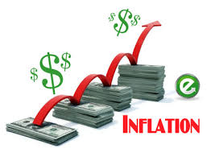

### ****Causes of Inflation****

Inflation is caused by multiple factors, here are a few:

**1. Money Supply**

Excess currency (money) supply in an economy is one of the primary cause of inflation. This happens when the money supply/circulation in a nation grows above the economic growth, therefore reducing the value of the currency.  
In the modern era, countries have shifted from the traditional methods of valuing money with the amount of gold they possessed. Modern methods of money valuation are determined by the amount of currency that is in circulation which is then followed by the public’s perception of the value of that currency.

**2. National Debt**

There are a number of factors that influence national debt, which include the nations borrowing and spending. In a situation where a country’s debt increases, the respective country is left with two options:   
Taxes can be raised internally  
Additional money can be printed to pay off the debt

**3. Demand-Pull Effect**

The demand-pull effect states that in a growing economy as wages increase within an economy, people will have more money to spend on goods and services. The increase in demand for goods and services will result in companies to raise prices that consumers will bear in order to balance supply and demand.

**4. Cost-Push Effect**

This theory states that when companies face increased input costs on raw materials and wages for manufacturing consumer goods, they will preserve their profitability by passing the increased production cost to the end consumer in the form of increased prices.

**5. Exchange Rates**

An economy with exposure to foreign markets mostly functions on the basis of the dollar value. In a trading global economy, exchange rates play an important factor in determining the rate of inflation.

**Types of Inflation**

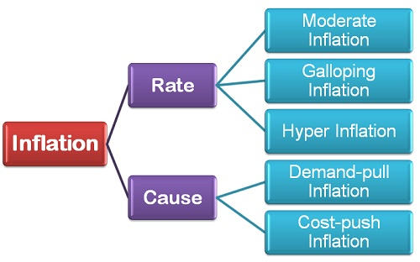

**Types of Inflation: On the Basis of Rate**

1. **Moderate Inflation:**The moderate inflation, also called as **Creeping Inflation** refers to a **single digit annual** increase in the general price level. During the moderate period, the price increases persistently, but at a mild or moderate rate, i.e. less than 10% or a single digit inflation rate. A moderate rate may vary from country to country, but however an important trait of this inflation rate is, it is predictable.
2. **Galloping Inflation:** The galloping inflation refers to the exceptionally high inflation rate that leads to an increase in the general price level. Generally, the inflation is in **double or triple digit**and is reflected in the high price of goods and services, i.e. prices increase manifold. The double-digit inflation varies from 10% to 999% per annum and there is a great difference between these two limits. A country with 900% inflation will have more devastating effects than the one having 20-30% inflation.
3. **Hyper Inflation:** As the name suggests, the hyper inflation is the situation when the prices rise at an alarmingly high rate, i.e. **more than a three-digit per annum**. The prices rising above 1000% per annum marks the beginning of hyper inflation. During this period, the paper currency becomes worthless, and people start trading in kind, such as gold and silver and often resort to the old barter system of commerce.

**Types of Inflation: On the Basis of Cause**

1. **Demand-pull Inflation:**The demand-pull inflation exists when the **aggregate demand increases rapidly than the aggregate supply**. In other words, for a given level of aggregate supply the aggregate demand increases manifold, then the demand-pull inflation occurs. This increase in the demand can be due to the **monetary factors**i.e., increase in money supply and **real factors,** Viz. Cut in tax rates, increase in government expenditure, upward shift in investment function, etc.
2. **Cost-Push Inflation:** The Cost-Push inflation occurs when the cost of raw material, labor, and inputs necessary for the production of final goods increases. Such inflation is often caused by the monopolistic groups of the society such as labor unions and firms in the monopoly and oligopolistic market setting.

Strong labor unions force the wage price to go up that leads to an increase in the price of goods and services. This rise in the price level is called as **wage-push inflation**. Also, the firms enjoying the monopoly in the market raise the price level to increase their profit margins due to which the general price level increases. This is called as **profit-push inflation**. Another kind of cost-push inflation is the **supply-shock inflation** when the firms restrict the aggregate supply of goods and services.

Thus, one may conclude that inflation is either caused due to its rate and cause, thereby leading to a sustainable increase in the general price level in the economy.

Regional imbalance is the disparity in economic and social development of two regions. One region/city/area is stronger than another region/city/area.   
  
Regions develop when investments are made to set up industries, service sectors, educational institutions, health care facilities etc. In India after liberalization, the role of private sector has increased in investment decisions. Naturally, the investments will flow in regions which are favorable to return maximum return on investments. This rules out the possibility of investments in poorly connected and geographically separated regions (for example mountains), and regions with hostile political environment. The maximum share in gained by the regions which have adequate physical and social infrastructure and a conducive environment.   
  
This results in development of one region as compared to the other region. Some consequences of this imbalanced development are:   
  
1. **Migration:** Migration from economically backward area towards economic strongholds. Foe example the rural-urban migration. Cities are more prosperous as compared to rural areas, providing better quality of life and more sources of income.   
  
2.**Social unrest-** Differences in prosperity and development leads to friction between different sections of the society causing social unrest. For example Naxalism. Naxalites in India function in areas which have been neglected for long for development purposes/economic prosperity.   
  
3.**Aggregation of the imbalance:**Once an area is prosperous and has adequate infrastructure for development, more investments pour-in neglecting the less developed regions. So an area which is already prosperous, develops further. For examples- the rate of growth of the four metropolitan cities, as compared to other metro cities is still higher.

**Inequality of incomes leads to some very serious economic and social consequences:**

**(a) Class-conflict:**

It has created two sections in society—the ‘haves’ and the ‘have-not’s—which are ever on the war path. This has resulted in ever mounting social tensions and political discontent.

**(b) Political Domination:**

The rich dominate the political machinery, and they use it to promote their own exclusive interests. This results in corruption, graft and social injustice.

**(c) Exploitation:**

The rich exploit the poor. The consciousness of this exploitation leads to political awakening and then agitation and even political revolution. Thus inequality of incomes is an important cause of social and political instability.

**(d) Creation of Monopolies:**

Unequal incomes promote monopolies. These powerful monopolies and industrial combines charge unfair prices from the consumer? And crush the small producers. The bigger fish swallow the small fry.

**(e) Suppression of Talent:**

It is said that ‘slow rises merit by poverty depressed’. It is not easy for a poor man to make his way in life, however brilliant he may be. It is a great social loss that brainy people without money are unable to make their due contribution to social welfare.

**(f) Undemocratic:**

Democracy is a farce when there is a wide gulf between the rich and the poor. Political equality is a myth without economic equality.

**(g) Moral Degradation:**

The rich are corrupted by vice and the poor demoralized by lack of economic strength. Thus inequalities spoil the rich and degrade the poor. Vice and corruption rule such a world. The poor man finds it almost impossible to regain the virtues of honesty and integrity. Human dignity is lost altogether.

**(h) Promotes Capital Formation:**

However, there is one good which comes out of these inequalities of incomes and that is that it facilitates savings. If the national income of the country is evenly distributed among all its citizens, it is clear that it will be only thinly spread over the whole population. Everyone will have nothing left for saving. It is only when income is unequally distributed that there are people who are so rich that in their case saving is automatic.

It is only a minority of the people who have the saving habit. To the rest if income comes, it is squandered away. Under a system, where there are large accretions of wealth in certain patches, not only is the capacity for savings greater, but the ability to invest and gain is also greater. There are people who save and turn their saving into capital. Thus inequality of incomes helps capital formation in a country.

**Main Causes of Regional Imbalances in India**:

The following points highlight the nine main causes of regional imbalances in India. Some of the causes are: 1. Historical Factor 2. Geographical Factors 3. Locational Advantages 4. Inadequacy of Economic Overheads 5. Failure of Planning Mechanism 6. Marginalisation of the Impact of Green Revolution to Certain Regions 7. Lack of Growth of Ancillary Industries in Backward States and Others.

**Historical Factor:**

Historically, regional imbalances in India started from its British regime. The British rulers as well as industrialists started to develop only those earmarked regions of the country which as per their own interest were possessing rich potential for prosperous manufacturing and trading activities.

British industrialists mostly preferred to concentrate their activities in two states like West Bengal and Maharashtra and more particularly to three metropolitan cities like Kolkata, Mumbai and Chennai. They concentrated all their industries in and around these cities neglecting the rest of the country to remain backward.

The land policy followed by the British frustrated the farmers to the maximum extent and also led to the growth of privileged class like zamindars and money lenders for the exploitation of the poor farmers. In the absence of proper land reform measures and proper industrial policy, the country could not attain economic growth to a satisfactory level.

The uneven pattern of investment in industry as well as in economic overheads like transport and communication facilities, irrigation and power made by the British had resulted uneven growth of some areas, keeping the other areas totally neglected.

**Geographical Factors:**

Geographical factors play an important role in the developmental activities of a developing economy. The difficult terrain surrounded by hills, rivers and dense forests leads to increase in the cost of administration, cost of developmental projects, besides making mobilisation of resources particularly difficult.

Most of the Himalayan states of India, i.e., Himachal Pradesh, Northern Kashmir, the hill districts of Uttar Pradesh and Bihar, Arunachal Pradesh and other North-Eastern states, remained mostly backward due to its inaccessibility and other inherent difficulties.

Adverse climate and proneness to flood are also responsible factors for poor rate of economic development of different regions of the country as reflected by low agricultural productivity and lack of industrialisation. Thus these natural factors have resulted uneven growth of different regions of India.

**Locational Advantages:**

Locational advantages are playing an important role in determining the development strategy of a region. Due to some locational advantages, some regions are getting special favour in respect of site selections of various developmental projects.

While determining the location of iron and steel projects or refineries or any heavy industrial project, some technical factors included in the locational advantage are getting special considerations. Thus regional imbalances arise due to such locational advantages attached to some regions and the locational disadvantages attached to some other backward regions.

**Inadequacy of Economic Overheads:**

Economic overheads like transport and communication facilities, power, technology, banking and insurance etc. are considered very important for the development of a particular region.

Due to adequacy of such economic overheads, some regions are getting a special favour in respect of settlement of some developmental projects whereas due to inadequacy of such economic overheads, some regions of the country, viz., North-Eastern Region, Himachal Pradesh, Bihar etc. remained much backward as compared to other developed regions of the country.

Moreover, new investment in the private sector has a general tendency to concentrate much on those regions having basic infrastructural facilities.

**Failure of Planning Mechanism:**

Although balanced growth has been accepted as one of the major objectives of economic planning in India, since the Second Plan onwards but it did not make much headway in achieving this object. Rather, in real sense, planning mechanisms has enlarged the disparity between the developed states and less developed states of the country.

In respect of allocating plan outlay relatively developed states get much favour than less developed states.

From First Plan to the Seventh Plan, Punjab and Haryana have received the highest per capita plan outlay, all along. The other three states like Gujarat, Maharashtra and Madhya Pradesh have also received larger allocation of plan outlays in almost all the five year plans.

On the other hand, the backward states like Bihar, Assam, Orissa, Uttar Pradesh and Rajasthan have been receiving the smallest allocation of per capita plan outlay in almost all the plans.

Due to such divergent trend, imbalance between the different states in India has been continuously widening, inspite of framing achievement of regional balance as one of the important objectives of economic planning in the country.

**Marginalisation of the Impact of Green Revolution to Certain Regions:**

In India, the green revolution has improved the agricultural sector to a considerable extent through the adoption of new agricultural strategy. But unfortunately the benefit of such new agricultural strategy has been marginalised to certain definite regions keeping the other regions totally untouched.

The Government has concentrated this new strategy to the heavily irrigated areas with the idea to use the scarce resources in the most productive manner and to maximise the production of foodgrains so as to solve the problem of food crisis.

Thus the benefit of green revolution is very much restricted to the states like Punjab, Haryana and plain districts of Uttar Pradesh leaving the other states totally in the dark about the adoption of new agricultural strategy.

This has made the well-off farmers much better off, whereas the dry land farmers and non-farming rural population remained totally untouched. Thus in this way new agricultural strategy has aggravated regional imbalances due to its lack of all-embracing approach.

**Lack of Growth of Ancillary Industries in Backward States:**

The Government of India has been following a decentralised approach for the development of backward regions through its investment programmes on public sector industrial enterprises located in backward areas like Rourkela, Barauni, Bhilai, Bongaigaon etc. But due to lack of growth of ancillary industries in these areas, all these areas remained backward in spite of huge investment made by the Centre.

**Lack of Motivation on the part of Backward States:**

Growing regional imbalance in India has also been resulted from lack of motivation on the part of the backward states for industrial development. While the developed states like Maharashtra, Punjab, Haryana, Gujarat, Tamil Nadu etc. are trying to attain further industrial development, but the backward states have been showing their interest on political intrigues and manipulations instead of industrial development.

**Political Instability:**

Another important factor responsible for regional imbalance is the political instability prevailing in the backward regions of the country. Political instability in the form of unstable government, extremist violence, law and order problem etc. have been obstructing the flow of investments into these backward regions besides making flight of capital from these backward states.

**Industrial Sickness**

Industrial Sickness is a Universal Phenomenon. It is a major problem of all industries in the world whether it is developed or developing countries. It is a serious matter of the countries. A sick unit is one which is not healthy. To an industrialist, it is a unit which is making losses. To an investor it is one which skips dividends. To a banker, it is one which is not repaying its loan or interest.

**Definition of Industrial Sickness:–**

**Acc. to State Bank of India,** “A sick unit is that unit which fails to generate internal surplus on a continuing basis and depends for its survival on frequent infusion of external funds.

Sickness are two types, namely:- 1. Born Sickness 2. Achieved Sickness

1. **Born Sickness**:-Industrial units born sick are those which are destined for disaster right from their conception due to various causes. e.g Lack of experience of promoters, Lack of funds, Lack of good location, Wrong plant layout.

2. **Achieved Sickness**:- Industries which achieve sickness are those which fail after becoming operational due to internal causes. e.g Bad Management, Poor inventory management, Poor labour management.

**Causes of Industrial Sickness-**

There are many causes for becoming sick units. The main reasons of Industrial sickness is explained are as follows:–

i) Management Problems

ii) Financial Problems

iii) Labour Problems

iv) Technological Factors

v) Personal Wasteful Expenditure

vi) Faulty Demand Forecasting

vii) Government Policy

viii) Power Cuts

ix) Shortage of Raw Material

x) Infrastructure Problems.

**Steps taken by the Govt. for Sickness-**

* 1. Takeover by Management
  2. Setting up of Industrial Investment Bank of India
  3. Amalgamation with healthy units
  4. Diversification
  5. Research and Development
  6. Soft Loans for Sick Units

vii) Periodical Review

viii) Avoid Excessive investment in Unproductive Capital Assets

ix) Strick Penalties to persons responsible for sick units.

**Regional Imbalance**

Regional imbalances or disparities means wide differences in per capita income, literacy rates, health and education services, levels of industrialization, infrastructural facilities etc. between different regions. Regions may be either States or regions within a State.

There are many other factors that were responsible for regional imbalances, those are-

1. **Historical Factors**- British regime policies created huge regional disparities across India. Britishers focused mainly on the development of coastal areas that created a difference the Coastal areas and hinter land. Also the Princely State lagged behind in the development as compared to British India.
2. **Geographical Factors**- Difficult terrain hills, rivers, forest make resource mobilization difficult in some of the areas of the state. Also adverse climatic conditions, proneness to disasters like floods, earthquakes etc hinders the development of some areas.
3. **Location Factors-** raw material availability, source of water, stable landform etc, give an edge to some areas as compared to other who do not have these advantages.
4. **Infrastructural issues-** Regions that have good connectivity, power availability. Financial Institutions are naturally the first preference of the investors as compared to the place which do not have these.
5. **Failure of Planning Mechanism**- Disparities in the five year plan layouts and failure of trickle down effects is also responsible for regional disparities in India.
6. **Faulty land reform measures**- Huge disparity in land reforms as land is a state subject and different state governments followed different land reforms policies.
7. **Flip side of Green Revolution**- Green revolution created disparities in agricultural production of different regions.
8. **Political instability**-some States are suffering from the problem of Naxalities, some by insurgency, militancy etc which kept them behind in the race of development.

**Measures to fight with Regional imbalance**

* Transfer of financial resources from Centre to the backward states.
* Special area development programme for backward areas.
* Measures to increase private investment in such areas.

**Unemployment**

Unemployment refers to a situation in which the workers who are capable of working and willing to work do not get employment. In other words, unemployment is a situation where the persons who are able to work and willing to work, fail to secure work or activity which gives them income or means of livelihood.

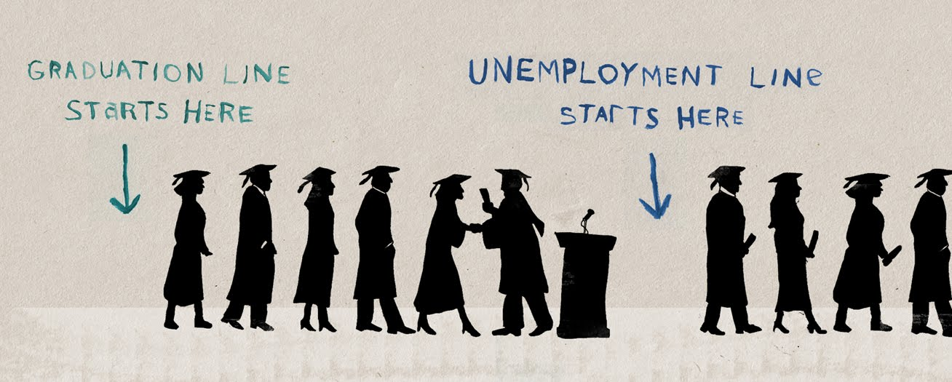

**Unemployment rate**

Unemployment is the ratio of the unemployed persons to the total labour force and is expected in percentage terms. Thus

Rate of unemployment = No. of unemployed persons X 100

Total labour force

### \

### Forms of Unemployment:

#### 1. Open Unemployment:

Open unemployment is a situation where in a large section of the labour force does not get a job that may yield them regular income. This type of unemployment can be seen and counted in terms of the number of unemployed persons. The labour force expands at a faster rate than the growth rate of economy. Therefore all people do not get jobs.

#### 2. Disguised Unemployment:

It is a situation in which more people are doing work than actually required. Even if some are withdrawn, production does not suffer. In other words it refers to a situation of employment with surplus manpower in which some workers have zero marginal productivity.

So their removal will not affect the volume of total production. Overcrowding in agriculture due to rapid growth of population and lack of alternative job opportunities may be cited as the main reasons for disguised unemployment in India.

#### 3. Seasonal Unemployment:

It is unemployment that occurs during certain seasons of the year. In some industries and occupations like agriculture, holiday resorts, ice factories etc., production activities take place only in some seasons. So they offer employment for only a certain period of time in a year. People engaged in such type of activities may remain unemployed during the off-season.

#### 4. Cyclical Unemployment:

It is caused by trade cycles at regular intervals. Generally capitalist economies are subject to trade cycles. The down swing in business activities results in unemployment. Cyclical unemployment is normally a shot-run phenomenon.

#### 5. Educated Unemployment:

Among the educated people, apart from open unemployment, many are underemployed because their qualification does not match the job. Faulty education system, mass output, preference for white collar jobs, lack of employable skills and dwindling formal salaried jobs are mainly responsible for unemployment among educated youths in India.

#### 6. Technological Unemployment:

It is the result of certain changes in the techniques of production which may not warrant much labour. Modern technology being capital intensive requires less labourers and contributes to this kind of unemployment.

#### 7. Structural Unemployment:

This type of unemployment arises due to drastic changes in the economic structure of a country. These changes may affect either the supply of a factor or demand for a factor of production.

#### 8. Underemployment:

It is a situation in which people employed contribute less than their capacity to production. In this type of unemployment people are not gainfully employed. They may be employed either on part-time basis, or undertake a job for which lesser qualification is required. For example a Post Graduate may work as a clerk for which only S.S.L.C. is enough.

#### 9. Casual Unemployment:

When a person is employed on a day-to-day basis, casual unemployment may occur due to short-term contracts, shortage of raw materials, fall in demand, change of ownership etc.

#### 10. Chronic Unemployment:

If unemployment continues to be a long term feature of a country, it is called chronic unemployment. Rapid growth of population and inadequate level of economic development on account of vicious circle of poverty are the main causes for chronic unemployment.

#### 11. Frictional Unemployment:

Frictional unemployment is caused due to improper adjustment between supply of labour and demand for labour. This type of unemployment is due to immobility of labour, lack of correct and timely information, seasonal nature of work. Etc

Main Causes of Unemployment

**Solutions to the unemployment in India**

1. The very first solution for the unemployment is to control the rising population of our country.

2. The quality of Indian education should be improved. The current education system is not upto the level. Government should keep a strict watch on the education system and try to implement new ways to generate skilled labour force.

3. Also today’s youth should join the institute or select the course where proper training is given and the course is as per the current industries requirements.

4. Government should encourage and develop the agriculture based industries in rural areas so that the rural candidates don’t migrate to the urban areas.

5. Rapid Industrialization should be created.

6. Development of the rural areas will stop the migration of the rural people to the urban cities and this will not put more pressure on the urban city jobs.

7. Government should allow more foreign companies to open their unit in India, so that more employment opportunities will be available.

### GOVERTONMENT MEASURES TO REDUCE UNEMPLOYMENT IN INDIA AS FOLLOWS

1. RURAL WORKS PROGRAMME (RWP)
2. MARGINAL FARMERS AND AGRICULTURAL LABOURERS AGENCY ( MFALA)
3. INTEGRATED DRY LAND AGRICULTURAL DEVELOPMENT PROGRAMME (IDLADP)
4. AGRO SERVICE CENTRE (ASC)
5. EMPLOYMENT GUARANTEE SCHEME OF MAHARASHTRA ( EGS )
6. NATIONAL RURAL EMPLOYMENT PROGRAMME (NREP)
7. RURAL LANDLESS EMPLOYMENT GUARENTEE PROGRAMME (RLEGP)
8. JAWAHAR ROZGAR YOJANA (JRY)
9. TRAINING RURAL YOUTH FOR SELF EMPLOYMENT (TRYSEM)
10. **TRAINING FOR SELF-EMPLOYMENT**

**Poverty**

**DEFINITIONS OF POVERTY**:

**AMARTY SEN:** “Poverty as consisting of a deprivation of a capabilities”, So that the poor have inadequate resources (financial, information, and so on) to participate fully in society in short, they are socially excluded.

**WORLD BANK :** “Poverty is pronounced as deprivation in well-being, and comprises many dimensions. It includes low incomes and the inability to acquire the basic goods and services necessary for survival with dignity. Poverty also encompasses low levels of health and education, poor access to clean water and sanitation, inadequate physical security, lack of voice and insufficient capacity and opportunity to better one’s life”

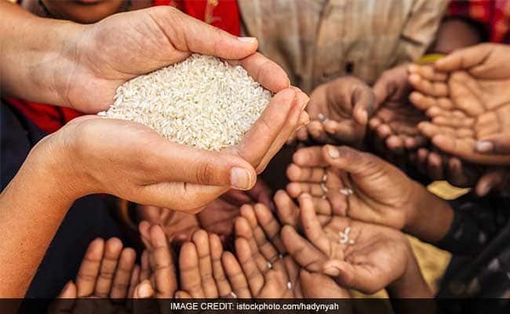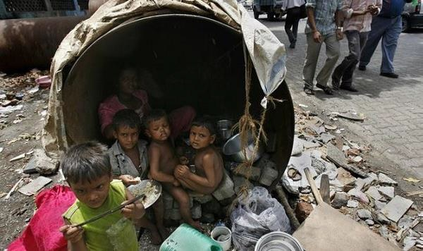

**Causes of poverty**

### Climatic factors

### Demographic factors

(i) Rapid growth of population

(ii) Size of family

### Personal causes

(i) Lack of motivation

(ii) Idleness

### 4. Economic causes

(i) Low agricultural productivity

(ii) Unequal distribution of land and other assets

(iii) Decline of village industries

(iv) Immobility of labour

(v) Lack of employment opportunities

### 5. Social causes

(i) Education

(ii) Caste system

(iii) Joint family system

(iv) Social customs

(v) Growing indebtedness

**REMEDIES TO ERADICATE POVERTY**

**1.Roshni: Skill Development Scheme for Tribals:**

**I.**The Ministry of Rural Development on 7 June 2013 launched a new skill development scheme designed to offer employment to tribal youth in 24 Naxal -affected districts.   
**II.**The scheme, which is named Roshni is supposed to provide training and employment to an anticipated 50000 youth in the 10-35 years age group, for a period of three years.  
**III.**As per the Ministry 50 per cent of the beneficiaries of the scheme will be women only.   
**IV.**The scheme is designed in light of the Himayat project model, which was launched in Jammu and Kashmir has been implemented in Sukma, Chhattisgarh, and West Singhbhum, Jharkand, on a pilot basis over the last 18 months.

**2.Mahatma Gandhi National Rural Employment Guarantee Scheme (MGNREGS):**

**I.**National Rural Employment Guarantee Act 2005, was launched on the 2nd Feb.2006. Now the new name of this scheme is "Mahatma Gandhi National Rural Employment Guarantee Act" (or, MGNREGA).   
**II.**This scheme is an Indian labour law and social security measure that aims to provide ‘right to work' to the people falling Below Poverty Line.   
**III.**It guarantees 100 days employment in a year to the village people.  
**IV.**Fifty percent workers should be women.  
**V.**Its 90% funding is borne by the central government and 10% by the state government.

**3. National Rural Livelihood Mission**:

**I.**This scheme was restructured from the Swarn Jayanti Gram Swarojgar Yojna in 2011.  
**II.** National Rural Livelihoods Mission (Aajeevika) is aimed to empower the women’s self-help group model across the country.  
**III.** Under this scheme govt. provides loan up to 3 lakh rupee at the rate of 7% which could be lowered to 4% on the timely repayment.

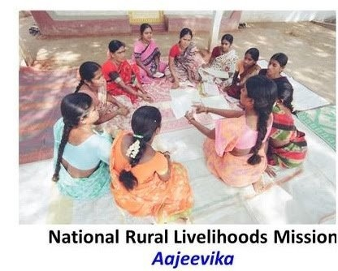

**4**. **Pradhan Mantri Gram Sadak Yojna:**

**I.**Initially it was 100% centrally funded scheme, launched on the December 25, 2000.  
**II.** After the recommendation of 14thfinance commission report now expenditure will be shared by the centre and state at ratio of 60:40.  
**III.** The main aim of this scheme is to provide all weather road connectivity to the rural areas whose population is more than 500 persons and in terms of hilly areas it is 250 persons.  
**IV.**This scheme is launched by the Ministry of Rural Development.

**5. Training to Rural Youth for Self Employment (TRYSEM)**

**I.** This centrally sponsored programme was started on august 15, 1979.  
**II.**The main target of this scheme was to provide technical and business expertise to rural BPL people who are in the age group of 18-35.  
**III.** This programme has been merged with Swarn Jayanti Gram Swarojgar Yojna on April1, 1999.

**6. Antyodaya Anna Yojna (AAY):**

**I.** The scheme was launched by the Prime Minister Atal Bihari Bajpayi on the 25 December 2000.  
**II.**The scheme provides food grains to around 2 cr. Below Poverty Line (BPL) families at a very subsidized rate.  
**III.** Total 35 kgs of food grains is provided to a family. Rice is provided at the rate of Rs. 3/kg and wheat at 2 Rs.2/kg.

### 7. Minister’s Rozgar Yojana (PMRY):

**I**. The PMRY is a self-employment programme for the educated unemployed youth.

**II**. This programme has been implemented since October 2, 1993 to provide employment opportunities to the educated unemployed youths in the country.

**III**. The minimum qualification required under the scheme is matriculation (passed or failed) or having undergone a government sponsored technical course for a period of six months or ITI passed. In this scheme the youth between the age of 18 and 35 belonging to families having income less than Rs. 25,000 per annum are provided assistance.

### 8. Jawahar Gram Samridhi Yojana (JGSY):

**I**.This scheme is in operation from 1999. It is implemented only at the village level to create village infrastructure and generates employment opportunities to alleviate poverty.

**SOCIAL INJUSTICE**

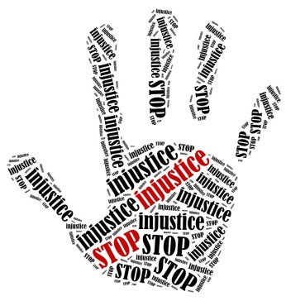

Social Injustice means that all facilities

are not given to all the persons of a

country based on caste, religion, sex, age,

level of income, physical disabilities or for

some other reasons. These disadvantaged

groups not only adversely affect economic

growth but also creates social tensions, crimes

and create barriers to social equality.

In India there is considerable discrimination on the basis of religion, race ,caste , sex or place of birth.

Therefore, the Constitution of india made many provisions to give equal rights to everyone under fundamental rights ie.

* Article 14
* Article 15
* Article 16
* Article 17
* Article 23
* Article 51
* Article 45

**Causes of Social Injustice**

* **Division of society according to nature of work in four categories centuries back.**
* **Zamindar system.**
* **Lack of education freedom to women.**
* **Poverty and economic poverty.**
* **Religious injustice.**

**Efforts to reduce Social injustice**

**Millennium Development Goals to be achieved by 2015**

1. Eradicate Extreme poverty and hunger

* Halve the proportion of people living on less than $1a day.
* Halve the people suffering from hunger.

1. Achieve universal primary education.
2. Promote gender equality and empower women
3. Reduce child mortality rates by two-thirds.
4. Improve maternal health and reduce maternal mortality ratios by three quarter.
5. Combat HIV/AIDS, maternal and other disease.
6. Ensure environmental sustainability.
7. Develop a global partnership for development.

**Unit IV**

Monetary Policy of India is formulated and executed by Reserve Bank of India to achieve specific objectives. It refers to that policy by which central bank of the country controls

* + 1. the supply of money, and
    2. cost of money or the rate of interest, with a view to achieve particular objectives.

In the words of D.C. Rowan, “The monetary policy is defined as discretionary act undertaken by the authorities designed to influence

(a) the supply of money,

(b) cost of money or rate of interest, and

(c) the availability of money for achieving specific objective.”

Thus, monetary policy of India refers to that policy which is concerned with the measures taken to regulate the volume of credit created by the banks. The main objectives of monetary policy are to achieve price stability, financial stability and adequate availability of credit for growth.

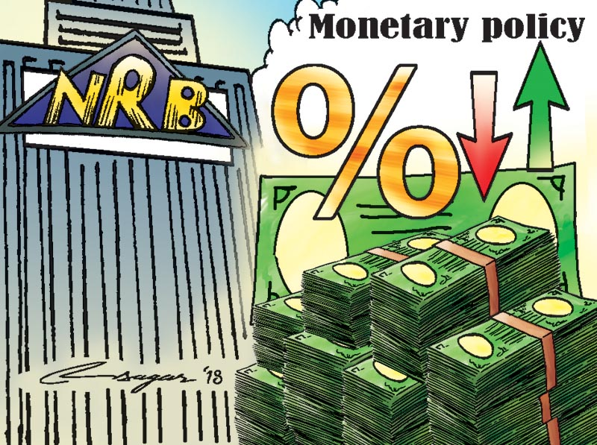

#### Following are the main elements of the monetary policy of India:

i. It regulates the stocks and the growth rate of money supply.

ii. It regulates the entire banking system of the economy.

iii. It determines the allocation of loans among different sectors

iv. It provides incentives to promote savings and to raise the savings-income ratio.

v. It ensures adequate availability of credit for growth and tries to achieve price stability.

#### Objectives of Monetary Policy:

According to RBI Governor Dr. D. Subba Rao, “The objectives of monetary policy in India are price stability and growth. These are pursued through ensuring credit availability with stability in the external value of rupee and overall financial stability.”

**Following are the main objectives of monetary policy:**

* 1. **To Regulate Money Supply in the Economy:** Money supply includes both money in circulation and credit creation by banks. Monetary policy is farmed to regulate the money supply in the economy by credit expansion or credit contraction.
  2. **To Attain Price Stability:** Another major objective of monetary policy in India is to maintain price stability in the country. It implies Control over inflation. Price level, is affected by money supply. Monetary policy regulates money supply to maintain price stability.

**iii. To promote Economic Growth:**

An important objective of monetary policy is to make available necessary supply of money and credit for the economic growth of the country. Those sectors which are quite significant for the economic growth are provided with adequate availability of credit.

**iv. To Promote saving and Investment:**

By regulating the rate of interest and checking inflation, monetary policy promotes saving and investment. Higher rates of interest promote saving and investment.

**v. To Control Business Cycles:** Boom and depression are the main phases of business cycle. Monetary policy puts a check on boom and depression. In period of boom, credit is contracted, so as to reduce money supply and thus check inflation. In period of depression, credit is expanded, so as to increase money supply and thus promote aggregate demand in the economy.

**vi. To Promote Exports and Substitute Imports:**

By providing concessional loans to export oriented and import substitution units, monetary policy encourages such industries and thus help to improve the position of balance of payments.

**vii. To Manage Aggregate Demand:**

Monetary authority tries to keep the aggregate demand in balance with aggregate supply of goods and services. If aggregate demand is to be increased than credit is expanded and the interest rate is lowered down. Because of low interest rate, more people take loan to buy goods and services and hence aggregate demand increases and vice-verse.

**viii. To Ensure more Credit for Priority Sector:**

Monetary policy aims at providing more funds to priority sector by lowering interest rates for these sectors. Priority sector includes agriculture, small- scale industry, weaker sections of society, etc.

**ix. To Promote Employment:**

By providing concessional loans to productive sectors, small and medium entrepreneurs, special loan schemes for unemployed youth, monetary policy promotes employment.

**x. To Develop Infrastructure:**

Monetary policy aims at developing infrastructure. It provides concessional funds for developing infrastructure.

**xi. To Regulate and Expand Banking:**

RBI regulates the banking system of the economy. RBI has expanded banking to all parts of the country. Through monetary policy, RBI issues directives to different banks for setting up rural branches for promoting agricultural credit. Besides it, government has also set up cooperative banks and regional rural banks. All this has expanded banking in all parts of the country.

**Measure of Money Stock**

* Knowledge of the measure of money stock in an economy would help us to understand monetary policy better.
* The Reserve bank of India employs four measures of money stock, namely, M1, M2, M3 & M4.

**M1**: described as the money supply. The components of money supply are currency with the public (notes in circulation, circulation of rupee coins &small coins) and deposits (deposit with bank & other deposits with RBI).

**M2**: Is M1 + Post office Savings Bank Deposits.

**M3**: Is M1+Time Deposits with the bank. (M3 is money supply plus fixed deposits with the banks.)

**M4**: Is M3+ the total Post Office Deposits.

**Measure**

**of** **money Stock**

## Monetary Policy Tools

To control inflation, the Reserve Bank of India needs to decrease the supply of money or increase cost of fund in order to keep the demand of goods and services in control.

### General Credit Controls (Quantitative tools) – it is important to stress that these are closely inter-related and have to be operated in co-ordination. All the three instruments affect the level of bank reserves.

The tools applied by the policy that impact money supply in the entire economy, including sectors such as manufacturing, agriculture, automobile, housing, etc.

1. **Reserve Ratio:**

Banks are required to keep aside a set percentage of cash reserves or RBI approved assets. Reserve ratio is of two types:

**Cash Reserve Ratio (CRR)** – Banks are required to set aside this portion in cash with the RBI. The bank can neither lend it to anyone nor can it earn any interest rate or profit on CRR.

**Statutory Liquidity Ratio (SLR)** – Banks are required to set aside this portion in liquid assets such as gold or RBI approved securities such as government securities. Banks are allowed to earn interest on these securities, however it is very low.

1. **Open Market Operations (OMO):**

Refer broadly to the purchase and sale by the Central Bank of a variety of assets, such as foreign exchange, gold, government securities and even company shares. In India, however in practice they are confined to the purchase & sale of government securities.

Central banks influence the economy either by

Increasing the money supply

(The central bank buys securities from commercial banks& public)

1. **Bank Rate Policy**- Also known as the Discount rate. The traditional definition of Bank rate is that it is the rate at which the central bank discounts or re-discounts- eligible bills. However, today the term Bank Rate is used in a broader sense and refers to the minimum rate at which the central bank provides accommodation to commercial banks in the discharge of its function as the lender of the last resort.

### Qualitative tools:

Refers to regulation of credit for specific purposes or branches of economic activity. It relates to the distribution or direction of available credit supplies.

Selective credit controls have been used in the western countries to prevent th demand for durable consumer goods outrunning the supply and generating inflationary pressure.

Unlike quantitative tools which have a direct effect on the entire economy’s money supply, qualitative tools are selective tools that have an effect in the money supply of a specific sector of the economy.

1. Margin requirements – RBI prescribes a certain margin against collateral, which in turn impacts the borrowing habit of customers. When the margin requirements are raised by the RBI, customers will be able to borrow less.
2. Moral suasion – By way of persuasion, RBI convinces banks to keep money in government securities, rather than certain sectors.
3. Selective credit control – Controlling credit by not lending to selective industries or speculative businesses.

### Fiscal policy

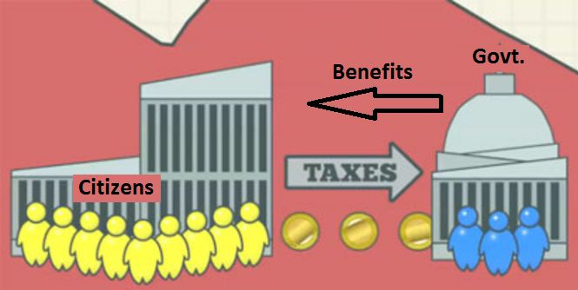

**Fiscal Policy is that part of Government policy which is concerned with raising revenue through taxation and other means and deciding on the level and patter of expenditure.**

**The fiscal polcy operates through the budget . The budget is an estimate of government expenditure and revenue for the ensuinf financial year, presented to Parliament usually by the Finance Minister.**

**Fiscal policy means the use of taxation and public expenditure by the government for stabilization or growth of the economy.** According to Culbarston, “By fiscal policy we refer to government actions affecting its receipts and expenditures which ordinarily as measured by the government’s receipts, its surplus or deficit.” The government may change undesirable variations in private consumption and investment by compensatory variations of public expenditures and taxes.

Fiscal policy also feeds into economic trends and influences monetary policy. **When the government receives more than it spends, it has a surplus**.

In India, the fiscal policy has to perform a significant role. Among other things, the budgetary policies are expected to achieve the following objectives:

• To promote and accelerate the growth of productive investment in the economy both in the public and the private sectors;

• To mobilize the maximum volume of real and financial resources for the investment plan of the public sector, keeping in view the expanding demand for real and financial resources of the private sector, and in this way, to promote the growth of marginal and average rates of savings in the economy;

• To promote the maintenance of a reasonable measure of economic stability in keeping with the maximum rate of growth of the economy;

• To redistribute the growing national output. There are vast differences in economic conditions, in the cultural, legal and political environment within which economic policy must operate and in the state of development of the art of taxation and the science of government.

### Objectives of Fiscal Policy

1. To maintain and achieve full employment.

2. To stabilise the price level.

3. To stabilise the growth rate of the economy.

4. To maintain equilibrium in the balance of payments.

5. To promote the economic development of underdeveloped countries.

There are two types of fiscal policy, they are:

* **Expansionary Fiscal Policy**: The policy in which the government minimises taxes and increase public spending.
* **Contractionary Fiscal Policy**: The policy in which the government increases taxes and reduce public expenditure.

| **MONETARY POLICY** | **FISCAL POLICY** |
| --- | --- |
| The main objective of the monetary policy is to achieve Price stability. | The main aim of fiscal policy is to maintain economic stability in the country and to bring Price stability. |
| **Aim** | |
| Monetary policy aims to attain Exchange rate stability. | Fiscal policy strives to promote export and introduce import substitution. |
| **Focused On** | |
| Monetary policy focuses on avoiding the negative impacts of the business cycle. | Fiscal policy concentrates on achieving balanced regional growth. |
| **Employment** | |
| Monetary policy tries to achieve full employment position. | Fiscal policy aims at social justice and full employment. |
| **Depends on** | |
| Success and failure of monetary measures depends on the banking system of the country. | Success of fiscal measures depends on the accurate predictions of various economic activities. |
| **Importance** | |
| The monetary measures are not very effective in overcoming depression. | In anti-depression fiscal policy, the expansion of public spending and reduction on taxes are the important elements. |
| **Restrictions** | |
| Monetary policy operates in a broad front, It has Institutional restrictions | The compensatory fiscal policies of the government may discourage private investment, since the private entrepreneurs have to face a competition from public enterprises |

### Comparison Chart

| **BASIS FOR COMPARISON** | **FISCAL POLICY** | **MONETARY POLICY** |
| --- | --- | --- |
| Meaning | The tool used by the government in  which it uses its tax revenue and  Expenditure policies to affect the economy is known as Fiscal Policy. | The tool used by the central  bank to regulate the money  supply in the economy is  known as Monetary Policy. |
| Administered by | Ministry of Finance | Central Bank |
| Nature | The fiscal policy changes every year. | The change in monetary policy depends on the  economic status of the nation. |
| Related to | Government Revenue & Expenditure | Banks & Credit Control |
| Focuses on | Economic Growth | Economic Stability |
| Policy instruments | Tax rates and government spending | Interest rates and credit ratios |
| Political influence | Yes | No |

**Privatisation**

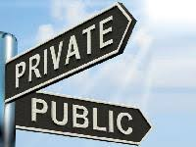

The transfer of ownership, property or business from the government to the private sector is termed privatization. The government ceases to be the owner of the entity or business.

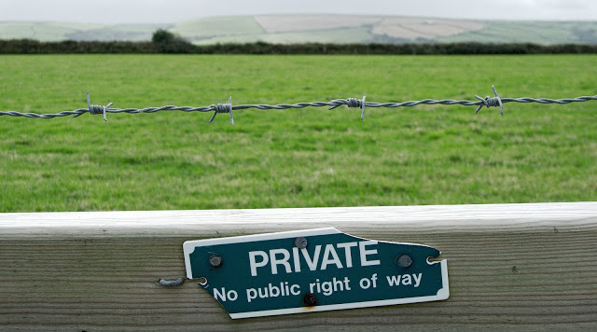

Government takes this step whenever any government enterprise does loss continuously or if the enterprise decreases profit alarmingly or if the government thinks the enterprise would cut more profit if it was operated by the private governing body.

**WHY PRIVATIZATION**

• To reduce government involvement in commercially viable activities

• Increase efficiency in the delivery of programs and services

• Provides competition in market place which transfers the lower price and greater choice for the consumers.

**Privatization is the process of transferring an enterprise or industry from the**[**public sector**](https://whatis.techtarget.com/definition/public-sector)**to the**[**private sector**](https://whatis.techtarget.com/definition/private-sector)**.**

**Methods of Privatisation**

**1. Share issue privatization** -selling shares on the stock market.

2. **Asset sale privatization**- selling entire organization to a strategic investor by auction.

3. **Voucher privatization** -distributing ownership to all for free or at lower cost.

**Sub methods:**

**1. Contracting out**:- Production of service by private firm under a contract. » Under this scenario, the private sector firm is paid directly by the government.

**Example**:¬

* collection of disposal waste.
* Other things include security services, data processing.

2. **Franchising:** -Government awarding a rights to perform services within a specific geographic area to a private firm

* The private firm generates revenue by collecting user fees
* Example:¬ Cable television, gas etc

3. **Open competition:**

* many private firms are allowed to compete for customers within a governmental jurisdiction.
* It is not appropriate for some services as it most likely would not be efficient to have multiple suppliers of electricity, gas, or water service.
* Example: It typically seen telephone and internet provider¬

**Six industries which are not reserved for private sector**

1. **Cigarette**
2. **Indian railways**
3. **Atomic energy**
4. **Chemical fertilizers**
5. **Arms and ammunition**
6. **Hazardous chemicals**

#### Arguments for and against privatization

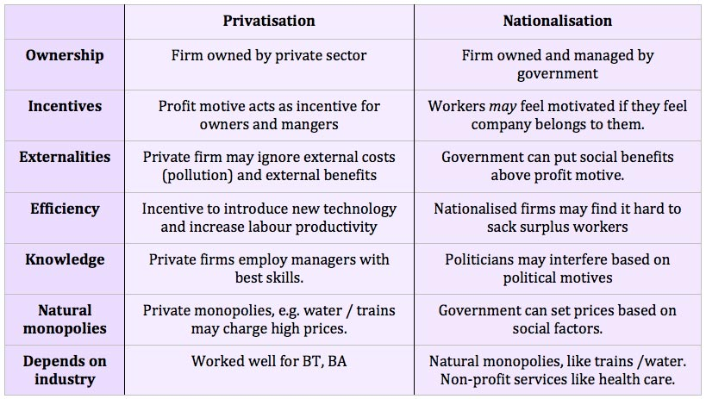

1. **Lack of Proper Strategy-**
2. **Ambiguity of objectives**
3. **Wrong timing**
4. **Lack of political Consensus**
5. **Problem of cultural Change**
6. **Poor financial Strategies**
7. **Problem of Cultural Change**
8. **Wrong labour Strategies**
9. **Prevalence of monopoly Elements.**

**Sins and Pitfalls**

**Of**

**Privatisation**

**Benefits of privatization**

1. Improved efficiency

2. Lack of political interference

3. Short term view

4. Increased competition.

**Industrial Licensing**

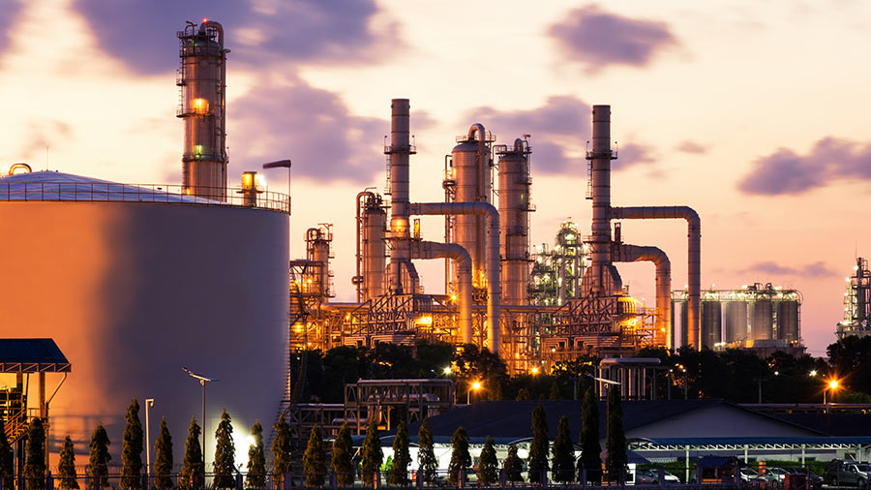

The Industrial Development and Regulation Act (IDRA), 1951 provides a basic framework for the growth and development of industries in India.

The Act mandates every existing or new industrial undertaking to register itself with the federal government.

According to the law, an ‘industrial undertaking’ is a planned industry that is carried on in one or more factories owned by an individual or authority, including government.

**Industrial licensing in India**

Industrial policy means rules, regulations, principles, policies and procedures laid down by government for regulating, developing procedures laid down by government for regulating, developing and controlling industrial undertakings in the country. and controlling industrial undertakings in the country.

It prescribes the respective roles of the public, private, joint and It prescribes the respective roles of the public, private, joint and co-operative sectors for the development co-operative sectors for the development of industries.

Incorporates fiscal and monetary policies, tariff policy, labour Incorporates fiscal and monetary policies, tariff policy, labour policy and government attitude towards foreign capital, and role to policy and government attitude towards foreign capital, and role to be played by multinational corporations in the development of thebe played by multinational corporations in the development of the industrial sector. industrial sector.

Government of India has formulated policies for industrial growth Government of India has formulated policies for industrial growth and development .and development.

In India, industrial licenses are regulated by the IDRA, 1951 Act, and are approved by the Secretarial of Industrial Assistance (SIA) on the recommendation of the licensing committee.

The provisions of the Act restrict a licensed industrial undertaking from manufacturing a new article unless the license has been renewed or a new license has been obtained to include the new article.

Industries that require industrial licensing for manufacturing in India include:

* Industries under compulsory licensing; and,
* Industrial undertakings attracting locational restrictions. The licensing provision also applies to the expansion of the existing industrial units.

**Industries subject to compulsory licensing in India**

Businesses planning to establish industries to produce any of the following items in India must obtain a compulsory license:

* Distillation and brewing of alcoholic drinks;
* Cigars and cigarettes of tobacco and manufactured tobacco substitutes;
* Electronics and aerospace and defense equipment;
* Industrial explosives including detonating fuses, safety fuses, gun powder, nitrocellulose and matches; and
* Hazardous chemicals including items hazardous to human safety and health and thus fall for mandatory licensing.

These industries are under compulsory licensing mainly because of environmental, safety and strategic considerations. Compulsory licensing is regulated by the Ministry of Industrial Development.

The Industries (Development & Regulation) Act, 1951, amended from time to time is one of the most effective weapons the Government possess to regulate the development and to control the activities of the Industrial sector.

Objectives-thus, the principal objective of the IDRA is to empower the Government:

* To take necessary steps for the development of industries.
* To regulate the pattern and direction of industrial development.
* To control the activities, performance and results of industrial undertakings in the public interest.

**Main Provisions**

The IDR act contains provisions to realize the above objective. Some of the salient features of the act are the following-

1. **Development Measures**: the act provides for the establishment by the Central Government, of a Central Advisory Council, consisting of representatives of the owners of industrial undertakings, employees, consumers, primary suppliers etc. for the purpose of advising the Central Governemt on matters concerning the development of the industries.
2. **Regulation of Entry and Growth**- the IDR act empower the Central Government to regulate the development of industries by means of licensing with suitable exemptions as decided by the government.
3. **Supervision & Control**- the Government under this act, can make a full and complete investigation .
4. **Take over management**- the power of control entrusted to the central Government under the IDRA extends to that of the take over of the management of the whole or any part of an industrial undertaking which fails to comply with any of the directions mentioned.
5. **Price & Distribution Controls**- to control its/their supply, distribution and price.

**Procedure for obtaining an industrial license**  
Industrial license is granted by the Secretariat for Industrial Assistance in Department of Industrial Policy and Promotion, Government of India. Application for industrial license is required to be submitted in Form FC-IL to Department of Industrial Policy and Promotion.

**DEVALUATION**

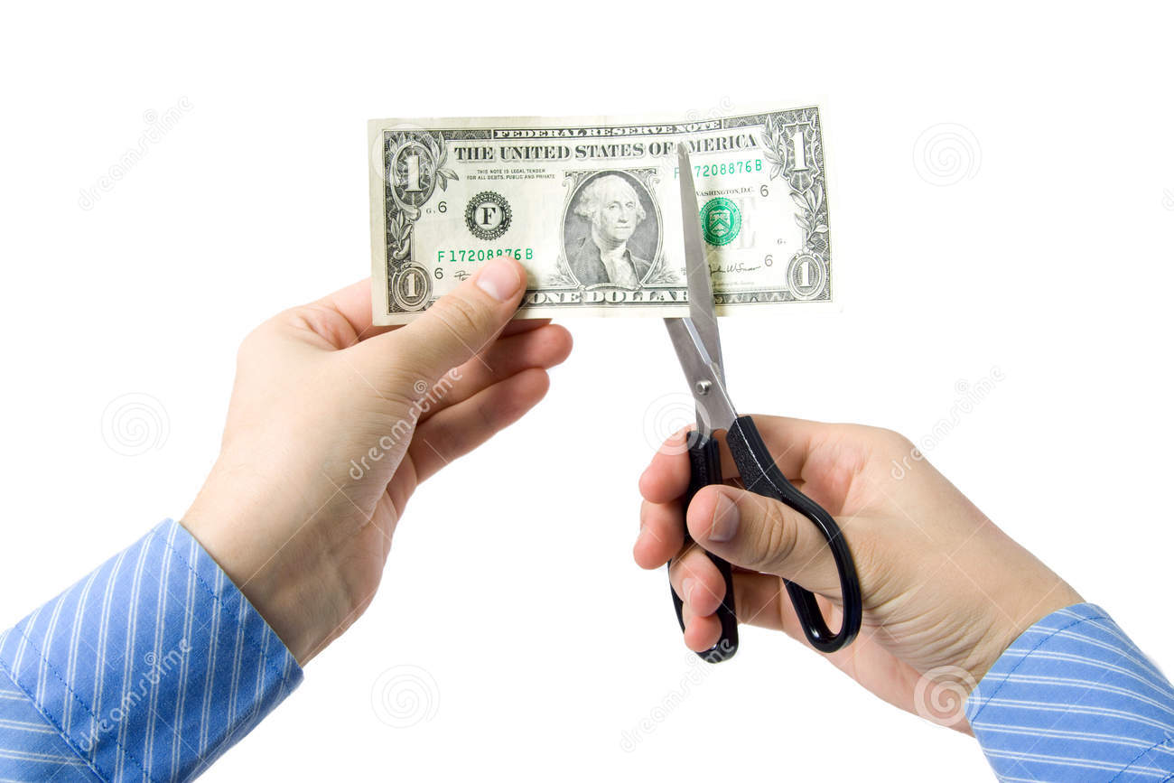

* Devaluation means decreasing the value of nation's currency relative to gold or the currencies of other nations. Under it , there is no change in the internal purchasing power of the currency.
* For example, Rs 25=1$ (before devaluation)

Rs 30=1$ (after devaluation)

• In modern monetary policy, it is a reduction in the value of currency with respect to those goods, services or other monetary units with which that currency can be exchanged.

**HISTORY OF DEVALUATION**

**The 1948 devaluation**

* It was done jointly by all those countries whose currency values were linked with pound Sterling.

**THE 1966 DEVALUATION**

* Current account deficit of over 290 crore due to¬ second five year plan
* Inflation has caused Indian prices to become much¬ higher than world prices
* Budget deficit due to defense spending in 1965/1966¬ was 24.06% of total expenditure.
* Money supply increase¬
* Depleting foreign reserves¬
* The first was India's war with Pakistan in late 1965.¬
* The US and other countries friendly towards pak¬ withdrew foreign aid to India

**THE 1991 DEVALUATION**

* The trade deficit in 1990 US $9.44 billion.
* The current account deficit was US $9.7 billion.
* The gulf war to higher imports due to the rise in oil¬ prices.
* Cost pull inflation.
* Political and economical instability.
* Depleting foreign exchange reserves.
* Gold is pledged to IMF by preceding government.

**Types of Devaluation**

**1) PLANNED DEVALUATION** - Planned devaluations are brought about almost exclusively by government decisions to deliberately reduce the relative value of a currency, usually intended as a means to some improvement in the country's trading position.

**2) Market-driven devaluation-** The value of a currency, relative to the world’s major currencies, especially the dollar, declines on its own through trading in the foreign exchange markets.

**Causes of Devaluation**

* Slow Export Growth
* High Growth rate of Imports
* Dependence upon Imported Oil
* Deficit Balance of trade
* Pressure on Balance of Payments
* High Inflation Rate
* Need of Export Promotion
* Discourage Imports
* Pressure of IMF
* To Encourage Import of Private Capital
* To Discourage Unofficial Dealings.

**Effects of Devaluation**

* To reduce debt burdens
* To increase competiveness in the foreign market
* To achieve higher economic growth
* To increase the standard of living