**Unit 1**

**Introduction to International Business**

Business activities done across national borders is International Business. The International business is the purchasing and selling of the goods, commodities and services outside its national borders. Such trade modes might be owned by the state or privately owned organization.

In which, the organization explores trade opportunities outside its domestic national borders to extend their own particular business activities, for example, manufacturing, mining, construction, agriculture, banking, insurance, health, education, transportation, communication and so on.

International Business conducts [business](http://kalyan-city.blogspot.com/2011/03/what-is-business-meaning-definitions.html) transactions all over the world. These transactions include the transfer of goods, services, technology, managerial knowledge, and capital to other countries. International business involves exports and imports.

International Business is also known, called or referred as a *Global Business* or an *International Marketing*.



Nations that were away from each other, because of their geological separations and financial and social contrasts are now connecting with each other. World Trade Organization established by the administration of various nations is one of the major contributory factors to the expanded connections and the business relationship among the countries.

The national economies are dynamically getting borderless and fused into the world economy as it is clear that the world has today come to be known as a ‘global village’. Numerous more organization are making passage into a worldwide business which presents them with opportunities for development and tremendous benefits.

India was trading with different nations for quite a while, yet it has quickened its progress of incorporating with the world economy and expanding its foreign trade and investment.

**Benefits of International Business**

International Business is important to both Nation and Business organizations. It offers them various benefits.

**Benefits to Nation**

* It encourages a nation to obtain foreign exchange that can be utilized to import merchandise from the global market.
* It prompts specialization of a country in the production of merchandise which it creates in the best and affordable way.
* Also, it helps a country in enhancing its development prospects and furthermore make opportunity for employment.
* International business makes it comfortable for individuals to utilise commodities and services produced in other nations which help in improving their standard of life.

**Benefits to Firms**

* It helps in improving profits of the organizations by selling products in the nations where costs are high.
* It helps the organization in utilizing their surplus resources and increasing profitability of their activities.
* Also, it helps firms in enhancing their development prospects.
* International business also goes as one of the methods for accomplishing development in the firms confronting extreme market conditions in the local market.
* And it enhances business vision as it makes firms more aggressive, and diversified.

**Features of International Business**

The nature and **characteristics** or features of international business are:-

[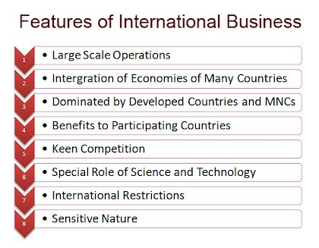](http://lh6.googleusercontent.com/-1ZEdMHeqmoE/Tl-fpbd5wkI/AAAAAAAAFMA/F55mz4rlNA0/Features-of-International-Business.png)

1. **Large scale operations** : In international business, all the operations are conducted on a very huge scale. Production and marketing activities are conducted on a large scale. It first sells its goods in the local market. Then the surplus goods are exported.
2. **Intergration of economies** : International business integrates (combines) the economies of many countries. This is because it uses finance from one country, labour from another country, and infrastructure from another country. It designs the product in one country, produces its parts in many different countries and assembles the product in another country. It sells the product in many countries, i.e. in the international market.
3. **Dominated by developed countries and MNCs** : International business is dominated by developed countries and their multinational corporations (MNCs). At present, MNCs from USA, Europe and Japan dominate (fully control) foreign trade. This is because they have large financial and other resources. They also have the best technology and research and development (R & D). They have highly skilled employees and managers because they give very high salaries and other benefits. Therefore, they produce good quality goods and services at low prices. This helps them to capture and dominate the world market.
4. **Benefits to participating countries** : International business gives benefits to all participating countries. However, the developed (rich) countries get the maximum benefits. The developing (poor) countries also get benefits. They get foreign capital and technology. They get rapid industrial development. They get more employment opportunities. All this results in economic development of the developing countries. Therefore, developing countries open up their economies through liberal economic policies.
5. **Keen competition** : International business has to face keen (too much) competition in the world market. The competition is between unequal partners i.e. developed and developing countries. In this keen competition, developed countries and their MNCs are in a favourable position because they produce superior quality goods and services at very low prices. Developed countries also have many contacts in the world market. So, developing countries find it very difficult to face competition from developed countries.
6. **Special role of science and technology** : International business gives a lot of importance to science and technology. Science and Technology (S & T) help the business to have large-scale production. Developed countries use high technologies. Therefore, they dominate global business. International business helps them to transfer such top high-end technologies to the developing countries.
7. **International restrictions** : International business faces many restrictions on the inflow and outflow of capital, technology and goods. Many governments do not allow international businesses to enter their countries. They have many trade blocks, tariff barriers, foreign exchange restrictions, etc. All this is harmful to international business.
8. **Sensitive nature** : The international business is very sensitive in nature. Any changes in the economic policies, technology, political environment, etc. has a huge impact on it. Therefore, international business must conduct [marketing research](http://kalyan-city.blogspot.com/2011/07/what-is-marketing-research-meaning.html) to find out and study these changes. They must adjust their business activities and adapt accordingly to survive changes

**Modes of Entering International Markets**

Managers should also recognize that their global context dictates two related but distinct sets of challenges. One set of challenges must be confronted when an organization chooses to change its level of international involvement. The other set of challenges occurs when the organization has achieved its desired level of international involvement and must then function effectively within that environment. Thus, managing the process of Globalization essentially involves :

(i) Choosing the level of international involvement and the mode of entry into the international market.

(ii) Functioning effectively at the level of international involvement that is desired.

**Basic Strategies of Market Entry**

**1. Exports**

* Exporting involves selling a product in the global market without establishing manufacturing facilities there.
* Exporting encompasses promotion to stimulate demand for the product, collecting revenues, making credit arrangements from sales, and shipping the product to the market. Most companies secure an agent to handle some or all of these tasks. However, once they become accustomed to the exporting business, a number of companies assume most or all of these tasks, often establishing a staff in the host country.
* The export entry strategy is a very popular approach for entering international market.In fact, the Export entry strategy is the simplest way for a firm to enter a foreign market. This strategy involves little or no change in the organization’s basic mission, objectives, and strategies since it continues to produce all of its products at home.
* The firm usually secures an agent in the particular foreign market who facilitates the transactions with foreign buyers. The recent trend of global outsourcing is being witnessed the world over. It involves the process of obtaining the cheapest sources of labour, raw materials, machinery or finished goods regardless of the country.
* Business process outsourcing (BPO) and knowledge process outsourcing (KPO) are the most recent trends in the area of Global outsourcing, while exporting involves making or sourcing a product, service or idea from the domestic market and selling it in another country, importing involves bringing a good, service or capital into the home Another concept called countertrade involves the barter of products for other products rather than selling for currency.

**II. Foreign Activities:**

As the importance of exports increases, the firm may decide that it now can justify its own foreign subsidiary.

This decision usually involves establishing production and/or marketing facilities in the host country. The foreign subsidiary entry strategy differs from direct investment. The Foreign subsidiary entry strategy is an approach to entry in a foreign market based on the fact that exports are increasing in importance to the firm. This decision usually involves joining with nationals in the foreign country to establish product and/or marketing facilities. It differs from direct investment in that some type of association is formed with a local firm or individual. This type of association usually takes the form of licensing, franchising or joint venture arrangements:

(a) **Licensing:** This involves granting a firm the right to an outside firm to produce and/or market the firm’s product in another country. It is a popular method of entering foreign markets. Licenses are more often granted to businesses that existed before the license was arranged and the business serving as the licensee is expected to outlive the license contract. For example, licensees around the world have contracts to produce and sell clothing bearing pictures of ‘High School Musical’ or ‘Hannah Montana’.

(b) **Franchising:** Franchising is a form of licensing which is very popular now-a-days. Pizza Hut, for example is rapidly expanding into new markets around the world via franchising agreements with local investors and managers. Pizza Hut has a presence in over 100 different countries using the concept of franchising. In this mode of entry, the oranization provides the complete package of materials and service to the foreign franchises. A franchise contract covers more aspects of the operation and are typically of a longer duration than licensing contracts. McDonald’s is another good example of a corporation with franchise contracts around the world.

**III. Direct Investment:**

The strongest commitment to becoming a global enterprise is made when the management decides to begin producing the firm’s products abroad with no association with a host country investor. The direct investment entry strategy is booming in international business in the present business scenario. Thus, the Direct investment entry strategy is a policy to begin producing a firm’s products in a foreign country without the association with a host country investor. It is the strongest commitment to becoming an MNE; it enables the firm to maintain full control over production, marketing and other key functions.

The direct investment strategy may involve:

**Strategic Alliance:** This is a cooperative arrangement between two or more firms for mutual benefits.

**Joint venture:** This refers to an arrangement involving foreign investors who form a group with local investors to begin a local business with each group sharing ownership. The partners share the ownership of an operation on an equity basis, thus sharing both costs and risks with another firm to build a manufacturing facility develop new products or set-up a sales and distribution network.

**Wholly owned foreign Affiliate:** This refers to a foreign subsidy over which an organization has complete control.

**Acquisition:** This involves the acquisition of a foreign company by the organization.

**Greenfield Venture:** This refers to a subsidiary of the company which has been built from scratch in a foreign country. This is a completely new company which is set-up by the organization entering the foreign market.

**Internalization process and managerial implications**

**MEANING OF INTERNATIONALIZATION**

‘’As the process of increasing involvement in′ international operations’’

-By Prof WELCH

Internationalization is the designing of the′ product in such a way that it will meet the needs of users in many countries or can be easily adapted to do so .

**The stages of internationalization**

**Stage 1: DomesticOperations**

* The firm’s market is exclusively domestic.′
* Most international companies have their′ origin as domestic companies.
* These companies focus on domestic operations only. Example: Patanjali have currently its major′ operations in India only.

**Stage 2: Export Operations**

* The firm expands its market to include othercountries, but retains production facilities within domestic borders.
* The firm expands its market by engaging′ into export operations and offering the domestic products to other countries also, but retains production facilities within domestic borders.
* Example: Indian firms exporting textiles,′ jute, spices, nuts, rice all around the world.

**Stage 3: Subsidiaries or Joint Ventures**

* The firm physically moves some of its operations out of the home country.
* The firm physically moves some of its′ operations out of the home country.
* There is a mutual cost, profit sharing and′ management in such method.
* Example: A joint venture between Maruti′ (Indian Company) and Suzuki (Japanese Company).

**Stage 4: Multinational Operations**

* The firm becomes the fully fledged′ multinational co.[MNC] with the assembly of production facilities in several countries & regions of the world. Some decentralization of decision making is common but many personnel decisions are still made at corporate level in headquarters.
* Example: Mc Donalds is a MNC operating′ worldwide.

**Stage 5: Transnational Operations**

* Firms that reach this stage are often called transnationalbecause they owe little allegiance to their country of origin. Operations are highly decentralized, with each business unit free to make personnel decisions with very loose control from corp.headquarters.
* In this the firms that reach this particular′ stage are often called transnational companies because they achieve both global efficiency and local responsiveness.
* They use global market and resources for their functioning. Example: Coca-Cola, Nestle′

**Models of Internalization**

Uppsala Model

**Who and Where**

* Developed by Johanson& Wiedersheim-Paul in 1975 at Uppsala University
* Complemented by Johanson &Vahlne in 1977
* Swedish researchers developed their own model as a more independent model to explain the sequential steps in the direction of increased foreign dedication (Johanson&Vahlne, 1977; 1990)[[1]](http://www.digitpro.co.uk/2012/06/21/the-uppsala-internationalization-model-and-its-limitation-in-the-new-era/#_ftn1).
* The model was based on empirical observation from four Swedish manufacturers and influenced by the works of Penrose (1959), Cyert& March (1963), Aharoni (1966) Vernon (1966) and others.
* The Uppsala Internationalization Model distinguishes four different steps of entering an international market, which cannot be viewed independently of a company’s situation, market and the market knowledge. (See Fig. 1:1 below)
* Step 1 is when the firm has no regular export activity;
* step 2 is when the firm begins to export to the target country through agents or independent representatives;
* step 3 involves the establishment of sales subsidiaries and finally the
* 4th step is starting to produce and or manufacture in the target country.

From the observation, they find out that companies normally start their expansion in a psychic nearby market. There, they have enhanced knowledge of the market and more control of resources, thereafter gradually when the companies have become more experienced and acquired better resources, they expand to the more distance market. (By distance market, they refer both to the cultural distance; as well the differences in language, politics, geographical and the difficulty to acquire knowledge and information from the market)[[3]](http://www.digitpro.co.uk/2012/06/21/the-uppsala-internationalization-model-and-its-limitation-in-the-new-era/#_ftn3). Secondly, most often companies entered a new market through export before establishment of foreign sales subsidiary or foreign production.

In their study, they refer to (Aharoni, 1966) about the interdependence of market knowledge and market commitment and they develop a matrix model to illustrate the positive correlation between market knowledge and the commitment decisions, as well to emphasize the sequential development of market activities and its positive correlation to market commitment.The core explanation of the model is that increased market knowledge will lead to increased market commitment, and vice versa.

Figure: 1:1 Internationalization of the firm

[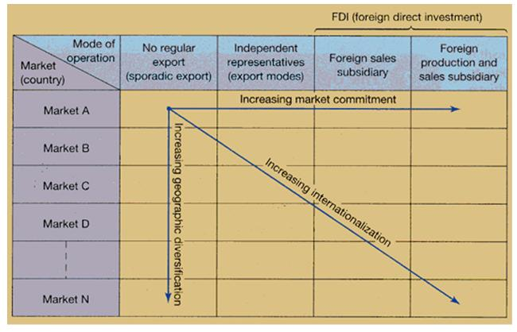](http://www.digitpro.co.uk/blog/wp-content/uploads/2012/06/fdi1.png)

**Figure 1.2 The Basic of Internationalization-State and Change Aspects**

[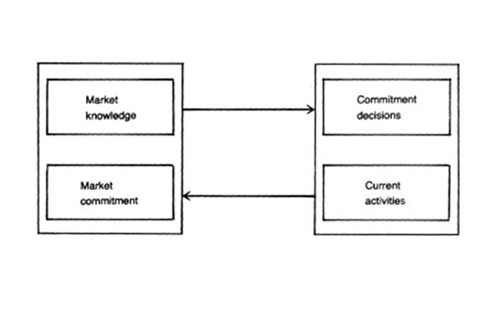](http://www.digitpro.co.uk/blog/wp-content/uploads/2012/06/Internationalization.png)

**Change Aspect**

**Stage Aspect**

They make a distinction between general knowledge and the specific knowledge. The former, which is more about the operation in the foreign market, can easily be transferred from one market to the other. It is important to note that the special knowledge, which is more specific to a market, cannot be achieved without specific activity in that market and it would be difficult to use this knowledge in other markets.

International activities require both general knowledge and market-specific knowledge. Market-specific knowledge is assumed to be gained mainly through experience in the market, whereas knowledge of the operations can be transferred from one country to another; the latter will thus facilitate the geographic diversification in Figure 1.1.

The geographical dimension in Figure 1.1 shows that firms enter new markets with successively greater psychic distance. Psychic distance is defined in terms of factors such as differences in language, culture and political systems, which disturb the flow of information between the firm and the market. Thus firms start internationalization by going to those markets they can most easily understand.

**Network Model**

Based on the Uppsala model (Johanson&Vahlne 1990) - process of internationalization through a network perspective.

If the relationships between the firms are seen as a network this implies that companies internationalize because other firms in their (inter)national network are doing so.

Because in industrial/ B2B marketing firms engaged in the production, distribution, and use of goods and services depend (specialization) Other industries will internationalize because of the world economy.

The model of business network emphasizes the value of commercial, personal and cognitive relationships between its members.

This model assumes that the organizational network of the company is a major incentive for internationalization and the companies produce their resources by interacting with other partners.

The companies of the network can be both individually independent and dependent on the resources controlled by other companies. The degree of dependence gradually increases and that means the resources of one company become more dependent on the ones of other companies for the benefit of all parties.

The business networks work throughout exchange relationships and their needs and capacities are mediated by the interactions during those relationships. The position of a company inside a network is a key concept of the network model. This position defines the present control of the company and its access to the network resources.

The business network allows the company to internationalize following three strategies :-

• **Extension-**when the company has relationships with companies and networks in new markets.

• **Penetration**-if the company deepens its relationships as part of existing international networks

. **• Coordination-** by improving its existing relationships inside different networks in various markets.

The internationalization of the company depends on its own position inside the network and on the general framework of the internationalization of the industry or market.

A four-field matrix of the company inside the network may be obtained by combining the two dimensions mentioned below as in Figure

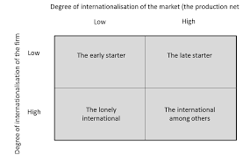

The position of the company depending on the internationalization degree

**The early starter.**

The company has not business relationships with foreign companies. It has to be a pioneer since no other company within the industry has such relationships. The company may follow a gradual and slow involvement in the foreign markets via an agent, leading to a sales subsidiary and then a manufacturing subsidiary.

**The lonely international.**

The company already has experience of relationships with others in foreign countries, but its competitors and customers are less internationalized. It may establish new relationships or to deepen the existing ones.

**The late starter.**

The company is still domestically focused, while the other industry companies already have long term relationships with foreign partners. Compared to early starter the late starter often finds it difficult to discover free partners and to establish new positions in a tightly structured market.

**The international among other**

In this situation, the company has the chance of using positions in one network to bridge over to other networks and partners with regard to both extension and penetration. The success of such moves depends on the coordination of the international activities along the value chain. The international business networks seem to evolve and change easier and faster. Thus, they may be more flexible and find faster answers to the change of market and business conditions

As a result, international business networks emerge in industries and markets where the coordination of interested parties gets important additional revenues.

**UNIT II**

**Frame work for analyzing International Business Environment**

Environmental analysis is defined as ―the process by which strategists monitor the economic, governmental/legal, market/competitive, supplier/technological, geographic, and social settings to determine opportunities and threats to their firms‖.

Environmental diagnosis consists of managerial decisions made by analyzing the significance of the data (opportunities and threats) of the environmental analysist.

The definition of environmental analysis given above has been made in the context of the strategic management process for an existing firm. It is,quite obvious that environmental analysis is the cornerstone of new business opportunity analysis too

It is now unquestionably accepted that the prospects of a business depend not only on its resources but also on the environment. An analysis of the strengths, weaknesses, opportunities and threats (SWOT) is very much essential for the business policy formulation.

Every business enterprise, thus, consists of a set of internal factors and is confronted with a set of external factors.

* The internal factors are generally regarded as controllable factors because the company has control over these factors; it can alter or modify such factors as its personnel, physical facilities, organization and functional means, such as the marketing mix, to suit the environment.
* The external factors, on the other hand, are by and large, beyond the control of a company. The external or environmental factors such as the economic factors, socio-cultural factors, government and legal factors, demographic factors, geophysical factors etc. are, therefore, generally regarded as uncontrollable factors.

As the environmental factors are beyond the control of a firm, its success will depend to a very large extent on its adaptability to the environment, i.e. its ability to properly design and adjust the internal (the controllable) variables to take advantage of the opportunities and to combat the threats in the environment. The business environment comprises a microenvironment and a macro environment.

http://cdn3.businessmanagementideas.com/wp-content/uploads/2016/08/clip_image002_thumb-14.jpg

**MICRO ENVIRONMENT** ―

The micro environment consists of the actors in the company‘s immediate environment‖ that effect the performance of the company. These include the suppliers, marketing intermediaries, competitors, customers, and publics. ―The macro environment consists of the larger societal forces that affect all the actors in the company‘s micro environment namely, the demographic, economic, natural, technological, political and cultural forces‖.

**(i) Customers**

**(ii) Suppliers**

**(iii) Competitors**

**(iv) Public**

**(v) Market intermediaries**

#### Macro Environment:

The macro environment consists of the economic and non- economic variables that provide opportunities and threats to firms. This is largely uncontrollable and, therefore, firms adjust their operations to these environmental factors.

**(a) Economic Environment**

The economic environment of the country is constituted by some important elements like country’s economic system, macro-economic scenario, prevailing phases of business cycle, current economic policies of the government and the financial system and its organisation.

**(b) Non-Economic Environment:**

It consists of socio-cultural, demographic, natural, physical, technological, political and legal environment that influence and are influenced by the economic environment. A large number of variables affect the non-economic environment.

***(i) Political-legal environment:***

***(ii) Socio-cultural environment:***

***(iii) Technical environment***

***(iv) Demographic environment***

***(v) Natural environment***

***(vi) International environment***

**Methods of scanning International Business Environment**

* **External analysis - What’s going on outside your business:**
  + Porter's Five Forces
  + PESTLE
* **Internal analysis: What's going on with your business**
  + SWOT
  + Value Chain Analysis
  + Balanced Scorecard

**PEST analysis**

**PEST analysis**

is an analysis of the political, economic, social and technological factors in the external environment of an organization, which can affect its activities and performance.

[1]

**PESTEL model**

involves the collection and portrayal of information about external factors which have, or may have, an impact on business.(Political, Economic, Socio-cultural, Technological, Legal, Environmental)

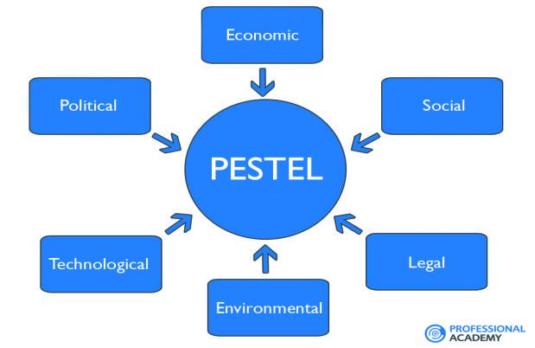

Understanding the tool

PEST or PESTEL analysis is a simple and effective tool used in situation analysis to identify the key external (macro environment level) forces that might affect an organization. These forces can create both opportunities and threats for an organization. Therefore, the aim of doing PEST is to:

* find out the current external factors affecting an organization;
* identify the external factors that may change in the future;
* to exploit the changes (opportunities) or defend against them (threats) better than competitors would do.

The outcome of PEST is an understanding of the overall picture surrounding the company.

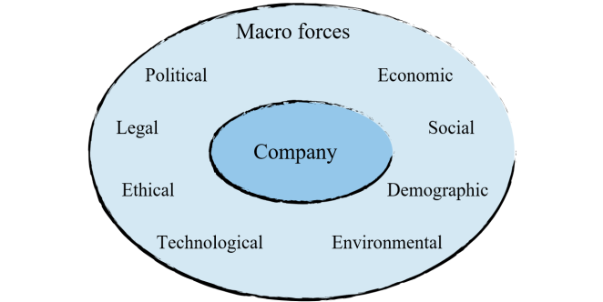

PEST analysis is also done to assess the potential of a new market. The general rule is that the more negative forces are affecting that market the harder it is to do business in it. The difficulties that will have to be dealt with significantly reduce profit potential and the firm can simply decide not to engage in any activity in that market.

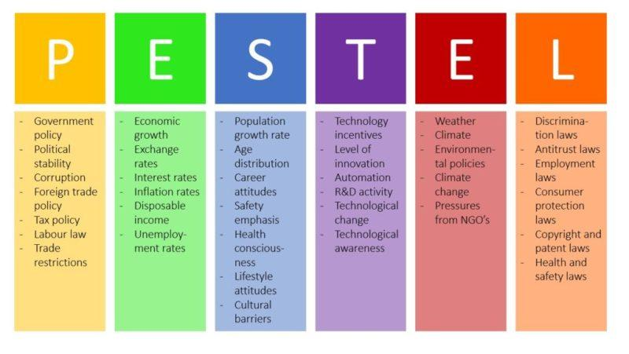

ECONOMIC ENVIRONMENT

POLITICAL ENVIRONMENT

SOCIAL ENVIRONMENT

TECHNOLOGICAL ENVIRONMENT

**Fig PEST analysis**

Using the tool

The process of carrying out PEST analysis should involve as many managers as possible to get the best results. It includes the following steps:

* Step 1. Gathering information about political, economic, social and technological changes + any other factor(s).
* Step 2. Identifying which of the PEST factors represent opportunities or threats.

**Benefits of PEST Analysis**

A company may have all the information it requires about the quality of its infrastructure, the extent of funds, and the employee talent available to it, but it may not be fully aware of the external environment in which it is to operate or launch a new project. It can even predict future prospects of a project or product by studying the PEST factors. Let's list out the some benefits that we can gain from the findings of a PEST Analysis:

* Provides an understanding of the wider business environment.
* Encourages the development of strategic thinking.
* Straightforward and only costs time to do.
* May raise awareness of threats to a project.
* Can help an organization to anticipate future difficulties and take action to avoid or minimize their effect.
* Can help an organization to identify and exploit opportunities.

## ****Pestle Analysis Examples: Uber****

In this section, we will share with you first of the five pestle analysis examples.

* [Uber](http://uber.com/) is a rapidly growing taxi service provider in the world. People like its features such as **easy accessibility with the app and taxi sharing**. However, there are controversies such as minimum wage complications and banning that are not helping its cause.

And now let us find out more about this company through a Pestle Analysis example. The infographic below will give you a brief on what we have discussed ahead:

**1.1 Political Factor**

As mentioned above, this company has many controversies to do away with. And one of the things that have put Uber in trouble is that it has not made its regulations clear. For example, people have **questions about its insurance policy**. Some of the questions that are in the mind of the users are if there is an accident, then the company will

* hold the driver as accountable or,
* the company will take the blame for itself.

**1.2 Economic Factor**

In this section of our sample pestle analysis of Uber, we will take a look at its economic factors.

* The company operates in a sharing economy. In other words, sharing of physical and intellectual resources take place in the economy in which Uber operates.
* Customers can easily connect with the driver through the app. Drivers can take them to their desired location. Customers find Uber cheaper than taxis.
* Uber has seen fast growth since its inception. However, some countries see unfair competition against regular taxis. It resulted in ban and restriction of its services.
* Other companies are also under the scanner of the authorities for the same reason. But, Uber has been the focal point of this controversy as it is a leading taxi service provider.
* People are also looking towards Uber to get new job opportunities. They are struggling to decide whether it is taking their job away or bringing new opportunities.
* One thing that favours Uber is its popularity. Taxi market is full of opportunities. Uber needs to keep doing its best.

**1.3 Social Factor**

* Uber taxi services are user-friendly and accessible.
* To book an Uber ride, all you need to do is order through a mobile app. In a few minutes, you will get the confirmation of your ride.
* People show gratitude to the Uber for an affordable ride. It increased the fare charges with its the popularity. But, people still prefer it due to its accessibility.

**1.4 Technological Factor**

* Uber has reaped many benefits through the technology directly and indirectly.
* People post positive views on the various social media platforms. It has helped the company to grow fast. Next, its app is much helpful for users.
* Users can book their cabs from anywhere. App also gives information like estimated ride charges, drop off location, traffic, and weather. Users can pay their charges through the app.

**1.5 Legal Factors**

Above we discussed how Uber has faced bans in many countries for different reasons. Hence, the company needs to follow technical usage laws, labour and employee safety laws and copyrights laws as well.

**1.6 Environmental Factors**

* The impact of Uber on the environment is not certain. Few say that fuel usage and traffic congestion is increasing.
* Studies say the same when it comes to traffic congestion. It is because people may use Uber instead of public transport. Analysts are yet to confirm such blame.

**Conclusion:**In conclusion, Uber is the fastest growing taxi service, provider. Its affordable charges, ease of use have helped it in becoming popular. Some controversies are also hindering its progress.

But, the company must carry on its service throughout the world. Of course! They need to keep a check on the controversies as well.

**Porter’s Five Forces**

Porter's Five Forces of Competitive Position Analysis were developed in 1979 by Michael E Porter of Harvard Business School as a simple framework for assessing and evaluating the competitive strength and position of a business organisation.

This theory is based on the concept that there are five forces that determine the competitive intensity and attractiveness of a market. Porter’s five forces help to identify where power lies in a business situation. This is useful both in understanding the strength of an organisation’s current competitive position, and the strength of a position that an organisation may look to move into.

Strategic analysts often use Porter’s five forces to understand whether new products or services are potentially profitable. By understanding where power lies, the theory can also be used to identify areas of strength, to improve weaknesses and to avoid mistakes.

**Porter’s five forces of competitive position analysis:**

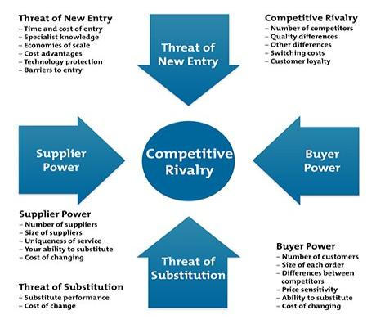

The five forces are:

**1. Supplier power.** An assessment of how easy it is for suppliers to drive up prices. This is driven by the: number of suppliers of each essential input; uniqueness of their product or service; relative size and strength of the supplier; and cost of switching from one supplier to another.

**2. Buyer power.**An assessment of how easy it is for buyers to drive prices down. This is driven by the: number of buyers in the market; importance of each individual buyer to the organisation; and cost to the buyer of switching from one supplier to another. If a business has just a few powerful buyers, they are often able to dictate terms.

**3. Competitive rivalry**. The main driver is the number and capability of competitors in the market. Many competitors, offering undifferentiated products and services, will reduce market attractiveness.

**4. Threat of substitution.**Where close substitute products exist in a market, it increases the likelihood of customers switching to alternatives in response to price increases. This reduces both the power of suppliers and the attractiveness of the market.

**5. Threat of new entry.**Profitable markets attract new entrants, which erodes profitability. Unless incumbents have strong and durable barriers to entry, for example, patents, economies of scale, capital requirements or government policies, then profitability will decline to a competitive rate.

Arguably, regulation, taxation and trade policies make government a sixth force for many industries.

**What benefits does Porter’s Five Forces analysis provide?**

Five forces analysis helps organisations to understand the factors affecting profitability in a specific industry, and can help to inform decisions relating to: whether to enter a specific industry; whether to increase capacity in a specific industry; and developing competitive strategies.

| **Actions to take / Dos** | **Actions to Avoid / Don'ts** |
| --- | --- |
| * Use this model where there are at least three competitors in the market * Consider the impact that government has or may have on the industry * Consider the industry lifecycle stage – earlier stages will be more turbulent * Consider the dynamic/changing characteristics of the industry | * Avoid using the model for an individual firm; it is designed for use on an ind |

**SWOT**

SWOT analysis is a strategic planning method used to evaluate the Strengths, Weaknesses, Opportunities, and Threats involved in a project or in a business venture. It involves specifying the objective of the business venture or project and identifying the internal and external factors that are favorable and unfavorable to achieve that objective. The technique is credited to Albert Humphrey, who led a convention at Stanford University in the 1960s and 1970s using data from Fortune 500 companies.

The SWOT analysis provides information that is helpful in matching the firm’s resources and capabilities to the competitive environment in which it operates. As such, it is instrumental in strategy formulation and selection.

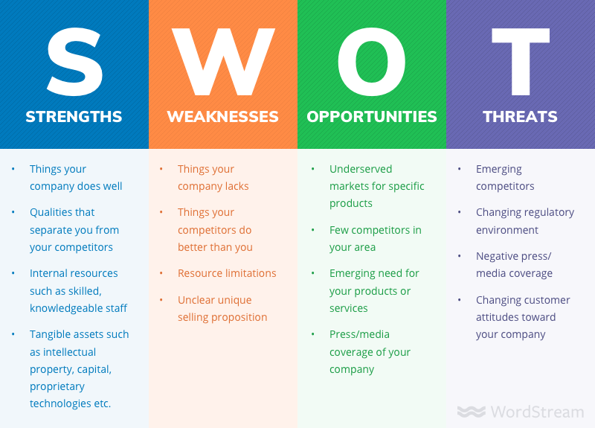

**The SWOT Matrix**

A firm should not necessarily pursue the more lucrative opportunities. Rather, it may have a better chance at developing a competitive advantage by identifying a fit between the firm’s strengths and upcoming opportunities. In some cases, the firm can overcome a weakness in order to prepare itself to pursue a compelling opportunity.

To develop strategies that take into account the SWOT profile, a matrix of these factors can be constructed. The SWOT matrix (also known as a TOWS Matrix) is shown below:

**SWOT Analysis Framework**

 Environmental Scan

  / \

Internal Analysis                                   External Analysis

              / \                                                         / \

Strengths Weaknesses                          Opportunities Threats

  SWOT Matrix

**Strengths:**

A firm’s strengths are its resources and capabilities that can be used as a basis for developing a competitive advantage. Examples of such strengths include:

patents,strong brand names ,good reputation among customers ,cost advantages from proprietary know-how ,exclusive access to high grade natural resources,favorable access to distribution networks.

**Weaknesses:**

The absence of certain strengths may be viewed as a weakness. For example, each of the following may be considered weaknesses:lack of patent protection ,

a weak brand name ,poor reputation among customers ,high cost structure ,

lack of access to the best natural resources ,lack of access to key distribution channels .

In some cases, a weakness may be the flip side of a strength. Take the case in which a firm has a large amount of manufacturing capacity. While this capacity may be considered a strength that competitors do not share, it also may be a considered a weakness if the large investment in manufacturing capacity prevents the firm from reacting quickly to changes in the strategic environment.

**Opportunities:**

The external environmental analysis may reveal certain new opportunities for profit and growth. Some examples of such opportunities include:an unfulfilled customer need ,arrival of new technologies ,loosening of regulations ,removal of international trade barriers

**Threats:**

Changes in the external environmental also may present threats to the firm. Some examples of such threats include:shifts in consumer tastes away from the firm’s products, emergence of substitute products ,new regulations ,increased trade barriers

**SWOT / TOWS Matrix**

**Strengths**           **Weaknesses**

**Opportunities**      S-O strategies          W-O strategies

**Threats**               S-T strategies             W-T strategies

S-O strategies pursue opportunities that are a good fit to the company’s strengths.

W-O strategies overcome weaknesses to pursue opportunities.

S-T strategies identify ways that the firm can use its strengths to reduce its vulnerability to external threats.

W-T strategies establish a defensive plan to prevent the firm’s weaknesses from making it highly susceptible to external threats.

## What Is a SWOT Analysis?

A SWOT analysis is an analytical technique used to determine and define several key characteristics: Strengths, Weaknesses, Opportunities, and Threats – SWOT.

SWOT analyses can be applied to an entire company or organization, or individual projects within a single department. Most commonly, SWOT analyses are used at the organizational level to determine how closely a business is aligned with its growth trajectories and success benchmarks, but they can also be used to ascertain how well a particular project – such as [an online advertising campaign](https://www.wordstream.com/blog/ws/2017/07/05/online-advertising-costs) – is performing according to initial projections.

### Internal and External Factors

The four elements above are common to all SWOT analyses. However, many companies further compartmentalize these elements into two distinct subgroups: Internal and External.

Typically, Strengths and Weaknesses are considered internal factors, in that they are the result of organizational decisions under the control of your company or team. A [high churn rate](https://www.wordstream.com/blog/ws/2014/05/12/customer-churn), for example, would be categorized as a weakness, but improving a high churn rate is still within your control, making it an internal factor. Similarly, emerging competitors would be categorized as a threat in a SWOT analysis, but since there’s very little you can do about this, this makes it an external factor. This is why you may have seen SWOT analyses referred to as Internal-External Analyses or IE matrices.

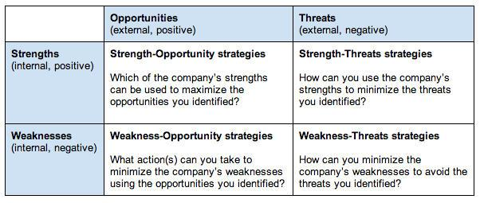

**Value Chain Analysis**

**Definition**

**Value chain analysis (VCA)**

* Is a process where a firm identifies its primary and support activities that add value to its final product and then analyze these activities to reduce costs or increase differentiation.
* Value chain analysis is a process of dividing various activities of the business in primary and support activities and analyzing them, keeping in mind, their contribution towards value creation to the final product. And to do so, inputs consumed by the activity and outputs generated are studied, so as to decrease costs and increase differentiation.

**Value chain**

represents the internal activities a firm engages in when transforming inputs into outputs.

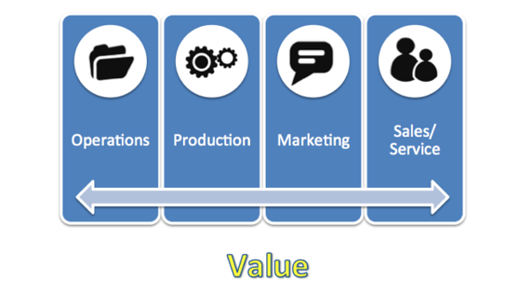

M. Porter introduced the generic value chain model in 1985. Value chain represents all the internal activities a firm engages in to produce goods and services. VC is formed of primary activities that add value to the final product directly and support activities that add value indirectly.

**Elements in Porter's Value Chain**

Rather than looking at departments or accounting cost types, Porter's Value Chain focuses on systems, and how inputs are changed into the outputs purchased by consumers. Using this viewpoint, Porter described a chain of activities common to all businesses, and he divided them into primary and support activities, as shown below.

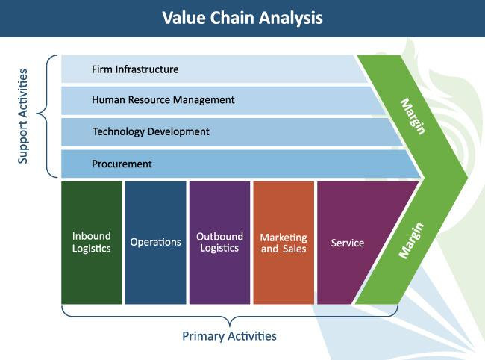

As shown in the figure, Michael Porter classified the entire value chain into nine activities which are interrelated to one another. While primary activities include the activities that are performed to satisfy external demand, secondary activities are those which are performed to satisfy internal requirements.

Classification of Value Chain Analysis

Value Chain Analysis is grouped into primary or line activities, and support activities discussed as under:

[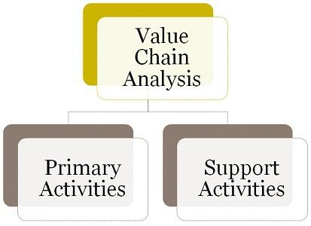](https://businessjargons.com/wp-content/uploads/2017/04/classification-value-chain.jpg)

1. **Primary Activities**: The functions which are directly concerned with the conversion of input into output and distribution activities are called primary activities. It includes:
   * **Inbound Logistics**: It includes a range of activities like receiving, storing, distributing, etc. which make available goods and services for operational processes. Some of those activities are material handling, transportation, stock control, etc.
   * **Operations**: The activity of transforming input raw material to final product ready for sale, is termed as operation. Machining, assembling, packaging are the activities covered under operations.
   * **Outbound Logistics**: As the name suggests, the activities that help in collecting, storage and delivering the product to the customer is outbound logistics.
   * **Marketing and Sales**: All the activities like advertising, promotion, sales, marketing research, public relations, etc. performed to make the customer aware of the product or service and create demand for it, comes under marketing.
   * **Service**: Service means service provided to the customer so as to improve or maintain the value of the product. It includes financing service, after-sales service and so on.
2. **Support Activities**: Those activities which assist primary activities in accomplishment, are support activities. These are:
   * **Procurement**: This activity serves the organization, by supplying all the necessary inputs like material, machinery or other consumable items, that required by the organization for performing primary activities.
   * **Technology Development**: At present, technology development requires heavy investment, which takes years for research and development. However, its benefits can be enjoyed for several years and by a multitude of users in the organization.
   * **Human Resource Management**: It is the most common plus important activity which excel all primary activities of the organization. It encompasses overseeing the selection, retention, promotion, transfer, appraisal and dismissal of staff.
   * **Infrastructure**: This is the management system, which provides, its services to the whole organization and includes planning, finance, information management, quality control, legal, government affairs, etc.

In the fast paced world, the main focus of the organization is customer satisfaction, and value chain analysis is the technique that helps to attain that level. Under this, each business activity is considered as essential, which contributes value and is constantly analyzed, to increase value as regards the cost incurred.

## ****Advantages Of Value Chain Analysis****

1. A big advantage is that the value chain is a very flexible strategy tool for looking at your business, your competitors and the respective places in the industry’s value system.  
   .
2. The value chain can be used to diagnose and create competitive advantages on both cost and differentiation. I’ve written about this in [Using The Value Chain To Create Competitive Advantage](http://www.differentiateyourbusiness.co.uk/using-value-chain-analysis-to-create-competitive-advantage).  
   .
3. It helps you to understand the organisation issues involved with the promise of making [customer value](http://www.differentiateyourbusiness.co.uk/customer-value-maps-clarify-your-position) commitments and promises because it focuses attention on the activities needed to deliver the value proposition.  
   .
4. Comparing your business model with your competitors using the value chain can give you a much deeper understanding of your strengths and weaknesses to be included in your [SWOT analysis](http://www.differentiateyourbusiness.co.uk/swot-analysis-what-is-swot-analysis-how-do-you-do-it).  
   .
5. The value chain is well known and has been a mainstay of strategy teaching in business schools for the last 20 to 25 years. The book, Competitive Advantage was published in 1985.  
   .
6. It can be adapted for any type of business – manufacturing, retail or service, big or small.  
   .
7. The value chain has developed into an extra model, the [industry value chain](http://www.differentiateyourbusiness.co.uk/industry-value-chain-analysis-the-bigger-competitive-picture) or value system which lets you get a better understanding of the much broader competitive arena. If you’re interested in this aspect of the value chain, watch the [Value Chain Videos](http://www.differentiateyourbusiness.co.uk/value-chain-videos) for an easy to understand introduction.

## ****Disadvantages Of Value Chain Analysis****

1. It’s very strengths of flexibility mean that it has to be adapted to a particular business situation and that can be a disadvantage since, to get the best from the value chain, it’s not “plug and play”.  
   .
2. The format of the value chain laid out in Porter’s book Competitive Advantage, is heavily oriented to a manufacturing business and the language can be off-putting for other types of business.  
   .
3. The scale and scope of a value chain analysis can be intimidating. It can take a lot of work to finish a full value chain analysis for your company and for your main competitors so that you can identify and understand the key differences and strategy drivers.  
   .
4. Many people are familiar with the value chain but few are experts in its use.  
   .
5. Michael Porter’s book is excellent but it is a tough read. It’s also dated in its examples which can make some of the ideas more difficult to relate to and understand how things fit together in the Internet age.  
   .
6. The value chain idea has been adopted by supply chain and operations experts and therefore its strategic impact for understanding, analysing and creating competitive advantage has been reduced.  
   .
7. Business information systems are often not structured in a way to make it easy to get information for value chain analysis.

**Balanced Scorecard**

**History**

The balanced scorecard approach was first set out by Dr. Robert Kaplan and Dr. David Norton in a Harvard Business Review article in 1992. It was designed as an alternate to traditional ways of measuring corporate performance. It built on performance measurement systems designed at General Electric in the 1950s and a system designed by French accountants in the 1930s, called Tableau do Bord, which used a “dashboard” of performance measures. In a series of articles and books, Kaplan and Norton then expanded the concept into a strategic planning system, providing guidance on what companies should measure to translate business goals into an action plan.

**Meaning**

Balanced Scorecard is a very functional strategic planning and management system that allows you to set, follow-up and achieve your objectives and strategies.

This tool helps you set the strategy and vision for the future and translate it into actions and measurement. This is a fundamental tool in strategy execution.

However, financial measures only tell you part of the story, and aren’t indicative of a comprehensive plan for execution.

The Balanced Scorecard suggests instead that we should form our business strategy and accompanying key performance indicators from four different perspectives:

## The four perspectives of a Balanced Scorecard

Kaplan & Norton have introduced four different perspectives based on which the activities a company can be assessed:

* Financial perspective  
  (How does our company look to shareholders?)
* Customer perspective  
  (How do customers see our company?)
* Process perspective  
  (How well do we manage our operational processes?)
* Learning and growth perspective  
  (Can our organization continue to improve and create value? How can we learn and grow?)

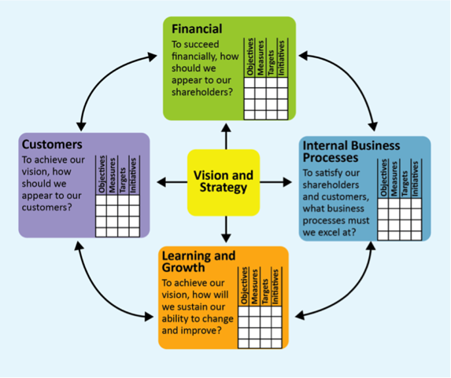

**Benefits of using Balanced Scorecard**

The benefits of running your business based on a Balanced Scorecard can be summarized as follows:

* A Balanced Scorecard helps you align business activities to the vision and strategy of your organization and to define appropriate success factors for all levels of your company.
* A Balanced Scorecard provides management with a comprehensive overview of all business activities.
* The method of Balanced Scorecard improves internal and external communication and facilitates the understanding of business objectives and strategies at all levels of your organization.
* An important step of the Balanced Scorecard approach is feedback and learning. Based on this step, the strategy can be adjusted where necessary.
* A Balanced Scorecard can help you break down the vast amount of information provided by IT systems to the required essentials.

**Domestic, Foreign and Global Environment**

Another way of understanding various factors constituting international business environment is to divide the various factors into three broad groups: domestic, foreign and global environments. This classification is based on the location at which environmental actors and forces exist and operate. Figure 1 .I where a schematic presentation of these three levels of environment along with their components has been shown.

[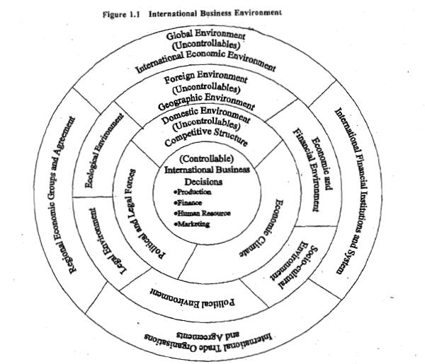](http://3.bp.blogspot.com/-k08ePpoS2y0/UuR8nTIx2LI/AAAAAAAADAg/Z8VxFPmHmAI/s1600/Untitled.png)

1. In the figure, **innermost circle** represents firm's business strategy and decisions with regard to production, finance, marketing, human resources and research activities.

* Since these strategies and decisions are made by the firm, they are called controllable.
* Firm can change them but within the constraints of various environmental factors.

2**.The next circle** represents domestic environment and it consists of factors such as competitive structure, economic climate, and political and legal forces which are essentially uncontrollable by a firm.

* Besides profound effect on the firm's domestic business, these factors exert influence on the firm's foreign market operations.
* Lack of domestic demand or intense competition in the domestic market, for instance, have prompted many Indian firms to plunge into international business.
* Export promotion measures and incentives in country have been other motivating factors for the firms to internationalize their business operations.
* Since these factors operate at the national level, firms are generally familiar with them and are able to readily react to them.

3. **The third circle** represents foreign environment consisting of factors like geographic and economic conditions, socio-cultural traits, political and legal forces, and technological and ecological facets prevalent in a foreign country.

* Because of being operative in foreign markets, firms are generally not cognizant of these factors and their influence on business activities.
* The firm can neglect them only at the cost of losing business in the foreign markets.
* The problem gets more complicated with increase in number of foreign markets in which a firm operates.
* Differences exist not only between domestic and foreign environments, but also among the environments prevailing in different foreign markets.
* Because of environmental differences, business strategies that are successful in one nation might fail miserably in other countries.
* Foreign market operations, therefore, require an increased sensitivity to the environmental differences and adaptation of business strategies to suit the differing market situations.

4. The **upper most circle**, viz., circle four, represents the global environment.

* Global environment transcends national boundaries and is not confined in its impact to just one country.
* Global environment exerts influence over domestic as well as foreign countries and comprises of forces like world economic conditions, international financial system, international agreements and treaties, and regional economic groupings.
* World-wide economic recession; international financial liquidity or stability; working of the international organizations such as World Trade Organization **(WTO),** International Monetary Fund (IMF), World Bank and the United Nations Conference on Trade and Development (UNCTAD); Agreement on Textiles and Clothing (ATC); Generalized System of Preferences (GSP); International Commodity Agreements; and initiatives taken at regional levels such as European Union (EU), North American Free Trade Association (NAFTA) and Association of South East Asian Nations (ASEAN) are some of the examples of global environmental forces having world-wide or regional influences on business operations.

**Impact of Domestic Environment :**

Impact of Domestic environment on International business decisions are depicted under following 5 categories :

**(1) Economic Environment**

* Type of home country Economy – Firms from developed and high-income countries.
* Home country FDI policies – Countriesforeign investment policies.
* Home country investors/shareholdersperception on foreign investment.
* Home country firms profit profile during lastfew years.
* Home country bank loan interest rate on firms foreign investment. Stability of home country currency exchangerates.

**(2) Political Environment**:

* Home country government support onforeign investment by firms for international investment decisions.
* Home country political stability to maintain aconstant outbound foreign policy.
* Home country policy on encouraging foreigninvestment through low-interest rate on bank finance.
* Home country government policy on tax• rates on foreign business profit and their reinvestment in the home country.
* Instability in home country government is• expected to shake the economic condition of the home country and decrease the confidence of firms on their foreign investment.

**(3)Socio-Cultural Environment**:

* Home country cultural diversity and the experience of the firm on doing successful domestic business may improve its confidence in foreign investment.
* The experience of the firm on nature ofpurchasing habit of diversified people based on its product feature.
* Variation in local religion, demography, tradition of doing business leads improved business strategy in the local market and it can be transferred to foreign countries.

**(4) Technological Environment**:

* The quality of technology and its ability to automate business processes by firms leads lost cost business performance in the home country.
* High competition in local firms leads enhanced investment on R & D by local firms, which results in better technology in the domestic country.
* High tech supporting industries in a country leads a firm to develop better internationally acceptable products.
* Firms which have developed better technology want to earn more by expanding from domain business to foreign business.
* Simplification of business processes through the use of advanced technologies in the home country leads to low-cost player in home country which encourages the firm to earn more from foreign investment.
* Technology monopoly as well as earnedpatents for business processes in home country also stimulates the firm to invest and expand its business to foreign countries.

**(5) The Legal Environment**:

* A firm’s experience in ethical business and success for sustainability in domestic environment.
* The nature of home country laws deals withthe conduct of the firm in the domestic market and trade with third countries.
* The difficulty in regulations of local lawsrelated to doing business may give enhanced confidence in the foreign business expansion.

**Impact of Foreign Environment**

Impact of foreign environment on International business decisions are depicted under following 5 categories :

**(1) Economic Environment**:

* The economic level of the foreign country based on per capita income/GDP.
* The current level of inflation in theprospective country and what is its forecast.
* Current exchange rates between home and host countries and possible future variations.
* The long-term prospects for the host country’s economy, gross domestic product (GDP) per capita, and other economic factors.

**(2) Political Environment**:

* The host country government policies for easy FDI money transfer, and simplifying the permissions for construction of manufacturing facilities for foreign investors.
* The supportive nature of the political• atmosphere in the host country to the foreign firm’s investment, their business, the employment creation to the locals, etc. has an impact on firm’s decision.
* The stability of the host country governmentgives security for the foreign firms in terms of changes in business policies towards foreign investors & permissions.

**(3) Socio-Cultural Environment**:

* The population and the educational level of the people in the host country.
* The set of values, beliefs, rules, and institutions held by a specific group of people in the host country society.
* The significance of socio-culture in deciding consumer attitudes, lifestyle, and behaviour of the host country on firm’s decision.
* The attitudes of the consumers on foreignproducts and services.
* The dominant religion and its support for the sales of firm’s products.
* The impact of host country language upon the diffusion of products onto markets. The roles of men and women within societyand its impact on firms production/marketing in the host country.
* The opinion of people of the host country on environmental and green issues.

**(4) Technological Environment**:

* The advanced technology owned by foreignfirm makes its products and services to be made more cheaply and to a better standard of quality.
* The advanced technologies possessed by theforeign firms offer consumers and businesses more innovative products and services.
* Impact on the distribution of products and services on customers in host country due to firms advanced distribution technology.
* Use of advanced technology by the foreign firms in a new way to communicate with consumers.

**(5) The Legal Environment**:

* Foreign companies usually face a number of regulations in host countries which include investment regulations, tariffs and duties, antidumping regulations and the protection policies of local industries.
* In many host countries, the laws for foreign firms are designed either to exclude them from competing with domestic firms in certain sectors or their involvement in many industry sectors is severely restricted.
* Tariffs and duties are used by the host• countries to discourage importation of nonessential products in order to conserve foreign exchange and maintain a favourable balance of trade.

**Impact of Global Environment**:

Impact of global environment on International business decisions are depicted under following 5 categories:

**(1) Economic Environment**

* The impact of the economic conditions of thepeople of the entire world has a considerable effect on the business performance of the global firms.
* The per-capita income of the people of theentire globe decides the business sustainability of the global firms in any country.
* The natural and acquired endowments of thecountries also in a continent decide business opportunities and the profit structure of the international firms.

**(2) Political Environment**:

* The global political environment also affects the international business investment decisions of the firms due to the fact of the inter-dependent economy.
* The process of globalization through decreased cross-border trade restrictions made the economy of the entire globe as inter-dependent.
* The political unrest in any part of the world• or any kind of natural or manmade distortion will affect the share market and GDP of the entire world.

**(3) Socio-Cultural Environment**:

* The demand for various products and services in a global context where the production spreads on several countries.
* The perception of people in any country on foreign product and services has an impact on the decision of international firms to customize their products or services as per local/domestic needs.
* Fast changes in unique cultures and traditions• of the countries and integration of them into global culture (unification of culture) has both positive and negative impact on the decision of the firms in international business investment.

**(4) Technological Environment :**

* The effect of anticipated breakthroughtechnologies on international business practices and decisions has a major role and perhaps has continued effect due to many firms involvement to develop such technology at international level.
* Technological leadership is achieved by many multinational companies through continuous innovation, research, and development by reserving a considerable part of their annual budget due to the reason that technological innovations are very costly but still profitable for long range.
* The impact of technology on employment,environment including clean & green atmosphere are also issues of discussions.

**(5) The Legal Environment**:

* International laws are particularly relevant in areas relating to patents and trademark protective' and piracy laws, UN resolutions, multilateral trade agreements, and codes of conduct for multinational firms.
* Legal protection of intellectual property and patents in foreign countries through some international agreements.
* The status of employment, health and safetyand product safety laws for all stakeholders in the international business based on protective measures taken under such international agreements.

The impact of domestic, foreign, and global environment on international business invest decisions are studied in this paper by providing a framework for analysing various business environments from the investor firms frame of reference. It is known that the international business investment is a risky process due to many unanticipated environmental changes and environmental factors which effects the successful management of the foreign business of a firm as sustainable for long time. Based on the objectives of the paper, the effec

**Unit III**

**Global trading environment**

**World trade**

World trade / international trade is the exchange of capital, goods, and services across international borders or territories, which could involve the activities of the government and individual.

• In most countries, such trade represents a significant share of gross domestic product (GDP).

• Trading globally gives consumers and countries the opportunity to be exposed to new markets and products. Almost every kind of product can be found on the international market: food, clothes, spare parts, oil, jewelry, wine, stocks, currencies and water.

• Services are also traded: tourism, banking, consulting and transportation.

• A product that is sold to the global market is an export, and a product that is bought from the global market is an import. Imports and exports are accounted for in a country's current account in the balance of payments.

**History of International trade**

• The barter system – exchange of commodities against commodities (local trade)

• Waterborne Traffic (3000-1000 BCE) – expansion of trade to distant places, mainly through waterways. • Camels and caravans (After 1000 BCE) – trade through land connected Africa and Asia.

• Routes from the west (After 300 BCE) – extension towards Europe

• The Silk Route (2nd Century BCE) – connecting China, India and Mediterranean. Trade of goods in exchange of gold. The Silk Road introduced global economics.

• World Trade (1st century CE to 15th century CE) – silk route remains the dominant route for trade. Entry of African traders, Vikings in Russia, Genghis Khan’s plunder and silk route’s control moved from China to Mongols.

• The Portuguese Slave Trade (15th – 17th Century) – slave trade from Africa to Europe and America.

• Portugal's eastern trade (1508-1595) – dominant trade of spices from India (Goa being the capital) through Arabia to European countries. Later taken over by Spanish.

• Dutch trade in the east (1595-1651) – formation of Dutch East India Company. Trade from Java to Europe. The Portuguese were deprived of trade on spices first from Java and Indonesia and then from Sri Lanka too.

• English trade in the east (17th century) – formation of British East India Company. Established their operations first at Surat, then Bombay and later Calcutta.

• The triangular Trade (18th century) – This involves trade between three countries, viz. Britain, Africa and America.

**Shaping of world trade**

• The central pillar of the 19th-century global economy was the international gold standard. By the end of the 1880s, virtually the whole world had joined Britain on the gold standard, effectively creating a single world financial system. Since every country fixed the value of its national currency in terms of gold, each currency had a fixed exchange rate against every other – thus virtually eliminating foreign exchange risk and barriers to international payments.

• One of the striking features of the 19th-century economic system – if it can be termed a “system” – is that it evolved piecemeal and autonomously, not by international design and agreement. Trade relations were underpinned by a patchwork quilt of separate bilateral undertakings, while the international gold standard entailed only countries’ individual commitments to fix the price of their domestic currencies in terms of a specific amount of gold.

• In the absence of formal international constraints or scrutiny, most European countries gradually raised the level of their tariffs in the last three decades of the 19th century to protect domestic producers against the increasing global competition that had flowed from falling transport costs. • By the turn of the century, the average tariff level in Germany and Japan was 12 per cent, in France 16 per cent, and in the United States 32.5 per cent.

• **De-globalization** - The first age of globalization was already under strain when the First World War (1914-1919) delivered a fatal blow – destroying not just the liberal economic order but the assumption, remarkably widespread in the 1800s, that technology-driven integration, interdependence and prosperity alone were sufficient to underpin international cooperation and peace. Trade was massively disrupted, the gold standard collapsed, economic controls and restrictions were widespread, and Europe, the former core of the world economy, was left devastated or exhausted.

• Economic challenges were compounded by financial challenges. In the face of widespread financial volatility and competitive devaluations, countries kept or re- imposed trade and exchange restrictions to slow imports and strengthen their balance of payments.

• **The Great depression (1929)** - To the problems of collapsing demand, banking crises and growing unemployment were added rising protectionism and economic nationalism. The US Congress then passed the infamous SmootHawley Tariff Act in 1930, raising US tariffs to historically high levels and prompting other countries to retreat behind new tariff walls and trade blocs. (the world average tariff rate was 25%); as a result of these new trade barriers and collapsing demand, international trade collapsed, its value declining by twothirds between 1929 and 1934.

• Economic insecurity fed political insecurity, resulting in the rise of political extremism, the breakdown of collective security, a race to re-arm, and ultimately the outbreak of the Second World War.

• **Re-globalization** – there is one important difference between the first and the second age of globalization. Whereas the 19th-century version was accompanied by only elementary efforts at international economic cooperation, the 20thcentury version, by explicit design, was built on a foundation of new multilateral economic institutions known collectively as the Bretton Woods system: the International Monetary Fund (IMF), the World Bank and the General Agreement on Tariffs and Trade (GATT).

• The aim of the IMF was to re-establish the exchange-rate stability of the gold standard era while at the same time preserving countries’ freedom to promote full employment and economic growth.

• Under the new Bretton Woods system, exchange rates were fixed, but adjustable, and international stabilization funds were made available to countries facing balance-of-payments difficulties.

• The World Bank was established to provide soft loans for both economic reconstruction and industrial development.

• **Transport and communications revolution** – post 2nd World War (1945), a lot of developments took place in transport and communications systems. Some major developments that took place were: – Innovations in trans-oceanic shipping – huge, specialized bulk carriers with the harbor facilities needed to handle these new vessels. – Expansion of railway networks – Introduction of commercial motor vehicles – rapid expansion of airfreight represented yet another major transportation breakthrough – Innovations in telecommunications, computing and the global information have spawned. Thanks to fiber optic cables, satellites and digital technology, the cost of overseas telecommunications is approaching zero.

**Protectionism**

**What is Protectionism?**

Protectionism is the practice of following protectionist trade policies. A protectionist trade policy allows the government of a country to promote domestic producers, and thereby boost the [domestic production of goods and services](https://corporatefinanceinstitute.com/resources/knowledge/economics/gross-domestic-product-gdp/) by imposing taxes or otherwise limiting foreign goods and services in the market.

Protectionist policies also allow the government to protect developing domestic industries from established foreign competitors.

### Defining Protectionism

Protectionism consists of economic policies that restrict trade between countries to promote fair competition. For instance, the United States may feel that China is [undervaluing its currency](https://www.thebalance.com/what-is-a-currency-intervention-1978925) to make exports cheaper and impose a tariff on certain goods imported from the country. Tariffs are only one form of protectionism.

Most of the time, protectionism stems from a desire to strengthen the domestic manufacturing industry by making it more competitive with [imported goods](https://www.thebalance.com/u-s-imports-and-exports-components-and-statistics-3306270). And often times, these desires result from a weak job market that could be improved with more domestic manufacturing jobs. Unfortunately, economists believe that many of these efforts may be misguided.

In other cases, a government may only be seeking to protect a single strategic industry. For example, many countries imposed tariffs on Chinese photo voltaic [solar panels](https://www.thebalance.com/how-solar-subsidies-impact-international-solar-stocks-4153809) after the country began dumping them into the global market to handle an oversupply due to a slowdown in demand. The goal was to protect their own domestic solar operations and ensure energy security in the future.

### 

### Arguments in favour of protectionism

So, why do some governments still protect trade? The main reasons include:

* To **safeguard domestic employment** - as protectionist polices reduce import penetration. In terms of the identity AD = C + I + G + (X-M), the lower is M, the greater will be aggregate demand and thus the higher the level of domestic output and employment.
* To **correct balance of payments disequilibrium** - as demand for imports is dampened and exports promoted. This makes the domestic output appear to be more competitive.
* To **prevent labour exploitation in developing economies** - this is really a moral argument as it rests on making imports more accurately reflect their true cost of production. However, it might also reduce imports from some of the poorest economies in the world.
* To **prevent dumping** - which is where economies sell goods in overseas markets at a price below the cost of production. Domestic consumers pay more than those buying overseas. Such low prices are part of a policy to destroy rivals in export markets.
* To **safeguard infant industries** - as shifts in comparative advantages arise, so some countries become able to enter new markets. Their fledgling industry needs some protection from the power of already established competitors.
* To enable a **developing country to diversify** - this is similar to the infant industries argument. Many developing countries are heavily dependent on exports of primary commodities. This can leave them very exposed to changes in international commodity prices. If they want to diversify and develop new export revenue streams, they may need to protect these new industries from full exposure to international competition for a while.
* **Source of government revenue** - where protectionism takes the form of a tariff, apart from reducing demand for imports via the impact of a higher price, this will also raise revenue for the government, like any other tax. The revenue raising function will be most successful where the demand for imports is price inelastic.
* **Strategic arguments** - a particular product or industry might be of strategic importance to a country, e.g. agriculture or coal, and protectionism may be justified on the grounds that it is keeping alive an industry which plays a vital part in the economy, perhaps because of social, political or military reasons.

**Reasons for Protectionism**

An economy usually adopts protectionist policies to encourage domestic investment in a specific industry. For instance, tariffs on the foreign import of shoes would encourage domestic producers to invest more resources in shoe production.

In addition, nascent domestic shoe producers would not be at risk from established foreign shoe producers. Although domestic producers are better off, domestic consumers are worse off as a result of protectionist policies, as they need to pay higher prices for somewhat inferior goods or services. Protectionist policies, therefore, tend to be very popular with businesses and very unpopular with consumers.

**Types of Protectionism**

Protectionist policies come in different forms, including:

**1. Tariffs**

The taxes or duties imposed on imports are known as [tariffs](https://corporatefinanceinstitute.com/resources/knowledge/other/tariff/). Tariffs increase the price of imported goods in the domestic market, which, consequently, reduce the demand for them.

Consider the following example, which analyzes the UK market for US-made shoes. Due to the imposition of tariffs, the price for the product increases from GBP100 (P1) to GBP120 500 (P2). The demand for US-made shoes in the UK market decreases (from Q2 to Q4).

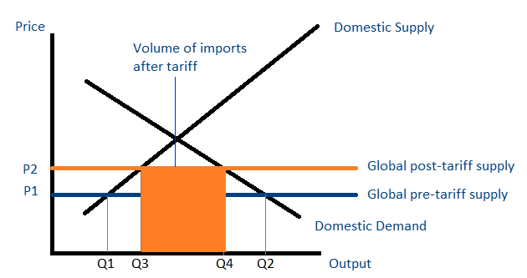

**2. Quotas**

[Quotas](https://corporatefinanceinstitute.com/resources/knowledge/economics/import-quotas/) are restrictions on the volume of imports for a particular good or service over a period of time. Quotas are known as “non-tariff trade barrier.” A constraint on the supply causes an increase in the prices of imported goods, reducing the demand in the domestic market.

**3. Subsidies**

Subsidies are negative taxes that are given to domestic producers by the government. They create a discrepancy between the price faced by consumers and the price faced by producers.

**4. Standardization**

The government of a country may require all foreign products to adhere to certain guidelines. For instance, the [UK Government](https://www.gov.uk/) may demand that all imported shoes include a certain proportion of leather. Standardization measures tend to reduce foreign products in the market.

**Advantages of Protectionism**

* **More growth opportunities**: Protectionism provides local industries with growth opportunities until they can compete against more experienced firms in the international market
* **Lower imports**: Protectionist policies help reduce import levels and allow the country to increase its trade balance.
* **More jobs**: Higher employment rates when domestic firms boost their workforce
* **Higher GDP**: Protectionist policies tend to boost the economy’s GDP due to a rise in domestic production.

**Disadvantages of Protectionism**

* **Stagnation of technological advancements**: As domestic producers don’t need to worry about foreign competition, they have no incentive to innovate or spend resources on [research and development (R&D)](https://corporatefinanceinstitute.com/resources/knowledge/accounting/research-and-development-rd/) of new products.
* **Limited choices for consumers**: Consumers have access to fewer goods in the market as a result of limitations on foreign goods.
* **Increase in prices (due to lack of competition)**: Consumers will need to pay more without seeing any significant improvement in the product.
* **Economic isolation**: It often leads to political and cultural isolation, which, in turn, leads to even more economic isolation.

#### Other protectionist measures

Countries can also use a range of other protectionist measures to restrict imports. These might include:

* **Administrative obstacles** - countries can set administrative hurdles. For example, they may require significant levels of paperwork and then deal with these processes slowly making it difficult for importers to compete on a level playing field with other firms.
* **Health and safety standards** - countries may set onerously high health and safety standards for goods that are imported, once again making life difficult for importers.
* **Environmental standards** - countries can set high environmental standards that they know only domestic firms are likely to be able to achieve, once again making life difficult for importers.

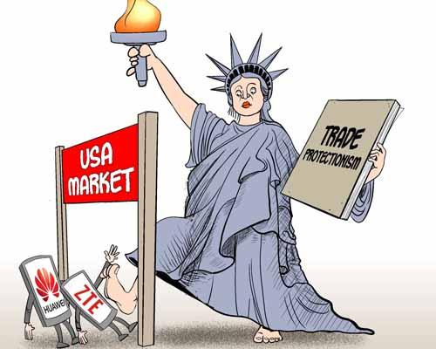

**Trade Barriers**

* Trade barriers are restrictions imposed on the movement of goods between countries (import and export).

• The major purpose of trade barriers is to promote domestic goods than exported goods, and there by safeguard the domestic industries.

• Trade barriers can be broadly divided into tariff barriers and non tariff barriers.

**Tariff Barriers**

• Term tariff means ‘Tax’ or ‘duty’.

• Tariff barriers are the ‘tax barriers’ or the ‘monetary barriers’ imposed on internationally traded goods when they cross the national borders.

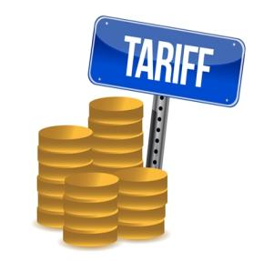

**Major tariff barriers:**

1. **Specific duty:** It is based on the physical characteristics of the good. A fixed amount of money can be levied on each unit of imported goods regardless of its price. Eg. Imposing of $15 on an imported shoe.

2. **Ad Valorem tariffs:** The Latin phrase ‘ad valorem’ means “according to the value”. This tax is flexible and depends upon the value or the price of the commodity. Eg. Imposing tax of 5$ for a 50$ shoe and 10$ for a 100$ shoe.

3**. Combined or compound duty:** It is a combination of specific and ad valorem duty on a single product, for instance , there can be a combined duty when 10% of value(ad valorem) and 1$ per kilogram(specific tax) are charged on metal M.

4. **Sliding scale duty:** The duty which varies along with the price of the commodity is known as sliding scale duty or seasonal duties. These duties are confined to agricultural products, as their prices frequently vary because of natural and other factors.

**5. Countervailing duty:** It is imposed on certain import where it is being subsidised by exporting governments. As a result of the government subsidy, imports become more cheaper than domestic goods, to nullify the effect of subsidy, this duty is imposed in addition to normal duties.

**6. Revenue tariff:** A tariff which is designed to provide revenue or income to the home government is known as revenue tariff. Generally this tariff is imposed with a view of earning revenue by imposing duty on consumer goods, particularly on luxury goods whose demand from the rich is inelastic.

**7. Anti –dumping duty:** At times exporters attempt to capture foreign markets by selling goods at rock-bottom prices, such practice is called dumping. As a result of dumping, domestic industries find it difficult to compete with imported goods. To offset anti-dumping effects, duties are levied in addition to normal duties.

**8. Protective tariff:**In order to protect domestic industries from stiff competition of imported goods, protective tariff is levied on imports. Normally a very high duty is imposed, so as to either discourage imports or to make the imports more expensive as that of domestic products.

**9. Classification of tariff on the basis of trade relationship:**

a) Single column tariff: here the tariff rates are fixed for various commodities and the same rates are charged for imports from all countries. Tariff rates are uniform for all countries and discrimination between importing countries is not made.

b) Double column tariff: here two rates of tariff on all or some commodities are fixed. The lower rate is made applicable to a friendly country or the country with which bilateral trade agreement is entered into. The higher rate is made with all other countries.

c) Triple column: here 3 rates are fixed. They are: general rate, international rate, preferential rate. The first two are similar to lower and higher rates while the preferential rate is substantially lower than the general rate and is applicable to friendly countries with trade agreement or with close trade relationship.

**Non Tariff Barriers**

• Any barriers other than tariff.

• It is meant for constructing barriers for the free flow of the goods.

• It do not affect the price of the imported goods.

• It affects the quality and quantity of the goods.

**1. Licenses:**License is granted by the government, and allows the importing of certain goods to the country.

**2. Voluntary export restrains(ver):** These type of barriers are created by the exporting country rather than the importing one. These restrains are usually levied on the request of the importing company. eg. Brazil can request Canada to impose VER on export of sugar to brazil and this helps to increase the price of sugar in Brazil and protects its domestic sugar producers.

**3. Quotas**: under this system, a country may fix in advance, the limit of import quantity of commodity that would be permitted for import from various countries during a given period. This is divided into the following categories:

a) Tariff quota: certain specified quantity of imports allowed at duty free or at a reduced rate of import duty. A tariff quota, therefore, combine the features of a tariff and import quota.

b) unilateral quota: the total import quantity is fixed without prior consultations with the exporting countries.

c) bilateral quota: here quotas are fixed after negotiations between the quota fixing importing country and the exporting country.

d) multi lateral quota: a group of countries can come together and fix quotas for each country.

**4. Product standards**: here the importing country imposes standards for goods. If the standards are not met, the goods are rejected.

**5. Domestic content requirements**: governments impose DCR to boost domestic production.

**6. Product Labeling**: certain countries insist on specific labeling of the products. Eg. EU insist on products labeling in major languages in EU.

**7. Packaging requirements:** certain nations insist on particular type of packaging of goods. Eg. EU insist on packaging with recyclable materials.

**8. Foreign exchange regulations:** the importer has to ensure that adequate foreign exchange is available for import of goods by obtaining a clearance from exchange control authorities prior to the concluding of contract with the supplier.

**9. State trading:** in some countries like India, certain items are imported or exported only through canalising agencies like MMTT( minerals and metals trading cooperation of India)

**10. Embargo:** partial or complete prohibition of trade with any particular country, mainly because of the political tensions.

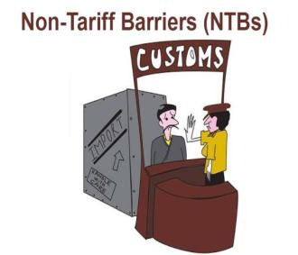

**Countertrade**

Countertrade is an important means of trade used by developing countries. In this lesson, you'll learn what countertrade is, the types of countertrade that are available, and also be provided some examples. A short quiz follows the lesson.

**Definition of Countertrade**

International trade by exchange of goods rather than by currency purchase.

**Countertrade** is a system of international trading that helps governments reduce imbalances in trade between them and other countries. It involves the direct or indirect exchange of goods for other goods instead of currency.

Countertrade is often used when a foreign currency is in short supply or when a country applies **foreign exchange controls**, which are limits imposed on the availability of foreign currencies to importers for the purchase of foreign products. Countertrade is often used by developing countries to control trade and as a development technique.

**Types of Countertrade**

There are several types of countertrade, including barter, counter purchase, compensation trade, switch trading, offsets and clearing agreements.

1. **Barter- Barter**, possibly the simplest of the many types of counter trade, is a onetime direct and simultaneous exchange of products of equal value (i.e., one product for another). By removing money as a medium of exchange barter makes it possible for cash-tight countries to buy and sell. Although price must be considered in any counter trade, price is only implicit at best in the case of barter. For example, Chinese coal was exchanged for the construction of a seaport by the Dutch, and Polish coal was exchanged for concerts given by a Swedish band in Poland. In these cases. the agreement dealt with how many tons of coal was to be given by China and Poland rather than the actual monetary value of the construction project or concerts. It is estimated that about half of the U.S. corporations engage in some form of barter primarily within the local markets of the United States.
2. **Counter purchase (Parallel Barter)** – Counter purchase occurs when there are two contracts or a set of parallel cash sales agreements, each paid in cash. Unlike barter which is a single transaction with an exchange price only implied. A counter purchase involves two separate transactions-each with its own cash value. A supplier sells a facility or product at a set price and orders unrelated or non-resultant products to offset the cost to the initial buyer. Thus, the buyer pays with hard currency, whereas the supplier agrees to buy certain products within a specified period. Therefore money does not need to change hands. In effect, the practice allows the original buyer to earn back the currency. GE won a contract worth $300’million to build aircraft engines for Sweden’s JAS fighters for cash only after agreeing to buy Swedish industrial products over a period of time in the same amount through a counter purchase deal. Brazil exports vehicles, steel, and farm products to oil-producing countries from which it buys oil in return.
3. **Compensation Trade (Buyback)** – A compensation trade requires a company to provide machinery, factories, or technology and to buy products made from this machinery over an agreed-on period. Unlike counter purchase, which involves two unrelated products, the two contracts in a compensation trade are highly related. Under a separate agreement to the sale of plant or equipment, a supplier agrees to buy part of the plant’s output for a number of years. For example, a Japanese company sold sewing machines to China and received payment in the form of 300,000 pairs of pajamas. Russia welcomes buyback.
4. **Switch Trading** – Switch trading involves a triangular rather than bilateral trade agreement. When goods, all or part, from the buying country are not easily usable or salable; it may be necessary to bring in a third party to dispose of the merchandise. The third party pays hard currency for the unwanted merchandise at a considerable discount. A hypothetical example could involve Italy having a credit of $4 million for Austria’s hams, which Italy cannot use, A third-party company may decide to sell Italy some desired merchandise worth $3 million for a claim on the Austrian hams. The price differential or margin is accepted as being necessary to cover the costs of doing business this way. The company can ‘then sell the acquired hams to Switzerland for Swiss francs, which are freely convertible to dollars.
5. **Offset** – In an offset, a foreign supplier is required to manufacture/assemble the product locally and/or purchase local components as an exchange for the right to sell its products locally. In effect, the supplier has to manufacture at a location that may not be optimal from an economic standpoint. Offsets are often found in purchases of aircraft and military equipment. One study found that more than half of the companies counter trading with the Middle East were in the defense industry and that the most common type of counter trade was offset. These companies felt that counter trade was a required element in order to enter these markets.
6. **Clearing Agreement** – A clearing agreement is clearing account barter with no currency transaction required. With a [line of credit](https://www.mbaknol.com/international-finance/buyers-credit-and-suppliers-credit/) being established in the central banks of the two countries, the trade in this case is continuous, and the exchange of products between two governments is designed to achieve an agreed-on value or volume of trade tabulated or calculated in nonconvertible “clearing account units.” For example, the former Soviet Union’s rationing of hard currency limited imports and payment of copiers. Rank Xerox decided to circumvent the problem by making copiers in India for sale to the Soviets under the country’s “clearing” agreement with India. The contract set forth goods, ratio of exchange, and time length for completion. Any imbalances after the end of the year were settled by credit into the next year, acceptance of unwanted goods, payment of penalty, or hard currency payment. Although nonconvertible in theory, clearing units in practice can be sold at a discount to trading specialists who use them to buy salable products.

**FINANCIAL ENVIRONMENT**

A financial environment is a part of an economy with the major players being firms, investors,and markets. Essentially, this sector can represent a large part of a well-developed economy asindividuals who retain private property have the ability to grow their capital. Firms are any business that offer goods or services to consumers. Investors are individuals or businesses that place capital into businesses for financial returns.

Markets represent the financial environmentthat makes this all possible.Historically, firms were very small or even nonexistent in economies or financial markets.Though a few firms have always been in existence, the ability for a large number of firms wasnot possible until markets became more mature. Mature markets allow for more access toresources necessary to produce goods and services. As firms begin to grow, expand, andmultiply, higher capital needs to persist in order for firms to succeed. Capital sources includemoney from outside parties, such as investors.

Many times investors are individuals who have more capital than is necessary to provide asufficient living standard. Any excess capital can actually make individuals more money if theyinvest the funds into a firm that offers a financial return. This symbiotic relationship in the financial environment allows both parties to increase their capital. Many different factors play arole for individuals making investments. A few of these may include risk, current marketconditions, and competition, among others.Financial environment of a company refers to all the financial institutions and financial marketaround the company that affects the working of the company as a whole.The financial environment has a number of factors. It includes the financial institutions,government, individuals and firms around the business. Firms use their financial markets to keeptheir savings as property. It is extremely important for the monetary markets.

### Foreign Investment

* **Foreign investment** is when a company or individual from one nation invests in assets or ownership stakes of a company based in another nation. As increased globalization in business has occurred, it's become very common for big companies to branch out and invest money in companies located in other countries
* They may make a foreign investment in another firm outside of their country because the firm being purchased has specific technology, products, or access to additional customers that the purchasing firm wants.
* Overall, foreign investment in a country is a good sign that often leads to growth of jobs and income. As more foreign investment comes into a country, it can lead to even greater investments because others see the country as economically stable.
* Foreign [investment](https://www.investopedia.com/terms/i/investment.asp) involves capital flows from one country to another, granting extensive ownership stakes in domestic companies and assets.
* Foreign investment denotes that foreigners have an active role in management as a part of their investment. A modern trend leans toward [globalization](https://www.investopedia.com/terms/g/globalization.asp), where [multinational firms](https://www.investopedia.com/video/play/multinational-corporations/) have investments in a variety of countries.

**Kinds of Foreign Investment**

**Foreign direct investment (FDI)** Foreign direct investment (FDI) is when a foreign company or individual makes an investment in India that involves either

(i) Establishing new business operations (known as **green-field FD**I) or

(ii) Acquiring business assets, including controlling interests, in an already existing Indian company. (known as **brown-field FDI**)

FDI is distinguished from FII in the sense it establishes a long-term relationship and involves substantial control over the decision making of the company.

* **Inward FDI** is when foreign companies or individuals invest in India.
* **Outward FDI** is when Indian companies or individuals invest in foreign countries

As per the Companies Act 2013, if a foreign investor owns more than 10 % shares in a listed company, it will be treated as FDI. The rationale behind the rule is that the higher equity ownership will result in substantial control over the decision-making of the company

**Foreign Portfolio Investment (FPI)**

Foreign Portfolio Investment (FPI) is an investment by foreign entities and non-residents in Indian securities including shares, government bonds, corporate bonds, convertible securities, infrastructure securities etc.  The intention is to ensure a controlling interest in India at an investment that is lower than FDI, with flexibility for entry and exit.

* 1. **Foreign institutional investment (FII)**

FII is when foreign institutional investors invest in the shares of an Indian company, or in bonds offered by an Indian company. So, if a foreign investor buys shares in Reliance, it is an FII.

Only institutional investors like Investment companies, Insurance funds etc. are allowed to invest in Indian stock market directly. Hence the term foreign institutional investor. These investors have to get a license from SEBI.

However, if foreign individuals want to invest in India’s markets, they have to get themselves registered as a sub-account of an FII. The FII will buy shares/ bonds from the India markets on their behalf.

India allows only wealthy foreign individuals or high net worth individuals (HNIs) who have a minimum net worth of $50 million to be registered as a sub-account of a foreign institutional investor (FII).

Foreign institutional investors are also known as **‘hot money’** because it is not stable in nature. The FIIs can pull out money from a country’s stock market/ bond market overnight.

* 1. **GDRs/ADRs & FCCBs**- are instruments issued by Indian companies in the foreign markets for mobilizing foreign capital by facilitating portfolio investments by foreigners in Indian Securities.

**ENTRY STRUCTURES**

## Entry Strategies for Foreign Investors

### STARTING OPERATIONS IN INDIA

A foreign company planning to set up business operations in India has the following options.

### AS AN INDIAN COMPANY

A foreign company can commence operations in India by incorporating a company under the Companies Act, 1956 through

* Joint Ventures; or
* Wholly Owned Subsidiaries

Foreign equity in such Indian companies can be up to 100% depending on the requirements of the investor, subject to equity caps in respect of the area of activities under the Foreign Direct Investment (FDI) policy. Details of the FDI policy, sectoral equity caps & procedures can be obtained from Department of Industrial Policy & Promotion, Government of India [(http://www.dipp.nic.in )](http://www.dipp.nic.in/#_blank) .

### Joint Venture with an Indian Partner

Foreign Companies can set up their operations in India by forging strategic alliances with Indian partners.  
Joint Venture may entail the following advantages for a foreign investor:

* Established distribution/ marketing set up of the Indian partner
* Available financial resource of the Indian partners
* Established contacts of the Indian partners which help smoothen the process of setting up of operations.

### Wholly Owned Subsidiary Company

Foreign companies can also to set up wholly-owned subsidiary in sectors where 100% foreign direct investment is permitted under the FDI policy.

### Incorporation of Company

For registration and incorporation, an application has to be filed with Registrar of Companies (ROC). Once a company has been duly registered and incorporated as an Indian company, it is subject to Indian laws and regulations as applicable to other domestic Indian companies.

For details please visit the website of Department of Company Affairs under Ministry of Finance at [http://www.mca.gov.in/](http://www.mca.gov.in/#_blank)

### AS A FOREIGN COMPANY

Foreign Companies can set up their operations in India through

* Liaison Office/Representative Office
* Project Office
* Branch Office

Such offices can undertake any permitted activities. Companies have to register themselves with Registrar of Companies (ROC) within 30 days of setting up a place of business in India.

### Liaison Office/Representative Office

Liaison office acts as a channel of communication between the principal place of business or head office and entities in India. Liaison office can not undertake any commercial activity directly or indirectly and cannot, therefore, earn any income in India. Its role is limited to collecting information about possible market opportunities and providing information about the company and its products to prospective Indian customers. It can promote export/import from/to India and also facilitate technical/financial collaboration between parent company and companies in India.

Approval for establishing a liaison office in India is granted by Reserve Bank of India (RBI).

### Project Office

Foreign Companies planning to execute specific projects in India can set up temporary project/site offices in India. RBI has now granted general permission to foreign entities to establish Project Offices subject to specified conditions. Such offices can not undertake or carry on any activity other than the activity relating and incidental to execution of the project. Project Offices may remit outside India the surplus of the project on its completion, general permission for which has been granted by the RBI.

### Branch Office

Foreign companies engaged in manufacturing and trading activities abroad are allowed to set up Branch Offices in India for the following purposes:

* Export/Import of goods
* Rendering professional or consultancy services
* Carrying out research work, in which the parent company is engaged.
* Promoting technical or financial collaborations between Indian companies and parent or overseas group company.
* Representing the parent company in India and acting as buying/selling agents in India.
* Rendering services in Information Technology and development of software in India.
* Rendering technical support to the products supplied by the parent/ group companies.
* Foreign airline/shipping Company.

A branch office is not allowed to carry out manufacturing activities on its own but is permitted to subcontract these to an Indian manufacturer. Branch Offices established with the approval of RBI, may remit outside India profit of the branch, net of applicable Indian taxes and subject to RBI guidelines Permission for setting up branch offices is granted by the Reserve Bank of India (RBI).

**FDI APPROVAL ROUTES IN INDIA**

In India the FDI is approved in the way of three routes:

**I. AUTOMATIC APPROVAL BY RESERVE BANK OF INDIA (RBI)**

a. Automatic approval within period of two weeks (subject to compliance of norms)

b. Foreign equity up to 24%, 50%, 51%, 74% and 100% depending on industry category and sector caps.

FDI in sectors/activities to the extent permitted under automatic route does not require any prior approval either by the Government or RBI. The investors are only required to notify the Regional office concerned of RBI within 30 days of receipt of inward remittances and file the required documents with that office within 30 days of issue of shares to foreign investors.

List of activities or items for which automatic route for foreign investment is not available, include the following:

a. Banking

b. NBFC's Activities in Financial Services Sector

c. Civil Aviation

d. Petroleum Including Exploration/Refinery/Marketing

e. Housing & Real Estate Development Sector for Investment from Persons other than NRIs/OCBs.

f. Venture Capital Fund and Venture Capital Company

g. Investing Companies in Infrastructure & Service Sector

h. Atomic Energy & Related Projects

i. Defence and Strategic Industries

j. Agriculture (Including Plantation)

k. Print Media

l. Broadcasting

m. Postal Services

**II. THE FIPB ROUTE** – Processing of non-automatic approval cases

a. FIPB stands for Foreign Investment Promotion Board.

b. Approves all cases where automatic parameters are not met.

c. Processing time 4 to 6 weeks

**III. GENERAL PERMISSION OF RBI UNDER FEMA**

Indian companies having foreign investment approval through FIPB route do not require any further clearance from RBI for receiving inward remittance and issue of shares to the foreign investors. The companies are required to notify the concerned Regional office of the RBI of receipt of inward remittances within 30 days of such receipt and within 30 days of issue of shares to the foreign investors or NRIs. Application can be made in Form FC-IL; Plain paper applications carrying all relevant details are also accepted. No fee is payable.

**IV. PROCEDURE UNDER GOVERNMENT APPROVAL**

FDI in activities not covered under the automatic route, requires prior Government approval and are considered by the Foreign Investment Promotion Board (FIPB). Approvals of composite proposals involving foreign investment/foreign technical collaboration are also granted on the recommendations of the FIPB. Application for all FDI cases, except Non-Resident Indian (NRI) investments and 100% Export Oriented Units (EOUs), should be submitted to the FIPB Unit, Department of Economic Affairs (DEA), Ministry of Finance. Application for NRI and 100% EOU cases should be presented to SIA in Department of Industrial Policy & Promotion.

**V. INVESTMENT BY WAY OF SHARE ACQUISITION**

A foreign investing company is entitled to acquire the shares of an Indian company without obtaining any prior permission of the FIPB subject to prescribed parameters/ guidelines. If the acquisition of shares directly or indirectly results in the acquisition of a company listed on the stock exchange, it would require the approval of the Security Exchange Board of India.

**VI. NEW INVESTMENT BY AN EXISTING COLLABORATOR IN INDIA**

A foreign investor with an existing venture or collaboration (technical and financial) with an Indian partner in particular field proposes to invest in another area, such type of additional investment is subject to a prior approval from the FIPB, wherein both the parties are required to participate to demonstrate that the new venture does not prejudice the old one.

**V. PARTICIPATION BY INTERNATIONAL FINANCIAL INSTITUTIONS**

Equity participation by international financial institutions such as ADB, IFC, CDC, DEG, etc., in domestic companies is permitted through automatic route, subject to SEBI/RBI regulations and sector specific cap on FDI.

* **FDI IN SMALL SCALE SECTOR (SSI) UNITS**

A small-scale unit cannot have more than 24 per cent equity in its paid up capital from any industrial undertaking, either foreign or domestic. If the equity from another company (including foreign equity) exceeds 24 per cent, even if the investment in plant and machinery in the unit does not exceed Rs 10 million, the unit loses its small-scale status and shall require an industrial license to manufacture items reserved for small-scale sector.

**VI. CCFI ROUTE**

a. CCFI stands for Cabinet Committee on Foreign Investment

b. Sector not notified in the automatic route

c. Cost of project should be 6000 million or more.

**OTHER STRATEGY ARE**

**AUTOMATIC ROUTE**

FDI Policy permits FDI up to 100 % from foreign/NRI investor without prior approval in most of the sectors including the services sector under automatic route. FDI in sectors/activities under automatic route does not require any prior approval either by the Government or the RBI. The investors are required to notify the concerned Regional office of RBI of receipt of inward remittances within 30 days of such receipt and will have to file the required documents with that office within 30 days after issue of shares to foreign investors.

The present Automatic Route allows Indian companies engaged in all industries except for certain select industries/sectors to issue shares to foreign investors up to 100% of their paid up capital in Indian companies. There are also some areas where though Automatic Route is available, foreign investors cannot invest beyond a certain percentage of the paid up capital of the Indian companies or where investment is subject to some other conditions.

**GOVERNMENT APPROVAL ROUTE**

All activities which are not covered under the automatic route, prior Government approval for FDI/NRI shall be necessary. Areas/sectors/activities hitherto not open to FDI/NRI investment shall continue to be so unless otherwise decided and notified by Government.

An investor can make an application for prior Government approval even when the proposed activity is under the automatic route.

**Proposals requiring Government Approval**

* FDI up to 100% is allowed under the automatic route in all activities/sectors except the following which will require approval of the Government:
* Activities/items that require an Industrial License.
* All proposals falling outside notified sectoral policy/caps or under sectors in which FDI is not permitted. Proposals in which the foreign collaborator has a previous/existing venture/tie up in India in the same.

Prior Government approval for new proposals would be required only in cases where the foreign investor has an existing joint venture, technology transfer, trade mark agreement in the same field. With the amendment of the Press Note 18, joint ventures formed with foreign investment before December 12, 2004 would be considered as “existing JVs” which will fall under the ambit of Press Note 18. The foreign partner in such JV has to obtain a No Objection Certificate (NOC) from the Indian partner for starting new venture in India in the “same” field of activity.

Application for proposals requiring prior Govt’s approval should be submitted to FIPB in fresh Application. The application shall be filed online through FIPB portal. Plain paper applications carrying all relevant details are also accepted. No fee is payable. The following information should form part of the proposals submitted to FIPB: -

a) Whether the applicant has had or has any previous/existing financial/technical collaboration or trade mark agreement in India in the same or allied field for which approval has been sought; and

b) If so, details thereof and the justification for proposing the new venture/technical collaboration (including trade marks).

c) Applications can also be submitted with Indian Missions abroad who will forward them to the Department of Economic Affairs for further processing.

d) Generally foreign investment proposals received in the DEA  (Department of Economic Affairs) are placed before the Foreign Investment Promotion Board (FIPB) within 15 days of receipt. The decision of the Government in all cases is usually conveyed by the DEA within 30 days.

**PROHIBITED SECTORS FOR FDI IN INDIA**

FDI is not permissible in the following cases

* + Gambling and Betting, or
  + Lottery Business, or
  + Business of chit fund
  + Housing and Real Estate business (to a certain extent has been opened. For details please see note on Construction)
  + Trading in Transferable Development Rights (TDRs)
  + Retail Trading (discussions are being held to open this area-B2B and Cash & Carry are permitted)
  + Atomic Energy
  + Agricultural or plantation activities or Agriculture (excluding Floriculture, Horticulture, Development of Seeds, Animal Husbandry, Pisiculture and Cultivation of Vegetables, Mushrooms etc. under controlled conditions and services related to agro and allied sectors) and Plantations(other than Tea plantations)

**UNIT IV**

**INTERNATIONAL ECONOMIC INSTITUTIONS AND AGREEMENTS**

**Introduction**

* International Trade is usually referred to the exchange of goods or services along international borders.
* It allows us to expand our markets for both goods and services.
* The growth of international trade can be increased, if the countries follow a common set of rules, regulations, and standards related to import and export.
* These common rules and regulations are set by various international economic institutions.
* These institutions aim to provide a level playing field for all the countries and develop economic cooperation.

**Reason**

* To boost the economic cooperation's among countries
* To help a quicker recovery of the international economy.
* Act as financial intermediary

**Origins of institution**

* After the great depression in 1930’s there was a need for an organization to create a system for exchange rate stability
* The World Bank & International Monitory Fund (IMF) were created after world war
* Need for reconstruction of Countries economies affected by World War II & for the development of under developed nations

**Major International Economic Institutions**

The Major International Economic Institutions are as followed-

* General Agreement on Tariffs and Trade (GATT)
* World Trade Organization (WTO)
* International Monetary Fund (IMF)
* World Bank (WB)
* South Asian Free Trade Area (SAFTA)
* Trade-Related Aspects of Intellectual Property Rights (TRIPS)
* South -South Cooperation.

**1. GATT**

**Origin :-**The [General Agreement on Tariffs and Trade](https://www.wto.org/english/tratop_e/gatt_e/gatt_e.htm)was a [free trade agreement](https://www.thebalance.com/free-trade-agreement-types-and-examples-3305897) between 23 countries that eliminated [tariffs](https://www.thebalance.com/tariff-pros-cons-and-examples-3305967) and increased [international trade](https://www.thebalance.com/international-trade-pros-cons-effect-on-economy-3305579). It was the first worldwide [multilateral free trade agreement](https://www.thebalance.com/multilateral-trade-agreements-pros-cons-and-examples-3305949). It was in effect from January 1, 1948 until January 1, 1995. It ended when it was replaced by the more robust [World Trade Organization](https://www.thebalance.com/what-is-the-world-trade-organization-wto-3306366).

Inspired by the success of agreement for international monetary co-operation as reflected in the formation of the IMF, similar co-operation as reflected in international trade also was desired by many trading nations for expansion of world trade.

It was thought that for healthy world trade, attempt must be made to relax the existing trade restrictions, such as tariffs.

As such, at the [International Conference](http://www.yourarticlelibrary.com) on Trade and [Employment](http://www.yourarticlelibrary.com) held in 1946 at Havana, a proposal for establishing an agency called the International Trade Organization (ITO) was made with the miscellaneous and general objective of augmenting and maintaining world trade and employment.

Though the Havana Charter for ITO was designed as a sort of international trade constitution, it was not translated into practice due to various difficulties and lack of common agreement.

However, some of the countries took up one of the important issues of the Havana Charter regarding relaxation of trade restrictions by incorporating it into a General Agreement on Tariffs and Trade (GATT). This was signed in 1947 by some twenty-three major trading nations, including India. GATT membership has now gone up to more than 64.

As the name itself suggests, the General Agreement was concerned only with tariffs and trade restrictions and related international matters. It serves as an important international forum for carrying on negotiations on tariffs.

Under GATT, member nations meet at regular intervals to negotiate agreements to reduce quotas, tariffs and such other restrictions on international trade. GATT, by its very nature, is a contractual agreement among parties (or nations). It is a treaty that is collectively administered by the contracting nations.

However, it has become a permanent international organisation for safeguarding the conduct of international trade and an institution for the multilateral expansion of trade.

**Highlights**

* The General Agreement on Tariffs and Trade (GATT) is a multilateral agreement regulating international trade, the purpose of which is the “substantial reduction of tariffs and other trade barriers and the elimination of preferences, on a reciprocal and mutually advantageous basis”.
* The failure to create the International Trade Organization (ITO) resulted in the GATT negotiation at the UN Conference on Trade and Employment.
* GATT was in place from 1947-1993, when it was replaced by the World Trade Organization (WTO) in 1995.
* GATT text is still in effect under the WTO framework, subject to modifications.
* During GATT’s eight rounds, countries exchanged tariff concessions and reduced tariffs

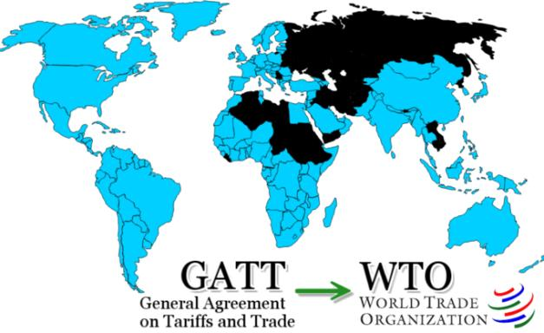

**Objectives of GATT-**

The General Agreement on Tariff and Trade was a multilateral treaty that laid down rules for conducting international trade. The preamble to the GATT can be linked to its objectives.

1. Expansion of international trade,

2. Increase of world production by ensuring full employment in the participating nations,

3. Development and full utilization of world resources

4. Raising standard of living of the world community as a whole.

However, the articles of the GATT do not provide directives for attaining these objectives. These are to be indirectly achieved by the GATT through the promotion of free (unrestricted) and multilateral international trade.

**Principles of GATT**

For the realization of the above mentioned objectives, GATT adopted the following principles.

1. Non Discrimination,
2. Protection through tariffs,
3. A stable basis of trade, and;
4. Consultation

**1. Non Discrimination:-**

The international trade should be conducted on the basis of nondiscrimination. No member country shall discriminate between the members of GATT in the conduct of international trade. On this basis, the principle “**Most favored Nation**” (MFN) was enunciated. This means that “each nation shall be treated as good as the most favored nation”.

**2. Protection through tariffs only:-**

GATT rules prohibit quantitative restrictions. Domestic industries should be protected only through customs tariffs. Restrictions on trade should be limited to the less rigid tariffs.

**3. A stable basis of trade:-**

GATT seeks to provide a stable and predictable basis for trade. It binds the tariff levels negotiated among the contracting countries. Binding of tariffs prevents the unilateral increase in tariffs, But still there is a provision for renegotiation of bound tariffs. A return to higher tariffs is discouraged by the requirement that any increase is to be compensated for.

**4. Consultation:-**

The member countries should consult one another on trade matters and problems. The members who feel aggrieved that their rights under GATT are withheld can call for a fair settlement. Panels of independent experts have been formed under the GATT council. Panel members are drawn from countries which have no direct interest in the disputes under investigation. They look into the trade disputes among members. The panel procedure aims at mutually satisfactory settlement among members.

**Most Favored Nations Clause:**

In general terms, members of GATT agree that reduction in tariffs and elimination of discrimination in inter To ensure against discrimination, members agree to grant to each other unconditional most favoured nation status in all import and export duties, with certain exceptions. Article I of the Agreement deals with the ‘most favoured nation clause meaning that any advantage, favour, privilege or immunity granted by a contracting party to any product originating in or designed for any other country shall be accorded immediately and unconditionally to a like product originating in or destined for the territories of all other contacting parties.

Thus, the principle of most favoured nation implies that each nation should be treated as the most favoured nation. As such, the contracting parties are forbidden from granting any new preference. And the negotiations and concessions materialised under bilateral agreements should be extended to all member countries on an equal basis so that the concessions are multilateralised. It also signifies that the permitted quantitative restrictions should be administered without favoring any party.

national commerce should be on a reciprocal and mutually advantageous basis.

**GATT permits such restrictions only for:**

(i) Safeguarding exchange reserves when a country has balance of payments difficulties.

(ii) Restricting imports that would harm domestic price supports and production control programmes of a country.

GATT also lays down that state trading should be non-discriminatory. However, the formation of customs unions or free trade areas are allowed by the General Agreement provided their purpose is to facilitate trade between the constituent territories and not to raise barriers to the trade of other member nations.

(iii) Underdeveloped countries to further their economic development under procedures approved by GATT.

**GATT Rounds:**

Between 1947 and 1995 there were 8 rounds of negotiations between the participating countries. The first 6 rounds were related to curtailing tariff rates, 7th round included the non-tariff obstacles.

The 8th round was entirely different from the previous rounds because it included a number of new subjects for consideration. This 8th round known as “Uruguay Round” became most controversial. The discussions at this round only gave birth to World Trade Organization (WTO).

**2.World Trade organization**

**Introduction:**

The establishment of the World Trade Organisation (WTO) as the successor to ,the GATT on 1 January 1995 under the Marrakesh Agreement places the global trading system on a firm constitutional footing with the evolution of international economic legislation resulted through the Uruguay Round of GATT negotiations.

A remarkable feature of the Uruguay Round was that it paved the way for further liberalisation of international trade with the fundamental shift from the negotiation approach to the institutional framework envisaged through transition from GATT to WTO Agreement.

The GATT 1947 and the WTO co-existed for the transitional period of one year in 1994. In January 1995, however, the WTO completely replaced the GATT. The membership of the WTO increased from 77 in 1995 to 127 by the end of 1996.

The Uruguay round of GATT (1986-93) gave birth to World Trade Organization. The members of GATT singed on an agreement of Uruguay round in April 1994 in Morocco for establishing a new organization named WTO.

Contrary to the temporary nature of GATT, WTO is a permanent organization which has been established on the basis of an international treaty approved by participating countries. It achieved the international status like IMF and IBRD, but it is not an agency of the United Nations Organization (UNO).

**Features of the WTO:**

**The distinctive features of the WTO are:**

i. Unlike the GATT, it is a legal entity.

ii. Unlike the International Monetary Fund (IMF) and the World Bank (WB) it is not an agent of the United Nations.

iii. Unlike the IMF and the World Bank, there is no weighted voting, but all the WTO members have equal rights.

iv. Unlike the GATT, the agreements under the WTO are permanent and binding to the member countries.

v. Unlike the GATT, the WTO dispute settlement system is based not on dilatory but automatic mechanism. It is also quicker and binding on the members. As such, the WTO is a powerful body.

vi. Unlike the GATT, the WTOs approach is rule- based and time-bound.

vii. Unlike the GATT, the WTOs have a wider coverage. It covers trade in goods as well as services.

viii. Unlike the GATT, the WTOs have a focus on trade-related aspects of intellectual property rights and several other issues of agreements.

ix. Above all, the WTO is a huge organizational body with a large secretariat.

Structure of WTO

The organisational structure of the WTO is outlined in the Chart 50.1.

The Ministerial Conference (MC) is at the top of the structural organisation of the WTO. It is the supreme governing body which takes ultimate decisions on all matters. It is constituted by representatives of (usually, Ministers of Trade) all the member countries.

The General Council (GC) is composed of the representatives of all the members. It is the real engine of the WTO which acts on behalf of the MC. It also acts as the Dispute Settlement Body as well as the Trade Policy Review Body.

There are three councils, viz.: the Council for Trade in Services and the Council for Trade-Related Aspects of Intellectual Property Rights (TRIPS) operating under the GC. These councils with their subsidiary bodies carry out their specific responsibilities

Further, there are three committees, viz., the Committee on Trade and Development (CTD), the Committee on Balance of Payments Restrictions (CBOPR), and the Committee on Budget, Finance and Administration (CF A) which execute the functions assigned to them by e WTO Agreement and the GC.

[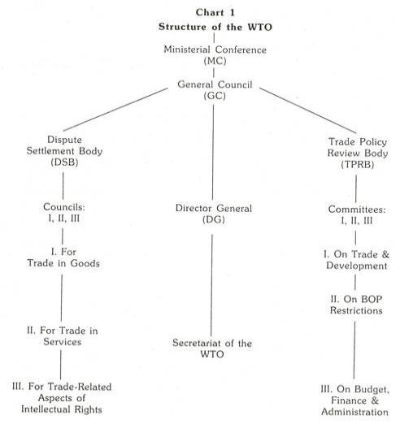](http://cdn.yourarticlelibrary.com/wp-content/uploads/2014/02/clip_image002119.jpg)

The administration of the WTO is conducted by the Secretariat which is headed by the Director General (DG) appointed by the MC for the tenure of four years. He is assisted by the four Deputy Directors from different member countries. The annual budget estimates and financial statement of the WTO are presented by the DG to the CBFA for review and recommendations for the final approval by the GC.

1. **Ministerial Conference**:  
   The topmost decision making body WTO is Ministerial Conference. It meets once in two years.
2. **General Council**: The second level of WTO is General Council. It consists of members, ambassadors and heads of delegations. It meets several times a year in Geneva.
3. **Other Councils**: There are many other types of council like Goods Council, Services Council, IP Council etc. These councils deal with specific issues.

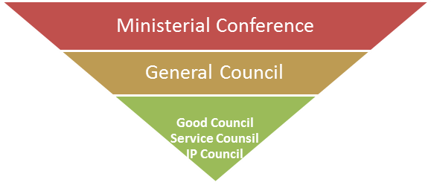

**Objectives of the WTO:**

The purposes and objectives of the WTO are spelled out in the preamble to the Marrakesh Agreement.

**In a nutshell, these are:**

1. To ensure the reduction of tariffs and other barriers to trade.

2. To eliminate discriminatory treatment in international trade relations.

3. To facilitate higher standards of living, full employment, a growing volume of real income and effective demand, and an increase in production and trade in goods and services of the member nations.

4. To make positive effect, which ensures developing countries, especially the least developed secure a level of share in the growth of international trade that reflects the needs of their economic development.

5. To facilitate the optimal use of the world’s resources for sustainable development.

6. To promote an integrated, more viable and durable trading system incorporating all the resolutions of the Uruguay Round’s multilateral trade negotiations.

Above all, to ensure that linkages trade policies, environmental policies with sustainable growth and development are taken care of by the member countries in evolving a new economic order.

Trading principles under WTO

Trade without discrimination:

* **Most Favored Nation**

If a member country of WTO grants special favor in trade to some favored country, then all other WTO countries will be given the same favor. Thus all countries become the most favored nation in all other countries, thereby making every country equal.

* **National Treatment**

It means treating foreign goods and services at par with local equally by all members of WTO

Benefits of WTO

* GATT/WTO has made significant achievements in reducing the tariff and non-tariff barriers to trade. Developing countries too have been benefiting significantly out it.
* The liberalization of investments has been fostering economic growth of a number of countries.
* The liberalization of trade and investment has been resulting in increase in competition, efficiency of resource utilization, improvement in quality and productivity and fall in prices and acceleration of economic development.
* WTO provides a forum for multilateral discussion of economic relations between nations.
* It has a system in place to settle trade disputes between nations.
* WTO has a mechanism to deal with violation of trade agreements.
* WTO does considerable research related to global trade and disseminates a wealth of information.

**Functions of WTO-**

* Administering trade agreements
* Forum for trade negotiations
* Handling trade disputes
* Monitoring national trade policies
* Technical assistance and training for developing countries
* Cooperation with other international organizations

**Drawbacks/Criticism:-**

* Negotiations and decision making in the WTO are dominated by the developed countries.
* Many developing countries do not have the financial and knowledge resources to effectively participate in the WTO discussions and negotiations.
* Because of thedependence of developing countries on the developed ones, the developed countries are able to resort to arms-twisting tactics.
* Many of the policy liberalization are done without considering the vulnerability of the developing countries and the possible adverse effect on them.
* The WTO has not been successful in imposing the organization discipline on the developed countries.
* The developing countries have, in general, been getting a raw deal from the WTO.

THE WTO IMPACT

Liberalization of international investments

Increase competitiveness of domestics firms

Benefits consumers

Facilitates joint ventures & technology acquisition

Facilitates foreign investments by Indian firms

Benefits the economy

Threat to domestic firms

Encourage globalization of Indians Firms

Opportunity for Indian firms to export.

Benefits domestic firms

Threat to domestic firm

Increase foreign investment & comp. from foreign firms

Facilitates global sourcing

Increase competition from foreign goods/services

Provides monopoly power to owners of intellectual property.

Liberalization of trade in goods & services

**TRIPS**

**TRIMS**

**GATT**

**Difference between WTO & GATT:**

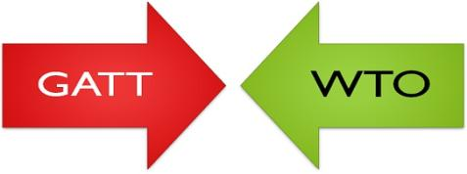

|  |  |  |
| --- | --- | --- |
| **S.No.** | **GENERAL AGREEMENT ON TARIFFS AND TRADE (GATT)** | **WORLD TRADE ORGANIZATION (WTO)** |
| 1. | GATT is a set of rules and multilateral agreement. | WTO is a permanent institution. |
| 2. | GATT is designed with an attempt to establish International Trade Organization. | WTO is established to serve its own purpose. |
| 3. | It was applied on a provisional basis. | Its activities are full and permanent. |
| 4. | Its rules are applicable to trade and merchandise goods. | Its rules are applicable to trade in merchandise services and trade in related aspects of intellect. |
| 5. | GATT was originally a multilateral instrument, but plurilateral agreements were added at a later stage. | Its agreement is almost multilateral. |
| 6. | Its dispute settlement system was not faster and automatic. | Its dispute settlement was faster and automatic. |
| 7. | It had contracting parties. | It has members. |
| 8. | It has no provisions for creating an organization. | It has a legal basis because member nations have verified the WTO agreements. |
| 9. | GATT is ad-hoc and provisional. | WTO commitments are full and permanent.. |

**3. International Monetary Fund**

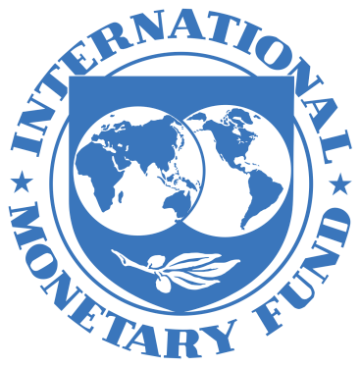

**Introduction**

* IMF is the intergovernmental organization that oversees the global financial system by following the macroeconomic policies of its member countries, in particular those with an impact on exchange rate and the balance of payments.
* It is an organization formed with a stated objective of stabilizing international exchange rates and facilitating development through the enforcement of liberalizing economic policies on other countries as a condition for loans, restructuring or aid. International Monetary Fund
* The IMF was created to support orderly international currency exchanges and to help nations having balance of payment problems through short term loans of cash.
* Its headquarters are in Washington, United States.

**Origin of IMF:**

* The origin of the IMF goes back to the days of international chaos of the 1930s. During the Second World War, plans for the construction of an international institution for the establishment of monetary order were taken up.
* At the Bretton Woods Conference held in July 1944, delegates from 44 non-communist countries negotiated an agreement on the structure and operation of the international monetary system.
* The Articles of Agreement of the IMF provided the basis of the international monetary system. The IMF com­menced financial operations on 1 March 1947, though it came into official existence on 27 December 1945, when 29 countries signed its Articles of Agreement (its charter).
* On May 2012, the IMF has near-global membership of 188 member countries. Virtually, the entire world belongs to the IMF. India is one of the founder- members of the Fund

**Objectives:**

Article 1 of the Articles of Agreement (AGA) spell out 6 purposes for which the IMF was set up.

**These are:**

I. To promote international monetary coope­ration through a permanent institution which provides the machinery for consolation and collaboration on international monetary problems.

II. To facilitate the expansion and balanced growth of international trade, and to contribute thereby to the promotion and maintenance of high levels of employment and real income and to the development of the productive resources of all members as primary objective of economic policy.

III. To promote exchange stability, to maintain orderly exchange arrangements among members, and to avoid competitive exchange depreciation.

IV. To assist in the establishment of a multila­teral system of payments in respect of current transactions between members and in the elimination of foreign exchange restrictions which hamper the growth of world trade.

V. To give confidence to members by making the general resources of the Fund tempo­rarily available to them under adequate safeguards, thus providing them with the opportunity to correct maladjustments in their balance of payments, without resor­ting to measures destructive of national or international prosperity.

VI. In accordance with the above, to shorten the duration and lessen the degree of dis­equilibrium in the international balance of payments of members.

**All these objectives of the IMF may be summarized:**

* To promote international coope­ration; to facilitate the expansion and balanced growth of international trade; to promote exchange stability; to assist in the establishment of a multi­lateralsystem of payments; to make its general resources available to its members experiencing balance of payments difficulties under adequate safeguards; and to shorten the duration and lessen the degree of disequilibrium in the international balance of payments of members.

**Purposes of the IMF**

* Promote international monetary cooperation.
* Expansion and balanced growth of international trade.
* Promote exchange rate stability.
* The elimination of restrictions on the international flow of capital.
* Make resources of the Fund available to members
* Help establish multilateral system of payments and eliminate foreign exchange restrictions.
* Shorten the duration and lessen the degree of disequilibrium in international balances of payment. o Foster economic growth and high levels of employment.
* Temporary financial assistance to countries to help the balance of payments adjustments.

**FUNCTIONS OF IMF**

The principal function of the IMF is to super­vise the international monetary system. Several functions are derived from this. These are: granting of credit to member countries in the midst of temporary balance of payments deficits, survei­llance over the monetary and exchange rate policy of member countries, issuing policy recommen­dations. It is to be noted that all these functions of the IMF may be combined into three.

**These are: regulatory, financial, and consultative fun­ctions:**

**Regulatory Function:**

The Fund functions as the guardian of a code of rules set by its (AOA— Articles of Agreement).

**Financial Function:**

It functions as an agency of providing resources to meet short term and medium term BOP disequilibrium faced by the member countries.

**Consultative Function:**

It functions as a centre for international cooperation and a source of counsel and technical assistance to its members.

The main function of the IMF is to provide temporary financial support to its members so that ‘fundamental’ BOP disequilibrium can be corrected. However, such granting of credit is subject to strict conditionality. The conditionality is a direct consequence of the IMF’s surveillance function over the exchange rate policies or adjustment process of members.

The main conditionality clause is the intro­duction of structural reforms. Low income countries drew attraction of the IMF in the early years of 1980s when many of them faced terrible BOP difficulties and severe debt repayment prob­lems. Against this backdrop, the Fund took up ‘stabilization programme’ as well as ‘structural adjustment programme’. Stabilization programme is a demand management issue, while structural programme concentrates on supply management. The IMF insists member countries to implement these programmes to tackle macroeconomic instability.

**Its main elements are:**

(i) Application of the principles of market economy;

(ii) Opening up of the economy by removing all barriers of trade; and

(iii) Prevention of deflation.

The Fund provides financial assistance. It includes credits and loans to member countries with balance of payments problems to support policies of adjustment and reform. It makes its financial resources available to member countries through a variety of financial facilities.

It also provides concessional assistance under its poverty reduction and growth facility and debt relief initiatives. It provides fund to combat money- laundering and terrorism in view of the attack on the World Trade Centre of the USA on 11 September 2001.

In addition, technical assistance is also given by the Fund. Technical assistance consists of expertise and support provided by the IMF to its members in several broad areas : the design and implementation of fiscal and monetary policy; institution-building, the handling and accounting of transactions with the IMF; the collection and retirement of statistical data and training of officials.

Maintenance of stable exchange rate is another important function of the IMF. It prohibits multiple exchange rates.

It is to be remembered that unlike the World Bank, the IMF is not a development agency. Instead of providing development aid, it provides financial support to tide over BOP difficulties to its members.

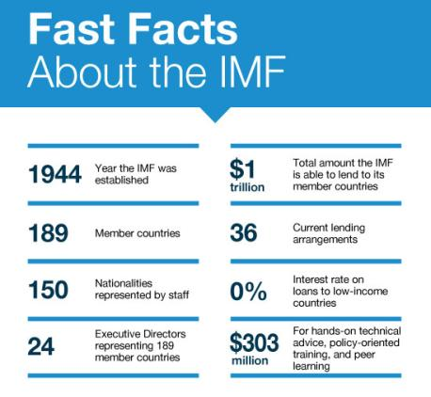

**Organisation and Management of the IMF:**

Like many international organisations, the IMF is run by a Board of Governors, an Exe­cutive Board and an international staff. Every member country delegates a representative (usually heads of central banks or ministers of finance) to the Board of Governors—the top link of the chain of command. It meets once a year and takes decision on fundamental matters such as electing new members or changing quotas.

The Executive Board is entrusted to the management of day-to-day policy decisions. The Board comprises 24 executive directors who supervise the implementation of policies set by the member governments through the Board of Governors.

The IMF is headed by the Managing Director who is elected by the Executive Board for a 5 year term of office.

Rights and obligations, i.e., the balance of Powers in the Fund is determined by a system of quotas. Quotas are decided by a vote of the Board of Governors. Quotas or subscriptions roughly reflect the importance of members in the world economy. It is the quota on which payment obligation, credit facilities, and voting rights of members are determined.

**Financial Structure of the IMF:**

**The capital or the resources of the Fund come from two sources:**

(i) Subscription or quota of the member nations, and

(ii) Borrowings.

Each member country is required to subscribe an amount equivalent to its quota. It is the quota on which payment obligations, credit facilities, and voting right of members are determined. As soon as a country joins the Fund, it is assigned a quota which is expressed in Special Drawing Rights (SDRs). At the time of formation of the IMF, the quota of each member was made up of 25 p.c. in gold or 10 p.c. of its net official holdings of gold and US dollars (whichever was less). Now this has been revised.

The capital subscriptions or quota is now made up of 25 p.c. of its quota in SDRs or widely accepted currencies (such as the US dollar, euro, the yen or the pound sterling) instead of gold and 75 p.c. in country’s own currency. The size of the Fund equals the sum of the subscriptions of members. Total quotas at the end-August 2008 were SDR 217.4 billion (about $341 billion).

The Fund is authorised to borrow in special circumstances if its own resources prove to be insufficient. It sells gold to member countries to replenish currency holdings. It is entitled to borrow even from international capital market. Though the Articles of Agreement permit the Fund to borrow from the private capital market, till today no such use has been made by the IMF

**4. World Bank/ IBRD: INTERNATIONAL BANK FOR RECONSTRUCTION AND MANAGEMENT**

### Image result for history of world bank

### History

The International Bank for Reconstruction and Development (IBRD), commonly referred to as the World Bank, is an international financial institution whose purposes include assisting the development of its member nation’s territories, promoting and supplementing private foreign investment and promoting long-range balance growth in international trade.

### The World Bank was established in December 1945 at the United Nations Monetary and Financial Conference in Bretton Woods, New Hampshire. It opened for business in June 1946 and helped in the reconstruction of nations devastated by World War II. Since 1960s the World Bank has shifted its focus from the advanced industrialized nations to developing third-world countries

The [1944 Bretton Woods Conference](https://www.thebalance.com/bretton-woods-system-and-1944-agreement-3306133) established the World Bank. Its loans helped [European](https://www.thebalance.com/what-is-the-european-union-how-it-works-and-history-3306356) countries rebuild after [World War II](https://www.thebalance.com/world-war-ii-economic-impact-4570917). That made it the world's first multilateral development bank.

It was funded through the sale of [World Bonds](https://www.thebalance.com/what-are-bonds-and-how-do-they-work-3306235). Its [first loans](https://www.thebalance.com/what-are-savings-and-loans-history-and-today-3305959) were to France and other European countries. In the 1970s, it lent money to Chile, [Mexico](https://www.thebalance.com/mexico-s-economy-facts-opportunites-challenges-3306351), and [India](https://www.thebalance.com/india-s-economy-3306348) to build power plants and railways. By 1975, its loans had helped with a wide variety of issues. They included family planning, pollution control, and environmental protections.

World Bank lending became controversial. Many countries used their loans to prevent [a sovereign debt](https://www.thebalance.com/sovereign-debt-definition-importance-and-rankings-3306353) default. Their debt was often a result of overspending and extensive borrowing. Even with the World Bank’s help, many [countries](https://www.thebalance.com/what-happens-when-a-country-defaults-1978981) devalued their currencies. That caused [hyperinflation](https://www.thebalance.com/what-is-hyperinflation-definition-causes-and-examples-3306097).

To combat this, the Bank required [austerity measures](https://www.thebalance.com/cost-of-living-define-calculate-compare-rank-3305737). The country had to agree to cut back on spending and support its currency. Unfortunately, this usually caused a recession, making it difficult to repay the Bank's loans.

**Organization and Structure:**

The organization of the bank consists of the Board of Governors, the Board of Executive Directors and the Advisory Committee, the Loan Committee and the president and other staff members. All the powers of the bank are vested in the Board of Governors which is the supreme policy making body of the bank.

The board consists of one Governor and one Alternative Governor appointed for five years by each member country. Each Governor has the voting power which is related to the financial contribution of the Government which he represents.

The Board of Executive Directors consists of 21 members, 6 of them are appointed by the six largest shareholders, namely the USA, the UK, West Germany, France, Japan and India. The rest of the 15 members are elected by the remaining countries.

Each Executive Director holds voting power in proportion to the shares held by his Government. The board of Executive Directors meets regularly once a month to carry on the routine working of the bank.

The president of the bank is pointed by the Board of Executive Directors. He is the Chief Executive of the Bank and he is responsible for the conduct of the day-to-day business of the bank. The Advisory committees appointed by the Board of Directors.

It consists of 7 members who are expects in different branches of banking. There is also another body known as the Loan Committee. This committee is consulted by the bank before any loan is extended to a member country.

**Objectives:**

1. To provide long-run capital to member countries for economic reconstruction and development.

2. To induce long-run capital investment for assuring Balance of Payments (BoP) equilibrium and balanced development of international trade.

3. To provide guarantee for loans granted to small and large units and other projects of member countries.

4. To ensure the implementation of development projects so as to bring about a smooth transference from a war-time to peace economy.

5. To promote capital investment in member countries by the following ways;

(a) To provide guarantee on private loans or capital investment.

(b) If private capital is not available even after providing guarantee, then IBRD provides loans for productive activities on considerate conditions.

**Functions:**

World Bank is playing main role of providing loans for development works to member countries, especially to underdeveloped countries. The World Bank provides long-term loans for various development projects of 5 to 20 years duration.

**The main functions can be explained with the help of the following points:**

1. World Bank provides various technical services to the member countries. For this purpose, the Bank has established “The Economic Development Institute” and a Staff College in Washington.

2. Bank can grant loans to a member country up to 20% of its share in the paid-up capital.

3. The quantities of loans, interest rate and terms and conditions are determined by the Bank itself.

4. Generally, Bank grants loans for a particular project duly submitted to the Bank by the member country.

5. The debtor nation has to repay either in reserve currencies or in the currency in which the loan was sanctioned.

6. Bank also provides loan to private investors belonging to member countries on its own guarantee, but for this loan private investors have to seek prior permission from those counties where this amount will be collected.

**5**. **United Nations Conference on Trade and Development** (**UNCTAD**)

* The **United Nations Conference on Trade and Development** (**UNCTAD**) was established in 1964 as a permanent intergovernmental body.
* UNCTAD is the part of the [United Nations Secretariat](https://en.wikipedia.org/wiki/United_Nations_Secretariat) dealing with trade, investment, and development issues.
* The organization's goals are to: "maximize the [trade](https://en.wikipedia.org/wiki/International_trade), [investment](https://en.wikipedia.org/wiki/Foreign_direct_investment) and development opportunities of [developing countries](https://en.wikipedia.org/wiki/Developing_countries) and assist them in their efforts to integrate into the world economy on an equitable basis".
* The primary objective of UNCTAD is to formulate policies relating to all aspects of development including trade, aid, transport, finance and technology
* The United Nations Conference on Trade and Development was established to provide a forum where the developing countries could discuss the problems relating to their economic development.
* The organisation grew from the view that existing institutions like [GATT](https://en.wikipedia.org/wiki/GATT) (now replaced by the [World Trade Organization](https://en.wikipedia.org/wiki/World_Trade_Organization), WTO), the [International Monetary Fund](https://en.wikipedia.org/wiki/International_Monetary_Fund) (IMF), and [World Bank](https://en.wikipedia.org/wiki/World_Bank) were not properly organized to handle the particular problems of developing countries. Later, in the 1970s and 1980s, UNCTAD was closely associated with the idea of a [New International Economic Order](https://en.wikipedia.org/wiki/New_International_Economic_Order) (NIEO).
* UNCTAD, which is governed by its 194 member States, is the United Nations body responsible for dealing with development issues, particularly international trade – the main driver of development. Its work can be summed up in three words: think, debate, and deliver.

**Organisation of the UNCTAD:**

* The UNCTAD was established as a permanent organ of General Assembly of the United Nations. However, it has its own subsidiary bodies and also a full-time secretariat to service it. It has a permanent organ called Trade and Development Board as the main executive body.
* The Board functions between the plenary sessions of the Conference. It meets twice annually. It is composed of 55 members, elected by the Conference from among its members on the basis of equitable geographical distribution.
* The Trade and Development Board have four subsidiary organs to assist it in its functions. These are:
* (1) The Committee on Commodities
* (2) The Committee on Manufactures
* (3) The Committee on Shipping
* (4) The Committee on Invisible Items and Financing related to Trade
* Generally, these committees meet annually. However, they may be called in special session to consider urgent matters.

**Objectives:-**

(a) To reduce and eventually eliminate the trade gap between the developed and developing Countries, and

(b) To accelerate the rate of economic growth of the developing world.

**Functions:**

(i) To promote international trade between developed and developing countries with a view to accelerate economic development.

(ii) To formulate principles and policies on international trade and related problems of economic development.

(iii) To make proposals for putting its principles and policies into effect, negotiate trade agreements.

(iv) To review and facilitate the coordination of activities of the other U.N. institutions in the field of international trade.

(v) To function as a center for a harmonious trade and related documents in development policies of governments.

**MAIN AREAS OF WORK OF UNCTAD**

• Globalization and Development

• International Trade and Commodities

• Investment and Enterprise

• Technology and Logistics

**Major activities of UNCTAD**

 (a) research and support of negotiations for commodity agreements;

(b) technical elaboration of new trade schemes; and

(c) various promotional activities designed to help developing countries in the areas of trade and capital flows.

**UNCTAD and GATT:**

**The UNCTAD may be distinguished from the GATT as follows:**

1. The UNCTAD is a formal, reflecting, deliberating, constructing and conciliating body while the GATT is a negotiating, committing, and controlling organisation.

2. The UNCTAD in essence is a dynamic, initiating body dedicated to economic growth and equity while the GATT poses a somewhat static view of commercial policy relations.

**6.Generalised Special Preferences (GSP)/GSTP**

The UNCTAD pressurized developed countries to give special preferences in tariff duties to developing countries so that they may be able to complete better and export more to developed countries. When the tariff concession had been given to selected countries it is called Generalized Special Preferences(GSP).When such tariff concessions are provided to all countries if importer is so close it is called Globalised Special tariff Preference(GSTP).

**Difference between GSP and GSTP** –

GSP gives tariff preferences to selected underdeveloped countries, the GSTP is for tariff concession to all the countries and therefore is called Globalised Special Preferences.

**Characteristics of GSP/GSTP**

* The countries giving the preferences first lok to the benefits of producers of that country.
* Import of agricultural products is allowed mainly from least developed countries but that list differs from country to country.
* Generally there is quota limit of imports to protect local interests.
* No exporting country gets benefits on more than 50% of total quota even when other countries fail to fulfill the rest of the quota.

**Which are the product groups covered under GSP?**

The products covered under GSP are mainly agricultural products including animal husbandry, meat and fisheries and handicraft products. These products are generally the specialized products of the developing countries.

**Who are the beneficiaries under GSP?**

The beneficiaries of GSP are around 120 developing countries. As of 2017, India and Brazil were the major beneficiaries in terms of export volume realized under GSP. Imports from China and some developing countries are ineligible for GSP benefits. The beneficiaries and products covered under the scheme are revised annually.

**Following are several principles and features of the Agreement:**

* The GSTP is reserved for the exclusive participation of members of the Group of 77 and China and the benefits accrue to those members that are also ´´participants" in the Agreement.
* The GSTP must be based and applied on the principle of mutuality of advantages in such a way as to benefit equitably all participants, taking into account their respective levels of economic development and trade needs. The Agreement recognizes the special needs of the LDCs and envisages concrete preferential measures in their favour.
* To provide a stable basis for GSTP preferential trade, tariff preferences are bound and form part of the Agreement.
* The GSTP must be negotiated step-by-step and improved and extended in successive stages, with periodic reviews.
* The GSTP must supplement and reinforce present and future sub-regional, regional and interregional economic groupings of developing countries and must take into account their concerns and commitments.

**Advantages of GSP**

* **It has increased competitive power of developing countries for the product included in the list with domestically produced goods.**
* **When a product has been import both under GSP , country exporting under GSP has benefited because of duty exemption the goods have lower landed .**

**Disadvantages or limitations of GSP**

In spite of the above advantages, GSP suffers from certain limitations:

1. The scope of GSP scheme is limited. Only dutiable products are covered under this scheme. So, the developing countries cannot take advantage of the GSP in respect of duty free products. Export of duty free products by developing countries suffers.

2. GSP gives only marginal relief to the export of agricultural products. In many countries, agricultural products are outside the purview of GSP.

3. Even manufactured products like textiles, leather products and petroleum products are not covered under the scheme.

4. Some of the GSP schemes limit the volume of exports. Ceilings that limit the quantity of imports adversely affect the export prospects of less developed countries

# International Commodity Agreements

International commodity agreements (ICA’s) are essentially multilateral instrumentalities of governmental control that support the international price of individual primary commodities, especially through such arrangements as export quotas or assured access to markets.

**7. AGREEMENT ON TEXTILES & CLOTHING (ATC)-1995-2004**

* The Agreement on Textiles and Clothing (**ATC**) was negotiated in the **Uruguay Round** of Trade Negotiations. It replaced the Arrangement Regarding International Trade in Textiles (MFA, or **Multi-Fibre Arrangement**) of 20 December 1973.
* An expired international **agreement** that set quotas on the **textiles and clothing**developing countries could export to developed countries. … It is formally called the**Agreement on Textile and Clothing**.

### What was the Multifiber Arrangement – MFA

The Multifiber Arrangement (MFA) was an international trade agreement on textiles and clothing in place from 1974 till 2004. It imposed [quotas](https://www.investopedia.com/terms/q/quota.asp) on the amount of clothing and textile exports from developing countries to developed countries.

Under the Multifiber Arrangement (MFA), the United States and the [European Union](https://www.investopedia.com/terms/e/europeanunion.asp) (EU) restricted imports from developing countries in an effort to protect their domestic textile industries. Under the agreement, each developing country signatory was assigned quotas (numerically limited quantities) of specified items which could be exported to the U.S. and EU. (Note that at the start of the agreement the EU did not exist in its current form; the agreement included what was then the[European Community](https://www.investopedia.com/terms/e/european-community.asp) (EC) and the [European Free Trade Association](https://www.investopedia.com/terms/e/european-free-trade-association-efta.asp)(EFTA).)

### History of the Multifiber Arrangement

* The agreement was first established under the auspices of the then-existing [General Agreement on Tariffs and Trade](https://www.investopedia.com/terms/g/gatt.asp) (GATT). The origins acknowledged both
  + the threat to developed markets from cheap clothing and textile imports in terms of market disruption and the impact on their own producers, and
  + the importance of these exports to developing countries in terms of their own economic development and as a means to diversify export earnings. At that stage, developing countries were often still heavily reliant on primary commodity exports. The agreement attempted to mitigate this potential conflict to ensure continued cooperation in international trade.
* In this context, the quotas were described as an orderly means in which to manage the global clothing and textiles trade in the shorter term to prevent market disruptions. The ultimate aim remained one of reduction of barriers and [liberalization of trade](https://www.investopedia.com/terms/t/trade-liberalization.asp), with developing countries expected to take an increasing role over time in this trade.
* The number of signatories to the agreement changed slightly over time but was generally in excess of 40, with the EC counting as one signatory. Trade between these countries dominated the global clothing and textile trade, accounting for as much as 80%.
* GATT has since been supplanted by the [World Trade Organization](https://www.investopedia.com/terms/w/wto.asp) (WTO), and at the Uruguay Round of GATT the decision was taken to transfer oversight of the global textile trade to the WTO.
* Also as a result of that round of negotiations, dismantling of quotas on the global clothing and textile trade began. The process was completed on 1 January 2005, effectively marking the end of the MFA.
* The agreement had helped protect industries of the developed economies as it was designed to, but also helped spur textile production in certain countries where the quotas actually gave them access they had not previously had.

**The ATC is a transitional instrument, built on the following key elements:**

* The product coverage basically encompassing yarns, fabrics, made-up textile product and clothing,
* A programme for the progressive integration of these textile and clothing products into GATT 1994 rules;
* A liberalization process to progressively enlarge existing quotas (until they are removed) by increasing annual growth rates at each stage;
* A special safeguard mechanism to deal with new cases of serious damage or threat thereof to domestic producers during the transition period;
* Establishment of a Textiles Monitoring Body (TMB) to supervise the implementation of the Agreement and ensure that the rules are faithfully followed ; and
* Other provision, including rules on circumvention of the quotas, their administration, treatment of non-MFA restrictions and commitments undertaken elsewhere under the WTO’s agreements and procedures affecting the sectors.

**Purpose of the ATC**

* According to its terms, the purpose of the ATC is to integrate the textile and clothing sector into the normal rules and disciplines of the GATT.

***Article 1:1 of ATC***

This Agreement sets out provisions to be applied by [WTO] Members during a transition period for the integration of the textiles and clothing sector into GATT 1994.

* The ATC however does not provide any explicit definition of the term “integration”. The ordinary meaning of the term “integration” is the act of unifying or ending the difference in treatment. Therefore, as used in the ATC, it implies the elimination of those practices from the sector which did not conform to the normal rules of the GATT.
* In order to determine the practices which did not conform to the rules of the GATT, and which therefore constitute the context of the ATC, reference to Paragraph 2 of the Preamble to the ATC recalling the April 1989 Decision of the Trade Negotiations Committee can be helpful. That Decision specified that integration of the sector will cover the phase out of restrictions under the Multi-fibre Arrangement and other restrictions on textiles and clothing not consistent with GATT rules and disciplines.
* Thus the context of the ATC demonstrates that the object and purpose of “integration” is the phase-out of restrictions on textile and clothing products that were maintained under the Multi-fibre Arrangement and any other restrictions that were not consistent with GATT rules and disciplines.
* Although the April 1989 Decision of the Trade Negotiations Committee also referred to “other restrictions not consistent with GATT rules and disciplines”in addition to restrictions under the multi-fibre agreement, such other restrictions were actually rather rare. Therefore the main purpose of the ATC is the phasing out of restrictions applied under the MFA. These restrictions were applied by major developed countries, almost exclusively, on imports from developing countries and economies.

**TEXTILES MONITORING BODY**

**The ATC establishes a two-step procedure for the resolution of disputes arising from violations of its provisions. Any unresolved issue has first to be reviewed by the Textiles Monitoring Body (“TMB”) before it can be referred to the Dispute Settlement Body for the establishment of a panel.**

**The TMB has been established to supervise the implementation of the ATC and to examine all measures taken under it, to ensure that they are in conformity with the rules.it is a quasi-judicial standing body which consists of a Chairman and 10 TMB members , discharging their functions, taking all decisions by consensus.**

**The 10 members are appointed by WTO member governments, according to n agreed groupings of WTO member into constituencies.**

**TMB Functions**

The TMB thus performs a dual function:

(1) a review and supervisory function; and

(2) a dispute resolution function.

In its review and supervisory role, the TMB undertakes regular, ongoing oversight of the operation and implementation of the Agreement. It may make observations and recommendations as deemed appropriate. In its dispute resolution role, the TMB’s remit is not to conciliate between the parties. Rather, in a certain sense, it acts as a tribunal of first instance and examines the conformity of the disputed measure with the provisions of the ATC.

**Structure & Functioning of EU and NAFTA**

# History

The European Commission, based in Brussels, is an extremely important and powerful body that has the right to impose its decisions on member states of the European Union (EU). It has the power to draw up treaties, laws and policies.

The idea of the European Commission was initiated in 1950, when the French Foreign Affairs Minister, R. Shuman, proposed the creation of an executive body for the European Steal and Coal Community (ECSC). This body would be known as the High Authority. The foundation for the [Treaty of Paris](http://europa.eu/legislation_summaries/institutional_affairs/treaties/treaties_ecsc_en.htm) to establish the ECSC was signed in 1951. The ECSC included France, Germany, Italy, the Netherlands, Belgium and Luxembourg.

In 1958, these six countries signed the Treaty of Rome to establish two more communities: the [European Economic Community](http://europa.eu/legislation_summaries/institutional_affairs/treaties/treaties_eec_en.htm) and [European Atomic Energy Community](http://europa.eu/legislation_summaries/institutional_affairs/treaties/treaties_euratom_en.htm), to work alongside the ECSC.

In 1967, the three communities merged to become collectively known as the European Communities (EC) whose main focus was on cooperation in economic and agricultural affairs. Denmark, Ireland and the UK became full EC members in 1973, Greece joined in 1981, Portugal and Spain in 1986, Austria, Finland and Sweden in 1995.

The [Treaty on European Union](http://eur-lex.europa.eu/legal-content/EN/TXT/?uri=CELEX:11992M/TXT) (1992), signed at Maastricht in 1991, formally established the European Union as the successor to the EC.

Further amendments to the treaty:

* [Treaty of Amsterdam](http://eur-lex.europa.eu/legal-content/EN/TXT/?uri=CELEX:11997D/TXT) (1997)
* [Treaty of Nice](http://eur-lex.europa.eu/legal-content/EN/TXT/?uri=CELEX:12001C/TXT) (2001)
* [Treaty of Lisbon](http://eur-lex.europa.eu/legal-content/EN/TXT/?uri=CELEX:12007L/TXT) (2007)
* [Accession Treaties](http://eur-lex.europa.eu/collection/eu-law/treaties-accession.html), for example:
  + [Treaty of Accession of Austria, Finland and Sweden](http://eur-lex.europa.eu/collection/eu-law/treaties-accession.html#new-2-21) (1994)
  + [Treaty of Accession of Cyprus, Estonia, Hungary, Latvia, Lithuania, Malta, Poland, the Czech Republic, Slovakia and Slovenia](http://eur-lex.europa.eu/collection/eu-law/treaties-accession.html#new-2-30) (2003)
  + [Treaty of Accession of Bulgaria and Romania](http://eur-lex.europa.eu/collection/eu-law/treaties-accession.html#new-2-36) (2005)
  + [Treaty of Accession of Croatia](http://eur-lex.europa.eu/collection/eu-law/treaties-accession.html#new-2-46) (2012)

**European Commission (EC)**, an institution of the [European Union](https://www.britannica.com/topic/European-Union) (EU) and its [constituent](https://www.merriam-webster.com/dictionary/constituent) entities that makes up the organization’s [executive](https://www.britannica.com/topic/executive-government) arm.

The [EC](https://www.britannica.com/topic/European-Community-European-economic-association) also has legislative functions, such as proposing new laws for the [European Parliament](https://www.britannica.com/topic/European-Parliament), and judicial functions, such as finding legal solutions to business and trade issues between countries within the EU. The body’s primary tasks, however, include:

1. Administration and implementation of EU and [community](https://www.merriam-webster.com/dictionary/community) policies and legislation, including formulation and spending of the budget
2. Initiation and drafting of community legislation
3. Enforcement of EU and community law
4. Representation of the EU and the [communities](https://www.merriam-webster.com/dictionary/communities) at the international level, including negotiation of international treaties

The EC is composed of members called commissioners, who are citizens of and are nominated by the respective governments of each member state. However, the EC is charged with representing the EU or community interest, not the interests of the member states, and the commissioners are called to act independently in that interest. They are expressly forbidden to take instructions from their member state. Because of its responsibility to represent the European interest and enforce the treaties and legislation that provide the legal foundation for the EU and communities, the EC is known as the guardian of the treaties.

The European Union is based on the rule of law and democracy. It is neither a new State replacing existing ones nor is it comparable to other international organizations. Its Member States delegate sovereignty to common institutions representing the interests of the Union as a whole on questions of joint interest. All decisions and procedures are derived from the basic treaties ratified by the Member States.

The European Union (EU) is a political and economic community of twenty-seven member states, located primarily in Europe. It was established in 1993 by the Treaty of M aastricht, adding new areas of policy to the existing European Community. With almost 500 million citizens, the EU combined generates an estimated 30% share of the world's nominal gross domestic product (US $16.6 trillion) in 2007.

**Founding Members-**

1. France

2. West Germany

3. Italy

4. B elgium

5. Netherlands

6. Luxembourg

## Goals -

## To continue to improve Europe’s economy by regulating trade and commerce.

## To form a single market for Europe's economic resources. As these goals were accomplished, other goals were developed:

## Environmental movements

## Regulatory acts

## Human rights concerns

# Structure of the European Union

**Principles of EU**

* Establish European Citizenship
* Ensure freedom, security, and justice
* Promote economic and social progress
* Assert Europe’s role in the world

**Structure of EU**

The EU is made up of multiple bodies and institutions. The most important are listed below, along with a summary of their functions

* [European Commission](http://ec.europa.eu/index_en.htm)

The European Commission acts as the executive of the European Union, and it is the only body that may propose new legislation. The Commission is made up of 28 commissioners, one from each member state. Each one is appointed in consultation with the member states and Parliament, although the Commission’s purpose is to represent the European perspective as a whole, rather than the perspectives of individual member states. A new Commission is appointed every five years. The Commission is divided into departments, each of which is responsible for proposing new legislation and policies in a given area. The Commission also plays a major role in implementing and enforcing EU directives and regulations and it represents the EU in international negotiations.

* [Council of the European Union](http://www.consilium.europa.eu/homepage.aspx?lang=en)

The Council of the European Union, also known as the Council of Ministers, is the main legislative body of the EU, along with the Parliament. It is made up of 28 “ministers,” one from each member state, who are assigned specific issue areas. Its chief responsibilities include passing laws (often, but not always, in conjunction with Parliament), coordinating economic, foreign, and criminal justice policy, and making treaties. Member states with larger populations receive more votes, but most decisions require assent by qualified majority voting, which requires not only assent by a majority of member states but also a minimum of 260 (out of a total 352) votes, though some require unanimity.

* [European Parliament](http://www.europarl.europa.eu/portal/en)

The European Parliament originally had a mostly advisory role in the EU; however, with the Treaty of Maastricht in 1993, it became an important legislating partner to the Council. The Parliament is currently made up of 785 members, elected directly by the population of the member states once every five years. Its major functions are to pass laws in conjunction with the Council and adopt or reject the EU budget. Parliament does not initiate legislation, but it may ask the European Commission to do so. Parliament is also responsible for holding the Commission politically accountable, and members of Parliament may question Commissioners regarding various policies. Parliament also has the power to dismiss the Commission by adopting a motion of censure.

* [European Court of Justice](http://curia.europa.eu/jcms/jcms/Jo2_6999/)

The European Court of Justice is the major judicial body of the EU. It is made up of 28 judges, each one appointed by a member state in consultation with the other member states for six-year terms. For convenience, cases are typically decided by smaller chambers of judges, and the Court is assisted by advocates-general who present the issues of law in the case. The ECJ decides cases arising from EU law including, but not limited to, disputes about interpretation and application of treaties and/or failure to implement EU legislation. It may decide cases arising between member states, EU institutions, businesses, and individuals, and its decisions are binding.

* [European General Court (formerly Court of First Instance)](http://curia.europa.eu/jcms/jcms/Jo2_7033/)

The European General Court is the lower court to the ECJ. (Prior to the Lisbon Treaty coming into force on Dec. 1, 2009, the court was called the Court of First Instance.) It was created with limited jurisdiction in 1989, but in 2001, its jurisdiction was expanded to cover most issues that can be decided by the ECJ. However, the Court of First Instance does not decide cases brought by the member states. The Court’s decisions are subject to appeal to the ECJ, and like the ECJ, it is made up of at least 28 judges (at least on per member state), each one selected by a member state.

* [European Central Bank](http://www.ecb.europa.eu/home/html/index.en.html)

The European Central Bank is charged with setting and implementing monetary policy and is responsible for issuing the Euro.

**Framework of Institutions**

European Council 15 Heads of State or government and the President of the Commission

Committee of The Regions 317 members

European Court of Justice 15 minister

Council of the EU 15 ministers

Court of Auditors 25 members

Econ. & Social Committee 317 members

European Parliament 626 members

European Commission 20 Commissioners

European Investment Bank

European Central Bank

**Starting of EU**

1. April 1951 European Coal and Steel Community
2. March 1957 Rome Treaties European Economic Community (EEC)

European Atomic Energy Community (EURATOM)

1. 1973 United Kingdom, Ireland and Demark
2. 1981 Greece
3. 1986 Spain and Portugal
4. 1992 “Deadline” for completing the single market (Dec. 31, 1992)
5. 1992 The Maastricht Treaty was ratified, which rechartered the EC as

the EuropeanUnion

1. 1989 Fall of the Berlin Wall
2. 1993 Treaty of European Union Established 3 pillars of Cooperation:

Economic, Political, Judicial

1. 1995 Austria, Finland and Sweden
2. 1999 EURO launched

**NAFTA**

The [North American Free Trade Agreement's](https://www.thebalance.com/nafta-definition-north-american-free-trade-agreement-3306147) purpose is to reduce trading costs, increase business investment, and help North America be more competitive in the global marketplace. The agreement is between Canada, the United States, and Mexico.That makes NAFTA the world’s largest [free trade agreement](https://www.thebalance.com/free-trade-agreement-types-and-examples-3305897). The [gross domestic product](https://www.thebalance.com/what-is-gdp-definition-of-gross-domestic-product-3306038) of its three members is more than $20 trillion. NAFTA is the first time two developed nations signed a trade agreement with an [emerging market](https://www.thebalance.com/what-are-emerging-markets-3305927) country.

The three signatories agreed to remove trade barriers between them. By eliminating tariffs, NAFTA increases investment opportunities. The NAFTA agreement is 2,000 pages, with eight sections and 22 chapters.

### History

* [President Ronald Reagan](https://www.thebalance.com/president-ronald-reagan-s-economic-policies-3305568) proposed a North American common market in his [1980 presidential campaign](https://www.heritage.org/trade/report/the-north-american-free-trade-agreement-ronald-reagans-vision-realized). Europe's common market, dubbed the European Economic Community, had already been initiated with the [Treaty of Rome](https://www.economist.com/the-economist-explains/2017/03/24/the-significance-of-the-treaty-of-rome).
* In 1984, Congress passed the [Trade and Tariff Act](https://www.congress.gov/bill/98th-congress/house-bill/3398), which itself built upon and amended a prior Trade Act of 1974. The 1984 gave enhanced "[fast-track](https://www.thebalance.com/trade-promotion-authority-3305899)" authority to negotiate bilateral [free trade agreements](https://www.thebalance.com/free-trade-agreement-pros-and-cons-3305845), streamlining negotiations.
* [In 1985, Canadian Prime Minister Mulroney](https://www.cbc.ca/archives/entry/free-trade-agreement-let-the-talks-begin) agreed to begin discussions for the Canada-U.S. Free Trade Agreement. Negotiations began in 1986 and it was signed 1988. It went into effect on January 1, 1989, and remained in force until NAFTA replaced it.
* In 1990, Mexican President Carlos Salinas de Gortari requested a free trade agreement with the U.S. In 1991, Reagan’s successor, President George H.W. Bush, began negotiations with President Salinas for a liberalized trade agreement between the two countries. Before NAFTA, [Mexican tariffs on U.S. imports were much higher](https://fas.org/sgp/crs/row/R42965.pdf)than [U.S. tariffs on Mexican imports](https://www.usitc.gov/publications/332/pub2353.pdf). Canada also joined the discussions.
* In 1992, NAFTA was signed by outgoing President George H.W. Bush, Mexican President Salinas, and Canadian Prime Minister Brian Mulroney. Earlier that year, the [European Union](https://www.thebalance.com/what-is-the-european-union-how-it-works-and-history-3306356) had been created by the [Treaty of Maastricht](https://www.ecb.europa.eu/explainers/tell-me-more/html/25_years_maastricht.en.html).
* Concerns about the liberalization of labor and environmental regulations led to the adoption of two addendums. NAFTA was ratified by the legislatures of the three countries in 1993. The [U.S. House of Representatives](https://www.thebalance.com/u-s-house-of-representatives-3305999) approved it by 234 to 200 on November 17, 1993. The [U.S. Senate approved](https://www.thebalance.com/us-senate-what-it-does-how-it-affects-the-us-economy-3305996) it by 61 to 38 three days later.
* [President Bill Clinton](https://www.thebalance.com/president-bill-clinton-s-economic-policies-3305559) signed it into law on [December 8, 1993](https://www.history.com/this-day-in-history/nafta-signed-into-law). It entered into force on January 1, 1994.

### Purpose

[Article 102 of the NAFTA agreement](https://tcc.export.gov/Trade_Agreements/All_Trade_Agreements/NAFTA_Part1_Chapter1.asp#102) outlines its purpose. There are seven specific goals.

1. Grant the signatories [most-favored-nation](https://www.thebalance.com/most-favored-nation-status-3305840) status.
2. Eliminate barriers to trade and facilitate the cross-border movement of goods and services.
3. Promote conditions of fair competition.
4. Increase investment opportunities.
5. Provide protection and enforcement of intellectual property rights.
6. Create procedures for the [resolution of trade disputes](https://www.nafta-sec-alena.org/Home/Resources/Frequently-Asked-Questions).
7. Establish a framework for further trilateral, regional, and multilateral cooperation to expand the trade agreement's benefits.

### NAFTA Fulfilled Its Purpose

NAFTA fulfilled all seven of its goals, establishing the region [world’s largest free trade](https://eric.ed.gov/?id=EJ1045635)zone in terms of [gross domestic product](https://www.thebalance.com/what-is-gdp-definition-of-gross-domestic-product-3306038). It increased [investment in the three countries.](https://ustr.gov/archive/Document_Library/Press_Releases/2004/July/NAFTA_Free_Trade_Commission_Joint_Statement_-_A_Decade_of_Achievement.html) Until the last of its changes came into effect in 2008, it lowered or eliminated tariffs between the three countries and allowed trade to triple. Most important, it increased the competitiveness of the three countries in the global marketplace.

**Functions of NAFTA**

First, NAFTA **grants the**[**most-favored-nation**](https://www.thebalance.com/most-favored-nation-status-3305840) status to all co-signers. That means countries must give all parties equal treatment. That includes [foreign direct investment](https://www.thebalance.com/foreign-direct-investment-fdi-pros-cons-and-importance-3306283). They cannot give better treatment to domestic investors than foreign ones. They can't offer a better deal to investors from non-NAFTA countries. Governments must also offer **federal contracts** to businesses in all three NAFTA countries.

Second, **NAFTA eliminates**[**tariffs**](https://www.thebalance.com/tariff-pros-cons-and-examples-3305967) on [imports](https://www.thebalance.com/imports-definition-examples-effect-on-economy-3305851) and exports between the three countries. Tariffs are taxes used to make foreign goods more expensive. NAFTA created specific rules to regulate trade in farm products, automobiles and clothing. These also apply to some services, such as telecommunications and finance.

Third, exporters must get [**Certificates of Origin**](https://www.cbp.gov/trade/nafta/guide-customs-procedures/description-nafta) to waive tariffs. That means the export must originate in the United States, Canada or Mexico. A product made in Peru but shipped from Mexico will still pay a duty when it enters the United States or Canada.

Fourth, NAFTA establishes procedures to [**resolve trade disputes**](http://www.naftanow.org/dispute/default_en.asp). Chapter 52 protects businesses from unfair practices. The [NAFTA Secretariat](https://www.nafta-sec-alena.org/Default.aspx?tabid=85&language=en-US) facilitates an informal resolution between the parties. If this doesn't work, it establishes a panel to review the dispute. That helps all parties to avoid costly lawsuits in local courts. It helps the parties interpret NAFTA’s complex rules and procedures. These trade dispute protections apply to investors as well.

Fifth, all NAFTA countries must respect **patents, trademarks, and copyrights**. At the same time, the agreement ensures that these intellectual property rights don’t interfere with trade.

Sixth, the agreement allows [**business travelers easy access**](http://www.naftanow.org/agreement/default_en.asp) throughout all three countries.

**NAFTA Structure**

NAFTA's governance structure is minimal and cantered on two institutions, the Free Trade Commission (TFC) and the Secretariat.

**The Free Trade Commission (FTC)**

* The Free Trade Commission (FTC) is the principal body of NAFTA, and oversees NAFTA’s performance and evolution. It is also responsible for dispute settlement, and is composed of the US Trade Representative, the Canadian Minister for International Trade, and the Mexican Secretary of Commerce and Industrial Development. The day-to-day work of the FTC is carried out by expert working groups and committees.
* The powers of the FTC can be characterized as technical, specific, and obligatory.
* The FTC operates by consensus and has no effective method of amending NAFTA rules. Lacking the ability to delegate power or vote by majority rule as a legislature might, the FTC suffers from a democratic deficit and this could damage its long term legitimacy (Maryse 2006).
* Also in view of this, it is no surprise that NAFTA focuses on precision and obligation and eschews delegation of power (Abbott 2000).
* At the time NAFTA was negotiated, political constraints among North American leaders prohibited greater regional democratization.

**The Secretariat**

* The Secretariat serves as an administrator for the FTC and is organized on a national basis, with each member responsible for supporting its own staff. Operationally, the secretariat assists the FTC, along with the dispute panels, committees, and working groups.
* The Secretariat is located in separate national offices in Mexico City, Ottawa and Washington (Lopes Lima 1997).
* Instead, it takes care of the day-to-day affairs that are prescribed by Article 2002.
* . This high level of legalization constrains the secretariat from acting independently and insures real decisions are made by the FTC or panels rather than at the discretion of secretariat staff. This low level of delegation limits the responsiveness of the secretariat to exogenous groups such as labour or environmental groups and guarantees that free trade and investor interests will be guarded vociferously.
* This trilateral secretariat was created on January 14, 1995. The main purpose of the central secretariat is to help administer labour and environmental issues that fall under NAFTA. In reality, due to limited enforceability and lax regulation, this body has not been very active, and is unequal in power to the investment and free trade lobbies.

**Why Trump Renegotiated NAFTA**

Trump was responding to the critics of NAFTA. U.S. opponents focus on the first two of [NAFTA's six major problems](https://www.thebalance.com/disadvantages-of-nafta-3306273):

1. Loss of U.S. jobs.
2. Suppression of U.S. wages.
3. Mexico's farmers were put out of business.
4. Not enough environmental protections in Mexico.
5. Free U.S. access for Mexican trucks

**REGIONAL ECONOMIC COOPERATION**

• Process whereby countries in a geographic region cooperate with one another to reduce or eliminate barriers to the international flow of products, people, or capital. A regional trading bloc is a group of nations in a geographic region undergoing economic integration.

• The goal is to increase cross-border trade and investment and raise living standards. Specialization and trade create real gains in terms of greater choice, lower prices, and increased productivity. Regional trade agreements help nations accomplish these objectives and protect intellectual property rights, the environment, or even eventual political union.  
**Regional economic cooperation** is an important means for creating new trade, investment and employment opportunities, enhancing **economic** security, and addressing broader socioeconomic and environmental issues. ... Yet significant challenges continue to hinder greater **cooperation** and integration.

**Levels of Regional Integration**

There are five levels. Free trade area is the lowest extent of national integration, political union the greatest. Each level of integration incorporates the properties of those levels that precede it.

**1. Free Trade Area**

a. Countries remove all barriers to trade among members, but each country determines its own barriers against nonmembers.

b. Policies differ greatly against nonmember countries from one country to another. Countries in a free trade area also establish a process to resolve trade disputes between members.

**2. Customs Union**

a. Countries remove all barriers to trade among members but erect a common trade policy against nonmembers.

b. Differs from a free trade area in that members treat all nonmembers similarly. Countries might also negotiate as a single entity with other supranational organizations such as the WTO.

**3. Common Market**

a. Countries remove all barriers to trade and the movement of labor and capital between themselves, but erect a common trade policy against nonmembers.

b. Adds the free movement of important factors of production such as people and cross-border investment. Requires cooperation in economic and labor policy, so is very difficult to attain.

**4. Economic Union**

a. Countries remove barriers to trade and the movement of labor and capital, erect a common trade policy against nonmembers, and coordinate their economic policies.

b. Requires members to harmonize their tax, monetary, and fiscal policies, create a common currency, and concede a certain amount of sovereignty to the supranational organization.

**5. Political Union**

a. Countries coordinate aspects of economic and political systems.

b. Members accept a common stance on economic and political policies regarding nonmember nations. Nations are allowed a degree of freedom in setting certain political and economic policies within their territories.

**Benefits of Regional Integration**

Nations engage in specialization and trade because of the gains in output and consumption. Higher levels of trade between nations should increase specialization, efficiency, and consumption, and raise standards of living.

1. **Trade Creation**

a. Increase in trade that results from regional economic integration.

b. Gives consumers and industrial buyers a wider selection of goods and services not available beforehand.

c. Lets buyers can acquire goods and services more cheaply following the lowering of trade barriers such as tariffs. Lower 4 costs lead to higher demand for goods because people have more money after a purchase to buy other products.

2. Greater Consensus eliminating trade barriers in smaller groups of countries may make it easier to gain consensus as opposed to working in the far larger WTO.

3. Political Cooperation A group of nations can have significantly greater political weight than nations have individually. The group may have more clout in negotiating in a forum like the WTO. Integration involving political cooperation reduces the potential for military conflict among members.

4. Employment Opportunities Regional integration can expand employment by enabling people to move from country to country for work, or to earn a higher wage.

**Drawbacks of Regional Integration**

**1. Trade Diversion**

a. Diversion of trade away from nations not belonging to a trading bloc and toward member nations. Trade diversion can occur after formation of a trading bloc because of the lower tariffs charged between member nations.

b. Can result in reduced trade with a more efficient nonmember nation in favor of trade with a less efficient member nation. Unless there is other internal competition, buyers will pay more due to inefficient production methods.

**2. Shifts in Employment**

a. Because trading blocs reduce or eliminate barriers to trade, the producer of a particular good or service will be decided by relative productivity. Industries requiring unskilled labor shift production to low-wage nations within a trading bloc.

b. Figures on jobs lost or gained vary with the source. But job dislocation allows a nation to upgrade the economy toward higher-wage-paying industries that can increase competitiveness due to a more educated and skilled workforce.

3**. Loss of National Sovereignty**

a. Successive levels of integration require nations to surrender more sovereignty. Political union requires nations to give up a high degree of sovereignty in foreign policy.

b. Because some members have delicate ties with nonmember nations while others have strong ties, the setting of a common foreign policy is difficult.

**Unit V**

**Multinational Corporation**

**Introduction:**



An enterprise operating in several countries but managed from one (home) country. Generally, any company or group that derives a quarter of its revenue from operations outside of its home country is considered a multinational corporation.

**According to ILO report, “the essential nature of the multinational enterprises lies in the fact that its managerial headquarters are located in one country (home country) while the enterprise carries out operations in a number of other countries as well (host countries).”**

**Neil H. Jacoby defines a multinational company as follows:**

**“A multinational corporation owns and manages business in two or more countries.”**

**Features of Multinational Corporations (MNCs):**

### Models of Multinational Corporations

The following are the different models of multinational corporations:

#### 1. Centralized

In the centralized model, companies put up an executive headquarters in its home country and then build various manufacturing plants and production facilities in other countries. Its most important advantage is being able to avoid tariffs and import quotas and take advantage of lower production costs.

#### 2. Regional

The regionalized model states that a company keeps its headquarters in one country that supervises a collection of offices that are located in various countries. Unlike the centralized model, the regionalized model includes subsidiaries and affiliates that all report to the headquarters.

#### 3. Multinational

In the multinational model, a parent company operates in the home country and puts up subsidiaries in different countries. The difference is that the subsidiaries and affiliates are more independent in their operations.

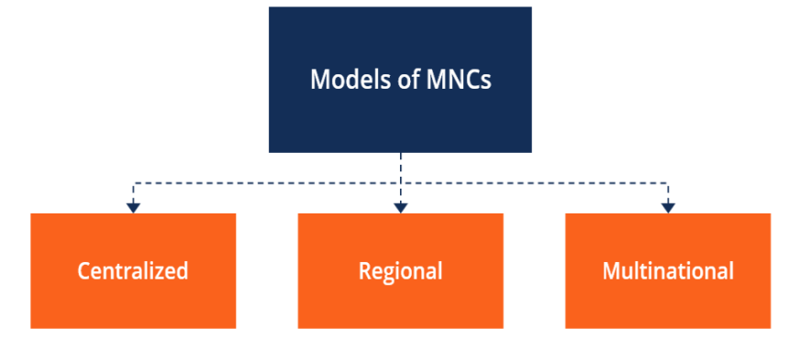

**Role of Multinational Corporations (MNCs) in Foreign Investments**

Multinational corporations are those large firms which are incorporated in one country but which own, control or manage production and distribution facilities in several countries. Therefore, these multinational corporations are also known as transnational corporations.

They transact business in a large number of countries and often operate in diversified business activities. The movements of private foreign capital take place through the medium of these multinational corporations. Thus multinational corporations are important source of foreign direct investment (FDI). Besides, it is through multinational corporations that modern high technology is transferred to the developing countries.

The important question about multinational corporations is why they exist. The multina­tional corporations exist because they are highly efficient. Their efficiencies in production and distribution of goods and services arise from internalizing certain activities rather than contract­ing them out to other forms.

Managing a firm involves which production and distribution activities it will perform itself and which activities it will contract out to other firms and individuals. In addition to this basic issue, a big firm may decide to set up and operate business units in other countries to benefit from advantages of location.

For examples, it has been found that giant American and European firms set up production units to explore and refine oil in Middle East Countries because oil is found there. Similarly, to take advantages of lower labour costs, and not strict environmental standards, multinational corporate firms set up production units in developing countries.

**Alternative Methods of Foreign Investment by Multinational Companies:**

In order to increase their profitability many giant firms find it necessary to go in for horizontal and vertical integration. For this purpose they find it profitable to set up their production or distribution units outside their home country.

The firms that sell abroad the products produced in the home country or the products produced abroad to sell in the home country must decide how to manage and control their assets in other countries. In this regard, there are three methods of foreign investment by multinational firms among which they have to choose which mode of control over their assets they adopt.

**There are three main modes of foreign investment:**

**1. Agreement with Local Firms for Sale of MNCs Products:**

A multinational firm can enter into an agreement with local firms for exporting the product produced by it in the home country to them for sale in their countries. In this case, a multinational firm allows the foreign firms to sell its product in the foreign markets and control all aspects of sale operations.

**2. Setting up of Subsidiaries:**

The second mode for investment abroad by a multinational firm is to set up a wholly owned subsidiary to operate in the foreign country. In this case a multinational firm has complete control over its business operations ranging from the production of its product or service to its sale to the ultimate use or consumers.

A subsidiary of a multinational corporation in a particular country is set up under the company act of that country. Such subsidiary firm benefits from the managerial skills, financial resources, and international reputation of their parent company. However, it enjoys some independence from the parent company.

**3. Branches of Multinational Corporation:**

Instead of establishing its subsidiaries, Multinational Corporation can set up their branches in other countries. Being branches they are not legally independent business unit but are linked with their parent company.

**4. Foreign Collaboration or Joint Ventures:**

Thirdly, the multinational corporations set up joint ventures with foreign firms to either produce its product jointly with local companies of foreign countries for sale of the product in the foreign markets. A multinational firm may set up its business operation in collaboration with foreign local firms to obtain raw materials not available in the home country. More often, to reduce its overall production costs multinational companies set up joint ventures with local foreign firms to manufacture inputs or sub­components in foreign markets to produce the final product in the home country.

Some of world’s largest multinational corporations are given below:

Table 1: World’s Some Important Non-Financial Multinational Corporations

**[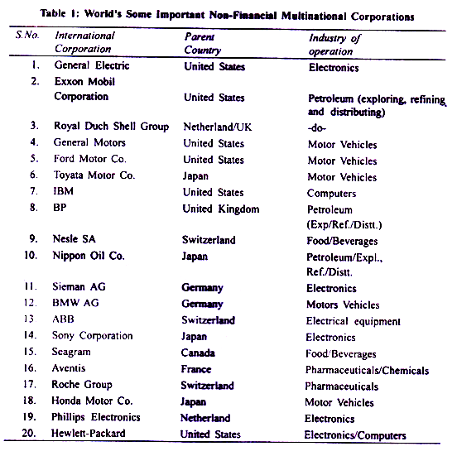](http://cdn.yourarticlelibrary.com/wp-content/uploads/2014/04/image236.png)**

**Role of Multinational Corporations in the Indian Economy:**

Prior to 1991 Multinational companies did not play much role in the Indian economy. In the pre-reform period the Indian economy was dominated by public enterprises. To prevent concentration of economic power industrial policy 1956 did not allow the private firms to grow in size beyond a point. By definition multinational companies were quite big and operate in several countries.

While multinational companies played a significant role in the promotion of growth and trade in South-East Asian countries they did not play much role in the Indian economy where import-substitution development strategy was followed. Since 1991 with the adoption of industrial policy of liberalisation and privatisation rote of private foreign capital has been recognised as important for rapid growth of the Indian economy.

Since source of bulk of foreign capital and investment are Multinational Corporation, they have been allowed to operate in the Indian economy subject to some regulations. The following are the important reasons for this change in policy towards multinational companies in the post-reform period.

**1. Promotion of Foreign Investment:**

In the recent years, external assistance to developing countries has been declining. This is because the donor developed countries have not been willing to part with a larger proportion of their GDP as assistance to developing countries. MNCs can bridge the gap between the requirements of foreign capital for increasing foreign investment in India.

The liberalised foreign investment pursued since 1991, allows MNCs to make investment in India subject to different ceilings fixed for different industries or projects. However, in some industries 100 per cent export-oriented units (EOUs) can be set up. It may be noted, like domestic investment, foreign investment has also a multiplier effect on income and employment in a country.

For example, the effect of Suzuki firm’s investment in Maruti Udyog manufacturing cars is not confined to income and employment for the workers and employees of Maruti Udyog but goes beyond that. Many workers are employed in dealer firms who sell Maruti cars.

Moreover, many intermediate goods are supplied by Indian suppliers to Maruti Udyog and for this many workers are employed by them to manufacture various parts and components used in Maruti cars. Thus their incomes also go up by investment by a Japanese multinational in Maruti Udyog Limited in India.

**2. Non-Debt Creating Capital inflows:**

In pre-reform period in India when foreign direct investment by MNCs was discouraged, we relied heavily on external commercial borrowing (ECB) which was of debt-creating capital inflows. This raised the burden of external debt and debt service payments reached the alarming figure of 35 per cent of our current account receipts.

This created doubts about our ability to fulfill our debt obligations and there was a flight of capital from India and this resulted in balance of payments crisis in 1991. As direct foreign investment by multinational corporations represents non-debt creating capital inflows we can avoid the liability of debt-servicing payments.

Moreover, the advantage of investment by MNCs lies in the fact that servicing of non-debt capital begins only when the MNC firm reaches the stage of making profits to repatriate Thus, MNCs can play an important role in reducing stress strains and on India’s balance of payments (BOP).

**3. Technology Transfer:**

Another important role of multinational corporations is that they transfer high sophisticated technology to developing countries which are essential for raising productivity of working class and enable us to start new productive ventures requiring high technology.

Whenever, multinational firms set up their subsidiary production units or joint- venture units, they not only import new equipment and machinery embodying new technology but also skills and technical know-how to use the new equipment and machinery.

As a result, the Indian workers and engineers come to know of new superior technology and the way to use it. In India, the corporate sector spends only few resources on Research and Development (R&D). It is the giant multinational corporate firms (MNCs) which spend a lot on the development of new technologies can greatly benefit the developing countries by transferring the new technology developed by them. Therefore, MNCs can play an important role in the technological up-gradation of the Indian economy.

**4. Promotion of Exports:**

With extensive links all over the world and producing products efficiently and therefore with lower costs multinationals can play a significant role in promoting exports of a country in which they invest. For example, the rapid expansion in China’s exports in recent years is due to the large investment made by multinationals in various fields of Chinese industry.

Historically in India, multinationals made large investment in planlations whose products they exported. In recent years, Japanese automobile company Suzuki made a large investment in Maruti Udyog with a joint collaboration with Government of India. Maruti cars are not only being sold in the Indian domestic market but are exported in a large number to the foreign countries.

As a matter of fact until recently, when giving permission to a multinational firm for investment in India, Government granted the permission subject to the condition that the concerned multinational company would export the product so as to earn foreign exchange for India.

However, in case of Pepsi, a famous cold -drink multinational company, while for getting a product license in 1961 to produce Pepsi Cola in India it agreed to export a certain proportion of its product, but later it expressed its inability to do so. Instead, it ultimately agreed to export things other than what it produced such as tea.

**5. Investment in Infrastructure:**

With a large command over financial resources and their superior ability to raise resources both globally and inside India it is said that multinational corporations could invest in infrastructure such as power projects, modernisation of airports and posts, telecommunication.

The investment in infrastructure will give a boost to industrial growth and help in creating income and employment in the India economy. The external economies generated by investment in infrastructure by MNCs will therefore crowd in investment by the indigenous private sector and will therefore stimulate economic growth.

In view of above, even Common Minimum Programme of the present UPA government provides that foreign direct investment (FDI) will be encouraged and actively sought, especially in areas of (a) infrastructure, (b) high technology and (c) exports, and (d) where domestic assets and employment are created on a significant scale.

**A Critique of Multinational Corporations:**

In recent years foreign direct investment through multinational corporations has vastly increased in India and other developing countries. This vast increase in investment by multinational corporations in recent years is prompted by factors (1) the liberalisation of industrial policy giving greater role to the private sector, (2) opening up of the economy and liberalisation of foreign trade and capital inflows. In this economic environment multinational corporations which are in search for global profits are induced to make investment in developing countries.

As explained above, foreign direct investment by multinational firms bring many benefits to the recipient countries but there are many potential dangers and disadvantages from the viewpoint of economic growth and employment generation.

Therefore, role of multinational corporations in India and other developing countries have been criticised on several grounds. We discuss below some of the criticisms levelled against multinational corporations.

**Capturing Markets:**

**1.** First, it is alleged that multinational corporations invest their capital and locate their manufacturing units on their own or in collaboration with local firms in order to sell their products and capture the domestic markets of the countries where they invest and operate. With their vast resources and competitive strength, they can weed out their competitive firms.

For example, in India if corporate multinational firms are allowed to sell or produce the products presently produced by small and medium enterprises, the latter would not be able to compete and therefore would be thrown out of business. This will lead to reduction in employment opportunities in the country.

**2. Use of Capital-intensive Techniques:**

It has been seen that increasing capital intensity in modern manufacturing sector is responsible for slow growth of employment opportunities in India’s industrial sector. These capital-intensive techniques may be imported by large domestic firms but presently they are being increasingly used by multinational corporations which bring their technology when they invest in India.

Emphasising this factor, Thirwall rightly writes, “In this case the technology may be inappropriate not because there is not a spectrum of technology or inappropriate selection is made but because the technology available is circumscribed by the global profit maximising motives of multinational companies investing in the less-developed country concerned

**3. Encouragement to Inessential Consumption:**

The investment by multinational compa­nies leads to overall increase in investment in India but it is alleged that they encourage conspicuous consumption in the economy. These companies cater to the wants of the already well-to-do people. For example, in India very expensive cars (such as City Honda, Hyundai’s Accent, Mercedes, Opal Astra, etc.) the air conditioners, costly laptops, washing machines, expensive fridges, 29″ and Plasma TVs are being produced/sold by multinational companies.

Such goods are quite inappropriate for a poor country like India. Besides, their consumption has a demonstration effect on the consumption of others. This tends to raise the propensity to consume and adversely affects the increase in savings of the country.

**4. Import of Obsolete Technology:**

Another criticism of MNCs is based on the ground that they import obsolete machines and technology. As mentioned above, some of the imported technologies are inappropriate to the conditions of Indian economy. It is alleged that India has been made a dumping ground for obsolete technology.

Moreover, the multinational corporations do not undertake Research and Development (R&D) in India to promote local technologies suited to the Indian factor-endowment conditions. Instead, they concentrate R&D activity at their head quarters.

**5. Setting up Environment-Polluting Industries:**

It has been found that investment by multinational corporations in developing countries such as India is usually made for capturing domestic markets rather than for export promotion. Moreover, in order to evade strict environ­ment control measures in their home countries they set up polluting industrial units in India.

A classic example of this is a highly polluting chemical plant set up in Bhopal resulting in gas tragedy when thousands of people were either killed or made handicapped due to severe ailments. “With the tightening of environmental measures in the such countries, there is a tendency among the MNCs to locate the polluting industries in the poor countries, where environmental legislation is non-existent or is not properly implemented, as exemplified in the Bhopal gas tragedy”.

**6. Volatility in Exchange Rate:**

Another major consequence of liberalised foreign invest­ment by multinational corporations is its impact on the foreign exchange rate of the host country. Foreign capital inflows affect the foreign exchange rate of the Indian rupee.

A large capital inflow through foreign investment brings about increase in the supply of foreign exchange say of US dollars. With demand for foreign exchange being given, increase in supply of foreign exchange will lead to the appreciation of exchange rate of rupee.

This appreciation of the Indian rupee will discourage exports and encourage imports causing deficit in balance of trade. For example, in India in the fiscal years 2004-05 and 2005-06, there were large capital inflows by FII (giant financial multinationals) in the Indian economy to take advantage of higher interest rates here and also booming of the Indian capital market.

On the other hand, when interest rates rise in the parent countries of these multinationals or rates of return from capital markets go up or when there is loss of confidence in the host country about its capacity to make payments of its debt as happened in case of South-East Asia in the late nineties there is large outflow of capital by multinational companies resulting in the crisis and huge depreciation of their exchange rate. Thus, capital inflows and outflows by multinationals have been responsible for large volatility of exchange rate.

Then there is the question of repatriation of profits by the multinationals. Though a part of profit is reinvested by the multinational companies in the host country, a large amount of profits are remitted to their own parent countries.

This has a potential disadvantage for the developing countries, especially when they are facing foreign exchange problem. Commenting on this Thirwall writes “FDI has the potential disadvantage even when compared with loan finance, that there may be outflow of profits that lasts much longer.

**Transfer Pricing and Evasion of Local Taxes:**

Multinational corporations are usually vertically integrated. The production of a commodity by multinational firm comprises various phases in its production the components used in the production of a final commodity may be produced in its parent country or in its affiliates in other countries.

Transfer pricing refers to the prices a vertically integrated multinational firm charges for its components or parts used for the production of the final commodity, say in India. These prices of components or parts are not real prices as determined by demand for and supply of them.

They are arbitrarily fixed by the companies so that they have to pay less taxes in India. They artificially inflate the transfer prices for intermediate products (i.e., components) produced in their parent country or their overseas affiliates so as to show lower profits earned in India. As a result, they succeed in evading corporate income tax.

**Conclusion:**

We have seen above foreign investment by multinational companies have both advantages and disadvantages. Therefore, they need regulation and should be permitted in selected sectors and also subject to a cap on their investment in particular fields. If objective of economic growth with stability and social justice is to be achieved, there should not be complete open door policy for them.

It is true that multinational corporations take risk in making investment in India, they bring capital and foreign exchange which are non-debt creating, they generally promote technology and can help in raising exports. But they must be regulated so that they serve these goals.

They should be allowed to invest in infrastructure, high-technology areas, and in industries whose products they can export and if they help in generating net employment opportunities. We agree with Colman and Nixon who write:

“Transnational corporations cannot be directly blamed for lack of development (or the direction development is taking) within less developed countries. Their prime objective is global profit maximisation and their actions are aimed at achieving that objective, not developing the host less developed country. If the technology and products that they introduce are inappropri­ate, if their actions exacerbate regional and social inequalities, if they weaken the balance of payments position, in the last resort it is up to the government of less developed country to pursue policies which will eliminate the causes of these problems.”

**Counter trade in International Business**

Countertrade means exchanging goods or services which are paid for, in whole or part, with other goods or services, rather than with money. A monetary valuation can however be used in counter trade for accounting purposes. In dealings between sovereign states, the term bilateral trade is used. OR "Any transaction involving exchange of goods or service for something of equal value."

**Need of Countertrade**

•Shortage of convertible currency

•Liquidity problems

•Develop new markets

•Stimulation of jobs and Industry

•To balance overseas trade

•Ensure future selling contracts (Counter purchase)

•To gain a competitive edge over other suppliers. It has become popular as a means of financing international trade to reduce risks or overcome problems associated with various national currencies.

**Types of Countertrade:**

Barter

Switch Trading

Counter purchase Buyback

Compensation

Trade

Offset

**1.Barter**

Exchange of goods or services directly for other goods or services without the use of money as means of purchase or payment.

**Examples** : Indo Iraq Wheat and Rice for Oil deal

**2**.**Switch Trading**:

•It involves at least three parties. This means a country may barter goods from another country which may be of no use to itself so it sells the goods to other country for hard cash

•Expands Exports

•Enables party to achieve satisfactory outcome

•May be difficult in brokering.

**Example- Switch Trading** : •Brazil exported corn to East Germany (before Unification) and received products in return. Germany did not use corn , so it sold the corn to other countries for hard cash.

Export imported goods from country 2 by country 1 to country 3

Import

**COUNTRY 3**

**COUNTRY 2**

**COUNTRY 1**

Export

**Counter purchase:**

•Counter purchase is a reciprocal buying agreement. It occurs when a firm agrees to purchase a certain amount of materials in future back from a country to which a sale is made.

•Volume of trade does not have to be equal (may be covered by cash) •Covered by two separate contracts.

•More flexible than barter

•Under one of the contracts, the sale of goods between an exporter and importer is negotiated and paid for in a specified currency. The second contract obligates the exporter to purchase goods from the importer at a specified value over a period of time. Unlike buybacks, counter purchases involve hard currency.

**Buyback:**

It occurs when a firm builds a plant in a country - or supplies technology, equipment, training, or other services to the country and agrees to take a certain percentage of the plant's output as partial payment for the contract.

**Compensation trade**:

Compensation trade is a form of barter in which one of the flows is partly in goods and partly in hard currency.

**Offset:**

Agreement that a company will offset a hard - currency purchase of an unspecified product from that nation in the future. Agreement by one nation to buy a product from another, subject to the purchase of some or all of the components and raw materials from the buyer of the finished product, or the assembly of such product in the buyer nation.

**Using Countertrade in International Commerce& IT**

A significant volume of international trade is covered by counter trade. Counter trade of course, is not a new phenomenon but the nineteen seventies and eighties witnessed a remarkable growth in this type of international trade, encouraged by many governments and actively involved by many trading houses, both private and public, although organizations like GATT (WTO) and IMF do not favor it.

According to one report, the number of countries practicing counter trade increased from 27 in 1973 to more than 90 by mid 1980s. A study by the US Departments of Commerce found that counter trade covered 38% of East-West trade in 1981 compared to 28% in 1976. According to the estimates made by the Economist quite sometime ago, counter trade accounted for one-fourth of all world trade. However, the GATT in a report had noted that in 1983 counter trade accounted for about 8% of the global trade. A source in the US Department of Commerce expected some time ago that counter trade would be reflected in one way or the other, in 50% of the world trade by the end of the 20th current century. The political and economic changes in the former USSR and Eastern Europe do not appear to adversely affect the growth of counter trade.

Counter trade had been growing with government patronage. According to one report more than 81 countries across the world had actual pro-counter trade government policies. Counter trade has been made mandatory by a number of countries including Indonesia, South Korea, Malaysia and Australia in case of government / public sector purchases of above certain specified value. Even though a number of other countries like Bangladesh, Burma, China, Pakistan, Philippines, Singapore, Thailand and Taiwan have no mandatory provisions all encourage their importers to settle transactions on counter trade basis. Indian public sector agencies like STC and MMTC are active in counter trade. Government of India set up a special cell in the Ministry of Commerce to monitor international developments in counter trade and to develop appropriate policy to enable Indian canalizing agencies to make best use of opportunities available to boost Indiaâ€™s exports through counter trade.

It may be noted that the South Commission has advocated counter trade as a useful mechanism for overcoming difficulties of payments, export credit, and foreign exchange which otherwise be serious obstacles to the expansion of trade between developing countries. As the commission points out, so far the bulk of counter trade between developing countries has been conducted mostly through intermediaries in the industrial countries. It is the developed countries who have benefited most from this type of trade, and they obviously have no interest in helping the indirect trading partners in the LCDs to establish direct contacts and develop durables trading relationships. Therefore, the developing countries need to organize themselves of counter trade as this can also pave the way for the growth of more conventional trading relations.