**Business Environment**

**B.Com VI sem**

**What is Business?**

• It is a continuous production and distribution of goods and services with the aim of earning profits under uncertain market conditions.

• It is a form of regular activity conducted with an objective of earning profits for the benefit of those on whose behalf the activity is conducted.

**Nature of Business**

* An activity to earn profit by providing goods/services
* No limit of partners (can be 1 or 10,000)
* Main purpose should be earning i.e. economic activity

**Features/Characteristics of Business**

* Exchange of goods and services
* Deals in numerous transactions
* Profit is the main Objective
* Business skills for economic success
* Risks and Uncertainties
* Buyer and Seller
* Connected with production 8. Marketing and Distribution of goods
* Deals in goods and services Consumer goods Producer goods
* To Satisfy human wants
* Social obligations

**Business Environment**

Environment refers to all external forces, which have a bearing on the functioning of business. Environment factors “are largely if not totally, external and beyond the control of individual industrial enterprises and their managements.  
  
The business environment poses threats to a firm or offers immense opportunities for potential market exploitation. Environmental business solutions will give way to the environmental business opportunities.

# Classification of Business Environment: Internal and External

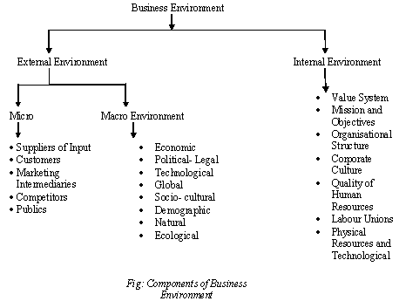

### Internal Environment:

The factors which can be controlled by company or Primary factors which directly affects the⎫ growth of organization….. man, material, money, machinery and management.

**Types of Internal Environment**

1. Value System

2. Mission & Objectives

3. Management Structure and Nature

4. Internal Power relationship

5. Human Resources

6. Company Image & Brand Equity …

### External Environment:

The external environment consists of legal, political, socio-cultural, demographic factors etc. These are uncontrollable factors and firms adapt to this environment. They adjust internal environment with the external environment to take advantage of the environmental opportunities and strive against environmental threats. Business decisions are affected by both internal and external environment.

[**[http://cdn3.businessmanagementideas.com/wp-content/uploads/2016/08/clip_image002_thumb-14.jpg](http://cdn3.businessmanagementideas.com/wp-content/uploads/2016/08/clip_image002-14.jpg)**](http://cdn3.businessmanagementideas.com/wp-content/uploads/2016/08/clip_image002-14.jpg)

The external environment consists of the micro environment and macro environment

#### 1. Micro Environment:

“The micro environment consists of factors in the company’s immediate environment”. These factors affect the performance of a company and its ability to serve the customers. Micro environment consists of customers, suppliers, competitors, public and market intermediaries.

**Firm’s micro environment is as follows:**

**(i) Customers:**

Customers constitute important segment of the micro environment. Business exists to serve its customers. Unless there are customers, business has no meaning. A company can have different types of customers like, households, producers, retailers, Government and foreign buyers.

**(ii) Suppliers:**

They supply inputs (money, raw material, fuel, power and other factors of production) and help in smooth conduct of the business. Firms should remain aware of the policies of suppliers as increase in prices of inputs will affect their sales and profits. Shortage of supplies also affects the production schedules. Firms should have more than one supplier so that change in policies of one supplier does not affect their production schedules.

**(iii) Competitors:**

Competitors form important part of the micro environment. Firms compete to capture big share of the market. They constantly watch competitors’ policies and adjust their policies to gain customer confidence.

**(iv) Public:**

“A public is any group that has an actual or potential interest in or impact on an organisation’s ability to achieve its interest”. Public can promote or demote company’s efforts to serve the market. The term ‘public’ consists of financial public (banks, financial institutions etc.), media public (newspapers, radio, television etc.), Government public, customer organisations, internal public (workers and managers), local public (neighbourhood or community residents) and general public (buyers at large). Companies observe the behaviour of these groups to make functional policies.

**(v) Market intermediaries:**

They are the links that help to promote, sell and distribute the products to final consumers. They are the physical distribution firms (transport firm), service agencies (media firms), financial intermediaries (banks, insurance companies) etc. that help in producing, marketing and insuring the goods against loss of theft, fire etc. Firms maintain good relations with them to carry their activities smoothly. All these factors are largely controllable by the firms but they operate in the larger macro environment beyond their control.

Micro Environment

• Suppliers

• Customers – Wholesalers – Retailers – Industries – Government and Other Institutions – Foreigners

• Market Intermediaries – Middleman – Marketing Agencies – Financial Intermediaries – Physical Intermediaries

• Competitors

• Public Macro Environment

• Economic Environment: It is very complex and dynamic in nature that keeps on changing with the change in policies or political situations.

It has three elements: –

* Economic Conditions of Public
* Economic Policies of the country
* Economic System
* Other Economic Factors Infrastructural Facilities, Banking, Insurance companies, money markets, capital markets etc.

**Macro Environment**

• Non-Economic Environment: Following are included in non-economic environment:

1. **Political Environment**: It affects different business units extensively. Components are

• Political Belief of Government

• Political Strength of the Country

• Relation with other countries

• Defense and Military Policies

• Centre State Relationship in the Country

• Thinking Opposition Parties towards Business Unit

**2. Socio-Cultural Environment**

– Influence exercised by social and cultural factors, not within the control of business, is known as Socio-Cultural Environment.

– These factors include: attitude of people to work, family system, caste system, religion, education, marriage etc.

**3. Technological Environment**

– A systematic application of scientific knowledge to practical task is known as technology.

– Everyday there has been vast changes in products, services, lifestyles and living conditions, these changes must be analyzed by every business unit and should adapt these changes.

**4. Natural Environment**

– It includes natural resources, weather, climatic conditions, port facilities, topographical factors such as soil, sea, rivers, rainfall etc

. – Every business unit must look for these factors before choosing the location for their business.

**5. Demographic Environment**

– It is a study of perspective of population i.e. its size, standard of living, growth rate, age-sex composition, family size, income level (upper level, middle level and lower level), education level etc.

– Every business unit must see these features of population and recognize their various needs and produce accordingly.

**6. International Environment**

– It is particularly important for industries directly depending on import or exports

. – The factors that affect the business are

• Globalization

• Liberalization

• Foreign business policies

• Cultural exchange

**Government interacts with the business in the following ways:**

**Some of the laws that exist in the country for smooth operation of business enterprises are as follows:**

* Economic Laws [Air (Prevention and Control of Pollution) Act, 1981;
* Consumer Protection Act, 1986;
* Essential Commodities Act, 1955;
* Foreign Exchange Management Act, 1999;
* Foreign Trade (Development & Regulation) Act, 1992;
* Industries (Development & Regulation) Act, 1951;
* Patents Act, 1970;
* Standards of Weights and Measures Act, 1976;
* Trade Marks Act, 1999],

**(ii) Socio-cultural environment:**

It represents the values, culture, beliefs, norms and ethics of the society in which business enterprises operate. People are important to organizations both as human resource and customers. Their buying habits, buying capacities, tastes, preferences and education affect business enterprises.

**The socio-cultural environment, thus, affects:**

**(a) Business objectives**:

**(b) Organizational processes:**

**(c) Goods and services to be produced:**

**(iii) Technical environment:**

Technology refers to application of scientific and organized knowledge to organizational tasks. It includes inventions and innovations regarding techniques of production.

**(iv) Demographic environment:**

It consists of population in its varied forms, such as gender, age, income, growth rate, language, religion, etc. Increasing population increases the demand for business products and also provides labour at low rate.

**(v) Natural environment:**

The natural environment consists of the renewable and non­renewable resources used in the production processes. The renewable resources are air, water and solar energy which can be replenished and non-renewable resources are oil, coal, wood etc. which cannot be replenished.

**(vi) International environment:**

It represents the global environment characterized by the “borderless world”. The Indian economy entered the global world in 1991 through its liberalization policies. There have been significant economic and political changes and increasing role for the private sector to play since then.

The global business environment is significantly influenced by the principles and agreements of World Trade Organization (WTO). WTO monitors and regulates the business transacted in the international environment.

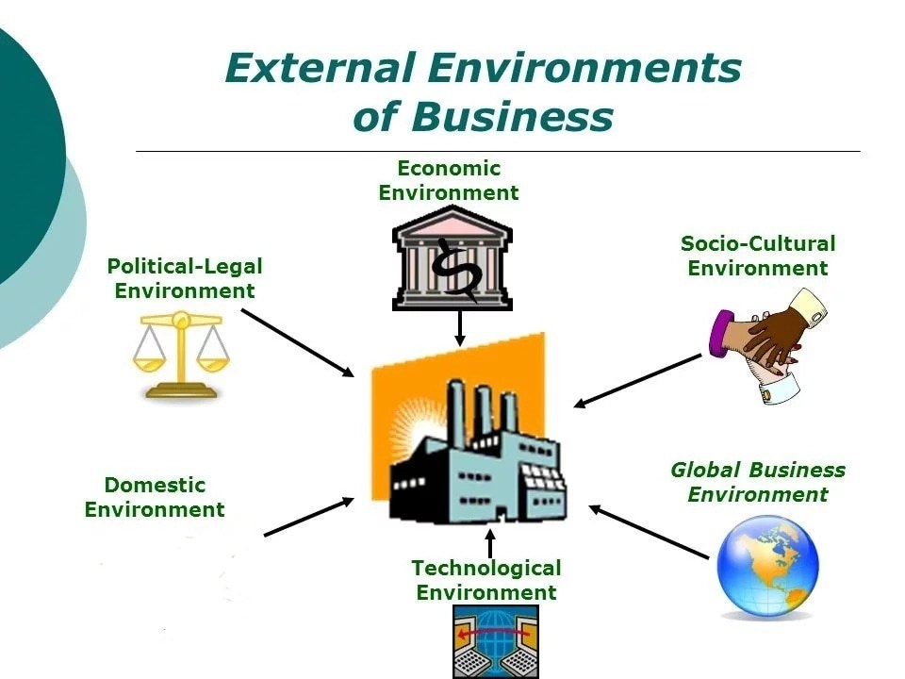

**Characteristics**

* Business environment is compound in nature.
* It is constantly changing process.
* It is different for different business units.
* It has both long term and short term impact.
* Unlimited influence of external environment factor
* . It is very uncertain.
* Inter-related components.
* It includes both internal and external environment.

**IMPORTANCE OF BUSINESS ENVIRONMENT**

There is a close and continuous interaction between the business and its environment. This interaction helps in strengthening the business firm and using its resources more effectively. As stated above, the business environment is multifaceted, complex, and dynamic in nature and has a far-reaching impact on the survival and growth of the business. To be more specific, proper understanding of the social, political, legal and economic environment helps the business in the following ways:

1. Determining Opportunities and Threats: The interaction between the business and its environment would identify opportunities for and threats to the business. It helps the business enterprises for meeting the challenges successfully.
2. Giving Direction for Growth: The interaction with the environment leads to opening up new frontiers of growth for the business firms. It enables the business to identify the areas for growth and expansion of their activities.
3. Continuous Learning: Environmental analysis makes the task of managers easier in dealing with business challenges. The managers are motivated to continuously update their knowledge, understanding and skills to meet the predicted changes in realm of business.
4. Image Building: Environmental understanding helps the business organizations in improving their image by showing their sensitivity to the environment within which they are working. For example, in view of the shortage of power, many companies have set up Captive Power Plants (CPP) in their factories to meet their own requirement of power.

**UNIT-II**

#### Concept of Social Responsibilities

Social responsibility implies formulation of business objectives, plans, policies and programmes etc. with emphasis on not only the economic concept of the profit-maximisation; but also with an orientation towards meeting social obligations.

**Definition**

“Social responsibilities refer to the businessman’s decisions and actions taken to reasons at least partially beyond the firm’s direct economic or technical interests.” —Keith Davis

“Social responsibilities refer to the obligation (of businessmen) to pursue those policies, to make those decisions, or to follow those lines of action which are desirable, in terms of objectives and values of society.” —Howard R. Bowen

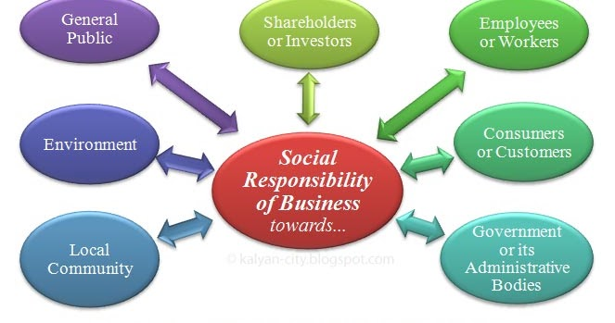

## CORE SUBJECTS AND KEY PRINCIPLES OF SOCIAL RESPONSIBILITY

[***ISO 26000: Guidance on social responsibility***](https://asq.org/quality-press/display-item?item=T866E) identifies [seven core social responsibility subjects](https://asq.org/quality-resources/iso-26000#cs):

1. [Organizational governance](https://asq.org/quality-resources/governance)
2. Human rights
3. Labor practices
4. The environment
5. Fair operating practices
6. Consumer issues
7. Community involvement and development

In addition to the core subjects, ISO 26000 also defines seven key principles of socially responsible behavior:

1. Accountability
2. Transparency
3. Ethical behavior
4. Respect for [stakeholder interests](https://asq.org/quality-resources/stakeholders)
5. Respect for the rule of law
6. Respect for international norms of behavior
7. Respect for human rights

#### Case for Social Responsibilities:

**(i) Creation of Society:**

A business enterprise is a creation of society. It gets all inputs-men, money, materials, technology, information etc. from society; and unloads its output onto society by marketing goods and services in society. Therefore, it must be loyal to society; and perform its social responsibilities.

**(ii) Theory of Trusteeship:**

Mahatma Gandhi evolved the theory of trusteeship, according to which businessmen are the trustees of the wealth of society; and should not use this wealth for their self-enrichment, at the cost of society. Hence, businessmen must perform social responsibilities to justify their role as trustees of the wealth of society.

**(iii) Long – Term Interest of Business:**

Fulfillment of social responsibilities is in the long-term best interest of business. Performance of social responsibilities will help in the survival and growth of business enterprises.

For example, if the business sector helps in spreading education in society; in the long-run, it will get more skilled and educated manpower for its functioning.

**(iv) ‘Joint-Venture’ Concept:**

A business enterprise is not an exclusive creation of owners, who provide funds for its functioning. Rather, it is run on a joint-venture concept i.e. employees, consumers, suppliers etc. all support the functioning of the enterprise, in their own ways.

**(v) Public Image:**

Performance of social responsibilities makes for the image of business in society. Such public image, is, yet another name for the goodwill of business. Creation of business goodwill pays huge rewards to business, in many ways.

**(vi) Government Intervention:**

Businessmen should perform social responsibilities voluntarily. In case otherwise, the government might intervene and force businessmen to perform social responsibilities through enactment and enforcement of suitable legislation vis-a-vis social responsibilities.

**(vii) Ample Financial Resources:**

There is no doubt that the ‘business-class’ is the richest class of society, endowed with huge financial resources. This class is the fittest agency to perform social responsibilities, by virtue of, its financial powers.

**(viii) Business Leadership Needed:**

Business leadership is very powerful and dynamic. Such leadership is needed to solve those social problems, which even the government cannot solve.

Hence, business should make a available to society the advantage of its talented leadership, through undertaking critical social responsibilities like controlling environmental pollution, promoting rural development, generation of employment opportunities in society etc.

**(ix) No Law for all Situations:**

Government cannot enact legislations covering all aspects and spheres of social responsibilities. The business should morally undertake to perform social responsibilities in those areas which are not regulated or guided by any of the governmental legislations e.g. eradication of poverty, holding the price-line, giving up cut-throat competition and so on.

**[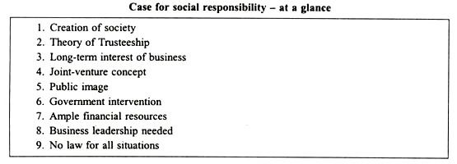](http://cdn.yourarticlelibrary.com/wp-content/uploads/2015/11/clip_image006_thumb72.jpg)**

#### Specific Social Responsibilities:

**Specific social responsibilities of business could be described under various categories as depicted in the following chart:**

**[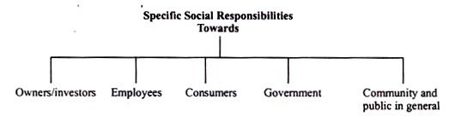](http://cdn.yourarticlelibrary.com/wp-content/uploads/2015/11/clip_image008_thumb9.jpg)**

**(1) Responsibilities towards Owners/Investors:**

**Some specific social responsibilities of business towards owners are:**

(i) Paying a reasonable rate of dividend as a reward for risking capital in business.

(ii) Ensuring safety of investment of funds provided by owners.

(iii) Giving owners a true and fair account of the functioning, profitability and financial position of the company.

(iv) Showing due regard towards the interest of minority of members.

(v) Ensuring growth of the company.

(vi) Not to indulge in undesirable speculation to the detriment of the interests of genuine investors.

(vii) Not to mislead prospective investors, by any means, whatsoever, to invest in the company.

**(2) Responsibilities towards employees**

**Some specific social responsibilities of business towards employees are:**

(i) Payment of adequate and timely wages

(ii) Providing congenial work environment

(iii) Providing adequate industrial safety devices

(iv) Granting job security.

(v) Providing opportunities for promotion and advancement.

(vi) Providing benefits like – subsidized housing, free medical care, leave with pay, entertainment and recreational facilities etc.

(vii)Ensuring reasonable workers participation in management.

(viii)Giving workers their due share in the excess profits of the business.

(ix)Giving humane treatment to workers.

(x)Taking care of the personal problems of workers, of a serious nature.

**(3) Responsibilities towards Consumers:**

**Some specific responsibilities of business towards consumers are:**

(i) Supplying goods of good quality, at fair prices.

(ii) Avoidance of indulging in unfair trade practices like:

1.  Supplying lesser weight

2. Defective packing of goods

3. Black-marketing, hoarding and profiteering.

4. Adulteration etc.

(iii) Taking due care of after-sales services.

(iv) Not to indulge in false, misleading and vulgar advertising.

(v) Immediate redress of consumer grievances.

(vi)Discouraging salesmen from resorting to pressurizing tactics to win customers.

**(4) Responsibilities towards the State or Government:**

**Some specific responsibilities of the business towards the State (i.e. the government) are:**

(i) Timely payment of legitimate taxes.

(ii) Co-operating with the government in the implementation of its economic and social policies.

(iii) Supplying the required information to government departments, from time to time.

(iv) Refraining from corrupting public servants.

(v) Not to indulge in winning political favours for selfish interests.

**(5) Responsibilities towards Community and Public in General:**

**Some specific responsibilities of business towards community and public in general are:**

(i) Ensuring best utilization of the scarce economic resources of society.

(ii) Generation of maximum employment opportunities.

(iii) Controlling environmental pollution.

(iv) Preventing urban congestion.

(v) Undertaking programmes for rural development.

(vi) Helping in spread of housing, medical, educational and recreational facilities in society.

(vii) Innovating and implementing schemes for the uplift of the downtrodden.

**BUSINESS ETHICS**

The term business Ethics refers to the system of moral principles and rules of conduct applied to business.

Business Ethics means that the business should be conducted according to certain self-recognized moral standards. Business being a social organ, shall be not conduct itself in a way detrimental to the interests of society and the business sector itself.

Peter Drucker ones stated that every individual and organ in society should abide by certain moral codes and there is no separate ethics of business.

In 1930s, Rotary International developed its Code of Ethics that is still used extensively. It uses 4questions that are called the four way ethical behavior for any ethical issue a business faces.

1. Is it the truth?
2. Is it fair to all concerned?
3. Will it build goodwill and better friendship?
4. Will it be beneficial to all concerned?

The most important professional ethics is expressed by the Hippocratic oath of the Greek physician: “***Premium non nocere”*** (not knowingly do harm).this dictum implies that a professional should carefully evaluate his decision and ensure that his actions will not produce negative effects. Thus,this code rules out all anti-social business practices.

**Important Ethical Principles**

* Do not deceive or cheat customers by selling sub-standard or defective

Products, by under-measurement or by any other means.

* Do not resort to hoarding, black-marketing or profiteering.
* Do not destroy or distort competition.
* Ensure sincerity and accuracy in advertising, labeling & packaging.
* Do not tarnish the image of competitors by unfair practices.
* Make accurate business records available to all authorized persons.
* Pay taxes and discharge other obligations promptly.
* Do not form cartel agreements, even informal, to control production, priceetc , to the common detriment.
* Refrain from secret payoffs to customers, suppliers, administrators, politicians, etc.
* Ensure payment of fair wages to and fair treatment of employees.

**Role of Trade Association**

Trade associations which are voluntary organizations of businessmen formed to promote their common interests can promote business ethics in three important ways-

**Unit- III**

**INDIAN BUSINESS ENVIRONMENT**

Business environment refers to those aspects of the surroundings of business enterprise which have influence on the functioning of business. An organization can survive and grow only when it continuously and quickly adopts to changing environment.

Acc. to Wheeler, “Business Environment is the total of all things external to business firms and industries which affect their organization and operations.”

**Components of Business Environment:-**Business Environment has two components :-

a) Internal Environment b) External Environment

**Significance of Business Environment**

* Business and its external environment interact in the following ways. Exchange of information. Exchange of resources.. Exchange of influence and power.
* For incorporating dynamic behavior of environment
* Complete knowledge of internal environment
* To understand international events, pressures& impact
* Economic policies of the govt.
* Economic policies of the govt.
* To face business problems &challenges
* Vigilant regarding dangers
* Administrative system
* Optimum utilization of resources
* Market conditions
* Scientific & industrial advancement
* Development & success of business

**Economic trends**

India is the [world's fourth-largest economy](https://www.thebalance.com/world-s-largest-economy-3306044). It produced [$9.4 trillion in goods and services](https://www.cia.gov/library/publications/the-world-factbook/geos/in.html) in 2017. But it has a long way to go to beat the top three: [China](https://www.thebalance.com/china-economy-facts-effect-on-us-economy-3306345), with a production worth $23.1 trillion; the [European Union](https://www.thebalance.com/what-is-the-european-union-how-it-works-and-history-3306356), with $19.9 trillion; and the United States, with $17.4 trillion.

[India](https://www.cia.gov/library/publications/the-world-factbook/geos/in.html) has had rapid growth despite the [Great Recession](https://www.thebalance.com/the-great-recession-of-2008-explanation-with-dates-4056832). It grew 6.7 percent in 2017, 7.1 percent in 2016 and 8 percent in 2015. From 2008 through 2014, it grew between 5 percent and 11 percent. That phenomenal growth rate has reduced [poverty](https://www.thebalance.com/federal-poverty-threshold-3305793) by 10 percent in the last decade.

### What Type of Economy Is India?

India has a [mixed economy](https://www.thebalance.com/mixed-economy-definition-pros-cons-examples-3305594). Half of India's workers rely on agriculture, the signature of a [traditional economy](https://www.thebalance.com/traditional-economy-definition-examples-pros-cons-3305587). One-third of its workers are employed by the services industry, which contributes two-thirds of India's output. The productivity of this segment is made possible by India's shift toward a [market economy](https://www.thebalance.com/market-economy-characteristics-examples-pros-cons-3305586). Since the 1990s, India has deregulated several industries. It's privatized many state-owned enterprises, and opened doors to foreign direct investment.

### India's Strengths

India is an attractive country for [outsourcing](https://www.thebalance.com/how-outsourcing-jobs-affects-the-u-s-economy-3306279) and a cheap source of imports. Its economy has these five [comparative advantages](https://www.thebalance.com/comparative-advantage-3305915):

1. The [cost of living](https://www.thebalance.com/cost-of-living-define-calculate-compare-rank-3305737) is lower than in the United States. Its [gross domestic product per capita](https://www.thebalance.com/gdp-per-capita-formula-u-s-compared-to-highest-and-lowest-3305848) is $7,200, half that of China or Brazil. This is an advantage because Indian workers don't need as much income since everything costs less.
2. India has many well-educated technology workers.
3. English is one of India’s official languages. Many Indians speak it. This, combined with the high level of education, attracts U.S. technology and call centers to India. For example, an Indian call center employee only costs $12 per hour. That's almost half the American counterpart of $20 an hour. According to the Technology Manufacturing Corporation, more than 250,000 call center jobs, as a result, were outsourced to India and the Philippines between 2001 and 2003.

4.[India’s 1.3 billion people](https://www.economist.com/special-report/2015/05/23/modis-many-tasks) come from a wide range of economic and cultural backgrounds. This [diversity can be a strength](https://www.thebalance.com/cultural-diversity-3306201) or a challenge. Socioeconomic status is largely determined by geography. India’s three main regions each have distinct class and education divisions. Annually, 11 million people leave the rural areas to live in the cities. Most of them are young and educated. They seek a higher quality of life.

5.The profitable Indian film industry is called "[Bollywood](http://www.ibtimes.com/bollywood-100-how-big-indias-mammoth-film-industry-1236299)." It's a portmanteau of Bombay, now called Mumbai, and Hollywood. Bollywood makes twice the number of movies Hollywood makes. The most popular actor in the world is India's Shah Rukh Khan. In 2016, Bollywood contributed $4.5 billion to India's GDP. It generates less revenue than Hollywood’s $51 billion only because its ticket prices are much lower. On the plus side, Bollywood films cost less to make: $1.5 million on average versus $47.7 million in Hollywood.

These comparative advantages mean great opportunities for American business. [Foreign direct investment](https://www.thebalance.com/foreign-direct-investment-fdi-pros-cons-and-importance-3306283) in Indian companies has the potential to be very profitable. The Indian middle class is almost 250 million people. That's bigger than the U.S. middle class. It will continue to drive India's consumer spending and economic growth.

In addition to FDI, India has seen more than 100 [initial public offerings](https://www.thebalancesmb.com/ipo-initial-public-offering-definition-2948116)in the last 18 months. [Private equity](https://www.thebalance.com/private-equity-firms-funds-trends-3305957) funding grew in 2012 and 2013, a trend that is expected to continue. Energy, health care, industry, and materials have been the top four sectors. While inbound [mergers and acquisitions deals](https://www.thebalancesmb.com/why-do-companies-merge-mergers-and-acquisitions-explained-392847) have declined in the last year, outbound deals have increased substantially in the emerging markets in the Middle East, Asia, Africa and South America. These deals are driven by depressed valuations due to the recent recession.

In March 2016, Mr. Modi dedicated [$1.5 billion in funding and tax breaks to boost high-tech startups](https://www.gfmag.com/magazine/march-2016/india-bets-big-start-companies). The program will streamline patent applications and investments. That should double India's new startups to 11,500 in the next five years.

**TRADE & BALANCE OF PAYMENT**

* Trade between two or more nations is called foreign trade or international trade
* Foreign trade is also known as external trade.

**Importance**

**Development of economy.**

**Meeting of shortage.**

**IMPORTs**

**Import for better living standards.**

**Improving quality of production.**

**Growth of the economy-Production, employment, expansion, demand of other goods: utilization of resources.**

**Sources of Foreign Exchange.**

Foreign trade is an important component of any economy even if its contribution to GNP mat not be large. In a country like India which faces problem of balance of payments due to trade deficit and overall balance of payments deficit, all efforts are being made to promote exports are being made to promote exports, curtail imports and encourages larger inflow of foreign capital and loans, encourage exports, of invisibles and discourage outgo of foreign exchange in such a manner that balance of payments becomes favorable or at least receipt and payments are equal.

**Factor Affecting Trade-**

1. If world trade rises at high speed it is likely that exports of various countries will also rise. When the rate of growth of world trade is high it implies that demands of various commodities are rising and so the exporters have greater chances to increase exports.
2. The comparative prices of goods of competing countries in international markets.
3. There should be demand in world markets of goods produced by a country.There is a big change in demand of structure of goods and services in the world markets.
4. The goods and services should be competitive not only in price but also in quality and packing. In some goods Indian prices are competitive but as India is not competitive on other fronts exports are not rising adequately.
5. The country should have some specific advantages to attract foreign customers
6. The country should be able to export in volume needed in international markets.
7. International trade agreements, tariff rates, quota restrictions and non- tariff restrictions imposed by various countries also influence trade growth.

**COMPOSITION**

**EXPORT**

**IMPORT**

**IMPORTS**

* It refers to goods that we buy from other countries.
* At times of independence India was an agrarian economy.
* Partition of our country has brought food shortage because wheat growing regions vested with Pakistan.
* Hence India needs to import in large quantities, food,and cotton jute. Etc
* With development of economy over these days, there occurred changes in composition of imports.
* The development required setting up of industries modernization of agriculture etc.
* Capital goods like machinery chemicals fertilizers metals minerals petroleum products etc.

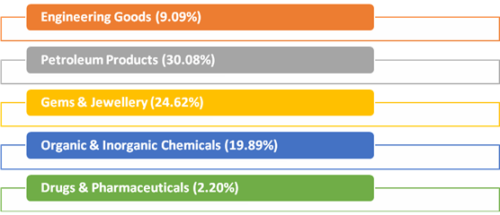

**EXPORTS**

* Exports mean that we are selling commodities to other countries.
* At the time of independence our exports comprise of agricultural products like tobacco, spices, raw materials of cotton and jute etc.
* Due to industrialization the proportion of raw materials in our export declined.

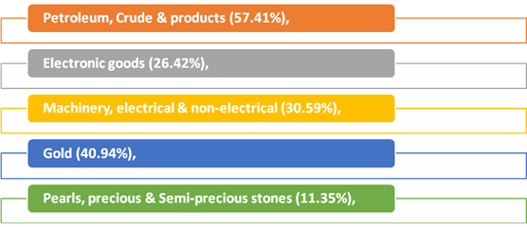

**CRUDE OIL AND NON-OIL IMPORTS:**

Oil imports during July 2018 were valued at US$ 12.35Billion(Rs. 84,828.57crore) which was 57.41 percent higher in Dollar terms and 67.76 percent higher in Rupee terms compared to US$ 7.84 Billion (Rs. 50,565.29crore) in July 2017.Oil imports during April-July2018-19 were valued at US$ 46.98 Billion (Rs. 3,17,097.71crore) which was 51.45 per cent higher in Dollar terms and 58.58 percent higher in Rupee terms compared to US$ 31.02 Billion (Rs. 1,99,961.19crore) in the corresponding period last year.

In this connection it is mentioned that the global Brent price ($/bbl) has increased by 53.16% in July 2018 vis-à-vis July 2017 as per data available from US Energy Information Administration(EIA).

Non-oil imports during July 2018 were estimated at US$ 31.44Billion(Rs.2,15,956.15crore) which was 20.23 per cent higher in Dollar terms and 28.13 percent higher in Rupee terms compared to US$ 26.15 Billion (Rs. 1,68,543.60crore) in July 2017.Non-oil imports during April-July2018-19 were valued at US$ 124.21 Billion(Rs.8,37,783.99crore) which was 7.79 per cent higher in Dollar terms and 12.79 percent higher in Rupee terms compared to US$ 115.23 Billion (Rs. 7,42,778.81crore in April-July, 2017-18.

Non-Oil and Non-Gold imports in July 2018 valued at US $ 28.47 billion has recorded a positive growth of 18.42 % as compared to Non-Oil and Non-Gold import in July 2017. Non-Oil and Non-Gold imports in April-July 2018 valued at US $ 112.80 billion has recorded a positive growth of 10.74 % as compared to Non-Oil and Non-Gold import in April-July 2017.

**TRADE IN SERVICES (for June, 2018, as per the RBI Press Release dated 14th August 2018)**

**EXPORTS (Receipts)**

Exports during June 2018 were valued at US$ 16.87Billion (Rs.1,14,380.52Crore) registering a positive growth of 4.32per cent in dollar terms as compared to negative growth of 7.91per cent during May2018(as per RBI’s Press Release for the respective months).

**IMPORTS (Payments)**

Imports during June2018 were valued at US$ 10.30Billion (Rs. 69,820.11Crore) registering a positive growth of 0.89per cent in dollar terms as compared to negative growth of 6.48per cent during May2018(as per RBI’s Press Release for the respective months).

**TRADE BALANCE**

**MERCHANDISE**: The trade deficit for July 2018 was estimated at US$ 18.02Billionas against the deficit of US$ 11.45Billion during July 2017.

**SERVICES**: As per RBI’s Press Release dated 14th August 2018, the trade balance in Services (i.e. net export of Services) for June, 2018 was estimated at US$ 6.57Billion.

**OVERALL TRADE BALANCE:** Taking merchandise and services together, overall trade deficit for April-July2018-19 is estimated at US$ 43.77Billion as compared to US$ 34.07 Billion during April-July2017-18. (Services data pertains to April-June 2018-19 as June 2018is the latest data available as per RBI’s Press Release dated 14th August 2018)

**DIRECTION OF INDIA’S FOREIGN TRADE**

* Direction means countries to which India exports its goods and countries from which it imports.
* Direction of trade also helps to understand the diplomatic relationship maintained by India with other countries of trade.
* West Europe (28.1 per cent), America (25.4 per cent), Africa⎫ (6.3 per cent) and East Europe (3.1 per cent)

**Group of countries to which India Exports**

Organization of Petroleum Exporting Countries (OPEC).

Eastern Europe.

Developing Nations.

Organization for Economic Cooperation & Development (OECD).

• China, Hong Kong, South Korea, Singapore and Malaysia.

• Romania, Russia and others.

• Kuwait, Iran, Iraq, Saudi Arabia and others.

* USA Canada, European (EU), Australia and Japan.

**QUICK ESTIMATES FOR SELECTED MAJOR COMMODITIES FOR JANUARY 2018**

**TRADE: EXPORT**

|  |  |  |  |  |
| --- | --- | --- | --- | --- |
| **Sl. No.** | **Commodities** | **(Values in Million USD)** | | **% change** |
| **JAN'17** | **JAN'18** | **JAN'18** |
| 1 | Tea | 62.70 | 70.55 | 12.52 |
| 2 | Coffee | 51.99 | 52.83 | 1.62 |
| 3 | Rice | 517.94 | 661.82 | 27.78 |
| 4 | Other cereals | 24.49 | 14.11 | -42.38 |
| 5 | Tobacco | 56.77 | 79.13 | 39.39 |
| 6 | Spices | 217.40 | 223.35 | 2.74 |
| 7 | Cashew | 64.65 | 66.61 | 3.03 |
| 8 | Oil Meals | 97.08 | 93.45 | -3.74 |
| 9 | Oil seeds | 154.75 | 84.41 | -45.45 |
| 10 | Fruits & Vegetables | 201.50 | 224.18 | 11.26 |
| 11 | Cereal preparations & miscellaneous processed items | 91.65 | 110.27 | 20.32 |
| 12 | Marine Products | 402.35 | 473.33 | 17.64 |
| 13 | Meat, dairy & poultry products | 273.70 | 296.39 | 8.29 |
| 14 | Iron Ore | 179.09 | 88.69 | -50.48 |
| 15 | Mica, Coal & Other Ores, Minerals including processed minerals | 274.25 | 326.24 | 18.96 |
| 16 | Leather & leather products | 415.81 | 439.28 | 5.64 |
| 17 | Ceramic products & glassware | 144.40 | 165.69 | 14.74 |
| 18 | Gems &Jewellery | 3002.17 | 3028.90 | 0.89 |
| 19 | Drugs & Pharmaceuticals | 1272.33 | 1381.81 | 8.60 |
| 20 | Organic & Inorganic Chemicals | 1206.94 | 1612.50 | 33.60 |
| 21 | Engineering Goods | 5498.98 | 6366.09 | 15.77 |
| 22 | Electronic Goods | 465.46 | 461.21 | -0.91 |
| 23 | Cotton Yarn/Fabs./made-ups, Handloom Products etc. | 933.41 | 843.72 | -9.61 |
| 24 | Man-made Yarn/Fabs./made-ups etc. | 406.02 | 402.95 | -0.76 |
| 25 | RMG of all Textiles | 1523.61 | 1395.93 | -8.38 |
| 26 | Jute Mfg. including Floor Covering | 27.33 | 28.36 | 3.77 |
| 27 | Carpet | 118.72 | 111.30 | -6.25 |
| 28 | Handicrafts excl. handmade carpet | 144.14 | 138.62 | -3.83 |
| 29 | Petroleum Products | 2746.79 | 3831.83 | 39.50 |
| 30 | Plastic & Linoleum | 465.95 | 607.01 | 30.27 |
|  | Sub-Total | 21042.37 | 23680.56 | 12.54 |
|  | **GRAND   TOTAL** | 22356.32 | 24383.97 | 9.07 |

**QUICK ESTIMATES FOR SELECTED MAJOR COMMODITIES FOR JANUARY 2018**

**TRADE: IMPORT**

|  |  |  |  |  |
| --- | --- | --- | --- | --- |
| **Sl. No.** | **Commodities** | **(Values in Rs. crores)** | | **% change** |
| **JAN'17** | **JAN'18** | **JAN'18** |
| 1 | Cotton Raw & Waste | 231.41 | 198.69 | -14.14 |
| 2 | Vegetable Oil | 5594.51 | 5907.47 | 5.59 |
| 3 | Pulses | 3175.59 | 755.96 | -76.19 |
| 4 | Fruits & vegetables | 1084.78 | 1289.83 | 18.90 |
| 5 | Pulp and Waste paper | 611.57 | 525.87 | -14.01 |
| 6 | Textile yarn Fabric, made-up articles | 806.97 | 960.13 | 18.98 |
| 7 | Fertilisers, Crude & manufactured | 1644.24 | 2819.37 | 71.47 |
| 8 | Sulphur& Unroasted Iron Pyrites | 74.57 | 119.29 | 59.97 |
| 9 | Metalliferous ores & other minerals | 4045.71 | 6491.49 | 60.45 |
| 10 | Coal, Coke & Briquettes, etc. | 11378.75 | 14004.63 | 23.08 |
| 11 | Petroleum, Crude & products | 55648.68 | 74194.72 | 33.33 |
| 12 | Wood &  Wood products | 2462.09 | 3141.65 | 27.60 |
| 13 | Leather & leather products | 479.62 | 532.55 | 11.04 |
| 14 | Organic & Inorganic Chemicals | 8234.72 | 11425.26 | 38.74 |
| 15 | Dyeing/tanning/colouring materials. | 1220.81 | 1754.62 | 43.73 |
| 16 | Artificial resins, plastic materials, etc. | 5863.28 | 7821.83 | 33.40 |
| 17 | Chemical material & products | 3059.23 | 4088.89 | 33.66 |
| 18 | Newsprint | 451.60 | 289.49 | -35.90 |
| 19 | Pearls, precious & Semi-precious stones | 10518.84 | 15309.91 | 45.55 |
| 20 | Iron & Steel | 6825.42 | 8220.34 | 20.44 |
| 21 | Non-ferrous metals | 5446.24 | 7257.05 | 33.25 |
| 22 | Machine tools | 1660.37 | 2398.56 | 44.46 |
| 23 | Machinery, electrical & non-electrical | 15849.56 | 19128.31 | 20.69 |
| 24 | Transport equipment | 12749.27 | 12398.78 | -2.75 |
| 25 | Project goods | 1190.97 | 873.33 | -26.67 |
| 26 | Professional instrument, Optical goods, etc. | 2075.92 | 2325.11 | 12.00 |
| 27 | Electronic goods | 26555.36 | 27848.56 | 4.87 |
| 28 | Medicinal & Pharmaceutical products | 2767.31 | 3023.28 | 9.25 |
| 29 | Gold | 13890.79 | 10119.16 | -27.15 |
| 30 | Silver | 1334.47 | 1650.92 | 23.71 |
|  | Sub-Total | 206932.65 | 246875.05 | 19.30 |
|  | **GRAND   TOTAL** | 219635.13 | 258890.43 | 17.87 |

**WEAKNESSES AND PROBLEM OF INDIA’S TRADE**

1. Indian imports have been rising faster than exports and so there is always a trade deficit. The imports no doubt will have to increase to meet developmental needs but industries developed in India through economic growth are largely for import substitution and not for export promotion.
2. Fuel especially petroleum is having a rising share because crude production in India has not risen; virtually we are at mercy of OPEC countries.
3. Direction of exports and imports is highly concentrated with OCED countries.
4. USA is another market and if in any year its imports decline India suffers badly.

**BALANCE OF PAYMENT**

The Balance of Payments or BoP is a statement or record of all monetary and economic transactions made between a country and the rest of the world within a defined period (every quarter or year). These records include transactions made by individuals, companies and the government.

Keeping a record of these transactions helps the country to monitor the flow of money and develop policies that would help in building a strong economy.

**Why balance of payment is vital for a country?**

A country’s BOP is vital for the following reasons:

* BOP of a country reveals its financial and economic status.
* BOP statement can be used as an indicator to determine whether the country’s currency value is appreciating or depreciating.
* BOP statement helps the Government to decide on fiscal and trade policies.
* It provides important information to analyze and understand the economic dealings of a country with other countries.

**Elements of balance of payment**

There are three components of balance of payment viz current account, capital account, and financial account. The total of the current account must balance with the total of capital and financial accounts in ideal situations.

##### **Current Account**

The current account is used to monitor the inflow and outflow of goods and services between countries. This account covers all the receipts and payments made with respect to raw materials and manufactured goods. It also includes receipts from engineering, tourism, transportation, business services, stocks, and royalties from patents and copyrights. When all the goods and services are combined, together they make up to a country’s Balance Of Trade.

##### **Capital Account**

All capital transactions between the countries are monitored through the capital account. Capital transactions include the purchase and sale of assets (non-financial) like land and properties. The capital account also includes the flow of taxes, purchase and sale of fixed assets etc by migrants moving out/in to a different country.

There are 3 major elements of capital account:

* Loans & borrowings – It includes all types of loans from both the private and public sectors located in foreign countries.
* Investments – These are funds invested in the corporate stocks by non-residents.
* Foreign exchange reserves – Foreign exchange reserves held by the central bank of a country to monitor and control the exchange rate does impact the capital account.

##### **Financial Account**

The flow of funds from and to foreign countries through various investments in real estates, business ventures, foreign direct investments etc is monitored through the financial account. This account measures the changes in the foreign ownership of domestic assets and domestic ownership of foreign assets. On analyzing these changes, it can be understood if the country is selling or acquiring more assets (like gold, stocks, equity etc).

**PARALLEL ECONOMY**

Parallel economy, based on the black money or unaccounted money, is a big menace to the Indian economy. It is also a cause of big loss in the tax-revenues for the government.



When economic activities goes unreported or not measured by societies current techniques to monitor economic activity it falls under parallel economy. Money that have neither been reported to the public authorities at the time of their generation or at any time of possession; no taxes have been paid on it. Also known as Phantom trades or Shadow economy.

A hidden economy in its broadest sense may consist of –

a) illegal economy, such as money laundering, smuggling, etc;

b) unreported economy including tax evasion;

c) unregulated economy, that is economic activities outside  law and regulations.

**Impact of the black money:**

In India, the black economy has resulted in an immense loss of tax revenue. If it accounted for 40% of GDP in 1998-99, the loss of direct tax revenue at the prevailing rate would amount to at least Rs. 200,000 crore. Only 2 million of India's billion people pay taxes, just 2% of the population. The government therefore suffers a perennial shortage of funds and public services languish.

Policies fail both at the macro-level and the micro-level. Targets for education, health, drinking water and so on are not achieved because “expenditures do not mean outcomes.” Much investment goes into wasteful and unproductive channels, like holding gold or real estate abroad.

A country is considered as capital-short has been exporting capital. A nation that gives concessions to multinational corporations to bring in capital loses more capital than it gets, and that too at a high cost, from foreign institutional investments or foreign direct investment.

**Strategy for recovering black money**

So far the Government has adopted a five-pronged strategy to tackle the sensitive issue of Black Money –

• Joining the Global Crusade Against Black Money

• Creating an Appropriate Legislative Framework using DTAA and Tax Information Exchange Agreement (TIEA)

• Setting up Institutions to Deal with Illicit Funds such as Income Tax Overseas Units.

• Manpower of FT&TR Division in CBDT has been doubled.

• Imparting Skills to the Manpower for Effective Action

Recommendations for Black Money Recovery

• Reducing disincentives by Rationalization of tax rates, reduce tax terrorism (retrospective amendments), pass GST and Reducing transaction costs by providing internet-based services to pay tax;

• Creation of effective credible deterrence by Setting up an investigation unit with Enforcement Directorate as the nodal coordinating agency to remove problem of lack of coordination; CAG should audit on suspicious exports vulnerable sectors like Real estate, jewelry, financial markets, have Time frame for Income Tax and CBEC for completing cases.

• Amend PMLA, FEMA and Make Tax evasion a serious "criminal offence. Reform political funding in India.

• Establishment of a central KYC (Know Your Customer) registry to deal with the problem of multiple identities of an individual in financial transactions.

• To ensure that banks, on a real time basis, report all suspicious transactions, SIT must seek a report from the Financial Intelligence Unit (FIU) of the Indian government on what it has done about suspicious transactions reported by banks.

• To pressurize Swiss authorities to give name of US citizens who have opened numbered bank account in Swiss Banks, US arrested senior bank officers of Union Bank of Switzerland on charges of espionage. India also has Swiss bank branch offices in Mumbai.

**Inflation**

### Meaning of Inflation:

Inflation is the rate at which the prices for goods and services increase. Inflation often affects the buying capacity of consumers. Most Central banks try to limit inflation in order to keep their respective economies functioning efficiently.  
There are advantages and disadvantages to inflation.

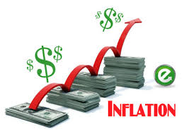

### ****Causes of Inflation****

Inflation is caused by multiple factors, here are a few:

**1. Money Supply**

Excess currency (money) supply in an economy is one of the primary cause of inflation. This happens when the money supply/circulation in a nation grows above the economic growth, therefore reducing the value of the currency.  
In the modern era, countries have shifted from the traditional methods of valuing money with the amount of gold they possessed. Modern methods of money valuation are determined by the amount of currency that is in circulation which is then followed by the public’s perception of the value of that currency.

**2. National Debt**

There are a number of factors that influence national debt, which include the nations borrowing and spending. In a situation where a country’s debt increases, the respective country is left with two options:   
Taxes can be raised internally  
Additional money can be printed to pay off the debt

**3. Demand-Pull Effect**

The demand-pull effect states that in a growing economy as wages increase within an economy, people will have more money to spend on goods and services. The increase in demand for goods and services will result in companies to raise prices that consumers will bear in order to balance supply and demand.

**4. Cost-Push Effect**

This theory states that when companies face increased input costs on raw materials and wages for manufacturing consumer goods, they will preserve their profitability by passing the increased production cost to the end consumer in the form of increased prices.

**5. Exchange Rates**

An economy with exposure to foreign markets mostly functions on the basis of the dollar value. In a trading global economy, exchange rates play an important factor in determining the rate of inflation.

**Types of Inflation**

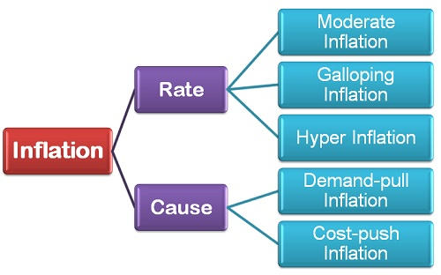

**Types of Inflation: On the Basis of Rate**

1. **Moderate Inflation:**The moderate inflation, also called as **Creeping Inflation** refers to a **single digit annual** increase in the general price level. During the moderate period, the price increases persistently, but at a mild or moderate rate, i.e. less than 10% or a single digit inflation rate. A moderate rate may vary from country to country, but however an important trait of this inflation rate is, it is predictable.
2. **Galloping Inflation:** The galloping inflation refers to the exceptionally high inflation rate that leads to an increase in the general price level. Generally, the inflation is in **double or triple digit**and is reflected in the high price of goods and services, i.e. prices increase manifold. The double-digit inflation varies from 10% to 999% per annum and there is a great difference between these two limits. A country with 900% inflation will have more devastating effects than the one having 20-30% inflation.
3. **Hyper Inflation:** As the name suggests, the hyper inflation is the situation when the prices rise at an alarmingly high rate, i.e. **more than a three-digit per annum**. The prices rising above 1000% per annum marks the beginning of hyper inflation. During this period, the paper currency becomes worthless, and people start trading in kind, such as gold and silver and often resort to the old barter system of commerce.

**Types of Inflation: On the Basis of Cause**

1. **Demand-pull Inflation:**The demand-pull inflation exists when the **aggregate demand increases rapidly than the aggregate supply**. In other words, for a given level of aggregate supply the aggregate demand increases manifold, then the demand-pull inflation occurs. This increase in the demand can be due to the **monetary factors**i.e., increase in money supply and **real factors,** Viz. Cut in tax rates, increase in government expenditure, upward shift in investment function, etc.
2. **Cost-Push Inflation:** The Cost-Push inflation occurs when the cost of raw material, labor, and inputs necessary for the production of final goods increases. Such inflation is often caused by the monopolistic groups of the society such as labor unions and firms in the monopoly and oligopolistic market setting.

Strong labor unions force the wage price to go up that leads to an increase in the price of goods and services. This rise in the price level is called as **wage-push inflation**. Also, the firms enjoying the monopoly in the market raise the price level to increase their profit margins due to which the general price level increases. This is called as **profit-push inflation**. Another kind of cost-push inflation is the **supply-shock inflation** when the firms restrict the aggregate supply of goods and services.

Thus, one may conclude that inflation is either caused due to its rate and cause, thereby leading to a sustainable increase in the general price level in the economy.

**Inequality of incomes leads to some very serious economic and social consequences:**

**(a) Class-conflict:**

It has created two sections in society—the ‘haves’ and the ‘have-not’s—which are ever on the war path. This has resulted in ever mounting social tensions and political discontent.

**(b) Political Domination:**

The rich dominate the political machinery, and they use it to promote their own exclusive interests. This results in corruption, graft and social injustice.

**(c) Exploitation:**

The rich exploit the poor. The consciousness of this exploitation leads to political awakening and then agitation and even political revolution. Thus inequality of incomes is an important cause of social and political instability.

**(d) Creation of Monopolies:**

Unequal incomes promote monopolies. These powerful monopolies and industrial combines charge unfair prices from the consumer? And crush the small producers. The bigger fish swallow the small fry.

**(e) Suppression of Talent:**

It is said that ‘slow rises merit by poverty depressed’. It is not easy for a poor man to make his way in life, however brilliant he may be. It is a great social loss that brainy people without money are unable to make their due contribution to social welfare.

**(f) Undemocratic:**

Democracy is a farce when there is a wide gulf between the rich and the poor. Political equality is a myth without economic equality.

**(g) Moral Degradation:**

The rich are corrupted by vice and the poor demoralized by lack of economic strength. Thus inequalities spoil the rich and degrade the poor. Vice and corruption rule such a world. The poor man finds it almost impossible to regain the virtues of honesty and integrity. Human dignity is lost altogether.

**(h) Promotes Capital Formation:**

However, there is one good which comes out of these inequalities of incomes and that is that it facilitates savings. If the national income of the country is evenly distributed among all its citizens, it is clear that it will be only thinly spread over the whole population. Everyone will have nothing left for saving. It is only when income is unequally distributed that there are people who are so rich that in their case saving is automatic.

It is only a minority of the people who have the saving habit. To the rest if income comes, it is squandered away. Under a system, where there are large accretions of wealth in certain patches, not only is the capacity for savings greater, but the ability to invest and gain is also greater. There are people who save and turn their saving into capital. Thus inequality of incomes helps capital formation in a country.

**Industrial Sickness**

Industrial Sickness is a Universal Phenomenon. It is a major problem of all industries in the world whether it is developed or developing countries. It is a serious matter of the countries. A sick unit is one which is not healthy. To an industrialist, it is a unit which is making losses. To an investor it is one which skips dividends. To a banker, it is one which is not repaying its loan or interest.

**Definition of Industrial Sickness:–**

**Acc. to State Bank of India,** “A sick unit is that unit which fails to generate internal surplus on a continuing basis and depends for its survival on frequent infusion of external funds.

According to Companies Act, 2002 Sick Industrial Company means an industrial company which has

i) The Accumulated losses in any financial year equal to 50 per cent or more of its average net worth during four years immediately preceding such financial year or

ii) Failed to repay its debts within any three consecutive quarters on demand made in writing for its repayment by a creditor or creditors of such company.

According to the Development Commissioner, a small scale industrial unit (SSI) becomes sick if its:

a) Capacity utilization is less than 50 per cent of the highest achieved during the preceding five years ,

(b) Net worth has been eroded by more than 50 per cent; and

(c) The unit has remained closed for a period more than six months

The Sick Industrial Companies Act 1985 identifies sickness in terms of cash losses for two consecutive financial years and accumulated losses equaling or exceeding the net worth of the second financial year.

The State Bank of India has defined a sick unit as one “which fails to generate an internal surplus on a continuous basis and depends for its survival upon frequent infusion of funds.”

**Features:-**

(1) **Socio-economic problem:** Industrial sickness is a serious socio-economic problem, which is result of unplanned industrial growth. It is a universal problem.

(**2) Outcome of various causes**: Industrial sickness is the net result of variety of financial, technical, managerial, personnel and marketing causes faced by industrial units.

(3) **Visible symptoms**: Industrial sickness is visible by various symptoms such as financial difficulties, low profitability, inability to pay interest and loan instalments.

(4) **Serious consequences:** The consequences of industrial sickness on employees, consumers, investors, management and the national economy are serious. In addition, banks and term lending institutions come in difficulties due to industrial sickness.

(5) **Gradual process:** Industrial sickness takes place in a gradual manner and not suddenly/overnight. Various stages are involved in this process. They include normal unit tending towards sickness, beginning of sickness and confirmed sickness with normal features. Preventive measures during incipient sickness are useful for avoiding sickness.

**Nature:-**

Sickness in industry can be classified into:

(a) Genuine sickness which is beyond the control of the promoters of the concern despite the sincere efforts by them,

(b) Incipient sickness due to basic non-viability of the project, and

(c) Induced sickness which is due to the managerial incompetence and wrong policies pursued deliberately for want of genuine stake. This is a man-made sickness in which some unscrupulous promoters adopt fraudulent practices to start a concern and to get away with the money obtained by fraud and deceit.

**TYPES OF SICK COMPANIES**

**MADE SICK**

**BECOME SICK**

**BORN SICK**

* Poor management.
* Poor Deliberate of Diversification of Funds.
* Wrong Recruitment.
* Faulty management Policy.
* Sudden change in Govt. policies.
* Technological changes.
* Macro-political-social-economic problems.
* Ill Conceived Project
* Bad Planning.
* Poor appraisal.
* Inadequate market survey
* False fixed Investment Decision.
* One customer-one product.

Sickness are two types, namely:- 1. Born Sickness 2. Achieved Sickness

1. **BornSickness**:-Industrial units born sick are those which are destined for disaster right from their conception due to various causes. e.g Lack of experience of promoters, Lack of funds, Lack of good location, Wrong plant layout.

2. **Achieved Sickness**:- Industries which achieve sickness are those which fail after becoming operational due to internal causes. e.g Bad Management, Poor inventory management, Poor labour management.

**Causes of Industrial Sickness**

* Internal Causes
* External Causes

**Internal Causes**

**1. Technical feasibility:**

a) Inadequate Technical know-how.

b) Outdated production process.

**2. Economic viability:**

a) High cost of inputs .

b) Breakeven point too high.

c) Unduly large investment in fixed assets.

d) Under-estimation of financial requirements.

**3. Production management:**

a) Poor capacity utilization.

b) High wastage.

c) Inappropriate product-mix.

d) Inadequate maintenance and replacement.

**4. Labour management:**

a) Poor labour productivity.

b) Excessive manpower.

c) Lack of trained/skilled labour .

d) Excessively high wage structure.

**5. Marketing management:**

a) Lack of market research and market feedback.

b) Defective pricing policy.

c) Dependence on limited number of customers.

**6. Financial management:**

a) Inadequate working capital.

b) Deficiency of funds.

**7. Administrative management:**

a) Excessive expenditure on R & D.

b) Incompetent management.

c) Lack of timely diversification.

**External Causes**

**1. Infrastructural bottlenecks:**

a) Irregular supply of critical raw materials.

b) Transport bottlenecks.

c) Chronic power shortage.

**2. Government controls and policies:**

a) Government price controls

b) Abrupt change in government policies.

c) Fiscal duties.

**3. Market Constraints:**

a) Market saturation.

b) Revolutionary technological advances rendering one’s products obsolete.

**4. Extraneous factors:**

a) Natural calamities

b) Political situation

c) Sympathetic strikes

**Steps taken by the Govt. for Sickness-**

* 1. Takeover by Management
  2. Setting up of Industrial Investment Bank of India

iii) Amalgamation with healthy units

iv) Diversification

v) Research and Development

vi).Soft Loans for Sick Units

vii) Periodical Review

viii) Avoid Excessive investment in Unproductive Capital Assets

ix) Strick Penalties to persons responsible for sick units.

**Regional Imbalance**

Regional imbalances or disparities means wide differences in per capita income, literacy rates, health and education services, levels of industrialization, infrastructural facilities etc. between different regions. Regions may be either States or regions within a State.

There are many other factors that were responsible for regional imbalances, those are-

1. **Historical Factors**- British regime policies created huge regional disparities across India. Britishers focused mainly on the development of coastal areas that created a difference the Coastal areas and hinter land. Also the Princely State lagged behind in the development as compared to British India.
2. **Geographical Factors**- Difficult terrain hills, rivers, forest make resource mobilization difficult in some of the areas of the state. Also adverse climatic conditions, proneness to disasters like floods, earthquakes etc hinders the development of some areas.
3. **Location Factors-** raw material availability, source of water, stable landform etc, give an edge to some areas as compared to other who do not have these advantages.
4. **Infrastructural issues-** Regions that have good connectivity, power availability. Financial Institutions are naturally the first preference of the investors as compared to the place which do not have these.
5. **Failure of Planning Mechanism**- Disparities in the five year plan layouts and failure of trickle down effects is also responsible for regional disparities in India.
6. **Faulty land reform measures**- Huge disparity in land reforms as land is a state subject and different state governments followed different land reforms policies.
7. **Flip side of Green Revolution**- Green revolution created disparities in agricultural production of different regions.
8. **Political instability**-some States are suffering from the problem of Naxalities, some by insurgency, militancy etc which kept them behind in the race of development.

**Measures to fight with Regional imbalance**

* Transfer of financial resources from Centre to the backward states.
* Special area development programme for backward areas.
* Measures to increase private investment in such areas.

Regional imbalance is the disparity in economic and social development of two regions. One region/city/area is stronger than another region/city/area.   
  
Regions develop when investments are made to set up industries, service sectors, educational institutions, health care facilities etc. In India after liberalization, the role of private sector has increased in investment decisions. Naturally, the investments will flow in regions which are favorable to return maximum return on investments. This rules out the possibility of investments in poorly connected and geographically separated regions (for example mountains), and regions with hostile political environment. The maximum share in gained by the regions which have adequate physical and social infrastructure and a conducive environment.   
  
This results in development of one region as compared to the other region.

Some consequences of this imbalanced development are:   
  
1. **Migration:** Migration from economically backward area towards economic strongholds. Foe example the rural-urban migration. Cities are more prosperous as compared to rural areas, providing better quality of life and more sources of income.   
  
2.**Social unrest-** Differences in prosperity and development leads to friction between different sections of the society causing social unrest. For example Naxalism. Naxalites in India function in areas which have been neglected for long for development purposes/economic prosperity.   
  
3.**Aggregation of the imbalance:**Once an area is prosperous and has adequate infrastructure for development, more investments pour-in neglecting the less developed regions. So an area which is already prosperous develops further. For examples- the rate of growth of the four metropolitan cities, as compared to other metro cities is still higher.

**Main Causes of Regional Imbalances in India**:

The following points highlight the nine main causes of regional imbalances in India. Some of the causes are:

1. Historical Factor

2. Geographical Factors

3. Locational Advantages

4. Inadequacy of Economic Overheads

5. Failure of Planning Mechanism

6. Marginalization of the Impact of Green Revolution to Certain Regions

7. Lack of Growth of Ancillary Industries in Backward States and Others.

**Historical Factor:**

Historically, regional imbalances in India started from its British regime. The British rulers as well as industrialists started to develop only those earmarked regions of the country which as per their own interest were possessing rich potential for prosperous manufacturing and trading activities.

British industrialists mostly preferred to concentrate their activities in two states like West Bengal and Maharashtra and more particularly to three metropolitan cities like Kolkata, Mumbai and Chennai. They concentrated all their industries in and around these cities neglecting the rest of the country to remain backward.

The land policy followed by the British frustrated the farmers to the maximum extent and also led to the growth of privileged class like zamindars and money lenders for the exploitation of the poor farmers. In the absence of proper land reform measures and proper industrial policy, the country could not attain economic growth to a satisfactory level.

The uneven pattern of investment in industry as well as in economic overheads like transport and communication facilities, irrigation and power made by the British had resulted uneven growth of some areas, keeping the other areas totally neglected.

**Geographical Factors:**

Geographical factors play an important role in the developmental activities of a developing economy. The difficult terrain surrounded by hills, rivers and dense forests leads to increase in the cost of administration, cost of developmental projects, besides making mobilization of resources particularly difficult.

Most of the Himalayan states of India, i.e., Himachal Pradesh, Northern Kashmir, the hill districts of Uttar Pradesh and Bihar, Arunachal Pradesh and other North-Eastern states, remained mostly backward due to its inaccessibility and other inherent difficulties.

Adverse climate and proneness to flood are also responsible factors for poor rate of economic development of different regions of the country as reflected by low agricultural productivity and lack of industrialisation. Thus these natural factors have resulted uneven growth of different regions of India.

**Locational Advantages:**

Locational advantages are playing an important role in determining the development strategy of a region. Due to some locational advantages, some regions are getting special favour in respect of site selections of various developmental projects.

While determining the location of iron and steel projects or refineries or any heavy industrial project, some technical factors included in the locational advantage are getting special considerations. Thus regional imbalances arise due to such locational advantages attached to some regions and the locational disadvantages attached to some other backward regions.

**Inadequacy of Economic Overheads:**

Economic overheads like transport and communication facilities, power, technology, banking and insurance etc. are considered very important for the development of a particular region.

Due to adequacy of such economic overheads, some regions are getting a special favour in respect of settlement of some developmental projects whereas due to inadequacy of such economic overheads, some regions of the country, viz., North-Eastern Region, Himachal Pradesh, Bihar etc. remained much backward as compared to other developed regions of the country.

Moreover, new investment in the private sector has a general tendency to concentrate much on those regions having basic infrastructural facilities.

**Failure of Planning Mechanism:**

Although balanced growth has been accepted as one of the major objectives of economic planning in India, since the Second Plan onwards but it did not make much headway in achieving this object. Rather, in real sense, planning mechanisms has enlarged the disparity between the developed states and less developed states of the country.

In respect of allocating plan outlay relatively developed states get much favour than less developed states.

From First Plan to the Seventh Plan, Punjab and Haryana have received the highest per capita plan outlay, all along. The other three states like Gujarat, Maharashtra and Madhya Pradesh have also received larger allocation of plan outlays in almost all the five year plans.

On the other hand, the backward states like Bihar, Assam, Orissa, Uttar Pradesh and Rajasthan have been receiving the smallest allocation of per capita plan outlay in almost all the plans.

Due to such divergent trend, imbalance between the different states in India has been continuously widening, inspite of framing achievement of regional balance as one of the important objectives of economic planning in the country.

**Marginalization of the Impact of Green Revolution to Certain Regions:**

In India, the green revolution has improved the agricultural sector to a considerable extent through the adoption of new agricultural strategy. But unfortunately the benefit of such new agricultural strategy has been marginalized to certain definite regions keeping the other regions totally untouched.

The Government has concentrated this new strategy to the heavily irrigated areas with the idea to use the scarce resources in the most productive manner and to maximize the production of food grains so as to solve the problem of food crisis.

Thus the benefit of green revolution is very much restricted to the states like Punjab, Haryana and plain districts of Uttar Pradesh leaving the other states totally in the dark about the adoption of new agricultural strategy.

This has made the well-off farmers much better off, whereas the dry land farmers and non-farming rural population remained totally untouched. Thus in this way new agricultural strategy has aggravated regional imbalances due to its lack of all-embracing approach.

**Lack of Growth of Ancillary Industries in Backward States:**

The Government of India has been following a decentralised approach for the development of backward regions through its investment programmes on public sector industrial enterprises located in backward areas like Rourkela, Barauni, Bhilai, Bongaigaon etc. But due to lack of growth of ancillary industries in these areas, all these areas remained backward in spite of huge investment made by the Centre.

**Lack of Motivation on the part of Backward States:**

Growing regional imbalance in India has also been resulted from lack of motivation on the part of the backward states for industrial development. While the developed states like Maharashtra, Punjab, Haryana, Gujarat, Tamil Nadu etc. are trying to attain further industrial development, but the backward states have been showing their interest on political intrigues and manipulations instead of industrial development.

**Political Instability:**

Another important factor responsible for regional imbalance is the political instability prevailing in the backward regions of the country. Political instability in the form of unstable government, extremist violence, law and order problem etc. have been obstructing the flow of investments into these backward regions besides making flight of capital from these backward states.

**Unemployment**

Unemployment refers to a situation in which the workers who are capable of working and willing to work do not get employment. In other words, unemployment is a situation where the persons who are able to work and willing to work, fail to secure work or activity which gives them income or means of livelihood.

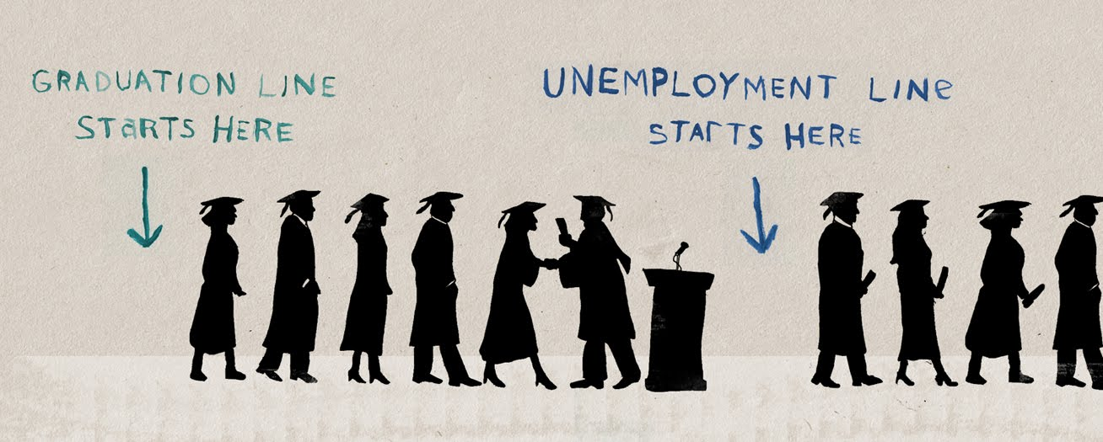

**Unemployment rate**

Unemployment is the ratio of the unemployed persons to the total labour force and is expected in percentage terms. Thus

Rate of unemployment = No. of unemployed persons X 100

Total labour force

### Forms of Unemployment:

#### 1. Open Unemployment:

Open unemployment is a situation where in a large section of the labour force does not get a job that may yield them regular income. This type of unemployment can be seen and counted in terms of the number of unemployed persons. The labour force expands at a faster rate than the growth rate of economy. Therefore all people do not get jobs.

#### 2. Disguised Unemployment:

It is a situation in which more people are doing work than actually required. Even if some are withdrawn, production does not suffer. In other words it refers to a situation of employment with surplus manpower in which some workers have zero marginal productivity.

So their removal will not affect the volume of total production. Overcrowding in agriculture due to rapid growth of population and lack of alternative job opportunities may be cited as the main reasons for disguised unemployment in India.

#### 3. Seasonal Unemployment:

It is unemployment that occurs during certain seasons of the year. In some industries and occupations like agriculture, holiday resorts, ice factories etc., production activities take place only in some seasons. So they offer employment for only a certain period of time in a year. People engaged in such type of activities may remain unemployed during the off-season.

#### 4. Cyclical Unemployment:

It is caused by trade cycles at regular intervals. Generally capitalist economies are subject to trade cycles. The down swing in business activities results in unemployment. Cyclical unemployment is normally a shot-run phenomenon.

#### 5. Educated Unemployment:

Among the educated people, apart from open unemployment, many are underemployed because their qualification does not match the job. Faulty education system, mass output, preference for white collar jobs, lack of employable skills and dwindling formal salaried jobs are mainly responsible for unemployment among educated youths in India.

#### 6. Technological Unemployment:

It is the result of certain changes in the techniques of production which may not warrant much labour. Modern technology being capital intensive requires less labourers and contributes to this kind of unemployment.

#### 7. Structural Unemployment:

This type of unemployment arises due to drastic changes in the economic structure of a country. These changes may affect either the supply of a factor or demand for a factor of production.

#### 8. Underemployment:

It is a situation in which people employed contribute less than their capacity to production. In this type of unemployment people are not gainfully employed. They may be employed either on part-time basis, or undertake a job for which lesser qualification is required. For example a Post Graduate may work as a clerk for which only S.S.L.C. is enough.

#### 9. Casual Unemployment:

When a person is employed on a day-to-day basis, casual unemployment may occur due to short-term contracts, shortage of raw materials, fall in demand, change of ownership etc.

#### 10. Chronic Unemployment:

If unemployment continues to be a long term feature of a country, it is called chronic unemployment. Rapid growth of population and inadequate level of economic development on account of vicious circle of poverty are the main causes for chronic unemployment.

#### 11. Frictional Unemployment:

Frictional unemployment is caused due to improper adjustment between supply of labour and demand for labour. This type of unemployment is due to immobility of labour, lack of correct and timely information, seasonal nature of work. Etc

Main Causes of Unemployment

**Solutions to the unemployment in India**

1. The very first solution for the unemployment is to control the rising population of our country.

2. The quality of Indian education should be improved. The current education system is not upto the level. Government should keep a strict watch on the education system and try to implement new ways to generate skilled labour force.

3. Also today’s youth should join the institute or select the course where proper training is given and the course is as per the current industries requirements.

4. Government should encourage and develop the agriculture based industries in rural areas so that the rural candidates don’t migrate to the urban areas.

5. Rapid Industrialization should be created.

6. Development of the rural areas will stop the migration of the rural people to the urban cities and this will not put more pressure on the urban city jobs.

7. Government should allow more foreign companies to open their unit in India, so that more employment opportunities will be available.

### GOVERTONMENT MEASURES TO REDUCE UNEMPLOYMENT IN INDIA AS FOLLOWS

1. RURAL WORKS PROGRAMME (RWP)
2. MARGINAL FARMERS AND AGRICULTURAL LABOURERS AGENCY ( MFALA)
3. INTEGRATED DRY LAND AGRICULTURAL DEVELOPMENT PROGRAMME (IDLADP)
4. AGRO SERVICE CENTRE (ASC)
5. EMPLOYMENT GUARANTEE SCHEME OF MAHARASHTRA ( EGS )
6. NATIONAL RURAL EMPLOYMENT PROGRAMME (NREP)
7. RURAL LANDLESS EMPLOYMENT GUARENTEE PROGRAMME (RLEGP)
8. JAWAHAR ROZGAR YOJANA (JRY)
9. TRAINING RURAL YOUTH FOR SELF EMPLOYMENT (TRYSEM)
10. **TRAINING FOR SELF-EMPLOYMENT**

POVERTY

**DEFINITIONS OF POVERTY**:

**AMARTY SEN:** “Poverty as consisting of a deprivation of a capabilities”, So that the poor have inadequate resources (financial, information, and so on) to participate fully in society in short, they are socially excluded.

**WORLD BANK :** “Poverty is pronounced as deprivation in well-being, and comprises many dimensions. It includes low incomes and the inability to acquire the basic goods and services necessary for survival with dignity. Poverty also encompasses low levels of health and education, poor access to clean water and sanitation, inadequate physical security, lack of voice and insufficient capacity and opportunity to better one’s life”

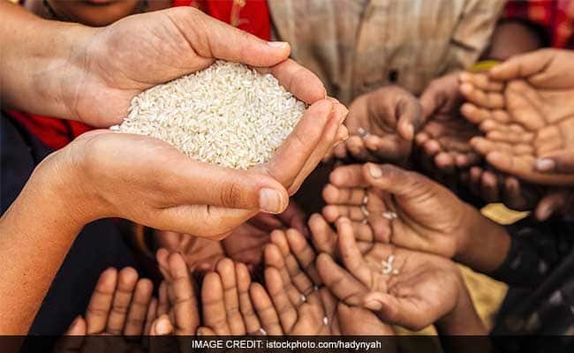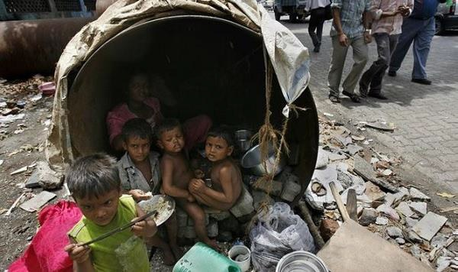

**Causes of poverty**

### Climatic factors

### Demographic factors

(i) Rapid growth of population

(ii) Size of family

### Personal causes

(i) Lack of motivation

(ii) Idleness

### 4. Economic causes

(i) Low agricultural productivity

(ii) Unequal distribution of land and other assets

(iii) Decline of village industries

(iv) Immobility of labour

(v) Lack of employment opportunities

### 5. Social causes

(i) Education

(ii) Caste system

(iii) Joint family system

(iv) Social customs

(v) Growing indebtedness

**REMEDIES TO ERADICATE POVERTY**

**1.Roshni: Skill Development Scheme for Tribal’s:**

**I.**The Ministry of Rural Development on 7 June 2013 launched a new skill development scheme designed to offer employment to tribal youth in 24 Naxal -affected districts.   
**II.**The scheme, which is named Roshni is supposed to provide training and employment to an anticipated 50000 youth in the 10-35 years age group, for a period of three years.  
**III.**As per the Ministry 50 per cent of the beneficiaries of the scheme will be women only.   
**IV.**The scheme is designed in light of the Himayat project model, which was launched in Jammu and Kashmir has been implemented in Sukma, Chhattisgarh, and West Singhbhum, Jharkand, on a pilot basis over the last 18 months.

**2.Mahatma Gandhi National Rural Employment Guarantee Scheme (MGNREGS):**

**I.**National Rural Employment Guarantee Act 2005, was launched on the 2nd Feb.2006. Now the new name of this scheme is "Mahatma Gandhi National Rural Employment Guarantee Act" (or, MGNREGA).   
**II.**This scheme is an Indian labour law and social security measure that aims to provide ‘right to work' to the people falling Below Poverty Line.   
**III.**It guarantees 100 days employment in a year to the village people.  
**IV.**Fifty percent workers should be women.  
**V.**Its 90% funding is borne by the central government and 10% by the state government.

**3. National Rural Livelihood Mission**:

**I.**This scheme was restructured from the Swarn Jayanti Gram SwarojgarYojna in 2011.  
**II.** National Rural Livelihoods Mission (Aajeevika) is aimed to empower the women’s self-help group model across the country.  
**III.** Under this scheme govt. provides loan up to 3 lakh rupee at the rate of 7% which could be lowered to 4% on the timely repayment.

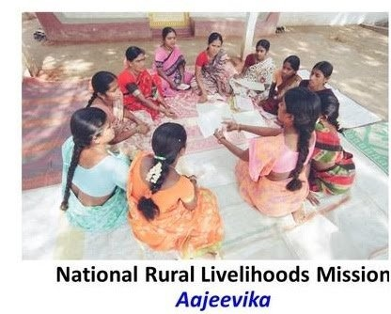

**4**. **Pradhan Mantri Gram SadakYojna:**

**I.**Initially it was 100% centrally funded scheme, launched on the December 25, 2000.  
**II.** After the recommendation of 14thfinance commission report now expenditure will be shared by the centre and state at ratio of 60:40.  
**III.** The main aim of this scheme is to provide all weather road connectivity to the rural areas whose population is more than 500 persons and in terms of hilly areas it is 250 persons.  
**IV.**This scheme is launched by the Ministry of Rural Development.

**5. Training to Rural Youth for Self Employment (TRYSEM)**

**I.** This centrally sponsored programme was started on august 15, 1979.  
**II.**The main target of this scheme was to provide technical and business expertise to rural BPL people who are in the age group of 18-35.  
**III.** This programme has been merged with Swarn Jayanti Gram SwarojgarYojna on April1, 1999.

**6. Antyodaya Anna Yojna (AAY):**

**I.** The scheme was launched by the Prime Minister Atal Bihari Bajpayi on the 25 December 2000.  
**II.**The scheme provides food grains to around 2 cr. Below Poverty Line (BPL) families at a very subsidized rate.  
**III.** Total 35 kgs of food grains is provided to a family. Rice is provided at the rate of Rs. 3/kg and wheat at 2 Rs.2/kg.

### 7. Minister’s Rozgar Yojana (PMRY):

**I**. The PMRY is a self-employment programme for the educated unemployed youth.

**II**. This programme has been implemented since October 2, 1993 to provide employment opportunities to the educated unemployed youths in the country.

**III**. The minimum qualification required under the scheme is matriculation (passed or failed) or having undergone a government sponsored technical course for a period of six months or ITI passed. In this scheme the youth between the age of 18 and 35 belonging to families having income less than Rs. 25,000 per annum are provided assistance.

### 8.Jawahar Gram Samridhi Yojana (JGSY):

**I**.This scheme is in operation from 1999. It is implemented only at the village level to create village infrastructure and generates employment opportunities to alleviate poverty.

**SOCIAL INJUSTICE**

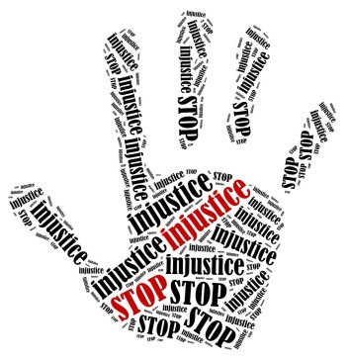

Social Injustice means that all facilities

are not given to all the persons of a

country based on caste,religion, sex,age,

level of income,physical disabilities or for

some other reasons. These disadvantaged

groups not only adversely affect economic

growth but also creates social tensions, crimes

and create barriers to social equality.

In India there is considerable discrimination on the basis of religion, race, caste , sex or place of birth.

Therefore, the Constitution of India made many provisions to give equal rights to everyone under fundamental rights ie.

* Article 14
* Article 15
* Article 16
* Article 17
* Article 23
* Article 51
* Article 45

**Causes of Social Injustice**

* **Division of society according to nature of work in four categories centuries back.**
* **Zamindar system.**
* **Lack of education freedom to women.**
* **Poverty and economic poverty.**
* **Religious injustice.**

**Efforts to reduce Social injustice**

**Millennium Development Goals to be achieved by 2015**

1. Eradicate Extreme poverty and hunger

* Halve the proportion of people living on less than $1a day.
* Halve the people suffering from hunger.

1. Achieve universal primary education.
2. Promote gender equality and empower women
3. Reduce child mortality rates by two-thirds.
4. Improve maternal health and reduce maternal mortality ratios by three quarter.
5. Combat HIV/AIDS, maternal and other disease.
6. Ensure environmental sustainability.
7. Develop a global partnership for development.

**Unit IV**

Monetary Policy of India is formulated and executed by Reserve Bank of India to achieve specific objectives. It refers to that policy by which central bank of the country controls

* + 1. the supply of money, and
    2. Cost of money or the rate of interest, with a view to achieve particular objectives.

In the words of D.C. Rowan, “The monetary policy is defined as discretionary act undertaken by the authorities designed to influence

(a) the supply of money,

(b) cost of money or rate of interest, and

(c) the availability of money for achieving specific objective.”

Thus, monetary policy of India refers to that policy which is concerned with the measures taken to regulate the volume of credit created by the banks. The main objectives of monetary policy are to achieve price stability, financial stability and adequate availability of credit for growth.

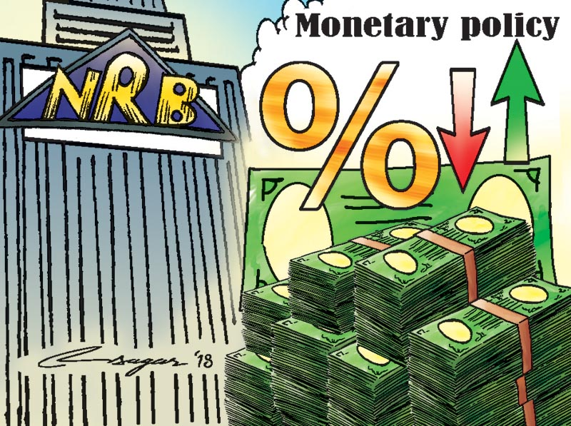

#### Following are the main elements of the monetary policy of India:

i. It regulates the stocks and the growth rate of money supply.

ii. It regulates the entire banking system of the economy.

iii. It determines the allocation of loans among different sectors

iv. It provides incentives to promote savings and to raise the savings-income ratio.

v. It ensures adequate availability of credit for growth and tries to achieve price stability.

#### Objectives of Monetary Policy:

According to RBI Governor Dr. D. Subba Rao, “The objectives of monetary policy in India are price stability and growth. These are pursued through ensuring credit availability with stability in the external value of rupee and overall financial stability.”

**Following are the main objectives of monetary policy:**

* 1. **To Regulate Money Supply in the Economy:** Money supply includes both money in circulation and credit creation by banks. Monetary policy is farmed to regulate the money supply in the economy by credit expansion or credit contraction.
  2. **To Attain Price Stability:** Another major objective of monetary policy in India is to maintain price stability in the country. It implies Control over inflation. Price level, is affected by money supply. Monetary policy regulates money supply to maintain price stability.

**iii. To promote Economic Growth:**

An important objective of monetary policy is to make available necessary supply of money and credit for the economic growth of the country. Those sectors which are quite significant for the economic growth are provided with adequate availability of credit.

**iv. To Promote saving and Investment:**

By regulating the rate of interest and checking inflation, monetary policy promotes saving and investment. Higher rates of interest promote saving and investment.

**v. To Control Business Cycles:** Boom and depression are the main phases of business cycle. Monetary policy puts a check on boom and depression. In period of boom, credit is contracted, so as to reduce money supply and thus check inflation. In period of depression, credit is expanded, so as to increase money supply and thus promote aggregate demand in the economy.

**vi. To Promote Exports and Substitute Imports:**

By providing concessional loans to export oriented and import substitution units, monetary policy encourages such industries and thus help to improve the position of balance of payments.

**vii. To Manage Aggregate Demand:**

Monetary authority tries to keep the aggregate demand in balance with aggregate supply of goods and services. If aggregate demand is to be increased than credit is expanded and the interest rate is lowered down. Because of low interest rate, more people take loan to buy goods and services and hence aggregate demand increases and vice-verse.

**viii. To Ensure more Credit for Priority Sector:**

Monetary policy aims at providing more funds to priority sector by lowering interest rates for these sectors. Priority sector includes agriculture, small- scale industry, weaker sections of society, etc.

**ix. To Promote Employment:**

By providing concessional loans to productive sectors, small and medium entrepreneurs, special loan schemes for unemployed youth, monetary policy promotes employment.

**x. To Develop Infrastructure:**

Monetary policy aims at developing infrastructure. It provides concessional funds for developing infrastructure.

**xi. To Regulate and Expand Banking:**

RBI regulates the banking system of the economy. RBI has expanded banking to all parts of the country. Through monetary policy, RBI issues directives to different banks for setting up rural branches for promoting agricultural credit. Besides it, government has also set up cooperative banks and regional rural banks. All this has expanded banking in all parts of the country.

**Measure of Money Stock**

* Knowledge of the measure of money stock in an economy would help us to understand monetary policy better.
* The Reserve bank of India employs four measures of money stock, namely, M1, M2, M3& M4.

**M1**: described as the money supply. The components of money supply are currency with the public (notes in circulation, circulation of rupee coins &small coins) and deposits (deposit with bank & other deposits with RBI).

**M2**: Is M1 + Post office Savings Bank Deposits.

**M3**: Is M1+Time Deposits with the bank. (M3 is money supply plus fixed deposits with the banks.)

**M4**: Is M3+ the total Post Office Deposits.

**Measure of**

**Money Stock**

## Monetary Policy Tools

To control inflation, the Reserve Bank of India needs to decrease the supply of money or increase cost of fund in order to keep the demand of goods and services in control.

### General Credit Controls (Quantitative tools) – it is important to stress that these are closely inter-related and have to be operated in co-ordination. All the three instruments affect the level of bank reserves.

The tools applied by the policy that impact money supply in the entire economy, including sectors such as manufacturing, agriculture, automobile, housing, etc.

1. **Reserve Ratio:**

Banks are required to keep aside a set percentage of cash reserves or RBI approved assets. Reserve ratio is of two types:

**Cash Reserve Ratio (CRR)** – Banks are required to set aside this portion in cash with the RBI. The bank can neither lend it to anyone nor can it earn any interest rate or profit on CRR.

**Statutory Liquidity Ratio (SLR)** – Banks are required to set aside this portion in liquid assets such as gold or RBI approved securities such as government securities. Banks are allowed to earn interest on these securities, however it is very low.

1. **Open Market Operations (OMO):**

Refer broadly to the purchase and sale by the Central Bank of a variety of assets, such as foreign exchange,gold, government securities and even company shares. In India, however in practice they are confined to the purchase & sale of government securities.

Central banks influence the economy either by

Increasing the money supply

(The central bank buys securities from commercial banks& public)

1. **Bank Rate Policy**- Also known as the Discount rate. The traditional definition of Bank rate is that it is the rate at which the central bank discounts or re-discounts- eligible bills. However, today the term Bank Rate is used in a broader sense and refers to the minimum rate at which the central bank provides accommodation to commercial banks in the discharge of its function as the lender of the last resort.

### Qualitative tools:

Refers to regulation of credit for specific purposes or branches of economic activity. It relates to the distribution or direction of available credit supplies.

Selective credit controls have been used in the western countries to prevent th demand for durable consumer goods outrunning the supply and generating inflationary pressure.

Unlike quantitative tools which have a direct effect on the entire economy’s money supply, qualitative tools are selective tools that have an effect in the money supply of a specific sector of the economy.

1. Margin requirements – RBI prescribes a certain margin against collateral, which in turn impacts the borrowing habit of customers. When the margin requirements are raised by the RBI, customers will be able to borrow less.
2. Moral suasion – By way of persuasion, RBI convinces banks to keep money in government securities, rather than certain sectors.
3. Selective credit control – Controlling credit by not lending to selective industries or speculative businesses.

### Fiscal policy

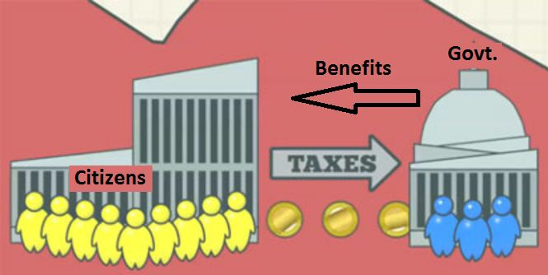

**Fiscal Policy is that part of Government policy which is concerned with raising revenue through taxation and other means and deciding on the level and patter of expenditure.**

**The fiscal policy operates through the budget. The budget is an estimate of government expenditure and revenue for the ensuing financial year, presented to Parliament usually by the Finance Minister.**

**Fiscal policy means the use of taxation and public expenditure by the government for stabilization or growth of the economy.** According to Culbarston, “By fiscal policy we refer to government actions affecting its receipts and expenditures which ordinarily as measured by the government’s receipts, its surplus or deficit.” The government may change undesirable variations in private consumption and investment by compensatory variations of public expenditures and taxes.

Fiscal policy also feeds into economic trends and influences monetary policy. **When the government receives more than it spends, it has a surplus**.

In India, the fiscal policy has to perform a significant role. Among other things, the budgetary policies are expected to achieve the following objectives:

• To promote and accelerate the growth of productive investment in the economy both in the public and the private sectors;

• To mobilize the maximum volume of real and financial resources for the investment plan of the public sector, keeping in view the expanding demand for real and financial resources of the private sector, and in this way, to promote the growth of marginal and average rates of savings in the economy;

• To promote the maintenance of a reasonable measure of economic stability in keeping with the maximum rate of growth of the economy;

• To redistribute the growing national output. There are vast differences in economic conditions, in the cultural, legal and political environment within which economic policy must operate and in the state of development of the art of taxation and the science of government.

### Objectives of Fiscal Policy

1. To maintain and achieve full employment.

2. To stabilize the price level.

3. To stabilize the growth rate of the economy.

4. To maintain equilibrium in the balance of payments.

5. To promote the economic development of underdeveloped countries.

There are two types of fiscal policy, they are:

* **Expansionary Fiscal Policy**: The policy in which the government minimises taxes and increase public spending.
* **Contractionary Fiscal Policy**: The policy in which the government increases taxes and reduce public expenditure.

| **MONETARY POLICY** | **FISCAL POLICY** |
| --- | --- |
| The main objective of the monetary policy is to achieve Price stability. | The main aim of fiscal policy is to maintain economic stability in the country and to bring Price stability. |
| **Aim** | |
| Monetary policy aims to attain Exchange rate stability. | Fiscal policy strives to promote export and introduce import substitution. |
| **Focused On** | |
| Monetary policy focuses on avoiding the negative impacts of the business cycle. | Fiscal policy concentrates on achieving balanced regional growth. |
| **Employment** | |
| Monetary policy tries to achieve full employment position. | Fiscal policy aims at social justice and full employment. |
| **Depends on** | |
| Success and failure of monetary measures depends on the banking system of the country. | Success of fiscal measures depends on the accurate predictions of various economic activities. |
| **Importance** | |
| The monetary measures are not very effective in overcoming depression. | In anti-depression fiscal policy, the expansion of public spending and reduction on taxes are the important elements. |
| **Restrictions** | |
| Monetary policy operates in a broad front, It has Institutional restrictions | The compensatory fiscal policies of the government may discourage private investment, since the private entrepreneurs have to face a competition from public enterprises |

### Comparison Chart

| **BASIS FOR COMPARISON** | **FISCAL POLICY** | **MONETARY POLICY** |
| --- | --- | --- |
| Meaning | The tool used by the government in  which it uses its tax revenue and  e xpenditure policies to affect the economy is known as Fiscal Policy. | The tool used by the central  bank to regulate the money  supply in the economy is  known as Monetary Policy. |
| Administered by | Ministry of Finance | Central Bank |
| Nature | The fiscal policy changes every year. | The change in monetary policy depends on the  economic status of the nation. |
| Related to | Government Revenue & Expenditure | Banks & Credit Control |
| Focuses on | Economic Growth | Economic Stability |
| Policy instruments | Tax rates and government spending | Interest rates and credit ratios |
| Political influence | Yes | No |

**Privatization**

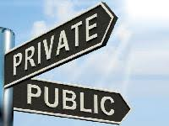

The transfer of ownership, property or business from the government to the private sector is termed privatization. The government ceases to be the owner of the entity or business.

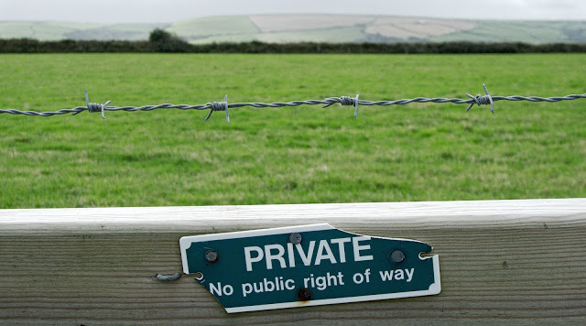

Government takes this step whenever any government enterprise does loss continuously or if the enterprise decreases profit alarmingly or if the government thinks the enterprise would cut more profit if it was operated by the private governing body.

**WHY PRIVATIZATION**

• To reduce government involvement in commercially viable activities

• Increase efficiency in the delivery of programs and services

• Provides competition in market place which transfers the lower price and greater choice for the consumers.

**Privatization is the process of transferring an enterprise or industry from the**[**public sector**](https://whatis.techtarget.com/definition/public-sector)**to the**[**private sector**](https://whatis.techtarget.com/definition/private-sector)**.**

**Methods of Privatisation**

**1. Share issue privatization** -selling shares on the stock market.

2. **Asset sale privatization**- selling entire organization to a strategic investor by auction.

3. **Voucher privatization** -distributing ownership to all for free or at lower cost.

**Sub methods:**

**1. Contracting out**:- Production of service by private firm under a contract. » Under this scenario, the private sector firm is paid directly by the government.

**Example**:¬

* collection of disposal waste.
* Other things include security services, data processing.

2. **Franchising:** -Government awarding a rights to perform services within a specific geographic area to a private firm

* The private firm generates revenue by collecting user fees
* Example:¬ Cable television, gas etc

3. **Open competition:**

* many private firms are allowed to compete for customers within a governmental jurisdiction.
* It is not appropriate for some services as it most likely would not be efficient to have multiple suppliers of electricity, gas, or water service.
* Example: It typically seen telephone and internet provider¬

**Six industries which are not reserved for private sector**

1. **Cigarette**
2. **Indian railways**
3. **Atomic energy**
4. **Chemical fertilizers**
5. **Arms and ammunition**
6. **Hazardous chemicals**

#### Arguments for and against privatization

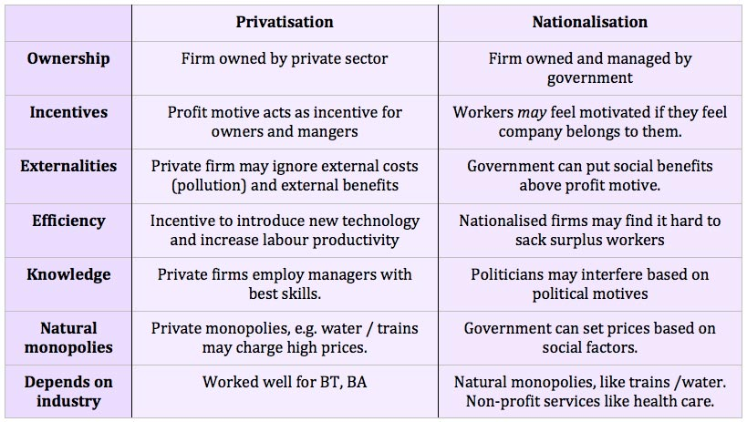

1. **Lack of Proper Strategy-**
2. **Ambiguity of objectives**
3. **Wrong timing**
4. **Lack of political Consensus**
5. **Problem of cultural Change**
6. **Poor financial Strategies**
7. **Problem of Cultural Change**
8. **Wrong labour Strategies**
9. **Prevalence of monopoly Elements.**

**Sins and Pitfalls**

**Of**

**Privatisation**

**Benefits of privatization**

1. Improved efficiency

2. Lack of political interference

3. Short term view

4. Increased competition.

**Industrial Licensing**

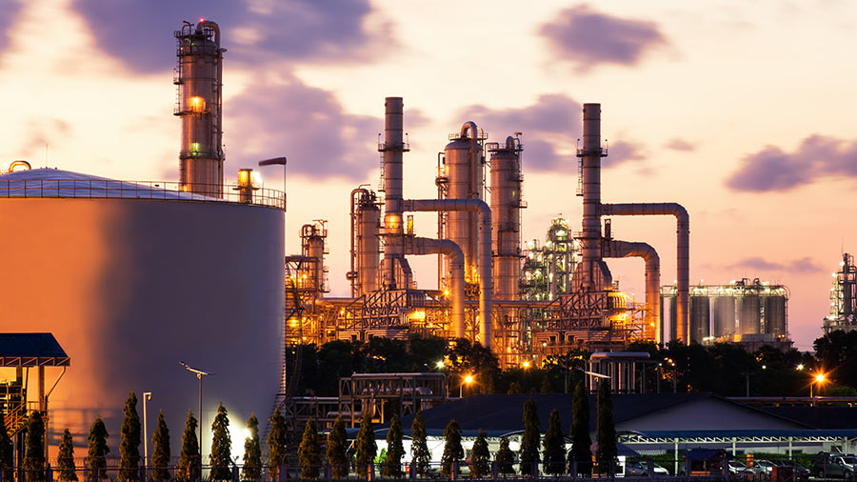

The Industrial Development and Regulation Act (IDRA), 1951 provides a basic framework for the growth and development of industries in India.

The Act mandates every existing or new industrial undertaking to register itself with the federal government.

According to the law, an ‘industrial undertaking’ is a planned industry that is carried on in one or more factories owned by an individual or authority, including government.

**Industrial licensing in India**

Industrial policy means rules, regulations, principles, policies andprocedures laid down by government for regulating, developingprocedures laid down by government for regulating, developingand controlling industrial undertakings in the country.and controlling industrial undertakings in the country.

It prescribes the respective roles of the public, private, joint andIt prescribes the respective roles of the public, private, joint andco-operative sectors for the developmentco-operative sectors for the development of industries.

Incorporates fiscal and monetary policies, tariff policy, labour Incorporates fiscal and monetary policies, tariff policy, labour policy and government attitude towards foreign capital, and role topolicy and government attitude towards foreign capital, and role tobe played by multinational corporations in the development of thebe played by multinational corporations in the development of theindustrial sector. industrial sector.

Government of India has formulated policies for industrial growthGovernment of India has formulated policies for industrial growthand development.and development.

In India, industrial licenses are regulated by the IDRA, 1951 Act, and are approved by the Secretarial of Industrial Assistance (SIA) on the recommendation of the licensing committee.

The provisions of the Act restrict a licensed industrial undertaking from manufacturing a new article unless the license has been renewed or a new license has been obtained to include the new article.

Industries that require industrial licensing for manufacturing in India include:

* Industries under compulsory licensing; and,
* Industrial undertakings attracting locational restrictions. The licensing provision also applies to the expansion of the existing industrial units.

**Industries subject to compulsory licensing in India**

Businesses planning to establish industries to produce any of the following items in India must obtain a compulsory license:

* Distillation and brewing of alcoholic drinks;
* Cigars and cigarettes of tobacco and manufactured tobacco substitutes;
* Electronics and aerospace and defense equipment;
* Industrial explosives including detonating fuses, safety fuses, gun powder, nitrocellulose and matches; and
* Hazardous chemicals including items hazardous to human safety and health and thus fall for mandatory licensing.

These industries are under compulsory licensing mainly because of environmental, safety and strategic considerations. Compulsory licensing is regulated by the Ministry of Industrial Development.

The Industries (Development & Regulation) Act, 1951, amended from time to time is one of the most effective weapons the Government possess to regulate the development and to control the activities of the Industrial sector.

Objectives-thus, the principal objective of the IDRA is to empower the Government:

* To take necessary steps for the development of industries.
* To regulate the pattern and direction of industrial development.
* To control the activities, performance and results of industrial undertakings in the public interest.

**Main Provisions**

The IDR act contains provisions to realize the above objective. Some of the salient features of the act are the following-

1. **Development Measures**: the act provides for the establishment by the Central Government, of a Central Advisory Council, consisting of representatives of the owners of industrial undertakings, employees, consumers, primary suppliers etc. for the purpose of advising the Central Governemt on matters concerning the development of the industries.
2. **Regulation of Entry and Growth**- the IDR act empower the Central Government to regulate the development of industries by means of licensing with suitable exemptions as decided by the government.
3. **Supervision & Control**- the Government under this act, can make a full and complete investigation .
4. **Take over management**- the power of control entrusted to the central Government under the IDRA extends to that of the take over of the management of the whole or any part of an industrial undertaking which fails to comply with any of the directions mentioned.
5. **Price & Distribution Controls**- to control its/their supply, distribution and price.

**Procedure for obtaining an industrial license**  
Industrial license is granted by the Secretariat for Industrial Assistance in Department of Industrial Policy and Promotion, Government of India. Application for industrial license is required to be submitted in Form FC-IL to Department of Industrial Policy and Promotion.

Devaluation

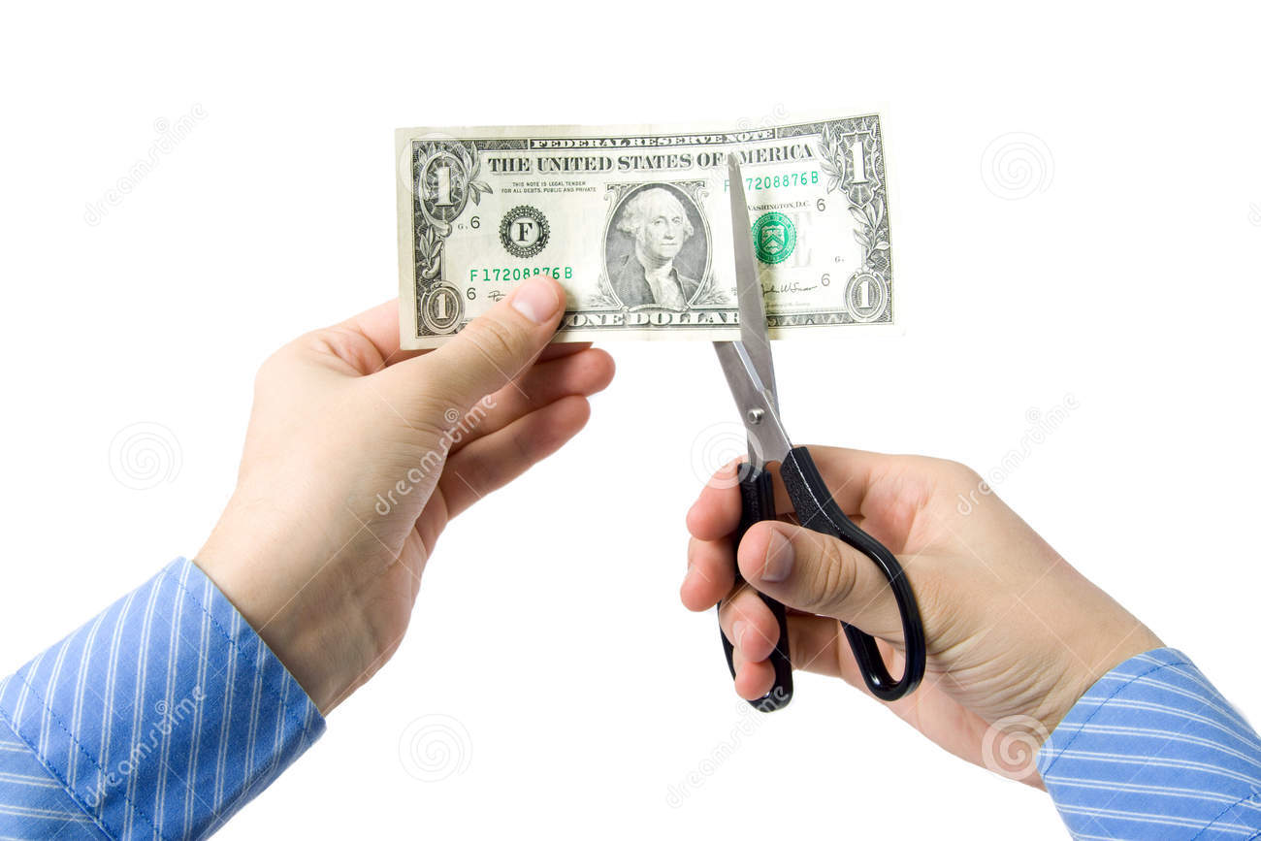

* Devaluation means decreasing the value of nation's currency relative to gold or the currencies of other nations. Under it , there is no change in the internal purchasing power of the currency.
* For example, Rs 25=1$ (before devaluation)

Rs 30=1$ (after devaluation)

• In modern monetary policy, it is a reduction in the value of currency with respect to those goods, services or other monetary units with which that currency can be exchanged.

**HISTORY OF DEVALUATION**

**The 1948 devaluation**

* It was done jointly by all those countries whose currency values were linked with pound Sterling.

**THE 1966 DEVALUATION**

* Current account deficit of over 290 crore due to¬ second five year plan
* Inflation has caused Indian prices to become much¬ higher than world prices
* Budget deficit due to defense spending in 1965/1966¬ was 24.06% of total expenditure.
* Money supply increase¬
* Depleting foreign reserves¬
* The first was India's war with Pakistan in late 1965.¬
* The US and other countries friendly towards pak¬ withdrew foreign aid to India

**THE 1991 DEVALUATION**

* The trade deficit in 1990 US $9.44 billion.
* The current account deficit was US $9.7 billion.
* The gulf war to higher imports due to the rise in oil¬ prices.
* Cost pull inflation.
* Political and economical instability.
* Depleting foreign exchange reserves.
* Gold is pledged to IMF by preceding government.

**Types of Devaluation**

**Causes of Devaluation**

* Slow Export Growth
* High Growth rate of Imports
* Dependence upon Imported Oil
* Deficit Balance of trade
* Pressure on Balance of Payments
* High Inflation Rate
* Need of Export Promotion
* Discourage Imports
* Pressure of IMF
* To Encourage Import of Private Capital
* To Discourage Unofficial Dealings.
* To reduce debt burdens
* To increase competiveness in the foreign market
* To achieve higher economic growth
* To increase the standard of living.

**Effects of Devaluation**

**Industrial Policy of India since Independence**

Industrialization is an important component of [economic growth](http://www.papertyari.com/general-awareness/economics/economic-growth-economic-development/). Industrial Policy refers to the strategies adopted by government for industrial development in the country. The government of India has amended first industrial policy of India in 1948. The new industrial policy was brought to address the changing environment. The objective of present industrial policy is to globalize the Indian economy and provide freer play of market forces in domestic economy.

**Industry Policy Resolution, 1948**

Industrial Policy Resolution, 1948 (IPR, 1948) was first policy of independent India. Its main focus was that the state must play an active role in the development of industries with government stressing on the socialistic pattern of society. This policy remains in force for 8 years.

**Objectives of IPR, 1948**

* To establish social order where justice and equality of opportunity should be assured to all
* Promote rapid rise in standard of living of people through exploitation of available resource of the country
* Accelerate production to meet the needs of growing population
* Provide more and more opportunities of employment

**The Industries (Development and Regulation) Act, 1951**

IDR Act, 1951 was passed by parliament in Oct, 1991 to control and regulate industrial development in the country. Its objectives were:

* The regulation of industrial investment and production according to planned priorities and targets
* The protection of small entrepreneurs against the competition from larger industries
* Prevention of monopoly and concentration of ownership industries
* Balanced regional development with the view to reduce the disparity level of development of different regions of the country

**Provisions of the Act**

The act laid down two provisions:

* **Restrictive provisions**: Under this category, all the measures were designed to curb the unfair practices adopted by industries
  + Registration and licensing of industrial undertakings
  + Enquiry of listed industries
  + Cancelation of registration license
* **Reformative provisions**:
  + Direct regulation and control by government
  + Control on price, distribution and supply
  + Constructive measures

**Industry Policy Resolution, 1956**

IPR, 1956 replaced the IPR, 1948. It stressed on:

* Speeding up the pace of industrialization, particularly heavy industries
* Expansion of public sector and growth of co-operative sector
* State to take up the responsibility of setting up new industrial set up and development of transport facitlities
* Prevent private monopolies and concentration of economic process in hands of few number of individuals

The features of this policy were:

* A new classification of Industries.
* Non-discriminatory and fair treatment for the private sector.  
  Promotion of village and small-scale industries.
* To achieve development by removing regional disparity.
* Labour welfare.

**Industrial Licensing Policy of 1970**

Indian Policy Statement of 1973 identified high priority industries with investment from large industrial houses and foreign companies were permitted. Large industries were permitted to start operations in rural and backward areas with a view to developing those areas and enabling the growth of small industries around. And so the basic features of Indian Policy Statement were:

* The policy was directed towards removing the distortions, it provided for closer interaction between agriculture and industrial sector.
* Priority was given towards generation and transmission of power.
* The list of industries reserved for the small-scale sector was expanded.
* Special legislation was made to protect cottage and household industries were introduced.

**Industrial Policy 1980**

The Congress government announced this policy on July 23rd, 1980. The features of this policy are:

* Promotion of balanced growth.
* Extension and simplification of automatic expansion.
* Taking over industrial sick units.
* Regulation and control of unauthorized excess production capabilities installed for industrial houses.
* Redefining the role of small-scale units.
* Improving the performance of the public sector.

**New Industrial Policy of India, 1991**

The new Industrial Policy was announced in July, 1991 in the midst of severe economic instability in the country. The objective of the policy was to raise efficiency and accelerate [economic growth](http://www.papertyari.com/general-awareness/economics/economic-growth-economic-development/).

**Features of New Industrial Policy**

1. **Strengthening of Private Sector**

* Abolition of licensing system for large number of industries
* Greater role of private sector envisaged
* Contraction in field of operations for public sector

1. **Dismantling of controls**
2. **Dispersing Industries**
   * Policy to shift industries away from big congested cities to rural and backward areas
   * Incentives were brought to attract industries to village and backward regions
   * Favoured agro-based industries near the farming areas
3. **Limiting role of public sector**
   * Policy pointed out the grey area which were not fit for PSUs and needs to be vacated by them
4. **Liberalization of foreign investments**
   * Foreign investment in the form of FDI allowed up to 50% with automatic approval
   * Foreign investment in export promotion activities
5. **Foreign technology had been made easy by allowing automatic approvals for technology related agreements**
6. **Promotion of Small Scale Industries (SSI)**
   * It ensured adequate supply of credit these industries based on their needs
   * To enable modernization and technical up gradation, the policy allows equity participation by other non-SSI undertakings in SSI sector
   * Limited partnership was allowed to enhance the supply of risk capital to the SSI sector
   * It ensured the speedy payment towards the sale of products by SSI sector
7. **Domestic Regulatory Reforms**
   * Reduced the number of reserve industries
   * Security and Industries of strategic concern were reserved for public sector
8. **Abolition of Industrial Licensing**: It abolished industrial licensing system for all industries except few such as security and strategic concerns, social concerns, related to safety and manufacture of hazardous industries.

New Industrial policy 2017

The Government of India will be introducing a New Industrial Policy that will replace the 27-year-old existing policy and pave the way for the promotion of new technology and reduced regulations.

* The policy aims to create jobs over the next two decades, promote foreign technology transfer and attract $100 billion FDI annually.

Why the need for a new industrial policy?

* It is time to shift from a policy of continuity to radical and accelerated reforms for greater strategic engagement with the world, i.e., it is time to Reform, Perform and Transform.
* A comprehensive, actionable, outcome-oriented industrial policy will enable Industry to deliver a larger role in the economy; to fulfil its role as the engine of growth and to shoulder the responsibility of adding more value and jobs.

Constraints to Industrial Growth

* **Inadequate infrastructure:** Rapid growth of the economy has put further stress on infrastructure. Lack of quality industrial infrastructure has resulted in high logistics cost and has in turn affected cost competitiveness of Indian goods in global markets.
* **Restrictive labour laws:** The labour laws have been overly protective of the labour force in the formal sector. Though labour protection and security are required, the flipside is that it discourages employers from hiring workers on a regular basis. It has probably also led to entrepreneurs choosing to stay away from labour-intensive sectors.
* **Complicated business environment:** Complex and time taking business processes and clearances have been a disincentive for businesses.
* **Slow technology adoption:** Indian industry has been a slow adopter of new and advanced technologies. Inefficient technologies led to low productivity and higher costs adding to the disadvantage of Indian products in international markets.
* **Low productivity:** Workers in India are overwhelmingly employed in low productivity and low wage activities. Productivity as measured by value added per worker and average wages in manufacturing in India are only one-third of that in China.
* **Challenges for trade:** Manufacturing sector especially exporters are facing challenges of stagnant/shrinking global demand and rising protectionist tendencies around the world. Indian MSME sector is particularly facing tough competition from cheap imports from China and FTA countries.
* **Inadequate expenditure on R&D and Innovation:** Investments in these areas is essential to ensure growth in the industry. Public investments have been constrained and private investment is not forthcoming as these involve long gestation periods and uncertain returns.

**Earlier Industrial Policies of India**

* The **Industrial Policy Resolution of 1956** set the stage for state-owned and government-run enterprises, as well as establishing a private sector that was regulated by a “system of licences.' It did so by dividing India’s industries into three categories:
  + Industries in which the government was going to be the primary actor and the exclusive actor, thereby setting a state monopoly in defence production, iron and steel production, electricity production and distribution, and mining.
  + Industries where the state would be the primary actor in creating enterprises, but there was no state monopoly, and private actors could “supplement the effort of the state.”
  + Industries that would be open to private enterprise, but had to obtain a license from the government for standard business practices such as opening a new firm, or expanding production.
* In 1991, when India faced a severe economic crisis, the government passed a new Industrial Policy resolution. The **Industrial policy of 1991** set out directions for industrialisation in an economy that began its journey in liberalisation. It dealt with liberalising licensing and measures to encourage foreign investments. A policy for public sector enterprises and the Monopolies and Restrictive Trade Practices Act were introduced.
* The Government decided to take a series of initiatives in key areas: (a) Industrial Licensing (b) Foreign Investment (c) Foreign Technology Agreements (d) Public Sector Policy (e) MRTP Act

**UNIT V**

**Trading Environment of International Trade**

The environment of International trade is regarded as the sum total of all the external forces working upon the firm as it goes about its affairs in foreign and domestic markets.The environment can be classified in terms of domestic,foreign and international spheres of impact.The domestic environment is familiar to managers and consists of those uncontrollable external forces that affect the firm in its home market.However,it may be underlined that some of these forces(e.g. the cost of capital and export restrictions) can also have significant effect on global operations of a firm.The foreign environment can be taken as those factors, which operate in those other countries within which the MNC operates.Generally,the factors are the same, but they can have widely differing impacts from the home country situation.

The various Environmental Forces are as follows:

1. Political-Legal Environment
2. Economic
3. Cultural
4. Technological

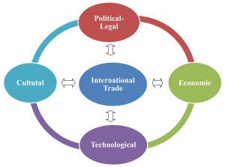

 4**. Technological Environment**

Technological Environment like its counterparts political and legal has a considerable influence on international business.Technology has facilitated international business in at least six ways:

**i.  E-Commerce**

The internet allows both small and big companies to expand their global presence at a lower cost than ever before.The internet makes it much easier for buyers and seller to find each other,wherever they may be located,and whatever their size.

**ii. Telecommunications**

Technology such as 3G,4G,MMS etc. have fostered closely knit global business.

**iii. Transportation**

In addition to developments in computers and telecommunications, several major innovations in transportation. In economic terms,the most important are probably the development of commercial jet aircraft and super freighters and the introduction of containerization, which simplifies trans-shipment from one mode of transport to another.

**iv. Globalization of production of Production**

Technological breakthroughs have facilitated globalization of production. A worldwide communications network has become essential for any MNC. Factors influencing the location of manufacturing facilities vary from country to country. They may be more favorable in foreign countries rather than in home country.

**v. Globalization of Markets**

Globalization of markets refers to the process of integrating and merging of the distinct world markets into a single market. This process involves the identification of some common norm, value, taste, preference and convenience and slowly enables the cultural shift towards the use of common product or service.

**vi. Technology Transfer**

Technology transfer and globalization are interconnected with each other. They are highly interdependent as well. The onset of globalization has brought up free passage of goods and services across the globe. The role of technology has also changed from time to time. It is currently considered as one of the important factors in the propagation of globalization.

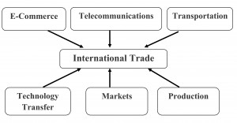

**Problems of Foreign Trade Faced by Developing Countries**

1.Primary Exporting:

2. Un-Favourable Terms of Trade:

3. Mounting Developmental and Maintenance Imports:

4. Higher Import Intensity:

5. BOP Crisis:

6. Lack of Co-ordination:

7. Depleting Foreign Exchange Reserve and Import Cover:

8. Steep Depreciation:

9. Higher Prices of POL imports:

10. International Liquidity Problem:

**Foreign Trade and the Economic Growth**

i. The primary function of foreign trade is to explore means of procuring imports of capital goods, without which no process of development can start;

ii. Trade provides for flow of technology, which allows for increases in productivity, and also result in short-term multiplier effect;

iii. Foreign trade generates pressure for dynamic change through (a) competitive pressure from imports, (b) pressure of competing export markets,- and (c) a better allocation of resources;

iv. Exports allow fuller utilisation of capacity resulting in achievement of economies of scale, separates production pattern from domestic demand, increases familiarity with absorption of new technologies;

v. Foreign trade increases most workers’ welfare. It does so at least in four ways: (a) Larger exports translate into higher wages; (b) because workers are also consumers, trade brings them immediate gains through products of imports; (c) it enables workers to become more productive as the goods they produce increase in value; and (d) trade increases technology transfers from industrial to developing countries resulting in demand for more skilled labour in the recipient countries.

vi. Increased openness to trade has been strongly associated with reduction in poverty in most developing countries. As the historian Arnold Toynbee said ‘civilisation’ has been spread though ‘mimesis’, i.e. emulation or simply copying.

**International Economic Groupings**

**The three major international economic organizations are**

**the World Bank,**

**the International Monetary Fund (IMF), and**

**the World Trade Organization (WTO).**

The WTO emerged out of the General Agreement on Tariffs and Trade (GATT) in 1995; it is an arrangement across countries that serves as a forum for negotiations on trading rules as well as a mechanism for dispute settlements in trade issues. By contrast, the World Bank and IMF deal with their member countries one at a time. They have little influence with industrial countries but can affect developing countries during times of economic crisis and when those countries seek additional foreign exchange resources. The origins and evolution of the three organizations are of considerable interest. Perhaps even more important in light of the recent financial crises in Mexico, East Asia, and a few other countries, are the questions that arise about the current and future roles of the IMF and the World Bank.

**GATT**

**Origin :-**The [General Agreement on Tariffs and Trade](https://www.wto.org/english/tratop_e/gatt_e/gatt_e.htm)was a [free trade agreement](https://www.thebalance.com/free-trade-agreement-types-and-examples-3305897) between 23 countries that eliminated [tariffs](https://www.thebalance.com/tariff-pros-cons-and-examples-3305967) and increased [international trade](https://www.thebalance.com/international-trade-pros-cons-effect-on-economy-3305579). It was the first worldwide [multilateral free trade agreement](https://www.thebalance.com/multilateral-trade-agreements-pros-cons-and-examples-3305949). It was in effect from January 1, 1948 until January 1, 1995. It ended when it was replaced by the more robust [World Trade Organization](https://www.thebalance.com/what-is-the-world-trade-organization-wto-3306366).

Inspired by the success of agreement for international monetary co-operation as reflected in the formation of the IMF, similar co-operation as reflected in international trade also was desired by many trading nations for expansion of world trade.

It was thought that for healthy world trade, attempt must be made to relax the existing trade restrictions, such as tariffs.

As such, at the [International Conference](http://www.yourarticlelibrary.com) on Trade and [Employment](http://www.yourarticlelibrary.com) held in 1946 at Havana, a proposal for establishing an agency called the International Trade Organization (ITO) was made with the miscellaneous and general objective of augmenting and maintaining world trade and employment.

Though the Havana Charter for ITO was designed as a sort of international trade constitution, it was not translated into practice due to various difficulties and lack of common agreement.

However, some of the countries took up one of the important issues of the Havana Charter regarding relaxation of trade restrictions by incorporating it into a General Agreement on Tariffs and Trade (GATT). This was signed in 1947 by some twenty-three major trading nations, including India. GATT membership has now gone up to more than 64.

As the name itself suggests, the General Agreement was concerned only with tariffs and trade restrictions and related international matters. It serves as an important international forum for carrying on negotiations on tariffs.

Under GATT, member nations meet at regular intervals to negotiate agreements to reduce quotas, tariffs and such other restrictions on international trade. GATT, by its very nature, is a contractual agreement among parties (or nations). It is a treaty that is collectively administered by the contracting nations.

However, it has become a permanent international organisation for safeguarding the conduct of international trade and an institution for the multilateral expansion of trade.

**Highlights**

* The General Agreement on Tariffs and Trade (GATT) is a multilateral agreement regulating international trade, the purpose of which is the “substantial reduction of tariffs and other trade barriers and the elimination of preferences, on a reciprocal and mutually advantageous basis”.
* The failure to create the International Trade Organization (ITO) resulted in the GATT negotiation at the UN Conference on Trade and Employment.
* GATT was in place from 1947-1993, when it was replaced by the World Trade Organization (WTO) in 1995.
* GATT text is still in effect under the WTO framework, subject to modifications.
* During GATT’s eight rounds, countries exchanged tariff concessions and reduced tariffs

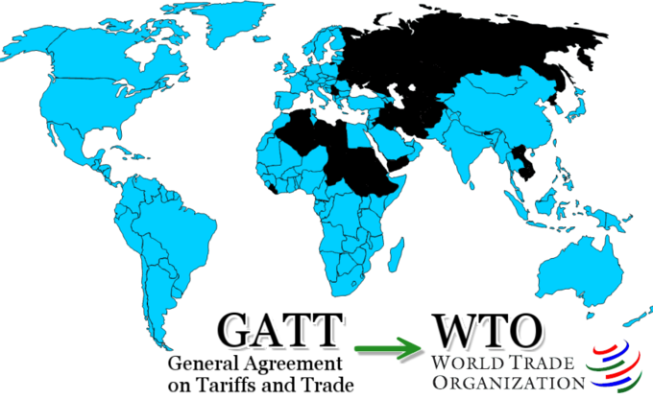

**Objectives of GATT-**

The General Agreement on Tariff and Trade was a multilateral treaty that laid down rules for conducting international trade. The preamble to the GATT can be linked to its objectives.

1. Expansion of international trade,

2. Increase of world production by ensuring full employment in the participating nations,

3. Development and full utilization of world resources

4. Raising standard of living of the world community as a whole.

However, the articles of the GATT do not provide directives for attaining these objectives. These are to be indirectly achieved by the GATT through the promotion of free (unrestricted) and multilateral international trade.

**Principles of GATT**

For the realization of the above mentioned objectives, GATT adopted the following principles.

1. Non Discrimination,
2. Protection through tariffs,
3. A stable basis of trade, and;
4. Consultation

**1. Non Discrimination:-**

The international trade should be conducted on the basis of nondiscrimination. No member country shall discriminate between the members of GATT in the conduct of international trade. On this basis, the principle “**Most favored Nation**” (MFN) was enunciated. This means that “each nation shall be treated as good as the most favored nation”.

**2. Protection through tariffs only:-**

GATT rules prohibit quantitative restrictions. Domestic industries should be protected only through customs tariffs. Restrictions on trade should be limited to the less rigid tariffs.

**3. A stable basis of trade:-**

GATT seeks to provide a stable and predictable basis for trade. It binds the tariff levels negotiated among the contracting countries. Binding of tariffs prevents the unilateral increase in tariffs, But still there is a provision for renegotiation of bound tariffs. A return to higher tariffs is discouraged by the requirement that any increase is to be compensated for.

**4. Consultation:-**

The member countries should consult one another on trade matters and problems. The members who feel aggrieved that their rights under GATT are withheld can call for a fair settlement. Panels of independent experts have been formed under the GATT council. Panel members are drawn from countries which have no direct interest in the disputes under investigation. They look into the trade disputes among members. The panel procedure aims at mutually satisfactory settlement among members.

**Most Favored Nations Clause:**

In general terms, members of GATT agree that reduction in tariffs and elimination of discrimination in inter To ensure against discrimination, members agree to grant to each other unconditional most favoured nation status in all import and export duties, with certain exceptions. Article I of the Agreement deals with the ‘most favoured nation clause meaning that any advantage, favour, privilege or immunity granted by a contracting party to any product originating in or designed for any other country shall be accorded immediately and unconditionally to a like product originating in or destined for the territories of all other contacting parties.

Thus, the principle of most favoured nation implies that each nation should be treated as the most favoured nation. As such, the contracting parties are forbidden from granting any new preference. And the negotiations and concessions materialised under bilateral agreements should be extended to all member countries on an equal basis so that the concessions are multilateralised. It also signifies that the permitted quantitative restrictions should be administered without favoring any party.

national commerce should be on a reciprocal and mutually advantageous basis.

**GATT permits such restrictions only for:**

(i) Safeguarding exchange reserves when a country has balance of payments difficulties.

(ii) Restricting imports that would harm domestic price supports and production control programmes of a country.

GATT also lays down that state trading should be non-discriminatory. However, the formation of customs unions or free trade areas are allowed by the General Agreement provided their purpose is to facilitate trade between the constituent territories and not to raise barriers to the trade of other member nations.

(iii) Underdeveloped countries to further their economic development under procedures approved by GATT.

**GATT Rounds:**

Between 1947 and 1995 there were 8 rounds of negotiations between the participating countries. The first 6 rounds were related to curtailing tariff rates, 7th round included the non-tariff obstacles.

The 8th round was entirely different from the previous rounds because it included a number of new subjects for consideration. This 8th round known as “Uruguay Round” became most controversial. The discussions at this round only gave birth to World Trade Organization (WTO).

**The World Bank**



**History**

The International Bank for Reconstruction and Development (IBRD), commonly referred to as the World Bank, is an international financial institution whose purposes include assisting the development of its member nation’s territories, promoting and supplementing private foreign investment and promoting long-range balance growth in international trade.

**The World Bank was established in December 1945 at the United Nations Monetary and Financial Conference in Bretton Woods, New Hampshire. It opened for business in June 1946 and helped in the reconstruction of nations devastated by World War II. Since 1960s the World Bank has shifted its focus from the advanced industrialized nations to developing third-world countries**

The [1944 Bretton Woods Conference](https://www.thebalance.com/bretton-woods-system-and-1944-agreement-3306133) established the World Bank. Its loans helped [European](https://www.thebalance.com/what-is-the-european-union-how-it-works-and-history-3306356) countries rebuild after [World War II](https://www.thebalance.com/world-war-ii-economic-impact-4570917). That made it the world's first multilateral development bank.

It was funded through the sale of [World Bonds](https://www.thebalance.com/what-are-bonds-and-how-do-they-work-3306235). Its [first loans](https://www.thebalance.com/what-are-savings-and-loans-history-and-today-3305959) were to France and other European countries. In the 1970s, it lent money to Chile, [Mexico](https://www.thebalance.com/mexico-s-economy-facts-opportunites-challenges-3306351), and [India](https://www.thebalance.com/india-s-economy-3306348) to build power plants and railways. By 1975, its loans had helped with a wide variety of issues. They included family planning, pollution control, and environmental protections.

World Bank lending became controversial. Many countries used their loans to prevent [a sovereign debt](https://www.thebalance.com/sovereign-debt-definition-importance-and-rankings-3306353) default. Their debt was often a result of overspending and extensive borrowing. Even with the World Bank’s help, many [countries](https://www.thebalance.com/what-happens-when-a-country-defaults-1978981) devalued their currencies. That caused [hyperinflation](https://www.thebalance.com/what-is-hyperinflation-definition-causes-and-examples-3306097).

To combat this, the Bank required [austerity measures](https://www.thebalance.com/cost-of-living-define-calculate-compare-rank-3305737). The country had to agree to cut back on spending and support its currency. Unfortunately, this usually caused a recession, making it difficult to repay the Bank's loans.

**Organization and Structure:**

The organization of the bank consists of the Board of Governors, the Board of Executive Directors and the Advisory Committee, the Loan Committee and the president and other staff members. All the powers of the bank are vested in the Board of Governors which is the supreme policy making body of the bank.

The board consists of one Governor and one Alternative Governor appointed for five years by each member country. Each Governor has the voting power which is related to the financial contribution of the Government which he represents.

The Board of Executive Directors consists of 21 members, 6 of them are appointed by the six largest shareholders, namely the USA, the UK, West Germany, France, Japan and India. The rest of the 15 members are elected by the remaining countries.

Each Executive Director holds voting power in proportion to the shares held by his Government. The board of Executive Directors meets regularly once a month to carry on the routine working of the bank.

The president of the bank is pointed by the Board of Executive Directors. He is the Chief Executive of the Bank and he is responsible for the conduct of the day-to-day business of the bank. The Advisory committees appointed by the Board of Directors.

It consists of 7 members who are expects in different branches of banking. There is also another body known as the Loan Committee. This committee is consulted by the bank before any loan is extended to a member country.

**Objectives:**

1. To provide long-run capital to member countries for economic reconstruction and development.

2. To induce long-run capital investment for assuring Balance of Payments (BoP) equilibrium and balanced development of international trade.

3. To provide guarantee for loans granted to small and large units and other projects of member countries.

4. To ensure the implementation of development projects so as to bring about a smooth transference from a war-time to peace economy.

5. To promote capital investment in member countries by the following ways;

(a) To provide guarantee on private loans or capital investment.

(b) If private capital is not available even after providing guarantee, then IBRD provides loans for productive activities on considerate conditions.

**Functions:**

World Bank is playing main role of providing loans for development works to member countries, especially to underdeveloped countries. The World Bank provides long-term loans for various development projects of 5 to 20 years duration.

**The main functions can be explained with the help of the following points:**

1. World Bank provides various technical services to the member countries. For this purpose, the Bank has established “The Economic Development Institute” and a Staff College in Washington.

2. Bank can grant loans to a member country up to 20% of its share in the paid-up capital.

3. The quantities of loans, interest rate and terms and conditions are determined by the Bank itself.

4. Generally, Bank grants loans for a particular project duly submitted to the Bank by the member country.

5. The debtor nation has to repay either in reserve currencies or in the currency in which the loan was sanctioned.

6. Bank also provides loan to private investors belonging to member countries on its own guarantee, but for this loan private investors have to seek prior permission from those counties where this amount will be collected.

**World Trade organization**

**Introduction:**

The establishment of the World Trade Organization (WTO) as the successor to ,the GATT on 1 January 1995 under the Marrakesh Agreement places the global trading system on a firm constitutional footing with the evolution of international economic legislation resulted through the Uruguay Round of GATT negotiations.

A remarkable feature of the Uruguay Round was that it paved the way for further liberalization of international trade with the fundamental shift from the negotiation approach to the institutional framework envisaged through transition from GATT to WTO Agreement.

The GATT 1947 and the WTO co-existed for the transitional period of one year in 1994. In January 1995, however, the WTO completely replaced the GATT. The membership of the WTO increased from 77 in 1995 to 127 by the end of 1996.

The Uruguay round of GATT (1986-93) gave birth to World Trade Organization. The members of GATT singed on an agreement of Uruguay round in April 1994 in Morocco for establishing a new organization named WTO.

Contrary to the temporary nature of GATT, WTO is a permanent organization which has been established on the basis of an international treaty approved by participating countries. It achieved the international status like IMF and IBRD, but it is not an agency of the United Nations Organization (UNO).

**Features of the WTO:**

**The distinctive features of the WTO are:**

i. Unlike the GATT, it is a legal entity.

ii. Unlike the International Monetary Fund (IMF) and the World Bank (WB) it is not an agent of the United Nations.

iii. Unlike the IMF and the World Bank, there is no weighted voting, but all the WTO members have equal rights.

iv. Unlike the GATT, the agreements under the WTO are permanent and binding to the member countries.

v. Unlike the GATT, the WTO dispute settlement system is based not on dilatory but automatic mechanism. It is also quicker and binding on the members. As such, the WTO is a powerful body.

vi. Unlike the GATT, the WTOs approach is rule- based and time-bound.

vii. Unlike the GATT, the WTOs have a wider coverage. It covers trade in goods as well as services.

viii. Unlike the GATT, the WTOs have a focus on trade-related aspects of intellectual property rights and several other issues of agreements.

ix. Above all, the WTO is a huge organizational body with a large secretariat.

Structure of WTO

The organisational structure of the WTO is outlined in the Chart 50.1.

The Ministerial Conference (MC) is at the top of the structural organisation of the WTO. It is the supreme governing body which takes ultimate decisions on all matters. It is constituted by representatives of (usually, Ministers of Trade) all the member countries.

The General Council (GC) is composed of the representatives of all the members. It is the real engine of the WTO which acts on behalf of the MC. It also acts as the Dispute Settlement Body as well as the Trade Policy Review Body.

There are three councils, viz.: the Council for Trade in Services and the Council for Trade-Related Aspects of Intellectual Property Rights (TRIPS) operating under the GC. These councils with their subsidiary bodies carry out their specific responsibilities

Further, there are three committees, viz., the Committee on Trade and Development (CTD), the Committee on Balance of Payments Restrictions (CBOPR), and the Committee on Budget, Finance and Administration (CF A) which execute the functions assigned to them by e WTO Agreement and the GC.

[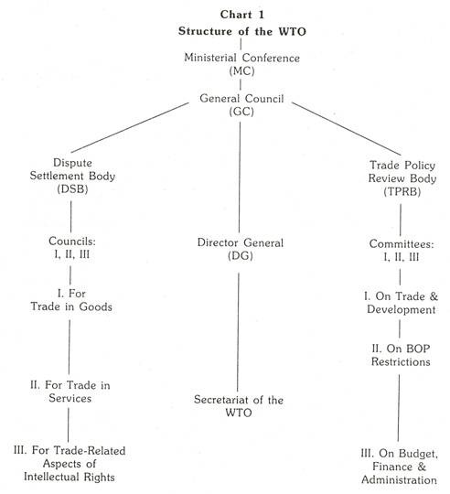](http://cdn.yourarticlelibrary.com/wp-content/uploads/2014/02/clip_image002119.jpg)

The administration of the WTO is conducted by the Secretariat which is headed by the Director General (DG) appointed by the MC for the tenure of four years. He is assisted by the four Deputy Directors from different member countries. The annual budget estimates and financial statement of the WTO are presented by the DG to the CBFA for review and recommendations for the final approval by the GC.

1. **Ministerial Conference**:  
   The topmost decision making body WTO is Ministerial Conference. It meets once in two years.
2. **General Council**: The second level of WTO is General Council. It consists of members, ambassadors and heads of delegations. It meets several times a year in Geneva.
3. **Other Councils**: There are many other types of council like Goods Council, Services Council, IP Council etc. These councils deal with specific issues.

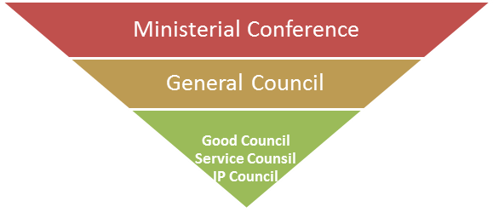

**Objectives of the WTO:**

The purposes and objectives of the WTO are spelled out in the preamble to the Marrakesh Agreement.

**In a nutshell, these are:**

1. To ensure the reduction of tariffs and other barriers to trade.

2. To eliminate discriminatory treatment in international trade relations.

3. To facilitate higher standards of living, full employment, a growing volume of real income and effective demand, and an increase in production and trade in goods and services of the member nations.

4. To make positive effect, which ensures developing countries, especially the least developed secure a level of share in the growth of international trade that reflects the needs of their economic development.

5. To facilitate the optimal use of the world’s resources for sustainable development.

6. To promote an integrated, more viable and durable trading system incorporating all the resolutions of the Uruguay Round’s multilateral trade negotiations.

Above all, to ensure that linkages trade policies, environmental policies with sustainable growth and development are taken care of by the member countries in evolving a new economic order.

Trading principles under WTO

Trade without discrimination:

* **Most Favored Nation**

If a member country of WTO grants special favor in trade to some favored country, then all other WTO countries will be given the same favor. Thus all countries become the most favored nation in all other countries, thereby making every country equal.

* **National Treatment**

It means treating foreign goods and services at par with local equally by all members of WTO

Benefits of WTO

* GATT/WTO has made significant achievements in reducing the tariff and non-tariff barriers to trade. Developing countries too have been benefiting significantly out it.
* The liberalization of investments has been fostering economic growth of a number of countries.
* The liberalization of trade and investment has been resulting in increase in competition, efficiency of resource utilization, improvement in quality and productivity and fall in prices and acceleration of economic development.
* WTO provides a forum for multilateral discussion of economic relations between nations.
* It has a system in place to settle trade disputes between nations.
* WTO has a mechanism to deal with violation of trade agreements.
* WTO does considerable research related to global trade and disseminates a wealth of information.

**Functions of WTO-**

* Administering trade agreements
* Forum for trade negotiations
* Handling trade disputes
* Monitoring national trade policies
* Technical assistance and training for developing countries
* Cooperation with other international organizations

**Drawbacks/Criticism: -**

* Negotiations and decision making in the WTO are dominated by the developed countries.
* Many developing countries do not have the financial and knowledge resources to effectively participate in the WTO discussions and negotiations.
* Because of the dependence of developing countries on the developed ones, the developed countries are able to resort to arms-twisting tactics.
* Many of the policy liberalization are done without considering the vulnerability of the developing countries and the possible adverse effect on them.
* The WTO has not been successful in imposing the organization discipline on the developed countries.
* The developing countries have, in general, been getting a raw deal from the WTO.

THE WTO IMPACT

Benefits consumers

Facilitates joint ventures & technology acquisition

Benefits the economy

Threat to domestic firms

Encourage globalization of Indians Firms

Opportunity for

Indian firms to export.

Threat to domestic firm

Increase foreign investment & comp. from

foreign firms

Facilitates

global

sourcing

**TRIPS**

**TRIMS**

**GATT**

Liberalization of

international investments

Provides monopoly power to

owners of intellectual

property.

Liberalization of trade in goods & services

Facilitates foreign

investments by Indian firms

Inc Increase

competition

from

foreign goods

/services

Benefits domestic firms

Increase

competitiveness of domestics firms

**Difference between WTO & GATT:**

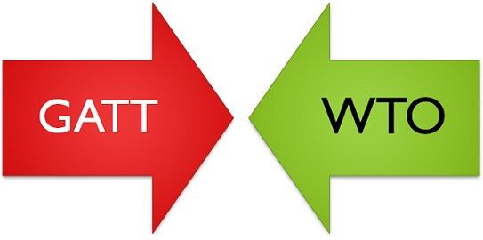

|  |  |  |
| --- | --- | --- |
| **S.No.** | **GENERAL AGREEMENT ON TARIFFS AND TRADE (GATT)** | **WORLD TRADE ORGANIZATION (WTO)** |
| 1. | GATT is a set of rules and multilateral agreement. | WTO is a permanent institution. |
| 2. | GATT is designed with an attempt to establish International Trade Organization. | WTO is established to serve its own purpose. |
| 3. | It was applied on a provisional basis. | Its activities are full and permanent. |
| 4. | Its rules are applicable to trade and merchandise goods. | Its rules are applicable to trade in merchandise services and trade in related aspects of intellect. |
| 5. | GATT was originally a multilateral instrument, but plurilateral agreements were added at a later stage. | Its agreement is almost multilateral. |
| 6. | Its dispute settlement system was not faster and automatic. | Its dispute settlement was faster and automatic. |
| 7. | It had contracting parties. | It has members. |
| 8. | It has no provisions for creating an organization. | It has a legal basis because member nations have verified the WTO agreements. |
| 9. | GATT is ad-hoc and provisional. | WTO commitments are full and permanent.. |

**International Monetary Fund**

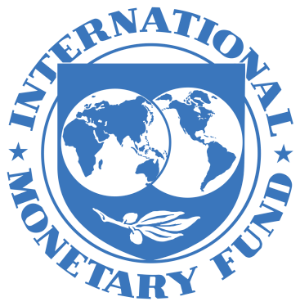

**Introduction**

* IMF is the intergovernmental organization that oversees the global financial system by following the macroeconomic policies of its member countries, in particular those with an impact on exchange rate and the balance of payments.
* It is an organization formed with a stated objective of stabilizing international exchange rates and facilitating development through the enforcement of liberalizing economic policies on other countries as a condition for loans, restructuring or aid. International Monetary Fund
* The IMF was created to support orderly international currency exchanges and to help nations having balance of payment problems through short term loans of cash.
* Its headquarters are in Washington, United States.

**Origin of IMF:**

* The origin of the IMF goes back to the days of international chaos of the 1930s. During the Second World War, plans for the construction of an international institution for the establishment of monetary order were taken up.
* At the Bretton Woods Conference held in July 1944, delegates from 44 non-communist countries negotiated an agreement on the structure and operation of the international monetary system.
* The Articles of Agreement of the IMF provided the basis of the international monetary system. The IMF com­menced financial operations on 1 March 1947, though it came into official existence on 27 December 1945, when 29 countries signed its Articles of Agreement (its charter).
* On May 2012, the IMF has near-global membership of 188 member countries. Virtually, the entire world belongs to the IMF. India is one of the founder- members of the Fund

**Objectives:**

Article 1 of the Articles of Agreement (AGA) spell out 6 purposes for which the IMF was set up.

**These are:**

I. To promote international monetary coope­ration through a permanent institution which provides the machinery for consolation and collaboration on international monetary problems.

II. To facilitate the expansion and balanced growth of international trade, and to contribute thereby to the promotion and maintenance of high levels of employment and real income and to the development of the productive resources of all members as primary objective of economic policy.

III. To promote exchange stability, to maintain orderly exchange arrangements among members, and to avoid competitive exchange depreciation.

IV. To assist in the establishment of a multila­teral system of payments in respect of current transactions between members and in the elimination of foreign exchange restrictions which hamper the growth of world trade.

V. To give confidence to members by making the general resources of the Fund tempo­rarily available to them under adequate safeguards, thus providing them with the opportunity to correct maladjustments in their balance of payments, without resor­ting to measures destructive of national or international prosperity.

VI. In accordance with the above, to shorten the duration and lessen the degree of dis­equilibrium in the international balance of payments of members.

**All these objectives of the IMF may be summarized:**

* To promote international coope­ration; to facilitate the expansion and balanced growth of international trade; to promote exchange stability; to assist in the establishment of a multi­lateral system of payments; to make its general resources available to its members experiencing balance of payments difficulties under adequate safeguards; and to shorten the duration and lessen the degree of disequilibrium in the international balance of payments of members.

**Purposes of the IMF**

* Promote international monetary cooperation.
* Expansion and balanced growth of international trade.
* Promote exchange rate stability.
* The elimination of restrictions on the international flow of capital.
* Make resources of the Fund available to members
* Help establish multilateral system of payments and eliminate foreign exchange restrictions.
* Shorten the duration and lessen the degree of disequilibrium in international balances of payment. o Foster economic growth and high levels of employment.
* Temporary financial assistance to countries to help the balance of payments adjustments.

**FUNCTIONS OF IMF**

The principal function of the IMF is to super­vise the international monetary system. Several functions are derived from this. These are: granting of credit to member countries in the midst of temporary balance of payments deficits, survei­llance over the monetary and exchange rate policy of member countries, issuing policy recommen­dations. It is to be noted that all these functions of the IMF may be combined into three.

**These are: regulatory, financial, and consultative fun­ctions:**

**Regulatory Function:**

The Fund functions as the guardian of a code of rules set by its (AOA— Articles of Agreement).

**Financial Function:**

It functions as an agency of providing resources to meet short term and medium term BOP disequilibrium faced by the member countries.

**Consultative Function:**

It functions as a centre for international cooperation and a source of counsel and technical assistance to its members.

The main function of the IMF is to provide temporary financial support to its members so that ‘fundamental’ BOP disequilibrium can be corrected. However, such granting of credit is subject to strict conditionality. The conditionality is a direct consequence of the IMF’s surveillance function over the exchange rate policies or adjustment process of members.

The main conditionality clause is the intro­duction of structural reforms. Low income countries drew attraction of the IMF in the early years of 1980s when many of them faced terrible BOP difficulties and severe debt repayment prob­lems. Against this backdrop, the Fund took up ‘stabilization programme’ as well as ‘structural adjustment programme’. Stabilization programme is a demand management issue, while structural programme concentrates on supply management. The IMF insists member countries to implement these programmes to tackle macroeconomic instability.

**Its main elements are:**

(i) Application of the principles of market economy;

(ii) Opening up of the economy by removing all barriers of trade; and

(iii) Prevention of deflation.

The Fund provides financial assistance. It includes credits and loans to member countries with balance of payments problems to support policies of adjustment and reform. It makes its financial resources available to member countries through a variety of financial facilities.

It also provides concessional assistance under its poverty reduction and growth facility and debt relief initiatives. It provides fund to combat money- laundering and terrorism in view of the attack on the World Trade Centre of the USA on 11 September 2001.

In addition, technical assistance is also given by the Fund. Technical assistance consists of expertise and support provided by the IMF to its members in several broad areas : the design and implementation of fiscal and monetary policy; institution-building, the handling and accounting of transactions with the IMF; the collection and retirement of statistical data and training of officials.

Maintenance of stable exchange rate is another important function of the IMF. It prohibits multiple exchange rates.

It is to be remembered that unlike the World Bank, the IMF is not a development agency. Instead of providing development aid, it provides financial support to tide over BOP difficulties to its members.

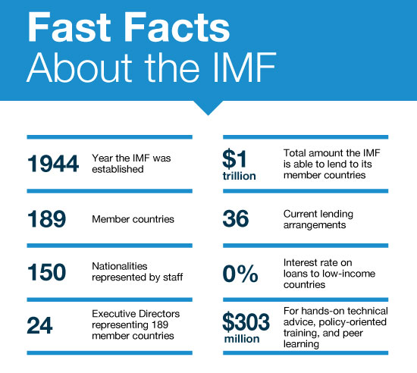

**Organization and Management of the IMF:**

Like many international organisations, the IMF is run by a Board of Governors, an Exe­cutive Board and an international staff. Every member country delegates a representative (usually heads of central banks or ministers of finance) to the Board of Governors—the top link of the chain of command. It meets once a year and takes decision on fundamental matters such as electing new members or changing quotas.

The Executive Board is entrusted to the management of day-to-day policy decisions. The Board comprises 24 executive directors who supervise the implementation of policies set by the member governments through the Board of Governors.

The IMF is headed by the Managing Director who is elected by the Executive Board for a 5 year term of office.

Rights and obligations, i.e., the balance of Powers in the Fund is determined by a system of quotas. Quotas are decided by a vote of the Board of Governors. Quotas or subscriptions roughly reflect the importance of members in the world economy. It is the quota on which payment obligation, credit facilities, and voting rights of members are determined.

**Financial Structure of the IMF:**

**The capital or the resources of the Fund come from two sources:**

(i) Subscription or quota of the member nations, and

(ii) Borrowings.

Each member country is required to subscribe an amount equivalent to its quota. It is the quota on which payment obligations, credit facilities, and voting right of members are determined. As soon as a country joins the Fund, it is assigned a quota which is expressed in Special Drawing Rights (SDRs). At the time of formation of the IMF, the quota of each member was made up of 25 p.c. in gold or 10 p.c. of its net official holdings of gold and US dollars (whichever was less). Now this has been revised.

The capital subscriptions or quota is now made up of 25 p.c. of its quota in SDRs or widely accepted currencies (such as the US dollar, euro, the yen or the pound sterling) instead of gold and 75 p.c. in country’s own currency. The size of the Fund equals the sum of the subscriptions of members. Total quotas at the end-August 2008 were SDR 217.4 billion (about $341 billion).

The Fund is authorized to borrow in special circumstances if its own resources prove to be insufficient. It sells gold to member countries to replenish currency holdings. It is entitled to borrow even from international capital market. Though the Articles of Agreement permit the Fund to borrow from the private capital market, till today no such use has been made by the IMF.

**BRICS**

BRICS is the acronym for an association of five major emerging national economies: **Brazil, Russia, India, China and South Africa**. South Africa entered in 2010.

**SOME DATA**

* Since 2009, the BRICS nations have met annually at formal summits.
* As of 2015, the five BRICS countries represent over 3.6 billion people, or about 41% of the world population; all five members are in the top 25 of the world by population, and four are in the top 10. The five nations have a combined nominal GDP of US$16.6 trillion, equivalent to approximately 22% of the gross world product, combined GDP (PPP) of around US$37 trillion and an estimated US$4 trillion in combined foreign reserves.

**RECENT SUMMITS**

* 2014 : Fortaleza, Brazil | Fortaleza Declaration
* 2015 : Ufa, Russia | Ufa Declaration + SCO, EEU Joint Meeting
* 2016 : Goa, India | Goa Declaration + BIMSTEC Joint Meeting
* 2017 : Xiamen, China | Xiamen Declaration

**FINANCIAL STRUCTURE**

* Currently, there are two components that make up the financial architecture of BRICS, namely, the **New Development Bank** (NDB) and the **Contingent Reserve Arrangement (CRA)**. Both of these components were signed into treaty in 2014 and became active in 2015.

**NEW DEVELOPMENT BANK**

* The New Development Bank (NDB), formerly referred to as the BRICS Development Bank, is a multilateral development bank operated by the BRICS states. The bank’s primary focus of lending will be infrastructure projects.
* **Headquarters** : Shanghai, China

**CONTINGENT RESERVE ARRANGEMENT**

* The BRICS Contingent Reserve Arrangement (CRA) is a framework for providing protection against global liquidity pressures.
* This includes currency issues where members’ national currencies are being adversely affected by global financial pressures.
* The CRA is generally seen as a competitor to the International Monetary Fund (IMF)  and along with the New Development Bank is viewed as an example of increasing  **South-South cooperation**.

**REGIONAL ECONOMIC INTEGRATION**

Agreements between group of countries within a geographic region To reduce & ultimately remove the tariff and non- tariff barriers to the free flow of the goods, Services and Factors of production between each other .

**ABOUT BRICS**

BRICS stands for Brazil, Russia, India, China, and® South Africa. Jim O'Neill, chairman of Goldman Sachs Asset® Management, coined the BRIC concept in 2001.

BRICS is the international political organization of® leading emerging economies.

With the entrance of South Africa, at the 3rd BRIC’s® Summit, in April 2011, the BRIC became BRICS, with capital "S".

**ABOUT BRICS FORUM**

The BRICS Forum was formed in 2011®

It is an independent international organization® that works for a structured social, economic and environmentally sustainable BRICS block.

Currently the forum is working on building® partnerships and collaborating with member state institutions.

**FOCUS OF BRICS FORUM**

To establish a development bank to balance the influence of the® World Bank and IMF, as well as creating a joint foreign exchange reserve.

* Business®
* Competitiveness®
* Governance®& Leadership
* Science®& Technology
* Poverty®
* Private Sector®&
* Prevention of Corruption
* Investment Landscape®
* Innovation in building Infrastructure®
* Trade®
* Healthcare®

**United Nations Conference on Trade and Development** (**UNCTAD**)

* The **United Nations Conference on Trade and Development** (**UNCTAD**) was established in 1964 as a permanent intergovernmental body.
* UNCTAD is the part of the [United Nations Secretariat](https://en.wikipedia.org/wiki/United_Nations_Secretariat) dealing with trade, investment, and development issues.
* The organization's goals are to: "maximize the [trade](https://en.wikipedia.org/wiki/International_trade), [investment](https://en.wikipedia.org/wiki/Foreign_direct_investment) and development opportunities of [developing countries](https://en.wikipedia.org/wiki/Developing_countries) and assist them in their efforts to integrate into the world economy on an equitable basis".
* The primary objective of UNCTAD is to formulate policies relating to all aspects of development including trade, aid, transport, finance and technology
* The United Nations Conference on Trade and Development was established to provide a forum where the developing countries could discuss the problems relating to their economic development.
* The organisation grew from the view that existing institutions like [GATT](https://en.wikipedia.org/wiki/GATT) (now replaced by the [World Trade Organization](https://en.wikipedia.org/wiki/World_Trade_Organization), WTO), the [International Monetary Fund](https://en.wikipedia.org/wiki/International_Monetary_Fund) (IMF), and [World Bank](https://en.wikipedia.org/wiki/World_Bank) were not properly organized to handle the particular problems of developing countries. Later, in the 1970s and 1980s, UNCTAD was closely associated with the idea of a [New International Economic Order](https://en.wikipedia.org/wiki/New_International_Economic_Order) (NIEO).
* UNCTAD, which is governed by its 194 member States, is the United Nations body responsible for dealing with development issues, particularly international trade – the main driver of development. Its work can be summed up in three words: think, debate, and deliver.

**Organization of the UNCTAD:**

* The UNCTAD was established as a permanent organ of General Assembly of the United Nations. However, it has its own subsidiary bodies and also a full-time secretariat to service it. It has a permanent organ called Trade and Development Board as the main executive body.
* The Board functions between the plenary sessions of the Conference. It meets twice annually. It is composed of 55 members, elected by the Conference from among its members on the basis of equitable geographical distribution.
* The Trade and Development Board have four subsidiary organs to assist it in its functions. These are:
* (1) The Committee on Commodities
* (2) The Committee on Manufactures
* (3) The Committee on Shipping
* (4) The Committee on Invisible Items and Financing related to Trade
* Generally, these committees meet annually. However, they may be called in special session to consider urgent matters.

**Objectives:-**

a) To reduce and eventually eliminate the trade gap between the developed and developing Countries, and

(b) To accelerate the rate of economic growth of the developing world.

**Functions:**

(i) To promote international trade between developed and developing countries with a view to accelerate economic development.

(ii) To formulate principles and policies on international trade and related problems of economic development.

(iii) To make proposals for putting its principles and policies into effect, negotiate trade agreements.

(iv) To review and facilitate the coordination of activities of the other U.N. institutions in the field of international trade.

(v) To function as a center for a harmonious trade and related documents in development policies of governments.

**MAIN AREAS OF WORK OF UNCTAD**

* Globalization and Development
* International Trade and Commodities
* Investment and Enterprise
* Technology and Logistics

**Major activities of UNCTAD**

1. research and support of negotiations for commodity

agreements;

(b) technical elaboration of new trade schemes; and

(c) various promotional activities designed to help

developing countries in the areas of trade and capital

flows.

**UNCTAD and GATT:**

**The UNCTAD may be distinguished from the GATT as follows:**

1. The UNCTAD is a formal, reflecting, deliberating, constructing and conciliating body while the GATT is a negotiating, committing, and controlling organisation.

2. The UNCTAD in essence is a dynamic, initiating body dedicated to economic growth and equity while the GATT poses a somewhat static view of commercial policy relations.

**GSP/GSTP**

The UNCTAD pressurized developed countries to give special preferences in tariff duties to developing countries so that they may be able to complete better and export more to developed countries. When the tariff concession had been given to selected countries it is called **Generalized Special Preferences (GSP**) .When such tariff concessions are provided to all countries if importer is so close it is called **Globalised Special tariff Preference (GSTP).**

**Difference between GSP and GSTP** –

GSP gives tariff preferences to selected underdeveloped countries, the GSTP is for tariff concession to all the countries and therefore is called Globalised Special Preferences.

**Characteristics of GSP/GSTP**

* The countries giving the preferences first lok to the benefits of producers of that country.
* Import of agricultural products is allowed mainly from least developed countries but that list differs from country to country.
* Generally there is quota limit of imports to protect local interests.
* No exporting country gets benefits on more than 50% of total quota even when other countries fail to fulfill the rest of the quota.

**Which are the product groups covered under GSP?**

The products covered under GSP are mainly agricultural products including animal husbandry, meat and fisheries and handicraft products. These products are generally the specialized products of the developing countries.

**Who are the beneficiaries under GSP?**

The beneficiaries of GSP are around 120 developing countries. As of 2017, India and Brazil were the major beneficiaries in terms of export volume realized under GSP. Imports from China and some developing countries are ineligible for GSP benefits. The beneficiaries and products covered under the scheme are revised annually.

**Following are several principles and features of the Agreement:**

* The GSTP is reserved for the exclusive participation of members of the Group of 77 and China and the benefits accrue to those members that are also ´´participants" in the Agreement.
* The GSTP must be based and applied on the principle of mutuality of advantages in such a way as to benefit equitably all participants, taking into account their respective levels of economic development and trade needs. The Agreement recognizes the special needs of the LDCs and envisages concrete preferential measures in their favour.
* To provide a stable basis for GSTP preferential trade, tariff preferences are bound and form part of the Agreement.
* The GSTP must be negotiated step-by-step and improved and extended in successive stages, with periodic reviews.
* The GSTP must supplement and reinforce present and future sub-regional, regional and interregional economic groupings of developing countries and must take into account their concerns and commitments.

**Advantages of GSP**

* It has increased competitive power of developing countries for the product included in the list with domestically produced goods.
* When a product has been import both under GSP , country exporting under GSP has benefited because of duty exemption the goods have lower landed .

**Disadvantages or limitations of GSP**

In spite of the above advantages, GSP suffers from certain limitations:

1. The scope of GSP scheme is limited. Only dutiable products are covered under this scheme. So, the developing countries cannot take advantage of the GSP in respect of duty free products. Export of duty free products by developing countries suffers.

2. GSP gives only marginal relief to the export of agricultural products. In many countries, agricultural products are outside the purview of GSP.

3. Even manufactured products like textiles, leather products and petroleum products are not covered under the scheme.

4. Some of the GSP schemes limit the volume of exports. Ceilings that limit the quantity of imports adversely affect the export prospects of less developed countries