# Limitations of Logistic Regression

Logistic regression is a simple and powerful linear classification algorithm. It also has limitations that suggest at the need for alternate linear classification algorithms.

* **Two-Class Problems**. Logistic regression is intended for two-class or binary classification problems. It can be extended for multi-class classification, but is rarely used for this purpose.
* **Unstable With Well Separated Classes**. Logistic regression can become unstable when the classes are well separated.
* **Unstable With Few Examples**. Logistic regression can become unstable when there are few examples from which to estimate the parameters.

Linear Discriminant Analysis does address each of these points and is the go-to linear method for multi-class classification problems. Even with binary-classification problems, it is a good idea to try both logistic regression and linear discriminant analysis.

# Learning LDA Models

LDA makes some simplifying assumptions about your data:

1. That your data is Gaussian, that each variable is is shaped like a bell curve when plotted.
2. That each attribute has the same variance, that values of each variable vary around the mean by the same amount on average.

With these assumptions, the LDA model estimates the mean and variance from your data for each class. It is easy to think about this in the univariate (single input variable) case with two classes.

The mean (mu) value of each input (x) for each class (k) can be estimated in the normal way by dividing the sum of values by the total number of values.

muk = 1/nk * sum(x)

Where muk is the mean value of x for the class k, nk is the number of instances with class k. The variance is calculated across all classes as the average squared difference of each value from the mean.

sigma^2 = 1 / (n-K) * sum((x – mu)^2)

Where sigma^2 is the variance across all inputs (x), n is the number of instances, K is the number of classes and mu is the mean for input x.

# Algorithm

### How does Linear Discriminant Analysis Work ?

The goal of Linear Discriminant Analysis is to project the features in higher dimension space onto a lower dimensional space.

This can be achieved in three steps :

The first step is to calculate the separability between different classes(i.e the distance between the mean of different classes) also called as between-class variance

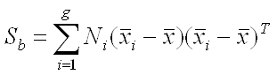

Second Step is to calculate the distance between the mean and sample of each class,which is called the within class variance

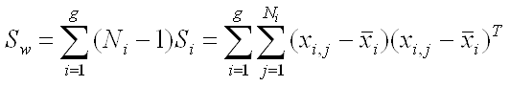

The third step is to construct the lower dimensional space which maximizes the between class variance and minimizes the within class variance.Let P be the lower dimensional space projection,which is called Fisher’s criterion.

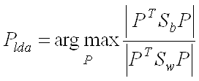

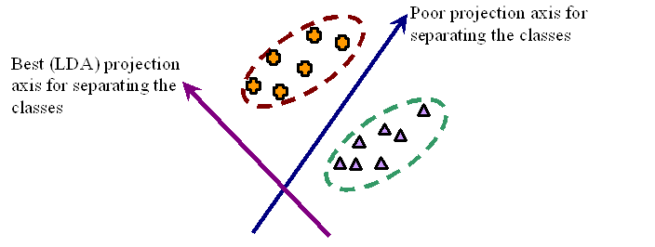

# Making Predictions with LDA

LDA makes predictions by estimating the probability that a new set of inputs belongs to each class. The class that gets the highest probability is the output class and a prediction is made.

The model uses Bayes Theorem to estimate the probabilities. Briefly [Bayes’ Theorem](https://en.wikipedia.org/wiki/Bayes%27_theorem) can be used to estimate the probability of the output class (k) given the input (x) using the probability of each class and the probability of the data belonging to each class:

P(Y=x|X=x) = (PIk * fk(x)) / sum(PIl * fl(x))

Where PIk refers to the base probability of each class (k) observed in your training data (e.g. 0.5 for a 50-50 split in a two class problem). In Bayes’ Theorem this is called the prior probability.

PIk = nk/n

The f(x) above is the estimated probability of x belonging to the class. A Gaussian distribution function is used for f(x). Plugging the Gaussian into the above equation and simplifying we end up with the equation below. This is called a discriminate function and the class is calculated as having the largest value will be the output classification (y):

Dk(x) = x * (muk/siga^2) – (muk^2/(2*sigma^2)) + ln(PIk)

Dk(x) is the discriminate function for class k given input x, the muk, sigma^2 and PIk are all estimated from your data.

# How to Prepare Data for LDA

This section lists some suggestions you may consider when preparing your data for use with LDA.

* **Classification Problems**. This might go without saying, but LDA is intended for classification problems where the output variable is categorical. LDA supports both binary and multi-class classification.
* **Gaussian Distribution**. The standard implementation of the model assumes a Gaussian distribution of the input variables. Consider reviewing the univariate distributions of each attribute and using transforms to make them more Gaussian-looking (e.g. log and root for exponential distributions and Box-Cox for skewed distributions).
* **Remove Outliers**. Consider removing outliers from your data. These can skew the basic statistics used to separate classes in LDA such the mean and the standard deviation.
* **Same Variance. LDA** assumes that each input variable has the same variance. It is almost always a good idea to standardize your data before using LDA so that it has a mean of 0 and a standard deviation of 1.