Contents

The two simplest ANOVA scenarios are 2

ANOVA Test Statistic - F 2

ANOVA - Assumptions 3

Formula 3

Example 5

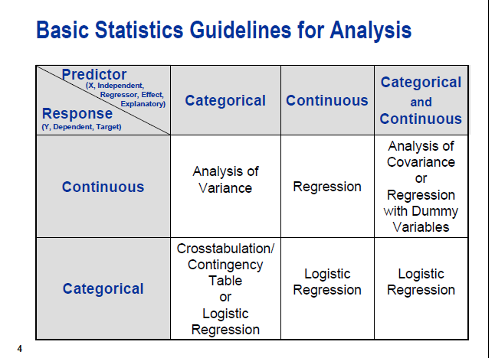

# What is this test for

The one-way analysis of variance (ANOVA) is used to determine whether there are any statistically significant differences between the means of three or more independent (unrelated) groups.

* one-way ANOVA for comparing **3 (+) groups on 1 variable**: do all children from school A, B and C have equal mean IQ scores? *
* [repeated measures ANOVA](https://www.spss-tutorials.com/spss-repeated-measures-anova/) for comparing **3(+) variables in 1 group**: is the mean rating for beer A, B and C equal for all people?*

Null hypothesis – All groups have same IQ

# What does this test do

The one-way ANOVA compares the means between the groups you are interested in and determines whether any of those means are statistically significantly different from each other. Specifically, it tests the null hypothesis:

One-way ANOVA Null Hypothesis

where *µ* = group mean and *k* = number of groups. If, however, the one-way ANOVA returns a statistically significant result, we accept the alternative hypothesis (HA), which is that there are at least two group means that are statistically significantly different from each other.

# At this point, it is important to realize that the one-way ANOVA is an ****omnibus**** test statistic and cannot tell you which specific groups were statistically significantly different from each other, only that at least two groups were. To determine which specific groups differed from each other, you need to use a ****post hoc test****. Post hoc tests are described later in this guide.

# ANOVA Test Statistic - F

So how likely are the population means to be equal? This depends on 3 pieces of information from our samples:

* the variance between sample means (MSbetween);
* the variance within our samples (MSwithin) and
* the sample sizes.

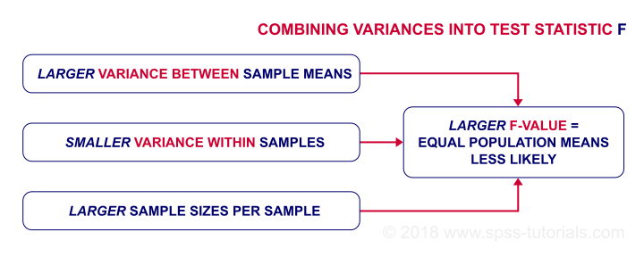

# ANOVA - Assumptions

The assumptions for ANOVA are

* independent observations;
* **normality**: the outcome variable must follow a normal distribution in each subpopulation. Normality is really only needed for small sample sizes, say n < 20 per group.
* **homogeneity**: the variances within all subpopulations must be equal. Homogeneity is only needed if sample sizes are very unequal. In this case, [Levene's test](https://www.spss-tutorials.com/levenes-test-in-spss/) indicates if it's met.

If these assumptions hold, then F follows an F-distribution with DFbetween and DFwithin degrees of freedom. In our example -3 groups of n = 10 each- that'll be F(2,27).

# Formula

**Ss between**

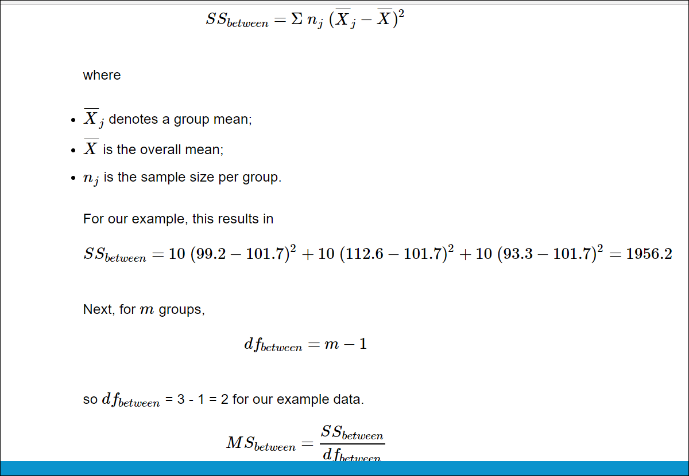

**Ss within**

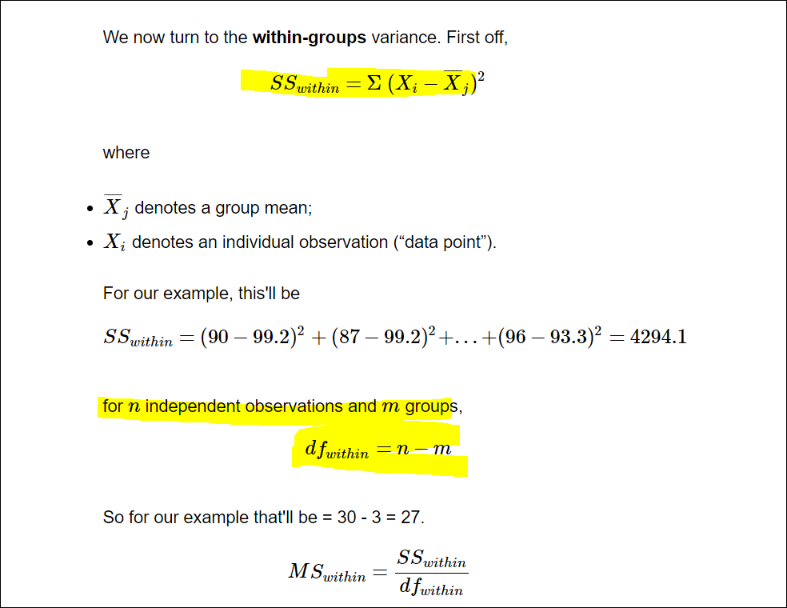

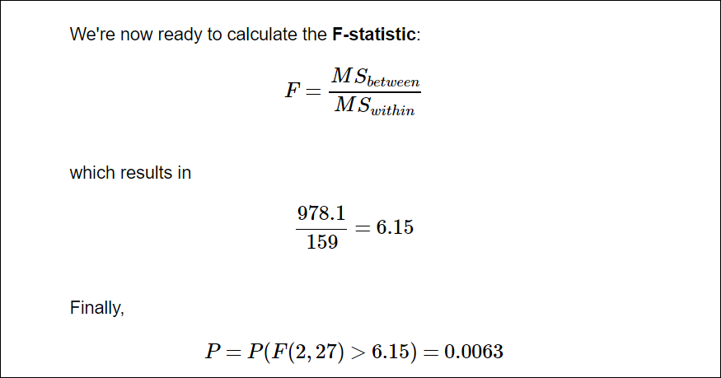

# Example

The one-way ANOVA tests whether the mean of some numeric variable differs across the levels of one categorical variable. It essentially answers the question: do any of the group means differ from one another? We won't get into the details of carrying out an ANOVA by hand as it involves more calculations than the t-test, but the process is similar: you go through several calculations to arrive at a test statistic and then you compare the test statistic to a critical value based on a probability distribution. In the case of the ANOVA, you use the "[f-distribution](https://en.wikipedia.org/wiki/F-distribution)".