# What is a Binomial Distribution?

A **binomial distribution** can be thought of as simply the probability of a SUCCESS or FAILURE outcome in an experiment or survey that is repeated multiple times. The binomial is a type of distribution that has **two possible outcomes** (the prefix “[bi](http://membean.com/wrotds/bi-twice)” means two, or twice). For example, a coin toss has only two possible outcomes: heads or tails and taking a test could have two possible outcomes: pass or fail.

# Criteria

1. Number of trials in the experiment is fixed,

2. The only outcomes are success and failure,

3. In each trial the success probability is the same, and

4. The trials are independent of each other.

# Bernauli Distribution

The binomial distribution is closely related to the [Bernoulli distribution](http://www.statisticshowto.com/bernoulli-distribution/). According to Washington State University, “If each Bernoulli trial is independent, then the number of successes in Bernoulli trails has a binomial Distribution. On the other hand, the Bernoulli distribution is the Binomial distribution with n=1.”

A [Bernouilli distribution](http://www.statisticshowto.com/bernoulli-sampling/" \t "_blank) is a set of Bernouilli trials. Each Bernouilli trial has one possible outcome, chosen from S, success, or F, failure. In each trial, the probability of success, P(S)=p, is the same. The probability of failure is just 1 minus the probability of success: P(F) = 1-p. (Remember that “1” is the total probability of an event occurring…probability is always between zero and 1). Finally, all Bernouilli trials are independent from each other and the probability of success doesn’t change from trial to trial, even if you have information about the other trials’ outcomes.

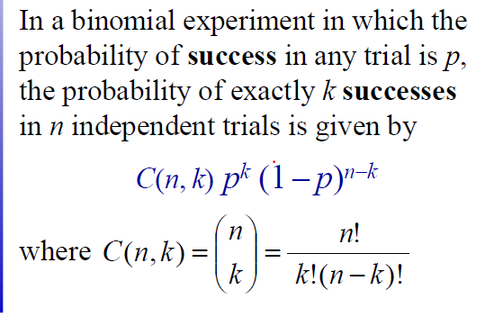

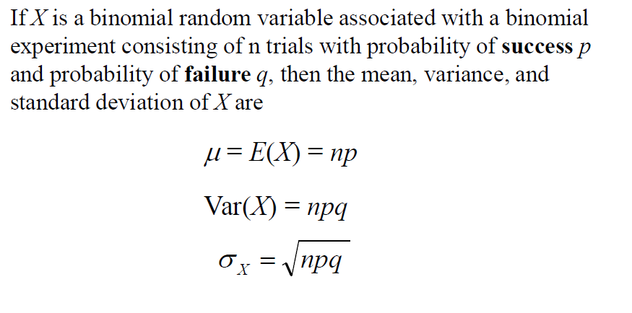

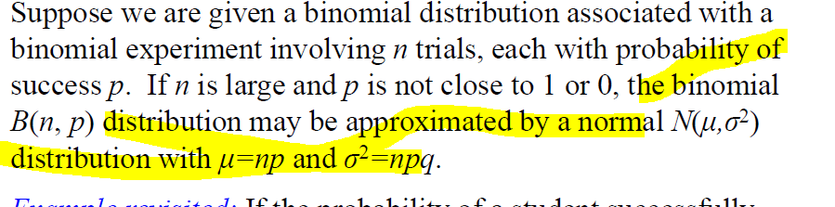

## Binomial distribution

|  |
| --- |
| ***Questio 5***  Five cards are drawn, with replacement, from a standard 52-card  deck. If drawing a club is considered a success, find the mean,  variance, and standard deviation of X (where X is the number of  successes).  Number of trials are fixed  It is a binomial distribution as each card is either a club or not.  And since it is done with replacement every experiment is independent of other experiment  And probability in each experiment is same  So p =1/4 , q=1-1/4 , mean = np, var = npq |

|  |
| --- |
| **Ten percent of computer parts produced by a certain supplier are defective. What is the probability that a sample of 10 parts contains more than 3 defective ones?**  n= 10,x=3 ,P = probability of success - .10  P(X > 3) = 1 − F(3)  1- pbinom(3,10,1/10)  If the question is atleast 3 parts  P(x>=3) 1-F(2) |

|  |
| --- |
| 1. dbinom(8,8,0.82) 2. dbinom(0,8,0.82) 3. atleast 6 pass =P(x>=6) = 1- Prob(x<=5)   1-pbinom(5,8,0.82) |

|  |
| --- |
| The Stanley Cup winner is determined in the final series between two teams. The  first team to win 4 games wins the Cup. Suppose that Dallas Stars advance to the final series, and they have a probability of 0.55 to win each game, and the game results are independent of each  other. Find the probability that  a) Dallas Stars wins the Stanley Cup  b) seven games are required to determine the Cup winner  (Hint: Without loss of generality, you can assume that the series continues until 7 games are played, even if the Cup winner is determined earlier. This ”change of Stanley Cup rules” will not change the answer to the problem!)  Suppose that the series continues until Dallas Stars win 4 games, even if the other rival wins the Cup earlier.   1. n = 7 , p = 0.55,x=3   P( Dallas wins ) = P(X >=4) = 1 - F(3) = 0.6083     1. pbinom(x,n,p) 2. First team to win 4 games will win the tournament so if 7 games are required to determine te game winner that means no team must have won 4 games   n = 6 ; p = 0.55 ;x=3  pbinom(3,n,p) - pbinom(2,n,p) |

|  |
| --- |
| **Suppose you toss a fair coin 12 times. What is the probability of getting exactly 7 Heads.**  X=7  N=12  P=1/2  dbinom(7,12,1/2)  atmost 7 heads  pbinom(7,12,1/2) |

|  |
| --- |
| ) An internet search engine looks for a certain keywordin a sequence of independent web sites. It is believed that 20% of the sites contain this keyword.  c) Out of the first 10 websites, let Y be the number of sites that contain the keyword. Find the distribution of Y .  d) Compute the expected value and the standard deviation of Y .  e) Compute the probability that at least 5 of the first 10 websites contain the keyword.  f) Compute the probability that the search engine had to visit at least 5 sites inorder to find the first occurrence of a keyword.  c) Y is Binomial(n = 10; p = 0:2).  d) E(Y ) = np = 2 and Std(Y ) =sqrt( np(1-p))  e) From the Binomial Table, P(X >=5) = 1- F(4) = 1 - 0:9672 = 0.0328 .  f) P(Y >= 5) = (1 – p(4) = 0.4096 : |

|  |
| --- |
| **Extra Credit**: (10 pts) Coin is tossed 11 times and 2 Heads and 9 Tails are recorded. The null hypothesis is that the coin is fair. Do you accept it at 5% significance level?  Hint: Take the number of Heads as your statistic of interest. Can you compute the *p value* for this statistic? Explain your reasoning.  H0 = coin is fair (p=0.5)  Ha = coin is not fair(p ≠ 0.5)  Binomial distribution  Pval = 2\*(pbinom(2,11,0.5)) = 0.06542968  Or we can just do  binom.test(2,11,0.5)  p-value = 0.06543  so we will accept the null hypothesis **, coin is fair** |