# Variance

What is variance - spread of the data

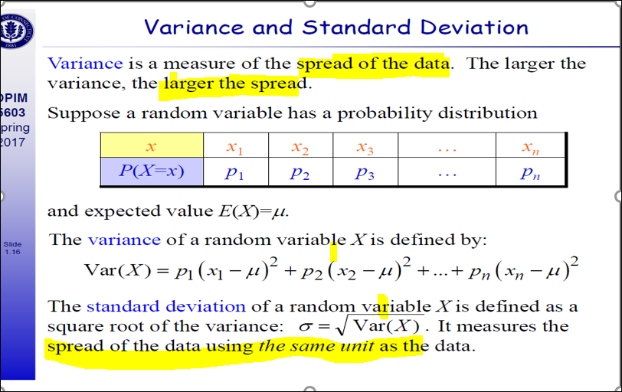

Standard deviation

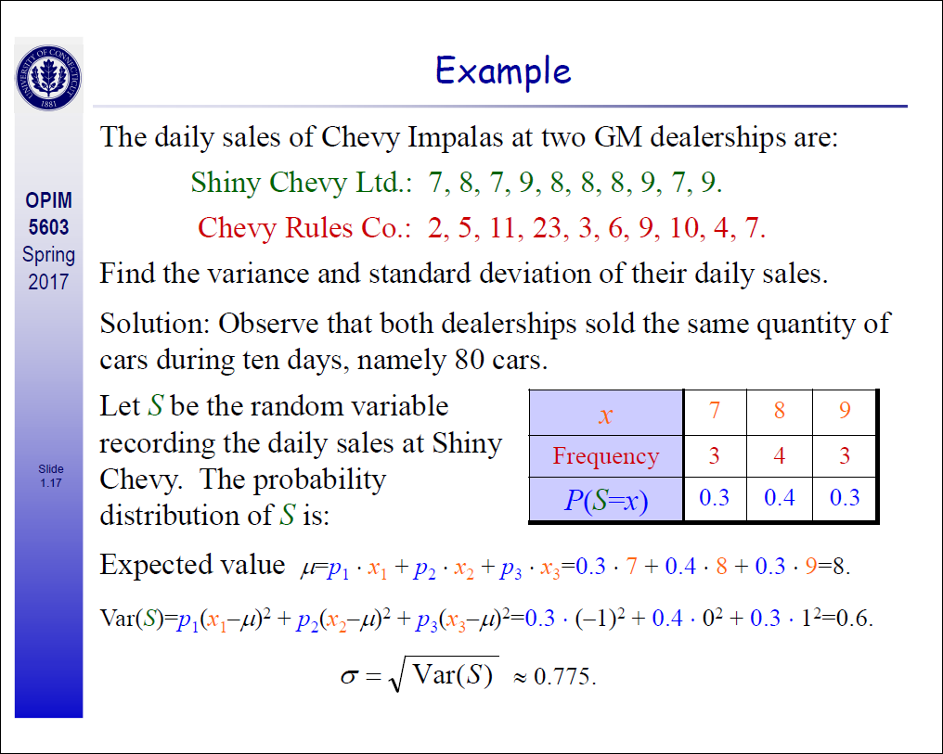

# Interview Questions

**How will you explain variance in layman terms**

You have two buckets containing billiard balls and apples. You weigh them accurate to .01g and plot the number at each weight, the billiard balls in red, the apples in blue. Since the billiard balls weigh almost exactly the same, the red curve is tall and narrow. The apples are not exactly the same, they have more variance. Statisticians call the square root of variance sigma or standard deviation. It means the width of the bell curve.

# Numericals

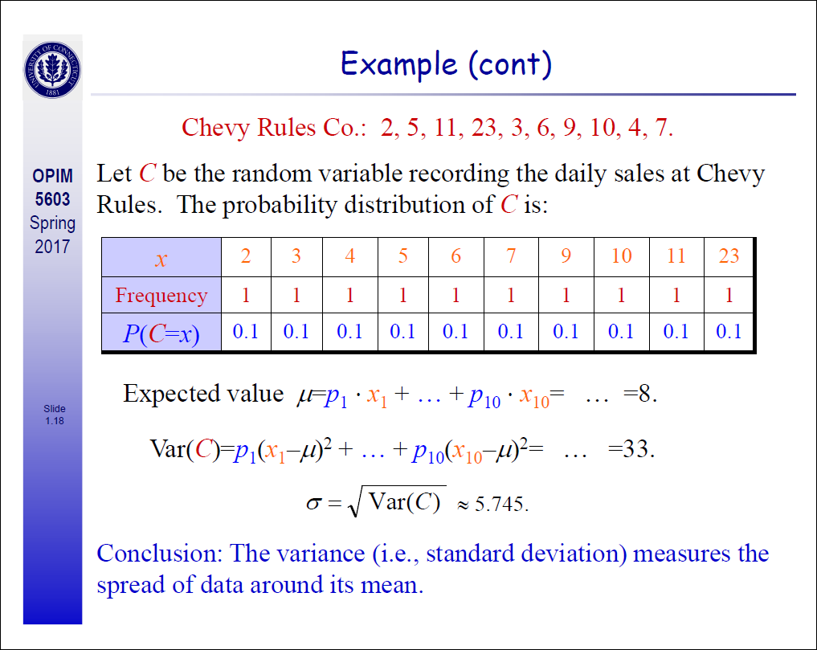

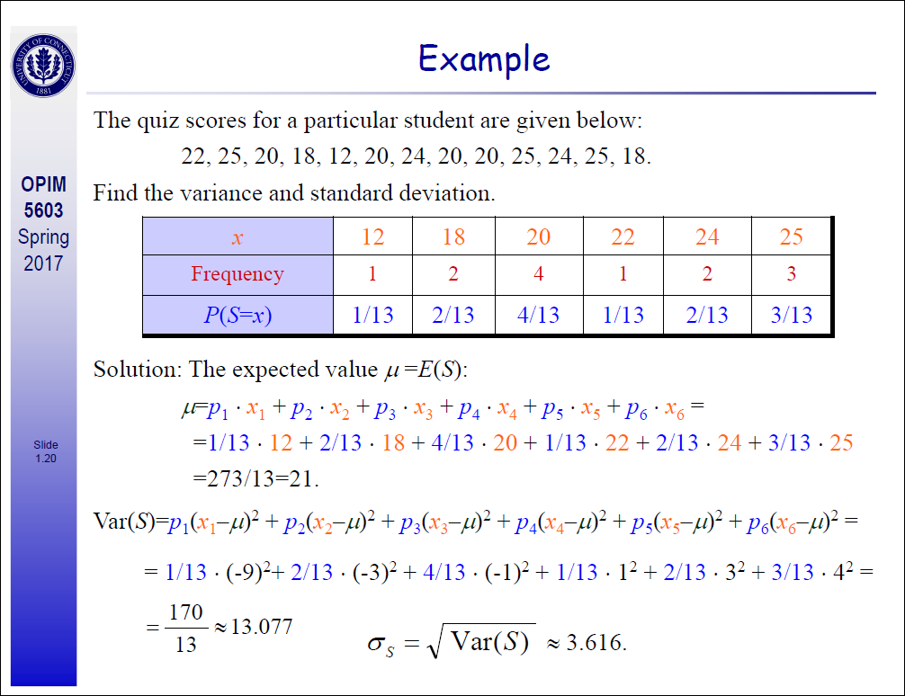

# Program to write variance and std

import math

def mean(numbers):

return sum(numbers)/float(len(numbers))

def stdev(numbers):

avg = mean(numbers)

variance = sum([pow(x-avg,2) for x in numbers])/float(len(numbers)-1)

return math.sqrt(variance)