Contents

Point Estimates 1

Interval estimator 2

Properties of estimator 2

Unbiasedness 2

Consistency 2

Efficiency 3

# Point Estimates

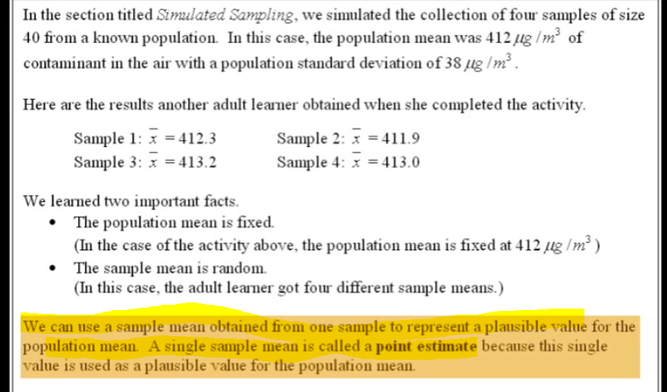

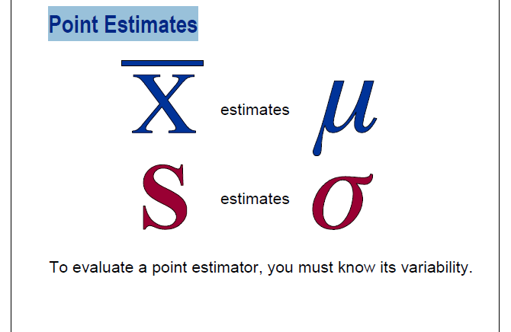

**========================================================================**

# Interval estimator

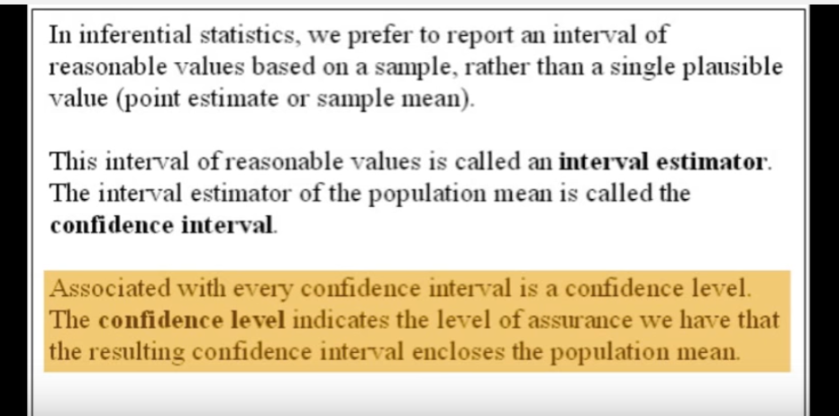

# Properties of estimator

Bias: $E\left[\hat{θ}-θ\right]$

Efficiency: $Var\left(\hat{θ}\right)$

Consistency: $plim\left(\hat{θ}\right)=θ$

Mean Squared Error: $E\left[{\left(\hat{θ}-θ\right)}^{2}\right]$

* Machine Learning (Y, prediction): bias is acceptable, generalizability (low variance) might be more important
* Causal inference (X, policy intervention): unbiasedness is critical to decision making, and efficiency (low variance) implies lower standard errors

## Unbiasedness

* + If an ordinary regression is estimated on each sample value of the Bets coefficient would change. If the value of the beta coefficient were plotted they would track a normal distribution(by assumption) . The mean of the normal distribution of beta coefficient of sampling distribution would be trur(population) parameter value.
  + Difference in the sample coefficient and population coefficient is bias
  + Expected value(sample estimator) = population parameter

We may want to make sure that the estimates are centered around the paramter of interest (the population parameter that we’re trying to estimate) •

One measurement of center is the mean, so may want to see how far the mean of the estimates is from the parameter of interest

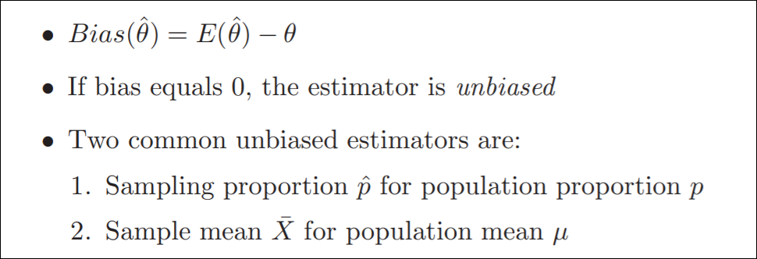

## Consistency

* + Consistency is the property that as n increases to infinity, the (on average) estimate on beta collapses onto the true population parameter
  + How far the estimator is likely to be from the underlying parameter, as sample size grows indefinitely
  + “asymptotic property” i.e large sample property
  + Definition: Let Wn be an estimator of $θ$ based on a sample Y1, Y2, …, Yn of size n. Wn is a consistent estimator of $θ$, if for every $ϵ>0$,
 $Prob.\left(\left|W_{n}-θ\right|>ϵ\right)→0 as n→∞$

 + Consistency is minimal requirement

## Efficiency

* + Out of all unbiased estimator, the efficient one is that which has the smallest variance.
  + If W1 and W2 are unbiased estimators of W, W1 is efficient relative to W2 when Var(W1)<Var(W2).
  + From previous example, for estimating population mean , Var(Y1)= whereas Var($\overline{Y}$) = $σ^{2}$/n; Here Y1 is the first observation of every sample
  + Var()<Var(Y1)

Important:

* + **First check whether estimators are unbiased.**
  + **Then, compare among unbiased estimators using efficiency**.

Interview Questions

#### What is unbiasedness as a property of an estimator? Is this always a desirable property when performing inference? What about in data analysis or predictive modeling?

* Unbiasedness means that the expectation of the estimator is equal to the population value we are estimating. This is desirable in inference because the goal is to explain the dataset as accurately as possible. However, this is not always desirable for data analysis or predictive modeling as there is the bias variance tradeoff. We sometimes want to prioritize the generalizability and avoid overfitting by reducing variance and thus increasing bias.