Assignment 7
Q.1 Problem Statement Design and implement the given network topology with three routers (R1, R2, R3), two LANs, and PCs. In addition on to configuration, analyze route select on using OSPF cost

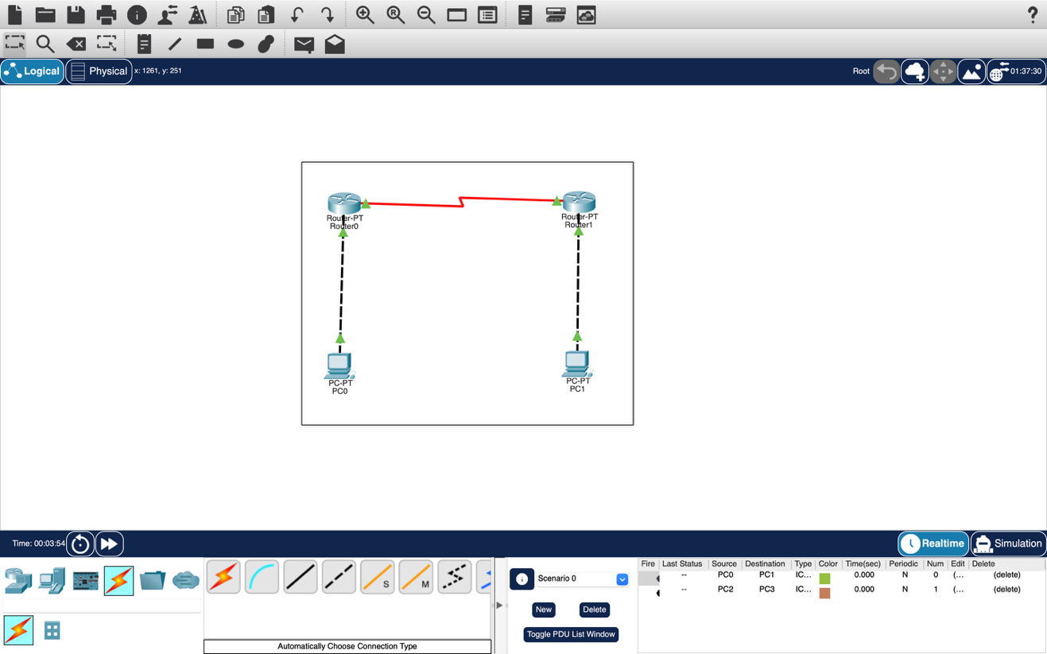

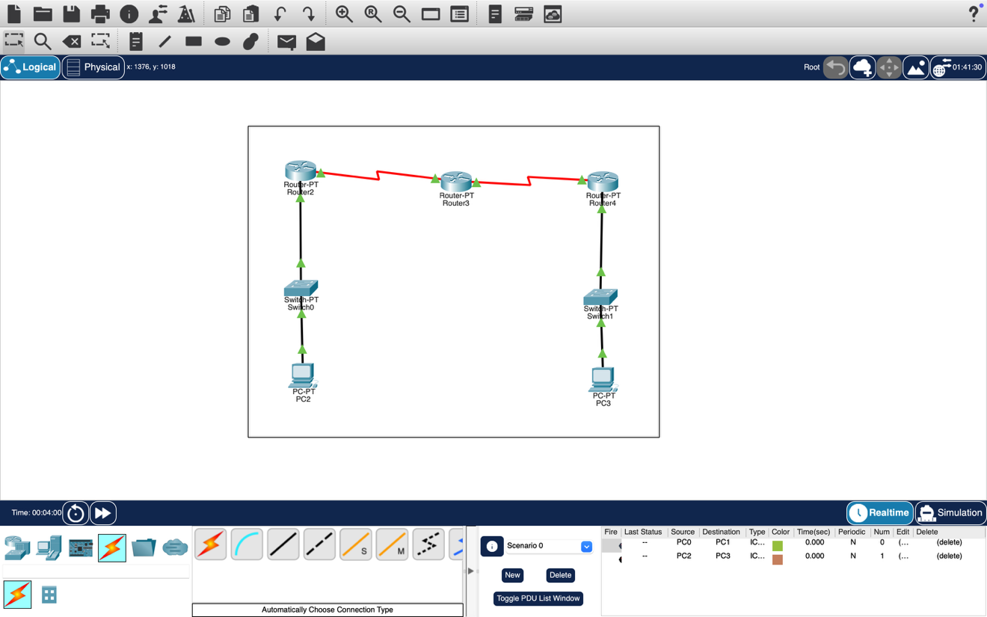

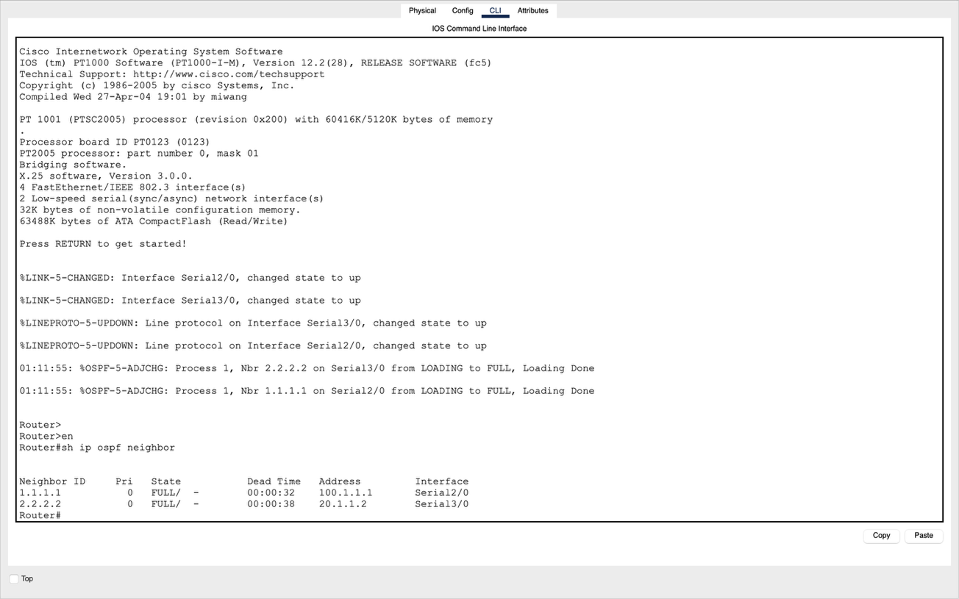

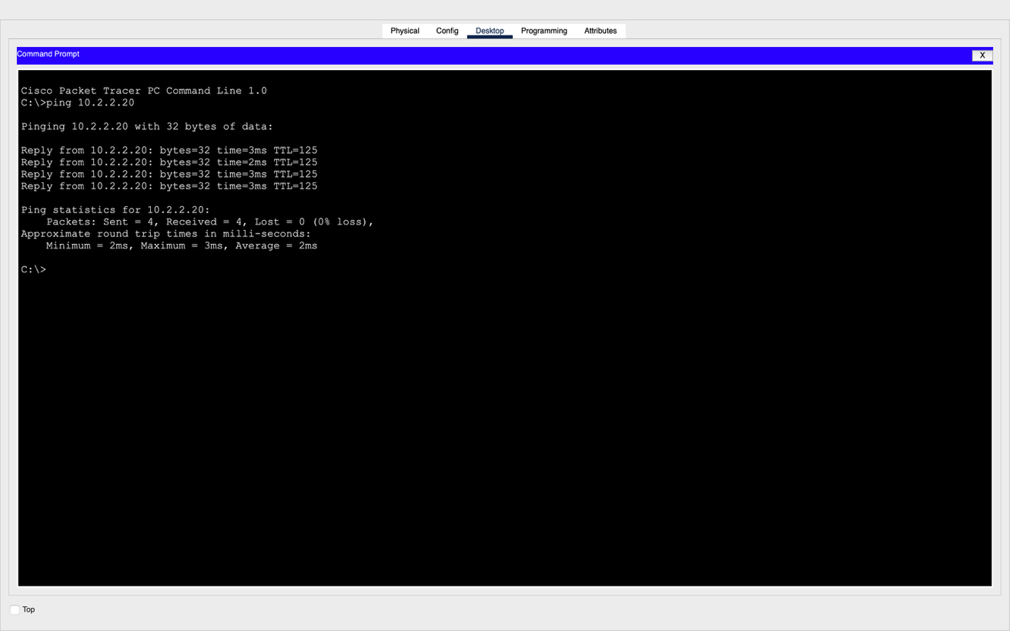

Name – Prachi
Roll No - 8025320072

