Assignment 1

To capture live network packets using Wireshark and identify basic network protocols such as TCP, UDP, IP, and DNS.

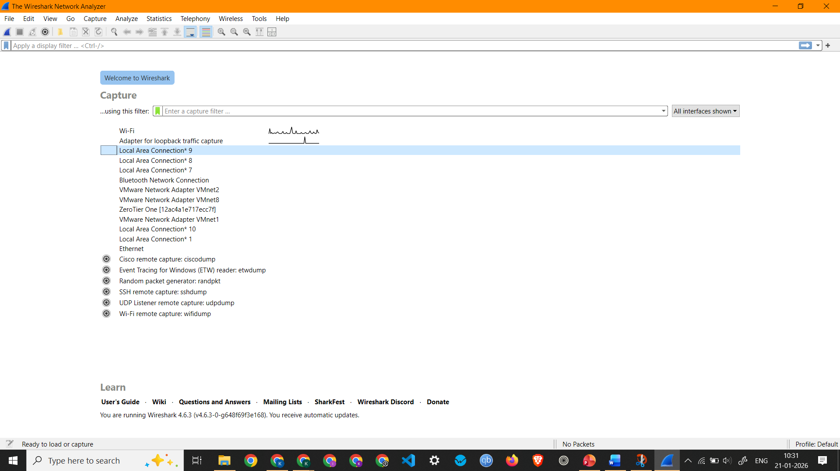

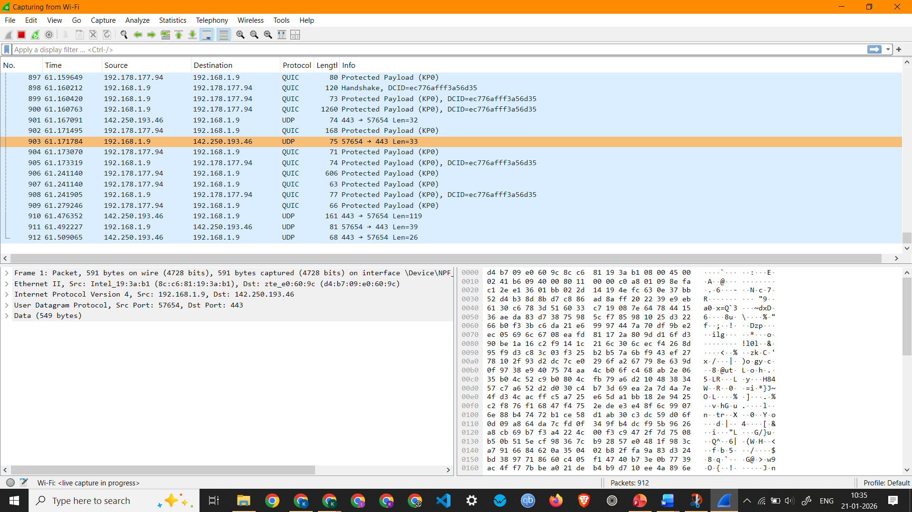
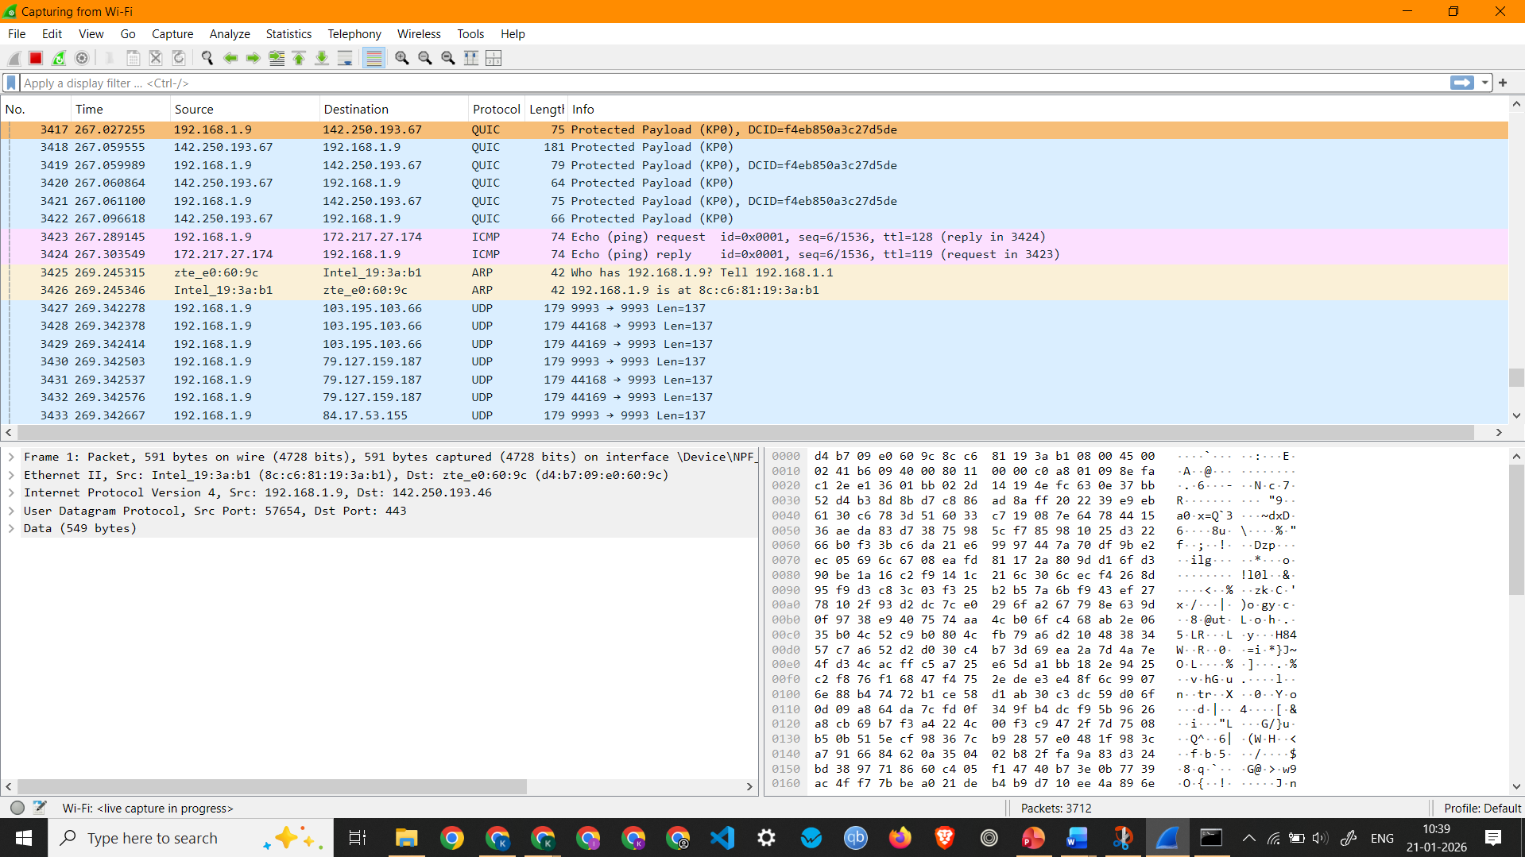

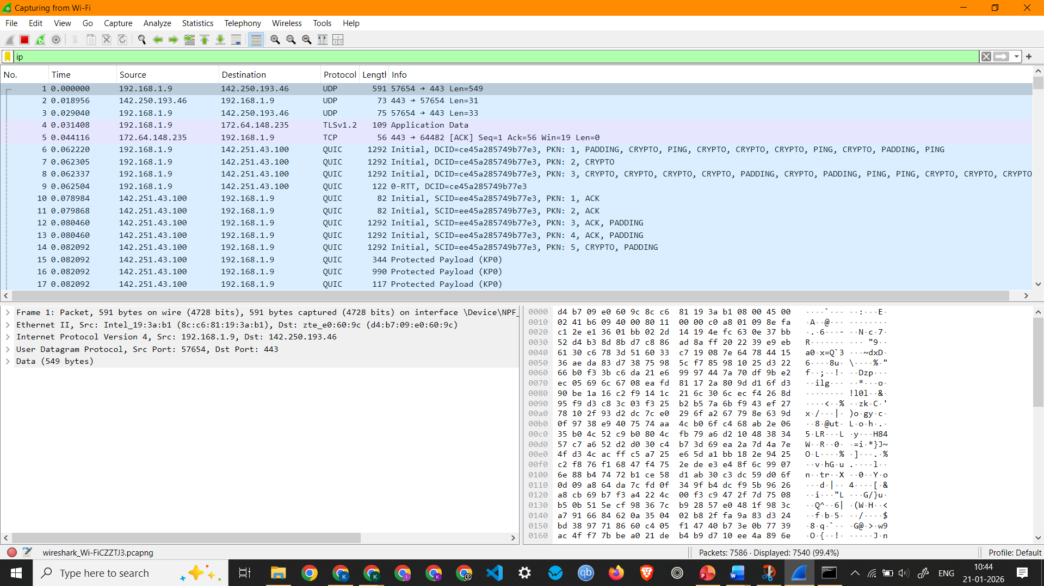
Screenshot showing IP Packets
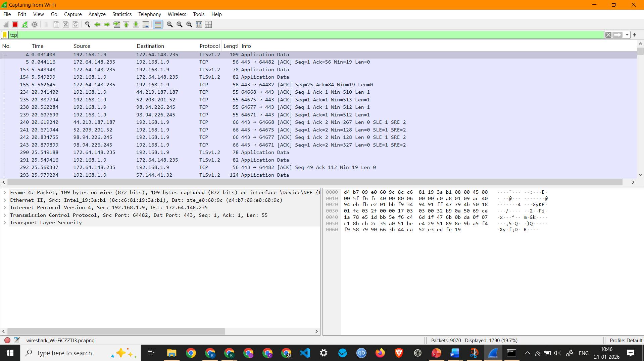
TCP Packets

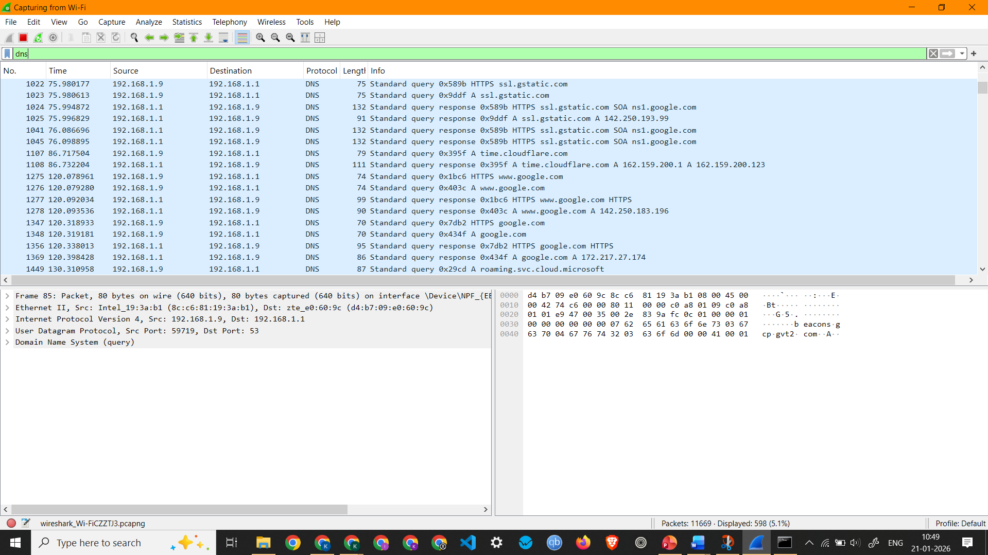
DNS Packets

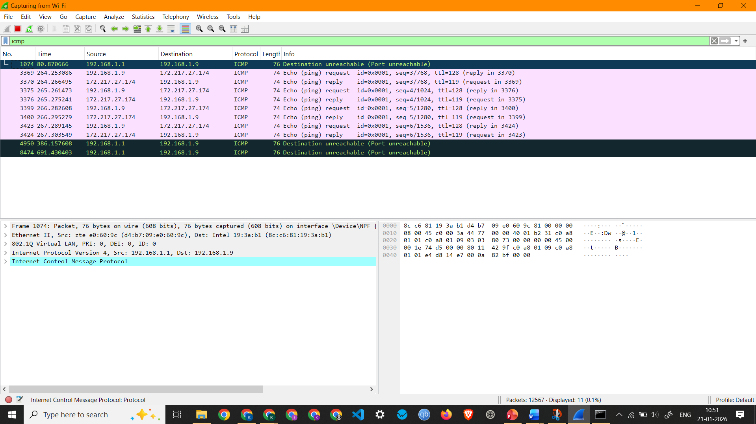
ICMP Packets
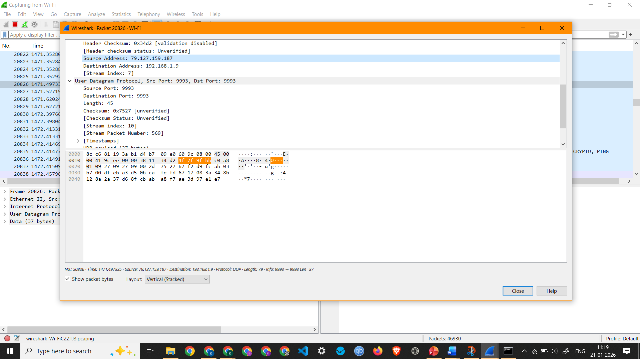
UDP Packet

Observation: UDP Packet 20826 –
  - Interface Used: Wi-Fi
  - Protocols Observed: Ethernet II, Internet Protocol Version 4, and User Datagram Protocol
  - Source IP Address: 79.127.159.187
  - Destination IP Address: 192.168.1.9
  - Packet Length: 79 Bytes

Name - Prachi
Roll No - 8025320072

