Assignment 2

1. To capture and analyze ICMP packets (Ping request and reply)
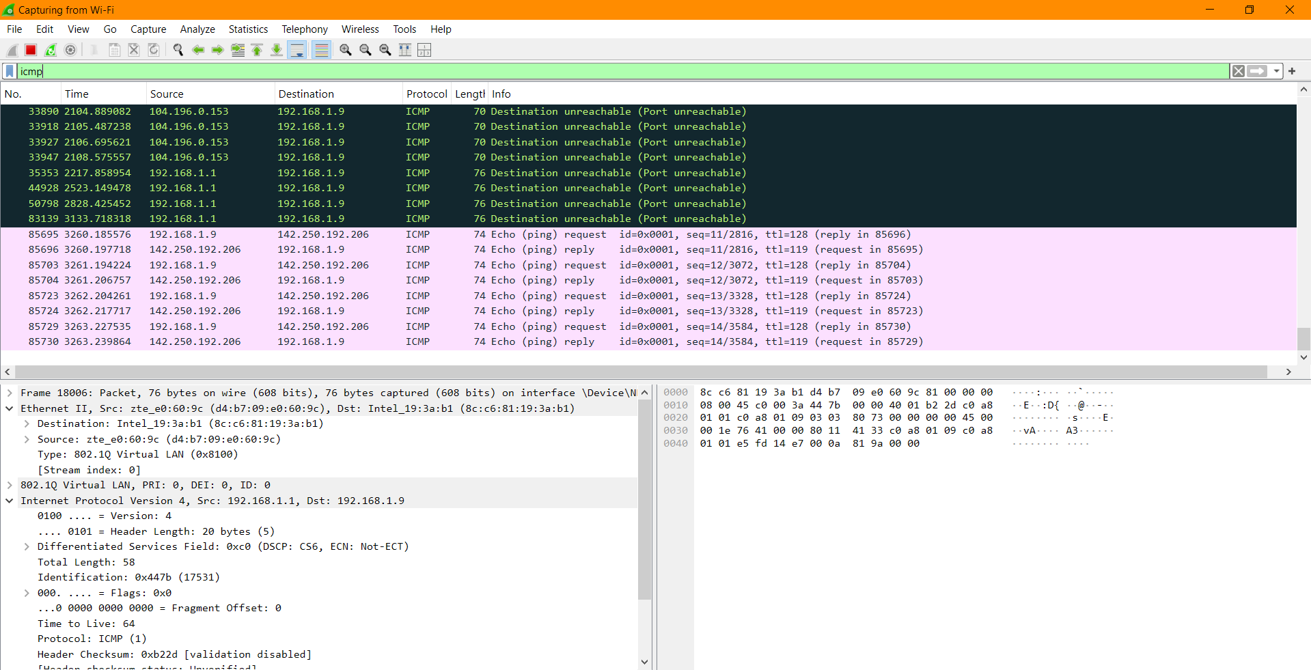
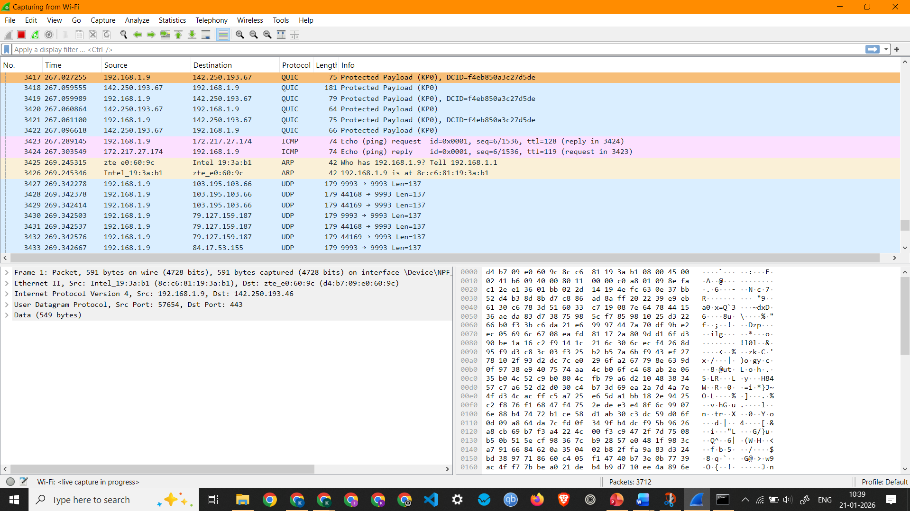

Observation and Analysis of ICMP Packet 85695 -
  - Interface Used: Wi-Fi
  - Protocols Observed: Ethernet II, Internet Protocol Version 4, and Internet Control Message Protocol
  - Source IP Address: 192.168.1.9
  - Destination IP Address: 142.250.192.206
  - Packet Length: 74 Bytes

2. To analyze TCP packets and observe the TCP three-way handshake
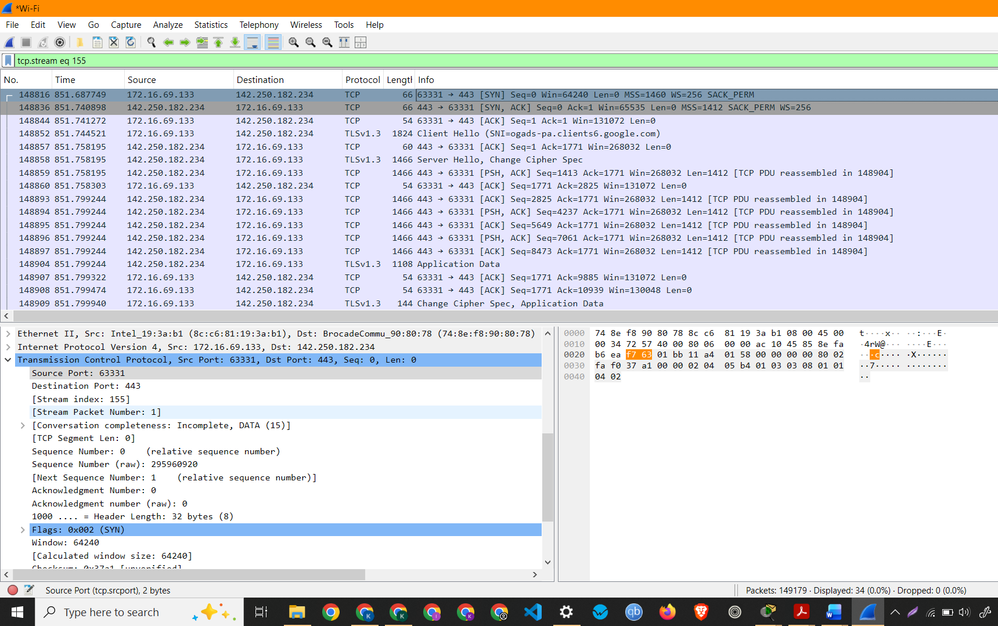
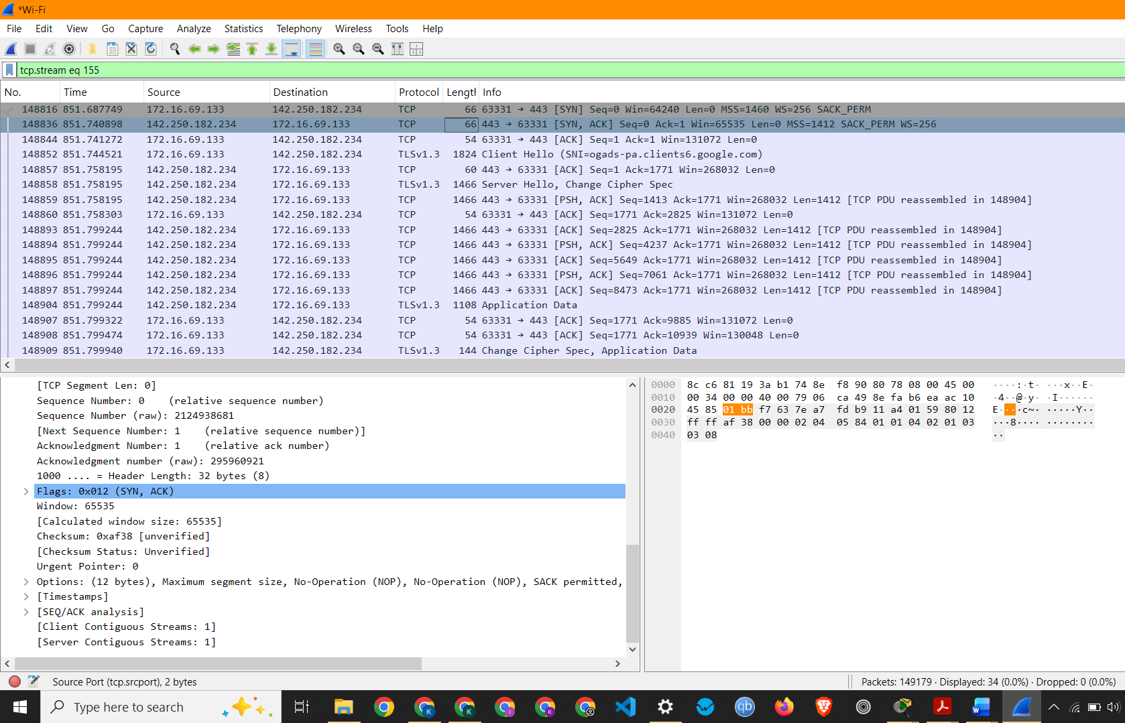

3. To capture and analyze UDP packets
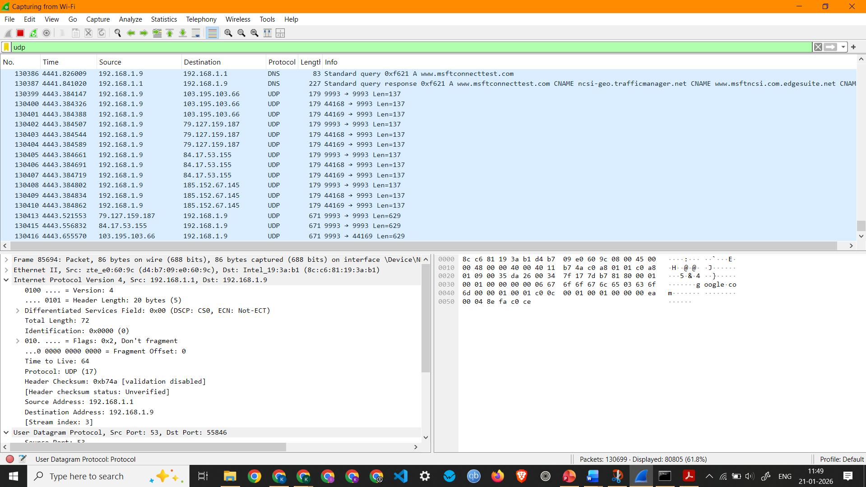
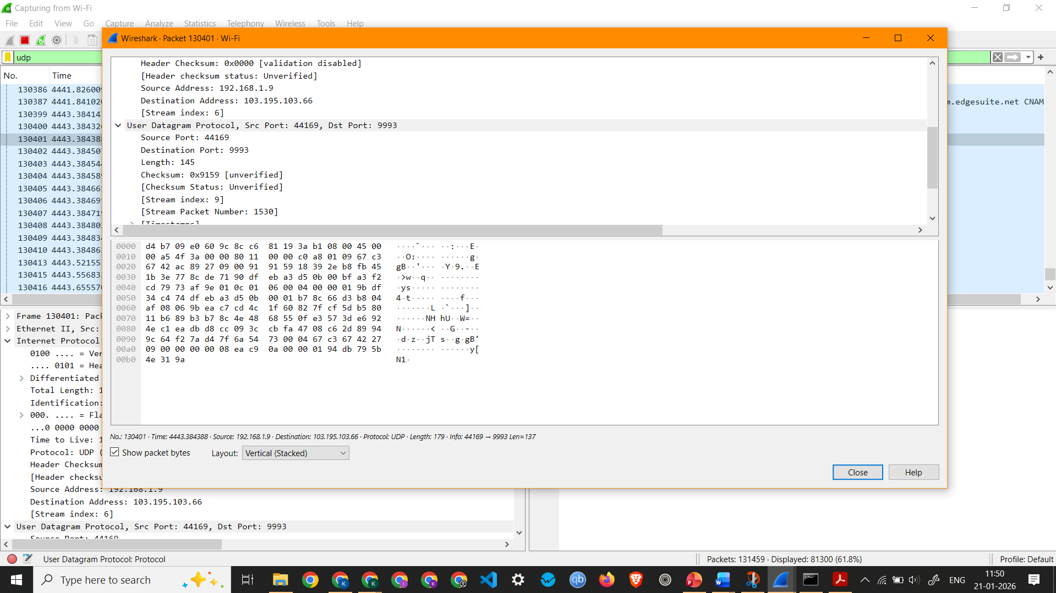

Observation: UDP Packet 130401 –
  - Interface Used: Wi-Fi
  - Protocols Observed: Ethernet II, Internet Protocol Version 4, and User Datagram Protocol
  - Source IP Address: 192.168.1.9
  - Destination IP Address: 103.195.103.66
  - Packet Length: 179 Bytes

4. To capture and analyze DNS query and response packets
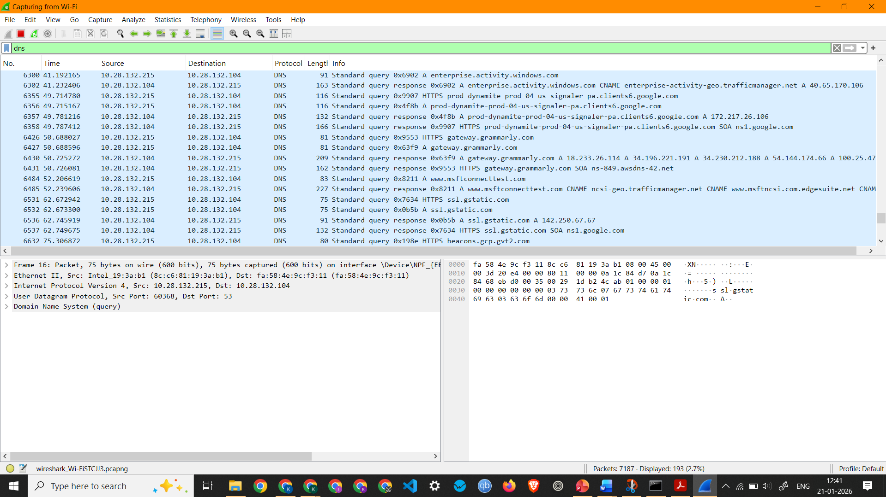
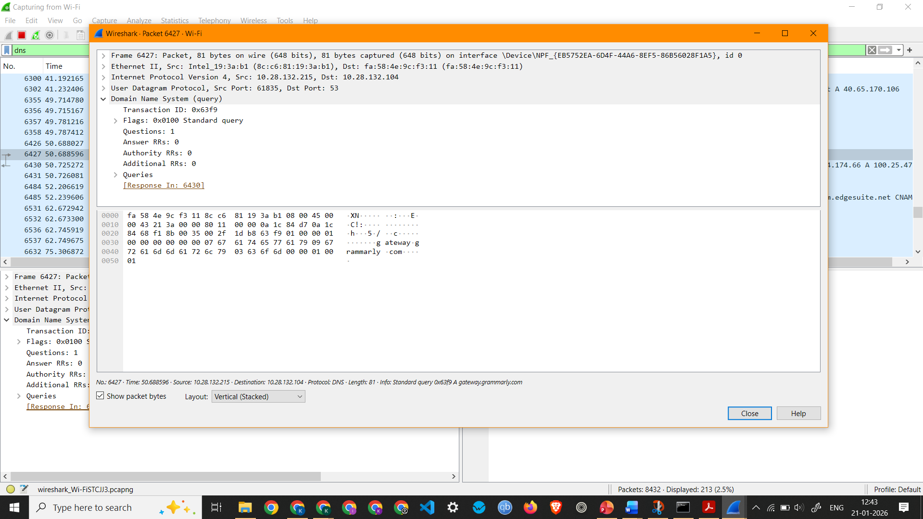

Observation: DNS Packet 6427 –
  - Interface Used: Wi-Fi
  - Protocols Observed: Ethernet II, Internet Protocol Version 4, and User Datagram Protocol
  - Source IP Address: 10.28.132.215
  - Destination IP Address: 10.28.132.104
  - Packet Length: 81 Bytes
  - Queries - gateway.grammarly.com: type A, class IN

5. To capture and analyze HTTP packets
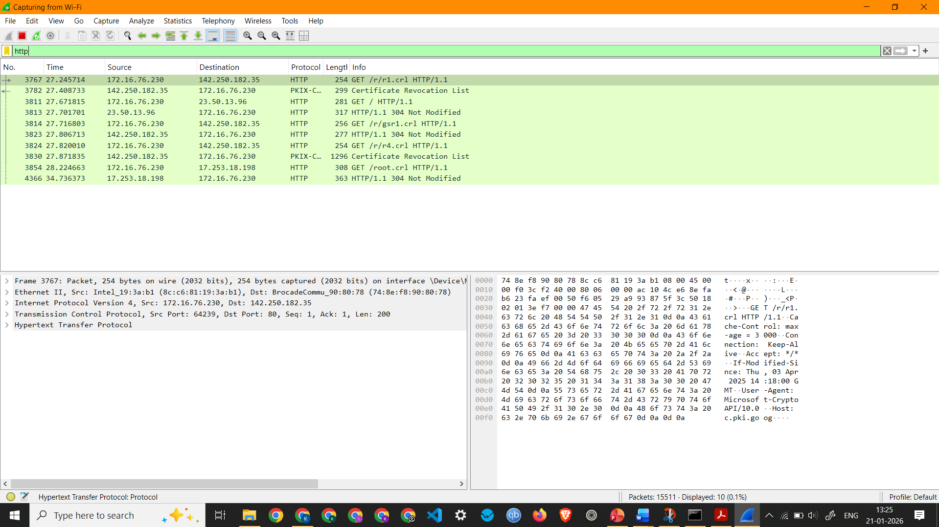
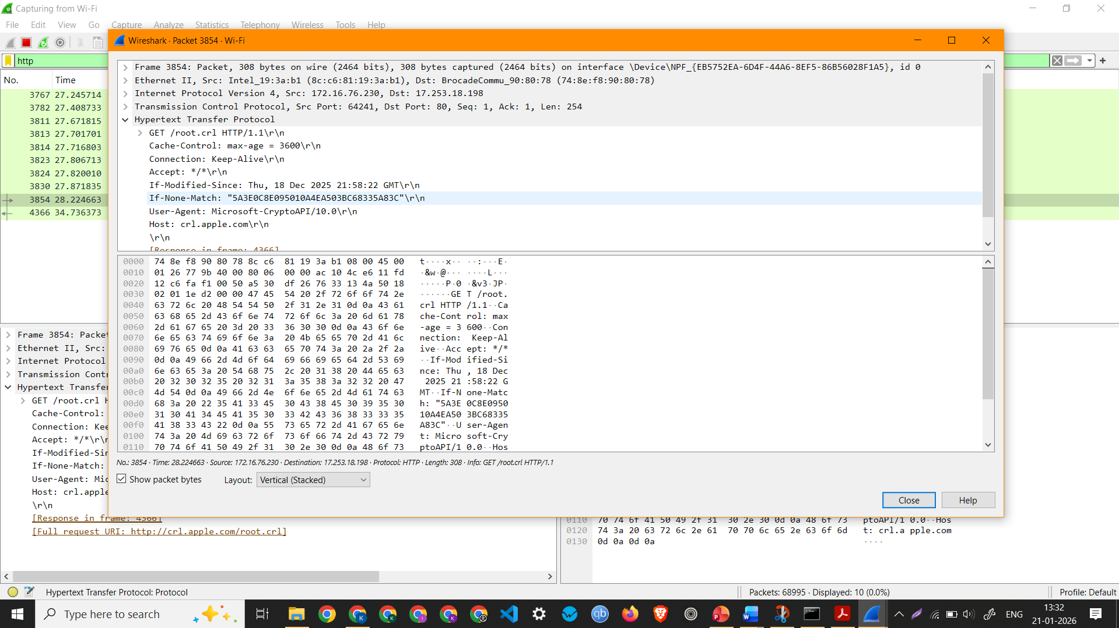

Observation: HTTP Request 3854 –
  - Interface Used: Wi-Fi
  - Protocols Observed: Ethernet II, Internet Protocol Version 4, Transmission Control Protocol, Hypertext Transfer Protocol
  - Source IP Address: 172.16.76.230
  - Destination IP Address: 17.253.18.198
  - Packet Length: 308 Bytes

6. To analyze ARP request and reply packets
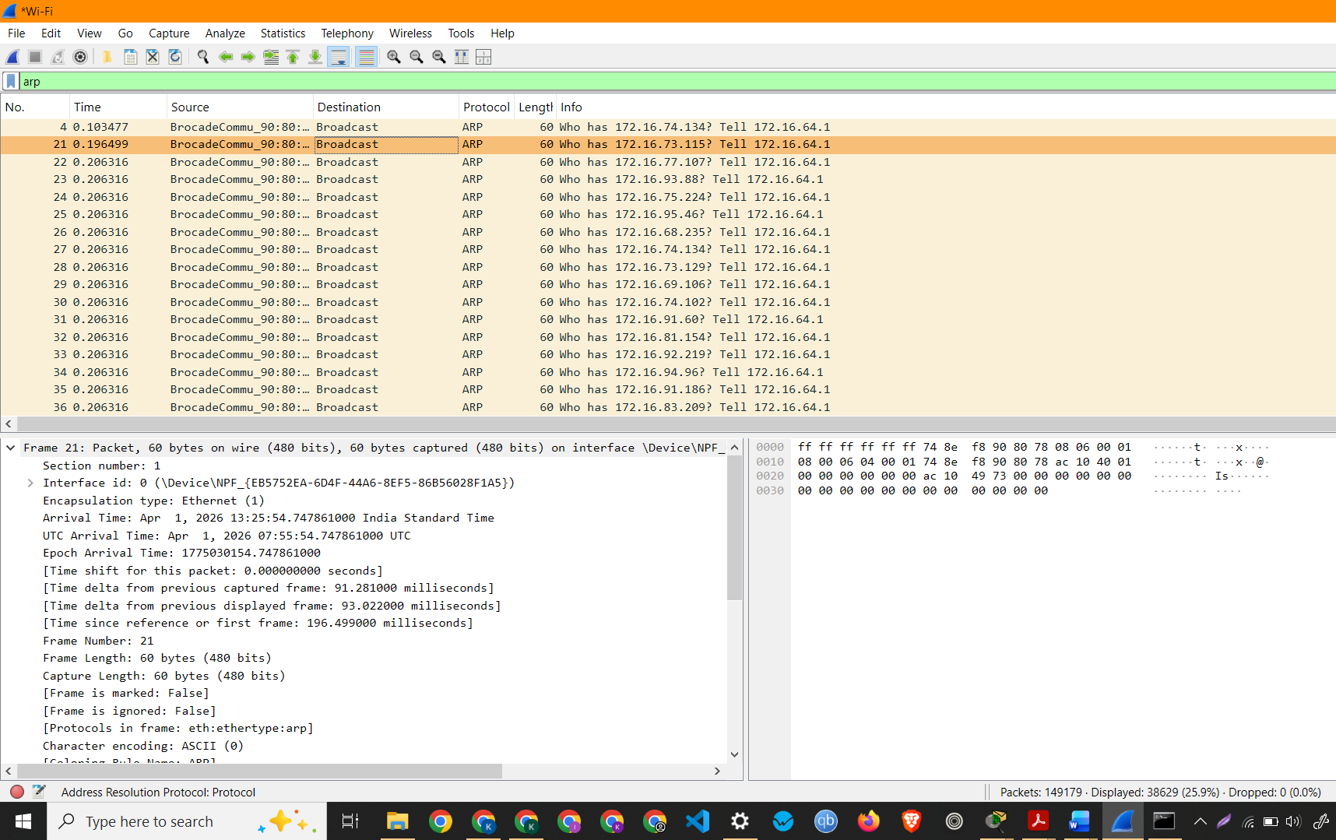

7. To identify source and destination MAC and IP addresses in captured packets
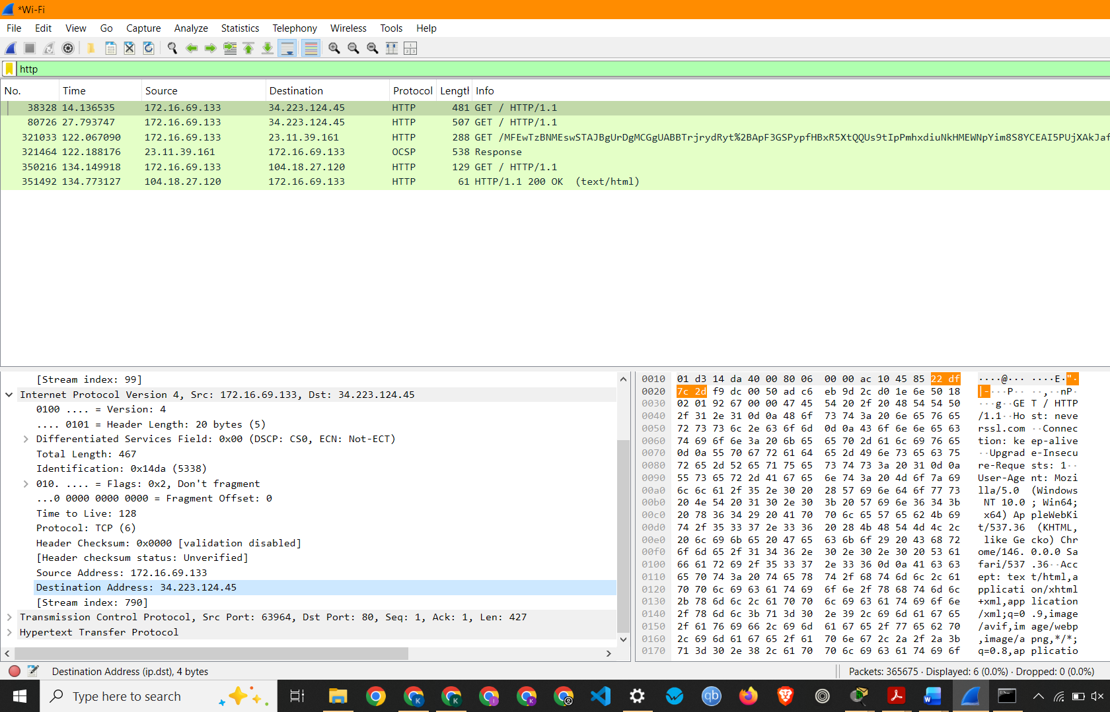
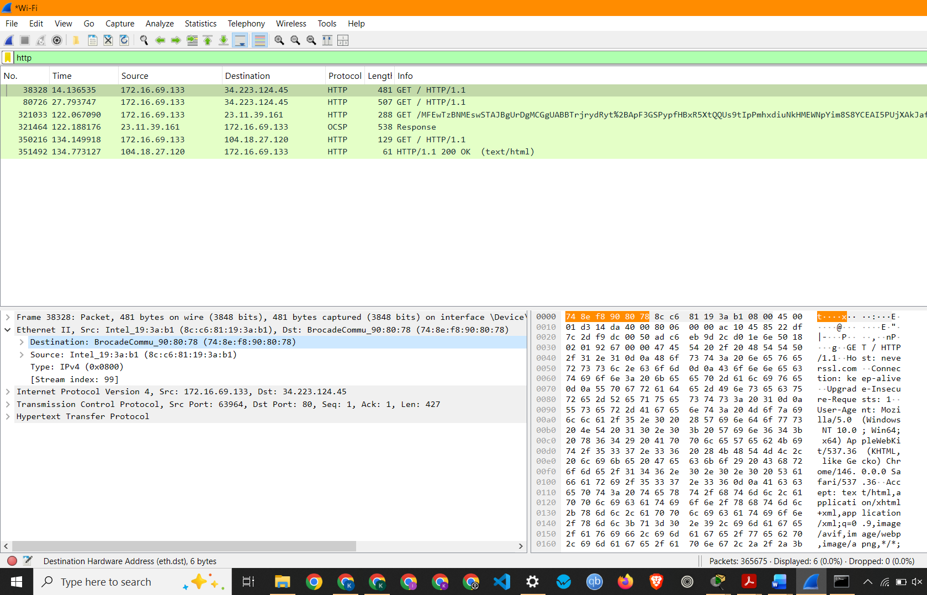
Observation: HTTP Packet 38328 –
  - Interface Used: Wi-Fi
  - Protocols Observed: Ethernet II, Internet Protocol Version 4, Transmission Control Protocol, Hypertext Transfer Protocol
  - Source IP Address: 172.16.69.133
  - Destination IP Address: 34.223.124.45
  - Source MAC Address: 8c:c6:81:19:3a:b1
  - Destination MAC Address: 74:8e:f8:90:80:78
  - Packet Length: 481 Bytes

Name – Prachi
Roll No - 8025320072

