Assignment 5
Q.1 Objective: Configure Static Route in Cisco packet tracer

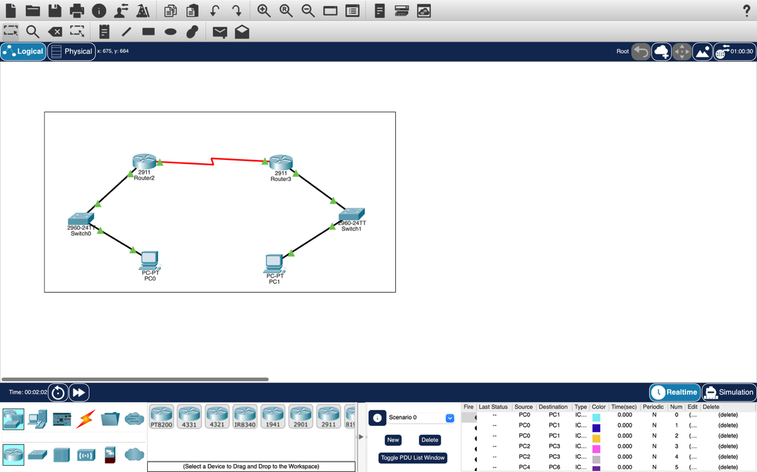
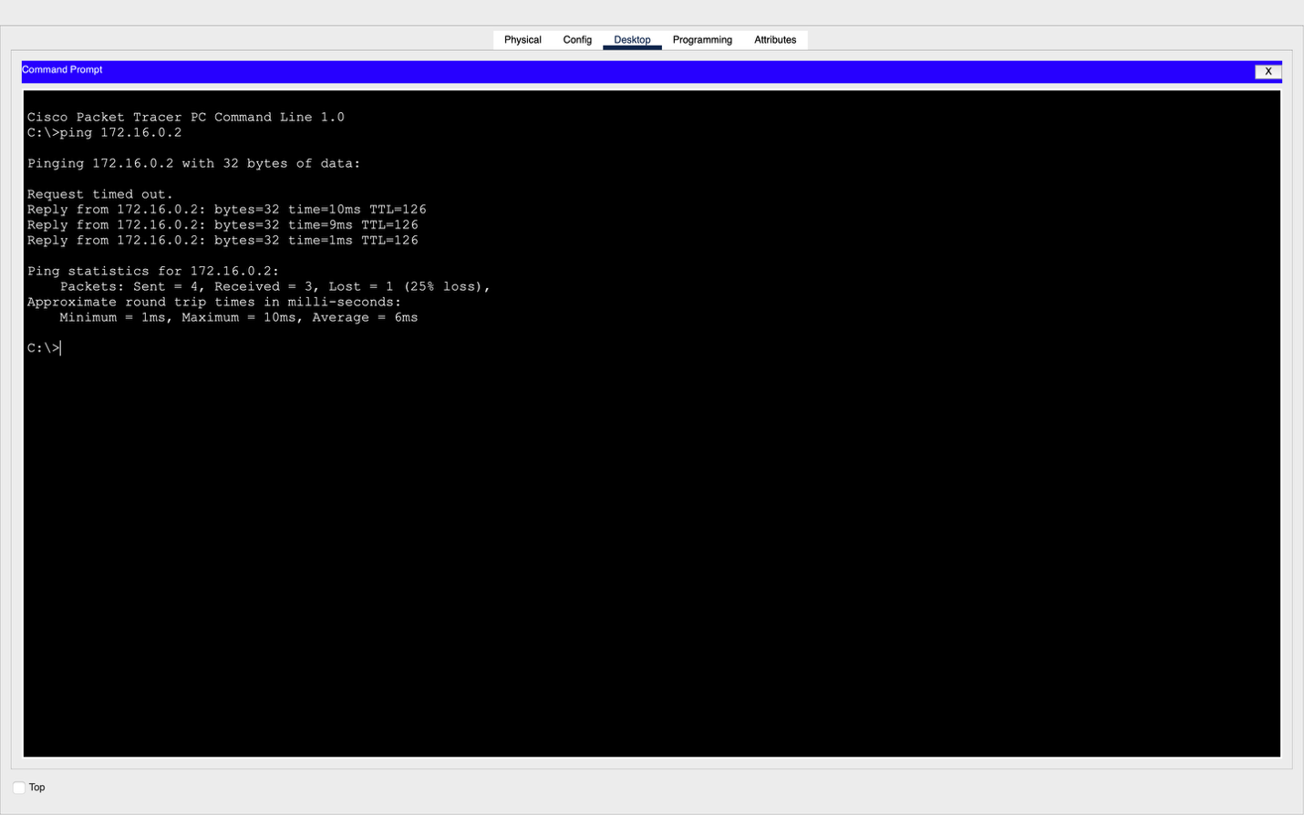

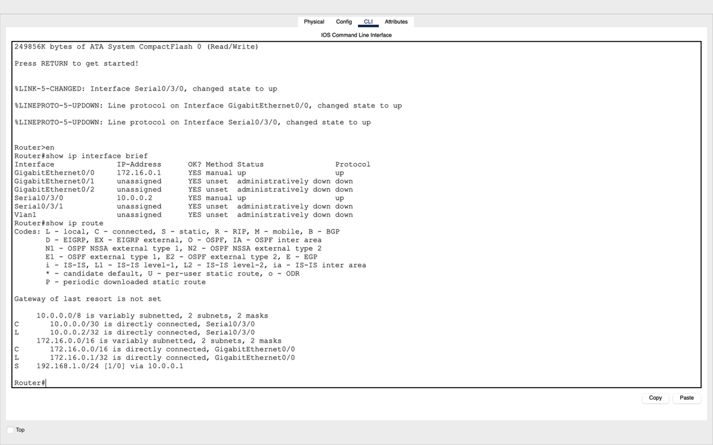

Q.2 Suppose you want to create 3 subnets of a network having network address 198.168.1.0. In another network with network address 220.168.2.0, you want to create 2 subnets. For this scenario configure the end devices and routers accordingly. Connect two different networks (both are subnetted) through static routing and show the message transmission among hosts of the two networks.
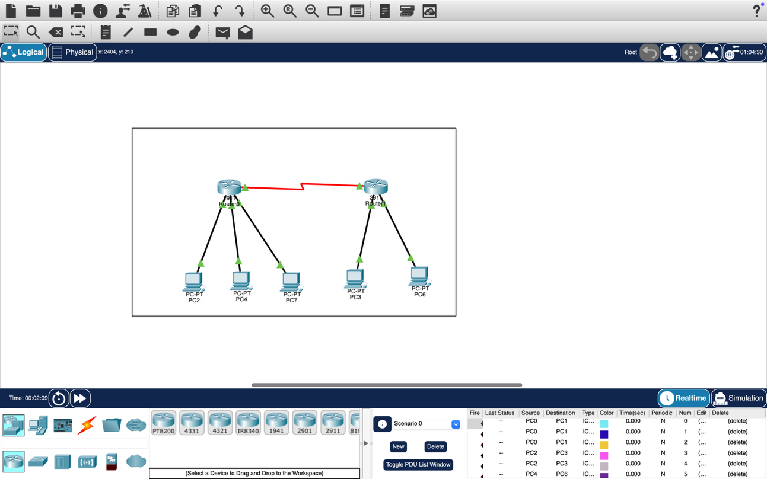
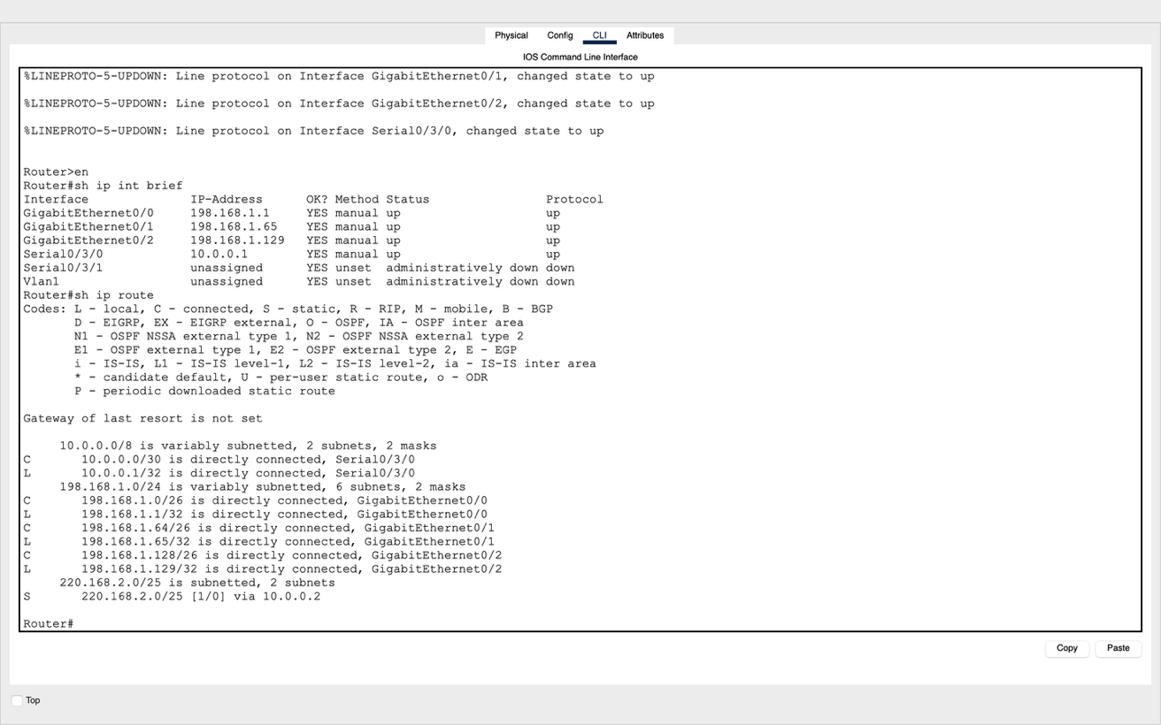

Q.3. Connect two networks having network address 192.168.3.0 and 224.152.1.0 respectively. Network 1 having 4 and network two having 3 hosts. Connect two different networks through a router. For this scenario configure the end devices and routers accordingly and show the message transmission among hosts of the two networks.

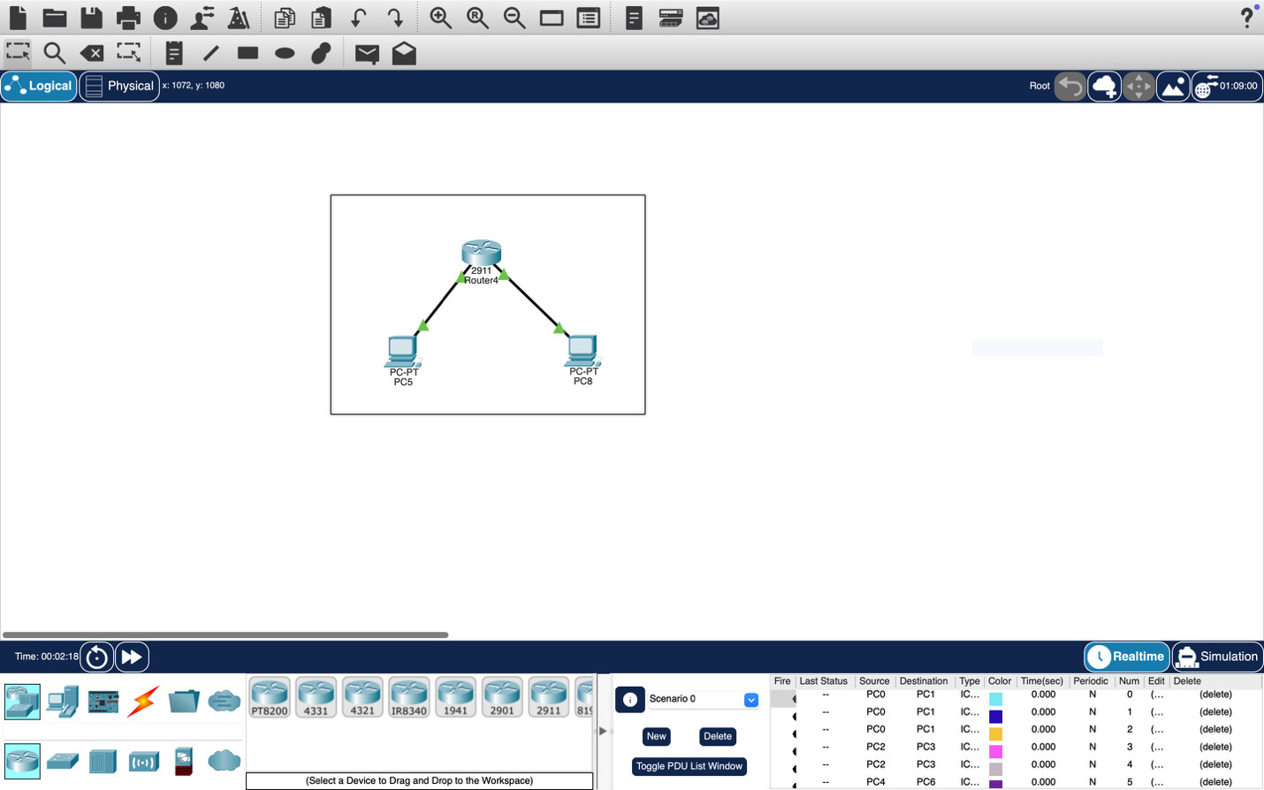
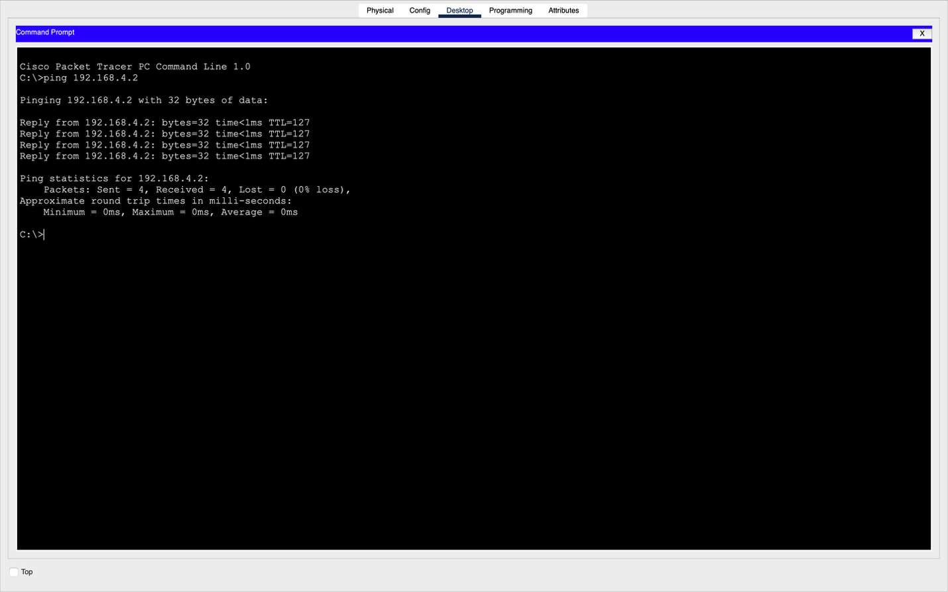
Name – Prachi
Roll No - 8025320072

