Assignment 4

Q.1 Create a pool on the DHCP Server router, named “xyz” and follow all the requirements.

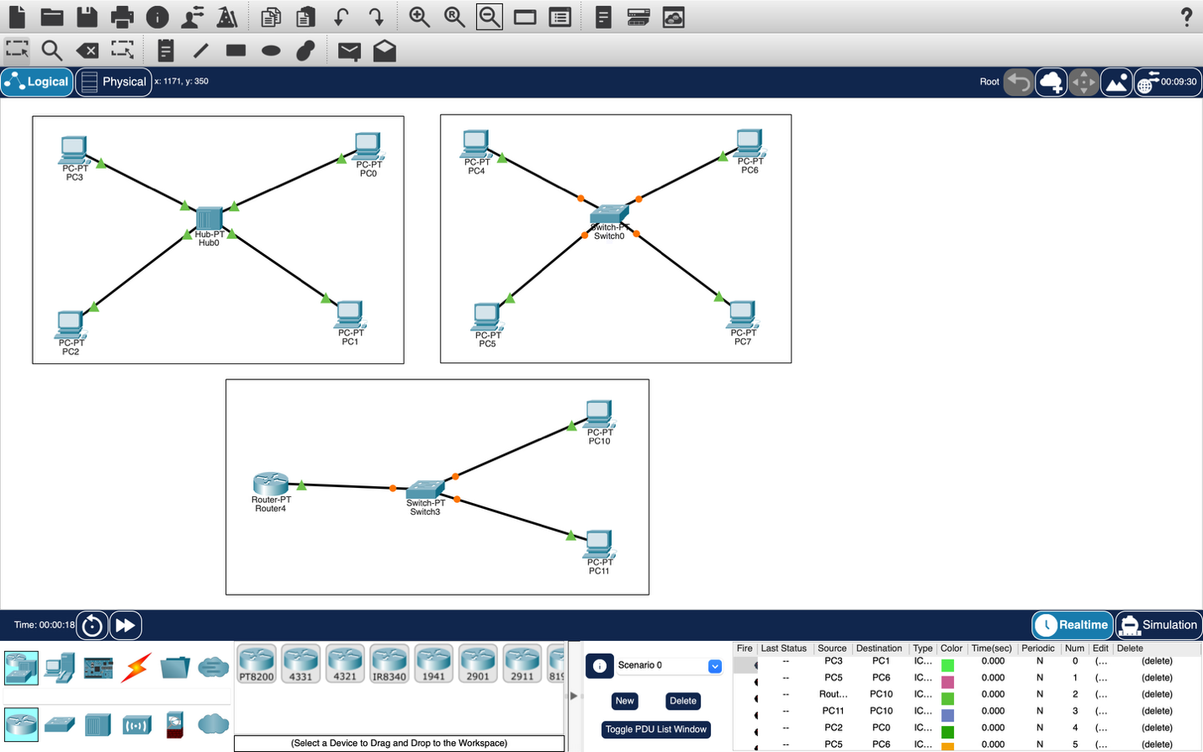

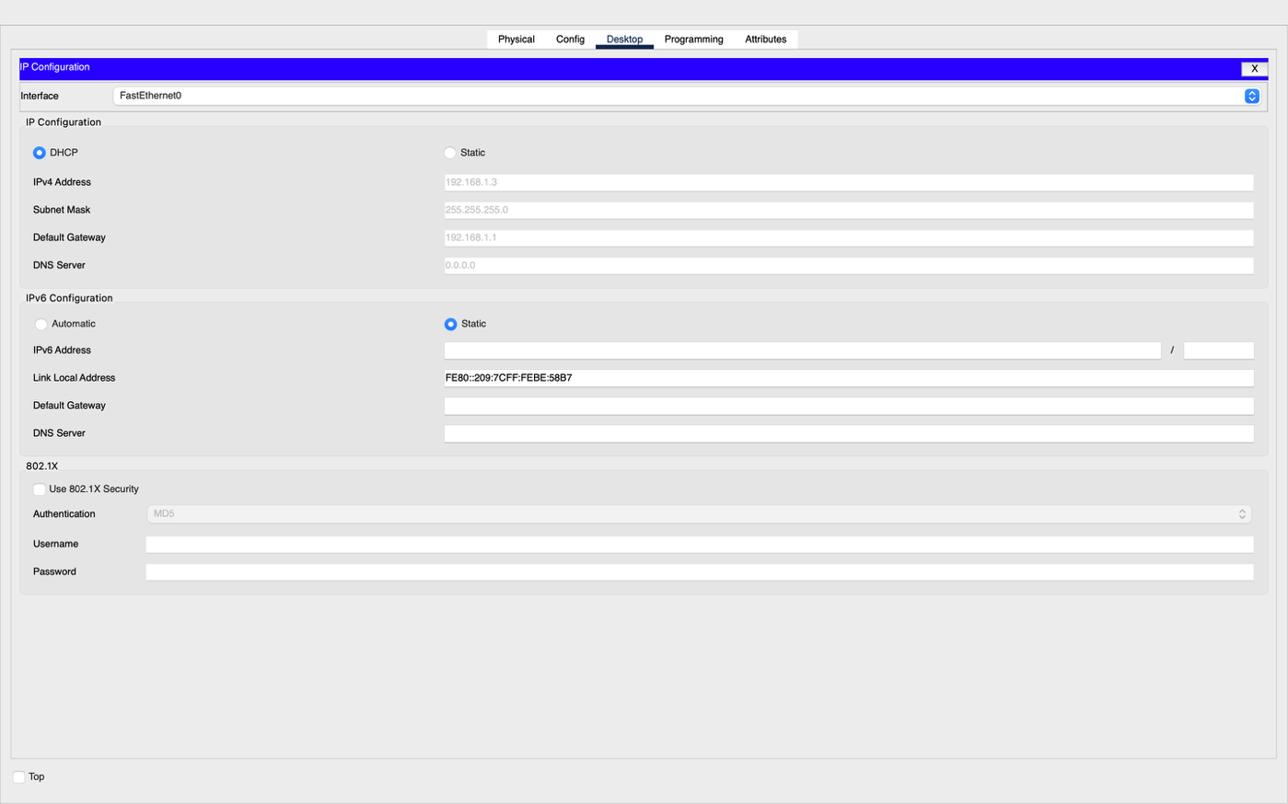

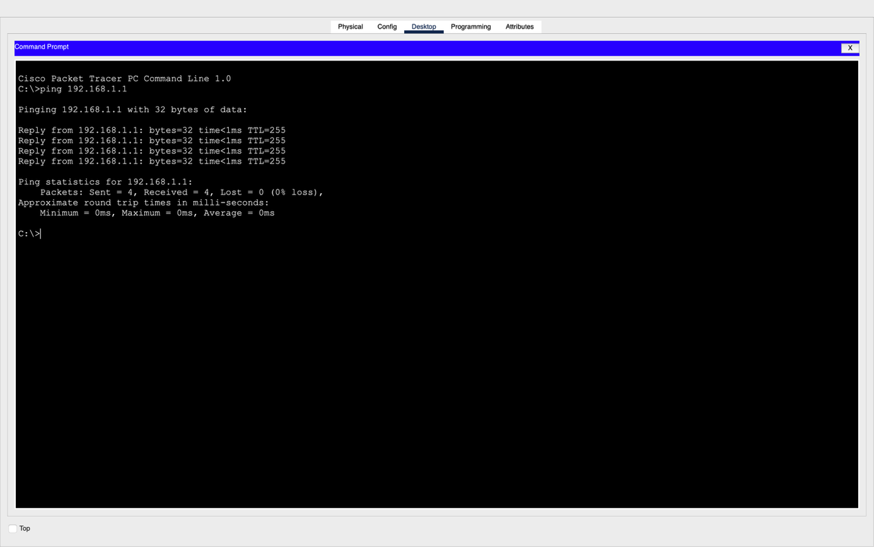

Name – Prachi
Roll No - 8025320072

