
Mini Project Report On
AI Mood Wave Music Player
BACHELOR OF ENGINEERING IN ARTIFICIAL INTELLIGENCE& MACHINE LEARNING
Submitted by
Prachi Kulkarni (3GN23AI036) Prachi Bellure (3GN23AI035)
Pratiksha (3GN23AI037)
Vaishnavi (3GN23AI060)
Under the guidance of: Dr. Dayanand Jhamkandikar


DEPARTMENT OF ARTIFICIAL INTELLIGENCE G MACHIINE LEARNING

GURU NANAK DEV ENGINEERING COLLEGE

MAILOOR ROAD ,BIDAR, KARNATAKA-585403

ACADEMIC YEAR 2025 - 2026

VISVESVARAYA TECHNOLOGICAL UNIVERSITY GURU NANAK DEV ENGINEERING COLLEGE BIDAR – 585403, KARNATAKA

DEPARTMENT OF ARTIFICIAL INTELLIGENCE AND MACHINE LEARNING
CERTIFICATE
This is to certify that the Mini Project Report entitled “ AI Mood Wave Music Player” is a Bonafide work carried out by Prachi Kulkarni(3GN23AI036), Prachi Bellure(3GN23AI035), Pratiksha(3GN23AI037), Vaishnavi(3GN23AI060) in practical fulfilment of the requirements for the award of Bachelor of Engineering in V Semester in “Artificial Intelligence And Machine Learning” by Visvesvaraya Technological University, Belagavi during the year 2025-26. It is certified that all the corrections/suggestions indicated for Internal Assessment have been incorporated in the report deposited in the department library. The mini project report has been approved as it satisfies the academic requirements in respect of mini project work prescribed for the said degree.

Signature of Guide Signature of HOD Signature of principal Dr.Dayanand J Dr.Dayanand J Dr.Veena S.Sorganvi

ACKNOWLEDGEMENT

The mini project report on “AI Mood Wave Music Player” is the outcome of guidance, moral support and devotion best owed throughout our work. For this we acknowledge and express out profound sense of gratitude and thanks to everybody who have been a source of inspiration during the project work.

First and foremost, we offer our sincere phrases of thanks with innate huminity to our Principal Dr. Veena S, who has been a constant source of support and encouragement. We feel deeply indepth to our H.O.D Dr. Dayanand J for right help provided from the time of inception till date. I would take this opportunity to acknowledge our HOD Dr.Dayanand J who not only stood by us as a source of inspiration, but also dedicated his time to enable us to present the project on time. We would be failing in Endeavour, if we do not thank our Co-ordinator.

PrachiKulkarni(3GN23AI036) Prachi Bellure(3GN23AI035) Pratiksha(3GN23AI037)
Vaishnavi(3GN23AI060)

DECLARATION

We Prachi Kulkarni ,Prachi Bellure ,Pratiksha ,Vaishnavi hereby declare that, this dissertation work entitled “AI Mood Wave Music Player” was independently carried out by us under the guidance and assistance of Dr. DAYANAND J, Department of Artificial Intelligence And Machine Learning, Guru Nanak Dev Engineering College, Bidar, Karnataka.

This dissertation work is submitted to “VISVESVARAYA TECHNOLOGICAL UNIVERSITY, BELAGAVI” in partial fulfilment of the requirements for the award of Degree of Bachelor of Engineering in “ DEPARTMENT OF ARTIFICIAL INTELLIGENCE AND MACHINE LEARNING”
during the academic year 2025-26.

Place : Bidar

Date : 16-11-2025

Prachi Kulkarni(3GN23AI036) Prachi Bellure(3GN23AI035) Pratiksha(3GN23AI037)
Vaishnavi(3GN23AI060)


ABSTRACT

Music is a universal language that profoundly impacts human emotions and well-being.
However, traditional music recommendation systems rely primarily on historical listening
data and trending content, failing to address users' real-time emotional states and regional
language preferences. This project presents an innovative AI-driven music recommendation
platform that detects facial emotions in real-time and delivers personalized, culturally
relevant playlists tailored to the user's current mood and language choice.The system utilizes
DeepFace, a CNN-based deep learning framework, combined with OpenCV for live webcam
video capture and facial expression analysis. Emotions such as happy, sad, calm, angry, and
energetic are classified automatically without requiring custom model training. Upon
emotion detection, users interactively select their preferred language from Hindi, English,
Kannada, and Telugu. The system then retrieves a curated playlist from a custom CSV dataset
containing emotion-language-song mappings with direct streaming links to popular
platforms including YouTube, JioSaavn, and Spotify.Implemented in Python, the solution
employs Pandas for efficient data management and the webbrowser module for seamless
music playback. The system prioritizes user privacy by processing all facial data locally,
ensuring no biometric information is stored or transmitted. This modular, scalable
architecture bridges technology and emotion, offering an inclusive platform that adapts to
both psychological and cultural needs. User studies demonstrate high satisfaction ratings in
usability, relevance, and cultural personalization, validating the system's effectiveness in
enhancing digital music experiences through intelligent, emotion-aware recommendations

TABLE OF CONTENT

    Chapter No: |   Title |   Page No
 |     ACKNOWLEDGEMENT DECLARATION  ABSTRACT |     i ii  iii
I | 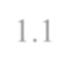    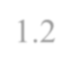  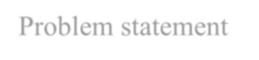  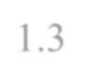    INTRODUCTION  - Background  - Problem statement  - Objectives
  II | 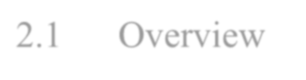  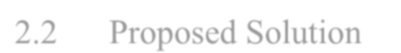  LITERATURE SURVEY  - Overview  - Proposed Solution
  III | 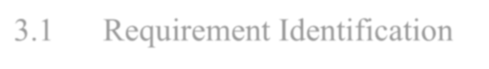  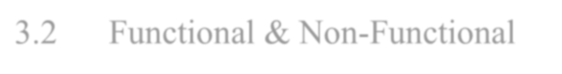    REQUIREMENTS & ANALYSIS  - Requirement Identification  - Functional & Non-Functional  Requirements

CHAPTER 1
INTRODUCTION

BACKGROUND
Music has always been an integral part of human life, transcending cultural, geographical, and linguistic boundaries. It plays a significant role in shaping emotions, influencing behavior, and enhancing overall well-being. Numerous studies in psychology and neuroscience suggest that music has the ability to regulate, shift, or enhance an individual’s emotional state, making it a powerful tool in mood management and mental health care. Because of this strong emotional influence, modern music therapy has also recognized the therapeutic benefits of analyzing and responding to human emotions.

With the rapid growth of technology, mainstream music-streaming platforms have introduced recommendation algorithms to personalize user experience. These algorithms typically rely on previous listening history, likes, skip patterns, and crowd-sourced trends to suggest songs. Although these systems are effective to some extent, they primarily focus on behavioral data and generic preference patterns. As a result, they fail to capture the user’s instantaneous emotional needs.

Human emotions can change quickly depending on the situation, environment, or momentary mood. Traditional recommendation systems do not consider these real-time emotional fluctuations, which limits their ability to deliver content that truly aligns with a user's current mental state. This gap highlights the need for emotionally intelligent, context-aware, and culturally nuanced music recommendation systems. Recognizing this challenge forms the central motivation and foundation of this project.

PROBLEM STATEMENT

Traditional music recommendation systems do not consider users real-time emotions or language preferences, leading to less personalized experiences. The goal is to create a system that uses facial emotion detection & language choice to recommend relevant, mood-based playlists.

OBJECTIVES

To detect the user’s mood using AI

The main objective is to analyse the user’s facial expressions or input text and identify their emotional state such as happy, sad, relaxed, stressed, or excited.

To automatically play music based on the detected mood

The system should select and play songs that match the user’s mood, helping to improve their emotional experience.

To create a personalized music recommendation system

The player should learn user preferences over time and recommend better and more accurate songs.

To provide a user-friendly interface

Design a simple and easy-to-use application where users can easily interact and control the music features.

To enhance emotional well-being through music therapy

Use music as a tool to reduce stress, improve focus, and create a positive emotional impact.

To integrate AI and machine learning technologies

Implement algorithms for mood detection and recommendation using ML techniques such as classification or neural networks.

To enable real-time mood recognition

The system should capture real-time expressions and respond quickly with suitable music.

CHAPTER 2:
LITERATURE SURVEY

An Accurate Algorithm for Generating a Music Playlist based on Facial Expressions (2014)
Author: Anukriti Dureha

Content: This paper presents a system that captures a person’s face, identifies their emotion (happy, sad, angry, neutral), and automatically selects a playlist that matches the mood. It uses image processing and emotion-mapping techniques to improve recommendation accuracy.

Music Playlist Generation using Facial Expression Analysis and Task Extraction (2023)
Authors: Arnaja Sen, Dhaval Popat, Hardik Shah, Priyanka Kuwor, Era Johri

Content: This system not only detects facial expressions but also checks what task the user is doing on their computer (like studying, browsing, etc.). Both emotion + task context are combined to recommend a more accurate playlist suitable for the moment.

Music Tune Generation based on Facial Emotion (2019)

Authors: Pooja Mishra, Himanshu Talele, Yogesh Sawarkar, Rohit Vidhate, Ganesh Naikare
Content:Instead of selecting existing songs, this research generates a new music tune based on the detected facial emotion. Different emotions (happy, sad, surprised) map to different musical patterns, creating a personalized melody.

Music Recommendation Based on Facial Emotion Recognition (2024)

Authors: Rajesh B., Keerthana V., Narayana Darapaneni, Anwesh Reddy P.

Content:This work uses a deep-learning model (ResNet50) to detect facial emotions. It then recommends songs from a predefined database. The authors also use explainable AI (Grad-CAM) to show which facial regions influenced emotion detection.

Emotion Detection and Music Recommendation System (2025)

Authors: Swetha Kambham, Hubert Jhonson, Sai Prathap Reddy Kambham

Content:This system captures real-time webcam images, analyzes facial emotion using the DeepFace library, and recommends a playlist accordingly. It is designed for live use and refreshes the playlist when the user's emotion changes.

Creation of a Music Recommendation System using Facial Expression Recognition with MATLAB (2024)
Authors: Maruthi Prasad V., Gutti Naga Swetha, K. M. Riyaz Ali

Content:The researchers built a MATLAB-based system that recognizes emotions such as happiness, anger, sadness, fear, or neutral expression. Based on the detected mood, the system suggests a suitable set of songs from categorized music folders.

DESIGN

ARCHITECTURAL DIAGRAM
Emotion
detection
Music language
classifier
Play the
song
Recommend
playlist
Song Database

Capture Image
Face detection using
CNN (Deepface)
Facial feature
extraction

Fig 1.1: architectural design

This diagram shows the complete workflow of an AI-based music player that detects a user’s emotion from their face and recommends songs from the database accordingly.

IMPLEMENTATION

TOOLS AND TECHNOLOGY

Python Programming Language

Python is the primary programming language used to develop the AI Mood-Wave Music Player. It provides a simple syntax and a powerful collection of libraries required for emotion detection, data processing, and music playback. Python acts as the core environment in which all modules such as DeepFace, OpenCV, and Pygame work together seamlessly.

DeepFace (Facial Emotion Recognition Framework)
DeepFace is used to perform emotion detection from the user's facial expressions. It provides:

  - Pre-trained deep learning models
  - Automic face detection, alignment, and emotion recognition
  - Prediction of emotions such as happy, sad, angry, surprised, neutral, etc.

DeepFace simplifies complex AI processes, making emotion recognition fast, accurate, and easy to integrate into the music player.

OpenCV (Open Source Computer Vision Library)
OpenCV is used for capturing and processing real-time video from the webcam. In the project, it helps in:

  - Accessing webcam frames
  - Detecting and isolating the face region
  - Preprocessing images before sending them to DeepFace

It ensures smooth real-time face tracking, which is essential for continuous mood detection.

Pandas
Pandas is used for handling datasets and organizing information related to music files, such as:

  - Maintaining a structured list of songs
  - Mapping moods with appropriate music
  - Managing any CSV or table-based data used during development It provides an efficient and easy way to manage data in tabular form.

Webcam (Hardware Tool)
The webcam is the input device used to capture the user's face in real time. Its role includes:

  - Providing continuous video feed
  - Allowing the system to detect facial expressions dynamically
  - Acting as the primary sensor for emotion-based music selection Without the webcam, real-time mood detection would not be possible.

Webbrowser (Python’s Webbrowser Module)
The webbrowser module is used to open webpages or online music platforms based on the detected emotion or user actions.
In the project, it can be used for:

  - Opening URLs for mood-based playlists
  - Redirecting the user to online music sources (optional feature)

This adds flexibility and expands the music player’s capability beyond local music files.

Visual Studio Code
VS Code is the development environment used to write, test, and debug the project’s Python code.
Its role includes:

  - Providing an easy-to-use interface for coding
  - Support for Python extensions and debugging tools
  - Managing project files efficiently
  - Terminal support for running the application

It improves productivity and helps maintain clean and structured project code.

Pygame (Audio Playback Library
Pygame is used for playing music based on the detected emotion. Its functions include:

  - Loading MP3/WAV files
  - Playing, pausing, and stopping music
  - Managing the audio system within the application

Pygame acts as the music engine of the project, enabling smooth playback and interaction with the audio files.

PSEUDOCODE

# CONFIG

MOODS = ["happy", "sad", "angry", "neutral"] AUDIO_WINDOW_SEC = 7
CONF_THRESHOLD = 0.55 # minimum probability to trust classifier TOP_TRACKS = 8
# mood -> playlist tags (example) MOOD_TO_TAGS = {
"happy": ["pop","upbeat"],

"sad": ["acoustic","melancholy"],

"angry": ["rock","intense"],

"neutral":["ambient","soft"]

}

# MAIN

function main(): init_audio_system()
load_mood_model() # pre-trained model load_user_preferences() # optional
while app_is_running():

if auto_detect_enabled():

audio = capture_audio(AUDIO_WINDOW_SEC) features = extract_audio_features(audio)
mood, conf = predict_mood(features)

if conf < CONF_THRESHOLD:

mood = fallback_mood_selection(mood, conf) # e.g., choose "neutral" or ask user else:
mood = get_user_selected_mood() # manual pick

playlist = fetch_playlist_by_mood(mood)

tracks = rank_and_select(playlist, TOP_TRACKS, user_preferences) play_tracks(tracks)
start_mood_visualizer(mood) # wave color/shape depends on mood # runtime interaction loop
while playback_active():

event = poll_ui_events() if event.type == "skip": play_next_track(tracks)
else if event.type == "like": update_user_preferences(event.track, positive=True) else if event.type == "dislike": update_user_preferences(event.track, positive=False) else if event.type == "stop":
stop_playback() break
save_session(mood, tracks) shutdown_audio_system()

# SUPPORTING FUNCTIONS

function capture_audio(seconds):

return microphone.record(seconds) function extract_audio_features(raw_audio):
audio = trim_silence(raw_audio) audio = normalize_amplitude(audio)
mfcc = compute_mfcc(audio) # e.g., 13 coeffs chroma = compute_chroma(audio)
tempo = estimate_tempo(audio)

features = aggregate([mfcc, chroma, tempo]) return features
function predict_mood(features):

probs = mood_model.predict_proba(features) # returns map mood->prob best_mood = argmax(probs)
best_conf = probs[best_mood] return best_mood, best_conf
function fallback_mood_selection(current_mood, confidence):

# simple rule: if confidence low choose neutral; optionally ask user if confidence < CONF_THRESHOLD:
return "neutral" return current_mood
function fetch_playlist_by_mood(mood): tags = MOOD_TO_TAGS[mood]
return search_tracks(tags) # local DB or streaming API

function rank_and_select(playlist, n, user_prefs):

scored = []

for track in playlist:

score = base_popularity(track) + pref_score(track, user_prefs) scored.append((score, track))
sort_descending(scored)

return first_n_tracks(scored, n) unction play_tracks(tracks):
for track in tracks:

audio_player.play(track)

# visualizer runs concurrently function start_mood_visualizer(mood):
cfg = visual_config_for(mood) # set color, intensity, waveform style visualizer.start(cfg)
function update_user_preferences(track, positive): adjust_preference_weights(track, positive) function save_session(mood, tracks):
history.log({time: now(), mood: mood, tracks: tracks}) persist_history()
# END OF PSEUDOCODE

CHAPTER 5:

RESULTS
1.1RESULTS OF HAPPY EMOTION FOR SONGS IN DIFFERENT LANGUAGES
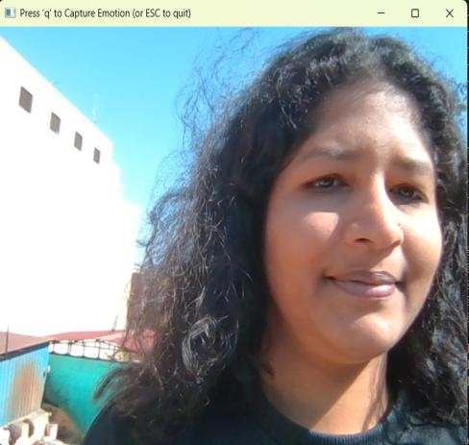
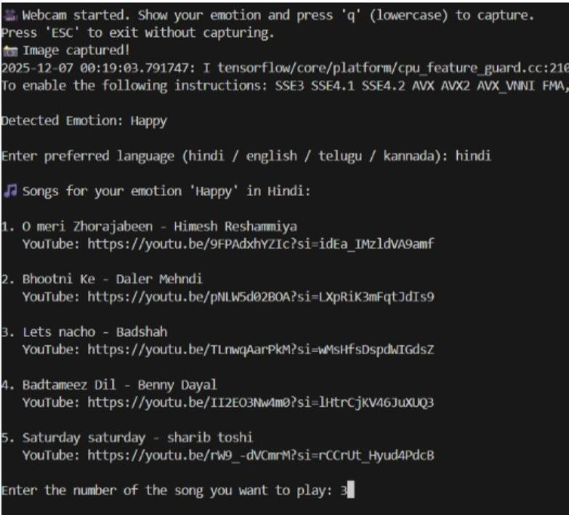

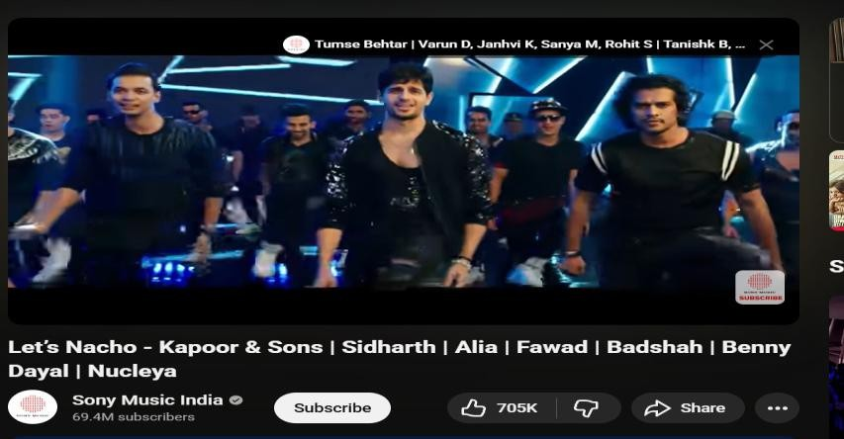

Fig 1.2: represents happy emotion and the language choosen by the user is hindi

The above result represnts ‘Happy’ emotion .The language selected by the user is Hindi , and the song choosen is the 3rd song – “Lets Nacho”

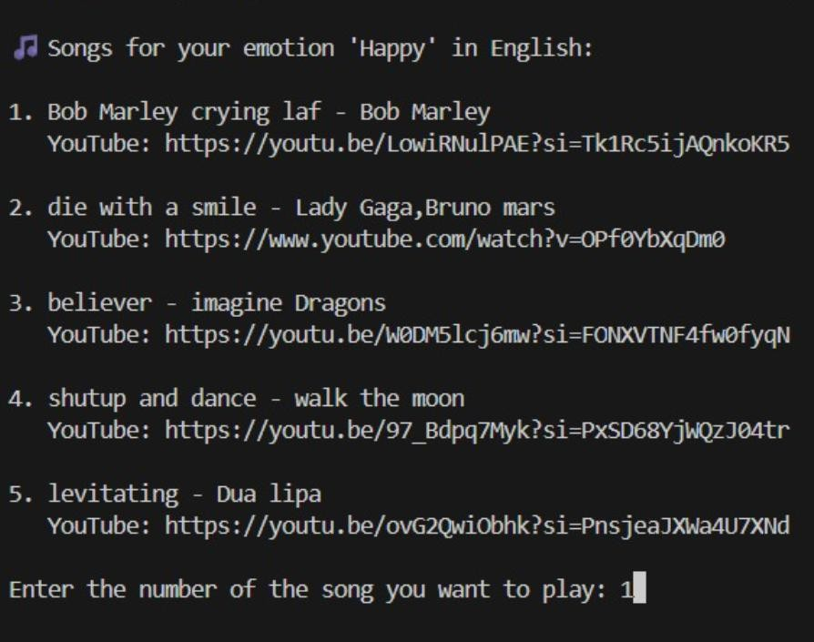
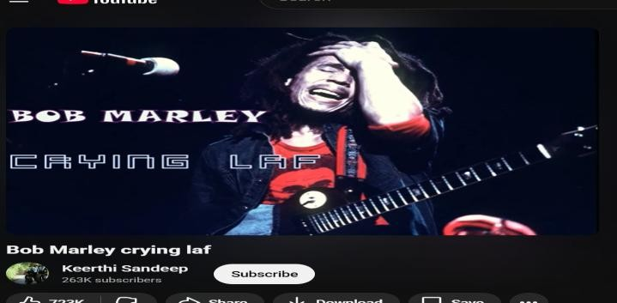

Fig 1.3: resprensts happy emotion and the language choosen by user in english

The above result represents ‘Happy’ emotion .The language selected by the user is English ,and the song choosen is 1st song – “Bob Marley Crying laf”

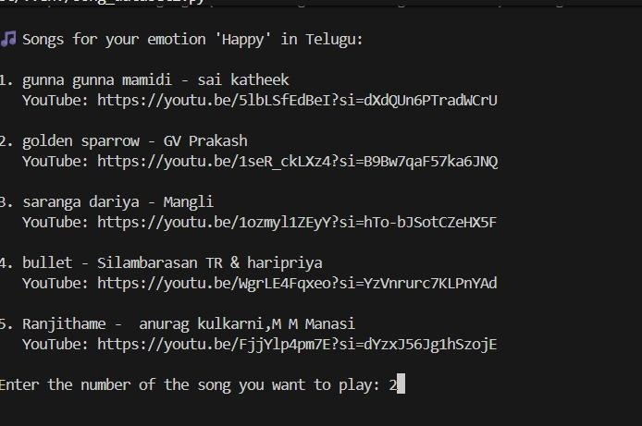
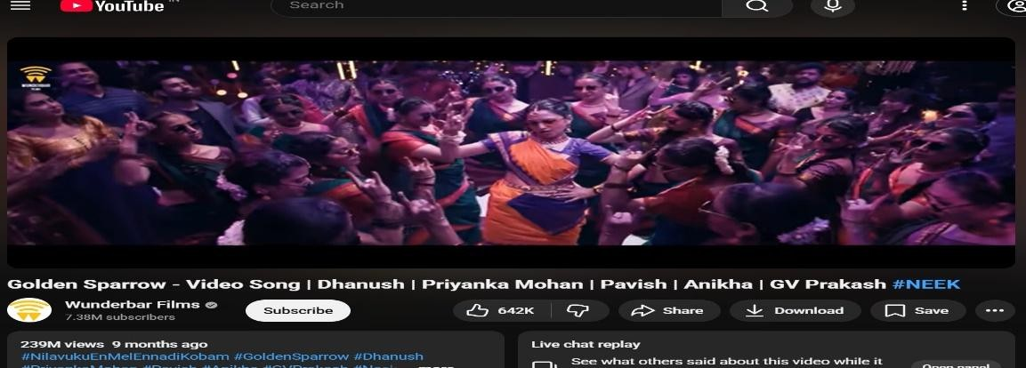

Fig 1.4: represents happy emotion and the language choosen by the user is telugu

The above result represents “Happy” emotion.The language selected by the user is Telugu,and the song choosen is the 2nd song – “Golden Sparrow”

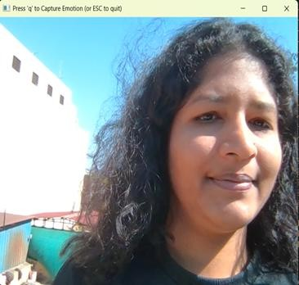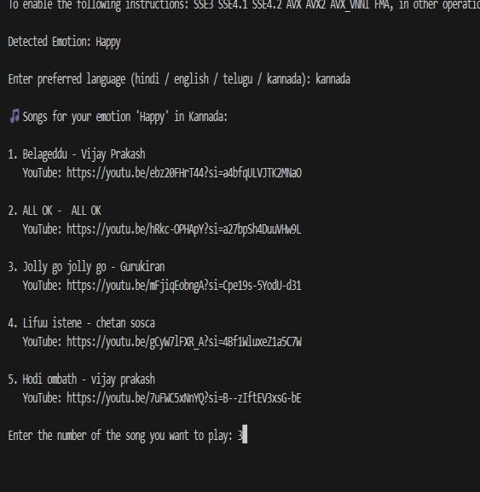
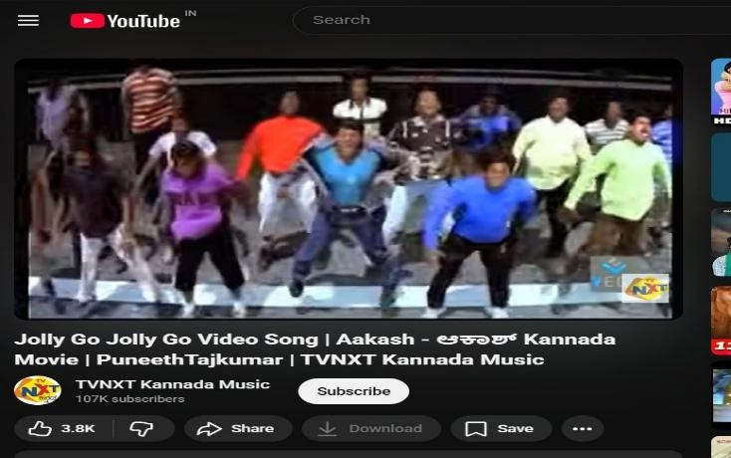

Fig 1.5: represents happy emotion and the language choosen by the user is kannada

The above result represents “Happy” emotion .The language selected by the user is Kannada,and the song choosen is the 3rd song – “Jolly Go Jolly”

1.1RESULTS OF SAD EMOTION FOR SONGS IN DIFFERENT LANGUAGES
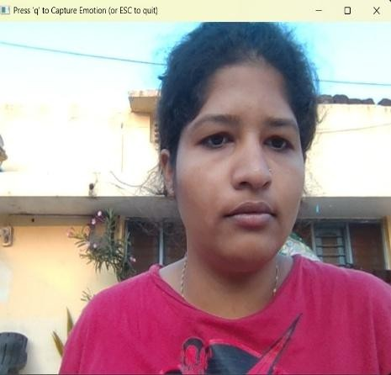
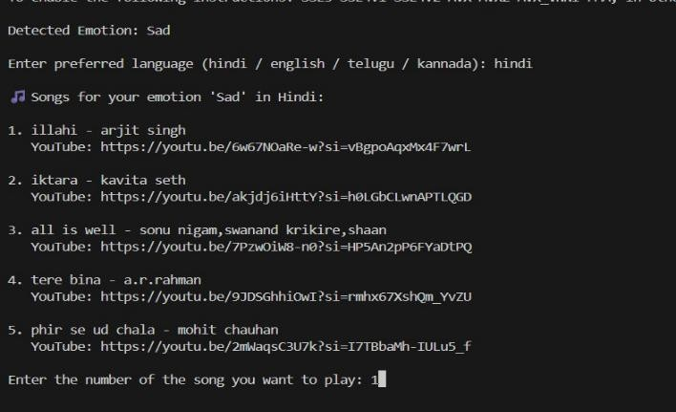
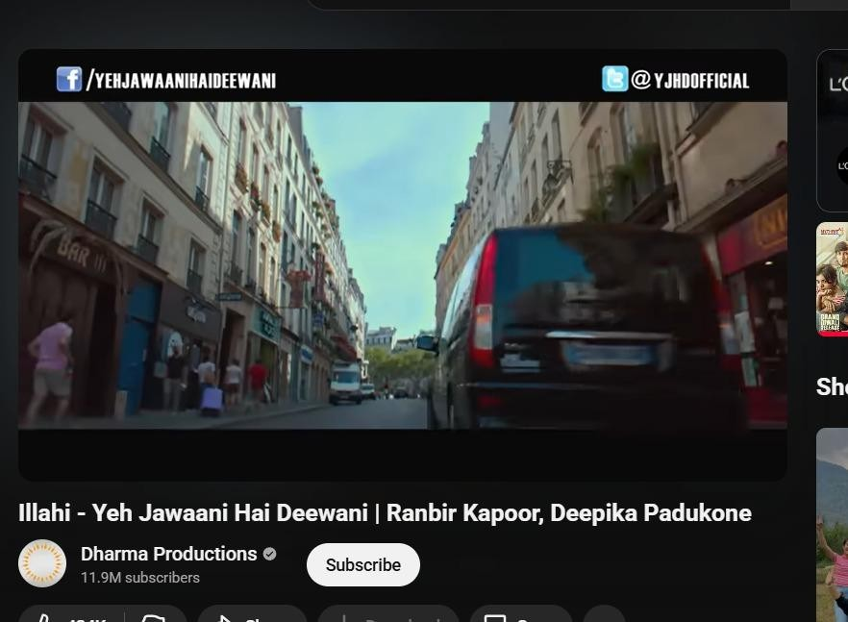

Fig 1.6: represents sad emotion and the language choosen by the user is hindi

The above result represents “Sad” emotion.The language selected by the user is hindi. Song selected by the user is 1st song – “illahi”

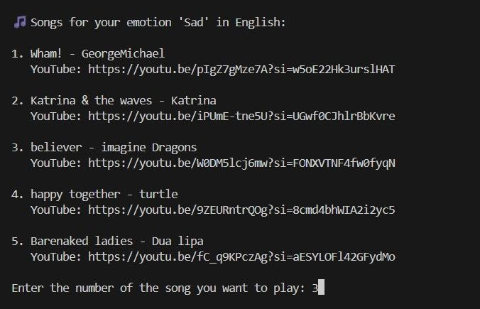

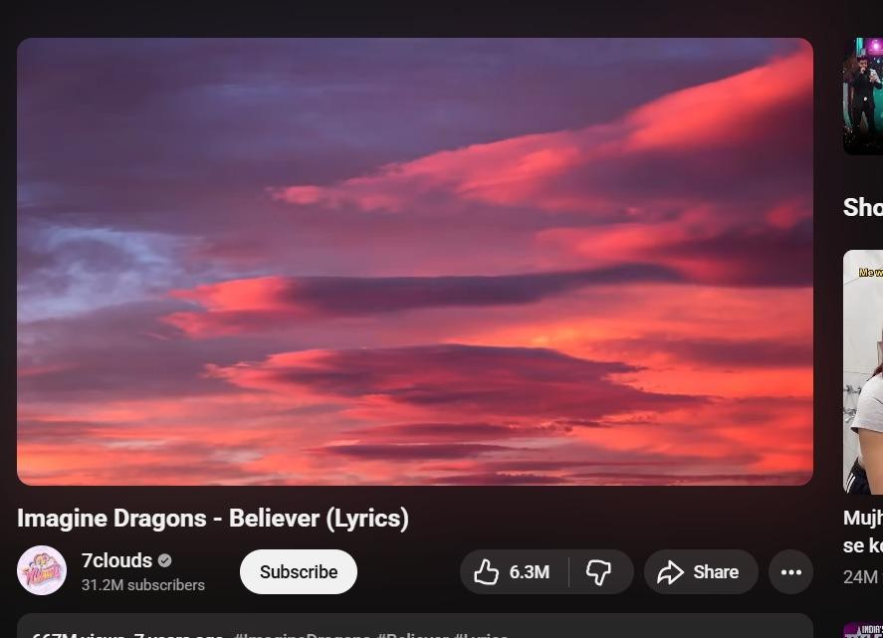

Fig 1.7: represents sad emotion and the language choosen by the user is english

The above result represents “Sad” emotion.The language selected by the user is english. Song selected by the user is 3rd song – “Imagine Dragon”

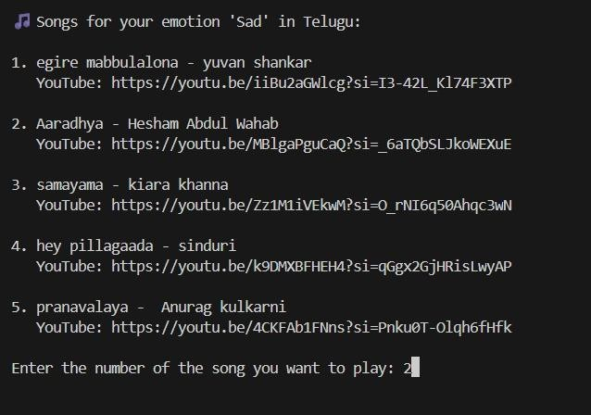
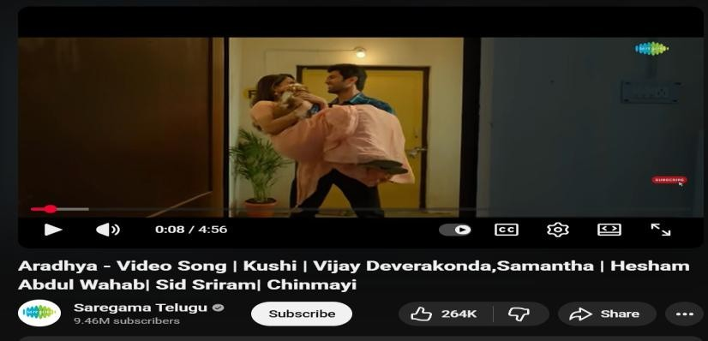

Fig 1.8: represents sad emotion and the language choosen by the user is teulgu

The above result represents “Sad” emotion.The language selected by the user is Teulgu. Song selected by the user is 2nd song – “Aradhya”

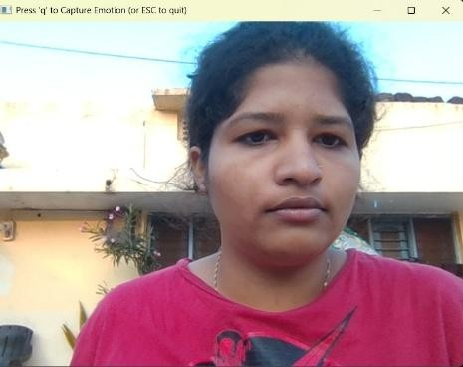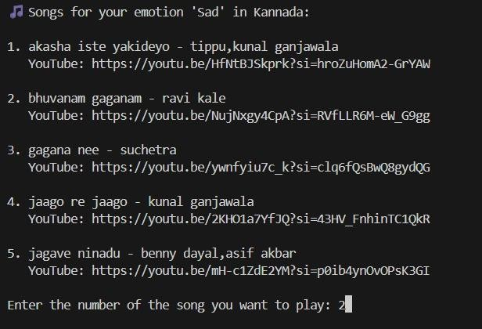
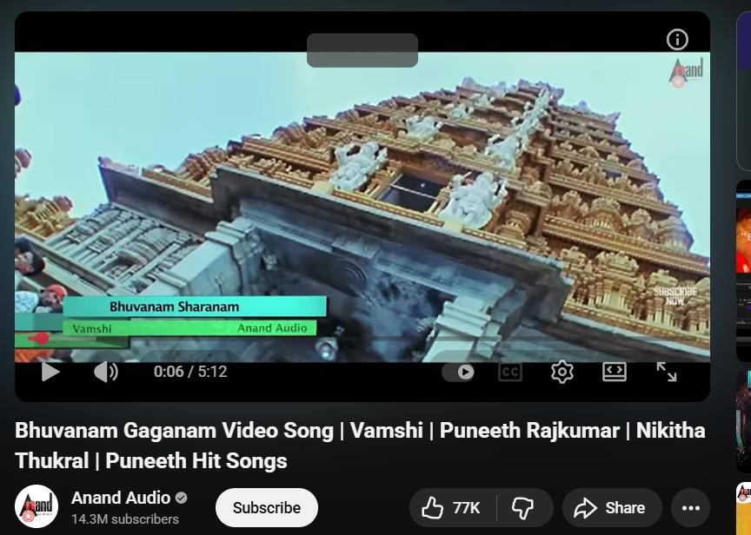

Fig 1.9: represents sad emotion and the language choosen by the user is kannada

The above result represents “Sad” emotion.The language selected by the user is Kannada. Song selected by the user is 2nd song – “Bhuvanam Gaganam”

RESULTS OF ANGRY EMOTION FOR SONGS IN DIFFERENT LANGUAGES
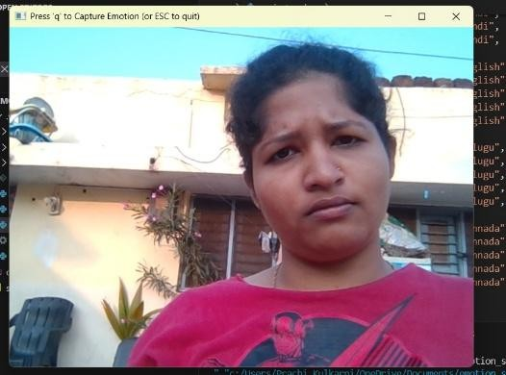
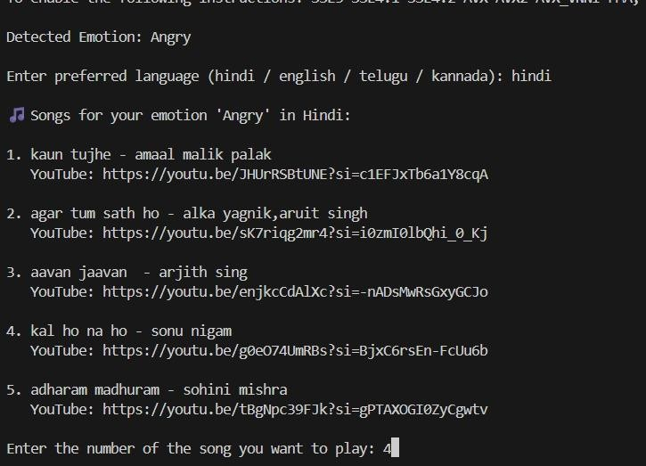
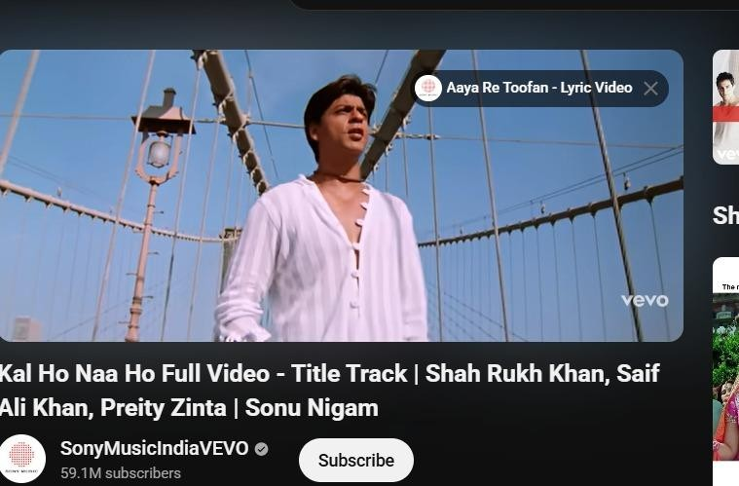

Fig 2: represents angry emotion and the language choosen by the user is hindi

The above result represents “Angry” emotion.The language selected by the user is Hindi. Song selected by the user is 4th song – “Kal ho naa ho”

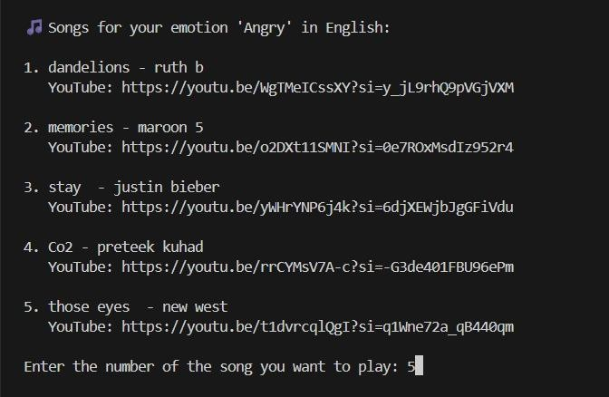
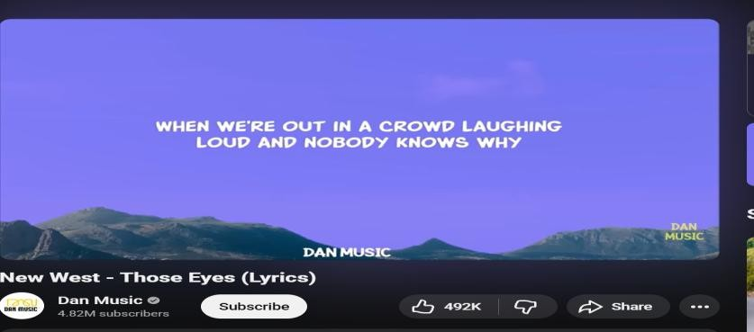

Fig 2.1: represents angry emotion and the language choosen by the user is english

The above result represents “Angry” emotion.The language selected by the user is English. Song selected by the user is 5th song – “New West”

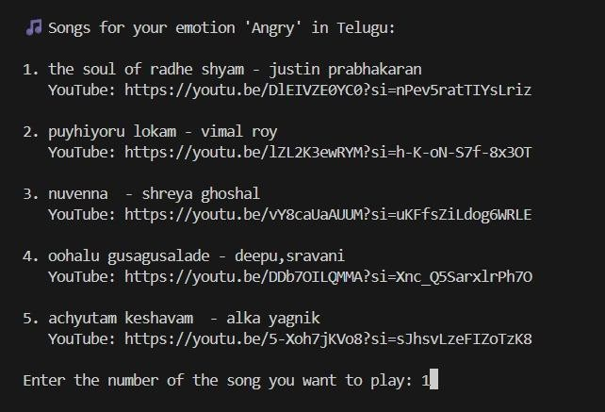
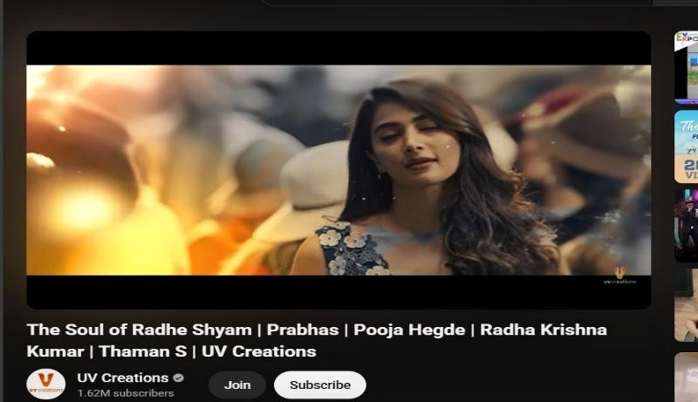

Fig 2.2: represents angry emotion and the language choosen by the user is telugu

The above result represents “Angry” emotion.The language selected by the user is Telugu. Song selected by the user is 1st song – “The Soul of Radhe Shyam”

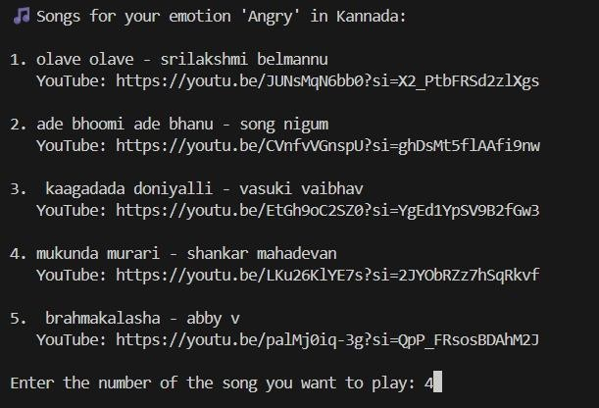
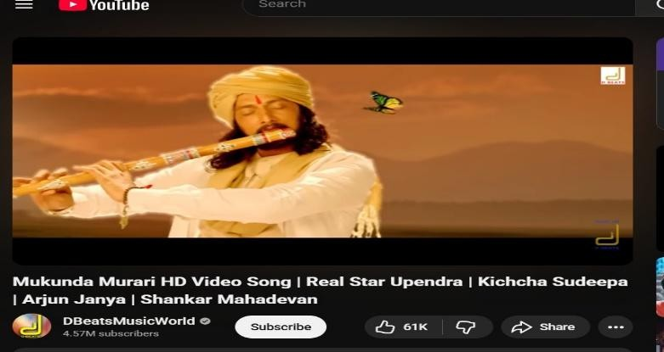

Fig 2.3: represents angry emotion and the language choosen by the user is kannada

The above result represents “Angry” emotion.The language selected by the user is Kaannada. Song selected by the user is 4th song – “Mukunda Murari”

RESULTS OF NEUTRAL EMOTION FOR SONGS IN DIFFERENT LANGUAGES
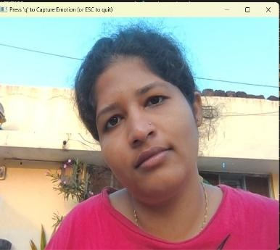
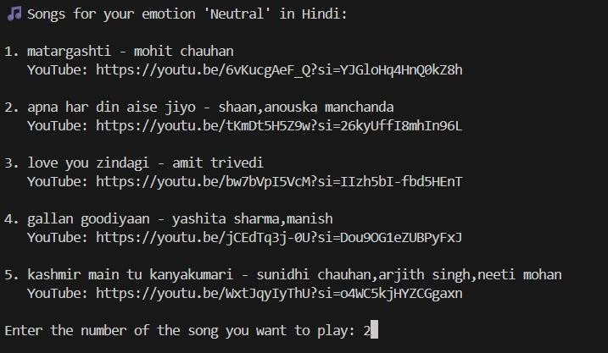
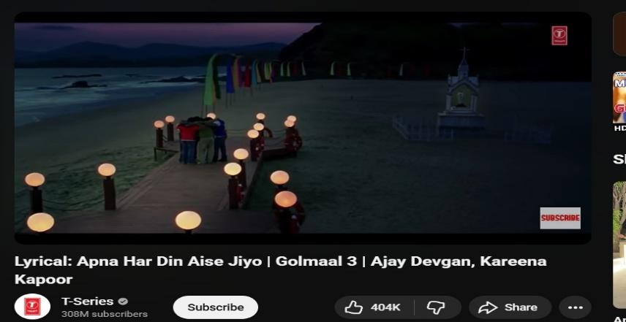

Fig 2.4: represents neutral emotion and the language choosen by the user is hindi

The above result represents “Neutral” emotion.The language selected by the user is Hindi. Song selected by the user is 2nd song – “Apna Har Din Aise Jiyo”

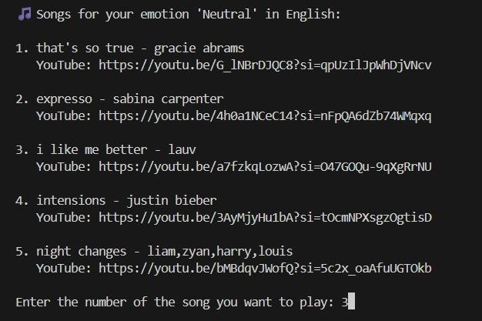
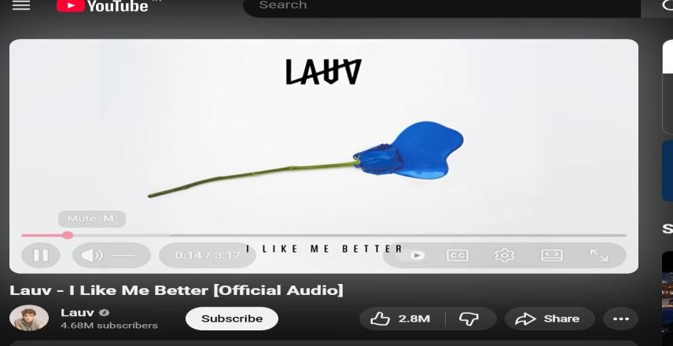

Fig 2.5: represents neutral emotion and the language choosen by the user is english

The above result represents “Neutral” emotion.The language selected by the user is English. Song selected by the user is 3rd song – “Lauv”

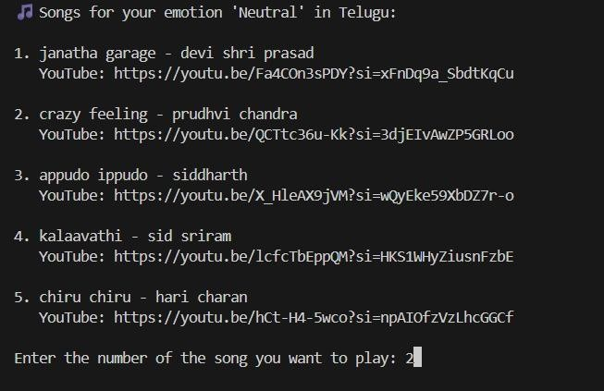
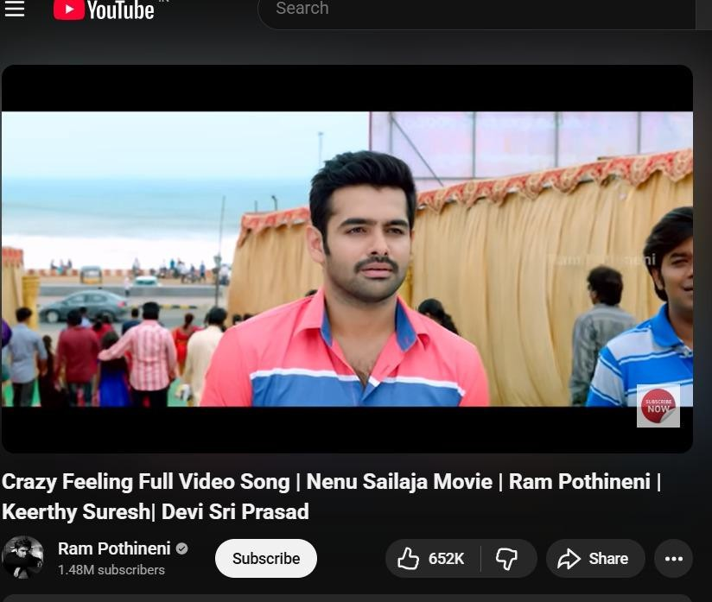

Fig 2.6: represents neutral emotion and the language choosen by the user is telugu

The above result represents “Neutral” emotion.The language selected by the user is Telugu. Song selected by the user is 2nd song – “Crazy Feeling ”

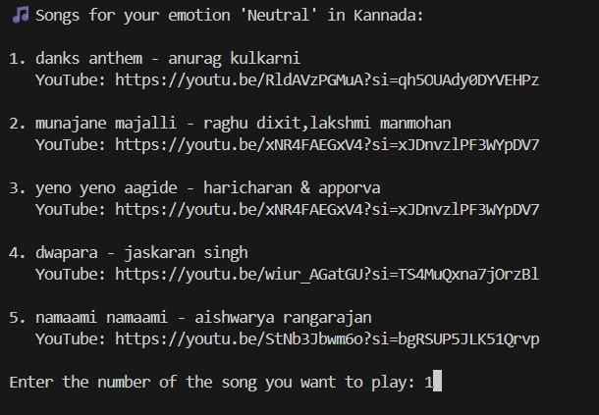
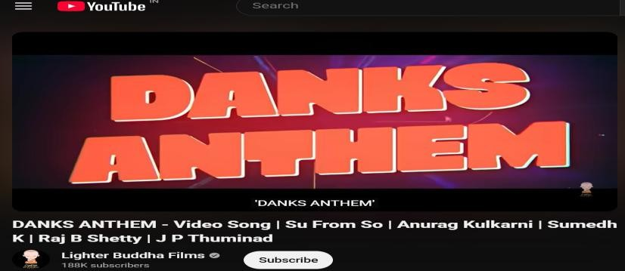

Fig 2.7: represents neutral emotion and the language choosen by the user is kannada

The above result represents “Neutral” emotion.The language selected by the user is Kannada. Song selected by the user is 1st song – “Danks Anthem ”

CHAPTER 6:

CONCLUSION AND FUTURE SCOPE
  - CONCLUSION

This project demonstrates a complete AI-based music recommendation system that links real-time facial emotion recognition with multilingual song suggestions. Using Python as the core language, the system combines DeepFace and OpenCV to capture the user’s live facial expressions through a webcam and accurately classify emotions such as happiness, sadness, calmness, or anger. These detected emotions are then mapped, via a customized CSV dataset handled with Pandas, to playlists in user-selected languages like Hindi, English, Kannada, and Telugu, while the webbrowser module launches the chosen songs directly on YouTube, providing a smooth end-to-end listening experience.

The results show that integrating emotion detection with personalized recommendations can significantly improve how users interact with digital music platforms. Instead of manually searching for songs, users receive playlists that match their current feelings and cultural preferences, which increases convenience and engagement. Because the processing is done locally and only song URLs are opened online, the design also respects user privacy by avoiding storage of facial images or sensitive data. Most importantly, the system does more than just play songs: by suggesting appropriate and uplifting tracks for a given emotional state, it actively helps enhance the user’s mood and overall sense of well-being, highlighting the positive impact that intelligent, emotion-aware technology can have in everyday life.

FUTURE SCOPE

Integrate more advanced deep learning models and larger facial datasets to improve emotion detection accuracy in diverse lighting and background conditions.
Expand the music database with automatic mood tagging from audio features and lyrics, and support more regional languages and genres.
Develop a full-fledged mobile or web application with a richer GUI, user profiles, and the ability to save or share emotion-based playlists.
Combine multiple signals (facial expression, voice tone, typing patterns, time of day) for multi-modal mood detection and even better mood enhancement.

REFERENCES

    - Accurate Algorithm for Generating a Music Playlist based on Facial Expressions
— Anukriti Dureha (2014) Full-text PDF available via journal site: https://research.ijcaonline.org/volume100/number9/pxc3898163
    - Music Recommendation Based on Facial Emotion Recognition — Rajesh B, Keerthana V, Narayana Darapaneni, Anwesh Reddy P (2024) arXiv preprint: https://arxiv.org/abs/2404.04654.
    - Emotion Detection and Music An Recommendation System — Swetha Kambham, Hubert Jhonson, Sai Prathap Reddy Kambham (2025) arXiv preprint: https://arxiv.org/abs/2503.20739
    - Music Recommendation Based on Face Emotion Recognition — Madhuri Athavle, Deepali Mudale, Upasana Shrivastav, Megha Gupta
DOI: 10.54060/JIEEE/002.02.018 — available at the journal site
    - Music Recommendation Based on Facial Emotion Recognition — Chakrapani D. S., Sidrath Iram, Suchitra R.B. Agni, Supritha L., Leelavathi S. (2023)
DOI: 10.17148/IJARCCE.2023.124144
    - Music Recommendation System based on User’s Facial Expression — Vaishnavi Gaikar, Astha Dhengle, Namrata Mhatre, Sujata Kullur (2023)
Available via journal site: title “Music Recommendation System based on User’s Facial Expression”

INSTALLATION AND RUN

Install Python

Download Python from the official website: https://www.python.org/ Install Python (version 3.8 or above recommended)
During installation, check the box “Add Python to PATH”

Install Visual Studio Code (VS Code)

Download from: https://code.visualstudio.com/

Install VS Code and add the Python Extension from the Extensions tab (Microsoft Python extension is needed to run Python programs)

Install Required Python Libraries

Open a terminal (Command Prompt or VS Code Terminal) and run the following commands:
  - Install DeepFace (Emotion Detection Framework) pip install deepface
  - Install OpenCV (Webcam & Image Processing) pip install opencv-python
  - Install Pandas (Song Database Handling) pip install pandas
  - Install pygame (Music Player – if using local MP3 playback) pip install pygame
  - Install Additional Required Libraries pip install numpy
pip install matplotlib

Connect and Test the Webcam

Ensure the laptop/PC webcam is working. Test with a simple OpenCV script:
import cv2

cam = cv2.VideoCapture(0) ret, frame = cam. Read () cv2.imshow("Test", frame) cv2.waitKey(0)
cam. release () cv2.destroyAllWindows()
If the video opens, your webcam is successfully configured.

Project Folder Setup

Create a folder containing:

-Main program

- songs.csv or Python song list

- Any local MP3 files (optional)

- Haarcascade file (if using OpenCV face detection)

- DeepFace installed in environment.

Run the Project

Open the terminal inside the project folder and run.

The webcam opens → emotion is detected → matching playlist is selected → YouTube or MP3 song starts playing.

