Name : Samiksha Thakur

Roll no:57

EXCEPTION HANDLING

CODE:

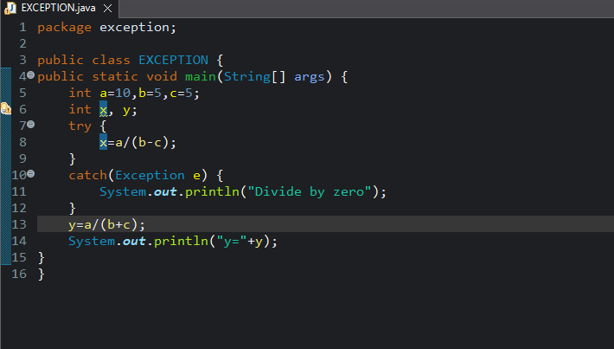

OUTPUT:

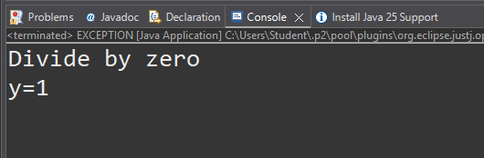

Name : Samiksha Thakur

Roll no:57

PACKAGE

CODE:

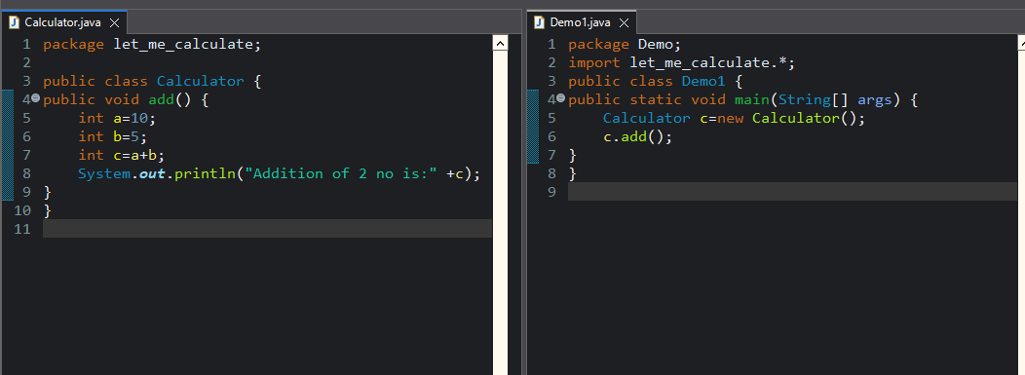

OUTPUT:

