Image Selection Guide:
Goal: Select images that vary in mean depth and meet the criterion listed below. Images should be selected from a variety of scene categories (e.g. bathroom, office, kitchen; images here are from the SUN database - https://groups.csail.mit.edu/vision/SUN/hierarchy.html)

Mean depth: corresponds to the scale or size of the space, ranging from a close-up view on single surfaces or object to panoramic scenes

Poor Image Characteristics

Scene Repeats
Do not select multiple images of the same scene. There may be multiple viewpoints of the same room - only select one so that we can maximize the scene variability in the database.

Clutter
Do not exclude, just note images that are very cluttered in the Excel doc
Extremely cluttered, to the point that objects take up the majority of the scene.
Clutter between the viewer and the end of the screen. Clutter on the wall is acceptable.
Examples:
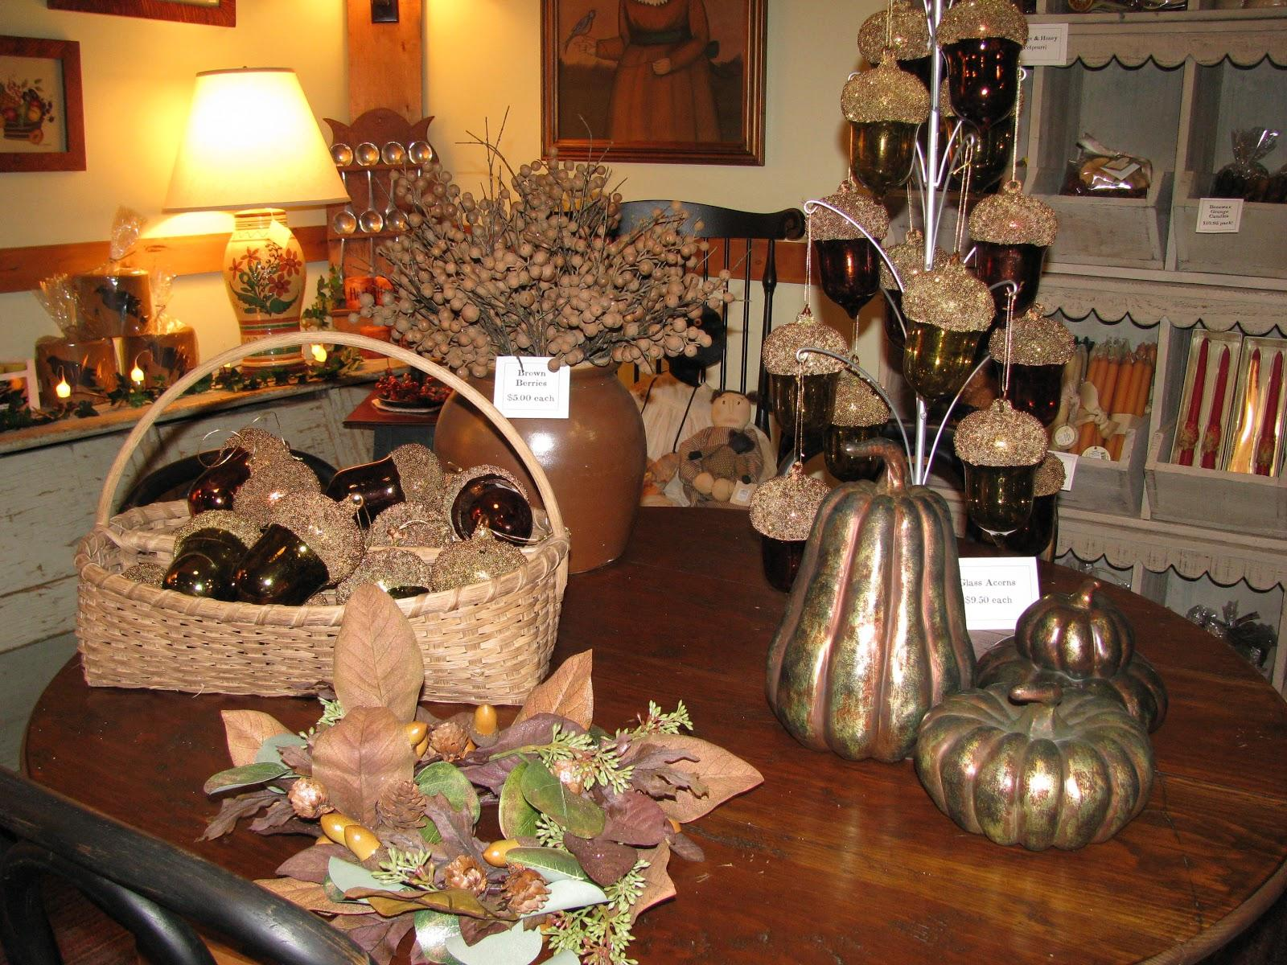
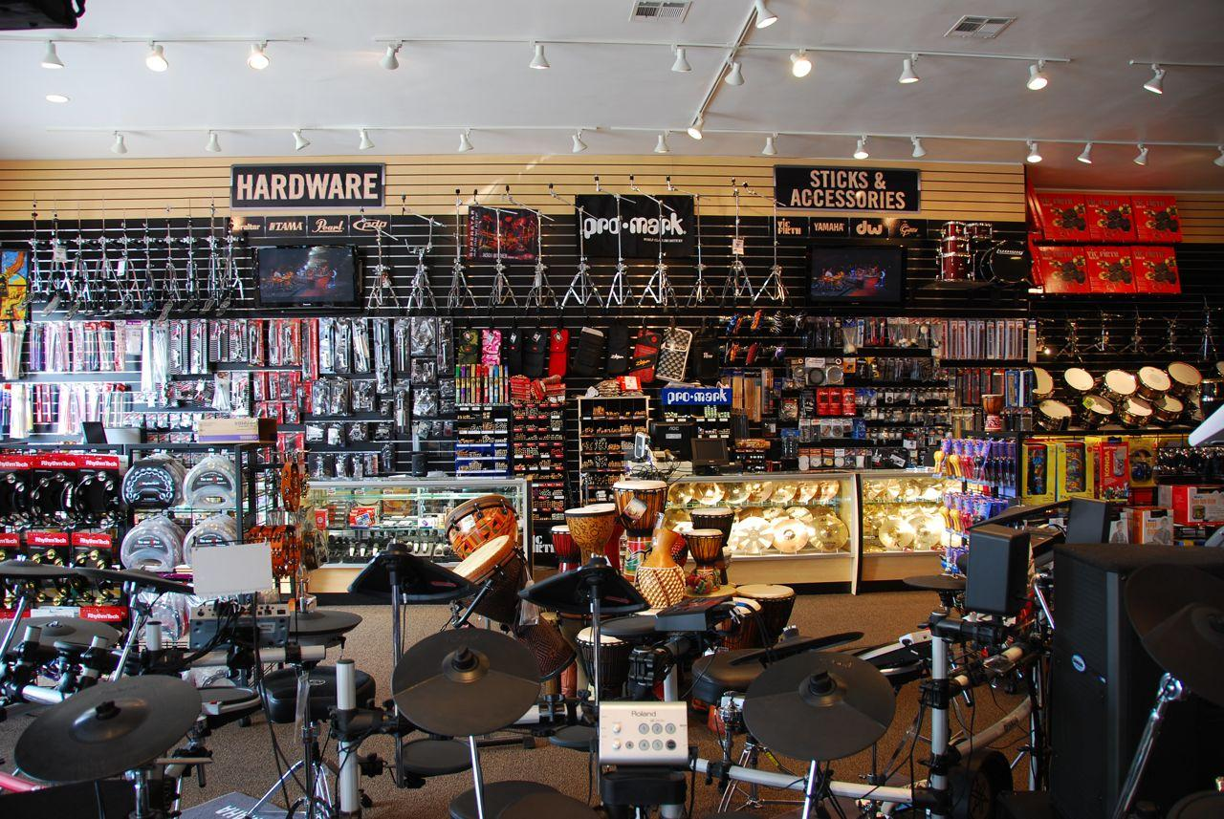

Irregular Angle or Birds Eye View
Extremely irregular angles can have a disproportionate amount of ceiling, wall, or ground plane. Exclude images that seem to be taken at a tilt.
Exclude images taken from a birds eye view entirely. Exclude images taken from a bottom-up angle as well. Keep eye height as constant as possible in selected images.
Examples:

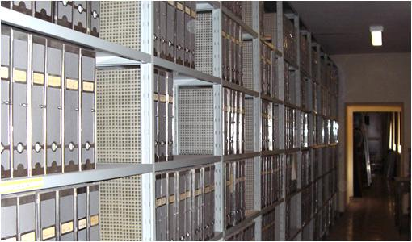
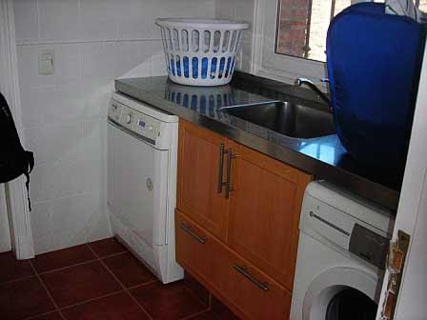

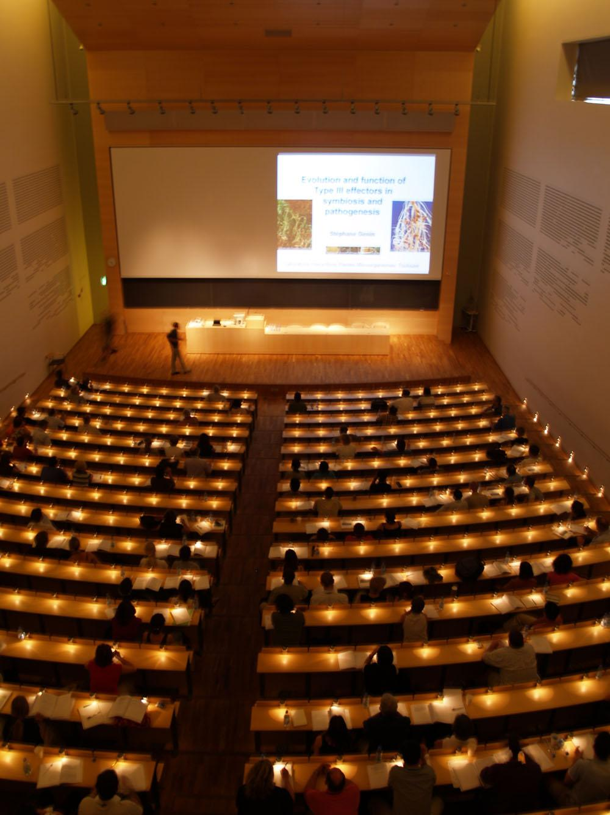(Birds Eye View)

Human Distraction - Crowding, Portrait
Images that are crowded with people should be excluded. Images that have a portrait style, i.e. a human is the focal point, should be excluded. If a person is even looking at the camera, exclude the images.
Examples:
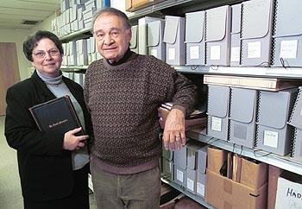
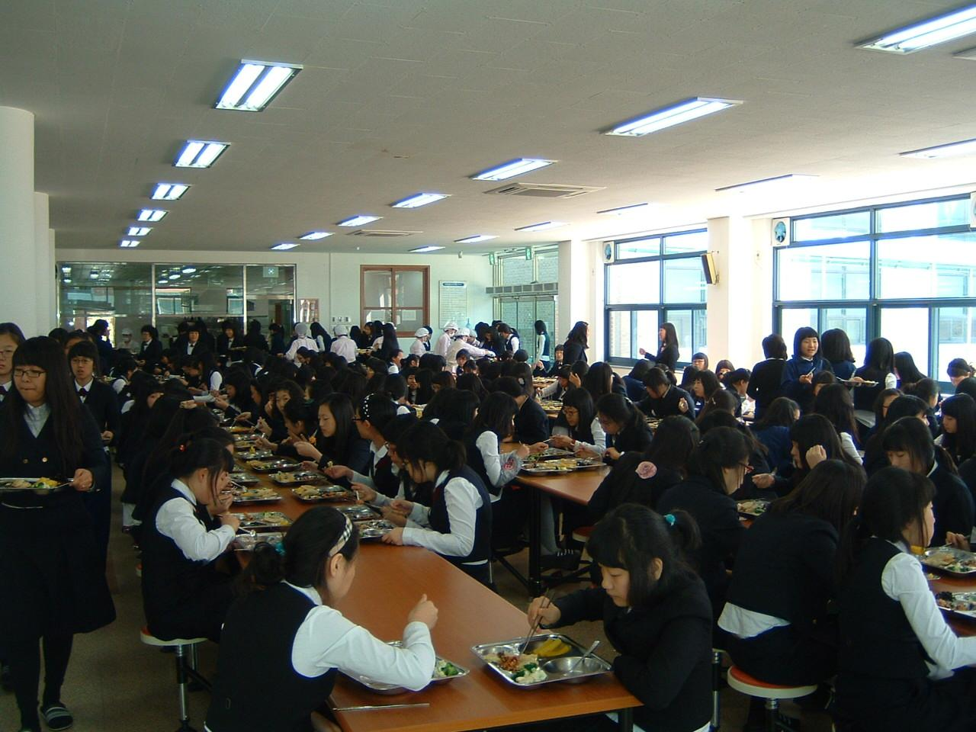

Confusing Scene
If the scene semantics make it difficult to categorize the scene, it will be too confusing for participants. Participants might be distracted by trying to understand the contents of the scene.
Examples:
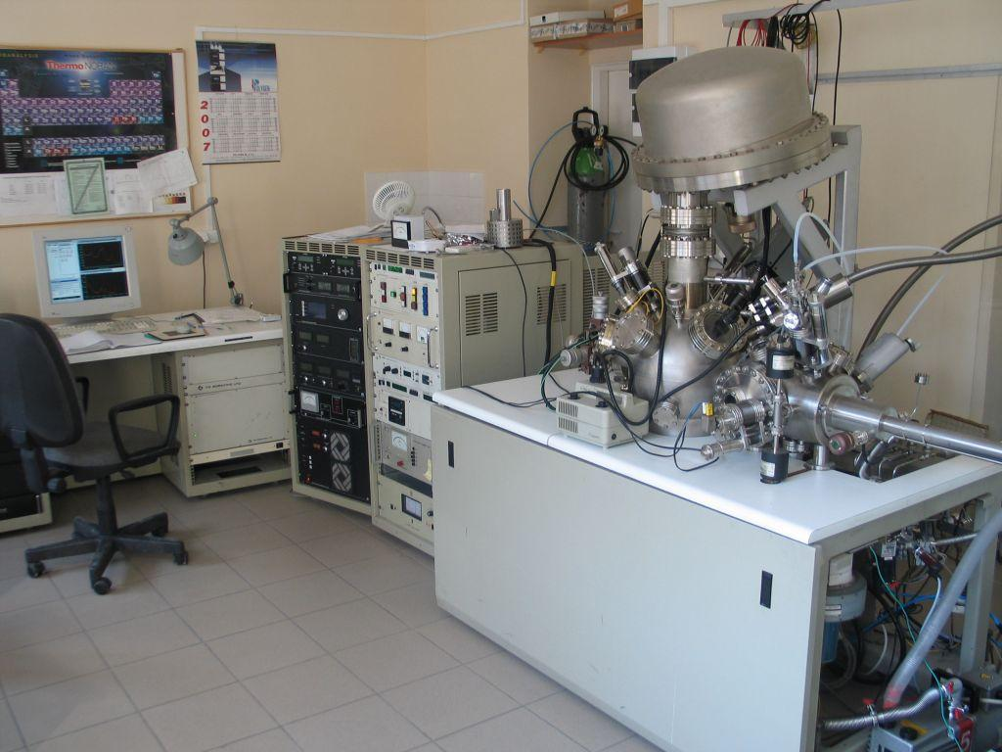
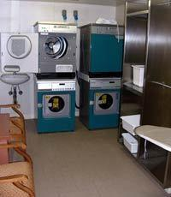

Evocative images
Images of prison, jail cells, surgery, etc. should not be included.
Examples:
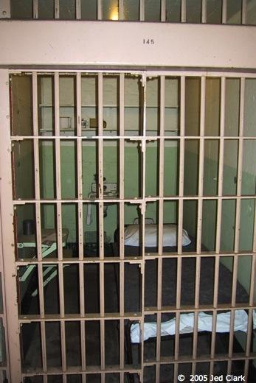
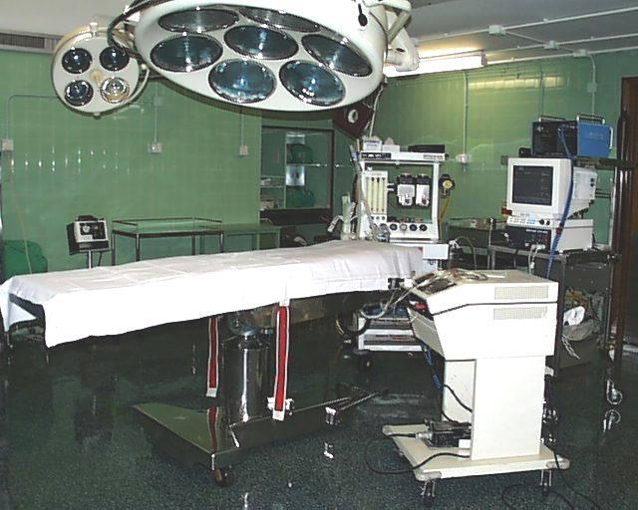

Lack of scene structure
If the scene does not have visible walls or floor, exclude the images. Not a lot of variation in depth - then note down.
Examples:
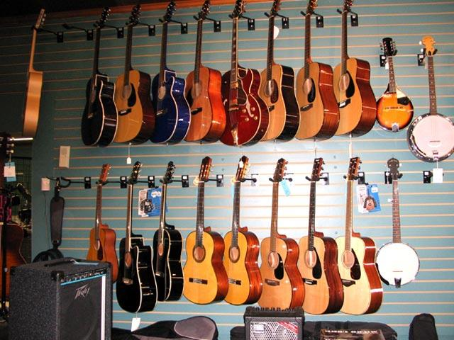
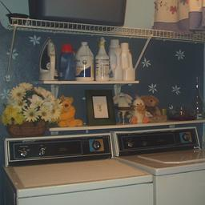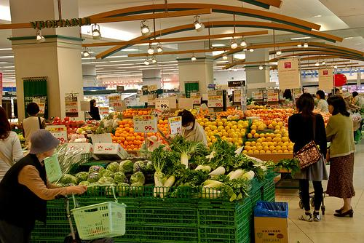
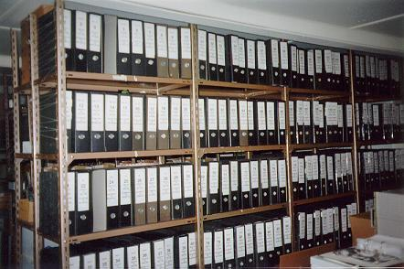

Conflicting Mean Depths
If there are multiple possible mean depths, exclude the image.
Examples:

