Image 2

Image 1

**START**

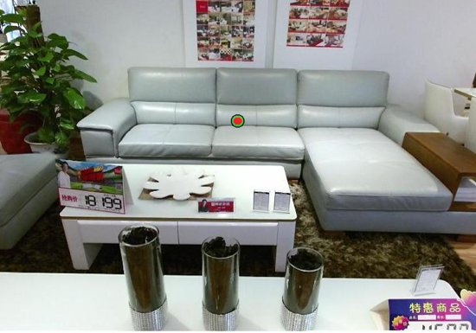

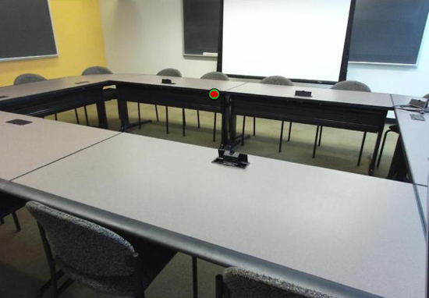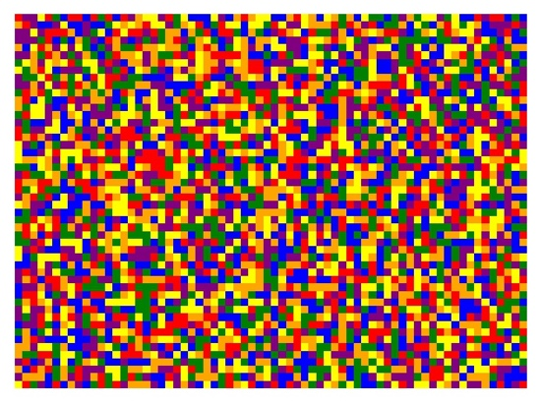

Respond which target was **closer**.

**END**

Trial is about to begin!