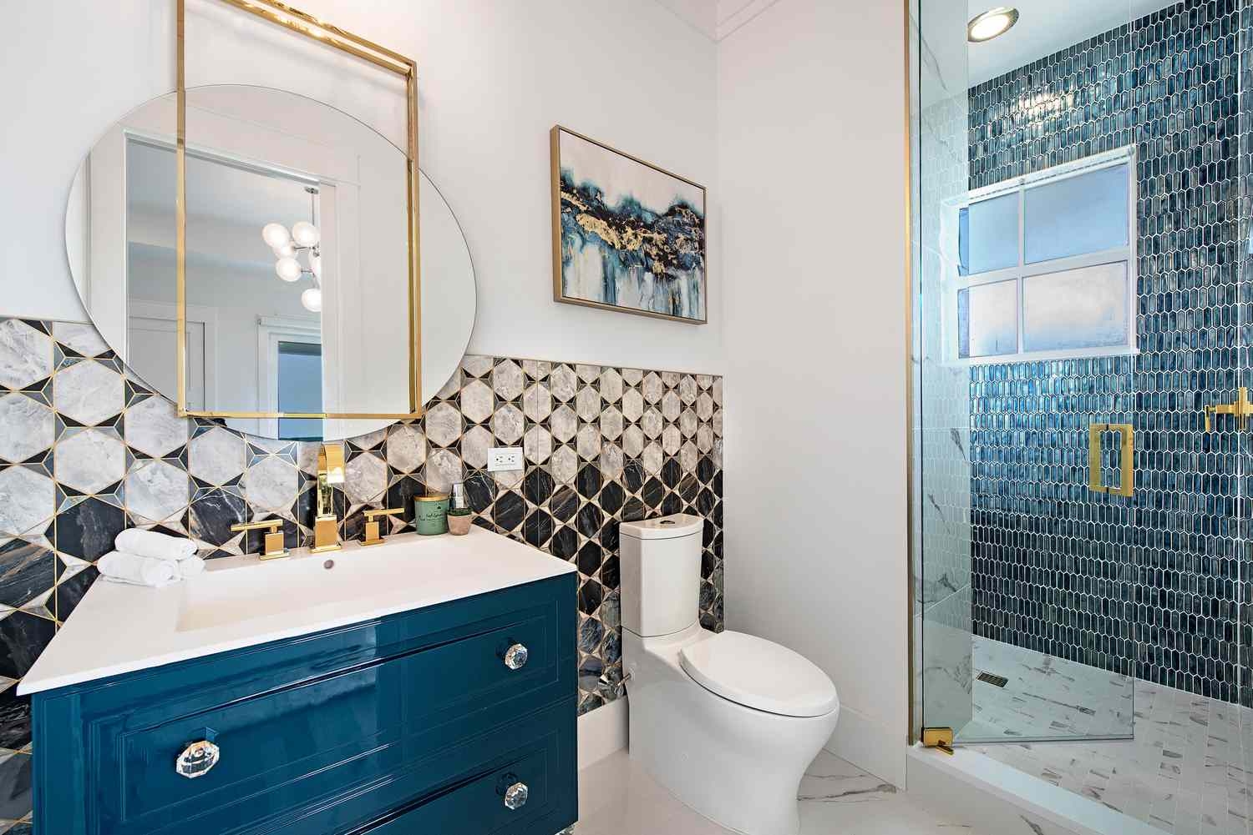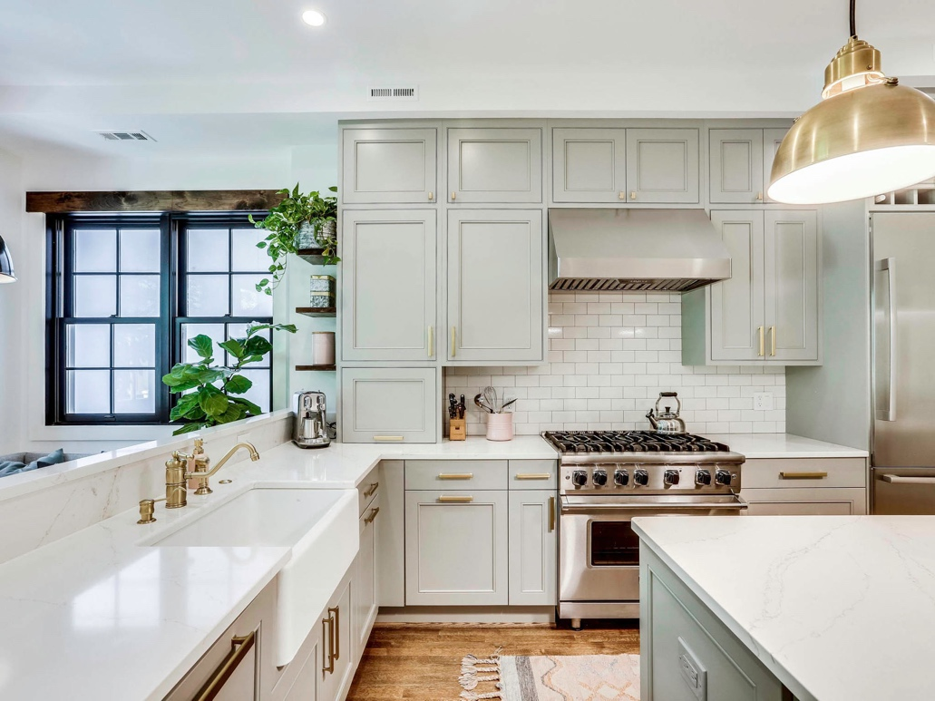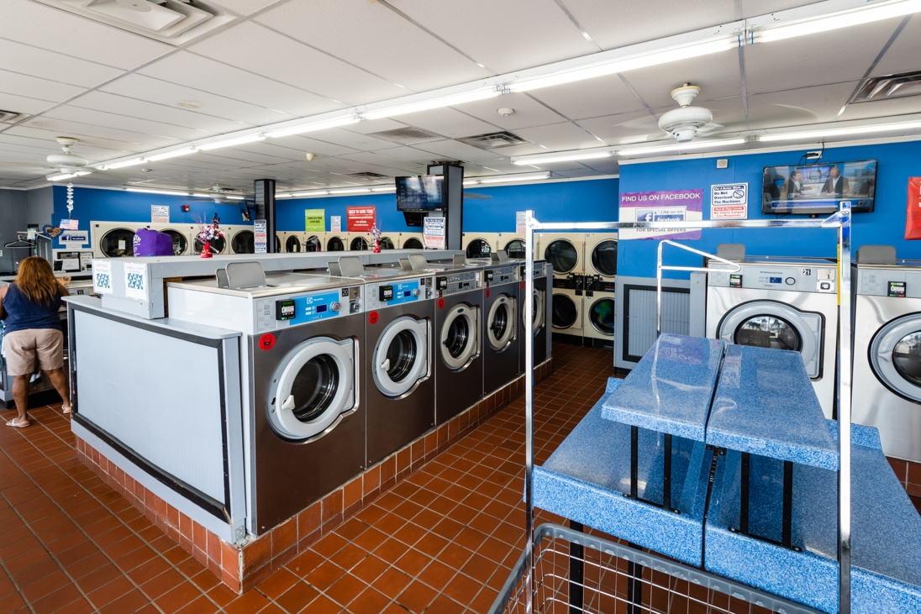

Bathroom

Kitchen

Laundromat

Classroom