mod_main <- lmer(s_residual ~ groundPlane + duration + groundPlane*duration + (1|subjID) + (1|actual_depth), data=df)

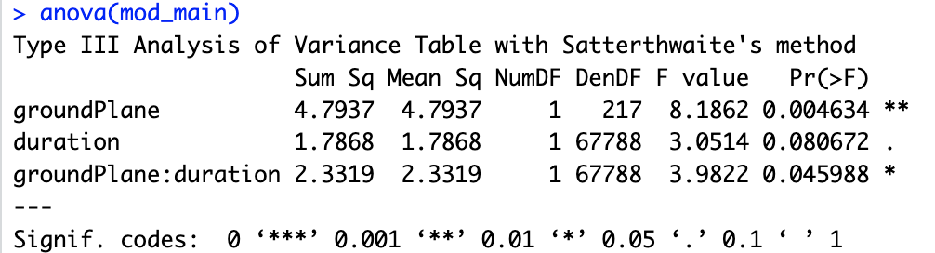

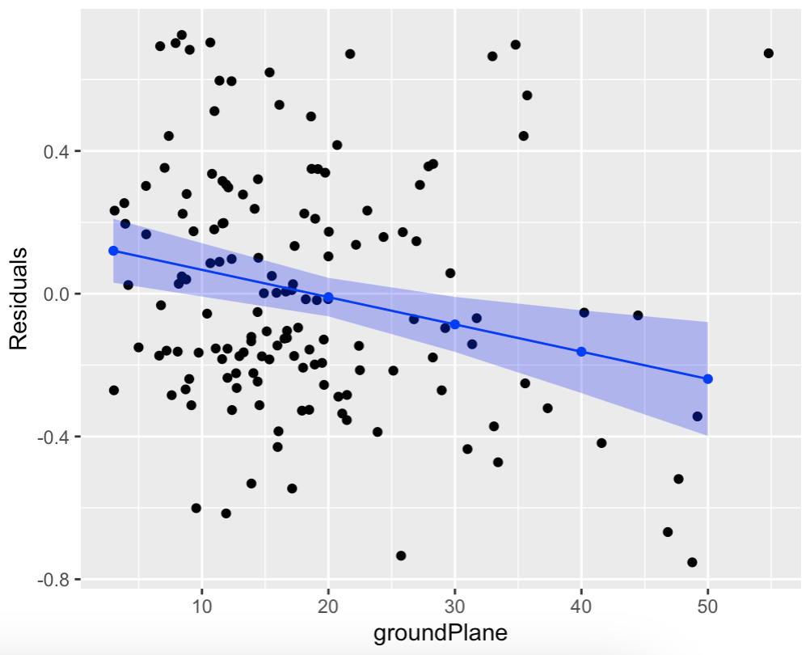

mod_main_abs <- lmer(abs_s_residual ~ groundPlane + duration + groundPlane*duration + (1|subjID) + (1|actual_depth), data=df)

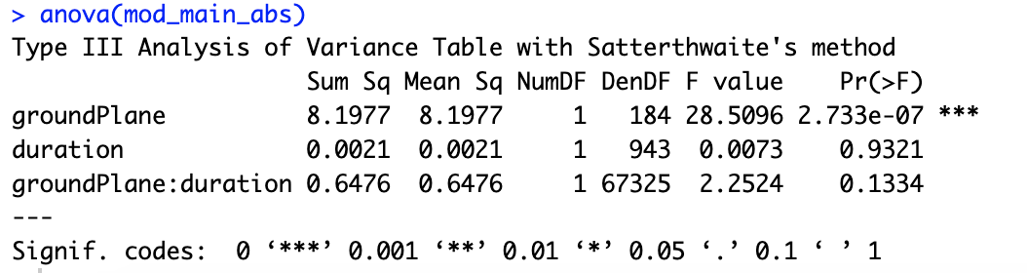

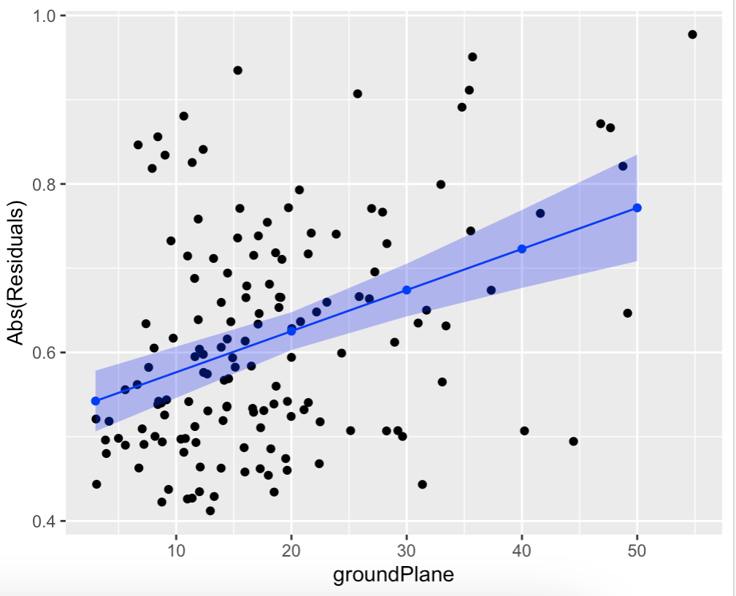

mod_pos <- lmer(pos_s_residual ~ groundPlane + duration + groundPlane*duration + (1|subjID) + (1|actual_depth), data=df_pos)

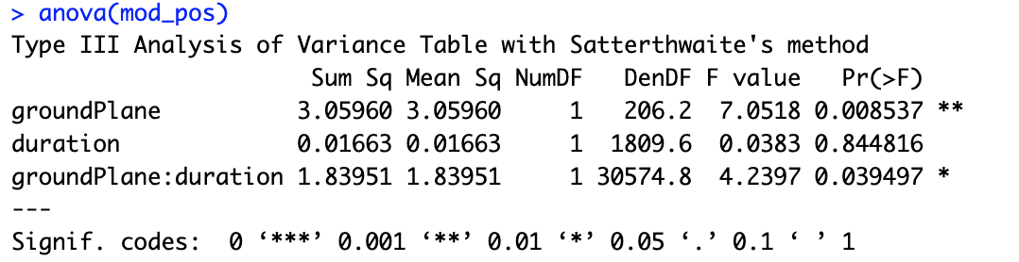

mod_neg <- lmer(neg_s_residual ~ groundPlane + duration + groundPlane*duration + (1|subjID) + (1|actual_depth), data=df_neg)

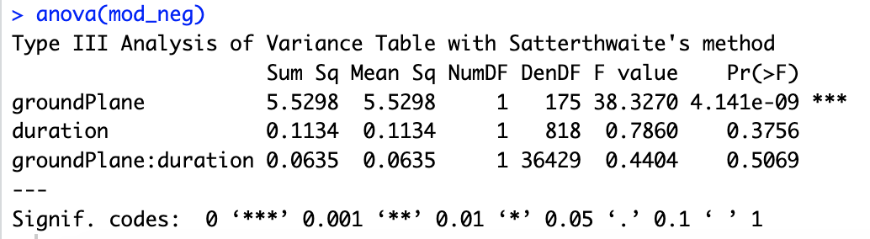
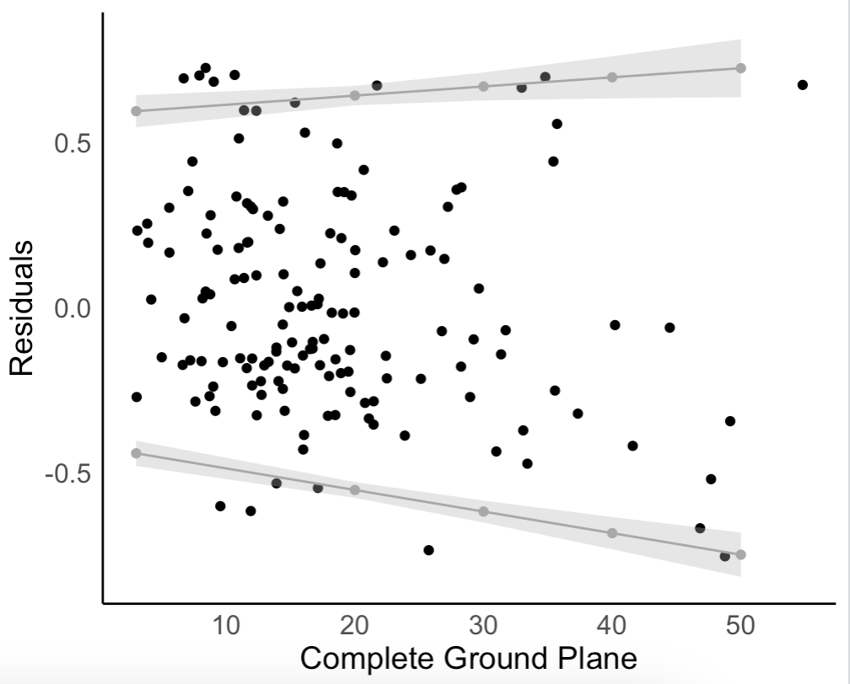
125 ms:
mod_pos <- lmer(pos_s_residual ~ groundPlane + (1|subjID) + (1|actual_depth), data=df_pos)

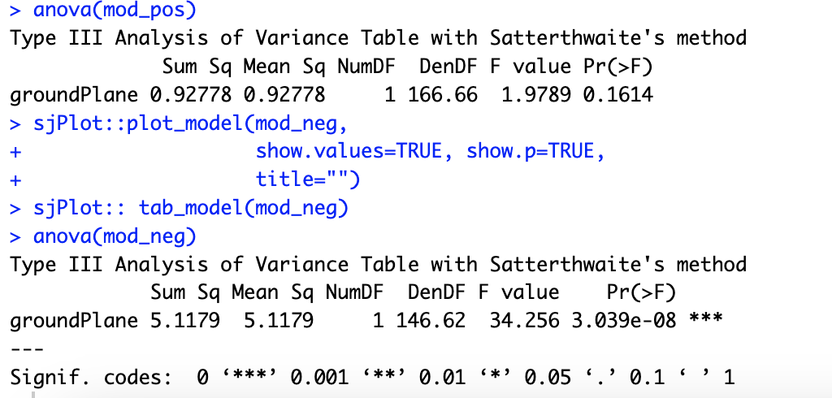

mod_neg <- lmer(neg_s_residual ~ groundPlane + (1|subjID) + (1|actual_depth), data=df_neg)

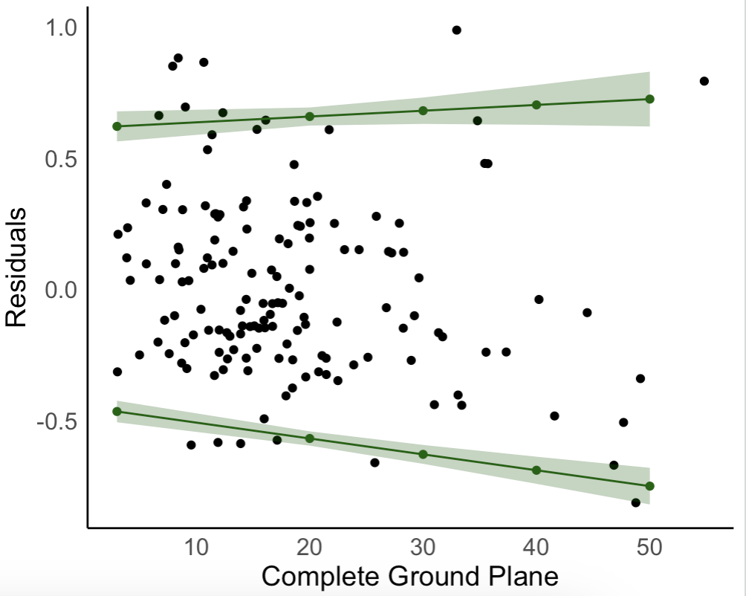

250 ms:
mod_pos <- lmer(pos_s_residual ~ groundPlane + (1|subjID) + (1|actual_depth), data=df_pos)

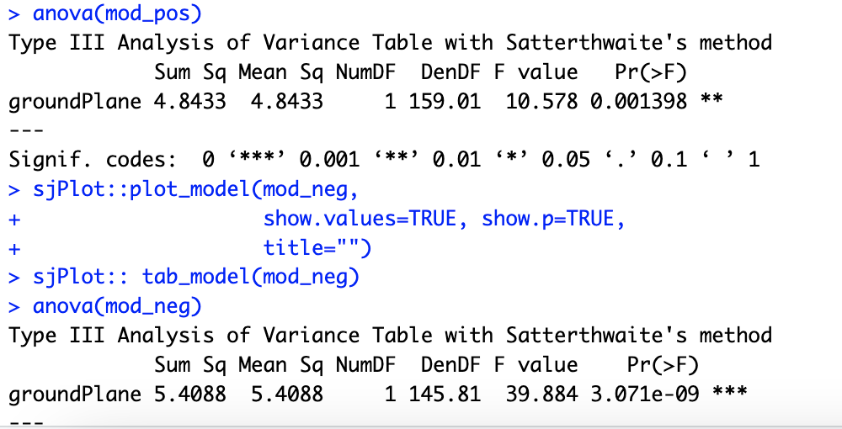

mod_neg <- lmer(neg_s_residual ~ groundPlane + (1|subjID) + (1|actual_depth), data=df_neg)

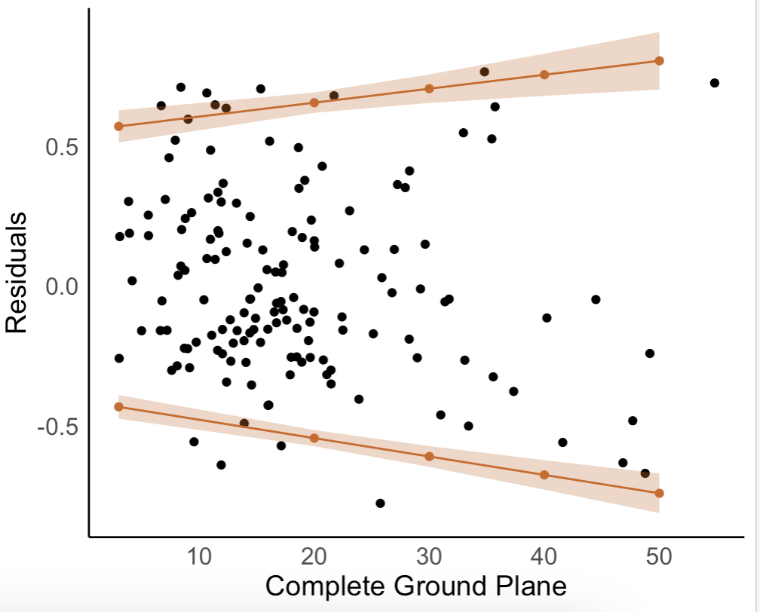

1000 ms:
mod_pos <- lmer(pos_s_residual ~ groundPlane + (1|subjID) + (1|actual_depth), data=df_pos)

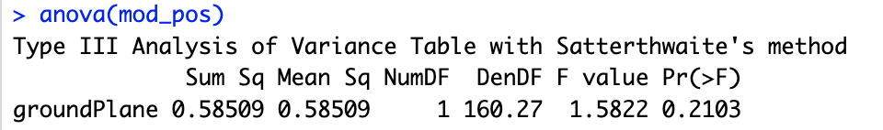

mod_neg <- lmer(neg_s_residual ~ groundPlane + (1|subjID) + (1|actual_depth), data=df_neg)

