mod_main <- lmer(s_residual ~ groundPlane + duration + groundPlane*duration + (1|subjID) + (1|actual_depth), data=df)

mod_main_abs <- lmer(abs_s_residual ~ groundPlane + duration + groundPlane*duration + (1|subjID) + (1|actual_depth), data=df)

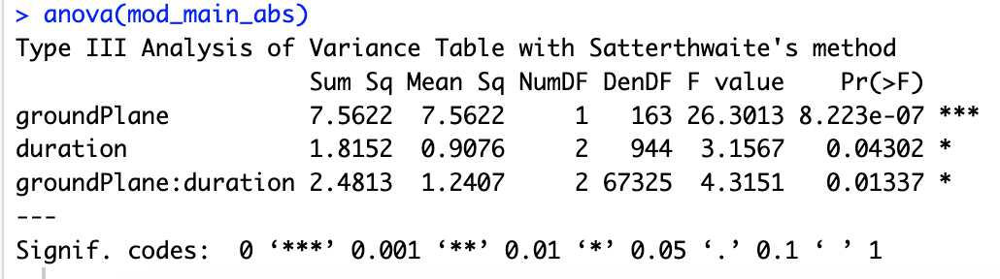

mod_pos <- lmer(pos_s_residual ~ groundPlane + duration + groundPlane*duration + (1|subjID) + (1|actual_depth), data=df_pos)

mod_neg <- lmer(neg_s_residual ~ groundPlane + duration + groundPlane*duration + (1|subjID) + (1|actual_depth), data=df_neg)

**125 ms:**

mod_pos <- lmer(pos_s_residual ~ groundPlane + (1|subjID) + (1|actual_depth), data=df_pos)

mod_neg <- lmer(neg_s_residual ~ groundPlane + (1|subjID) + (1|actual_depth), data=df_neg)

**250 ms:**

mod_pos <- lmer(pos_s_residual ~ groundPlane + (1|subjID) + (1|actual_depth), data=df_pos)

mod_neg <- lmer(neg_s_residual ~ groundPlane + (1|subjID) + (1|actual_depth), data=df_neg)

**1000 ms:**

mod_pos <- lmer(pos_s_residual ~ groundPlane + (1|subjID) + (1|actual_depth), data=df_pos)

mod_neg <- lmer(neg_s_residual ~ groundPlane + (1|subjID) + (1|actual_depth), data=df_neg)

