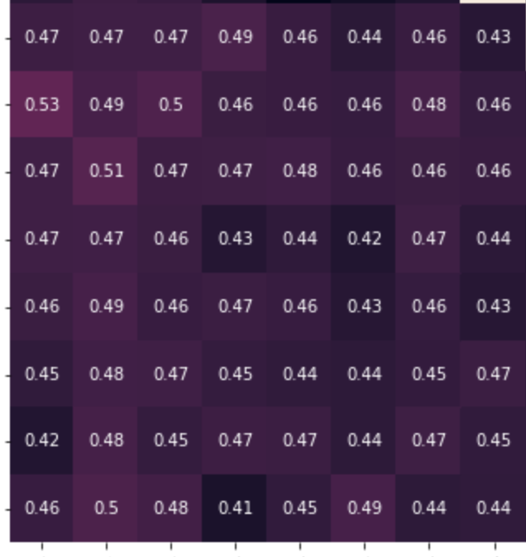

250 ms 500 ms 750 ms 1000 ms 250 ms 500 ms 750 ms 1000 ms

Split 2: TV

Split 2: TAC

250 ms 500 ms 750 ms 1000 ms 250 ms 500 ms 750 ms 1000 ms

Split 1: TV

Split 1: TAC

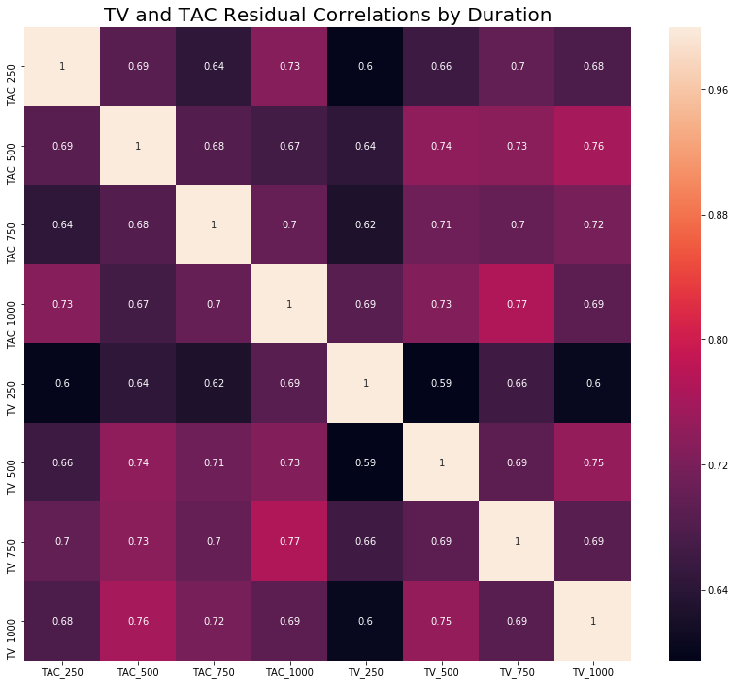

250 ms 500 ms 750 ms 1000 ms 250 ms 500 ms 750 ms 1000 ms

250 ms 500 ms 750 ms 1000 ms

TAC

TV

250 ms 500 ms 750 ms 1000 ms 250 ms 500 ms 750 ms 1000 ms

TAC

TV

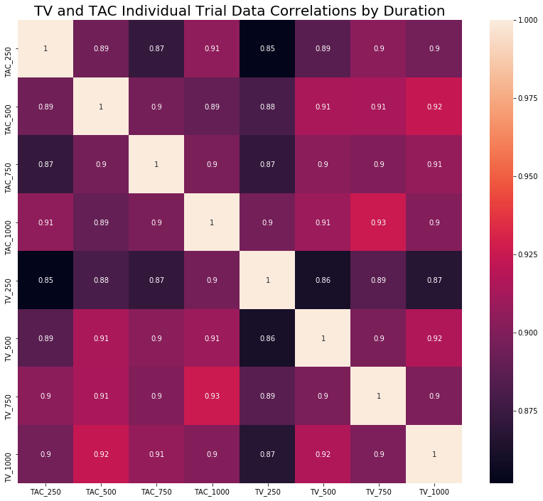

250 ms 500 ms 750 ms 1000 ms 250 ms 500 ms 750 ms 1000 ms

TAC

TV

250 ms 500 ms 750 ms 1000 ms 250 ms 500 ms 750 ms 1000 ms

250 ms 500 ms 750 ms 1000 ms

TAC

TV