PROJECT REPORT
On

“Word Counter”
[Python Programming Post-Lab]

Submitted By:
Prachi Narekar[CS24028]

Guided By:
Ms.AshviniTarar



DEPARTMENT OF COMPUTER SCIENCE & ENGINEERING

S. B. JAIN INSTITUTE OF TECHNOLOGY MANAGEMENTANDRESEARCH,NAGPUR.
(An Autonomous Institute,Affiliated to RTMNU,Nagpur)

2025-2026

©S.B.J.I.T.M.RNagpur2026

2

S.B.JAIN INSTITUTE OF TECHNOLOGY MANAGEMENT AND RESEARCH, NAGPUR
(An Autonomous Institute,Affiliated to RTMNU,Nagpur)
DEPARTMENT OF COMPUTER SCIENCE & ENGINEERING

SESSION 2025-2026

CERTIFICATE

This is to certify the Mini Project titled “Word Counter”is a bonafide work of Prachi Narekar carried out for the partial fulfillment of course work of “Python Programming(N-SECCS401P)”, 4thSemester, Bachelor of Technology in Computer Science & Engineering, S. B. Jain Institute of Technology, Management & Research, Nagpur.

Ms. Ashvini Tarar  Assistant Professor | Dr.Anup Gade  Head of Department
(Project Guide)

CERTIFICATE |  | i
INDEX |  | ii
LIST OF FIGURES |  | iii
CHAPTER 1 | INTRODUCTION | 1
CHAPTER 2 | METHODOLOGY | 2-3
CHAPTER 3 | TOOLS/PLATFORMS | 4
CHAPTER 4 | DESIGN & IMPLEMENTATION | 5-8
 | 4.1 ALGORITHM
 | 4.2 FLOWCHART
 | 4.3 SOURCE CODE
CHAPTER 5 | RESULT & DISCUSSION | 9-11
 | 5.1 OUTPUT
 | 5.2 DISCUSSION
 | 5.3 APPLICATION
CHAPTER 6 | CONCLUSION | 12
 | REFERENCES | 13

FIG. NO. | TITLE OF FIGURE | PAGENO.
1 | INTRODUCTION
2 | METHODOLOGY
3 | TOOLS/PLATFORMS
4 | DESIGN & IMPLEMENTATION
5 | RESULT & DISCUSSION
6 | CONCLUSION

INTRODUCTION

1. Introduction
The Word Counter is a simple yet effective program developed to count the number of words present in a given text. The program can take input either directly from the user or by reading from a file. It processes the input text using string manipulation techniques to identify and separate individual words. By implementing loops and conditional logic, the program calculates the total number of words accurately.
This project is especially useful for beginners as it demonstrates fundamental programming concepts in a practical way. It also helps in understanding how text data can be processed and analyzed using basic coding techniques. The Word Counter can serve as a foundation for developing more advanced applications related to text processing and data analysis.

2. Features
- Word Counting Functionality: Accurately counts the number of words in a given text input.
- Multiple Input Methods: Supports input from both the user (keyboard) and external files.
- Punctuation Handling: Manages punctuation marks such as commas, periods, and special characters to ensure correct word count.
- Efficient String Processing: Uses string methods like splitting and trimming for effective text handling.
- Loop Implementation: Utilizes loops to iterate through words and perform counting operations.
- User-Friendly Design: Simple logic and easy-to-understand structure, making it suitable for beginners.
- Extensibility: Can be expanded to include additional features like counting characters, sentences, or frequency of words.
- Error Handling: Can be modified to handle empty inputs or incorrect file paths.

3. Background Information
Word counting is one of the fundamental tasks in the field of text processing and data analysis. It is widely used in applications such as document editing software, search engines, content analysis tools, and natural language processing (NLP) systems. The primary goal of word counting is to analyze textual data by breaking it down into smaller units called words.
This project is based on several key programming concepts:
- String Manipulation: Splitting text into words using functions like split() and removing unnecessary characters.
- Loops: Iterating through each word to count them systematically.
- File Handling: Reading input text from files, which is essential for handling large datasets.
- Conditional Statements: Handling edge cases such as punctuation, extra spaces, or empty input.
Handling punctuation and special characters is an important aspect of this project, as they can affect the accuracy of the word count. For example, words followed by commas or periods should still be counted as valid words. By addressing such challenges, this project provides a deeper understanding of how real-world text data is processed.
Top of Form
Bottom of Form

METHODOLOGY

Methodology
The development of the Word Counter project followed a systematic and step-by-step process to ensure accuracy and efficiency. The methodology includes the following stages:

1. Problem Identification
The first step was to clearly understand the problem, which is to count the number of words in a given text. The requirements included accepting input from the user or a file and handling special cases such as punctuation and extra spaces.

2. Requirement Analysis
In this phase, the necessary features and tools were identified. The program needed:
- Input handling (user input or file input)
- String manipulation techniques
- Looping structures for counting
- Handling punctuation and edge cases

3. Design Planning
A simple design was created before coding:
- Decide the flow of the program (input → processing → output)
- Choose appropriate methods such as split() for dividing text into words
- Plan logic to remove or ignore punctuation

4. Algorithm Development
A step-by-step algorithm was prepared:
- Start the program
- Accept input (user or file)
- Store the text in a variable
- Remove or handle punctuation
- Split the text into words
- Count the words using a loop or built-in function
- Display the total count
- End the program

5. Implementation (Coding)
The planned algorithm was implemented using a programming language (such as Python). String methods, loops, and file handling techniques were used to develop the working program.

6. Testing
The program was tested with different types of inputs:
- Normal sentences
- Text with punctuation
- Empty input
- Large text files
This ensured the program worked correctly in all cases.

7. Debugging
Errors found during testing were corrected. Special attention was given to:
- Incorrect word counts due to punctuation
- Extra spaces or empty strings

8. Result Evaluation
The output of the program was verified to ensure accurate word counting. The results were compared with expected outputs.

9. Documentation
Finally, all steps including introduction, algorithm, code, and output were documented properly for understanding and presentation.

Conclusion of Methodology
The project followed a structured approach from problem identification to final implementation and testing. This ensured that the Word Counter program is reliable, accurate, and easy to understand.

TOOLS/PLATFORMS
SOFTWARE REQUIREMENT

Tools / Platform / Software Requirements
1. Programming Language:
- Python (version 3.x recommended)
2. Development Environment (IDE):
- Any Python-supported IDE such as:
  - IDLE (comes with Python)
  - VS Code
  - Py Charm
3. Operating System:
- Windows / Linux / macOS (any OS that supports Python)
4. Software Requirements:
- Python installed on the system
- Basic text editor (for creating input files)
5. Hardware Requirements:
- Minimum 2 GB RAM
- Any standard computer/laptop
6. Input Requirements:
- Text file (.txt) or user input from keyboard

DESIGN & IMPLEMENTATION
ALGORITHM : Word Counter
- Start
- Declare variables (text, word_count)
- Initialize word_count = 0
- Ask user to choose input method:
  - Enter text manually OR
  - Read from file
- If user chooses file:
  - Open the file
  - Read the content into a string
- Else:
  - Accept text input from the user
- Remove punctuation from the text
- Split the text into words using spaces
- Loop through the list of words:
  - For each word, increment word_count by 1
- Display the total number of words
- Stop
FLOWCHART

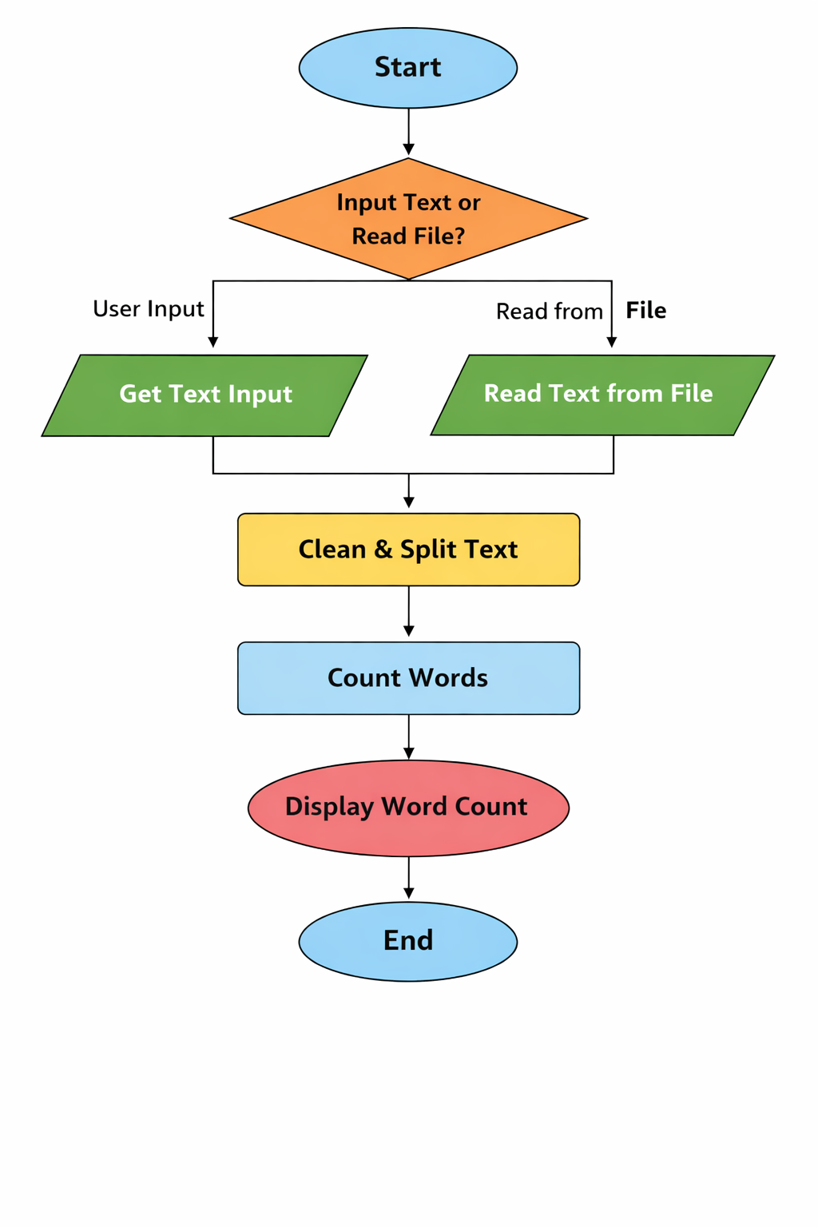

SOURCE CODE

RESULT & DISCUSSION
OUTPUT

DISCUSSION

APPLICATION

CONCLUSION

- ChapterTitle–Fontsize=14,FontType=TimesNewRoman,Alignment=Centered, Bold.
(Example–CHAPTER1)

- ChapterName–Frontsize=16,FontType=TimesNewRoman,Alignment=Centered, Bold.
(Example –INTRODUCTION)

- Heading–Fontsize=14,FontType=TimesNewRoman,Alignment=Left,Bold. (Example – 3.1 SOFTWARE REQUIREMENT)

- SubHeading-Fontsize=12,FontType=TimesNewRoman,Alignment=Left,Bold. (Example – MODULE, FEATURES)

- Content-Fontsize=12,FontType=TimesNewRoman,Alignment=Left. (Example – Write down proper information about you project)

- Figure–Give propername toyour figureand screenshot.
Frontsize=12,FontType=TimesNewRoman,Alignment=Centered. (Example – Fig. 4.1.1 Flowchart of Tic-Tac-Toe)

- Spacingbetweenallcontents=1.5,Alignment=JustifyandTextcolor=Black.

