Session – 17
1.Create a SQL table called Restaurant with columns: id, name, cuisine, location, and average_rating. Insert at least 5 sample rows representing popular restaurants from Zomato.
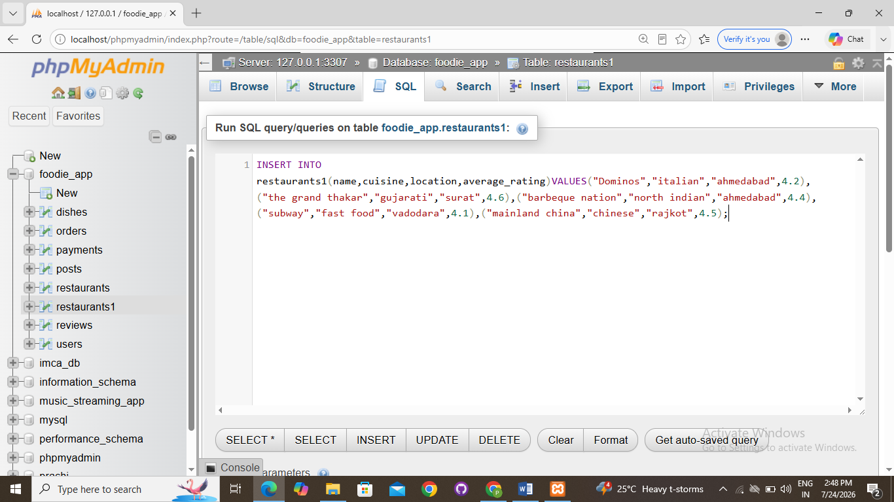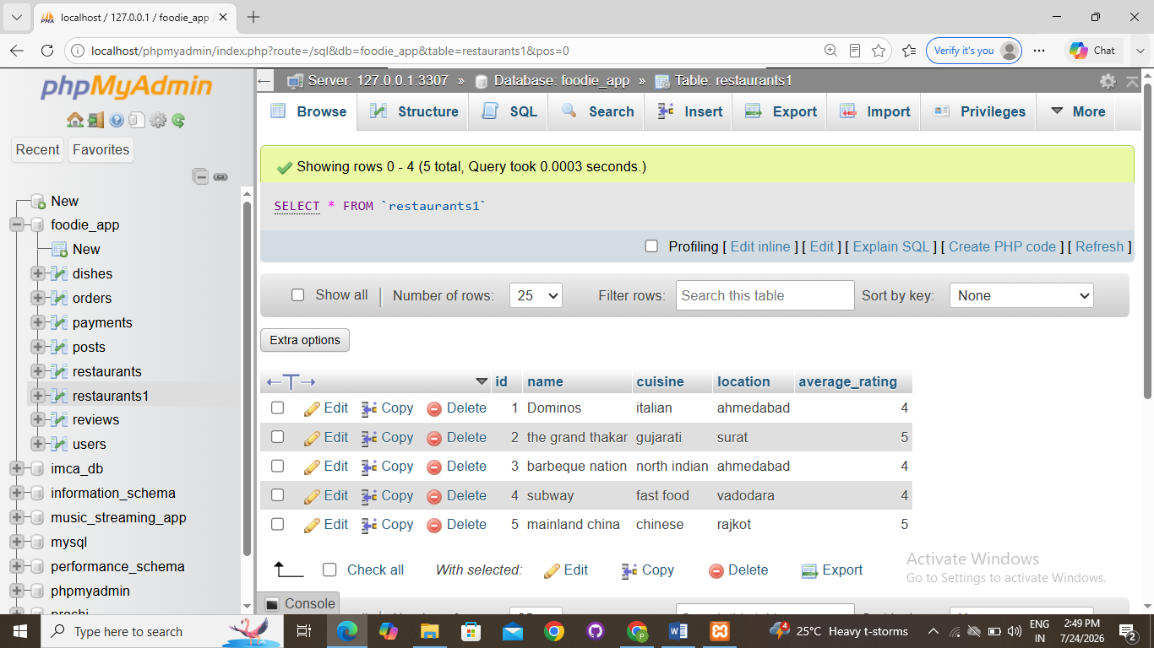
2.Write a SQL query to generate a report showing the number of restaurants for each cuisine type from your Restaurant table, ordered by the count in descending order.<br><br><em><strong>Hint:</strong> Use GROUP BY and ORDER BY.</em>
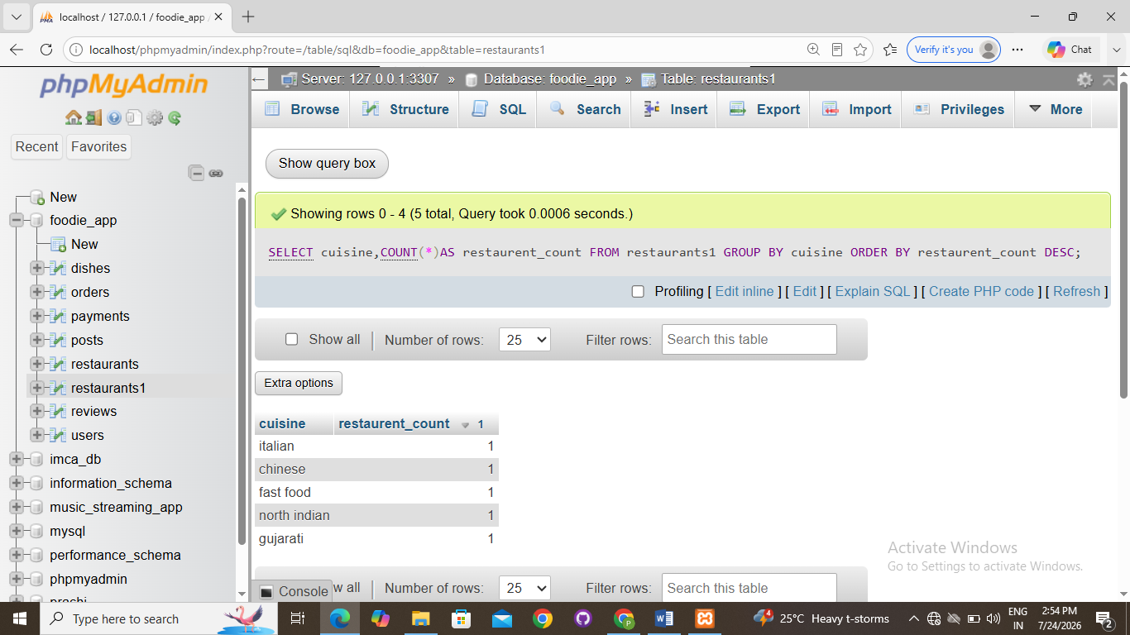

3.Add a new table called Review with columns: id, restaurant_id, user_name, rating, and review_date. Insert at least 10 sample reviews, linking them to restaurants using restaurant_id.
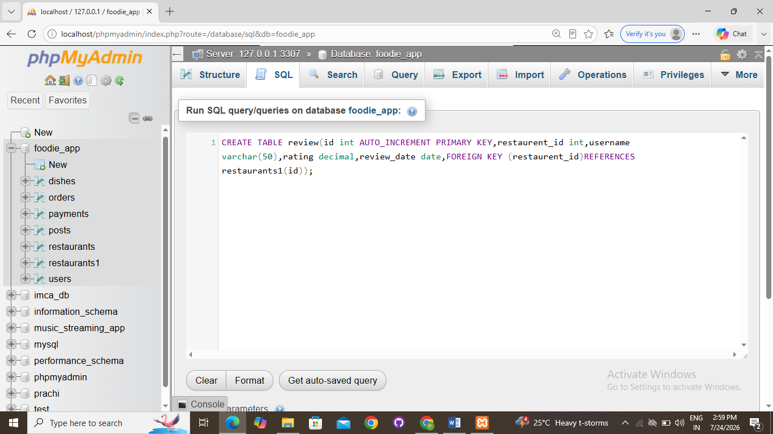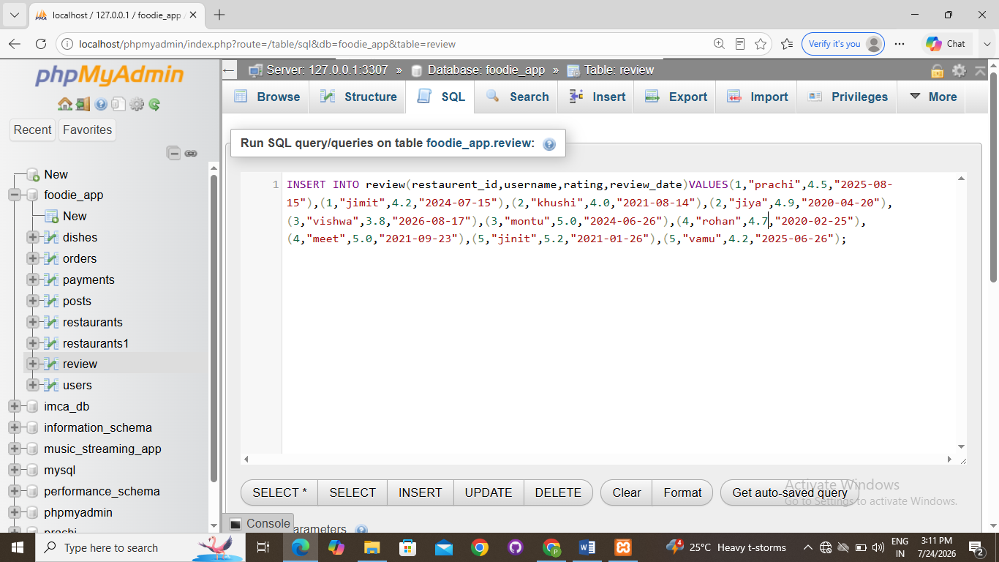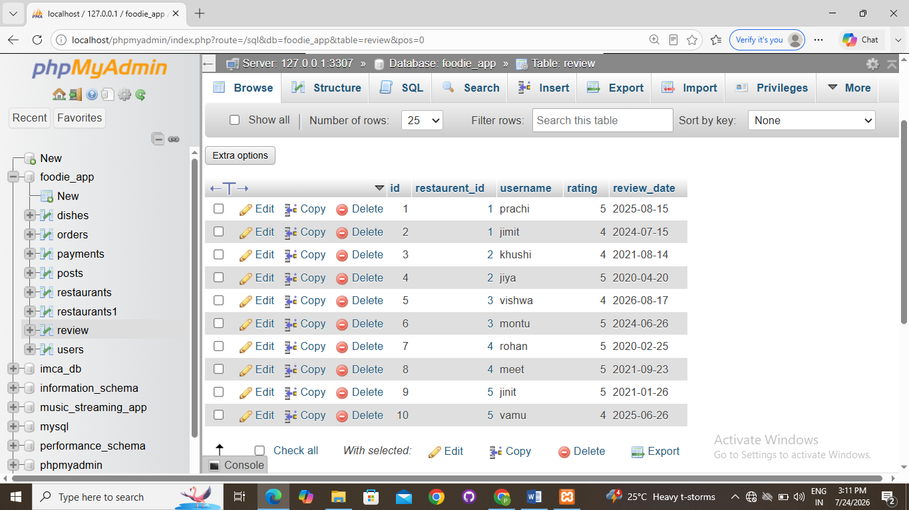

4.Write a SQL query using a JOIN to display each restaurant's name, cuisine, and its average review rating (from the Review table), ordered by highest average rating first.<br><br><em><strong>Hint:</strong> Use JOIN and GROUP BY with aggregate functions.</em>

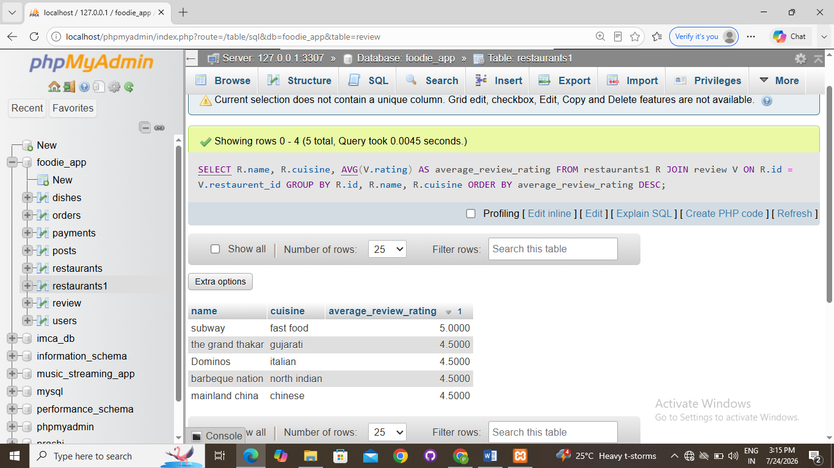

5.Use a window function to rank restaurants by their average review rating within each cuisine type, showing the restaurant name, cuisine, average rating, and rank.<br><br><em><strong>Hint:</strong> Use the RANK() or DENSE_RANK() window function partitioned by cuisine.</em>
