**EXPERIMENT NO.5**

**Aim :** Program for 16 bit BCD addition

**Program :**

.model small  
.data

a dw 1234H  
 b dw 0100H

.code  
  
main:

mov ax, @data ; Initialize data section  
 mov ds, ax  
 mov ax, a ; Load number1 in ax  
 mov bx, b ; Load number2 in bx  
 add ax, bx ; add numbers. Result in ax  
 mov ch, 04h ; Count of digits to be displayed  
 mov cl, 04h ; Count to roll by 4 bits  
 mov bx, ax ; Result in reg bh

l2:

rol bx, cl ; roll bl so that msb comes to lsb  
 mov dl, bl ; load dl with data to be displayed  
 and dl, 0fH ; get only lsb  
 cmp dl, 09 ; check if digit is 0-9 or letter A-F  
 jbe l4  
 add dl, 07 ; if letter add 37H else only add 30H

l4:

add dl, 30H  
 mov ah, 02 ; Function 2 under INT 21H (Display character)  
 int 21H

 dec ch ; Decrement Count  
 jnz l2  
 mov ah, 4cH ; Terminate Program  
 int 21H

end main

**OUTPUT :**

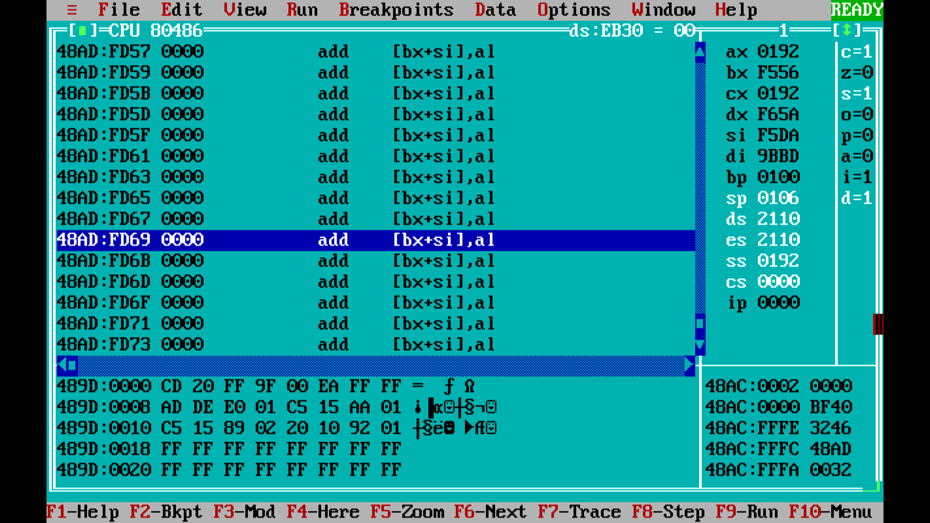

**Conclusion :** Thus we have successfully implemented 16-bit BCD addition.