**NUNIT**

1. TestFixture & Test

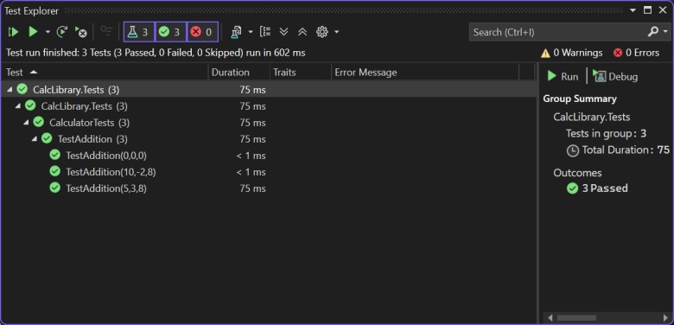

2. Parameterized test cases

