Employee Management System SQL Exercises
Database Schema
The following schema defines the structure for an Employee Management System:

Departments Table
CREATE TABLE Departments (
DepartmentID INT PRIMARY KEY,
DepartmentName VARCHAR(100)
);
Employees Table
CREATE TABLE Employees (
EmployeeID INT PRIMARY KEY,
FirstName VARCHAR(50),
LastName VARCHAR(50),
DepartmentID INT FOREIGN KEY REFERENCES Departments(DepartmentID),
Salary DECIMAL(10,2),
JoinDate DATE
);

Sample Data
The following sample data can be used for testing:

Departments Sample Data
INSERT INTO Departments (DepartmentID, DepartmentName) VALUES
(1, 'HR'),
(2, 'Finance'),
(3, 'IT'),
(4, 'Marketing');
Employees Sample Data
INSERT INTO Employees (EmployeeID, FirstName, LastName, DepartmentID, Salary,
JoinDate) VALUES
(1, 'John', 'Doe', 1, 5000.00, '2020-01-15'),
(2, 'Jane', 'Smith', 2, 6000.00, '2019-03-22'),
(3, 'Michael', 'Johnson', 3, 7000.00, '2018-07-30'),
(4, 'Emily', 'Davis', 4, 5500.00, '2021-11-05');

Exercises
Exercise 1: Create a Stored Procedure
Goal: Create a stored procedure to retrieve employee details by department.
Steps:
1. Define the stored procedure with a parameter for DepartmentID.
2. Write the SQL query to select employee details based on the DepartmentID.
3. Create a stored procedure named `sp_InsertEmployee` with the following code:
CREATE PROCEDURE sp_InsertEmployee
@FirstName VARCHAR(50),
@LastName VARCHAR(50),
@DepartmentID INT,
@Salary DECIMAL(10,2),
@JoinDate DATE
AS BEGIN
INSERT INTO Employees (FirstName, LastName, DepartmentID, Salary, JoinDate)
VALUES (@FirstName, @LastName, @DepartmentID, @Salary, @JoinDate); END;
CREATE TABLE Departments (
DepartmentID INT PRIMARY KEY,
DepartmentName VARCHAR(100)
);

CREATE TABLE Employees (
EmployeeID INT PRIMARY KEY IDENTITY(1,1),
FirstName VARCHAR(50),
LastName VARCHAR(50),
DepartmentID INT FOREIGN KEY REFERENCES Departments(DepartmentID),
Salary DECIMAL(10,2),
JoinDate DATE
);

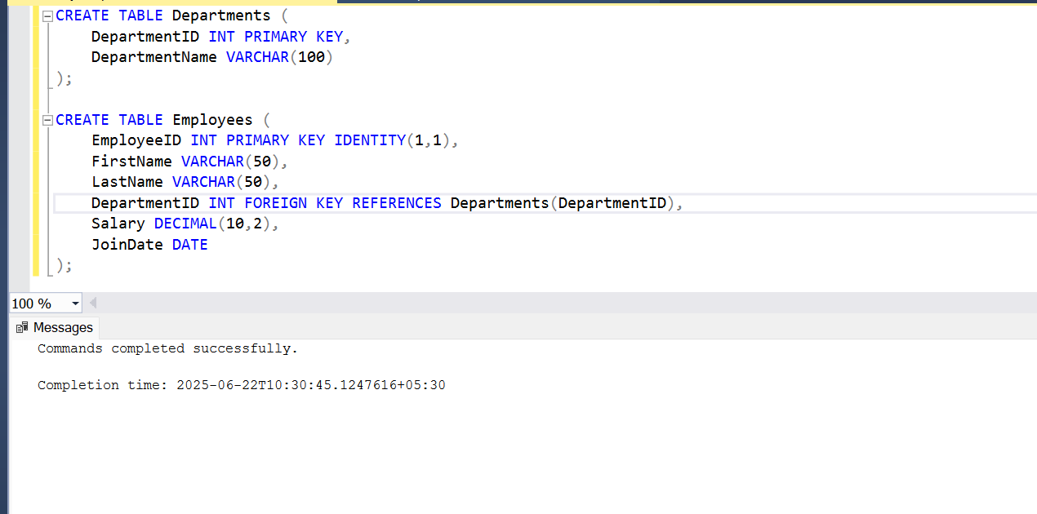

INSERT INTO Departments (DepartmentID, DepartmentName) VALUES (1, 'HR'), (2, 'Finance'), (3, 'IT'), (4, 'Marketing');
SELECT * FROM Departments;

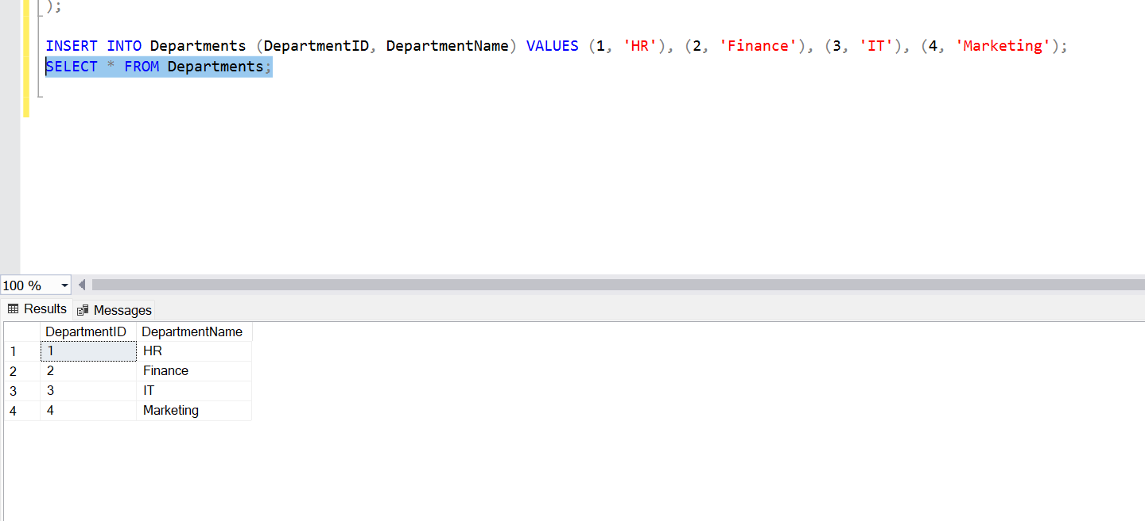

INSERT INTO Employees (FirstName, LastName, DepartmentID, Salary, JoinDate) VALUES
('John', 'Doe', 1, 5000.00, '2020-01-15'), ('Jane', 'Smith', 2, 6000.00, '2019-03-22'),
('Michael', 'Johnson', 3, 7000.00, '2018-07-30'), ('Emily', 'Davis', 4, 5500.00, '2021-11-05');
SELECT * FROM Employees;

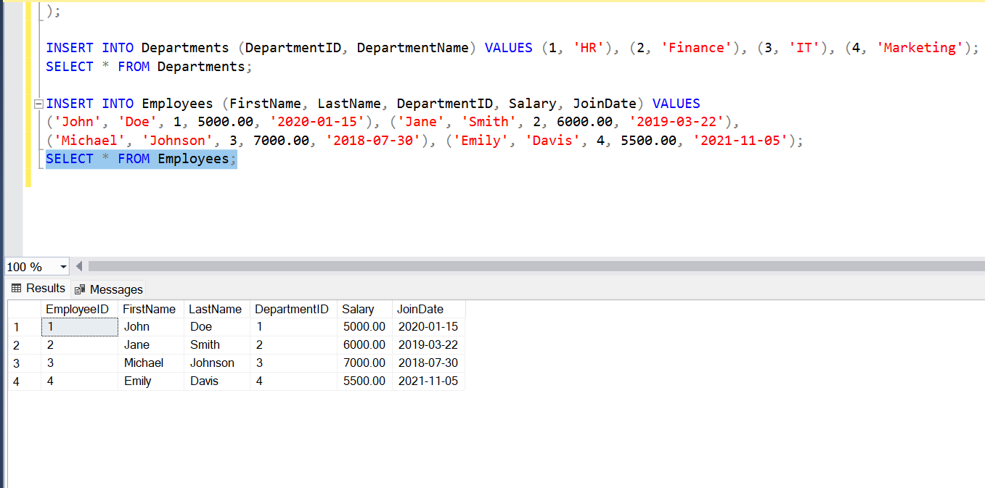

--Create Stored Procedure to Get Employees by Department

GO
CREATE PROCEDURE sp_GetEmployeesByDepartment
@DepartmentID INT
AS
BEGIN
SELECT
E.EmployeeID,
E.FirstName,
E.LastName,
D.DepartmentName,
E.Salary,
E.JoinDate
FROM Employees E
INNER JOIN Departments D ON E.DepartmentID = D.DepartmentID
WHERE E.DepartmentID = @DepartmentID;
END;

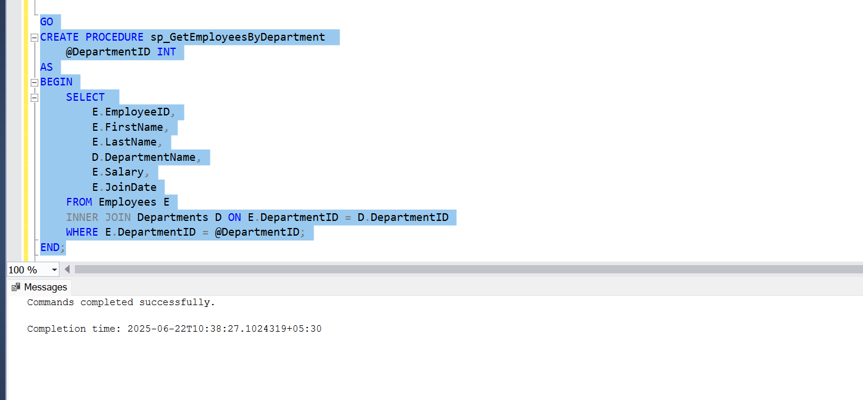

--Test sp_GetEmployeesByDepartment

EXEC sp_GetEmployeesByDepartment @DepartmentID = 2;

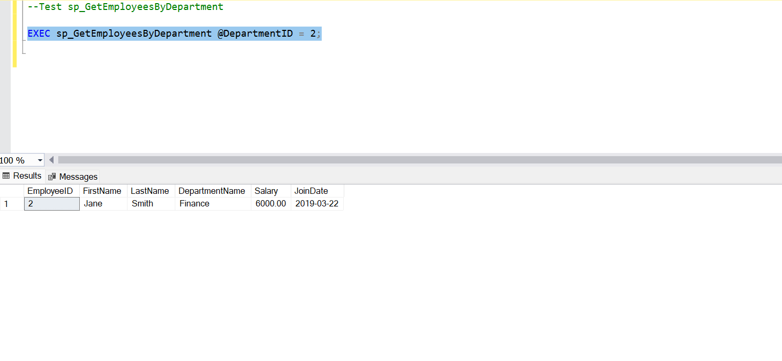

--Create sp_InsertEmployee Procedure

GO
CREATE PROCEDURE sp_InsertEmployee
@FirstName VARCHAR(50),
@LastName VARCHAR(50),
@DepartmentID INT,
@Salary DECIMAL(10,2),
@JoinDate DATE
AS
BEGIN
INSERT INTO Employees (FirstName, LastName, DepartmentID, Salary, JoinDate)
VALUES (@FirstName, @LastName, @DepartmentID, @Salary, @JoinDate);
END;

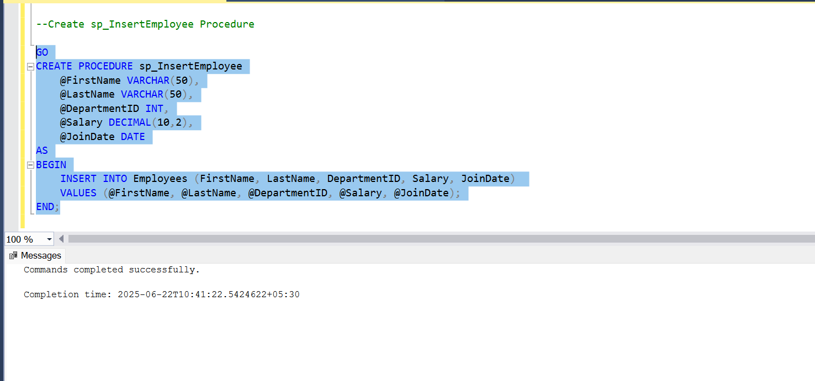

--Test sp_InsertEmployee

EXEC sp_InsertEmployee
@FirstName = 'Amit',
@LastName = 'Kumar',
@DepartmentID = 3,
@Salary = 6500.00,
@JoinDate = '2022-08-01';

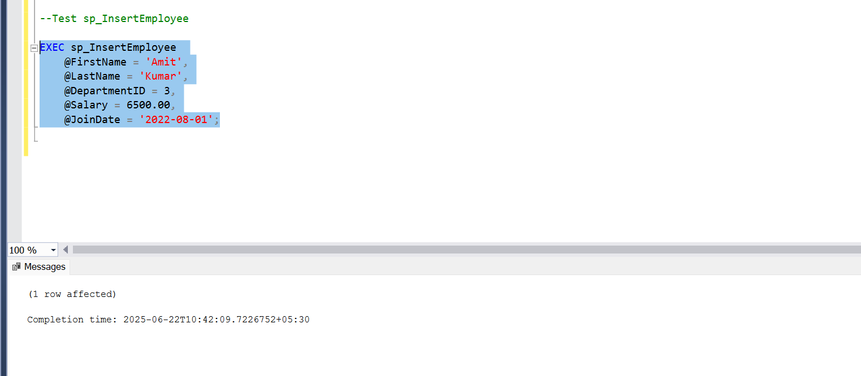

--Verify

SELECT * FROM Employees;
