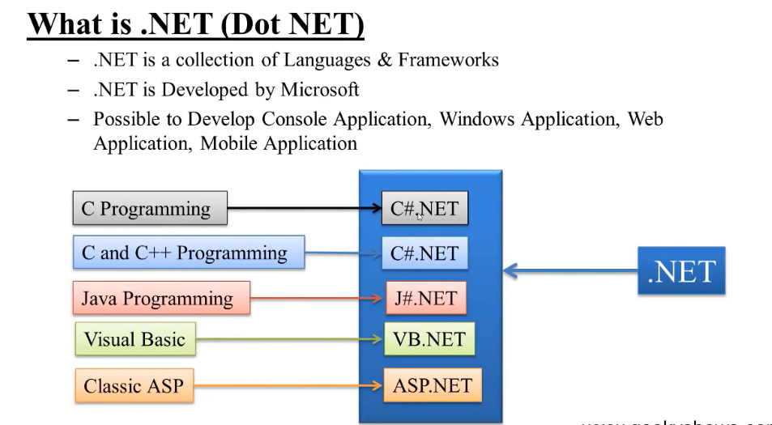**C#**

1. C# version 1 was released in January 2002
2. Modern
3. Innovative
4. open-source
5. cross-platform
6. Type safe
7. object-oriented programming language
8. games,gui,console application bnane k liy use hoti hai
9. the goal was to provide the power and expressiveness of C++ and the RAD (Rapid Application Development) capabilities of Visual Basic.
10. Visual basics nd asp are other lanuages like java and c
11. C# is similar to Java in the sense that it runs within its own environment. Java runs within an environment known as the JRE (Java Runtime Environment) whereas C# runs in an environment known as .NET. Both the JRE and .NET run on top of the relevant operating system
12. C# is a statically typed programming language
13. **Dynamic** data type allows a variable to be similar to how variables are typed in a dynamically typed language like JavaScript.
14. **Console**.writeline likhne se sirf likh k turant hat jayga console to uske liy readline bhhi likhne padega taki vo rahe

**Console**.writeline(“hello world”);

**Console**.readline();

1. Code

using System; // system ek tareeke se ye ek package hai jo methods aur classes provide krvata hai

namespace ConsoleApp1 // namespace container h jisme hm multiple classess likh sakte hain

{

internal class Program // class hai

{

static void Main(string[] args) // main method hain

{

Console.WriteLine("hello world"); //writeline: likho aur line chhordo

Console.Write("hello world");// write : likho but line mt chhodo

Console.WriteLine("hello world");

Console.ReadLine(); // readline :ruko vrna console gayab ho jayga

}

}

}

1. Commnets : // anything multiline: /* */
2. Data types :
   1. Int 🡪 4 bytes
   2. Long🡪 8 bytes
   3. Float 🡪 4 bytes // by default decimal values are double type so to store it as float add F as suffix
   4. Double 🡪 bytes // provides 15 precision decimal value in double we can also write D as suffix but it is not mandatory its for code useful purpose
   5. Char🡪2 bytes
   6. Bool 🡪 1 bit
   7. String🡪 2 byte /character
3. Type Casting

* Implicit

Char🡪int🡪long🡪float🡪double

// char can be converted into int,long,float,double

//int can be converted into long float double similarly float and double

// as chhota vala bade vale me store krsakte hain to jase ek char hai ‘D’ usko hm int //me krsakte hain apne aap vo D ki integer value le lega

// same int 89 long me store ho jayga

// float 67 double me hosakta hai implicitly hojqynge ye sab

* Explicit

double 🡪 float 🡪 long 🡪int 🡪char

Int a=(int) 78.90;

Int a=(int)’d’;

* Methods
  + Convert.toInt32
  + Convert.toInt64
  + Convert.toString
  + Convert.toDouble