**1:Create Date class with members day,month ,year.**

**Write no argument and parameterised constructor .Create two object s and initialize them using no argument and parameterised constructor**

**respectively.Print date using display function.**

**public** **class** Date {

**private** **int** Day,Month,Year;

**public** Date()

{

System.***out***.println("INSIDE NO ARGUMENT CONSTRUCTOR:");

**this**.Day=0;

**this**.Month=0;

**this**.Year=0;

System.***out***.println("data that we have get from no-argument constructor"+Day+" / " +Month +" / "+Year);

}

**public** Date(**int** Day,**int** Month,**int** Year)

{

System.***out***.println("INSIDE PARAMETERISED CONSTRUCTOR:");

**this**.Day=Day;

**this**.Month=Month;

**this**.Year=Year;

System.***out***.println("data that we have get from PARAMETERISED constructor"+Day+" / " +Month +" / "+Year);

}

**public** **void** Display()

{

System.***out***.println(Day +"/" +Month +"/"+Year);

}

}

**public** **class** TesterDate {

**public** **static** **void** main(String[] args) {

// **TODO** Auto-generated method stub

Date dobj1=**new** Date();

Date dobj2=**new** Date(10,02,2023);

dobj1.Display();

dobj2.Display();

}

}

Output:

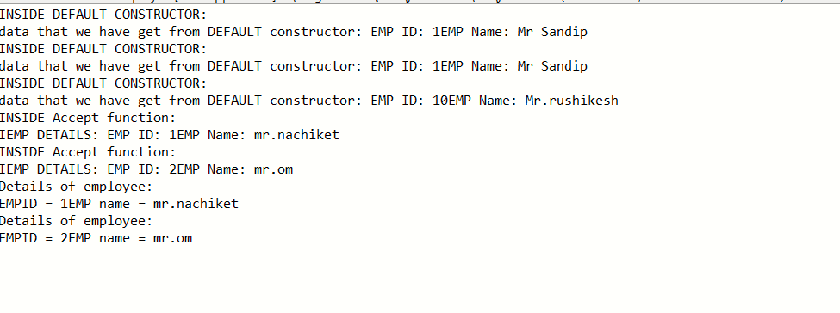

**----------------------------------------------------------------------------------------------------------------------------------------------------------------------**

**2:Create Employee class with members id(int),name(string)**

**Write default and parameterised constructor in Employee Class.Write accept() function to accept information and display() to display emp information.**

/*2:Create Employee class with members id(int),name(string)

Write default and parameterised constructor in Employee Class.

Write accept() function to accept information and display() to display emp information.*/

**public** **class** Employee {

**private** **int** Id;

**private** String name;

**public** Employee()

{

System.***out***.println("INSIDE DEFAULT CONSTRUCTOR:");

**this**.Id=1;

**this**.name="Mr Sandip";

System.***out***.println("data that we have get from DEFAULT constructor: "+"EMP ID: "+Id+"EMP Name: "+name);

}

**public** Employee(**int** Id,String name)

{

System.***out***.println("INSIDE DEFAULT CONSTRUCTOR:");

**this**.Id=Id;

**this**.name=name;

System.***out***.println("data that we have get from DEFAULT constructor: "+"EMP ID: "+Id+"EMP Name: "+name);

}

**public** **void** Accept(**int** Id,String name)

{

System.***out***.println("INSIDE Accept function:");

**this**.Id=Id;

**this**.name=name;

System.***out***.println("IEMP DETAILS: " +"EMP ID: "+Id+"EMP Name: "+name);

}

**public** **void** Display()

{

System.***out***.println("Details of employee:");

System.***out***.println("EMPID = "+Id+"EMP name = "+name);

}

}

**public** **class** TesterEmployee {

**public** **static** **void** main(String[] args) {

// **TODO** Auto-generated method stub

Employee Emp=**new** Employee();

Employee Emp2=**new** Employee();

Employee Emp1=**new** Employee(10,"Mr.rushikesh");

Emp.Accept(01, "mr.nachiket");

Emp2.Accept(02, "mr.om");

Emp.Display();

Emp2.Display();

}

}

Output:

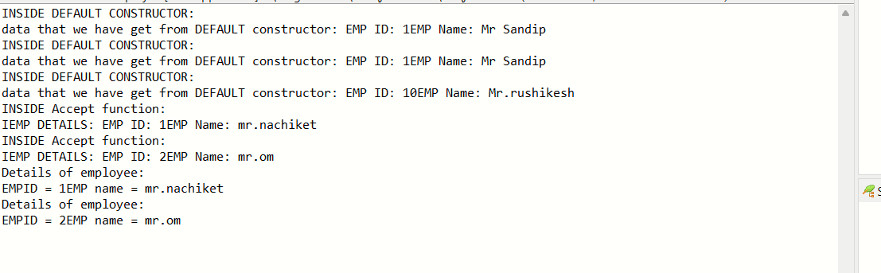

--------------------------------------------------------------------------------------------------------------------------------------------------------------------

3. Create a class Person with data members as name, age, city. Write getters and setters for all the data

members. Also add the display function. Create Default and Parameterized constructors. Create the

object of this class in main method and invoke all the methods in that class.

**public** **class** Person {

**private** String name;

**private** String city;

**private** **int** age;

**public** Person()

{

System.***out***.println("INSIDE Default CONSTRUCTOR: \n");

**this**.name=**null**;

**this**.city=**null**;

**this**.age=0;

System.***out***.println("data that we have get from Default constructor : "+ " NAME= " +name + "City= " +city+ " Age= "+age);

}

**public** Person(String name,String city,**int** age)

{

System.***out***.println("INSIDE PARAMETERISED CONSTRUCTOR:\n");

**this**.name="MAhesh";

**this**.city="mumbai";

**this**.age=26;

System.***out***.println("data that we have get from PARAMETERISED constructor"+ " NAME= " +name + "City= " +city+ " Age= "+age);

}

**public** **void** Accept(String name,String city,**int** age)

{

**this**.name=name;

**this**.city=city;

**this**.age=age;

}

**public** **void** Display()

{

System.***out***.println(" \n Details of employee : "+ " NAME= " +name + "City= " +city+ " Age= "+age);

}

**public** **void** Setname(String Nm)

{

**this**.name=Nm;

}

**public** **void** Setcity(String ct)

{

city=ct;

}

**public** **void** Setname(**int** ag)

{

age=ag;

}

**public** String getname()

{

**return** name;

}

**public** String getcity()

{

**return** city;

}

**public** **int** getage()

{

**return** age;

}

}

**public** **class** TesterPerson {

**public** **static** **void** main(String[] args) {

// **TODO** Auto-generated method stub

Person Per =**new** Person();

Person Per1 =**new** Person("sarika","Mumbai",26);

Per1.Accept("Sanika", "sinnar", 21);

Per1.Display();

System.***out***.println("Update the name of customer \n");

Per1.Setname("prachi");

System.***out***.println("Changed the name of customer :"+ Per1.getname());

System.***out***.println("Update the city of customer \n");

Per1.Setname("nashik");

System.***out***.println("Changed the name of customer :"+ Per1.getcity());

System.***out***.println("Update the name of customer \n");

Per1.Setname("26");

System.***out***.println("Changed the name of customer :"+ Per1.getage());

System.***out***.println("Updated the details of person");

Per1.Display();

}

}

OUTPUT:

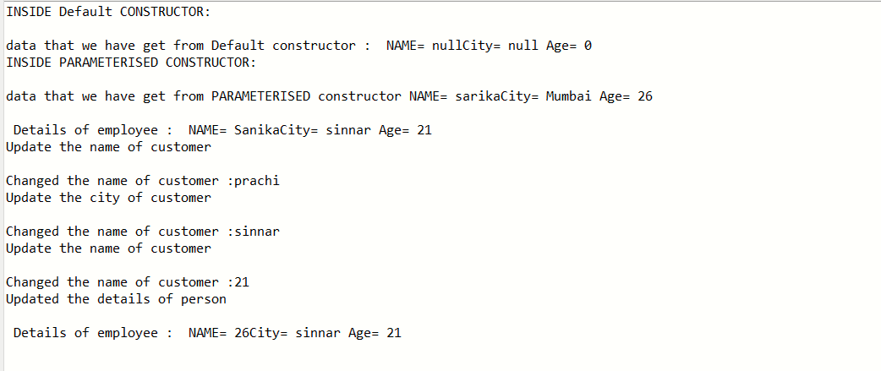

--------------------------------------------------------------------------------------------------------------------------------------------------------------------

**4: Create a class Book with data members as bname,id,author,price. Write getters and setters for all the data members. Also add the display function.**

**Create the object of this class in main method and invoke all the methods in that class.**

**public** **class** Book {

**private** String bname;

**private** String author;

**private** **int** id;

**private** **int** price;

**public** Book(String bname,String author,**int** id,**int** price)

{

System.***out***.println("INSIDE PARAMETERISED CONSTRUCTOR:\n");

**this**.bname="the games";

**this**.author="Mr.atri";

**this**.id=12001;

**this**.price=1300;

System.***out***.println("data that we have get from PARAMETERISED constructor"+ " bookNAME= " +bname + " author= " +author+ " id= "+id+" price= "+price);

}

**public** **void** Accept(String bname,String author,**int** id,**int** price)

{

**this**.bname="the games";

**this**.author="Mr.atri";

**this**.id=12001;

**this**.price=1300;

}

**public** **void** Display()

{

System.***out***.println(" \n Details of employee : "+" bookNAME = " +bname + " author= " +author+ " id= "+id+" price= "+price);

}

**public** **void** Setbname(String Nm)

{

**this**.bname=Nm;

}

**public** **void** Setauthor(String at)

{

author=at;

}

**public** **void** Setid(**int** ide)

{

id=ide;

}

**public** **void** Setprice(**int** pr)

{

price=pr;

}

**public** String getbname()

{

**return** bname;

}

**public** String getauthor()

{

**return** author;

}

**public** **int** getid()

{

**return** id;

}

**public** **int** getprice()

{

**return** price;

}

**public** **class** TesterBook {

**public** **static** **void** main(String[] args) {

// **TODO** Auto-generated method stub

Book Per1 =**new** Book("apli mumabi","Mr.yadav",13012,1200);

Per1.Accept("lifehistory", "Mr.panchal", 21002,5200);

Per1.Display();

System.***out***.println("Update the name of book \n");

Per1.Setbname("googly");

System.***out***.println("Changed the name of book :"+ Per1.getbname());

System.***out***.println("Update the city of author \n");

Per1.Setauthor("divaram");

System.***out***.println("Changed the name of author :"+ Per1.getauthor());

System.***out***.println("Update the name of id \n");

Per1.Setid(22320);

System.***out***.println("Changed the name of id :"+ Per1.getid());

System.***out***.println("Update the name of price \n");

Per1.Setprice(2000);

System.***out***.println("Changed the name of price :"+ Per1.getprice());

System.***out***.println("Updated the details of book");

Per1.Display();

}

}

}

Output:

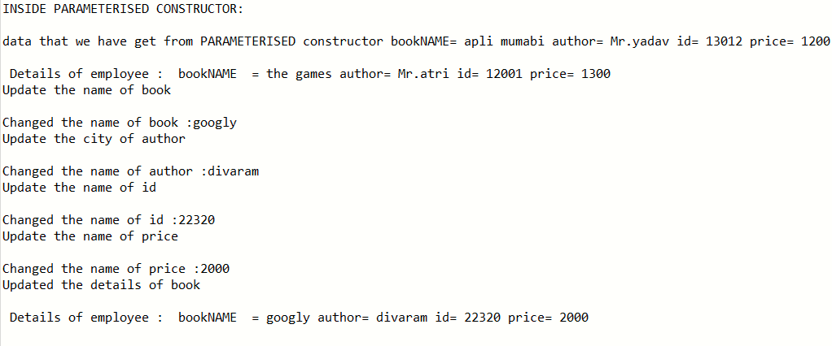

----------------------------------------------------------------------------------------------------------------------------------------

5. Create a class Point with data members as x,y. Write

getters and setters for all the data members. Also add the display function. Create the object of this class in main method and invoke all the methods in that class.

**public** **class** Point {

**private** **int** X;

**private** **int** Y;

**public** **void** AcceptDetails(**int** X,**int** Y)

{

**this**.X=X;

**this**.Y=Y;

}

**void** Display()

{

System.***out***.println("numbers: x = "+ X+" Y= "+Y);

}

**public** **void** setX(**int** no)

{

X=no;

}

**public** **void** setY(**int** no)

{

Y=no;

}

**public** **int** getX()

{

**return** X;

}

**public** **int** getY()

{

**return** Y;

}

**public** **class** TesterPoint {

**public** **static** **void** main(String[] args) {

// **TODO** Auto-generated method stub

Point pt=**new** Point();

pt.AcceptDetails(10,20);

pt.Display();

System.***out***.println("Update the POINT X \n");

pt.setX(56);

System.***out***.println("Changed the POINT X :"+ pt.getX());

System.***out***.println("Update the POINT Y \n");

pt.setX(66);

System.***out***.println("Changed the POINT Y :"+ pt.getY());

}

}

OUTPUT:

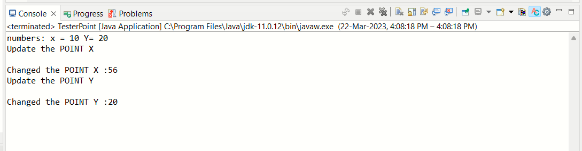

------------------------------------------------------------------------------------------------------------------------------------------------------------------------------------------------------------

6. Create a class ComplexNumber with data members real, imaginary. Write getters and setters for all the data members. Also add the display function. Create the object of this class in main method and invoke all the methods in that class.

**public** **class** ComplexNumber {

**private** **int** A;

**private** **int** B;

**public** **void** AcceptDetails(**int** A,**int** B)

{

**this**.A=A;

**this**.B=B;

}

**void** Display()

{

System.***out***.println("numbers: A = "+ A+" B= "+"i"+B);

}

**public** **void** setA(**int** no)

{

A=no;

}

**public** **void** setB(**int** no)

{

B=no;

}

**public** **int** getA()

{

**return** A;

}

**public** **int** getB()

{

**return** B;

}

}

**public** **class** TesterComplexNumber {

**public** **static** **void** main(String[] args) {

// **TODO** Auto-generated method stub

ComplexNumber Ct=**new** ComplexNumber();

Ct.AcceptDetails(10,20);

Ct.Display();

System.***out***.println("Update the Imaginary number\n");

Ct.setA(13);

System.***out***.println("Changed the Imaginary number :"+ Ct.getA());

System.***out***.println("Update the Complex number \n");

Ct.setB(66);

System.***out***.println("Changed the Complex number:"+"i"+ Ct.getB());

}

}

Output:

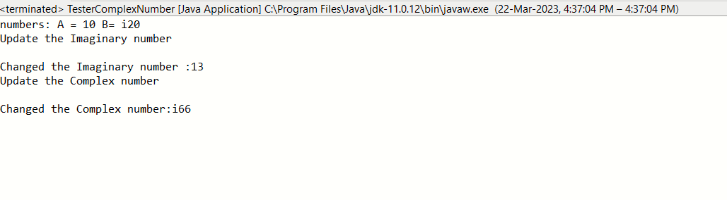

6:create BankAccount aaplication for operations like withdraw ,deposite and moneyTransfer.

Create menu drive program for bank operations..

7:Create Student class with rollno,name address.

Write business logic for auto incrment of rollno(don't accept roll no from user)

Write parameterised constr for accepting name and address only

Write getter and setter and display function

7.1 Test Student class by creating 5 diff object.and display aal details(chk rollno created automatically)

**package** Stud;

**public** **class** Student {

/*:Create Student class with rollno,name address.

Write business logic for auto incrment of rollno(don't accept roll no from user)

Write parameterised constr for accepting name and address only

Write getter and setter and display function

7.1 Test Student class by creating 5 diff object.and display aal details(chk rollno created automatically)

7.2 Create an array of 5 students and show only names */

**private** **int** Rollno;

**private** String name;

**private** String Address;

**private** **static** **int** *stdcnt*;

**static**

{

*stdcnt*=0;

}

**public** Student( String name,String Address)

{

*stdcnt*++;

System.***out***.println(*stdcnt*);

**this**.name=name;

**this**.Address=Address;

Rollno=*stdcnt*;

}

**public** String getName() {

**return** name;

}

**public** **void** setName(String name) {

**this**.name = name;

}

**public** String getAddress() {

**return** Address;

}

**public** **void** setAddress(String address) {

Address = address;

}

**public** **void** display()

{

System.***out***.println("NAME : "+name +" Roll no: "+Rollno+" Address : "+Address+ " StudentCount : "+*stdcnt* );

}

**public** String toString()

{

**return** " Name : "+name+" ROLLNO: "+Rollno+" Address : "+Address+ " StudentCount : "+*stdcnt*;

}

}

**import** java.util.*;

**public** **class** TesterStudent {

**public** **static** **void** main(String[] args) {

// **TODO** Auto-generated method stub

Student S1=**new** Student("manuka","londhelane");

Student S2=**new** Student("sanika","warje");

Student S3=**new** Student("prachi","ghoti");

Student S4=**new** Student("shruti","chandrapur");

Student S5=**new** Student("prajwal","nashik");

System.***out***.println("---------data displayes using Display function--------");

S1.display();

S2.display();

S3.display();

S4.display();

S5.display();

System.***out***.println("---------data displayes using toString function--------");

System.***out***.println(S1);

System.***out***.println(S2);

System.***out***.println(S3);

System.***out***.println(S4);

System.***out***.println(S5);

}

}

package Stud;

import Stud.Student;

import java.util.Scanner;

public class TestArr {

public static void main(String[] args) {

// TODO Auto-generated method stub

System.out.println("---------7.2 array creation--------");

Scanner sc=new Scanner(System.in);

System.out.println("Enter number of elements");

int size = sc.nextInt();

Student s[]=new Student[size];

System.out.println("Size of array is : "+s.length); // length is the property for array in java

System.out.println("enter the elementss:");

for(int iCnt = 0; iCnt < size; iCnt++)

{

System.out.println("enter the name address:");

s[iCnt]=new Student(sc.next(),sc.next());

}

System.out.println(" the elementss of array are:");

for (int i=0;i<size;i++)

{

System.out.println(s[i]);

}

System.out.println("to get only names preseent in array of student:");

for (int i=0;i<size;i++)

{

System.out.println(s[i].getName());

}

}

}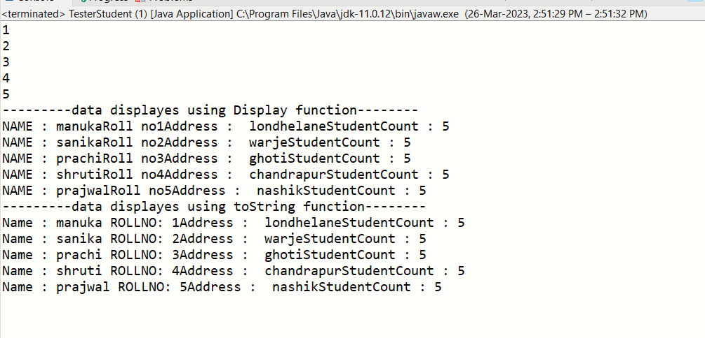

7.2 Create an array of 5 students and show only names

package Stud;

import Stud.Student;

import java.util.Scanner;

public class TestArr {

public static void main(String[] args) {

// TODO Auto-generated method stub

System.out.println("---------7.2 array creation--------");

Scanner sc=new Scanner(System.in);

System.out.println("Enter number of elements");

int size = sc.nextInt();

Student s[]=new Student[size];

System.out.println("Size of array is : "+s.length); // length is the property for array in java

System.out.println("enter the elementss:");

for(int iCnt = 0; iCnt < size; iCnt++)

{

System.out.println("enter the name address:");

s[iCnt]=new Student(sc.next(),sc.next());

}

System.out.println(" the elementss of array are:");

for (int i=0;i<size;i++)

{

System.out.println(s[i]);

}

System.out.println("to get only names preseent in array of student:");

for (int i=0;i<size;i++)

{

System.out.println(s[i].getName());

}

}

}

