PROJECT REPORT
AI-BASED MANUFACTURING EFFICIENCY CLASSIFICATION

1. Executive Summary
During my internship, I worked on a manufacturing efficiency analytics project using 100,000 minute-level manufacturing records covering 50 machines and three operating modes: Active, Idle and Maintenance. The dataset contains machine sensor readings, production measures, quality indicators, network conditions and an existing Efficiency_Status label with three classes: High, Medium and Low.
Microsoft Excel was used for data validation, date-time preparation and creation of business-oriented analytical metrics. Microsoft Power BI was then used to create an interactive two-page dashboard covering executive efficiency monitoring and operational sensor/network analysis.
The analysis shows that Low efficiency is the dominant recorded state (77.83% of observations), followed by Medium (19.19%) and High (2.99%). Average production speed increases substantially from 254.9 units/hour for Low efficiency to 450.8 units/hour for High efficiency. Average error rate also differs strongly, from 1.01% for High efficiency to 8.93% for Low efficiency.
In contrast, average temperature, vibration, power consumption, network latency and packet loss are relatively similar across the three efficiency classes in this dataset. Therefore, the analysis identifies production speed and operational error rate as the clearest associated indicators, while the network and basic sensor averages show weaker separation.
The dashboard is intended as a decision-support solution rather than a production AI model. Because this implementation was restricted to Excel and Power BI, no Logistic Regression, Random Forest, Gradient Boosting or XGBoost model was trained. The existing Efficiency_Status field is therefore treated as the classification label for descriptive and diagnostic analysis.

2. Business Context and Relevance
As part of the internship assignment, the project was framed as a smart-manufacturing analytics use case relevant to a technology organization such as Thales. Thales publicly describes manufacturing environments in terms of operational technology (OT), industrial control systems, connected environments and the need to protect and monitor increasingly digital operations. Its published material also describes Industry 4.0, IoT sensors, data-driven performance improvement and AI-enabled automation as part of its industrial transformation.
This report does not claim that the supplied dataset is proprietary Thales production data. The supplied internship dataset is used for analytical practice and the Thales connection is used to frame the business context; the report does not present the dataset as proprietary Thales operational data.

3. Business Problem
Manufacturing operations generate large volumes of data from machines, sensors, production systems, quality checks and connected networks. When these measurements are reviewed manually, efficiency degradation can be difficult to detect quickly and the relationship between operational errors and output can be unclear.
The business problem addressed in this project is how to organize and analyze these signals so that manufacturing stakeholders can quickly identify efficiency states, compare machines, investigate operational conditions and prioritize areas for improvement.

4. Project Objectives
- Measure and visualize the distribution of High, Medium and Low manufacturing efficiency.
- Compare production performance across efficiency classes.
- Identify differences in operational error and quality indicators.
- Analyze machine sensor variables such as temperature and vibration.
- Analyze network variables such as latency and packet loss.
- Compare efficiency patterns across Active, Idle and Maintenance modes.
- Provide machine-level performance visibility.
- Create an interactive Power BI dashboard for business users.
- Translate the analysis into practical manufacturing recommendations.

5. Dataset Overview
The source dataset contains 100,000 records and 14 original fields. The records cover 50 machines and 3 operation modes. The parsed date range is 01 Jan 2025 to 10 Mar 2025, with minute-level timestamps.
Field | Business Meaning
Date | Calendar date of the manufacturing record.
Timestamp | Time of data capture.
Machine_ID | Identifier for the manufacturing machine.
Operation_Mode | Operating state: Active, Idle or Maintenance.
Temperature_C | Machine operating temperature in °C.
Vibration_Hz | Machine vibration frequency.
Power_Consumption_kW | Electrical power consumption.
Network_Latency_ms | Communication latency in milliseconds.
Packet_Loss_% | Percentage of packets lost during communication.
Quality_Control_Defect_Rate_% | Percentage of defective units.
Production_Speed_units_per_hr | Production output rate.
Predictive_Maintenance_Score | Maintenance-readiness score.
Error_Rate_% | Percentage of operational errors.
Efficiency_Status | Existing target label: High, Medium or Low.

6. Data Quality and Preparation
Check | Result | Interpretation
Records | 100,000 | Complete dataset
Original columns | 14 | Before calculated metrics
Missing values | 0 | No missing values found
Exact duplicate rows | 0 | No exact duplicate rows found
Unique machines | 50 | Machine-level analysis possible
Operation modes | 3 | Active / Idle / Maintenance
Unique dates | 69 | 69 calendar dates
Date and Timestamp were combined into a DateTime field in Excel to support time-based analysis in Power BI. The dataset was converted into an Excel Table so calculated formulas could be propagated consistently across the full dataset.

7. Excel Feature and Metric Preparation
To make the raw data more useful for business analysis, five calculated metrics were prepared in Excel. These are analytical indicators, not machine-learning model outputs.
Metric | Logic | Business Purpose
DateTime | Date + Timestamp | Enables chronological and time-window analysis.
Energy_Efficiency | Production Speed / Power Consumption | Approximate output generated per kW.
Network_Reliability_Score | 100 − latency penalty − packet-loss penalty | Converts network conditions to a 0–100 style score.
Quality_Score | 100 − defect penalty − error penalty | Higher score indicates better quality/operations.
Operational_Risk_Score | Weighted error + defect + packet-loss + latency | Higher score indicates greater operational risk.

8. Work Performed During the Internship
- Load the manufacturing CSV dataset into Excel.
- Validate completeness, duplicates, data types and time fields.
- Create the DateTime field and business-oriented calculated metrics.
- Load the cleaned Excel data into Power BI.
- Create KPI cards for record volume, production, network reliability, quality and energy efficiency.
- Create class-distribution visuals for High, Medium and Low efficiency.
- Compare production, error, sensor and network measures across efficiency classes.
- Analyze efficiency by machine and operation mode.
- Add interactive filters for machine, operation mode and date.
- Translate observed patterns into business insights and recommendations.

9. Power BI Dashboard
The Power BI solution contains two pages. The Executive Dashboard provides a management-level view of efficiency and machine performance. The Operational Analysis page provides deeper diagnostic views across sensors, production, quality and network indicators.
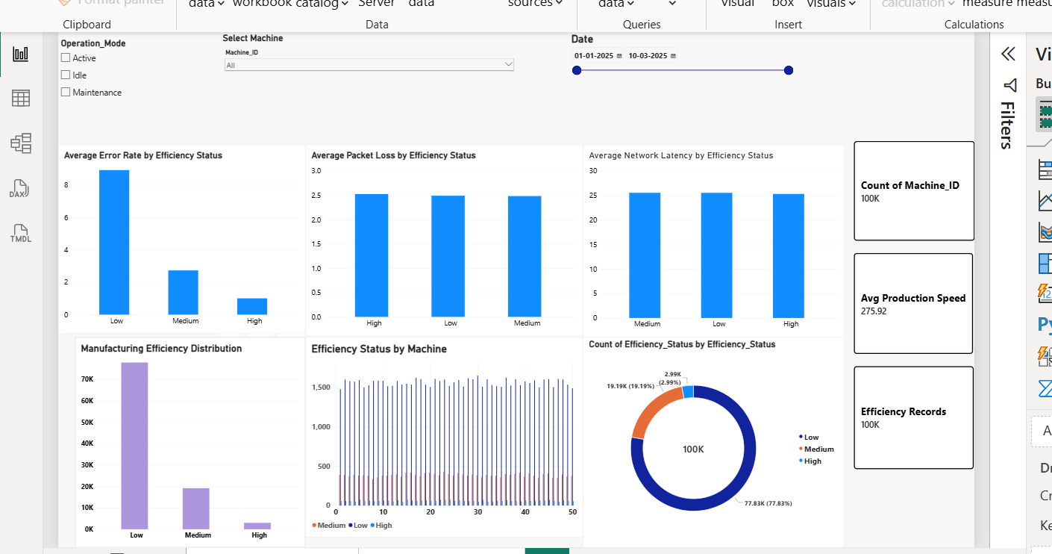
Figure 1. Executive Dashboard — overall efficiency, machine and network analysis.
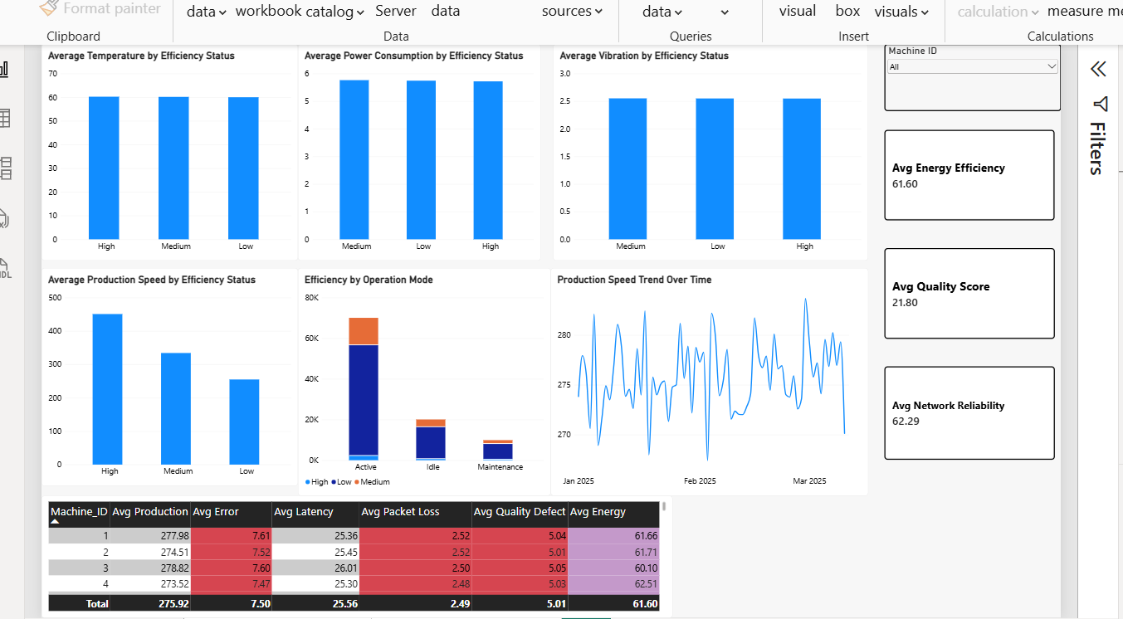
Figure 2. Operational Analysis — sensor, production, operation-mode and machine-level analysis.

10. Key Performance Indicators
KPI | Result | Interpretation
Total records | 100,000 | Overall volume analyzed
Low efficiency | 77,825 (77.83%) | Dominant efficiency class
Medium efficiency | 19,189 (19.19%) | Second-largest class
High efficiency | 2,986 (2.99%) | Smallest class
Average production speed | 275.92 units/hr | Overall output rate
Average energy efficiency | 61.60 | Output per kW indicator
Average network reliability | 62.29 | Derived 0–100 style score
Average quality score | 21.80 | Derived quality indicator

11. Exploratory Data Analysis and Findings
11.1 Efficiency distribution
Low efficiency accounts for 77.83% of all observations, while Medium accounts for 19.19% and High accounts for 2.99%. This indicates that the dataset is heavily concentrated in the Low-efficiency state. This concentration should be considered when interpreting comparisons because the three classes are not equally represented.
11.2 Production speed
Efficiency Status | Average Production Speed (units/hr)
High | 450.79
Medium | 334.13
Low | 254.85
Average production speed rises from 254.85 units/hr for Low efficiency to 334.13 for Medium and 450.79 for High. This is one of the clearest separations between the efficiency classes.

11.3 Operational error rate
Efficiency Status | Average Error Rate
High | 1.01%
Medium | 2.73%
Low | 8.93%

The average error rate is 8.93% in the Low class, 2.73% in the Medium class and 1.01% in the High class. The strong separation suggests that operational errors are an important diagnostic indicator in this dataset.
11.4 Sensor and network indicators
Efficiency | Temp. | Vibration | Power | Latency | Packet Loss
High | 60.23 °C | 2.548 Hz | 5.718 kW | 25.33 ms | 2.53%
Medium | 60.15 °C | 2.552 Hz | 5.762 kW | 25.57 ms | 2.49%
Low | 60.01 °C | 2.550 Hz | 5.743 kW | 25.56 ms | 2.49%
The class averages for temperature, vibration, power consumption, latency and packet loss are close to one another. Therefore, these variables do not show strong class separation at the simple-average level. This does not prove that they are irrelevant; it means that additional time-series analysis, thresholds, interactions or machine-specific analysis would be needed before treating them as major drivers.
11.5 Operation mode
Operation Mode | Records | Share
Active | 70,054 | 70.05%
Idle | 20,057 | 20.06%
Maintenance | 9,889 | 9.89%
Active mode contains the majority of records, followed by Idle and Maintenance. The Power BI operation-mode visual helps stakeholders compare efficiency composition across these states.
11.6 Exploratory association check
Variable | Correlation with Ordinal Efficiency Label
Production_Speed_units_per_hr | 0.334
Temperature_C | 0.004
Power_Consumption_kW | 0.001
Packet_Loss_% | 0.001
Vibration_Hz | 0.000
Network_Latency_ms | -0.002
Predictive_Maintenance_Score | -0.003
Quality_Control_Defect_Rate_% | -0.006
Error_Rate_% | -0.604
For an exploratory check, the efficiency classes were encoded as Low=0, Medium=1 and High=2. Production speed shows a positive association (approximately +0.334), while error rate shows a stronger negative association (approximately −0.604). These statistics are descriptive only and should not be interpreted as proof of causation.

12. Business Recommendations
Prioritize error reduction: Because Low-efficiency records have a much higher average error rate, operational teams should prioritize root-cause analysis of recurring production errors, process deviations and machine alerts.
Monitor production speed against efficiency: Production speed is strongly differentiated across the efficiency classes. A monitoring rule can flag sustained output reductions and trigger investigation before losses accumulate.
Use machine-level benchmarking: Compare machines against peer machines using production speed, error rate, quality, energy efficiency and network indicators. Machines consistently performing below the fleet average should receive targeted review.
Use network metrics as supporting indicators: Latency and packet loss are important operational measures, but their simple averages do not strongly separate the classes in this dataset. Network monitoring should therefore be combined with production and error indicators rather than used alone.
Strengthen quality monitoring: Use defect rate and the derived Quality Score as supporting measures when investigating low-efficiency periods.
Move toward predictive analytics: A future implementation can connect the Power BI dashboard to a validated machine-learning model that generates a real-time efficiency prediction and confidence score, subject to appropriate model validation.

13. Limitations
- The supplied Efficiency_Status field is an existing classification label; during this internship project I analyzed the label rather than independently generating it with a trained ML model.
- No Logistic Regression, Random Forest, Gradient Boosting or XGBoost model was trained because the implementation was intentionally restricted to Excel and Power BI.
- The derived scores are business-analysis metrics created for this project and are not validated industrial control limits.
- Relationships shown in the dashboard are observational and do not establish causation.
- The supplied internship dataset should not be interpreted as proprietary Thales operational data.
- A production deployment would require validated sensor thresholds, model governance, cybersecurity controls, data-quality monitoring and integration with operational systems.

14. Future Scope
- Train and validate a multiclass machine-learning model using a dedicated ML environment.
- Add probability/confidence scores to every efficiency prediction.
- Use feature-importance and explainability techniques such as SHAP.
- Introduce anomaly detection for unusual sensor and network behavior.
- Create real-time streaming dashboards for factory monitoring.
- Integrate maintenance events and machine downtime history.
- Develop machine-specific baselines and dynamic thresholds.
- Add secure OT/IoT data pipelines and governance for production deployment.

15. Conclusion
This internship project demonstrates how I used Excel and Power BI to convert a large manufacturing dataset into a practical business analytics solution. The analysis provides a consolidated view of efficiency status, production output, operational errors, machine performance, quality, energy and network conditions.
The main finding is that Low efficiency represents 77.83% of the observations and is associated with substantially lower production speed and higher operational error rates than the High-efficiency class. Basic averages of temperature, vibration, power, latency and packet loss show much less separation between classes. This suggests that production and operational error indicators deserve priority in diagnostic workflows, while sensor and network metrics should continue to be monitored as supporting signals.
The resulting dashboard provides an accessible foundation for decision-making and can be extended later into a validated predictive-maintenance or efficiency-classification system.

