**CS697A – Topic in Computer Science – Machine Learning**

Assignment 3

**Submitted by: Prachi Panse**

**NetID: ve3568**

**Q1:** Decision Trees, classification: Use **sklearn.tree** library’s DecisionTreeClassifier algorithm. For the DecisionTreeClassifier determine the value of the **tree depth** parameter (experiment with depth=2, 3, 5, 10) that results in the best test error for each of the 4-training data sets you created. How does the best depth value change as the number of instances and classes change?

***Answer:***

Program file: <Assignment3Q1.ipynb>

* Output For the given training and random testing data:

X100_C69

tree_depth :2 testing_error : 0.02000 accuracy_score : 0.98000

tree_depth :3 testing_error : 0.02000 accuracy_score : 0.98000

tree_depth :5 testing_error : 0.02000 accuracy_score : 0.98000

tree_depth :10 testing_error : 0.02000 accuracy_score : 0.98000

X100_CAll

tree_depth :2 testing_error : 0.68500 accuracy_score : 0.31500

tree_depth :3 testing_error : 0.53400 accuracy_score : 0.46600

tree_depth :5 testing_error : 0.35100 accuracy_score : 0.64900

tree_depth :10 testing_error : 0.24100 accuracy_score : 0.75900

X500_69

tree_depth :2 testing_error : 0.00600 accuracy_score : 0.99400

tree_depth :3 testing_error : 0.00600 accuracy_score : 0.99400

tree_depth :5 testing_error : 0.00600 accuracy_score : 0.99400

tree_depth :10 testing_error : 0.00600 accuracy_score : 0.99400

X500_CAll

tree_depth :2 testing_error : 0.70080 accuracy_score : 0.29920

tree_depth :3 testing_error : 0.61620 accuracy_score : 0.38380

tree_depth :5 testing_error : 0.31100 accuracy_score : 0.68900

tree_depth :10 testing_error : 0.15100 accuracy_score : 0.84900

* Analysis:

As we increase the tree depth, training error always reduces or stays constant, but it never gets increased with more depth of the tree. Whereas, for testing errors, initially with it deceases with increase in depth till a certain point and then increases due to overfitting. Considering depth value=2/3/5/10, minimum error is found at depth 10 for all datasets. With variance in the number of classes in datasets, the best tree depth value remained the same in this case of random testing instances. Below is the reference graph to analyze data behavior,

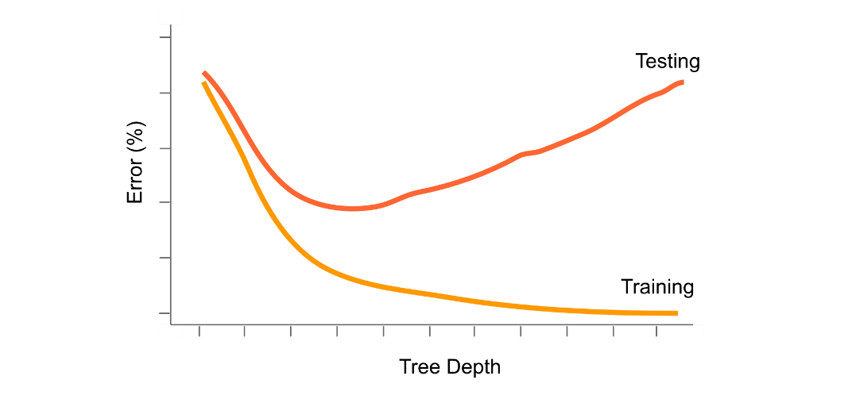

Image reference: <https://allmodelsarewrong.github.io/tree-basics.html>

* Tree-plotting for X100_C69:

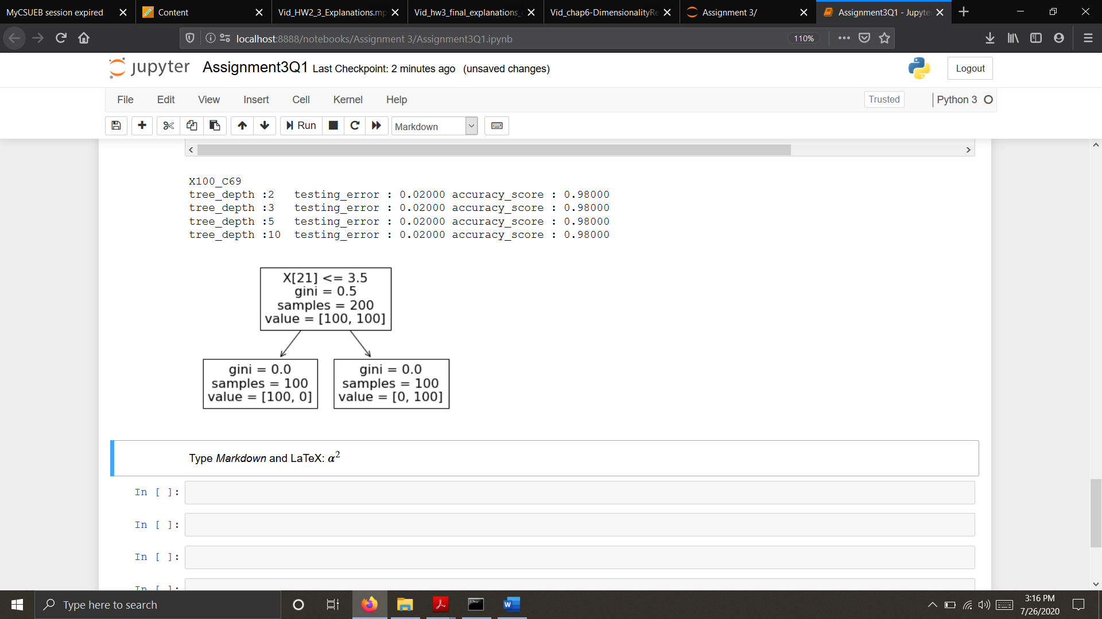

Likewise, it can be done for all the datasets.

**Q2:** Nonparametric Classification: Use **sklearn.tree** library’s KneighborsClassifier algorithm. For the KneighborsClassifier determine the value of the best k parameter (experiment with k=1, 3, 5, 9) that results in the best test error for each of the 4 training data sets you created. How does the best k value change as the number of instances and classes change?

***Answer:***

Program file: <Assignment3Q2.ipynb>

* Output For the given training and random testing data:

X100_C69

k_value :1 testing_error : 0.00000 accuracy_score : 1.00000

k_value :3 testing_error : 0.00000 accuracy_score : 1.00000

k_value :5 testing_error : 0.00000 accuracy_score : 1.00000

k_value :9 testing_error : 0.00000 accuracy_score : 1.00000

X100_CAll

k_value :1 testing_error : 0.05100 accuracy_score : 0.94900

k_value :3 testing_error : 0.04300 accuracy_score : 0.95700

k_value :5 testing_error : 0.04600 accuracy_score : 0.95400

k_value :9 testing_error : 0.04300 accuracy_score : 0.95700

X500_69

k_value :1 testing_error : 0.00000 accuracy_score : 1.00000

k_value :3 testing_error : 0.00000 accuracy_score : 1.00000

k_value :5 testing_error : 0.00000 accuracy_score : 1.00000

k_value :9 testing_error : 0.00000 accuracy_score : 1.00000

X500_CAll

k_value :1 testing_error : 0.02000 accuracy_score : 0.98000

k_value :3 testing_error : 0.02420 accuracy_score : 0.97580

k_value :5 testing_error : 0.02360 accuracy_score : 0.97640

k_value :9 testing_error : 0.02320 accuracy_score : 0.97680

* Analysis:

For datasets with only 2 classes, class 6 and class, accuracy rate was always 1, that means it has 0 errors. When it comes to all classes, the best k value changed as the number of instances did. For X100_CAll, minimum testing error was at k value = 3 and 9, but for X500_Call, best k value was 9 because it gave the minimum error.

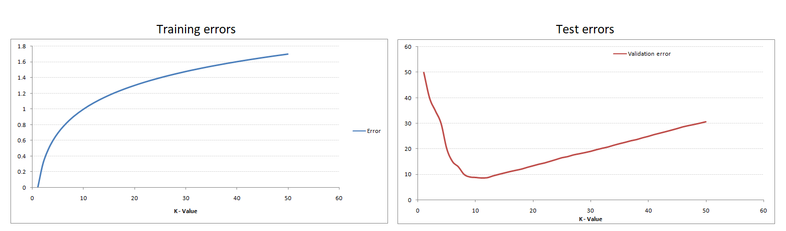

Image reference: [https://miro.medium.com/max/3144/0*GXpGf2DXU4ogtpiI.png](https://miro.medium.com/max/3144/0*GXpGf2DXU4ogtpiI.png)

**Q3:** Decision Trees, regression for digit completion: Using only the data in X500_69 for training, use the first 48 features as inputs and predict the next 16 features, i.e. create 16 decision tree regression models, using the sklearn library. Report the test error (use only the instances from classes 6 and 9) for each of the 16 regression models. Which pixels are easier to predict?

(Clarification, each of your models will have the same set of features, namely features 1…48.)

***Answer:***

Program file: <Assignment3Q3.ipynb>

* Output For the given training and testing data:

X500_69

mserror for feature 49 : 0.0

mserror for feature 50 : 2.5290858725761773

mserror for feature 51 : 21.545706371191137

mserror for feature 52 : 14.903047091412743

mserror for feature 53 : 20.398891966759003

mserror for feature 54 : 19.822714681440445

mserror for feature 55 : 13.595567867036012

mserror for feature 56 : 1.074792243767313

mserror for feature 57 : 0.0

mserror for feature 58 : 0.09141274238227147

mserror for feature 59 : 3.7174515235457064

mserror for feature 60 : 7.080332409972299

mserror for feature 61 : 8.60387811634349

mserror for feature 62 : 20.803324099722992

mserror for feature 63 : 22.670360110803323

mserror for feature 64 : 0.7257617728531855

* Analysis:

The features which have minimum error will be considered as the best features and they will be easiest to predict. In the given dataset, feature 49 and feature 57 have the minimum error as 0. Therefore, predicting those pixels are easier.