Here we have 3 applications:

1. New registration – Here a new applicant can register in the organisation.
2. Login – Here the employee, manager and hr can login using their employee id and password.
3. Exit – Here the employee can logout or exit from the system.

To register as employee/ manager/ hr we must fill some details like employee id, first name, last, date of joining and create a new password.

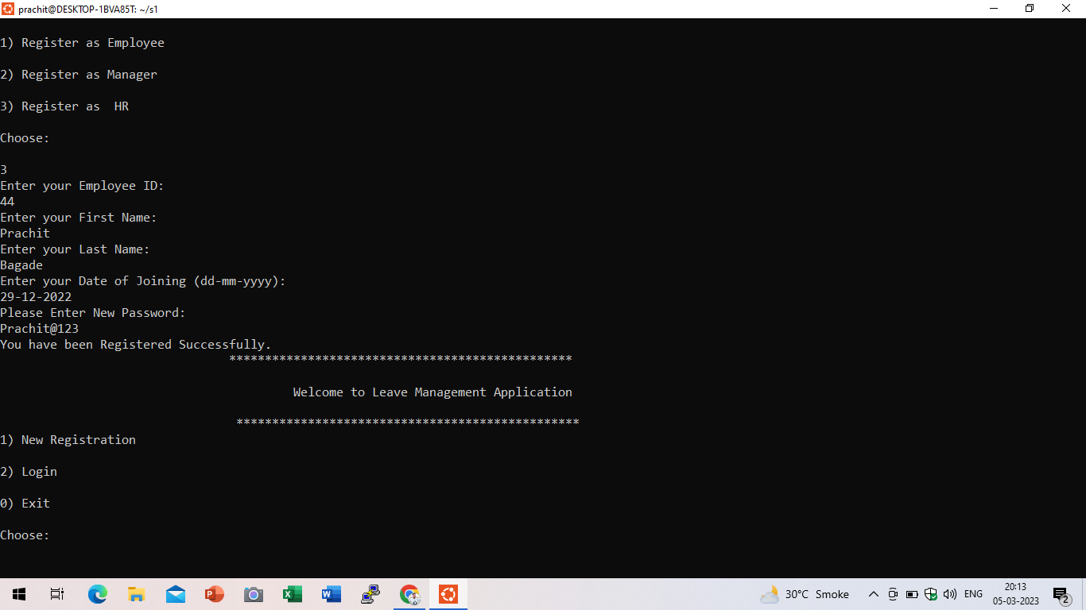

We have 3 options to choose your role login application:

1. Employee login
2. Manager login
3. HR login

Here employee can login using employee id and password.

After logging in, we can then choose the below options accordingly:

1. Apply leave.
2. Check leave balance.
3. Check my leave history.
4. Exit.

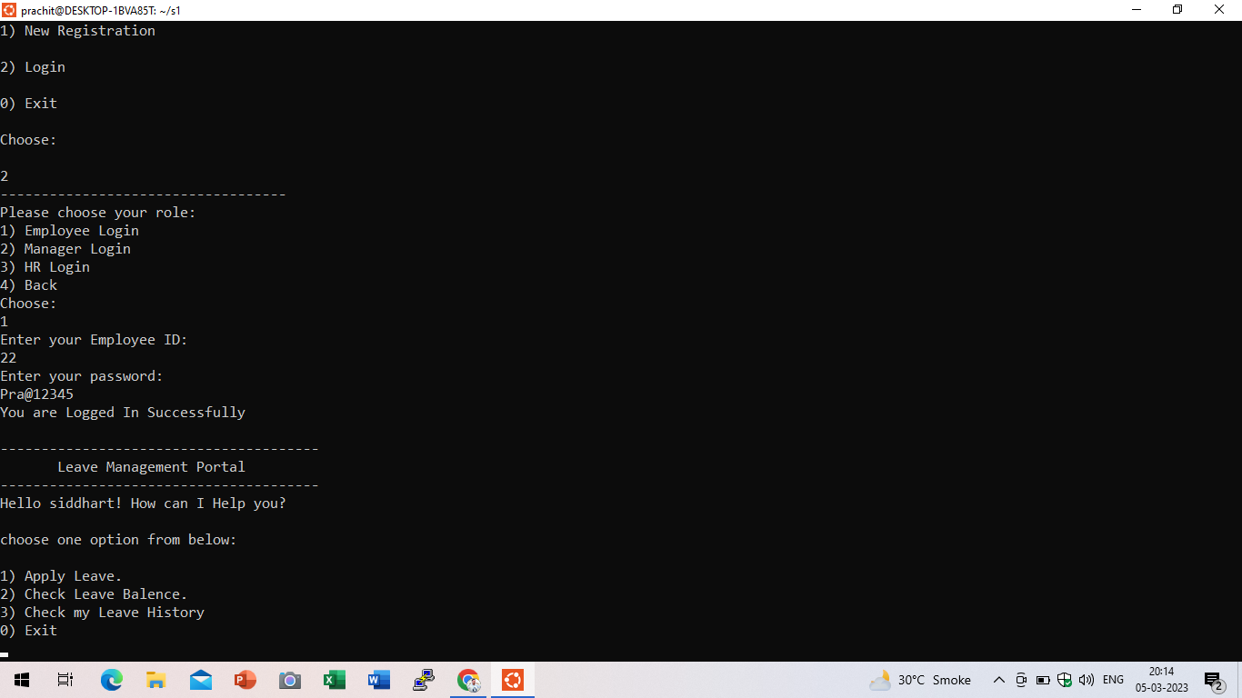

To apply for a leave.

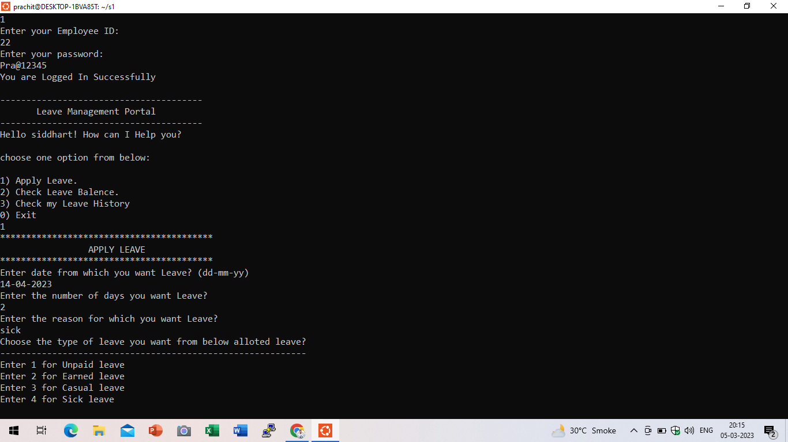

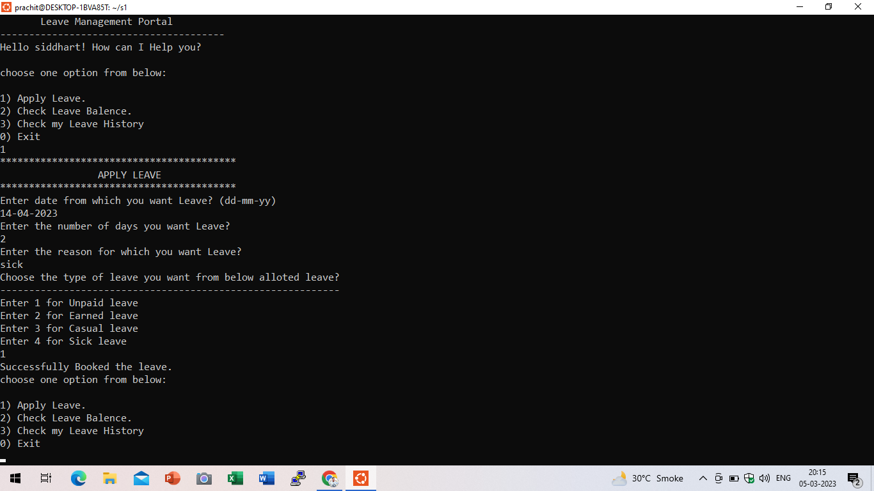

To check the leave balance and leave history of the employee.

In login, by choosing the 2nd option we can log in to manager.

Here in manager login, the manager can log in by using the employee id and password.

After logging in, we can then choose the below options accordingly:

1. Accept / Reject the employee leaves.
2. Check the leave history of employee.
3. Leave applied by every employee.

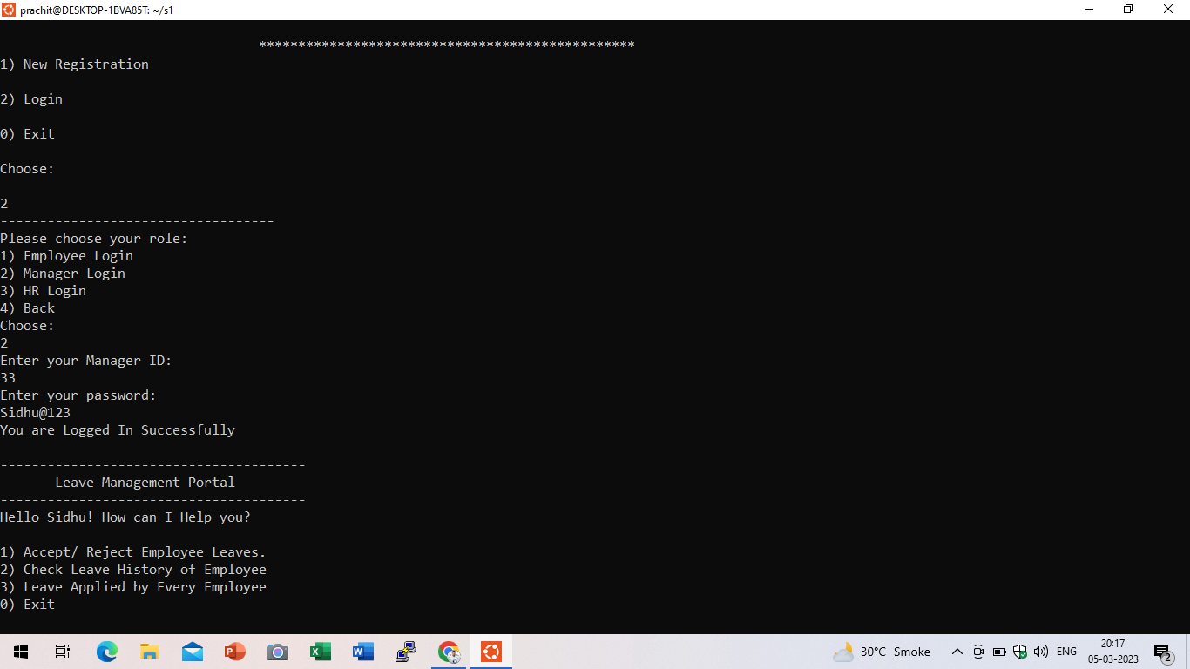

To accept/ reject the employee leaves.

To check the leave history of employee.

To check the leaves applied by every employee.

In login, by choosing the 3rd option we can log in to HR.

Here in HR login, the HR can log in by using the employee id and password.

After logging in, we can then choose the below options accordingly:

1. Add leave balance of employee.
2. Check the leave history of employee.
3. Leave applied by every employee.
4. Exit.

