Industrial Machine Maintenance
& Spare-Parts Analysis Report
Prepared for: Plant Operations & Maintenance Leadership
Data period: 3 January 2022 – 1 January 2025 | 10 Assets | 3 Plants
Prepared by: Data Analytics Team | 25 July 2026

1. Executive Summary
This report analyses three years of daily sensor and spare-parts transaction data across 10 machines (5 machine types) in 3 plants, to understand where breakdowns happen, what they cost, and what warning signs appear before they occur.

Key numbers at a glance
Metric | Value
Total spare-parts spend | ₹1,33,40,945 (₹1.33 Crore)
Total work orders raised | 42,793
Breakdown (unplanned) work orders | 21,636 (50.6%)
Planned maintenance work orders | 21,157 (49.4%)
Machines tracked | 10, across CNC Lathe, Hydraulic Press, Belt Conveyor, Screw Compressor, EOT Crane
Plants covered | PUN-01 (Pune), CHN-02 (Chennai), DHR-03 (Dhar)
Highest-spend part family | Bearings (₹32.60 Lakh, 24.4% of spend)
Costliest single part | Hydraulic Seal Kit 50mm Bore (₹28.48 Lakh)

Top takeaways
- Reactive (breakdown) maintenance is almost as common as planned maintenance — nearly 1 in 2 work orders is a breakdown, which is a strong signal that preventive schedules are not catching problems early enough.
- Hydraulic Press and Screw Compressor machine types have the highest breakdown work-order counts, and are also close to the top in spend — they deserve first priority for a condition-monitoring push.
- Bearings and Seals & Gaskets together account for nearly half of total spare-parts spend and also lead in breakdown counts, making them the biggest cost and reliability lever.
- On breakdown days, machines run noticeably hotter, more loaded and draw more power — power consumption is 12.5% higher and load is 6.3% higher than on normal days, making these two the most useful early-warning signals.
- Plant DHR-03 has the highest breakdown rate (69.0%) among the three plants, even though it has fewer assets than PUN-01 — worth a local review of maintenance practices.
- Spend is fairly stable month-to-month (₹3–4.8 Lakh/month) but breakdown counts show mild seasonal bumps, generally rising toward Dec–Jan each year.

2. About the Data
The dataset contains 2,19,000 daily records covering 10 machines, each tracked with 20 spare-part lines, sensor readings and work-order details over a 3-year window.

What's in the data
Field group | Examples
Machine identity | Asset tag, machine type, plant code, criticality (A/B/C)
Parts & cost | Part number, description, family, unit cost, quantity issued, issue value
Condition sensors | Bearing temp, motor temp, horizontal & vertical vibration, oil pressure, load %, shaft RPM, power (kW)
Maintenance events | Breakdown flag, work order type (Breakdown / Planned)

Machine fleet covered
- 5 machine types, 2 machines each: CNC Lathe, Hydraulic Press, Belt Conveyor, Screw Compressor, EOT Crane
- 3 plants: PUN-01 (4 machines), CHN-02 (3 machines), DHR-03 (3 machines)
- 9 spare-part families: Bearing, Seal & Gasket, Drive Belt, Filter, Lubrication, Sensor, Fastener, Electrical, Coupling

3. Spare-Parts Spend Analysis
Total spend across the 3-year period is ₹1.33 Crore. This section breaks it down by part family, plant, machine type and the top individual parts driving cost.
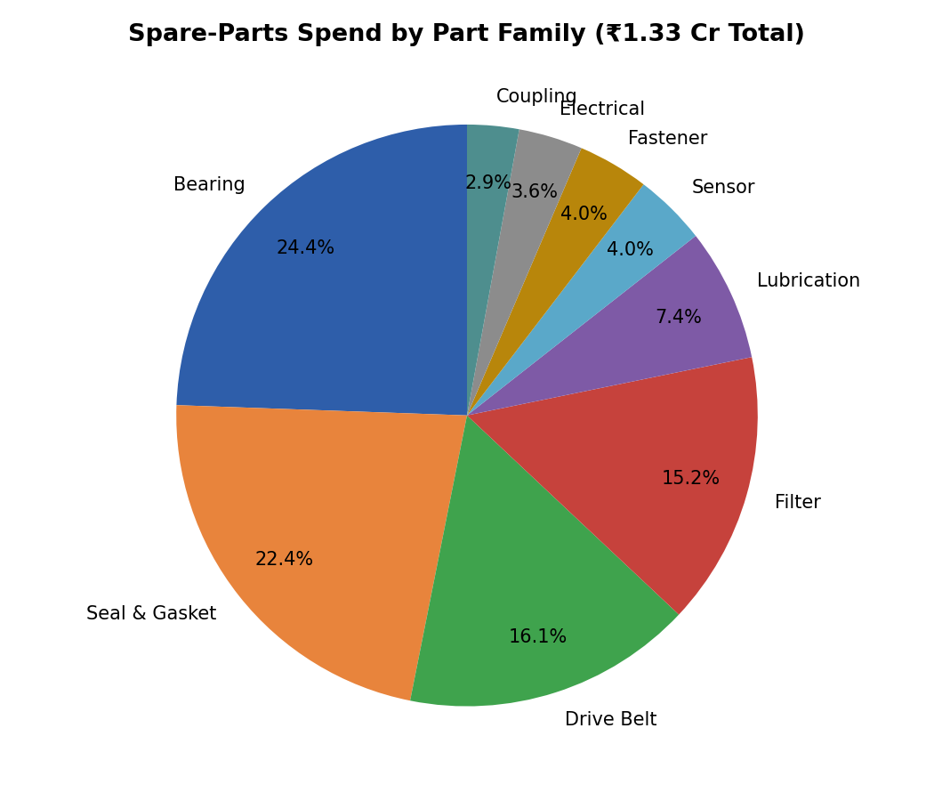
Figure 1: Where the spend goes — Bearings and Seal & Gasket parts together make up ~47% of all spend.

Spend by plant
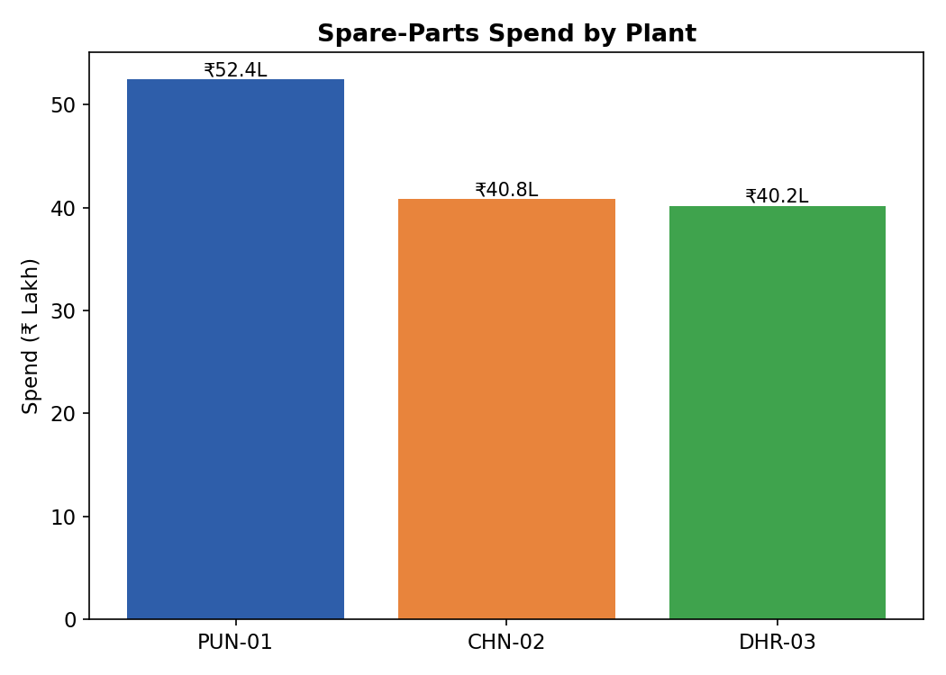
Figure 2: PUN-01 has the highest total spend, but it also runs the most machines (4 of 10).

Spend by machine type and criticality
Machine Type | Spend (₹) | % of Total
Belt Conveyor | 27,45,522 | 20.6%
Screw Compressor | 27,14,335 | 20.3%
EOT Crane | 26,42,723 | 19.8%
Hydraulic Press | 26,32,803 | 19.7%
CNC Lathe | 26,05,562 | 19.5%

- Criticality-A (most critical) assets account for ₹68.87 Lakh — 51.6% of total spend — despite being a smaller share of the fleet, confirming spend is correctly weighted toward critical equipment.
- Criticality-B assets: ₹49.34 Lakh (37.0%); Criticality-C: ₹15.20 Lakh (11.4%).

Top 10 parts by spend
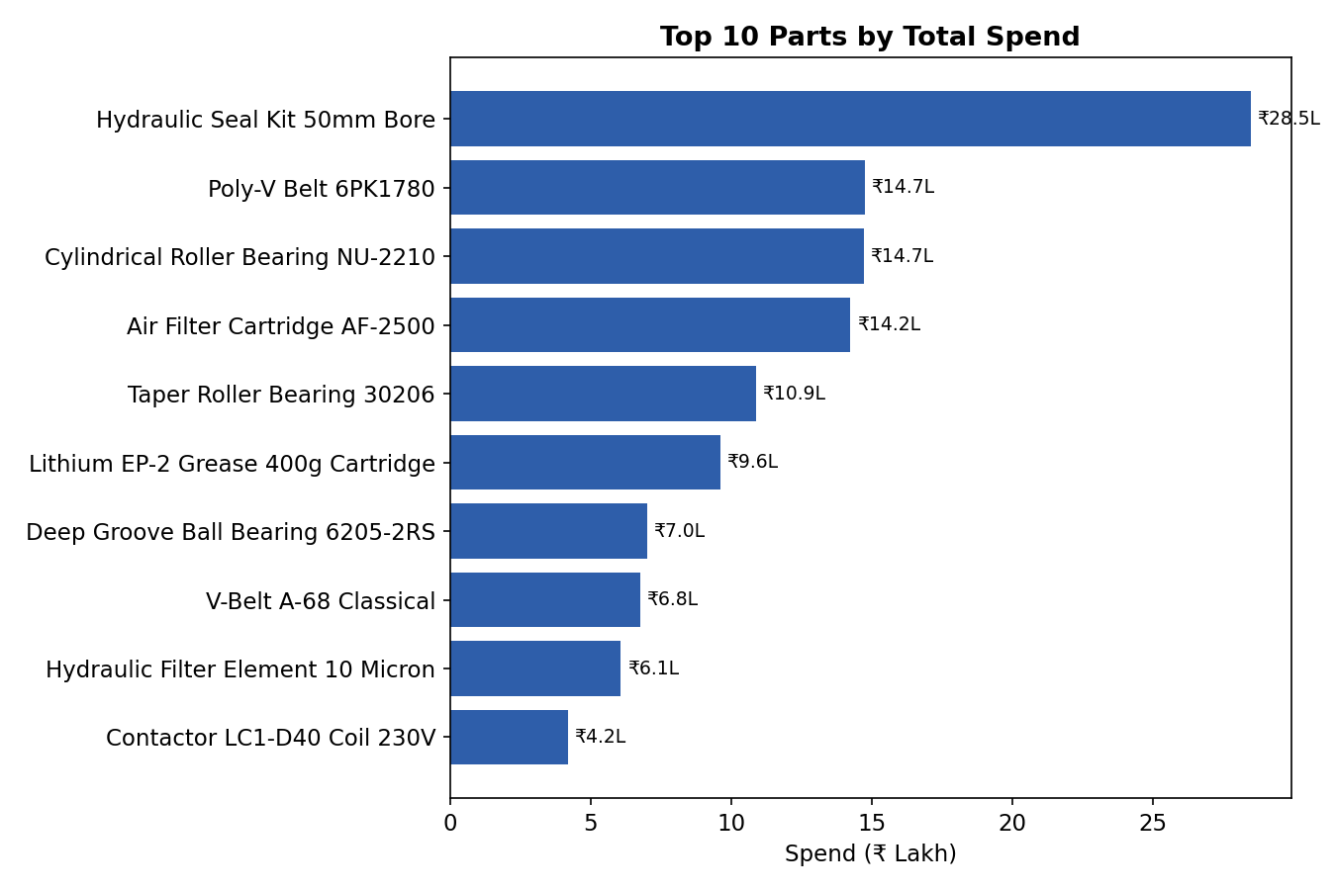
Figure 3: The Hydraulic Seal Kit alone accounts for over ₹28 Lakh — more than double the next item.

4. Breakdown & Work Order Analysis
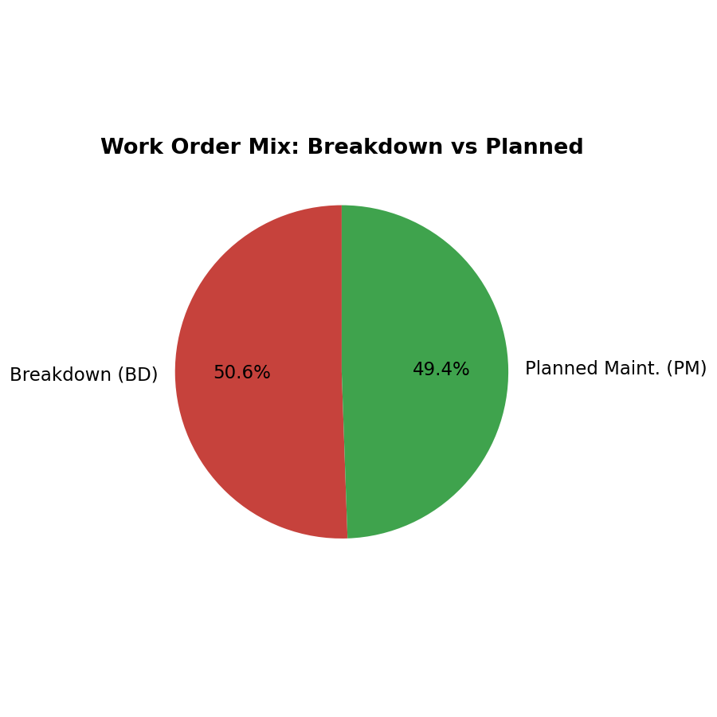
Figure 4: Roughly half of all work orders are unplanned breakdowns rather than planned maintenance — a sign of a largely reactive maintenance approach.

Breakdowns by machine type
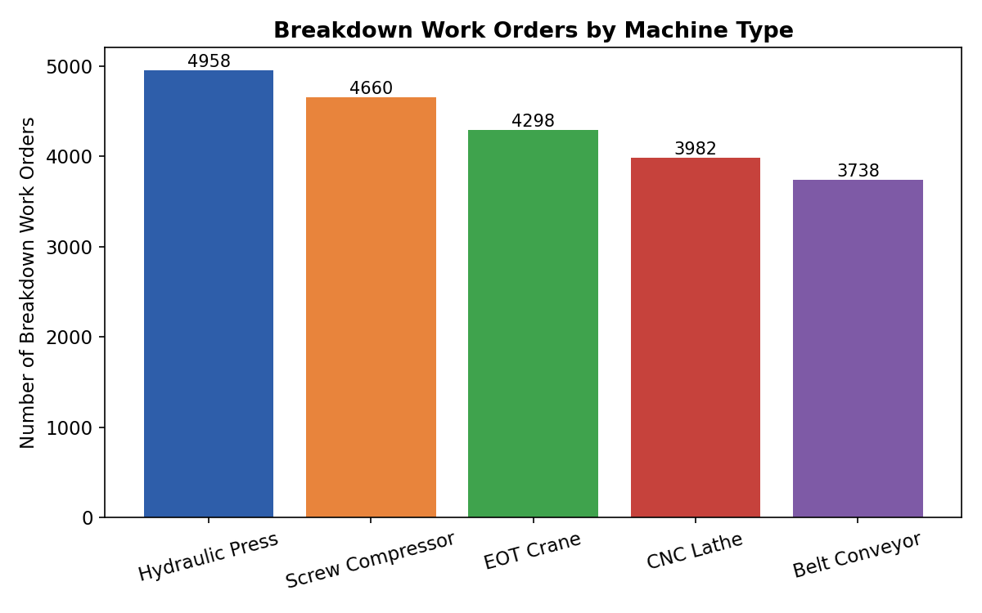
Figure 5: Hydraulic Press and Screw Compressor lead in breakdown work orders.

Breakdowns by asset criticality
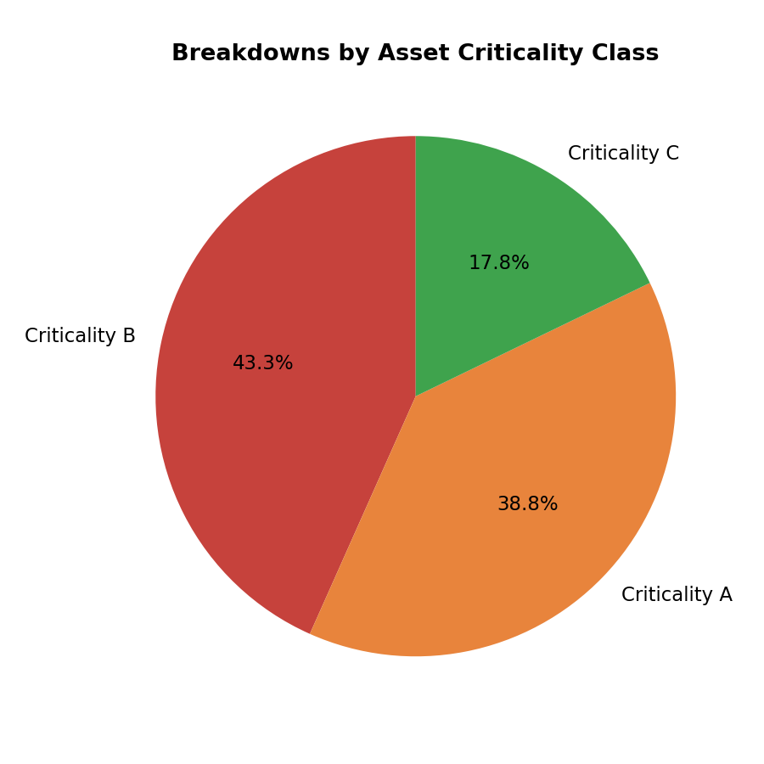
Figure 6: Criticality-B assets actually see the most breakdown events (43.3%), ahead of Criticality-A (38.8%) — worth investigating why 'less critical' assets are breaking down more.

Breakdowns by part family
Part Family | Breakdown Work Orders | Share
Bearing | 4,221 | 19.5%
Seal & Gasket | 3,118 | 14.4%
Sensor | 2,454 | 11.3%
Electrical | 2,417 | 11.2%
Filter | 2,136 | 9.9%
Drive Belt | 2,134 | 9.9%
Coupling | 1,987 | 9.2%
Fastener | 1,626 | 7.5%
Lubrication | 1,543 | 7.1%

Bearings are the single biggest contributor to breakdowns, consistent with them also being the top spend item — reinforcing bearings as the number-one focus area for reliability improvement.

Which specific assets break down most
Asset Tag | Breakdown Work Orders
AST-2017 | 2,647
AST-5003 | 2,565
AST-4055 | 2,558
AST-2031 | 2,311
AST-4061 | 2,102

These five assets alone account for over half of all breakdown events and are strong candidates for a focused root-cause review or replacement study.

5. Early-Warning Signals: Sensor Behaviour Before Breakdown
Comparing average sensor readings on days when a breakdown occurred against normal days shows which signals are the most reliable early warning indicators.
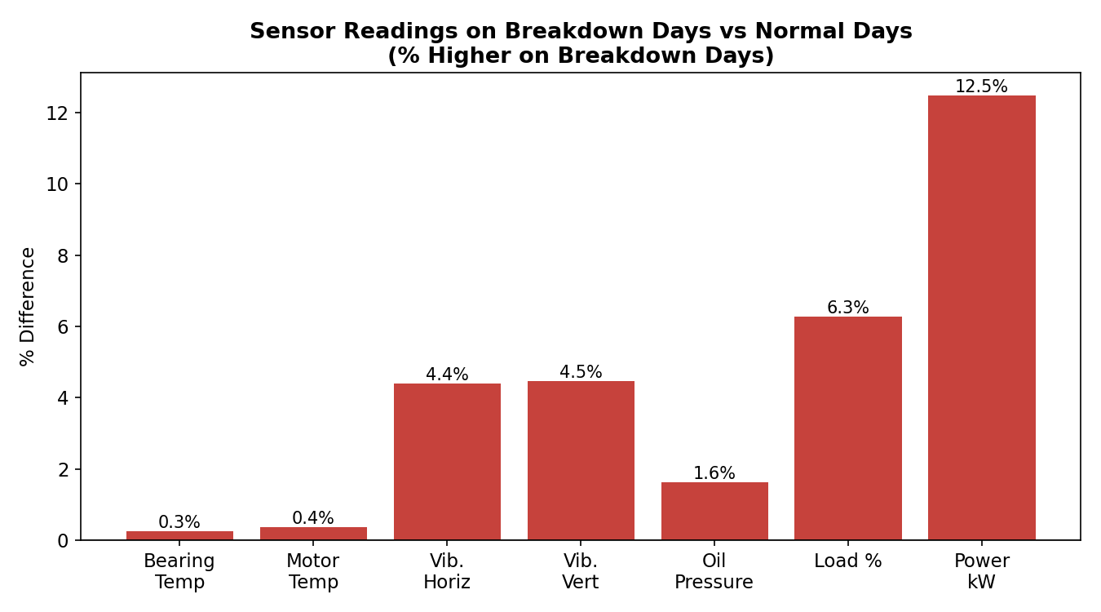
Figure 7: Power consumption and load % rise the most on breakdown days, making them the strongest predictive signals; temperature and vibration shift only slightly.
Sensor | Normal Days (avg) | Breakdown Days (avg) | % Higher
Power consumption (kW) | 26.13 | 29.40 | +12.5%
Load (%) | 67.92 | 72.18 | +6.3%
Vertical vibration (mm/s) | 2.89 | 3.02 | +4.5%
Horizontal vibration (mm/s) | 3.85 | 4.02 | +4.4%
Oil pressure (bar) | 5.00 | 5.08 | +1.6%
Motor temperature (°C) | 71.06 | 71.33 | +0.4%
Bearing temperature (°C) | 65.08 | 65.25 | +0.3%

What this means
- Power consumption is the single most useful leading indicator in this dataset — a sustained rise is worth flagging for inspection before a breakdown work order is raised.
- Load % moving up in tandem with power draw strengthens the signal — the two together could form a simple two-variable alert rule.
- Temperature and vibration shift only marginally around breakdown events in this data, so on their own they are weaker predictors here, though they remain standard safety and condition checks.

6. Trend Over Time
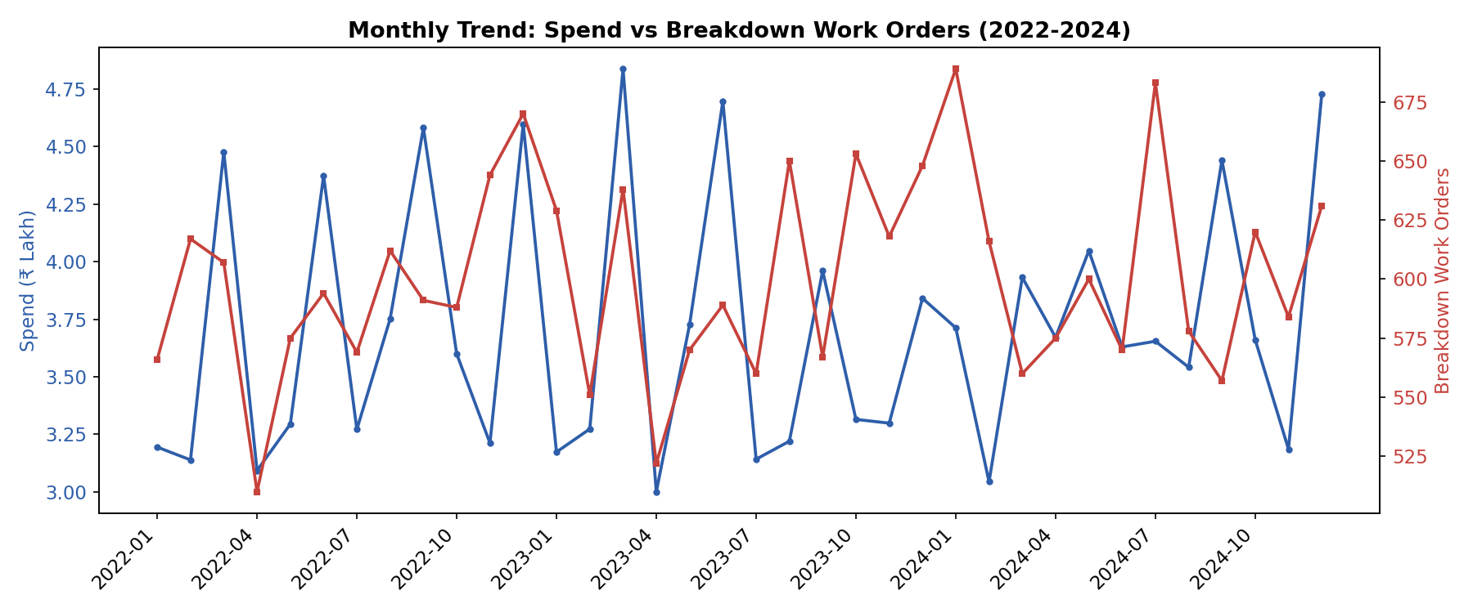
Figure 8: Monthly spend (blue, left axis) versus breakdown work orders (red, right axis), Jan 2022 – Dec 2024.
Spend stays in a fairly narrow band of ₹3.0–4.8 Lakh per month, with recurring spikes around March, June, September and December — consistent with quarterly planned-maintenance cycles. Breakdown work orders fluctuate between roughly 500 and 690 per month without a strong long-term upward or downward trend, meaning the underlying breakdown rate has stayed broadly steady across the 3 years rather than improving.

7. Recommendations

Immediate actions
- Prioritise a reliability review on the top 5 breakdown-prone assets (AST-2017, AST-5003, AST-4055, AST-2031, AST-4061) — they drive over half of all breakdown events.
- Set up a monitoring alert on power consumption and load % — these showed the clearest gap between normal and breakdown days and are the most actionable early-warning pair.
- Standardise bearing replacement intervals — bearings are simultaneously the top spend item and the top breakdown contributor, so small reliability gains here have outsized cost impact.

Medium-term actions
- Shift the maintenance mix from reactive to planned — with breakdown work orders at 50.6% of the total, moving even 10-15 percentage points toward planned maintenance should reduce both downtime and emergency-purchase costs.
- Review maintenance practices at plant DHR-03, which has the highest breakdown rate (69.0%) despite a smaller fleet than PUN-01.
- Investigate why Criticality-B assets show more breakdowns than Criticality-A assets — criticality classification may need to be revisited, or B-class assets may be under-maintained relative to their actual duty.

Data & process suggestions
- Extend sensor logging to include a derived 'load-power ratio' metric, which may sharpen the early-warning signal further.
- Track mean-time-between-failures (MTBF) per asset going forward to complement this spend/breakdown-count view with a reliability-engineering perspective.
— End of Report —

