

**DEPARTMENT OF INFORMATION SCIENCE & ENGINEERING**

**CERTIFICATE**

This is to certify that the project work entitled “**spiral movement of particles**” is a bonafide work done by ***Prachitha S Jain*** (*USN* ***4NM16IS066)*** ***& Reethika Shetty (***USN ***4NM16IS053)***, in partial fulfillment for the award of degree of Bachelor of Engineering in Information Science and Engineering under the Visvesvaraya Technological University, Belagavi during the year 2018-2019. It is verified that all corrections/suggestions indicated for internal assessment have been incorporated in the report deposited in the department library. The project report has been approved as it satisfies the academic requirements in respect of project work prescribed by Bachelor of Engineering Degree.

**Project Guide Head, Dept. of ISE**

**Mr. Abhishek S. Rao Dr. Karthik Pai B H Assistant Professor Professor**

**Name of the Examiners Signature with Date**

**1.**

**2.**

**CHAPTER 1**

**INTRODUCTION**

**1.1 Introduction to Blender**

### ● Blender is a free, open-source computer graphics suite

### ● Developed as a commercial product

### ● Freed by the community as GPL software by a one-time payment of 100.000 EUR in 2002

### ● Since then, managed and developed by the non-profit Blender Foundation

### ● A set of open-source movies have been made, to improve Blenders feature set in certain areas

### ● The movies are produced by the Blender Foundation with donations from the community

### ● A professional team of artists gathers in the Blender Institute in Amsterdam for ~5 month

### ● The movie and all source material (models, textures) are available for free once the production in done The most recent production

### ● Goal was to improve the tracking and mixing of rendered and real-film

### ● Visual Effects Breakdown done with blender alone, almost they also used

### ● 3d Modeling mesh modifiers | sculpting mode | texturing

### ● Animation character rigging | inverse kinematics |

### ● Rendering & raytracing material effects | ambient occlusion | GPU-based raytracing

### ● Physics simulation particle systems | soft & rigid body | fluid dynamics

### ● Game engine OpenGL based | python scriptable | full physics simulation

### ● Compositing Object tracking | video 1.2 User interface

### 1.2 Operating system that supports blender:

### Linux | Windows | MacOS | Free BSD Ubuntu

**1.3 Editing modes**

The two primary modes of work are *Object Mode* and *Edit Mode*, which are toggled with the Tab key. Object mode is used to manipulate individual objects as a unit, while Edit mode is used to manipulate the actual object data. For example, Object Mode can be used to move, scale, and rotate entire [polygon meshes](https://en.wikipedia.org/wiki/Polygon_mesh), and Edit Mode can be used to manipulate the individual vertices of a single mesh. There are also several other modes, such as Vertex Paint, Weight Paint, and Sculpt Mode.

**1.4 Numeric input**

Numeric buttons can be "dragged" to change their value directly without the need to aim at a particular widget, as well as being set using the keyboard. Both sliders and number buttons can be constrained to various step sizes with modifiers like the Ctrl and Shift keys. [Python](https://en.wikipedia.org/wiki/Python_(programming_language)) expressions can also be typed directly into number entry fields, allowing mathematical expressions to specify values.

**1.5 File format**

### filename.blender

### 1.6 GPU rendering

Cycles supports [GPU](https://en.wikipedia.org/wiki/GPU) rendering which is used to help speed up rendering times. There are two GPU rendering modes: [CUDA](https://en.wikipedia.org/wiki/CUDA), which is the preferred method for [NVIDIA](https://en.wikipedia.org/wiki/Nvidia" \o "Nvidia)graphics cards; and [OpenCL](https://en.wikipedia.org/wiki/OpenCL" \o "OpenCL), which supports rendering on [AMD](https://en.wikipedia.org/wiki/Advanced_Micro_Devices) graphics cards. Multiple GPUs are also supported, which can be used to create a [render farm](https://en.wikipedia.org/wiki/Render_farm) – although having multiple GPUs doesn't increase the available memory because each GPU can only access its own memory.

**CHAPTER 2**

**REQUIREMENT SPECIFICATION**

**Hardware requirements:**

Processor: Intel Core i5

Memory:8GB RAM

Minimum resolution: 1024*768

**Software requirements:**

Blender Version: 2.79b

**CHAPTER 3**

**DESIGN and IMPLEMENTATION**

**3.1 PLANE**

1.To add plane, go to mesh🡪 add🡪plane and place it above the ground, scale the plane and press enter.

2.Press “G” to grab the plane and place it accordingly.

3.Then go to particle settings to add some particles. Click new 🡪object 🡪 cube, as object.

4.Now press play button where you can see cubes falling downword.

5.Now you need to add the path , to guide the cubes.

For that go to 🡪force filed🡪 curveguide.

6.Now place the curveguide right below the plane and scale it by pressing “S”. Inorder to edit it, change the mode from object mode to edit mode.

7.Now guide the cubes by giving the path downword spiral shape.

8. Text is added with plane in background. Go to add🡪plane .Rotate and Scale in using “R” and “S”. And grab it using “G” to place in front of the plane.

9.Change the mode from edit mode to object mode and press play button. Now you can see the spiral movement of particles .

**3.2 COLORING**

To color we need to go to material select new material and select color from diffuse

option.

**3.3 RENDERING**

After designing , the image or the vedio must be rendered.To do that image must be inside the camera view. So, go to view🡪camera🡪active camera.Then go to render option where we have render,animation and vedio. Since this project is animation, click animation and do the settings. Add how many number of frames and how much resolution we need. In ouput option , select the path to store the rendered frames.

Rendered images will be stored in that specified path. Then press render option.Now the rendering starts. Once rendering id done desired output is obtained in screen.

**CHAPTER 4**

**RESULTS**

**5.1 SCREENSHOTS:**

**BEFORE RENDERING:**

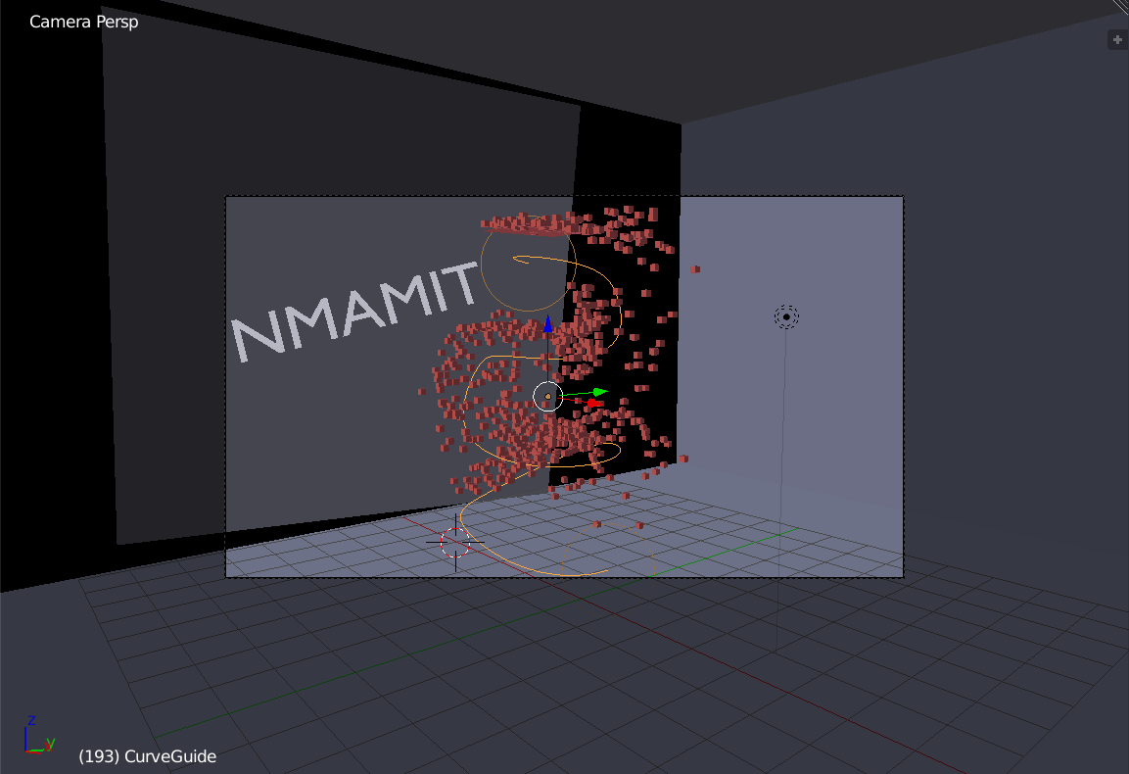

**AFTER RENDERING: (Animation)**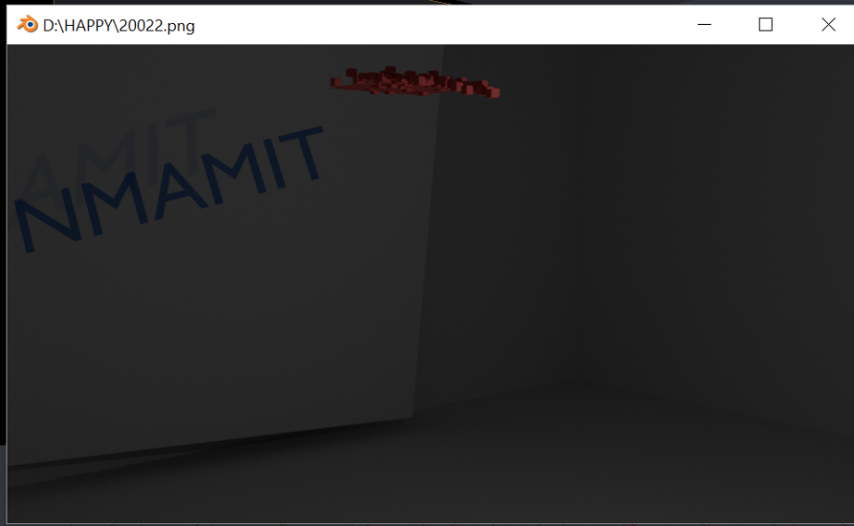 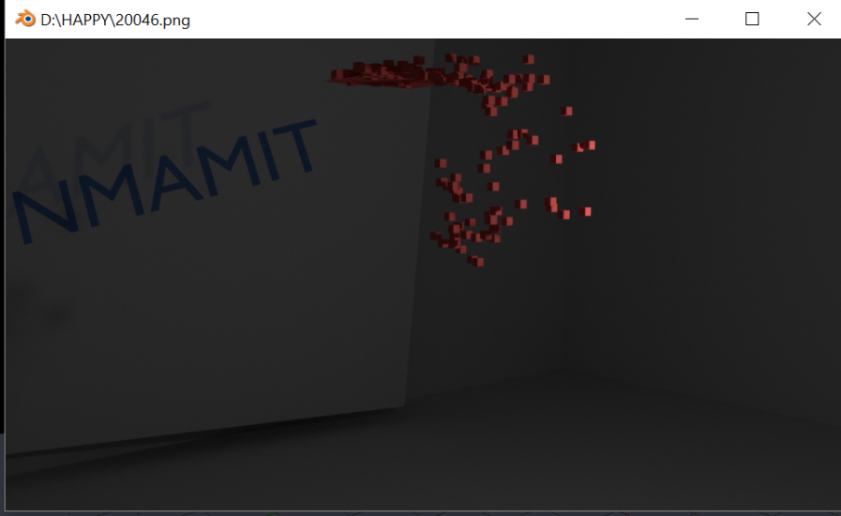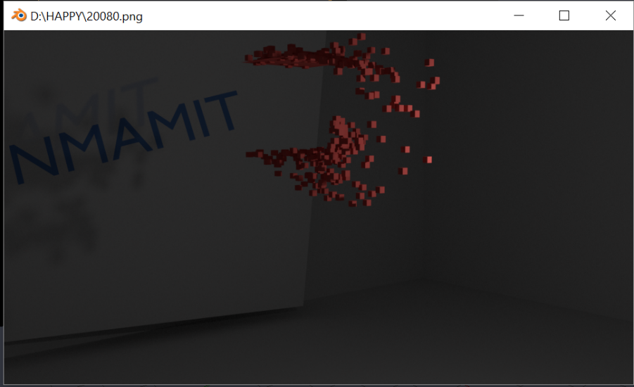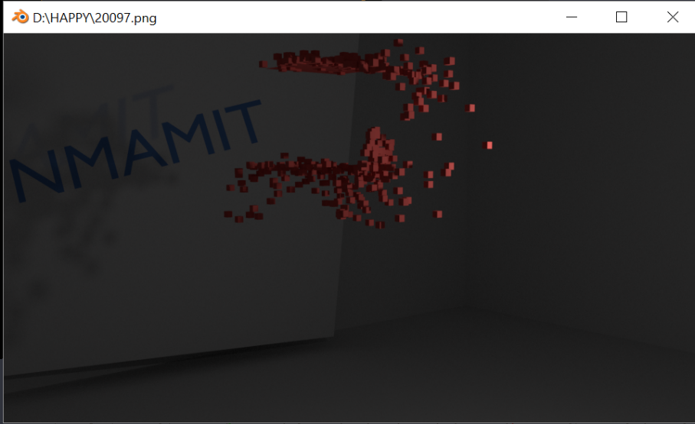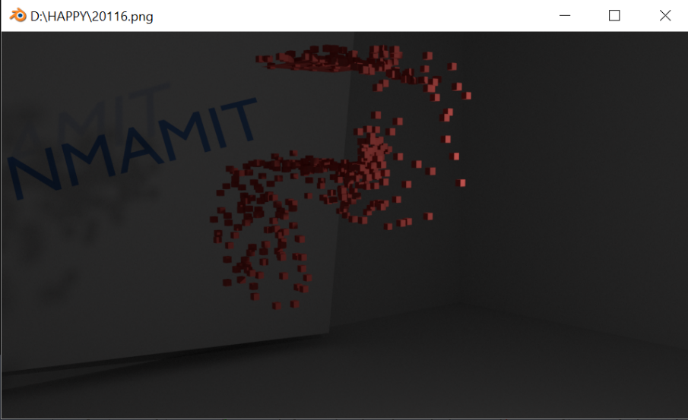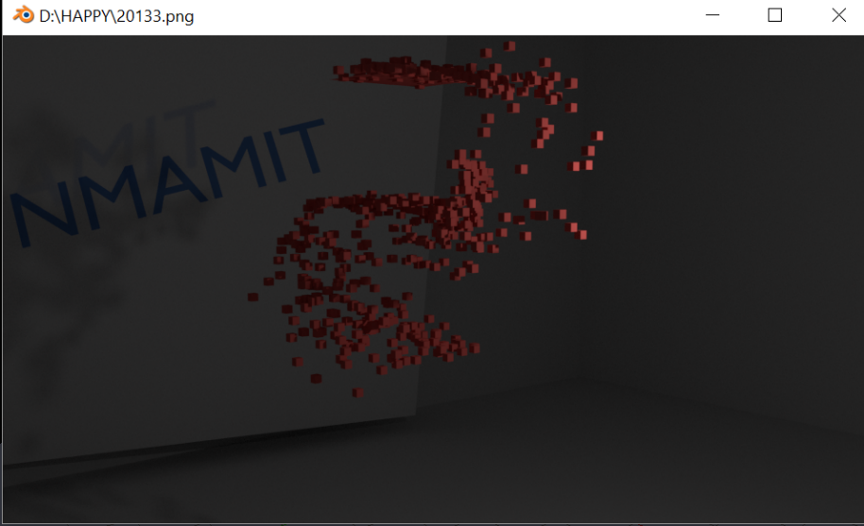

**CHAPTER 5**

**CONCLUSION & FUTURE ENHANCEMENT**

In this project we demonstrated the spiral movement of particles with text in background.

Where the colors is added and particles are made to move.

In future many more things can be implemented like different guide path, mirror image of that etc..,

**REFERENCES**

* **Referred Books**

# **Interactive Computer Graphics A Top-Down Approach with OpenGL -Edward Angel, 5th Edition, Addison-Wesley, 2008.**

* **Websites Referred**

1.Blenders begineer’s tutorial.