Assignment 2

Prachi Tiwari, id=23102057

28 September, 2023

## Simple example

I have created a vector of data called data1 and have calculated some numerical and graphical summaries.

These are the data:

data1 <- c(10, 23, 14, 12, 34, 26, 28, 24)

The mean is

mean(data1)

## [1] 21.375

The summary statistics (minimum, maximum, $Q_{1}$, median, and $Q_{3}$) are:

summary(data1)

## Min. 1st Qu. Median Mean 3rd Qu. Max.   
## 10.00 13.50 23.50 21.38 26.50 34.00

The five number summary which uses Tukey’s method to estimate the lower and upper quartiles ( $Q_{1}$ and $Q_{3}$) is given below. Sometimes there are small differences between the quartiles given by the summary function and quartiles given using Tukey’s method.

fivenum(data1)

## [1] 10.0 13.0 23.5 27.0 34.0

A boxplot of the data below uses Tukey’s method. I would describe the shape of the distribution using the boxplot as left skewed.

boxplot(data1)

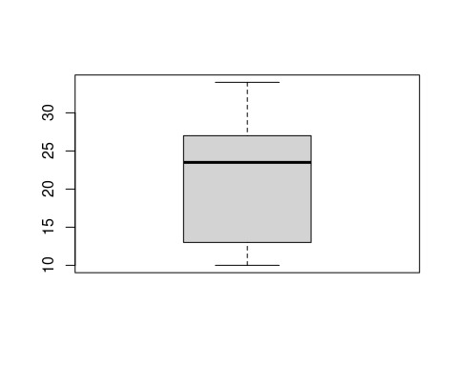

A histogram with R’s default settings is shown below. I would describe the shape of the distribution using the histogram as right skewed.

hist(data1)

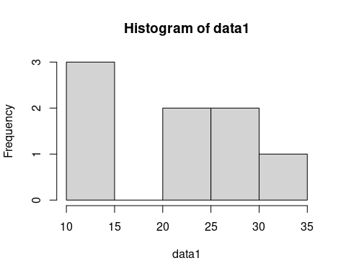

A histogram with about ten bins is also shown below.

hist(data1, breaks = 10)

