Chapter 1:- INTRODUCTION
1.1 Background
In today's digital world, people use mobile phones and the internet for online banking, shopping, communication, education, and many other activities. However, the increasing use of the internet has also increased cybercrime, such as phishing attacks, fake websites, fraudulent links, malicious QR codes, scam SMS messages, and fake emails. These attacks can trick users into sharing sensitive information such as passwords, OTPs, bank details, and personal information.
Many users are unable to identify whether a link, message, QR code, or email is genuine or fraudulent. Traditional security methods often depend on previously identified malicious websites, which may not detect newly created scam links. Therefore, there is a need for a system that can help users identify potential cyber threats before interacting with suspicious content.
AI Cyber Shield is an Android-based cybersecurity application developed to help users identify and understand different types of digital scams. The application uses Java for the Android frontend and Python Flask for the backend server. Machine Learning techniques, including the Random Forest Classifier, are used along with rule-based checks to analyse suspicious content.
The application allows users to scan URLs, QR codes, SMS messages, and emails. After analysing the submitted content, it displays a result such as SAFE, SUSPICIOUS, or DANGEROUS, along with a confidence score, possible threat indicators, and security advice.
Firebase Authentication is used for user registration and login, while Cloud Firestore stores user profiles, scan history, and cybersecurity awareness scores. Local storage is also used to keep recent scan records available when an internet connection is unavailable. In addition, the application includes a Cyber Awareness Challenge that helps users improve their knowledge of online safety through interactive quizzes.
The main aim of AI Cyber Shield is to make cybersecurity easier to understand and more accessible to everyday mobile users by combining threat detection, security warnings, scan history, and awareness training in a single application.

1.2 Objectives
The main objectives of the AI Cyber Shield project are as follows:
1. To develop an Android mobile application that helps users identify potential phishing attacks and digital scams.
2. To provide scanning facilities for suspicious URLs, QR codes, SMS messages, and emails.
3. To use Machine Learning and rule-based techniques to analyse suspicious content and classify it as SAFE, SUSPICIOUS, or DANGEROUS.
4. To display threat explanations, confidence scores, security indicators, and safety tips so users can understand the scan results.
5. To provide secure user registration and login using Firebase Authentication.
6. To store scan history and user information using Firebase Cloud Firestore, with local storage as a fallback when offline.
7. To prevent users from directly opening links identified as dangerous and provide appropriate warning messages.
8. To improve cybersecurity awareness through interactive quizzes, score calculation, and explanations of correct and incorrect answers.
9. To provide a simple, user-friendly, and modern interface that makes the application easy to use.

1.3 Purpose, Scope, and Applicability
1.3.1 Purpose
The purpose of the AI Cyber Shield project is to provide a simple and useful mobile security solution that helps users identify possible online threats before they interact with suspicious content.
The application is designed to reduce the risk of phishing attacks and digital scams by analysing links, QR codes, SMS messages, and emails. It combines Machine Learning algorithms with rule-based techniques to identify suspicious patterns and provide meaningful results to users.
The system also aims to educate users about cybersecurity through interactive quizzes and safety tips. Firebase is used to manage user authentication and store scan history, while local storage helps retain recent scan records when the internet is unavailable.
Overall, the purpose of this project is to improve online safety, increase awareness about cybercrime, and help users make safer decisions while using digital services.
1.3.2 Scope
The scope of the AI Cyber Shield project includes the following features:
- User Registration and Login: Secure login using Firebase Authentication.
- URL Detection: Checks links and identifies potential phishing threats.
- QR Code Scanning: Scans QR codes and analyses extracted links.
- SMS and Email Analysis: Detects suspicious messages, links, and scam patterns.
- Machine Learning Detection: Uses a Random Forest Classifier and rule-based checks through a Flask backend.
- Threat Results: Displays threat status, confidence score, reasons, and safety advice.
- Scan History: Stores previous scan results using Firestore and local caching.
- Cyber Awareness Challenge: Provides quizzes at beginner, intermediate, and advanced levels.
- Profile and Awareness Score: Maintains user details and cybersecurity quiz scores.
The project helps users identify potential digital threats through a mobile application. However, its accuracy depends on the datasets, detection rules, and trained models. It is a security assistance tool, not a guarantee of complete threat detection.
1.3.3 Applicability
AI Cyber Shield can be useful for different categories of users who regularly use mobile phones and internet-based services.
1. Students: Students can learn about phishing attacks, fake websites, online fraud, and safe browsing practices.
2. General Mobile Users: People who receive unknown links, suspicious messages, or unfamiliar QR codes can use the application to check for potential threats.
3. Online Banking and Shopping Users: Users can analyse suspicious messages and links that claim to be related to bank accounts, payments, refunds, prizes, or online shopping.
4. Email Users: Users can check suspicious emails for possible impersonation, misleading subject lines, and fraudulent requests for sensitive information.
5. Cybersecurity Awareness Programs: The application can be used as a learning tool to explain common cyber threats and improve awareness through quizzes and security tips.
6. Educational Institutions: Colleges and training institutes can use the application as a demonstration of how Android development, Machine Learning, cloud databases, and cybersecurity techniques can work together.
The application is mainly intended for individual users who need assistance in identifying potential digital scams. It can also serve as an educational project for understanding the practical use of Artificial Intelligence and cybersecurity in mobile application development.

1.4 Achievements
The AI Cyber Shield project combines mobile application development, Machine Learning, cybersecurity analysis, and cloud services into one system. The major achievements of the project are as follows:
1. Android Application Development: A mobile application was developed using Java in Android Studio with a modern Material Design 3 interface.
2. Multiple Scanning Facilities: The application provides separate facilities to analyse URLs, QR codes, SMS messages, and emails for potential digital threats.
3. Machine Learning Integration: A Python Flask backend was developed to process submitted content using Scikit-learn, TF-IDF feature extraction, a Random Forest Classifier, and rule-based threat detection.
4. QR Code Integration: The ZXing Android Embedded library was integrated to scan QR codes and extract their contents for security analysis.
5. Firebase Integration: Firebase Authentication was implemented for user registration and login, while Cloud Firestore was integrated to maintain user profiles, scan records, and awareness scores.
6. Threat Classification: The system provides three main results: SAFE, SUSPICIOUS, and DANGEROUS, together with confidence information, threat indicators, and security advice.
7. Scan History and Local Storage: Recent scan records can be cached locally using Android SharedPreferences and Gson, while Firestore supports cloud-based storage and synchronisation.
8. Cyber Awareness Training: An interactive quiz system was included with three difficulty levels, answer explanations, and a score-based assessment of cybersecurity awareness.
9. Link Safety Mechanism: The application prevents direct opening of links identified as dangerous and displays a warning to help users avoid risky interactions.
10. Testing and Validation: The project documentation records successful Gradle builds and testing of the backend with SAFE, SUSPICIOUS, and DANGEROUS test cases.

1.5 Organisation of Report
The project report of “AI Cyber Shield – Intelligent Multi-Modal Phishing & Digital Scam Protection System” is divided into six chapters. Each chapter explains a different stage of the project, from its introduction to its final results and future improvements.
Chapter 1: Introduction
This chapter provides an introduction to the AI Cyber Shield project. It explains the background of the project, objectives, purpose, scope, applicability, and achievements. It also describes how the report is organised.
Chapter 2: Survey of Technologies
This chapter explains the technologies, programming languages, software, tools, and libraries used in the project. It describes the importance of Java, Android Studio, Python, Flask, Machine Learning, Firebase, Cloud Firestore, and the ZXing library, along with the reasons for selecting them.
Chapter 3: Requirements and Analysis
This chapter describes the problem definition, limitations of the existing system, and proposed solution. It includes functional and non-functional requirements, project planning and scheduling, Gantt chart, PERT diagram, hardware and software requirements, preliminary product description, and conceptual models of the system.
Chapter 4: System Design
This chapter explains the design and structure of the AI Cyber Shield application. It covers the basic modules, data design, database schema, data integrity and constraints, procedural design, logic diagrams, data structures, algorithm design, user interface design, security issues, and test case design.
Chapter 5: Result and Discussion
This chapter presents the results obtained after implementing and testing the application. It discusses the major features, including user registration and login, URL scanning, QR code scanning, SMS and email analysis, threat classification, scan history, and the Cyber Awareness Challenge. It also explains the observed test results and limitations of the system.
Chapter 6: Conclusion and Future Work
This chapter summarises the project, its objectives, and its achievements. It explains how AI Cyber Shield helps users identify potential phishing attacks and digital scams. It also describes future improvements, such as advanced Machine Learning models, multilingual phishing detection, automated threat monitoring, and community-based threat reporting.

CHAPTER 2:- SURVEY OF TECHNOLOGY
The AI Cyber Shield project uses various software, programming languages, and libraries to develop a secure Android application for detecting potential phishing attacks and digital scams.
2.1 Java
Java is used to develop the Android application's frontend. It handles user interaction, URL scanning, QR code scanning, and displaying results. It was selected because it supports Android development and provides reliable application functionality.
2.2 Android Studio
Android Studio is the development environment used to build, test, and debug the Android application. It was selected because it provides tools for designing user interfaces and developing Android apps using Java.
2.3 Python
Python is used for Machine Learning and backend processing. It was selected because it is easy to use and supports many libraries for data analysis and threat detection.
2.4 Flask
Flask is used to create the backend REST API that connects the Android application with the Machine Learning model. It was selected because it is lightweight and suitable for developing APIs.
2.5 Machine Learning and Scikit-learn
Scikit-learn is used to implement the Random Forest Classifier for analysing suspicious content. It helps classify submitted content into SAFE, SUSPICIOUS, or DANGEROUS categories. It was selected because it provides useful Machine Learning algorithms.
2.6 Firebase Authentication
Firebase Authentication manages user registration and login using email and password. It was selected because it provides a convenient and secure authentication service.
2.7 Cloud Firestore
Cloud Firestore stores user profiles, scan history, and awareness scores. It was selected because it provides cloud-based data storage and allows data to be accessed across devices.
2.8 ZXing Library
The ZXing library is used to scan QR codes and extract their contents. It was selected because it supports QR code scanning in Android applications.
2.9 SharedPreferences and Gson
SharedPreferences stores small amounts of data locally, while Gson converts data between Java objects and JSON. They were selected to support local scan caching and data handling.
2.10 Retrofit and OkHttp
Retrofit and OkHttp are used for communication between the Android application and the Flask backend. They help send scan requests and receive analysis results over the internet.

CHAPTER 3:- REQIREMENT AND ANALYSIS
3.1 Problem Definition
In today's digital world, users face cyber threats such as phishing websites, fake links, malicious QR codes, scam SMS messages, and fraudulent emails. Many users cannot easily identify these threats, which may lead to financial loss or theft of personal information.
The AI Cyber Shield project aims to develop an Android application that analyses suspicious content using Machine Learning and rule-based checks. It classifies the content as SAFE, SUSPICIOUS, or DANGEROUS and provides security advice.
The main problems are:
- Phishing URL Detection: Identifying fake and suspicious website links.
- QR Code Analysis: Detecting potentially harmful links extracted from QR codes.
- SMS and Email Analysis: Identifying suspicious messages, scam patterns, and misleading links.
- Threat Classification: Analysing submitted content and displaying understandable results.
- User and Data Management: Managing user accounts, scan history, and cybersecurity awareness scores.

3.2 Requirements Specification
The system requirements describe the functions that the application must perform.
Functional Requirements:
- Users can register and log in securely.
- Users can scan URLs and QR codes and analyse SMS messages and emails.
- The system displays a threat category, confidence score, possible indicators, and safety advice.
- Users can view previous scan results and filter them by threat status.
- Users can attempt cybersecurity quizzes and view their awareness scores.
- Users can manage their profile and access stored information.
Non-Functional Requirements:
- The application should be easy to use.
- User information should be stored securely.
- The system should provide results within a reasonable time.
- The application should handle invalid input and network errors.
- The system should support reliable communication between the Android application and backend.
Existing System and Its Problems:
Traditional security systems often depend on known malicious websites or basic security rules. They may fail to identify newly created scam links and suspicious messages. Users may also need separate tools to check URLs, QR codes, SMS messages, and emails. AI Cyber Shield aims to provide these checking features in a single application.

3.4 Software and Hardware Requirements
3.4.1 Hardware Requirements
Hardware Component | Minimum Requirement
Processor | Intel Core i3 or equivalent and above
RAM | Minimum 8 GB recommended
Storage | At least 10 GB of free space
Display | Standard monitor with suitable resolution
Input Devices | Keyboard and mouse
Mobile Device | Android smartphone or emulator for application testing
Internet Connection | Required for Firebase services and backend communication

3.4.2 Software Requirements
Software Component | Description/Purpose
Operating System | Windows 10/11 or a compatible operating system
Android Studio | Used for Android application development and testing
Programming Language | Java for frontend and Python for backend development
Backend Framework | Flask for developing REST APIs
Machine Learning Library | Scikit-learn for implementing the Random Forest Classifier
Database and Authentication | Firebase Authentication and Cloud Firestore
QR Code Library | ZXing for QR code scanning
Communication Libraries | Retrofit, OkHttp, and Gson for API communication and JSON handling
Testing Tools | Android emulator, Android smartphone, and API testing tools if required

3.5 Preliminary Product Description
AI Cyber Shield is an Android-based application designed to help users identify potential digital scams. Users can enter or share URLs, scan QR codes, and submit SMS messages or emails for analysis. The Flask backend uses Machine Learning and rule-based checks to classify the submitted content.
The application displays the threat category, confidence score, possible warning signs, and security advice. It also provides user authentication, scan history, profile management, and a Cyber Awareness Challenge. The main objective is to improve online safety and help users make informed decisions before interacting with suspicious content.
3.6 Conceptual Models
Conceptual models represent the working and structure of the system.

A: Data Flow Diagram (DFD)
A Data Flow Diagram shows how information moves between the user, the application, the backend and the database.
- Level 0: Shows the complete AI Cyber Shield system as a single process and its interaction with the user, Flask/ML backend and Firebase.

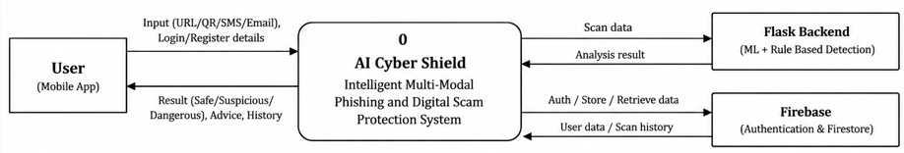

- Level 1: Explains the internal processes, such as user authentication, receiving a URL/QR/SMS/email input, analysing threats, displaying results and storing scan history.

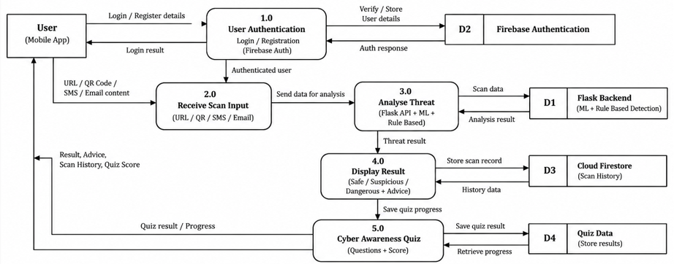

B: Entity Relationship (ER) Diagram
The ER Diagram represents the data entities and their relationships in the system. It includes User, Profile, Scan Record and Quiz Result. It explains how user information, scan details, threat results and quiz scores are organised and related.

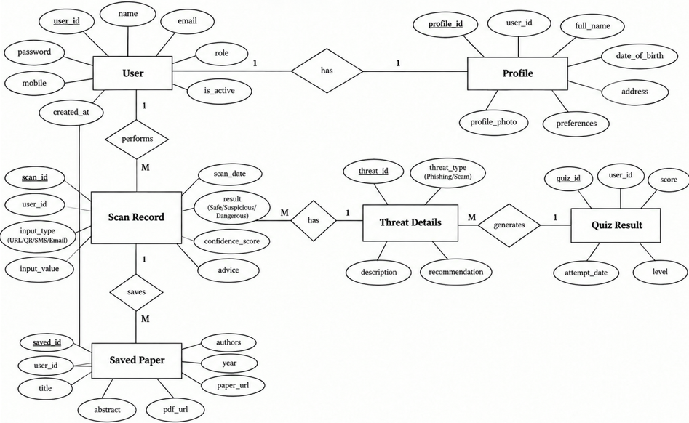

C: Object-Oriented Diagram
The Object-Oriented Diagram shows the main objects involved in the application and how they interact. It includes the user interface, scan controller, threat analysis service, detection engine and data services. It explains how different objects work together to detect phishing and digital scams.

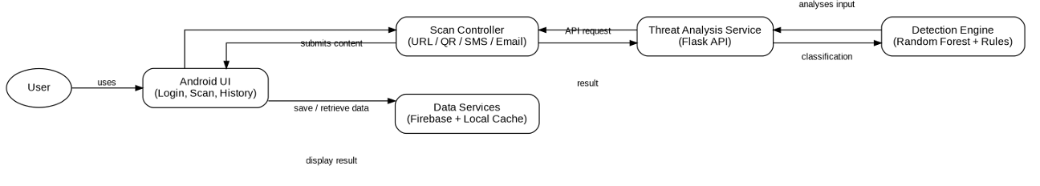

D: System Flowchart
The System Flowchart represents the step-by-step working of AI Cyber Shield. The process begins with login or registration, followed by selecting a scanning option, submitting the input, analysing the threat and displaying the result. If the input is invalid, the system displays an error message. Dangerous links are handled through safety warnings.

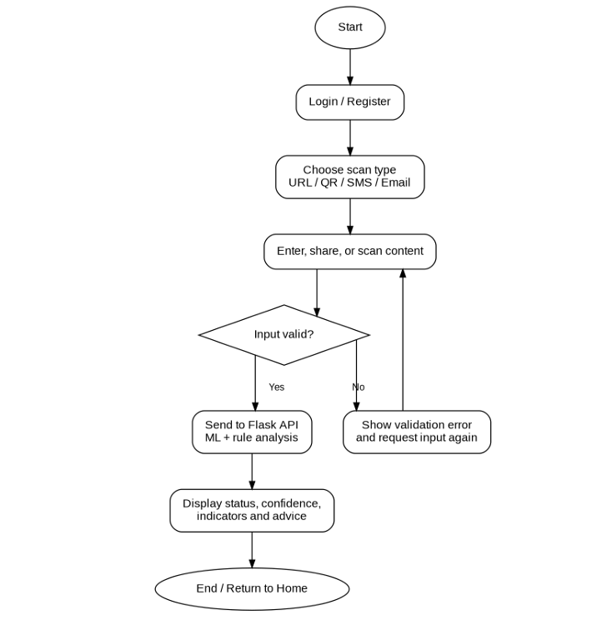

E: Activity Diagram
The Activity Diagram describes the activities performed by the user and the system. It shows login, selecting URL/QR/SMS/email scanning or the awareness quiz, submitting input, processing information and displaying the final result or quiz score.

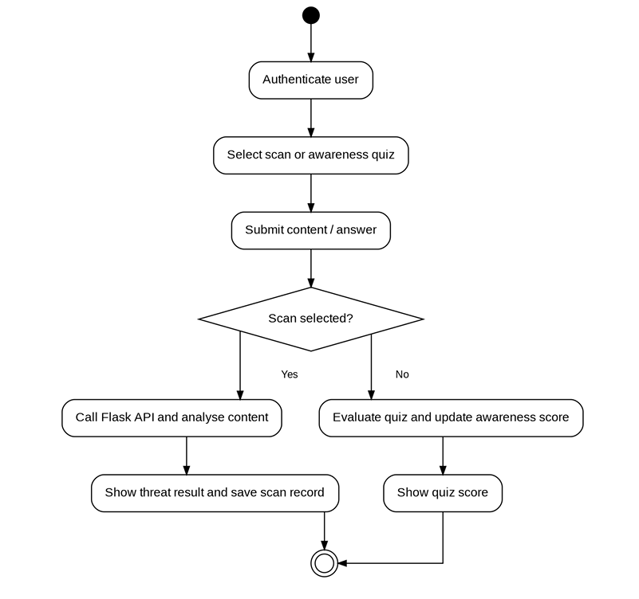

F: Class Diagram
The Class Diagram represents the main classes and their relationships. It may include User, ScanRecord, QuizResult, AuthService, ScanService and ApiClient. It explains the responsibilities of each class and how the classes support authentication, threat scanning, API communication and record management.

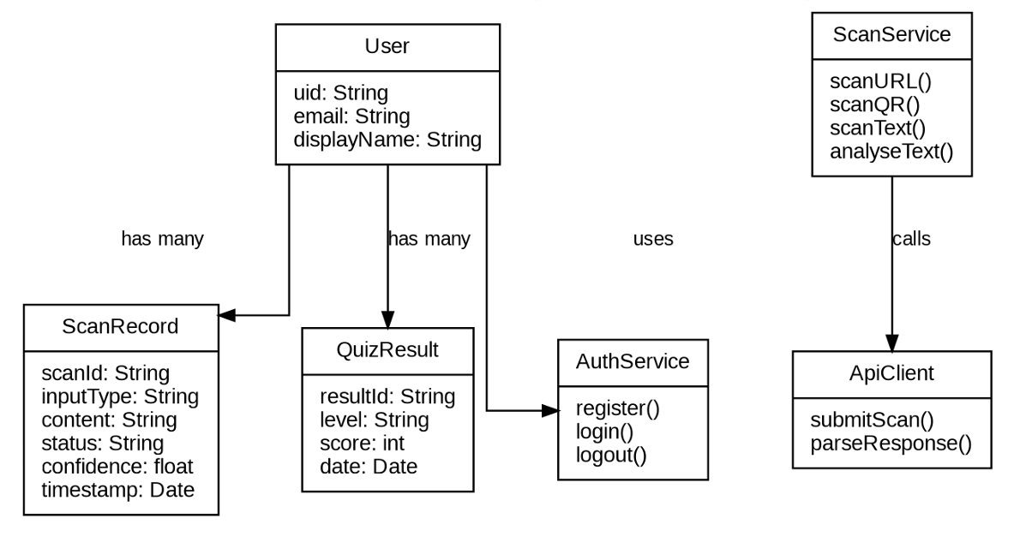

G: Component Diagram
The Component Diagram shows the major software components and their connections. These include the Android application, REST API client, Flask backend, machine learning and rule-based detection engine, Firebase Authentication, Cloud Firestore and local storage. It explains how these components work together to provide the application's functionality.

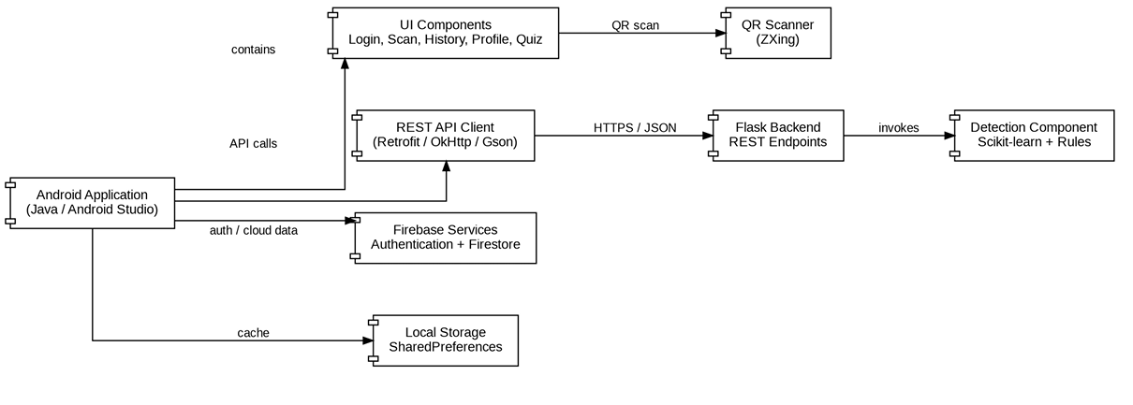

H: Use Case Diagram
The Use Case Diagram represents the interactions between the user and the system. It includes registration, login, scanning URLs and QR codes, checking SMS and email content, viewing threat results, checking scan history, taking awareness quizzes and viewing the profile or awareness score.

