**Books Table** Rachna Patil(24/DSC/27)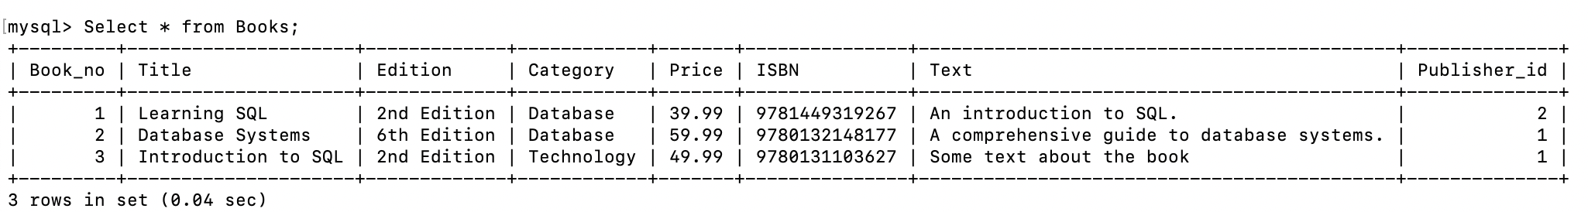

**Non-Correlated Subqueries**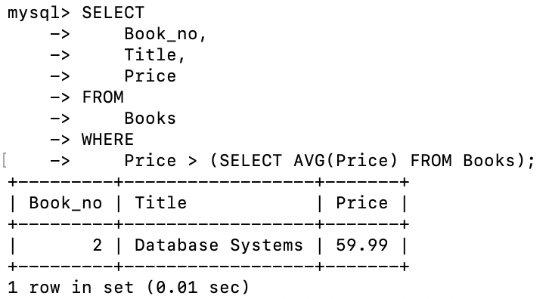

**Reserve Table**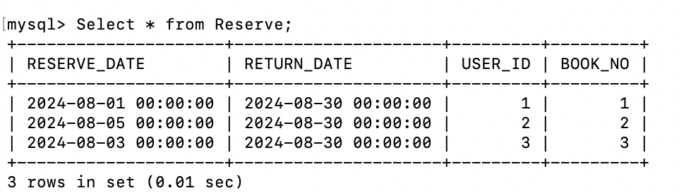

**Readers Table**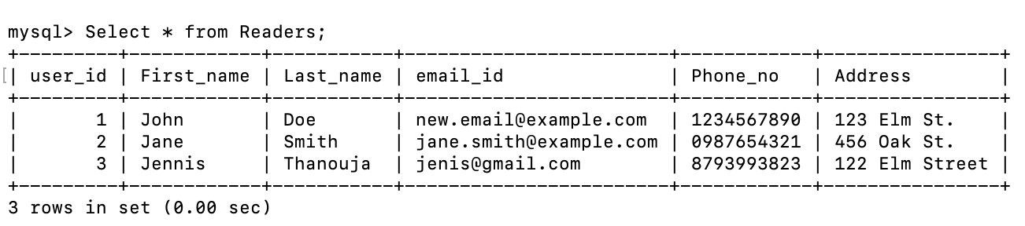

**Correlated subquery** Rachna Patil(24/DSC/27)