

In [9]:

*#Importing required libraries.*

**from keras.datasets import** mnist

**from keras.utils import** np_utils

**from keras.models import** Sequential, Model

**from keras.layers import** Input, Dense, Activation, Flatten, Reshape

**from keras.layers.convolutional import** Conv2D, Conv2DTranspose, UpSampling2D, Convolution2D

**from keras.layers.normalization import** BatchNormalization **from keras.layers.advanced_activations import** LeakyReLU **from keras.optimizers import** Adam **import numpy as np**

**import matplotlib.pyplot as plt**

**import random**

**from tqdm import** tqdm_notebook

(60000, 28, 28)

In [ ]:

* *Dataset of 60,000 28x28 grayscale images of the 10 digits, along with a test set of 10, 000 images.*

(X_train, Y_train), (X_test, Y_test) = mnist.load_data() print(X_train.shape)

In [10]:

* *Preprocessing : This step is crucial for this type of GAN , because here the images fed to discriminator must have a size with channels included.*

*#Therefore we reshape the b&w images with 1 channel to (28,28,1).*

X_train = X_train.reshape(60000, 28, 28, 1)

X_test = X_test.reshape(10000, 28, 28, 1)

X_train = X_train.astype('float32')/255

X_test = X_test.astype('float32')/255

In [17]:

*#Using images of 0 only so to make datset smaller and training time faster.*

X_train= X_train[Y_train==0]

In [11]:

* *Set the dimensions of the noise* z_dim = 100

In [34]:

nch = 200

In [32]:

* *Here we define the architecture of GAN which consists of both "generator" and "discrimi nator".*

*#We define architecture of Generator which is fully-convolutional network. It accepts noi se as input and generates am image out of it.*

*#Generator learns when gradients are backpropagated through the network just after discri minator clasifies any image real or fake.*

*#A special type of convolutional layer is being used here which increases the dimension o f input image/array by using transpose convolution notion.*

*#Because network discriminates between real and generated image , therefore this uses "bi nary_crossentropy" as loss.*

*#First encoding is fed to generator which generates an image from it and then subsequentl y the generated image is fed into discriminator for it to classify*

* *image as real or fake.*

*#Thus in the whole architecture , they both fight against each other. And thus make each other learn more everytime.*



adam = Adam(lr=0.0002, beta_1=0.5)

g = Sequential()

g.add(Dense(7*7*112, input_dim=z_dim))

g.add(Reshape((7, 7, 112)))

g.add(BatchNormalization())

g.add(Activation(LeakyReLU(alpha=0.2)))

g.add(Conv2DTranspose(56, 5, strides=2, padding='same'))

g.add(BatchNormalization())

g.add(Activation(LeakyReLU(alpha=0.2)))

g.add(Conv2DTranspose(1, 5, strides=2, padding='same', activation='sigmoid'))

g.compile(loss='binary_crossentropy', optimizer=adam, metrics=['accuracy'])

g.summary()

d = Sequential()

d.add(Conv2D(56, 5, strides=2, padding='same', input_shape=(28, 28, 1), activation=Leaky ReLU(alpha=0.2)))

d.add(Conv2D(112, 5, strides=2, padding='same'))

g.add(BatchNormalization())

g.add(Activation(LeakyReLU(alpha=0.2)))

d.add(Conv2D(224, 5, strides=2, padding='same'))

g.add(Activation(LeakyReLU(alpha=0.2)))

d.add(Flatten())

d.add(Dense(112, activation=LeakyReLU(alpha=0.2)))

d.add(Dense(1, activation='sigmoid'))

d.compile(loss='binary_crossentropy', optimizer=adam, metrics=['accuracy'])

d.summary()

Model: "sequential_2"

_________________________________________________________________

Layer (type) Output Shape Param #

=================================================================

dense_5 (Dense) (None, 5488) 554288

_________________________________________________________________

reshape_3 (Reshape) (None, 7, 7, 112) 0

_________________________________________________________________

|  |  |
| --- | --- |
| batch_normalization_7 (Batch (None, 7, 7, 112) | 448 |

_________________________________________________________________

activation_9 (Activation) (None, 7, 7, 112) 0

_________________________________________________________________

|  |  |
| --- | --- |
| conv2d_transpose_2 (Conv2DTr (None, 14, 14, 56) | 156856 |

_________________________________________________________________

|  |  |
| --- | --- |
| batch_normalization_8 (Batch (None, 14, 14, 56) | 224 |

_________________________________________________________________

activation_10 (Activation) (None, 14, 14, 56) 0

_________________________________________________________________

|  |  |
| --- | --- |
| conv2d_transpose_3 (Conv2DTr (None, 28, 28, 1) | 1401 |

=================================================================

Total params: 713,217

Trainable params: 712,881

Non-trainable params: 336

_________________________________________________________________

Model: "sequential_3"

_________________________________________________________________

Layer (type) Output Shape Param #

=================================================================

conv2d_6 (Conv2D) (None, 14, 14, 56) 1456

_________________________________________________________________

conv2d_7 (Conv2D) (None, 7, 7, 112) 156912

_________________________________________________________________

conv2d_8 (Conv2D) (None, 4, 4, 224) 627424

_________________________________________________________________

flatten_1 (Flatten) (None, 3584) 0

_________________________________________________________________

dense_6 (Dense) (None, 112) 401520

_________________________________________________________________

dense_7 (Dense) (None, 1) 113

=================================================================

Total params: 1,187,425

Trainable params: 1,187,425

Non-trainable params: 0



_________________________________________________________________

In [33]:

*#We first make discriminator non-trainable so it just classify images simply and do not l earn anything from the data fed to it.*

*#And we set the complete loss-fnunction and optimizer. Advanced architectures uses variou*

*s kind of loss so to make it more*

*# efficient.*

d.trainable = **False**

inputs = Input(shape=(z_dim, ))

hidden = g(inputs)

output = d(hidden)

gan = Model(inputs, output)

gan.compile(loss='binary_crossentropy', optimizer=adam, metrics=['accuracy'])

gan.summary()

Model: "functional_5"

_________________________________________________________________

Layer (type) Output Shape Param #

=================================================================

input_5 (InputLayer) [(None, 100)] 0

_________________________________________________________________

sequential_2 (Sequential) (None, 28, 28, 1) 713221

_________________________________________________________________

sequential_3 (Sequential) (None, 1) 1187425

=================================================================

Total params: 1,900,646

Trainable params: 712,883

Non-trainable params: 1,187,763

_________________________________________________________________

In [13]:

*#This is train function which trains the whole architecture in one.*

*#First an random noise is generated and is fed to generator "g" which generates some nois y image from it as the generator is not yet trained.*

*#The generated noisy image is then concatenated with real images and all of them are fed into discriminator. Discriminator is tricked to believe that they*

*#real images as we give target as "0". It then learns somehting about the real images. #Then comes the generator's training. We simply generate some more random noise, set targ et as "1" so to make the "GAN" believe that they are real images.*

*#Just then we make discriminator non-trainable and feed this data into whole "GAN" archit ecture. Thus the generator learns when the loop completes and*

*# the gradients flow back assuming that all of the images given were real images.*

In [18]:

* *Set up a vector (dict) to store the losses* samples = []

**def** train(epochs=1, plt_frq=1, BATCH_ SIZE=128):batchCount = int(X_train.shape[0] / BATCH_SIZE) print('Epochs:', epochs)

print('Batch size:', BATCH_SIZE)

print('Batches per epoch:', batchCount)

**for** e **in** tqdm_notebook(range(1, epochs+1)):

**if** e== 1 **or** e%plt_frq== 0:

print('-'*15, 'Epoch **%d**' % e, '-'*15)

**for** _ **in** range(batchCount): *# tqdm_notebook(range(batchCount), leave=False):*

*# Create a batch by drawing random index numbers from the training set*

image_batch = X_train[np.random.randint(0, X_train.shape[0], size=BATCH_SIZE

)]

image_batch = image_batch.reshape(image_batch.shape[0], image_batch.shape[1]

* image_batch.shape[2], 1)
  + *Create noise vectors for the generator*

noise = np.random.normal(0, 1, size=(BATCH_SIZE, z_dim))

* *Generate the images from the noise* generated_images = g.predict(noise) samples.append(generated_images)

X = np.concatenate((image_batch, generated_images))

* *Create labels*

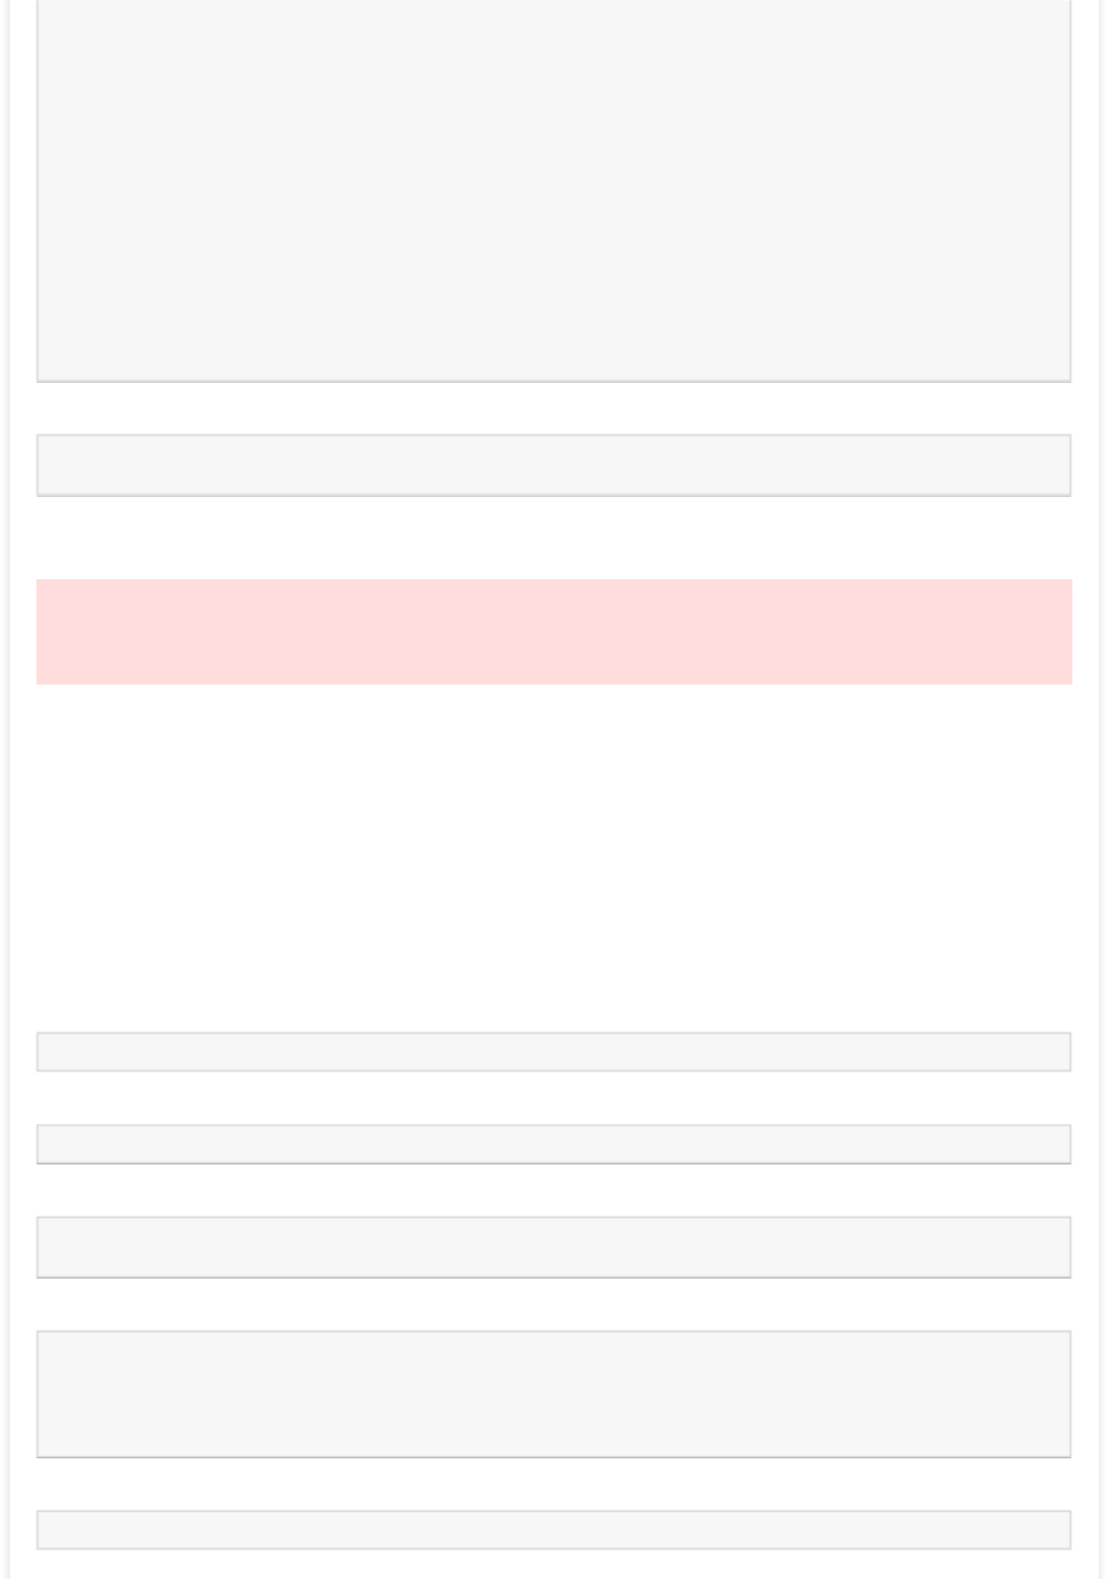

* = np.zeros(2*BATCH_SIZE)

y[:BATCH_SIZE] = 0.9 *# One-sided label smoothing*

* *Train discriminator on generated images* d.trainable = **True**

d_loss = d.train_on_batch(X, y)

* *Train generator*

noise = np.random.normal(0, 1, size=(BATCH_SIZE, z_dim))

y2 = np.ones(BATCH_SIZE)

d.trainable = **False**

g_loss = gan.train_on_batch(noise, y2)

In [21]:

*#Training 50 epochs.*

train(epochs=200, plt_frq=20, BATCH_SIZE=128)

Epochs: 200

Batch size: 128

Batches per epoch: 46

/usr/local/lib/python3.6/dist-packages/ipykernel_launcher.py:10: TqdmDeprecationWarning:

This function will be removed in tqdm==5.0.0

Please use `tqdm.notebook.tqdm` instead of `tqdm.tqdm_notebook`

# Remove the CWD from sys.path while we load stuff.

--------------- Epoch 1 ---------------

--------------- Epoch 20 ---------------

--------------- Epoch 40 ---------------

--------------- Epoch 60 ---------------

--------------- Epoch 80 ---------------

--------------- Epoch 100 ---------------

--------------- Epoch 120 ---------------

--------------- Epoch 140 ---------------

--------------- Epoch 160 ---------------

--------------- Epoch 180 ---------------

--------------- Epoch 200 ---------------

In [34]:

In [33]:

In [33]:

*#generating random noise and then feeding it to generator which generates some image/arra y from it .*

In [29]:

n_ex=10

dim=(1, 10)

noise = np.random.normal(0, 1, size=(n_ex, z_dim))

generated_images = g.predict(noise)

generated_images = generated_images.reshape(generated_images.shape[0], 28, 28)

In [30]:

plt.imshow(generated_images[0, :, :], interpolation='nearest', cmap='gray_r')

Out[30]:

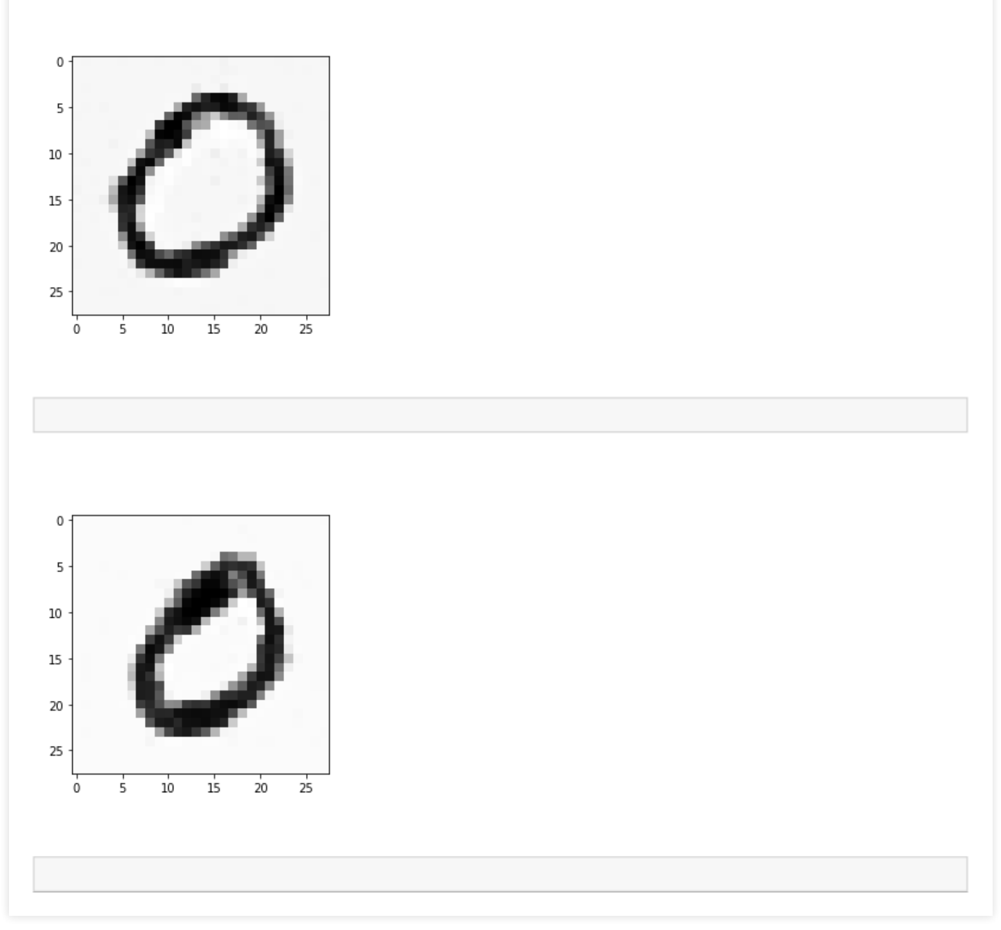<matplotlib.image.AxesImage at 0x7f37ba574828>

In [31]:

plt.imshow(generated_images[1, :, :], interpolation='nearest', cmap='gray_r')

Out[31]:

<matplotlib.image.AxesImage at 0x7f37ba62c7f0>

In [31]: