Practical :- 2

import math

from collections import Counter

def tokenize(text):

# Simple tokenization, you might want to improve it based on your specific needs

return text.lower().split()

def compute_tf(doc):

# Computes term frequency (TF) for each term in the document

word_count = Counter(tokenize(doc))

total_words = len(tokenize(doc))

tf = {word: count/total_words for word, count in word_count.items()}

return tf

def compute_idf(documents):

# Computes inverse document frequency (IDF) for each term in the collection of documents

N = len(documents)

idf = {}

for doc in documents:

terms = set(tokenize(doc))

for term in terms:

idf[term] = idf.get(term, 0) + 1

idf = {term: math.log(N/frequency) for term, frequency in idf.items()}

return idf

def compute_tf_idf(tf, idf):

# Computes TF-IDF for each term in the document

tf_idf = {term: tf[term] * idf.get(term, 0) for term in tf}

return tf_idf

def compute_cosine_similarity(query_tf_idf, doc_tf_idf):

# Computes cosine similarity between query and document TF-IDF vectors

common_terms = set(query_tf_idf.keys()) & set(doc_tf_idf.keys())

dot_product = sum(query_tf_idf[term] * doc_tf_idf[term] for term in common_terms)

query_norm = math.sqrt(sum(value**2 for value in query_tf_idf.values()))

doc_norm = math.sqrt(sum(value**2 for value in doc_tf_idf.values()))

if query_norm == 0 or doc_norm == 0:

return 0

similarity = dot_product / (query_norm * doc_norm)

return similarity

similarity = dot_product / (query_norm * doc_norm)

return similarity

def vector_space_model(documents, query):

# Build TF-IDF vectors for documents and query

tf_idf_vectors = []

for doc in documents:

tf = compute_tf(doc)

idf = compute_idf(documents)

tf_idf = compute_tf_idf(tf, idf)

tf_idf_vectors.append(tf_idf)

query_tf = compute_tf(query)

query_idf = compute_idf(documents)

query_tf_idf = compute_tf_idf(query_tf, query_idf)

# Compute cosine similarity between query and each document

similarities = []

for doc_tf_idf in tf_idf_vectors:

similarity = compute_cosine_similarity(query_tf_idf, doc_tf_idf)

similarities.append(similarity)

return similarities

# Example usage:

documents = [

"This is the first document.",

"This document is the second document.",

"And this is the third one.",

"Is this the first document?",

]

query = "This is a query document."

similarities = vector_space_model(documents, query)

print("Cosine Similarities:")

for i, sim in enumerate(similarities):

print(f"Document {i + 1}: {sim}")

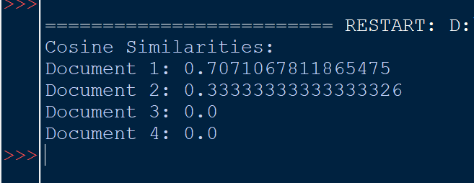

Practical :- 3

def edit_distance(str1, str2):

m, n = len(str1), len(str2)

dp = [[0] * (n + 1) for _ in range(m + 1)]

for i in range(m + 1):

for j in range(n + 1):

if i == 0:

dp[i][j] = j

elif j == 0:

dp[i][j] = i

elif str1[i-1] == str2[j-1]:

dp[i][j] = dp[i-1][j-1]

else:

dp[i][j] = 1 + min(dp[i][j-1], # Insert

dp[i-1][j], # Remove

dp[i-1][j-1] # Replace

)

return dp[m][n]

def correct_spelling(query, dictionary):

corrected_query = query.lower() # Convert to lowercase for case-insensitive correction

suggestions = []

for word in dictionary:

distance = edit_distance(corrected_query, word.lower())

if distance <= 2: # You can adjust this threshold based on your preference

suggestions.append((word, distance))

suggestions.sort(key=lambda x: x[1]) # Sort by distance in ascending order

return suggestions

# Example usage

dictionary = ["information", "retrieval", "spelling", "correction", "system"]

query = input("Enter your query: ")

suggestions = correct_spelling(query, dictionary)

if suggestions:

print("Did you mean:")

for suggestion, distance in suggestions:

print(f"{suggestion} (Edit Distance: {distance})")

else:

print("No suggestions found.")

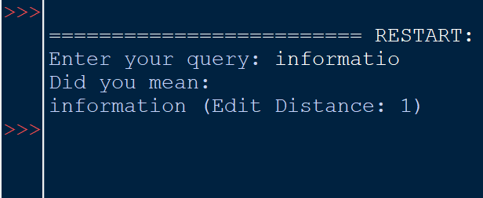

Practical :- 4

4.A

def calculate_metrics(retrieved_set, relevant_set):

true_positive = len(retrieved_set.intersection(relevant_set))

false_positive = len(retrieved_set.difference(relevant_set))

false_negative = len(relevant_set.difference(retrieved_set))

print("True Positive: ", true_positive,

"\nFalse Positive: ", false_positive,

"\nFalse Negative: ", false_negative, "\n")

precision = true_positive / (true_positive + false_positive)

recall = true_positive / (true_positive + false_negative)

f_measure = 2 * precision * recall / (precision + recall)

return precision, recall, f_measure

retrieved_set = set(["doc1", "doc2", "doc3"]) # Predicted set

relevant_set = set(["doc1", "doc4"]) # Actually Needed set (Relevant)

precision, recall, f_measure = calculate_metrics(retrieved_set, relevant_set)

print(f"Precision: {precision}")

print(f"Recall: {recall}")

print(f"F-measure: {f_measure}")

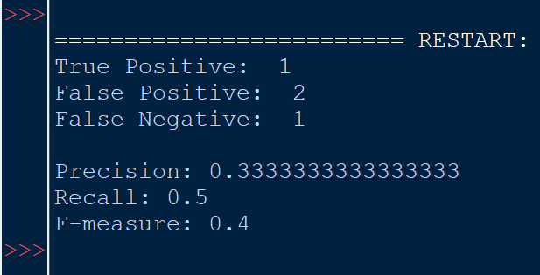

4.B

from sklearn.metrics import average_precision_score, precision_recall_curve, auc

from sklearn.metrics import accuracy_score, precision_score, recall_score, f1_score, roc_auc_score

import matplotlib.pyplot as plt

import numpy as np

def calculate_classification_metrics(y_true, y_pred_prob):

"""

Calculate various classification metrics.

Parameters:

- y_true: True labels (ground truth).

- y_pred_prob: Predicted probabilities for the positive class.

Returns:

- Dictionary containing different evaluation metrics.

"""

# Convert probabilities to binary predictions

y_pred_binary = (np.array(y_pred_prob) >= 0.5).astype(int)

# Accuracy

accuracy = accuracy_score(y_true, y_pred_binary)

# Precision, Recall, F1 Score

precision = precision_score(y_true, y_pred_binary)

recall = recall_score(y_true, y_pred_binary)

f1 = f1_score(y_true, y_pred_binary)

# ROC-AUC

roc_auc = roc_auc_score(y_true, y_pred_prob)

# Average Precision and Precision-Recall curve

average_precision = average_precision_score(y_true, y_pred_prob)

precision_curve, recall_curve, _ = precision_recall_curve(y_true, y_pred_prob)

area_under_pr_curve = auc(recall_curve, precision_curve)

# Print metrics

print(f'Accuracy: {accuracy}')

print(f'Precision: {precision}')

print(f'Recall: {recall}')

print(f'F1 Score: {f1}')

print(f'ROC-AUC: {roc_auc}')

print(f'Average Precision: {average_precision}')

print(f'Area under Precision-Recall curve: {area_under_pr_curve}')

# Plot Precision-Recall curve

plt.figure(figsize=(8, 6))

plt.plot(recall_curve, precision_curve, color='blue', lw=2, label='Precision-Recall curve')

plt.xlabel('Recall')

plt.ylabel('Precision')

plt.title('Precision-Recall Curve')

plt.legend()

plt.show()

# Example usage:

# Replace the following placeholders with your actual data

# Example for binary classification

y_true_binary = [1, 0, 1, 0, 1] # True binary labels (1 for positive, 0 for negative)

y_pred_prob_binary = [0.8, 0.6, 0.9, 0.5, 0.7] # Predicted probabilities for the positive class

calculate_classification_metrics(y_true_binary, y_pred_prob_binary)

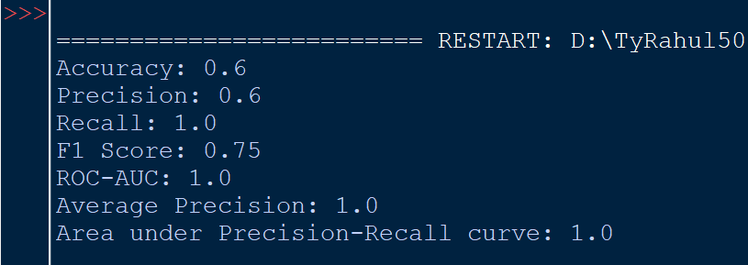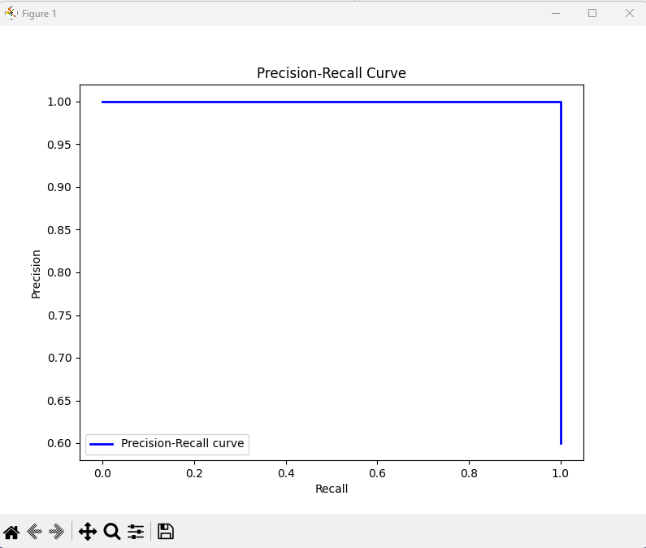

Practical :- 5

# Import necessary libraries

from sklearn.datasets import fetch_20newsgroups

from sklearn.feature_extraction.text import TfidfVectorizer

from sklearn.model_selection import train_test_split

from sklearn.svm import SVC

from sklearn.metrics import accuracy_score, classification_report

# Load the 20 Newsgroups dataset

newsgroups = fetch_20newsgroups(subset='all', remove=('headers', 'footers', 'quotes'))

# Split the dataset into training and testing sets

X_train, X_test, y_train, y_test = train_test_split(newsgroups.data, newsgroups.target, test_size=0.2, random_state=42)

# Convert text data to TF-IDF features

vectorizer = TfidfVectorizer()

X_train_tfidf = vectorizer.fit_transform(X_train)

X_test_tfidf = vectorizer.transform(X_test)

# Train a Support Vector Machine (SVM) classifier

svm_classifier = SVC(kernel='linear', C=1.0)

svm_classifier.fit(X_train_tfidf, y_train)

# Make predictions on the test set

y_pred = svm_classifier.predict(X_test_tfidf)

# Evaluate the performance of the classifier

accuracy = accuracy_score(y_test, y_pred)

classification_rep = classification_report(y_test, y_pred, target_names=newsgroups.target_names)

# Print the results

print(f"Accuracy: {accuracy:.2f}")

print("\nClassification Report:")

print(classification_rep)

