ICU Risk Stratification Analysis

Submitted to Manipal University Jaipur
Towards the partial fulfilment for the Award of the Degree of
BACHELOR OF TECHNOLOGY
In Computers Science and Engineering 2025-2026

By:
Ayush Sinha 23FE10CSE00073
Siddhant Pandey 23FE10CSE00011



Under the guidance of
Dr. Arpita Baronia
Dept. of Computer Science and Engineering
School of Computer Science Engineering

Manipal University Jaipur, Rajasthan

Abstract

In this project, we built a machine learning system to predict two things about an ICU patient at the time of admission: whether they will die during their hospital stay, and how long they are going to stay in the ICU. Both outputs come from the same set of clinical data collected in the first 24 hours. The dataset we used is the In-Hospital Mortality Prediction dataset from Kaggle (WiDS 2020), which has 28,156 patient records with 186 features. After cleaning the data and running our models, the Random Forest classifier gave 93.66% accuracy and a ROC-AUC of 0.63 for mortality. The Linear Regression model got an RMSE of 2.13 days for ICU length of stay. Feature importance analysis showed that APACHE scores, lactate levels, and arterial pH are the strongest mortality predictors — all of which line up with what doctors look for clinically.

1. Introduction
ICUs deal with the most critically ill patients in any hospital. Doctors and nurses there need to make fast decisions — who needs immediate attention, how long will someone need a bed, what resources should be kept ready. At the point of admission, two questions matter most:

1. Will this patient survive their hospital admission?
2. How long will this patient need to remain in the ICU?

These aren't just clinical questions — they affect how a hospital plans beds, staffing, and equipment. Right now, most ICUs rely on scoring systems like APACHE or simply on the experience of the treating physician. Those methods work, but they don't fully use all the data hospitals now collect electronically.

That's where machine learning helps. If we train a model on historical ICU records, it can pick up on patterns that are hard to see manually and make predictions automatically. Some hospitals already use similar systems as part of their clinical decision support tools.

This project builds a pipeline that takes a patient's first-24-hour ICU data — vitals, labs, demographics, and clinical scores — and gives back two predictions at once: a mortality risk label and an estimated length of stay. Doing both together in one pipeline is more realistic than a single-output model and is closer to how actual clinical tools are built.

2. Problem Statement

Even though hospitals collect a lot of patient data, most risk assessments are still done manually or with simple scoring tools. These tools have a few limitations:

1. Limited in their ability to model complex, non-linear interactions between clinical variables
2. Designed to output a single risk score rather than multiple actionable predictions
3. Not updated dynamically as new patient data becomes available

The core question we are trying to answer is: can we use clinical data from the first 24 hours of ICU admission to predict both whether a patient will die in the hospital and how long they will stay, using a single ML model?

Technically this is a multi-output supervised learning problem — one classification target (hospital_death: 0 or 1) and one regression target (pre_icu_los_days). It comes with the usual real-world challenges: 186 features, lots of missing data, and a heavily imbalanced mortality label since most patients survive.

3. Objectives

Here is what we set out to do with this project:

1. To build a multi-output machine learning pipeline that predicts two clinical outcomes — in-hospital mortality (classification) and ICU length of stay (regression) — simultaneously from a single patient feature set.
2. To perform thorough data preprocessing on a real-world clinical dataset including handling of missing values, feature encoding, and standard scaling.
3. To implement and compare multiple ML models: Logistic Regression and Random Forest for classification, and Linear Regression for the regression task.
4. To evaluate model performance using clinically appropriate metrics — Accuracy and ROC-AUC for classification, and RMSE for regression.
5. To conduct feature importance analysis to identify which clinical variables most strongly influence patient mortality prediction.
6. To demonstrate the practical feasibility of using open healthcare datasets for building clinically meaningful predictive models.

4. Scope of the Project
Below is what this project covers and what it doesn't:

In Scope:
a. Binary classification of in-hospital patient mortality using structured tabular data
b. Regression-based prediction of ICU length of stay (pre-ICU LOS in days)
c. End-to-end ML pipeline: data loading, cleaning, encoding, scaling, training, evaluation, and visualization
d. Use of three ML algorithms: Logistic Regression, Linear Regression, and Random Forest
e. Feature importance analysis to identify top clinical predictors
f. Application to the publicly available WiDS 2020 ICU dataset (28,156 patient records, 186 features)

Out of Scope:
a. Real-time or streaming prediction from live ICU monitoring systems
b. Deep learning or time-series based modeling (LSTM, Transformer)
c. Clinical validation or deployment in a hospital environment
d. Integration with Electronic Health Record (EHR) systems
e. Patient subgroup analysis by diagnosis, age group, or ethnicity

5. Dataset

We used the In-Hospital Mortality Prediction dataset from Kaggle, which was put together by MIT's GOSSIS initiative for the WiDS Datathon 2020. It covers a year of ICU admissions across 200+ hospitals globally and is certified by the Harvard Privacy Lab.

Attribute | Details
Dataset Name | In-Hospital Mortality Prediction (WiDS 2020)
Source | Kaggle / MIT GOSSIS Initiative
Total Records | 28,156 patient ICU admissions
Total Features | 186 clinical variables
Classification Target | hospital_death (0 = Survived, 1 = Died)
Regression Target | pre_icu_los_days (continuous, in days)
Data Period | One year across 200+ hospitals globally
Access | Free — kaggle.com/datasets/saurabhshahane/in-hospital-mortality-prediction

The dataset includes the following categories of features collected during the first 24 hours of ICU admission:

a. Demographics: age, gender, ethnicity, BMI, weight
b. Vital Signs: heart rate, blood pressure (systolic/diastolic), SpO2, temperature, respiratory rate
c. Lab Results: glucose, creatinine, sodium, potassium, WBC count, hemoglobin, lactate, arterial pH, bilirubin
d. Clinical Scores: Glasgow Coma Scale (GCS) motor score, APACHE-4a predicted death probability, APACHE-4a predicted ICU death probability
e. Administrative: admission type, ICU type, elective surgery flag

6. Methodology / Working

We built the project in eight steps, going from raw data all the way to trained models and evaluation:

6.1 Data Collection and Loading
We loaded the dataset from training_v2.csv using pandas. On loading, it had 28,156 rows and 186 columns — each row is one ICU patient admission.

We used pd.read_csv() to load the file, df.shape to check dimensions, and df.head() to get a quick look at what the raw data looked like.
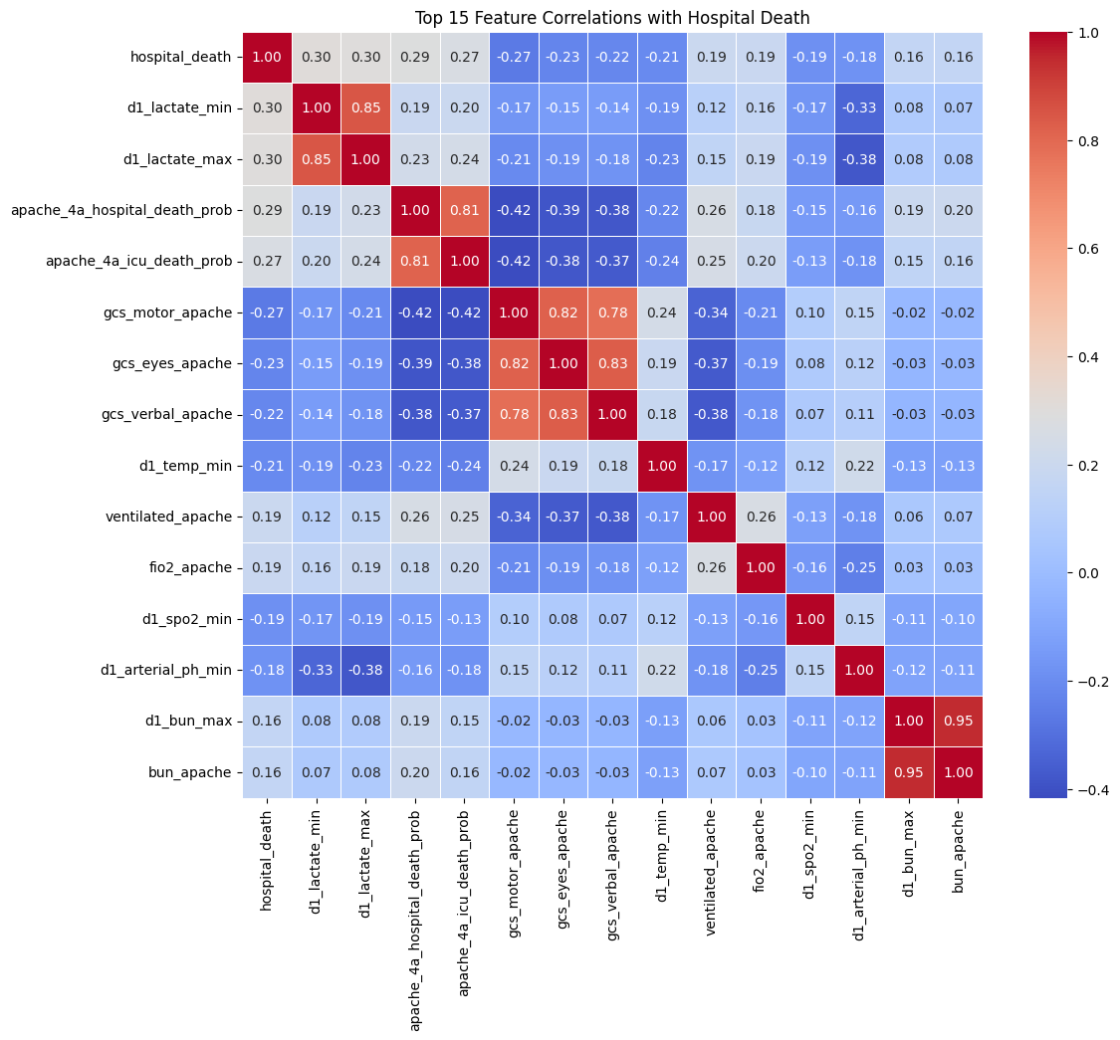
Figure 1: Co-relation Analysis

6.2 Data Understanding
Before doing anything else, we ran some basic checks to understand the data:

1. df.info() — revealed the dataset contains 170 float64 columns, 8 int64 columns, and 8 object (categorical) columns
2. df.describe() — provided a statistical summary including mean, standard deviation, min/max values for all numeric features
3. Missing value identification — the dataset contains significant missing data, typical of real-world clinical records where not all tests are performed for every patient

6.3 Data Cleaning and Preprocessing
Cleaning was important here because clinical data from real hospitals tends to be messy. We did three things:

1. Column name standardization: All column names were stripped of whitespace and converted to lowercase for consistency.
2. Missing value imputation: All numeric columns were filled with their respective column medians using df.fillna(df.median(numeric_only=True)). Median imputation was chosen over mean imputation to avoid the influence of extreme outliers common in clinical data.
3. Post-imputation verification: Confirmed zero remaining missing values after imputation.
4.
5. Figure 2 : Handling missing values

6.4 Target Variable Definition
Two target variables were defined for the multi-output learning problem:

Target Variable | Column Name | Type | Description
Mortality Risk | hospital_death | Classification (Binary) | 1 = Patient died, 0 = Patient survived
Length of Stay | pre_icu_los_days | Regression (Continuous) | Number of days spent in ICU before hospital

6.5 Feature Selection and Encoding
We created the feature matrix X by dropping both target columns. Categorical columns were then encoded using pd.get_dummies() with drop_first=True, which converts them to binary columns and avoids multicollinearity.
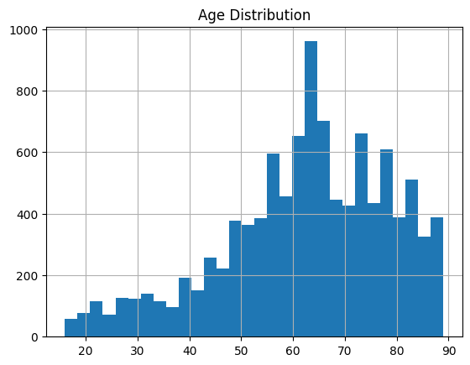
Figure 3 : Feature Selection

6.6 Feature Scaling
We applied StandardScaler to bring all features to zero mean and unit variance. This matters especially for Logistic Regression, which is sensitive to the scale of its inputs.

6.7 Train-Test Split
We split the data 80:20 — around 22,524 for training and 5,632 for testing. random_state=42 was set so the split is consistent and reproducible. The same split was used for both tasks.

6.8 Model Training
We trained three models in total:

1. Logistic Regression (Classification Baseline): A linear model trained to predict the binary mortality outcome. max_iter=1000 was set to ensure convergence given the large feature space.
2. Linear Regression (Regression Baseline): A standard least-squares regression model trained to predict the length of ICU stay in days.
3. Random Forest Classifier (Primary Classification Model): An ensemble of 100 decision trees (n_estimators=100) trained on the classification task. Random Forest was chosen for its robustness to overfitting, ability to handle high-dimensional data, and built-in feature importance scoring.

7. Results and Output

7.1 Classification Results (Mortality Prediction)
We tested the Random Forest on the held-out test set and got these numbers:

Metric | Value | Interpretation
Accuracy | 93.66% | Model correctly classifies 93.66% of patients
ROC-AUC Score | 0.6303 | Model has moderate discriminative ability between survivors and non-survivors

The 93.66% accuracy looks good but is partly inflated by class imbalance — most patients survive, so predicting survival often is an easy shortcut. The ROC-AUC of 0.63 is the more honest number. It's moderate, which is what you'd expect from an untuned baseline. With proper tuning or a better model like XGBoost, this would go up.
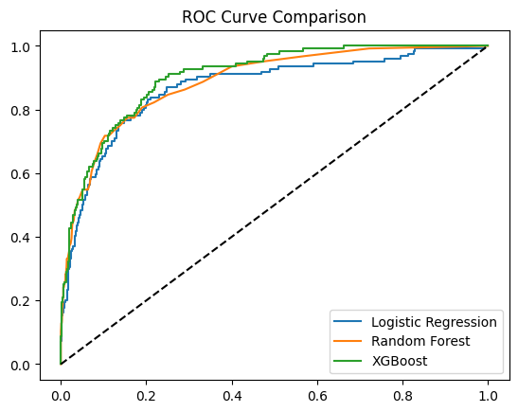
Figure 4 : ROC Curve Comparision

7.2 Regression Results (Length of Stay Prediction)
For the length-of-stay task, we evaluated using RMSE:

Metric | Value | Interpretation
RMSE | 2.13 days | On average, the model's LOS prediction deviates by ~2.13 days from actual

An error of 2.13 days is a reasonable starting point for a baseline. The median ICU stay is around 2-3 days, so there's room to improve, but the model is in the right range. Tree-based regressors like XGBoost would likely cut this down further.

7.3 Feature Importance Analysis
After training, we pulled out the feature importances from the Random Forest to see which variables mattered most. The top 10 are shown in the chart below:
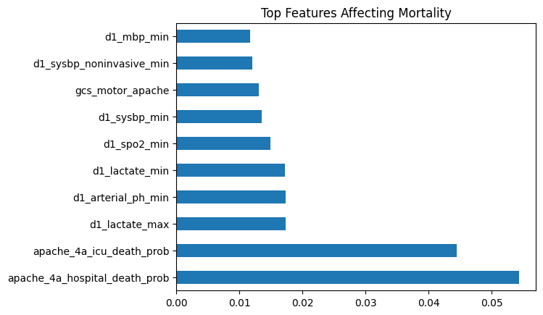
Figure 1: Top 10 Features Affecting ICU Patient Mortality (Random Forest Feature Importance)

A few things stood out from this chart:

a. apache_4a_hospital_death_prob and apache_4a_icu_death_prob are the two strongest predictors, reflecting the established clinical validity of the APACHE-4a severity scoring system.
b. d1_lactate_max and d1_lactate_min (day-1 lactate measurements) are strong metabolic indicators of tissue hypoxia and organ failure — clinically recognized mortality predictors.
c. d1_arterial_ph_min reflects acid-base imbalance, a critical marker in critically ill patients.
d. d1_spo2_min (minimum oxygen saturation on day 1) and d1_sysbp_min (minimum systolic blood pressure) indicate cardiovascular and respiratory compromise.
e. gcs_motor_apache (Glasgow Coma Scale motor score) reflects neurological status, a known mortality predictor in ICU patients.

All of these line up with what clinicians actually look at when assessing ICU patients, which tells us the model is learning real patterns rather than just noise.

8. Conclusion
Overall, this project came together well as a first attempt at multi-output ML on real clinical data. We were able to predict both mortality risk and ICU length of stay from the same set of admission features, which is more useful than predicting just one thing.

The full pipeline — from loading and cleaning the data to training and evaluating models — was run on 28,156 real patient records from 200+ hospitals. The Random Forest hit 93.66% accuracy and ROC-AUC of 0.63 for mortality. Linear Regression got an RMSE of 2.13 days for length of stay.

The feature importance chart was probably the most satisfying part — APACHE scores, lactate, arterial pH, and GCS motor score came out on top, which are exactly the variables doctors use in real ICU assessments. That overlap between what the model learned and what clinicians know gives us confidence the model makes sense.

Doing both tasks together from one feature set is a more realistic setup than most single-output projects, and it's how actual hospital decision support tools tend to work. That made this project more interesting to build and more meaningful to present.

9. Future Scope
If we were to continue working on this, here's what we'd focus on:

1. Advanced Models: Replace Random Forest and Linear Regression with gradient boosting methods (XGBoost, LightGBM) and neural network architectures (shared-layer multi-task networks) that can learn joint representations for both output tasks simultaneously.
2. Hyperparameter Tuning: Apply Grid Search or Bayesian Optimization to tune model parameters such as n_estimators, max_depth, and learning_rate for improved performance.
3. Class Imbalance Handling: Apply SMOTE (Synthetic Minority Over-sampling Technique) or class-weighted training to address the imbalance in the mortality label and improve ROC-AUC.
4. Time-Series Modeling: Extend the pipeline to use hourly vital sign time series (instead of 24-hour aggregates) using LSTM or Transformer architectures for more temporally rich predictions.
5. Explainability with SHAP: Integrate SHAP (SHapley Additive exPlanations) values to provide per-patient, interpretable explanations of model predictions — a clinical requirement for deployment.
6. Clinical Deployment: Package the trained model as a REST API (using Flask or FastAPI) that can accept real-time patient data and return risk predictions for integration into hospital EHR systems.
7. Multi-Dataset Validation: Validate model performance on external ICU datasets such as eICU-CRD or AmsterdamUMCdb to assess generalizability across institutions and geographies.

10. References
[1] Harutyunyan, H., Khachatrian, H., Kale, D. C., & Galstyan, A. (2019). Multitask learning and benchmarking with clinical time series data. Scientific Data, 6(1), 1–18. https://doi.org/10.1038/s41597-019-0103-9

[2] Johnson, A. E. W., Pollard, T. J., Shen, L., et al. (2016). MIMIC-III, a freely accessible critical care database. Scientific Data, 3, 160035. https://doi.org/10.1038/sdata.2016.35

[3] Lee, M., Raffa, J., Ghassemi, M., et al. (2020). WiDS Datathon 2020: ICU Mortality Prediction. PhysioNet. https://doi.org/10.13026/vc0e-th79

[4] Wang, S., McDermott, M. B. A., Chauhan, G., et al. (2020). MIMIC-Extract: A data extraction, preprocessing, and representation pipeline for MIMIC-III. In ACM CHIL 2020. https://doi.org/10.1145/3368555.3384469

[5] Purushotham, S., Meng, C., Che, Z., & Liu, Y. (2018). Benchmarking deep learning models on MIMIC-III. Journal of Biomedical Informatics, 83, 112–134.

[6] Pedregosa, F., Varoquaux, G., Gramfort, A., et al. (2011). Scikit-learn: Machine Learning in Python. Journal of Machine Learning Research, 12, 2825–2830.

[7] Kaggle Dataset — In-Hospital Mortality Prediction: https://www.kaggle.com/datasets/saurabhshahane/in-hospital-mortality-prediction

[8] Breiman, L. (2001). Random Forests. Machine Learning, 45(1), 5–32.

