JavaScript physical models

Table of Contents

1. Purpose 3
2. physical topics 3
2.1. Addition of forces by an angle 3
2.2. Archimedes' Law 3
2.3. Mathematical Pendulum 4
3. Features of the project 4
3.1. CSS styles 4
3.2. The HTML pages 5
4. JavaScript code 6
4.1. Physical appliances 6
4.1.1. Arrow dynamometer 6
4.1.2. Spring 9
4.1.3. Ruler 10
4.1.4. Spring dynamometer 11
4.2. Stage items 13
4.3. JavaScript physics models 14
4.3.1. “Addition of forces by an angle” model 14
4.3.2. “Archimedes' Law” model 15
4.3.3. “Mathematical Pendulum” model 16

Purpose
The project is JavaScript, HTML based application to demonstrate physical computer models, i.e. to simulate physical experiments, processes or idealized model situations encountered in the physical tasks. Here are covered three subjects “Addition of forces by an angle” from the “Dynamics” chapter of physics, “Archimedes’ Principle” from the chapter “Pressure of liquids” and “Mathematical pendulum” from the chapter ”Mechanical oscillations”.

physical topics

Addition of forces by an angle
A force is a push or pull upon an object resulting from the object's interaction with another object. In the International System of Units (SI) unit of force is the newton (N). It is a vector quantity. We can add or subtract forces. Resultant force is the combination of two or more forces, it produces the same acceleration as all those forces.
In the simple case in which an object is subject to two forces that act in the same direction, the resultant has the magnitude equal to the sum of the two magnitudes 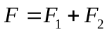
3N
4N
Resultant Force 7N
Graphically, the resultant force of two forces applied by an angle can be found by using the parallelogram rule:
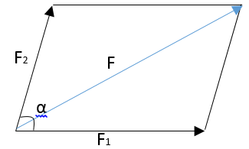
The resultant force is: 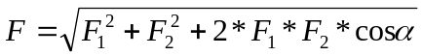. If the force F1 equals to the force F2, then they can be found by the equation: 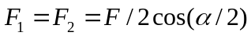

Archimedes' Law
Archimedes' principle states that the buoyant force on a submerged object is equal to the weight of the fluid that is displaced by the object. The force, which acts downward on an object, is the weight of an object. If the buoyant force is more than the weight, the object rises, if it is less, the object sinks. If the buoyant force is equal to the weight, then an object stays put
The buoyant force can be expressed as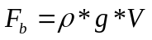, where is the density of fluid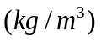, g is the acceleration of gravity 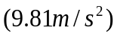, V is the volume of body 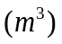. Volume of body is found by the equation 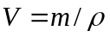, where is the density of body, m is the weight of body.
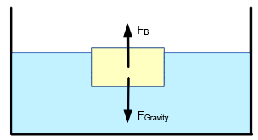

Mathematical Pendulum
A mathematical pendulum is a material point (a small body) that is suspended on a thin weightless inextensible string or on a weightless rod. The period of the motion for a pendulum is how long it takes to swing back-and-forth and measured in seconds
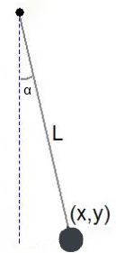
The equation for the period of a simple pendulum starting at an angle α is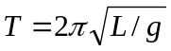, where L is the length of the rod, g is the acceleration of gravity
The frequency of a pendulum is how many back-and-forth swings there are in a second, measured in hertz. The equation for the frequency is 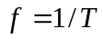

Features of the project

CSS styles
In the folder “css” are located Cascading Style Sheets. In this folder “controls.css" contains styles regarding input elements, buttons, labels. The file “main.css" contains styles for the “main.html” page, “menu.css" contains styles for building menin on the main page and “variables.css” file contains global CSS variables of the project.

The HTML pages
The project consists of several HTML pages with pure JavaScript coding. The main page is “main.html” in the root of project. It contains main the main menu, which is made out of DIV elements and IFRAME element to load content of each topic of physics.
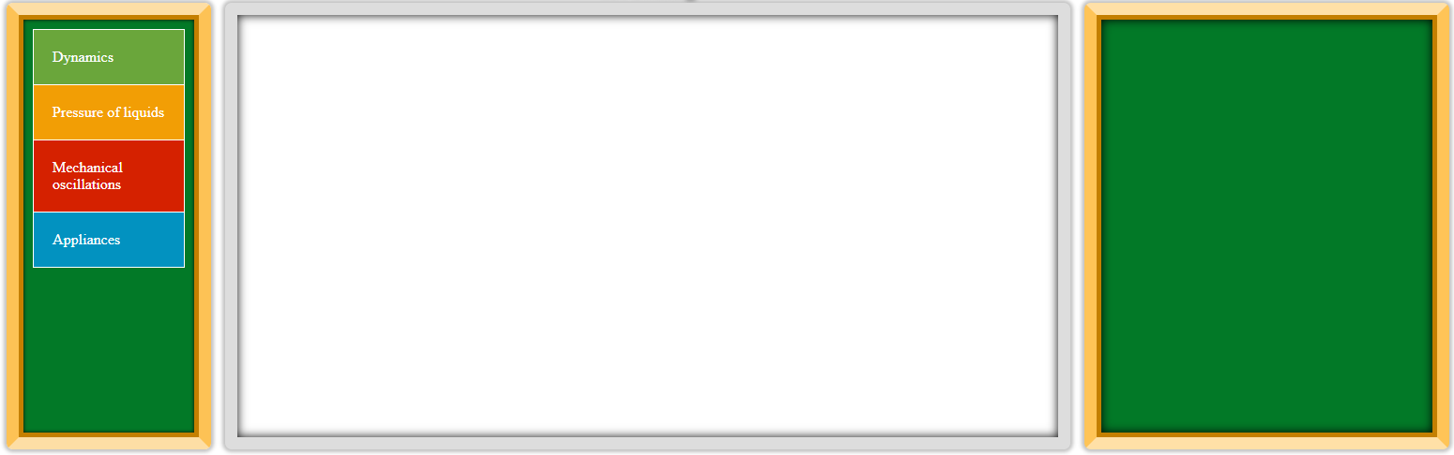
The folder “BoardArea” contains HTML pages to loading into the Iframe on the main page.
The folder "./BoardArea/Forces/ForcesByAngle.html" allows user to change variables for the topic “Addition of forces by an angle”.
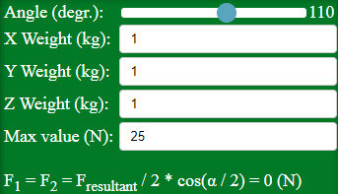
The folder "./BoardArea/FluidMechanics/ArchimedesPrinciple.html" allows user to manipulate by variables for the topic “Archimedes’ Principle”.
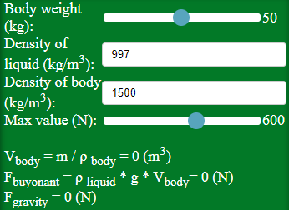
Though the page "./BoardArea/MechanicalOscillations/Pendulum.html" user can manipulate by variables for the topic “Mathematical pendulum”.
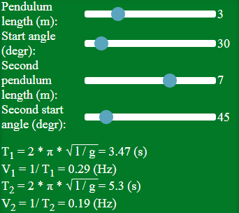

JavaScript code
All JS code scripts are located in the folder "./js”. The JS code for the main page is located in the "./js/main.js" folder.
Here you can find JS code "./js/appMethods.js", this file contains methods and variables, which are used across all application
In this file constant application consists of common methods and variables
const application = {
arcPath: (2 * Math.PI),
degrToRad: (degrees) => (Math.PI / 180) * degrees,
…
}
Constant contextLayout consists of methods concerning canvas, context and drawing on canvas methods
const contextLayout = {
clearCanvas: function (canvas) {
let context = canvas.getContext("2d");
context.clearRect(0, 0, canvas.width, canvas.height);
}
…
}
In the file "./js/dragging.js" is constant dragRendering to create dragging of different canvas drawn objects
const dragRendering = {

canvas: undefined,
dragElements: [{ id: undefined, isDraggable : true, elem: undefined }],
…
}

Physical appliances
To show demonstrations the project uses some physical appliances from the world of physics, such as dynamometer, ruler, spring and movable on the stage items. JavaScript code for their creation is located in the folder "./js/Tools/".

Arrow dynamometer
To create arrow dynamometer are used two canvas drawn objects Appliance and Dynamometer.
The code for creation of class Appliance is located in the file "./js/Tools/appliance.js". The class allows changing it’s properties like center coordinates, it’s radius, rotation of object on canvas around it’s center point and colors of object’s elements.
function Appliance(options = {}) {

// default values for the appliance
Object.assign(this, {
centerX: 0, // X center coordinate
centerY: 0, // Y center coordinate
radius: 50,
angle: 0, // rotation angle around center point
ringColor: "#5f5f5f",
backRingColor: "#e9e9e9",
innerRingColor: "#7e7e7e",
pointerColor: "#d95358",// color of arrow pointer
canvas: undefined
}, options);
…
The draw this appliance on canvas there is a method draw, the second method is drawPointer, which allows drawing arrow pointer with required width and angle.
Appliance.prototype = {
draw : function () {
…
}
drawPointer : function (angle = 0, arcWidth = 10) {
…
}
}

The example how to draw appliance on canvas is shown below.
let appliance = new Appliance({
centerX: 600,
centerY: 300,
radius: 100,
angle: 45,
ringColor: "red",
backRingColor: "yellow",
innerRingColor: "green",
pointerColor: "#d95358",
canvas: this.canvas
});

appliance.draw();
appliance.drawPointer(45);

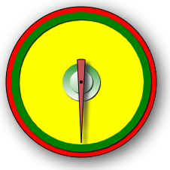
The code for creation of class Dynamometer is located in the file "./js/Tools/ dynamometer.js". The class inherits from the class Appliance. You can apply additional properties for Dynamometer, like maximum drawn value on it, current value and speed of rotation of an arrow.
function Dynamometer(options) {

// inheritance from Appliance
Appliance.call(this, options);

// default values for Dynamometer
Object.assign(this, {
maxValue: 10, // maximum possible value of dynamometer
value: 0, // current value of dynamometer
rotateStep : undefined // speed of rotation of arrow
}, options);
…
}
Dynamometer.prototype = Object.create(Appliance.prototype);
Dynamometer.prototype.constructor = Dynamometer;

To draw this dynamometer on canvas there is a method draw. The second method is setStaticValue, which allows drawing arrow pointer for applied value. The method setValue allows drawing arrow pointer for applied value with animation.
Dynamometer.prototype = {
/**
* draws entire Dynamometer
*/
draw: function () {
…
},

/**
* sets arrow indicator to value without animation
*/
setStaticValue: function (valuePointer = 0) {
…
}, // setStaticValue

/**
* sets arrow indicator to value with animation
*/
setValue: async function (valuePointer = 0) {
…
}
}
The function setValue is asynchronous and returns promise. The example how to draw dynamometer on canvas is shown below.
let dynamometer = new Dynamometer({
centerX: 250,
centerY: 300,
radius: 100,
ringColor: "red",
backRingColor: "yellow",
canvas: this.canvas,
angle: 45,
maxValue: 20
});

dynamometer.draw();
dynamometer.setStaticValue(-3);
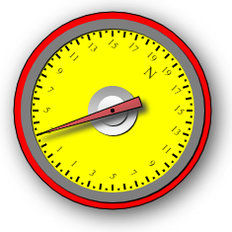

Spring
Spring is a canvas drawn sine wave. The code for creation of class Spring is located in the file "./js/Tools/ spring.js". The class allows changing its properties like start coordinates, radius of sine wave, rotation of object on canvas around its upper left point, colors of front, back swings, number of swings
function Spring(options = {}) {
// default values for the spring
Object.assign(this, {
canvas: undefined,
swingFrontColor: "lightGray", // color of front swing
swingBackColor: "gray",// color to simulate back swing
startX: 0, // star X coordinate of spring
startY: 0,// star Y coordinate of spring
length: 100, // length of spring
radius: 50, // radius of sine wave
swings: 5, // number of swings
angle: 0, // rotation angle relatively of upper left corner
swingWidth: 3 // width of each swing
}, options);
}

The draw spring on canvas there is a prototype method draw. The method draws several required sine waves in period between 0 degrees and 360 degrees
The example how to draw spring on canvas is shown below.
let spring = new Spring({
radius: 30,
startX: 200,
startY: 150,
length : 200,
canvas: this.canvas,
swings : 20
});

spring.draw();

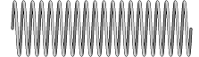

Ruler
The class to draw ruler on canvas is located in the folder "./js/Tools/ ruler.js". It is possible to apply many properties for ruler, like start coordinates length, height, rotation of object on canvas around its upper left point, colors of background and stroke etc.
function Ruler(options = {}) {
// default values for ruler
Object.assign(this, {
canvas: undefined,
startX: 0, // star X coordinate of ruler
startY: 0, // star Y coordinate of ruler
length: 200,
height: 50,
maxValue: 10, // max ruler value
backColor: "orange", // background color of ruler
strokeColor: "black",
showBackground: true, //shows/hides background of ruler
showBottom: true, //shows/hides bottom ruler lines
angle: 0, // rotation angle relatively of upper left corner
}, options);

}

The draw ruler on canvas there is a prototype method draw. The example how to draw ruler on canvas is shown below.
let ruler = new Ruler({
startX: 200,
startY: 50,
canvas: this.canvas,
length: 500,
height: 60,
strokeColor: "black",
maxValue: 500
});

ruler.draw();

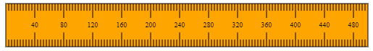

Spring dynamometer
Canvas drawn spring dynamometer class consists of several elements: the class Ruler, the class Spring, the class Hook. The class is located in the folder "./js/Tools/ springDynamometer.js".
function SpringDynamometer(options = {}) {
// default values for the ruler
Object.assign(this, {
canvas: undefined,
startX: 0, // left top start X coordinate of spring dynamometer
startY: 0, // // left top start Y coordinate of spring dynamometer
length: 200,
height: 50,
maxValue: 10, // maximum possible value of spring dynamometer
backColor: "orange",
strokeColor: "black",
angle: 0, // rotation angle relatively of upper left corner
animatedHolder: false, // are holder and hook animated
value: 0, // current value of spring dynamometer
animationStep: undefined // speed of animation of arrow
}, options);
…
}
The prototype of SpringDynamometer has three functions: To draw this dynamometer on canvas there is a method draw, which draws entire dynamometer on canvas, setStaticValue, which sets drawn indicator for applied value, setValue, which animates drawn indicator for applied value. The method setValue is asynchronous and returns promise.
SpringDynamometer.prototype = {
/**
* draws entire Spring Dynamometer
*/
draw: function () {
…
}

/**
* sets spring indicator to value without animation
*/
setStaticValue: function (valuePointer = 0) {
…
}

/**
* sets spring indicator to value with animation
*/
setValue: async function (valuePointer = 0) {
…
}
}
Also the class SpringDynamometer has the method, which can be called during value changing :
// function to call during value changing
this.valueOnChange = function (value) { }

The example how to draw dynamometer on canvas is shown below.
let springDynamometer = new SpringDynamometer({
startX: 100,
startY: 50,
canvas: this.canvas,
angle: 90,
length: 400,
height: 60,
strokeColor: "black",
value: 0,
animatedHolder: true,
maxValue: 50
});

springDynamometer.draw();
springDynamometer.setValue(30).then(function () {
springDynamometer.setValue(0);
});
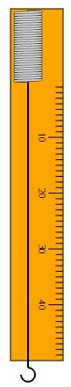

Stage items
Time to time physics experiments require to suspend different items onto physical contraptions. There is special class for this purpose StageItem from the folder "./js/Tools/ stageElements.js". ". It has properties, like start coordinates, width, height, colors of background and stroke etc.
/**
* Canvas drawn object for physics experiments like cargo, brick etc.
*/
function StageItem(options = {}) {

/**
* default values for an item
*/
Object.assign(this, {
x: 0, // left top start X coordinate of item
y: 0, // left top start Y coordinate of item
width: 40, // width of item in pixels
height: 40, // height of item in pixels
fill: "#7aa7ca", // background color of item
strokeColor: "black", // stroke color of item
weight: 1, // weight of item ( can be kg, g, pound etc.)
itemText: "item", // text on item
lineWidth: 2, // stroke width of item
canvas: undefined,
}, options);
…
}

From this class derive two additional classes to draw cargo on canvas and to draw cargo ball on canvas

/**
* Canvas drawn brick object
*/
function Brick(options) {

// inheritance from StageItem
StageItem.call(this, options);

// default values for Brick
Object.assign(this, {
roundRadius: 5, // round roudius of rectangle
},
options);

}// Brick

Brick.prototype = Object.create(StageItem.prototype);
Brick.prototype.constructor = Brick;

/**
* Canvas drawn ball object
*/
function Ball(options) {

// inheritance from StageItem
StageItem.call(this, options);

// default values for Ball
Object.assign(this, options);

}// Ball

Ball.prototype = Object.create(StageItem.prototype);
Ball.prototype.constructor = Ball;

These two classes have prototype method draw. Drawing of brick on canvas is shown below.
let brick = new Brick({
x: 450,
y: 130,
width: 40,
height: 40,
fill: "LightGray",
strokeColor: "black",
itemText: "Brick",
lineWidth: 2,
canvas: this.canvas,
});

brick.draw();

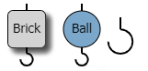

JavaScript physics models
To create models of physical experiments there are three JavaScript files "./js/topicsRender/forcesbyAngleRender.js" , "./js/topicsRender/archimedesPrincipleRender.js" , "./js/topicsRender/pendulumRender.js" for topics “Addition of forces by an angle”, “Archimedes' Law” and “Mathematical Pendulum” respectively.
All models are used on the main page in the constant applicationRendering in the file "./js/main.js".

“Addition of forces by an angle” model
Constant forcesbyAngleDemo from the file "forcesbyAngleRender.js" applies two dynamometers, which can be placed by some angle and three bricks, which can be dragged and suspended under the dynamometers to the thread. Through changing parameters of bricks’ weight and angle between dynameters user can calculate total force applied to dynamometers.
const forcesbyAngleDemo = {
dynamometers: undefined,
canvas: undefined,
ctx: undefined,
…
init: function () {
…
}
}
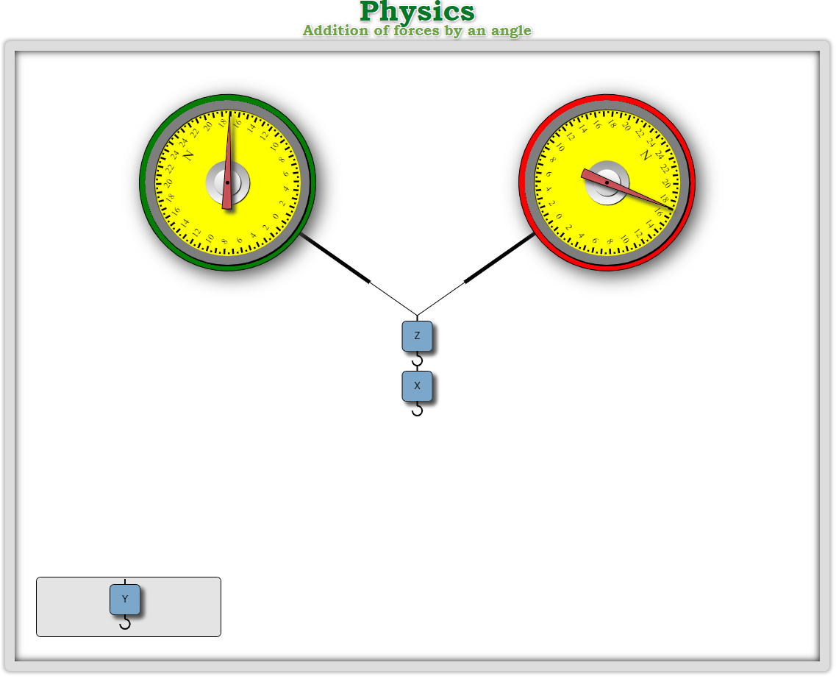

“Archimedes' Law” model
Constant archimedesPrincipleDemo from the file " archimedesPrincipleRender.js" applies one spring dynamometer and one brick, which can be dragged and suspended under the dynamometer to the thread. After suspending the brick, the dynamometer moves towards the box with liquid to show buoyant force applied to it. User is allowed to change brick’s weight, its density and density of liquid to calculate force applied to the dynamometer.
const archimedesPrincipleDemo = {
dynamometer: undefined,
canvas: undefined,
ctx: undefined,
cancelTimer: false,
…
init: function () {
…
},
…
}
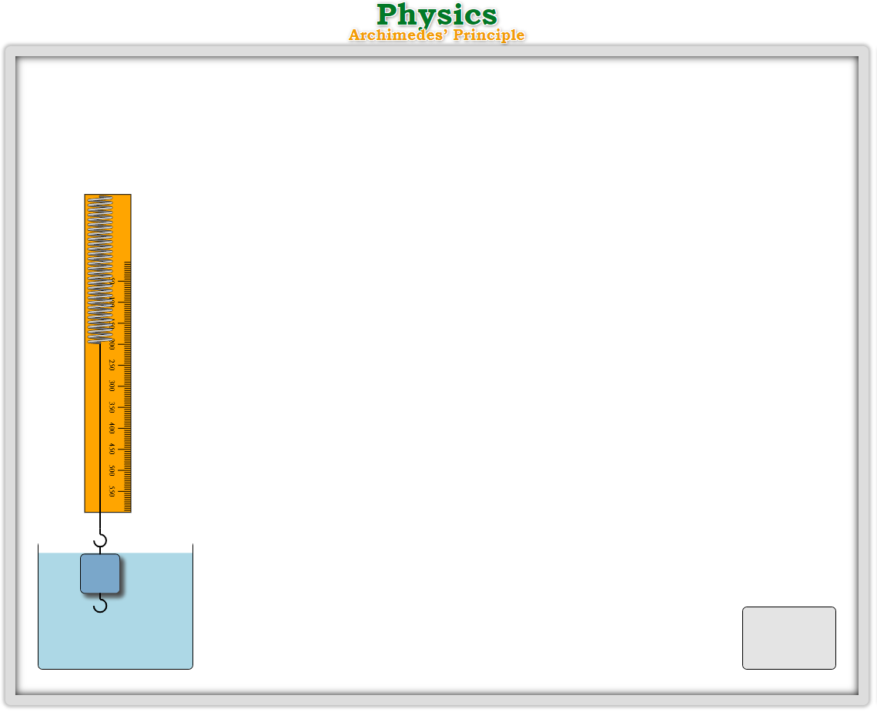

“Mathematical Pendulum” model
Constant pendulumDemo from the file " pendulumRender.js" draws on canvas two animated pendulums.
Parameters for applying their period can be changed by user
const pendulumDemo = {
canvas: undefined,
ctx: undefined,
cancelTimer: false,
timer: undefined,
…
init: function () {
this.applySettings();
},

drawPendulum: function (xCoord, yCoord, ballColor) {
…
}
…
}
