Top of Form

|  |
| --- |
|  |

Bottom of Form

**Assingnment No: B3**

**Title:**Simulation of WAN (RIP) using packet tracer/Network Simulator 3 (NS3)or higher equivalent.

**Roll NO:**

**Batch:**

[**[ns-3] Installing and Testing ns-3 with NetAnim on Ubuntu 14.04**](http://mohittahiliani.blogspot.in/2014/08/ns-3-installing-and-testing-ns-3-on.html)

|  |  |
| --- | --- |
| Reactions: |  |

This post describes a step-by-step procedure to download, install and test *ns-*3 with NetAnim on Ubuntu 14.04 LTS.  
  
*ns-*3 version considered: **ns-allinone-3.21**  
  
**List of Prerequisite Packages to be installed:**  
1. gcc  
2. g++  
3. python  
4. python-dev (Optional: If you want to use Python as the main language for network configuration)  
5. mercurial (Optional: If you choose Method 2 (explained below) for downloading and installing *ns-*3)  
6. qt4-dev-tools (Optional: If you want to install *NetAnim* (animator for *ns-*3) along with *ns-*3)  
7. tcpdump (Optional: Required for analyzing packet capture files (.pcap) generated by *ns-*3)  
8. wireshark (Optional: Alternative to tcpdump. You can use anyone of these)  
9. gnuplot (Optional: Required for plotting high quality graphs through *.dat* files generated by *ns-*3)  
  
**Installing Prerequisite Packages:**  
Give the following command to install the above mentioned packages:  
  
**sudo apt-get install gcc g++ python python-dev mercurial qt4-dev-tools tcpdumpwiresharkgnuplot**  
  
You may remove the optional package's name from the above command if it is not required!  
  
**Downloading *ns-*3:**  
*ns-*3 can be downloaded in at least two different ways [1]:  
  
**Method 1 (Recommended for beginners):** Downloading a *ns-*3 tarball i.e., a zipped folder (We follow this method here)  
  
Go to following link to download ns-allinone-3.20 tarball:  
  
<https://www.nsnam.org/release/ns-allinone-3.20.tar.bz2>  
  
For older versions of *ns-*3, you can download the tarball from the following link:  
  
<http://www.nsnam.org/releases/older/>  
  
**Method 2:** Downloading through *bake*  
  
You need to have packages 4 and 5 from the list shown above to download *ns-*3 using bake. Once the prerequisite packages are installed, follow the instructions given on [1] to download *ns-*3:  
  
**Installing *ns-*3 and NetAnim:**  
*ns-*3 can be installed in three different ways [2]:  
  
Method 1: by using build.py (We follow this method in this post)   
Method 2: by using bake   
Method 3: by using Waf  
  
For Method 2 and Method 3 of installation, follow [2].

After you have followed Method 1 for downloading ns-allinone-3.20 tarball, you may keep your downloaded tarball on the Desktop and then follow the steps given below to install it:

**NOTE:** NetAnim (the animator for *ns-*3) package comes bundled in ns-allinone-3.xx tarball. So if you want to install *NetAnim* along with ns-allinone-3.20, then install **qt4-dev-tools** packagebefore you proceed to the next steps because when you try to install ns-allinone-3.xx package, it first tries to install NetAnim. It searches for qt4-dev-tools package and if it is not found - NetAnim installation will be skipped! Alternatively, you can also choose to install NetAnim later via apt-get

Step 1: Go to Desktop via terminal and unzip the ns-allinone-3.20.tar.bz2 tarball  
  
**cd Desktop**  
  
**tar xjf ns-allinone-3.20.tar.bz2**  
  
Step 2: Go in ns-allinone-3.20 folder and give the following command for installation:  
  
**./build.py --enable-examples --enable-tests**  
  
After a while, you may see the following message  
  
**Leaving directory './ns-3.20'**  
  
which indicates that *ns-*3 is installed !!!  
  
**Testing *ns-*3:**  
To test whether all modules of *ns-*3 are installed successfully, follow the procedure as given below:  
  
Step 1: Go to ns-allinone-3.20/ns-3.20 folder and give the following directory:  
  
**./test.py -c core**  
  
Some tests may be skipped while testing but that should not bother you if your module is not among those that were skipped!  
  
**Testing NetAnim (only for those users who installed qt4-dev-tools package before *ns-*3 installation):**  
To test whether NetAnim is installed successfully, follow the procedure given below:  
  
Step 1: Go to ns-allinone-3.20/netanim-3.105 and give the following command:  
  
**./NetAnim**  
  
A window as shown below should open:

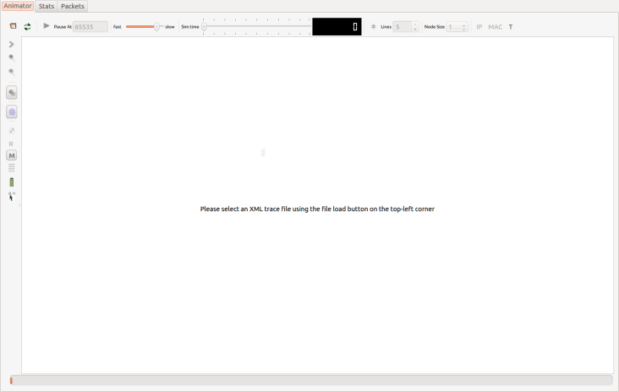

[Click on the Image to enlarge]

You are done with it!

OUTPUT: third.cc

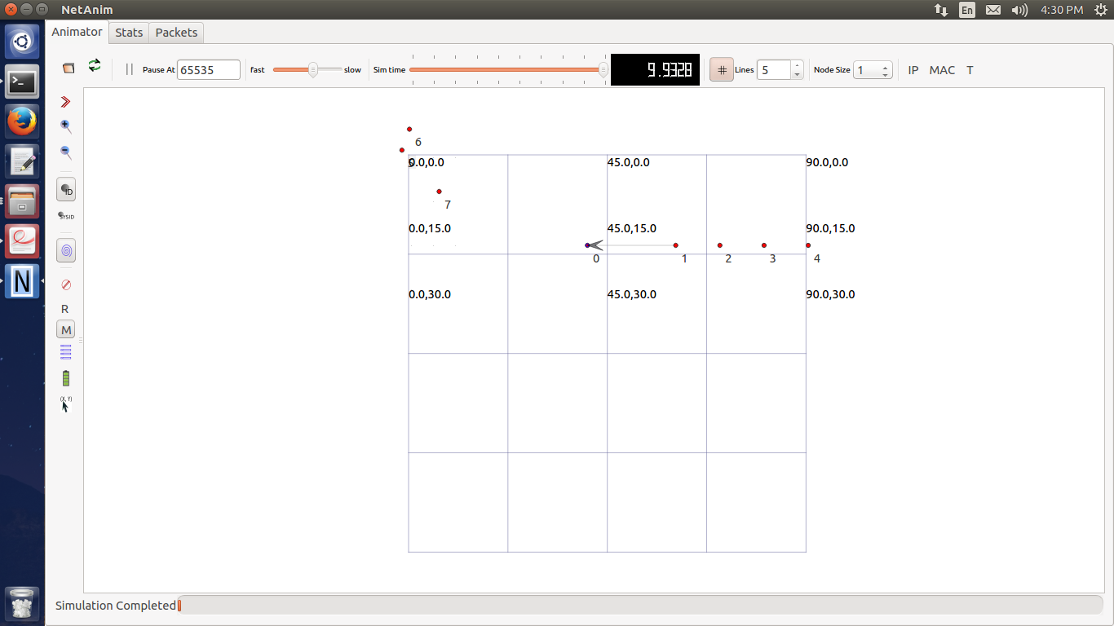

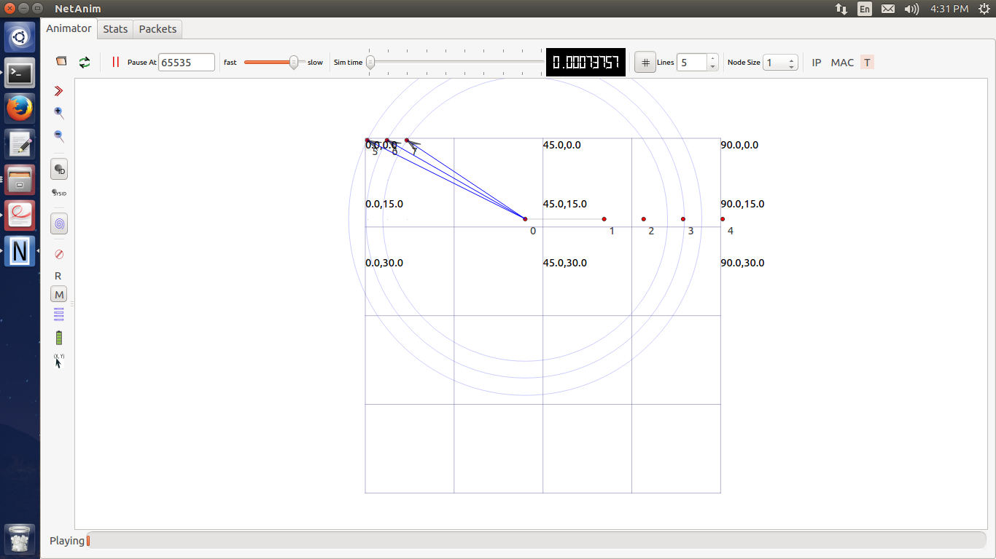

**Conclusion:**

Hence in this way we studied how to install NS3 on ubuntu operating system and implement sample program.