QUESTION NO 1.
In drupal by default we have bartik theme
here we have to create html.html.twig in own custom theme

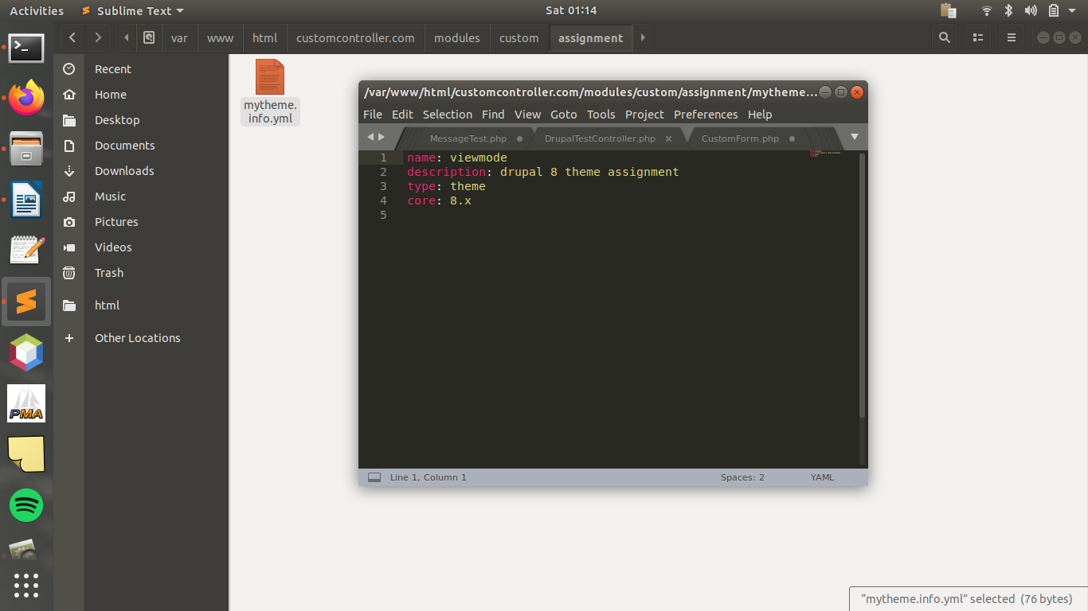
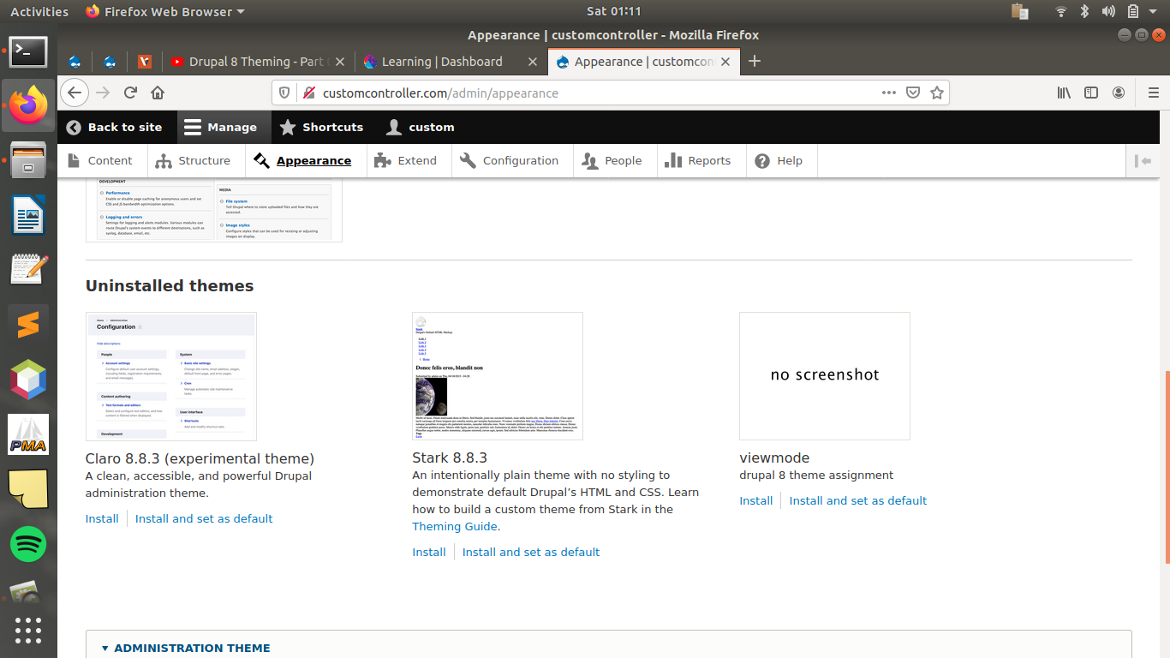
CUSTOM THEME CREATED (VIEWMODE)

NOW AS PER THE QUESTION CREATED HTML.HTML.TWIG IN MY CUSTOM THEME

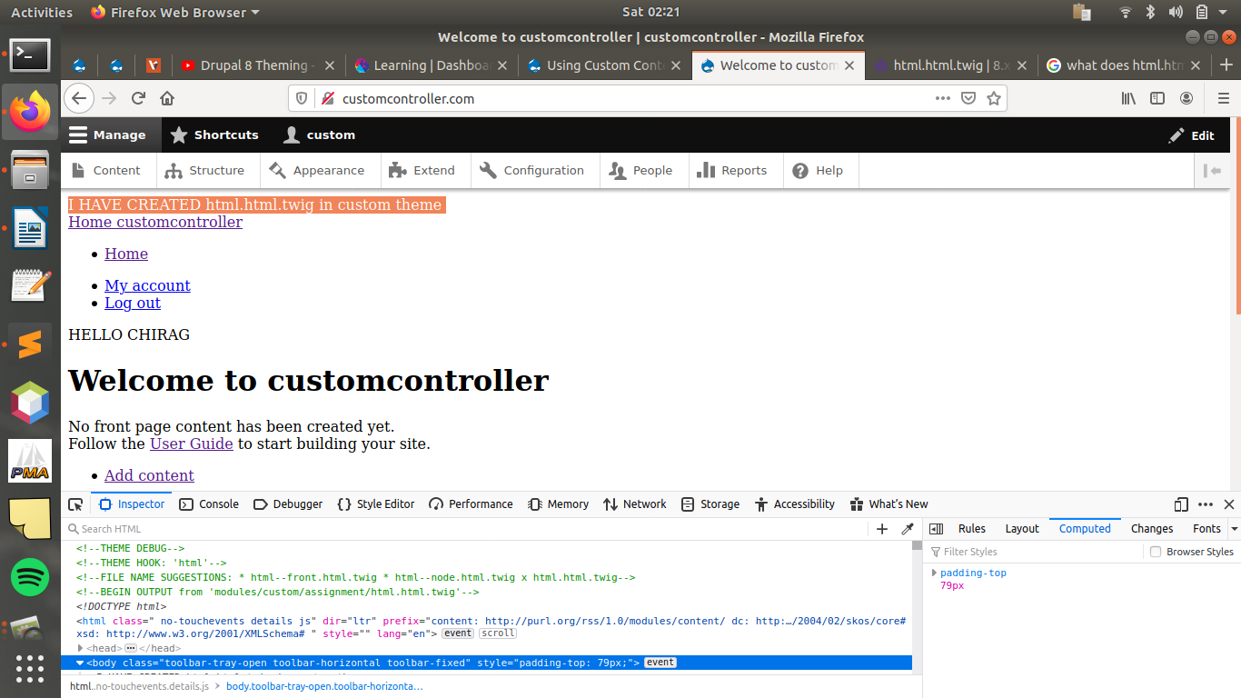

QUESTION NO 2.

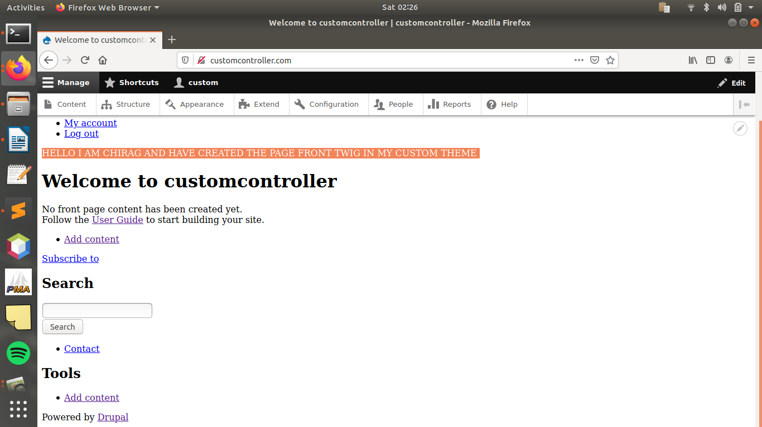

QUESTION NO 3.

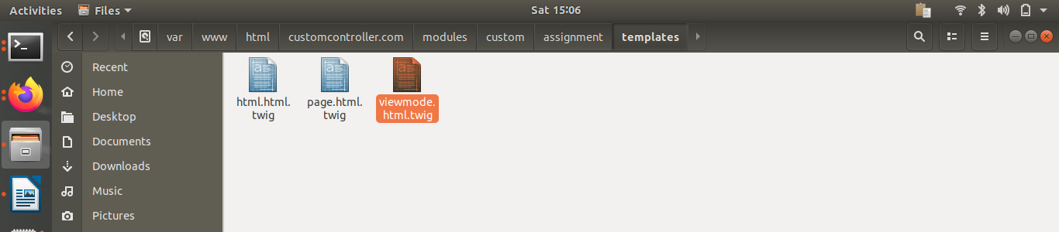
RENAME WITH THE VIEW

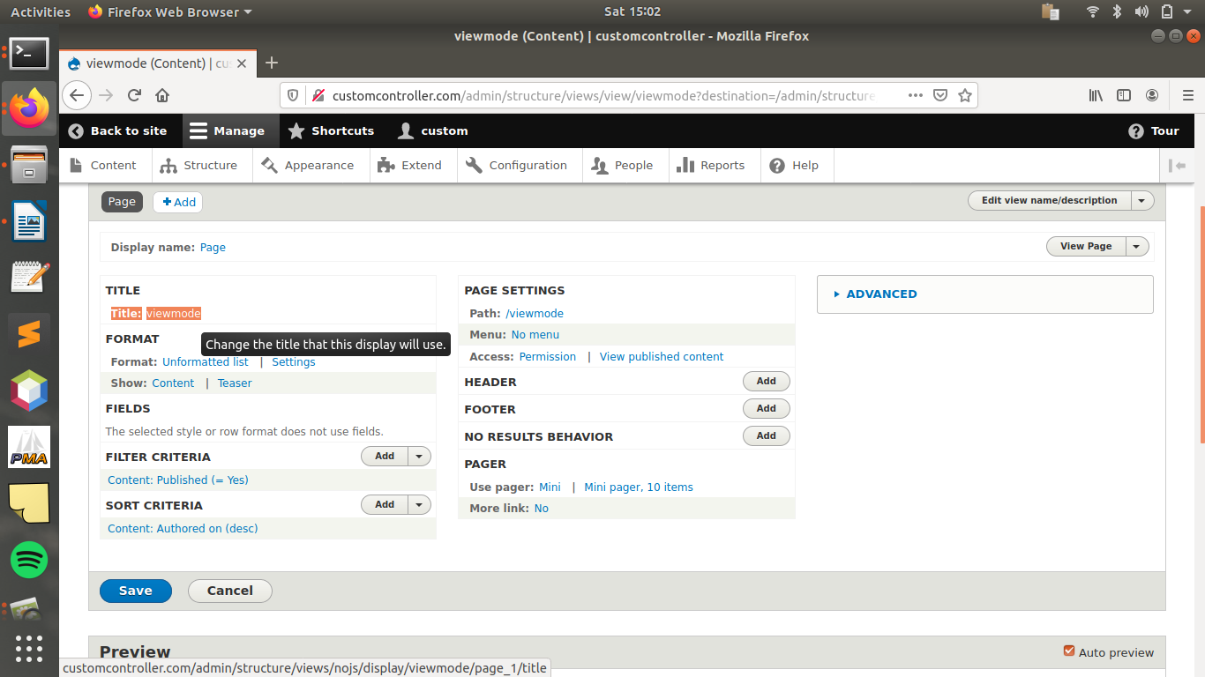
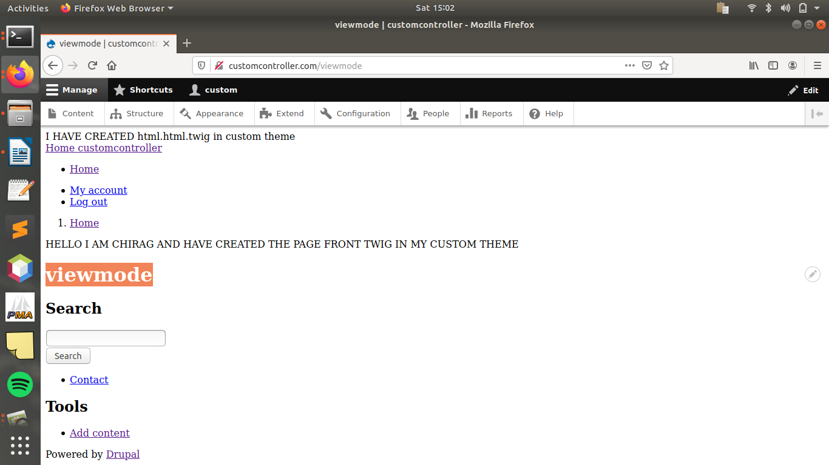
QUESTION NO 4.
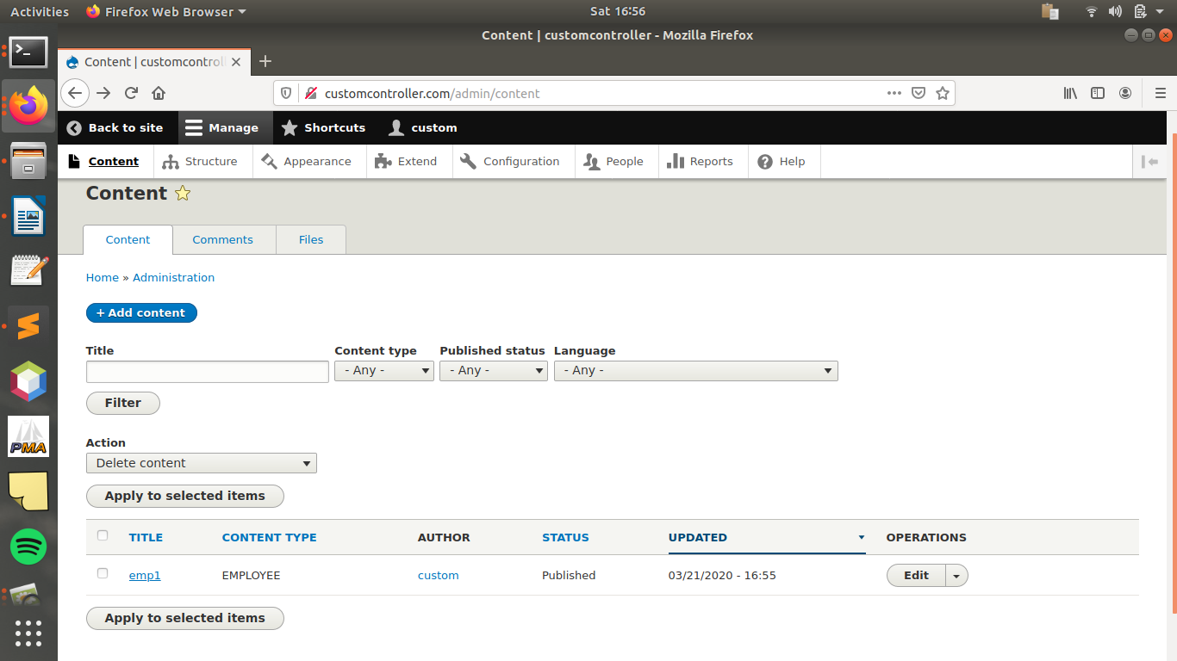
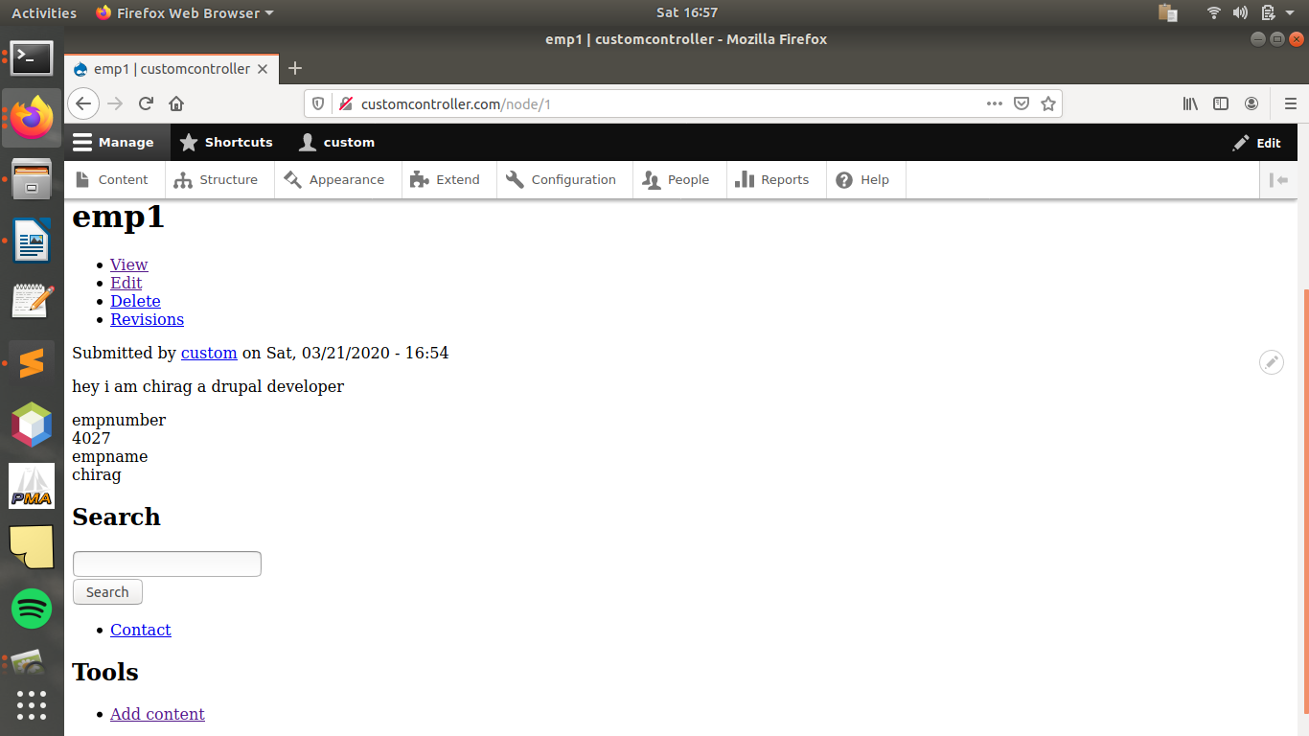
QUESTION NO 5.
FIELDS
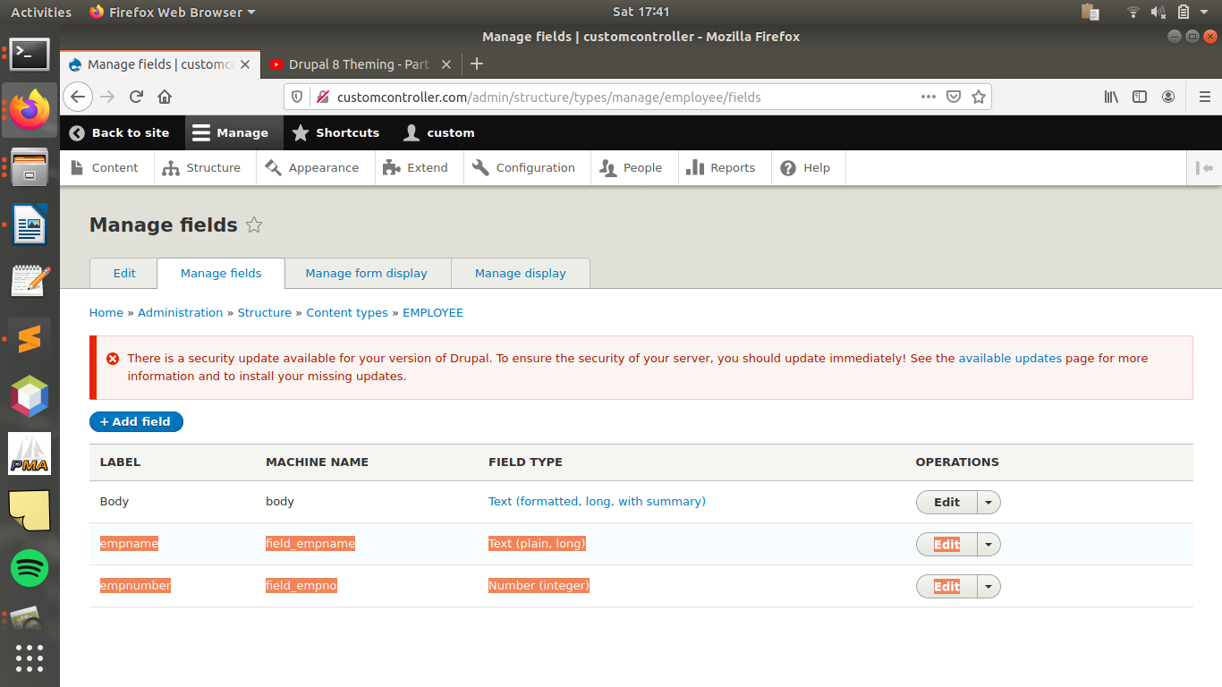
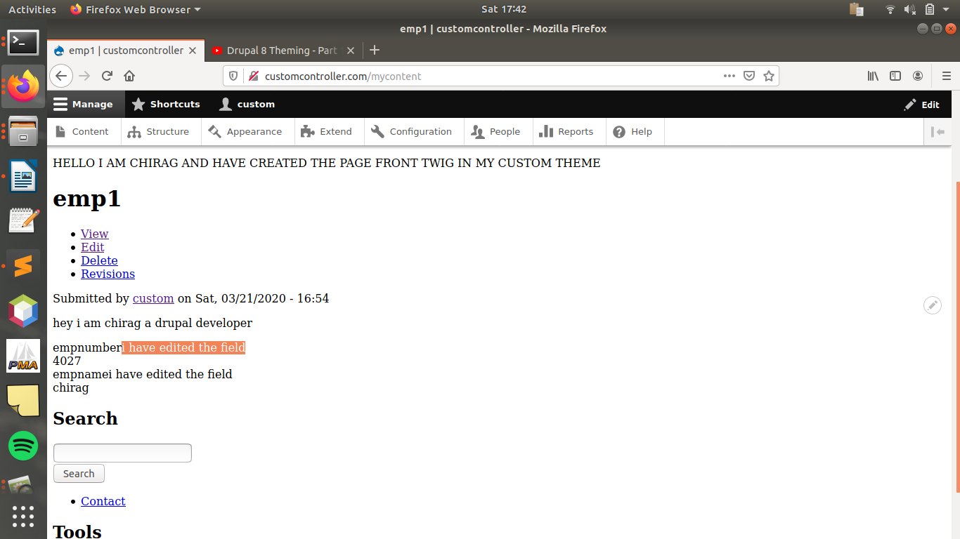
QUESTION NO 6.
SPECIFIC NODE ID TWIG

we have created a specific node id for view mycontent

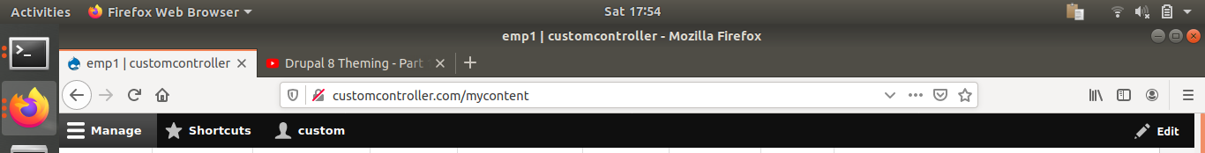

now for this we can add a twig by naming the mycontent.twig.html
and make changes to particular node

QUESTION NO 7.(DB)
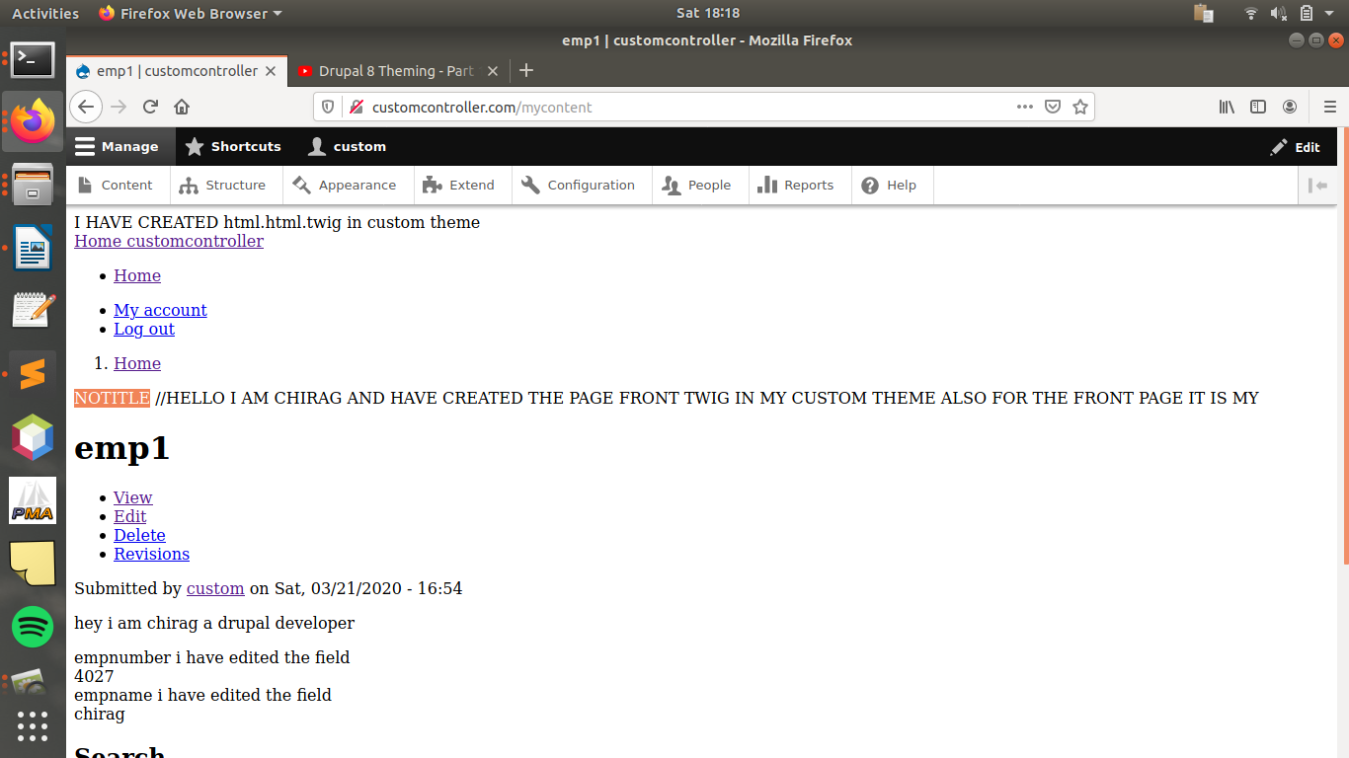
QUESTION NO 8.(DB)
