# How to prevent browser caching on OBIEE client side

It's a short story why I always use HTTP Server in my OBIEE installations.

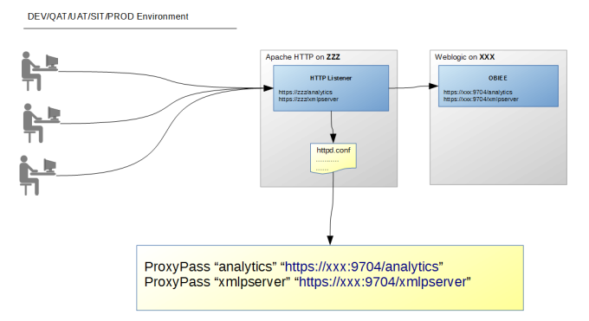

I spent some time last week looking into a bug in the browser cache. The symptoms of this bug are as follows: users can see irrelevant data on dashboards, and F5 isn't working to refresh data on the dashboard.

There is a workaround to fix this problem, you need to do the following steps:

1. Close browser
2. Open browser and clear browser cache
3. Reopen dashboard

After a short investigation, I found out that it happens because OBIEE default settings allow storing temporary data on client side. To avoid it we need to disable client side caching. I tried to find a solution in official documentation but I didn't find it. Instead of this, I have found a blog post http://cristian.sulea.net/blog.php?p=2014-01-14-disable-browser-caching-with-meta-html-tags with the common solution for such bugs. So it can be done by setting the following HTTP request headers:

Cache-Control: no-cache, no-store, must-revalidate

Pragma: no-cache

Expires: 0

I have checked HTTP headers default value and figure out that it includes only the following values:

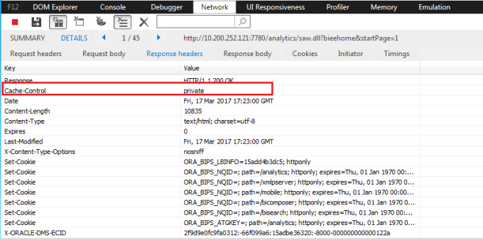

I wanted to change these settings but it seems it impossible to configure it on OBIEE or Weblogic level. But as I mentioned before, I recommend to use Apache HTTP Server in front of Weblogic Server, thus you can configure Apache HTTP Server to do that using hppd.conf file.

As additional benefits, you can configure the Apache HTTP Server to serve static content, single sign-on, clustered deployment, and high availability enhance.

Just add the code "Header set ..." to your httpd.conf file and restart Apache HTTP Server.

Please find below the working example from my httpd.conf file.

LoadModule proxy_module modules/mod_proxy.so

LoadModule proxy_http_module modules/mod_proxy_http.so

LoadModule headers_module modules/mod_headers.so

<VirtualHost *:80>

<Location /analytics>

ProxyPass http://servername:port/analytics

ProxyPassReverse http://servername:port/analytics

<IfModule mod_headers.c>

Header set Cache-Control "max-age=0, no-cache, no-store, must-revalidate"

Header set Pragma "no-cache"

Header set Expires "01 Jan 1990 00:00:00 GMT"

</IfModule>

</Location>

<Location /xmlpserver>

ProxyPass http://servername:port/xmlpserver

ProxyPassReverse http://servername:port/xmlpserver

<IfModule mod_headers.c>

Header set Cache-Control "max-age=0, no-cache, no-store, must-revalidate"

Header set Pragma "no-cache"

Header set Expires "01 Jan 1990 00:00:00 GMT"

</IfModule>

</Location>

</VirtualHost>

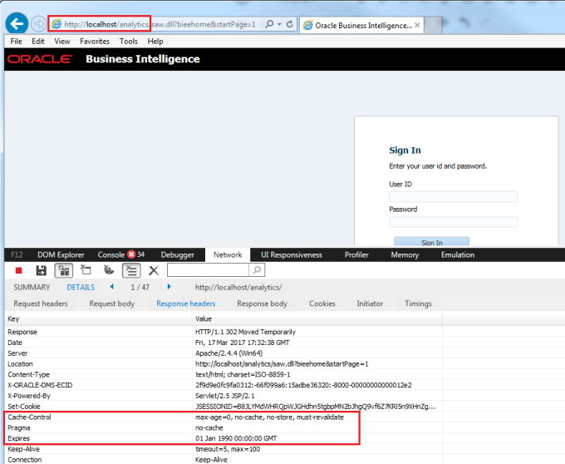

And that's about it. Until next time. ))