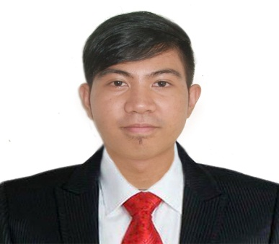

**Name:** John Paul B. Fajardo

**Email:** Jppogipogi@gmail.com

**Address:** #136 area 5 luzon

Avenue Old Balara Q.C.

**Age:** 21

**Sex:** Male

**B-day:** December 25, 1995

**Cp#:** 09223689429

**Contact Person:** Charilou Fajardo

**Relation:** Mother

**Cp**#: 09977250447

**Name:** Louie Rosello

**Company:** Telus

**Position:** Tech Support

**Contact#:** 09956239395

**Name:**  Shara Michelle Feir

**Company:** Alorica

**Position:** Customer Service Representative

**Contact#:** 09098206916

**Name:** Michael Forbile

**Company:** Datamex College of Saint Adeline

**Position:** Professor

**Contact#:** 09215608358

**John Paul B. Fajardo**

**OBJECTIVE**

To obtain a job that will fit on my skills and to learn new one.

**Information**

**QUALIFICATIONS**

Hardworking person, never giving up, can work with a minimum supervision, willing to work even in long hours

**EDUCATIONAL PROFILE**

Datamex College of Saint Adeline 2015-2017

Datamex Institute of Computer Technology 2013-2015

New Era High School 2009-2013

San Agustin Elementary School 2007-2008

New Era Elementary School (2003-2006)-(2008-2009)

**In case of Emergency**

**CERTIFICATION**

MTA Software Development Fundamentals – 2016

MTA Database Fundamentals – 2017

**SKILLS**

Computer Hardware and Software Installation

WEB Designing HTML5, CSS3, BOOTSTRAP4

**Reference**

**DECLARATION**

I hereby that the statements above are true and correct to the best of my knowledge and belief.

John Paul B. Fajardo

Signature