architecture- without pooling and with dropout and btach normalization

First iteration
batch_size = 128
learning_rate = 0.01
num_epochs = 20
Val loss: 0.044723264686763284, Stress RMSE: 64.54781341552734 MAE: 0.1392139494419098
Test loss: 0.04463772438466549, Stress RMSE: 64.53205871582031 MAE: 0.13883256912231445
Run time 2779.7080018520355
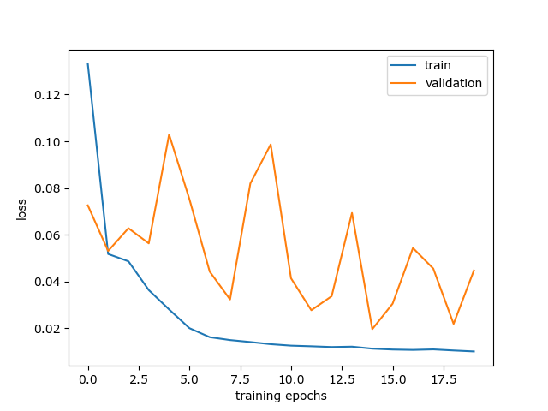
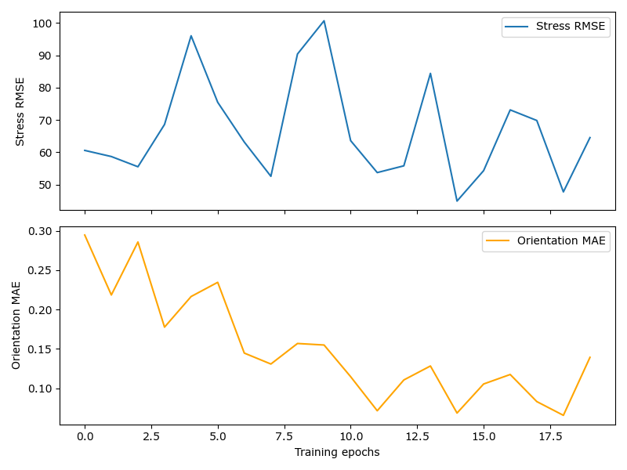
2nd iteration
batch_size = 128
learning_rate = 0.01
num_epochs = 10
Val loss: 0.05204760376363993, Stress RMSE: 58.47566604614258 MAE: 0.2173546850681305
Test loss: 0.05186571143567562, Stress RMSE: 58.2177848815918 MAE: 0.21780309081077576
1445.2720394134521
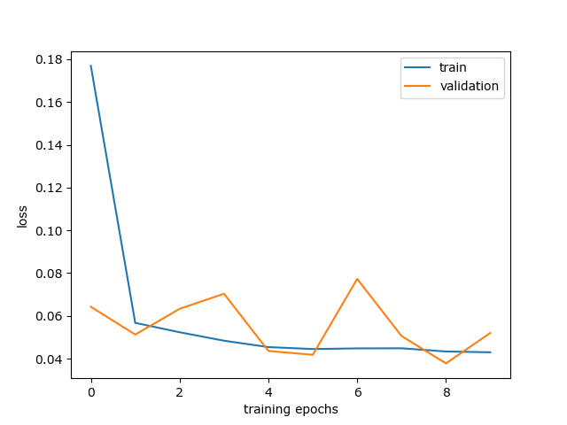
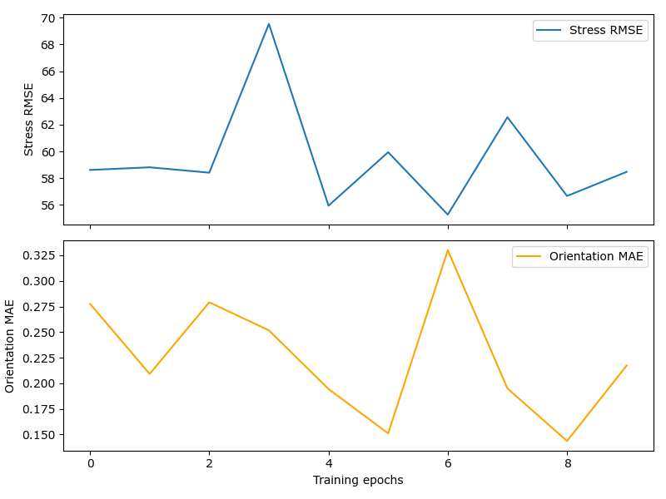

3rd iteration
batch_size = 128
learning_rate = 0.005
num_epochs = 10
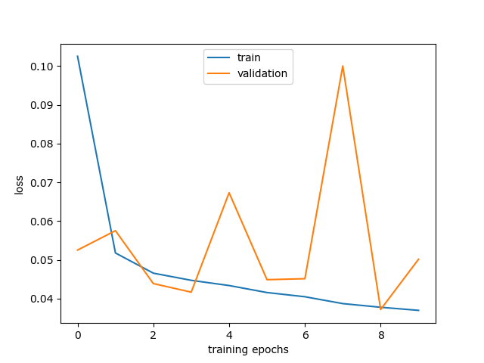
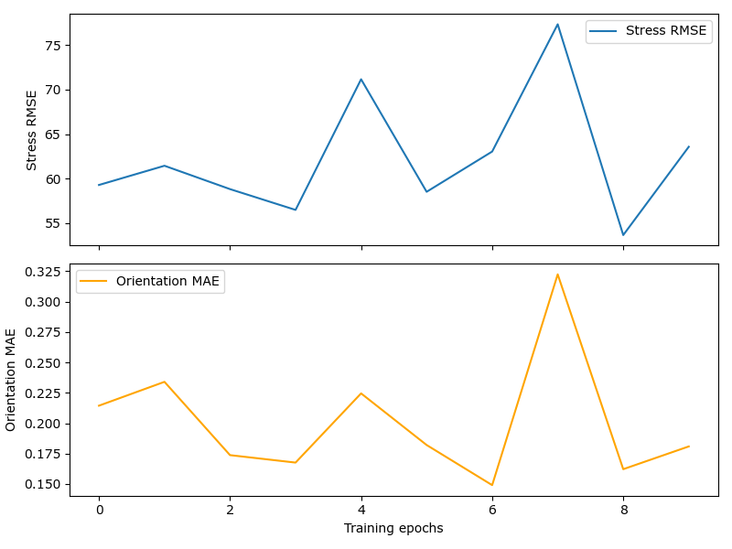
Val loss: 0.05016435347497463, Stress RMSE: 63.57494354248047 MAE: 0.18088480830192566
Test loss: 0.050888733193278315, Stress RMSE: 64.24718475341797 MAE: 0.18092843890190125
1463.2145247459412
4th iteration
batch_size = 128
learning_rate = 0.01
num_epochs = 15
70% train 20%valid 10% test
Val loss: 0.035247512543812774, Stress RMSE: 55.14199447631836 MAE: 0.13151179254055023
Test loss: 0.03572798538953066, Stress RMSE: 55.5518684387207 MAE: 0.13203275203704834
2155.125422000885
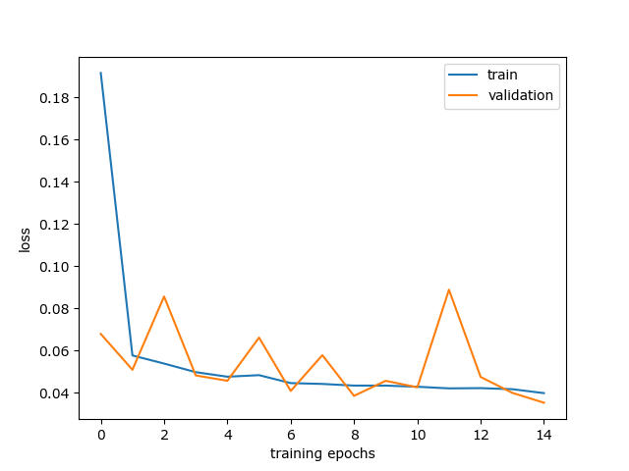
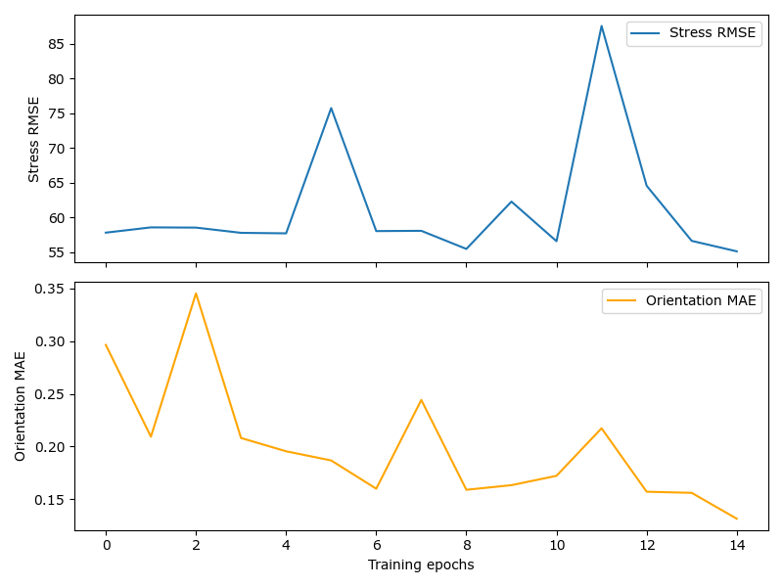

5th iteration
Val loss: 0.02557266030747157, Stress RMSE: 49.597354888916016 MAE: 0.09639603644609451
Test loss: 0.025579114723950625, Stress RMSE: 49.591854095458984 MAE: 0.096364498138427
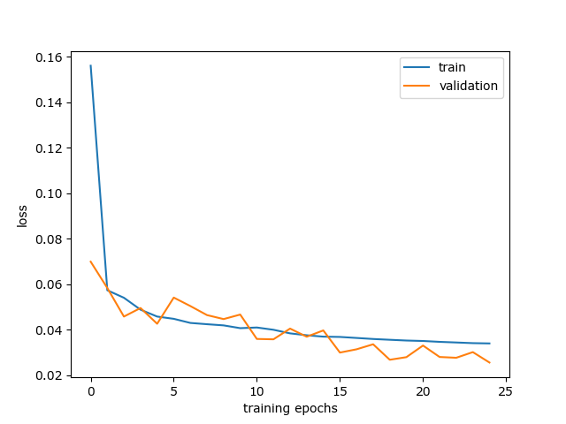
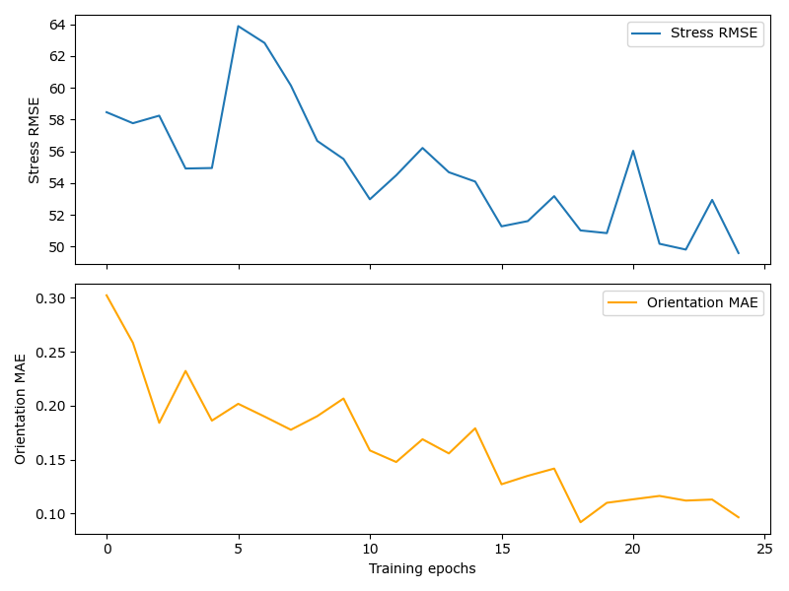
Aranya

50 epochs
Learning 0.01
Batch size 128
architecture- without pooling and without dropout and btach normalization 80-10-10 datasplit
1st iteration
batch_size = 128
learning_rate = 0.01
num_epochs = 10
Val loss: 0.020613392908126117, Stress RMSE: 41.00623321533203 MAE: 0.11185858398675919
Test loss: 0.020519882906228304, Stress RMSE: 40.860260009765625 MAE: 0.11216209828853607
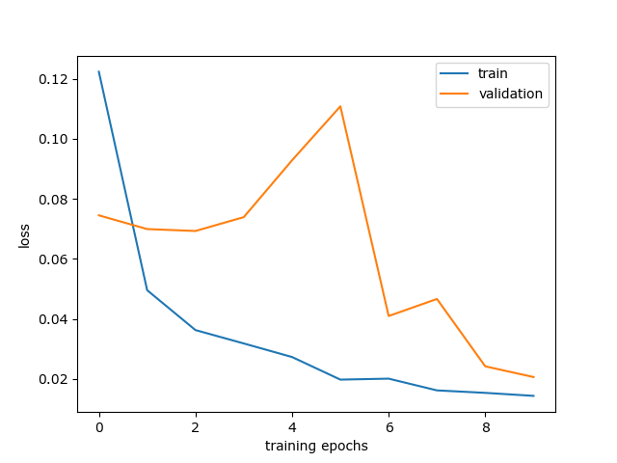
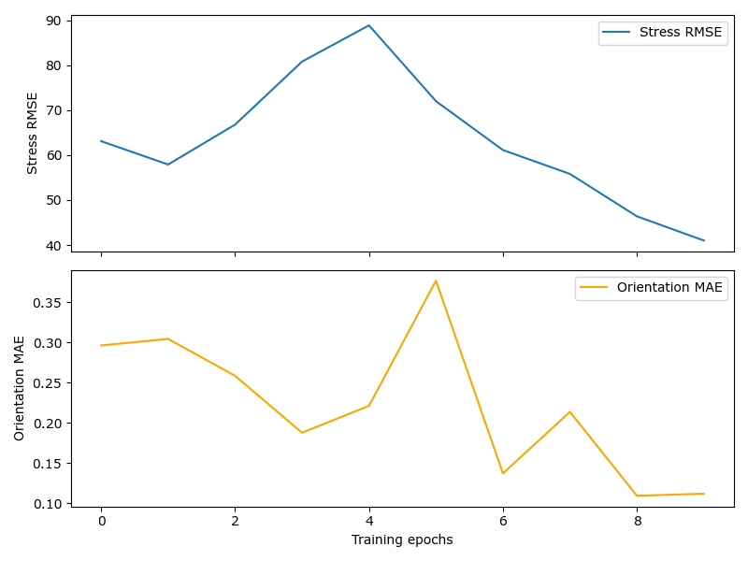

2nd iteration
batch_size = 128
learning_rate = 0.01
num_epochs = 10
Val loss: 0.021715279296040536, Stress RMSE: 44.752845764160156 MAE: 0.08645022660493851
Test loss: 0.02140768188983202, Stress RMSE: 44.38495635986328 MAE: 0.0867137536406517
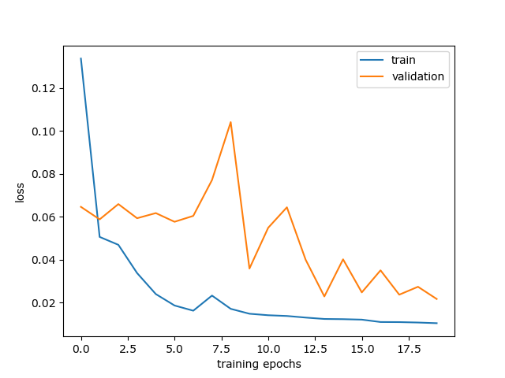
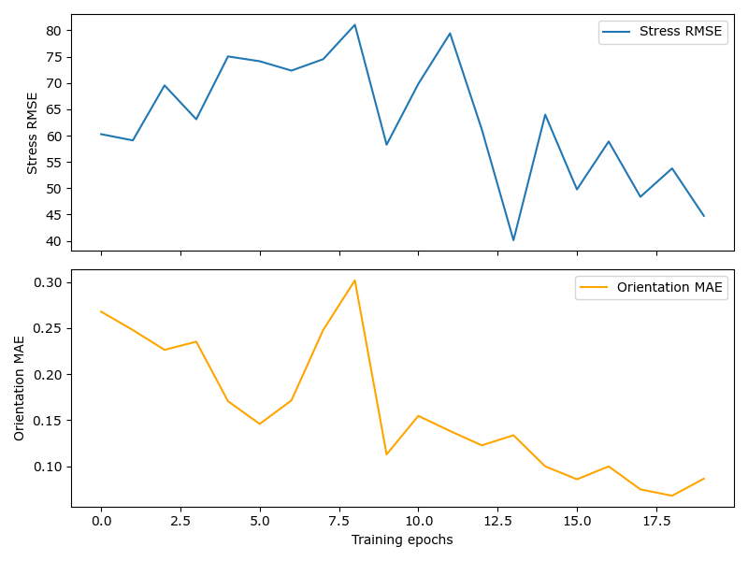
3rd iteration
batch_size = 128
learning_rate = 0.005
num_epochs = 10
Val loss: 0.04170538708567619, Stress RMSE: 53.323402404785156 MAE: 0.20319657027721405
Test loss: 0.04092117492109537, Stress RMSE: 52.55547332763672 MAE: 0.20275795459747314
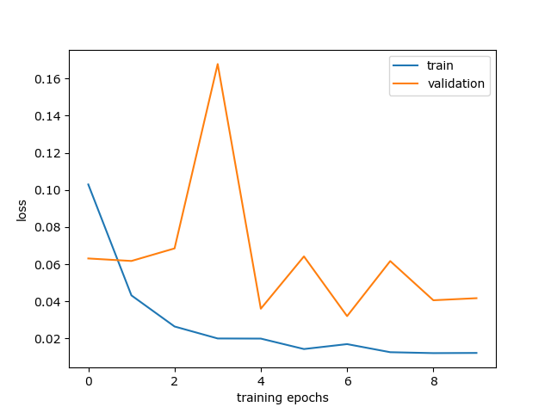
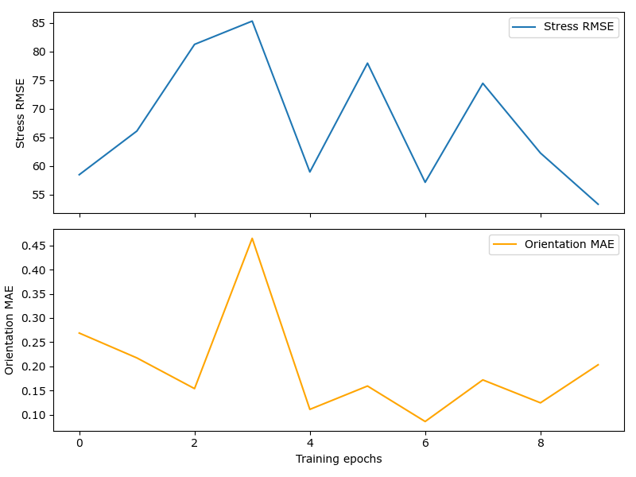

architecture- without pooling and without dropout and btach normalization 70-20-10 datasplit
batch_size = 128
learning_rate = 0.01
num_epochs = 15

Val loss: 0.02543773803000267, Stress RMSE: 52.63875198364258 MAE: 0.052590008825063705
Test loss: 0.025513472966849804, Stress RMSE: 52.742767333984375 MAE: 0.05212156102061272
